|  |  |
| --- | --- |
|  | 惠州学院  HUIZHOU UNIVERSITY |

高级网页设计

**题目：** **高级网页设计课程设计**

**姓 名 何树深**

**学 号 1314080903212**

**专业班级 13网络2班**

**指导教师 曾志**

**提交日期 2015-12-12**

目录

1.实验环境 3

2.实现功能 3

3.应用技术 3

4.源码目录 4

5.网页截图 5

5.1 home 5

5.2 about 6

5.3 blog 7

5.4 login 7

5.4 details 8

5.5 singup 8

6. 源码 9

6.1 index.html 9

6.2 about.html 13

6.3 blog.html 16

6.4 details.html 20

# 1.实验环境

1、硬件环境：个人机，CPU主频：3.1GHz 内存：8G

2、软件环境：操作系统：ubuntu

编程语言：css, javascript, html

# 2.实现功能

实现的是小型公司的主页.

主要功能:

注册, 登陆, 页面跳转等.

# 3.应用技术

使用Js脚本, html语言, css语言.

# 4.源码目录

Small_company/

Css/

Jquery_mmenu.all.css

style.css

Image/

.

.

.

Js/

Jquery.min.js

Jquery.mmenu.js

login.js

Index.html

About.html

Blog.html

Details.html

# 5.网页截图

## 5.1 home

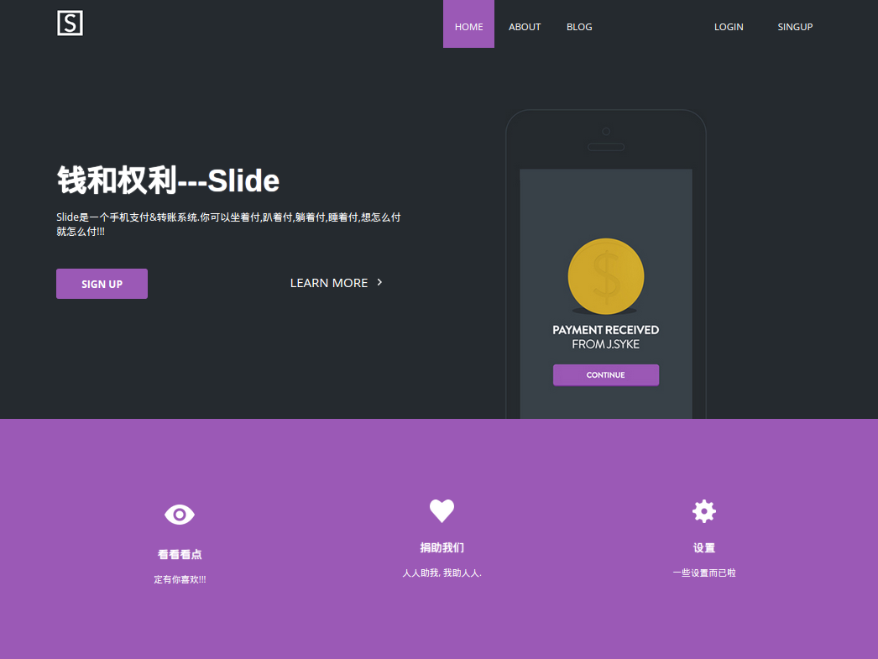

## 5.2 about

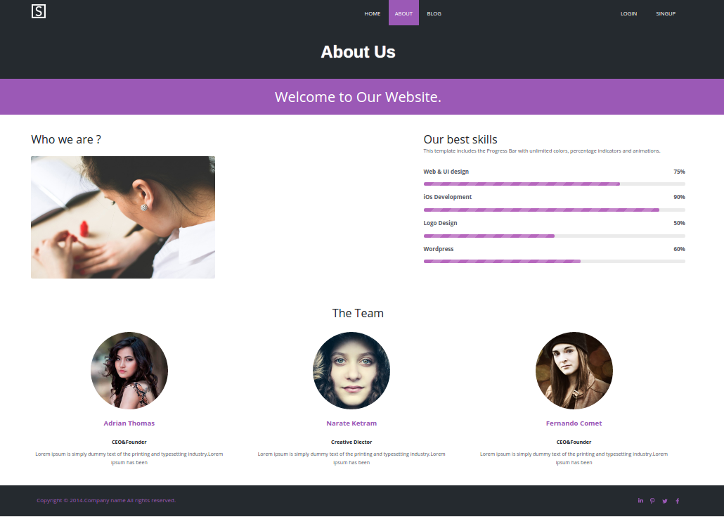

## 5.3 blog

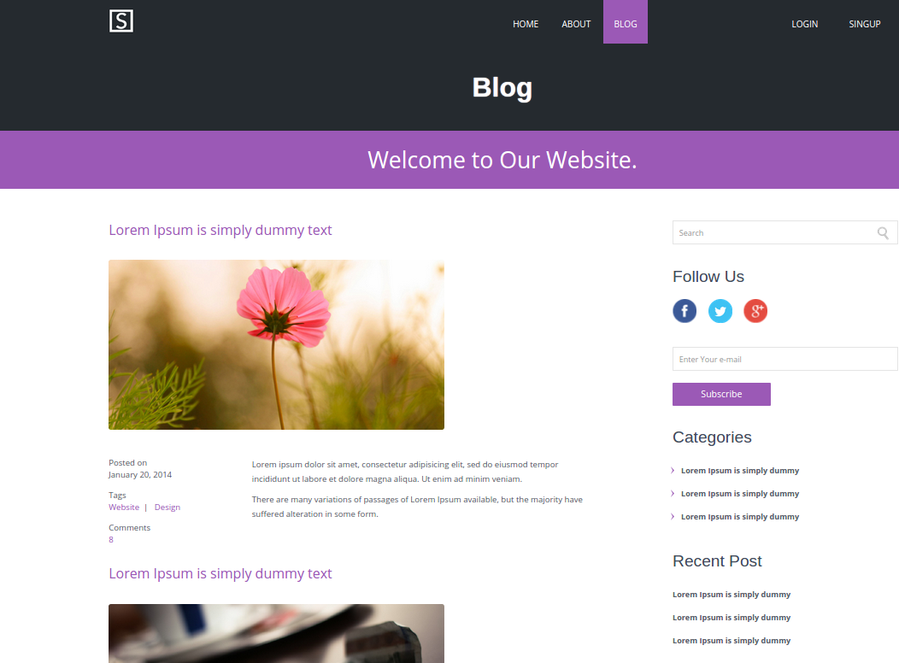

## 5.4 login

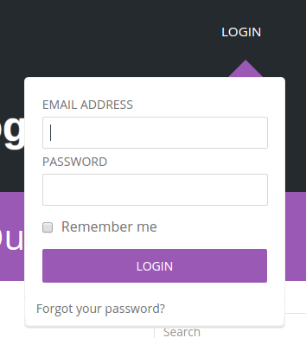

## 5.4 details

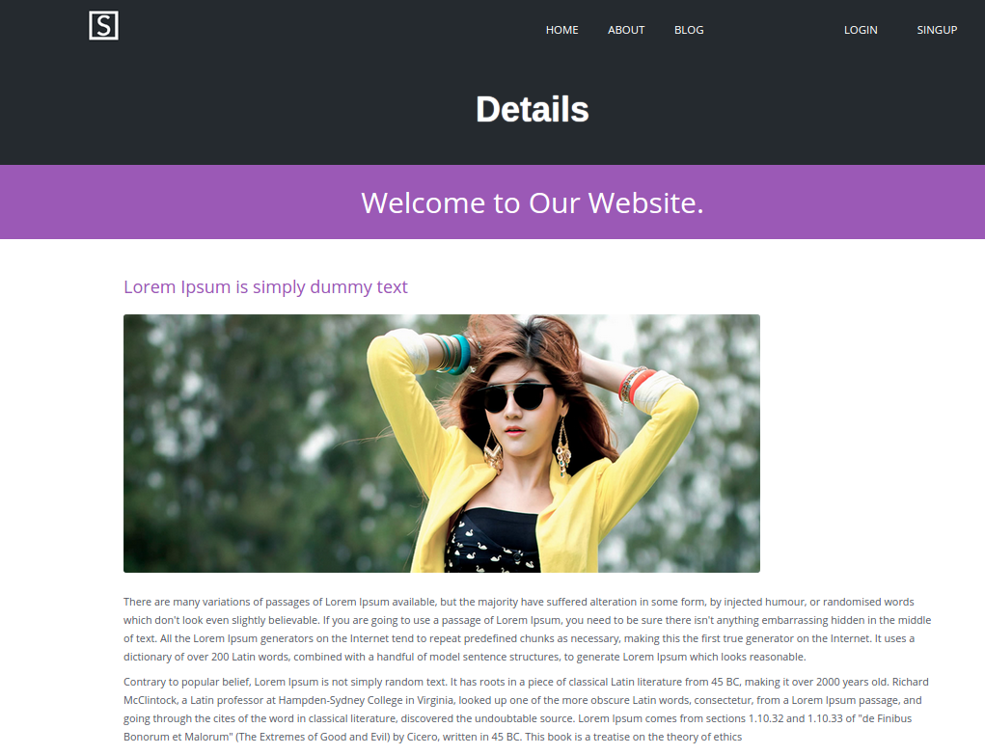

## 5.5 singup

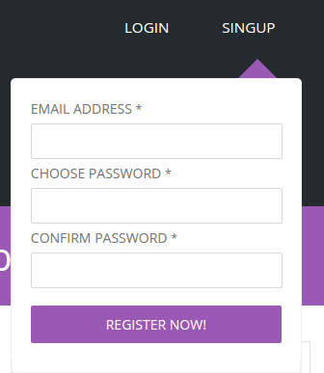

# 6. 源码

## 6.1 index.html

<!DOCTYPE html PUBLIC "-//W3C//DTD XHTML 1.0 Transitional//EN" "http://www.w3.org/TR/xhtml1/DTD/xhtml1-transitional.dtd">

<html xmlns="http://www.w3.org/1999/xhtml">

<head>

<meta http-equiv="Content-Type" content="text/html; charset=utf-8" />

<title>Home</title>

<meta name="viewport" content="width=device-width, initial-scale=1, maximum-scale=1">

<link href="css/style.css" rel="stylesheet" type="text/css" media="all" />

<script src="js/jquery.min.js"></script>

<!---start-login-script--->

<script src="js/login.js"></script>

<!---//End-login-script--->

<!-----768px-menu----->

<link type="text/css" rel="stylesheet" href="css/jquery.mmenu.all.css" />

<script type="text/javascript" src="js/jquery.mmenu.js"></script>

<script type="text/javascript">

// The menu on the left

$(function() {

$('nav#menu-left').mmenu();

});

</script>

<!-----//768px-menu----->

</head>

<body>

<div class="content">

<!------start-768px-menu---->

<div id="page">

<div id="header">

<a class="navicon" href="#menu-left"> </a>

</div>

<nav id="menu-left">

<ul>

<li class="active"><a href="index.html">Home</a></li>

<li><a href="about.html">About</a></li>

<li><a href="blog.html">Blog</a></li>

<div class="clear"> </div>

</ul>

</nav>

</div>

<!------end-768px-menu---->

<!---start-header---->

<div class="header">

<!---start-wrap---->

<div class="wrap">

<div class="header-left">

<div class="logo">

<a href="index.html"><img src="images/logo.jpg"/></a>

</div>

</div>

<div class="header-right">

<div class="top-nav">

<ul>

<li class="active"><a href="index.html">Home</a></li>

<li><a href="about.html">About</a></li>

<li><a href="blog.html">Blog</a></li>

</ul>

</div>

<div class="sign-ligin-btns">

<ul>

<li id="loginContainer"><a class="login" id="loginButton" href="#"><span>LOGIN</span></a>

<div class="clear"> </div>

<div id="loginBox">

<form id="loginForm">

<fieldset id="body">

<fieldset>

<label for="email">Email Address</label>

<input type="text" name="email" id="email" />

</fieldset>

<fieldset>

<label for="password">Password</label>

<input type="password" name="password" id="password" />

</fieldset>

<label class="remeber" for="checkbox"><input type="checkbox" id="checkbox" />Remember me</label>

<input type="submit" id="login" value="login" />

</fieldset>

<span><a href="#">Forgot your password?</a></span>

</form>

</div>

<!-- Login Ends Here -->

</li>

<li id="signupContainer"><a class="signup" id="signupButton" href="#"><span>SINGUP</span></a>

<div class="clear"> </div>

<div id="signupBox">

<form id="signupForm">

<fieldset id="signupbody">

<fieldset>

<label for="email">Email Address <span>*</span></label>

<input type="text" name="email" id="signupemail" />

</fieldset>

<fieldset>

<label for="password">Choose Password <span>*</span></label>

<input type="password" name="password" id="signuppassword" />

</fieldset>

<fieldset>

<label for="password">Confirm Password <span>*</span></label>

<input type="password" name="password" id="signuppassword1" />

</fieldset>

<input type="submit" id="signup" value="Register Now!" />

</fieldset>

</form>

</div>

<!-- Login Ends Here -->

</li>

<div class="clear"> </div>

</ul>

</div>

<div class="clear"> </div>

</div>

<div class="clear"> </div>

</div>

</div>

<div class="main">

<div class="wrap">

<div class="main_left">

<h2>钱和权利---Slide</h2>

<p>Slide是一个手机支付&转账系统.你可以坐着付,趴着付,躺着付,睡着付,想怎么付就怎么付!!!</p>

<div class="buttons">

<div class="sign_up">

<a href="#">SIGN UP</a>

</div>

<div class="learn">

<a href="details.html" class="arrow_btn">LEARN MORE</a>

</div>

<div class="clear"> </div>

</div>

</div>

<div class="main_right">

<span> </span>

</div>

<div class="clear"> </div>

<!---//End-header---->

</div>

</div>

</div>

<div class="buttom">

<div class="wrap">

<div class="top-grids">

<div class="top-grid">

<a href="#"><img src="images/icon1.png"/></a>

<h3><a href="#">看看看点</a></h3>

<p>定有你喜欢!!!</p>

</div>

<div class="top-grid">

<a href="#"> <img src="images/icon2.png"/></a>

<h3><a href="#">捐助我们</a></h3>

<p>人人助我, 我助人人.</p>

</div>

<div class="top-grid">

<a href="#"><img src="images/icon3.png"/> </a>

<h3><a href="#">设置</a></h3>

<p>一些设置而已啦</p>

</div>

<div class="clear"> </div>

</div>

</div>

</div>

<div class="footer">

<div class="wrap">

<div class="footer-left">

<div class="copy">

<p>Copyright &copy; 2014.Company name All rights reserved. </p>

</div>

</div>

<div class="social_icons">

<ul>

<li class="in"><a href="#"><span> </span></a></li>

<li class="pro"><a href="#"><span> </span></a></li>

<li class="twitter"><a href="#"><span> </span></a></li>

<li class="facebook"><a href="#"><span> </span></a></li>

<div class="clear"> </div>

</ul>

</div>

<div class="clear"> </div>

</div>

</div>

</body>

</html>

## 6.2 about.html

<!DOCTYPE html PUBLIC "-//W3C//DTD XHTML 1.0 Transitional//EN" "http://www.w3.org/TR/xhtml1/DTD/xhtml1-transitional.dtd">

<html xmlns="http://www.w3.org/1999/xhtml">

<head>

<meta http-equiv="Content-Type" content="text/html; charset=utf-8" />

<title>Home</title>

<meta name="viewport" content="width=device-width, initial-scale=1, maximum-scale=1">

<link href="css/style.css" rel="stylesheet" type="text/css" media="all" />

<script src="js/jquery.min.js"></script>

<!---start-login-script--->

<script src="js/login.js"></script>

<!---//End-login-script--->

<!-----768px-menu----->

<link type="text/css" rel="stylesheet" href="css/jquery.mmenu.all.css" />

<script type="text/javascript" src="js/jquery.mmenu.js"></script>

<script type="text/javascript">

// The menu on the left

$(function() {

$('nav#menu-left').mmenu();

});

</script>

<!-----//768px-menu----->

</head>

<body>

<div class="content">

<!------start-768px-menu---->

<div id="page">

<div id="header">

<a class="navicon" href="#menu-left"> </a>

</div>

<nav id="menu-left">

<ul>

<li class="active"><a href="index.html">Home</a></li>

<li><a href="about.html">About</a></li>

<li><a href="blog.html">Blog</a></li>

<div class="clear"> </div>

</ul>

</nav>

</div>

<!------end-768px-menu---->

<!---start-header---->

<div class="header">

<!---start-wrap---->

<div class="wrap">

<div class="header-left">

<div class="logo">

<a href="index.html"><img src="images/logo.jpg"/></a>

</div>

</div>

<div class="header-right">

<div class="top-nav">

<ul>

<li class="active"><a href="index.html">Home</a></li>

<li><a href="about.html">About</a></li>

<li><a href="blog.html">Blog</a></li>

</ul>

</div>

<div class="sign-ligin-btns">

<ul>

<li id="loginContainer"><a class="login" id="loginButton" href="#"><span>LOGIN</span></a>

<div class="clear"> </div>

<div id="loginBox">

<form id="loginForm">

<fieldset id="body">

<fieldset>

<label for="email">Email Address</label>

<input type="text" name="email" id="email" />

</fieldset>

<fieldset>

<label for="password">Password</label>

<input type="password" name="password" id="password" />

</fieldset>

<label class="remeber" for="checkbox"><input type="checkbox" id="checkbox" />Remember me</label>

<input type="submit" id="login" value="login" />

</fieldset>

<span><a href="#">Forgot your password?</a></span>

</form>

</div>

<!-- Login Ends Here -->

</li>

<li id="signupContainer"><a class="signup" id="signupButton" href="#"><span>SINGUP</span></a>

<div class="clear"> </div>

<div id="signupBox">

<form id="signupForm">

<fieldset id="signupbody">

<fieldset>

<label for="email">Email Address <span>*</span></label>

<input type="text" name="email" id="signupemail" />

</fieldset>

<fieldset>

<label for="password">Choose Password <span>*</span></label>

<input type="password" name="password" id="signuppassword" />

</fieldset>

<fieldset>

<label for="password">Confirm Password <span>*</span></label>

<input type="password" name="password" id="signuppassword1" />

</fieldset>

<input type="submit" id="signup" value="Register Now!" />

</fieldset>

</form>

</div>

<!-- Login Ends Here -->

</li>

<div class="clear"> </div>

</ul>

</div>

<div class="clear"> </div>

</div>

<div class="clear"> </div>

</div>

</div>

<div class="main">

<div class="wrap">

<div class="main_left">

<h2>钱和权利---Slide</h2>

<p>Slide是一个手机支付&转账系统.你可以坐着付,趴着付,躺着付,睡着付,想怎么付就怎么付!!!</p>

<div class="buttons">

<div class="sign_up">

<a href="#">SIGN UP</a>

</div>

<div class="learn">

<a href="details.html" class="arrow_btn">LEARN MORE</a>

</div>

<div class="clear"> </div>

</div>

</div>

<div class="main_right">

<span> </span>

</div>

<div class="clear"> </div>

<!---//End-header---->

</div>

</div>

</div>

<div class="buttom">

<div class="wrap">

<div class="top-grids">

<div class="top-grid">

<a href="#"><img src="images/icon1.png"/></a>

<h3><a href="#">看看看点</a></h3>

<p>定有你喜欢!!!</p>

</div>

<div class="top-grid">

<a href="#"> <img src="images/icon2.png"/></a>

<h3><a href="#">捐助我们</a></h3>

<p>人人助我, 我助人人.</p>

</div>

<div class="top-grid">

<a href="#"><img src="images/icon3.png"/> </a>

<h3><a href="#">设置</a></h3>

<p>一些设置而已啦</p>

</div>

<div class="clear"> </div>

</div>

</div>

</div>

<div class="footer">

<div class="wrap">

<div class="footer-left">

<div class="copy">

<p>Copyright &copy; 2014.Company name All rights reserved. </p>

</div>

</div>

<div class="social_icons">

<ul>

<li class="in"><a href="#"><span> </span></a></li>

<li class="pro"><a href="#"><span> </span></a></li>

<li class="twitter"><a href="#"><span> </span></a></li>

<li class="facebook"><a href="#"><span> </span></a></li>

<div class="clear"> </div>

</ul>

</div>

<div class="clear"> </div>

</div>

</div>

</body>

</html>

## 6.3 blog.html

<!DOCTYPE html PUBLIC "-//W3C//DTD XHTML 1.0 Transitional//EN" "http://www.w3.org/TR/xhtml1/DTD/xhtml1-transitional.dtd">

<html xmlns="http://www.w3.org/1999/xhtml">

<head>

<meta http-equiv="Content-Type" content="text/html; charset=utf-8" />

<title>Home</title>

<meta name="viewport" content="width=device-width, initial-scale=1, maximum-scale=1">

<link href="css/style.css" rel="stylesheet" type="text/css" media="all" />

<script src="js/jquery.min.js"></script>

<!---start-login-script--->

<script src="js/login.js"></script>

<!---//End-login-script--->

<!-----768px-menu----->

<link type="text/css" rel="stylesheet" href="css/jquery.mmenu.all.css" />

<script type="text/javascript" src="js/jquery.mmenu.js"></script>

<script type="text/javascript">

// The menu on the left

$(function() {

$('nav#menu-left').mmenu();

});

</script>

<!-----//768px-menu----->

</head>

<body>

<div class="content">

<!------start-768px-menu---->

<div id="page">

<div id="header">

<a class="navicon" href="#menu-left"> </a>

</div>

<nav id="menu-left">

<ul>

<li class="active"><a href="index.html">Home</a></li>

<li><a href="about.html">About</a></li>

<li><a href="blog.html">Blog</a></li>

<div class="clear"> </div>

</ul>

</nav>

</div>

<!------end-768px-menu---->

<!---start-header---->

<div class="header">

<!---start-wrap---->

<div class="wrap">

<div class="header-left">

<div class="logo">

<a href="index.html"><img src="images/logo.jpg"/></a>

</div>

</div>

<div class="header-right">

<div class="top-nav">

<ul>

<li class="active"><a href="index.html">Home</a></li>

<li><a href="about.html">About</a></li>

<li><a href="blog.html">Blog</a></li>

</ul>

</div>

<div class="sign-ligin-btns">

<ul>

<li id="loginContainer"><a class="login" id="loginButton" href="#"><span>LOGIN</span></a>

<div class="clear"> </div>

<div id="loginBox">

<form id="loginForm">

<fieldset id="body">

<fieldset>

<label for="email">Email Address</label>

<input type="text" name="email" id="email" />

</fieldset>

<fieldset>

<label for="password">Password</label>

<input type="password" name="password" id="password" />

</fieldset>

<label class="remeber" for="checkbox"><input type="checkbox" id="checkbox" />Remember me</label>

<input type="submit" id="login" value="login" />

</fieldset>

<span><a href="#">Forgot your password?</a></span>

</form>

</div>

<!-- Login Ends Here -->

</li>

<li id="signupContainer"><a class="signup" id="signupButton" href="#"><span>SINGUP</span></a>

<div class="clear"> </div>

<div id="signupBox">

<form id="signupForm">

<fieldset id="signupbody">

<fieldset>

<label for="email">Email Address <span>*</span></label>

<input type="text" name="email" id="signupemail" />

</fieldset>

<fieldset>

<label for="password">Choose Password <span>*</span></label>

<input type="password" name="password" id="signuppassword" />

</fieldset>

<fieldset>

<label for="password">Confirm Password <span>*</span></label>

<input type="password" name="password" id="signuppassword1" />

</fieldset>

<input type="submit" id="signup" value="Register Now!" />

</fieldset>

</form>

</div>

<!-- Login Ends Here -->

</li>

<div class="clear"> </div>

</ul>

</div>

<div class="clear"> </div>

</div>

<div class="clear"> </div>

</div>

</div>

<div class="main">

<div class="wrap">

<div class="main_left">

<h2>钱和权利---Slide</h2>

<p>Slide是一个手机支付&转账系统.你可以坐着付,趴着付,躺着付,睡着付,想怎么付就怎么付!!!</p>

<div class="buttons">

<div class="sign_up">

<a href="#">SIGN UP</a>

</div>

<div class="learn">

<a href="details.html" class="arrow_btn">LEARN MORE</a>

</div>

<div class="clear"> </div>

</div>

</div>

<div class="main_right">

<span> </span>

</div>

<div class="clear"> </div>

<!---//End-header---->

</div>

</div>

</div>

<div class="buttom">

<div class="wrap">

<div class="top-grids">

<div class="top-grid">

<a href="#"><img src="images/icon1.png"/></a>

<h3><a href="#">看看看点</a></h3>

<p>定有你喜欢!!!</p>

</div>

<div class="top-grid">

<a href="#"> <img src="images/icon2.png"/></a>

<h3><a href="#">捐助我们</a></h3>

<p>人人助我, 我助人人.</p>

</div>

<div class="top-grid">

<a href="#"><img src="images/icon3.png"/> </a>

<h3><a href="#">设置</a></h3>

<p>一些设置而已啦</p>

</div>

<div class="clear"> </div>

</div>

</div>

</div>

<div class="footer">

<div class="wrap">

<div class="footer-left">

<div class="copy">

<p>Copyright &copy; 2014.Company name All rights reserved. </p>

</div>

</div>

<div class="social_icons">

<ul>

<li class="in"><a href="#"><span> </span></a></li>

<li class="pro"><a href="#"><span> </span></a></li>

<li class="twitter"><a href="#"><span> </span></a></li>

<li class="facebook"><a href="#"><span> </span></a></li>

<div class="clear"> </div>

</ul>

</div>

<div class="clear"> </div>

</div>

</div>

</body>

</html>

## 6.4 details.html

<!DOCTYPE html PUBLIC "-//W3C//DTD XHTML 1.0 Transitional//EN" "http://www.w3.org/TR/xhtml1/DTD/xhtml1-transitional.dtd">

<html xmlns="http://www.w3.org/1999/xhtml">

<head>

<meta http-equiv="Content-Type" content="text/html; charset=utf-8" />

<title>Home</title>

<meta name="viewport" content="width=device-width, initial-scale=1, maximum-scale=1">

<link href="css/style.css" rel="stylesheet" type="text/css" media="all" />

<script src="js/jquery.min.js"></script>

<!---start-login-script--->

<script src="js/login.js"></script>

<!---//End-login-script--->

<!-----768px-menu----->

<link type="text/css" rel="stylesheet" href="css/jquery.mmenu.all.css" />

<script type="text/javascript" src="js/jquery.mmenu.js"></script>

<script type="text/javascript">

// The menu on the left

$(function() {

$('nav#menu-left').mmenu();

});

</script>

<!-----//768px-menu----->

</head>

<body>

<div class="content">

<!------start-768px-menu---->

<div id="page">

<div id="header">

<a class="navicon" href="#menu-left"> </a>

</div>

<nav id="menu-left">

<ul>

<li class="active"><a href="index.html">Home</a></li>

<li><a href="about.html">About</a></li>

<li><a href="blog.html">Blog</a></li>

<div class="clear"> </div>

</ul>

</nav>

</div>

<!------end-768px-menu---->

<!---start-header---->

<div class="header">

<!---start-wrap---->

<div class="wrap">

<div class="header-left">

<div class="logo">

<a href="index.html"><img src="images/logo.jpg"/></a>

</div>

</div>

<div class="header-right">

<div class="top-nav">

<ul>

<li class="active"><a href="index.html">Home</a></li>

<li><a href="about.html">About</a></li>

<li><a href="blog.html">Blog</a></li>

</ul>

</div>

<div class="sign-ligin-btns">

<ul>

<li id="loginContainer"><a class="login" id="loginButton" href="#"><span>LOGIN</span></a>

<div class="clear"> </div>

<div id="loginBox">

<form id="loginForm">

<fieldset id="body">

<fieldset>

<label for="email">Email Address</label>

<input type="text" name="email" id="email" />

</fieldset>

<fieldset>

<label for="password">Password</label>

<input type="password" name="password" id="password" />

</fieldset>

<label class="remeber" for="checkbox"><input type="checkbox" id="checkbox" />Remember me</label>

<input type="submit" id="login" value="login" />

</fieldset>

<span><a href="#">Forgot your password?</a></span>

</form>

</div>

<!-- Login Ends Here -->

</li>

<li id="signupContainer"><a class="signup" id="signupButton" href="#"><span>SINGUP</span></a>

<div class="clear"> </div>

<div id="signupBox">

<form id="signupForm">

<fieldset id="signupbody">

<fieldset>

<label for="email">Email Address <span>*</span></label>

<input type="text" name="email" id="signupemail" />

</fieldset>

<fieldset>

<label for="password">Choose Password <span>*</span></label>

<input type="password" name="password" id="signuppassword" />

</fieldset>

<fieldset>

<label for="password">Confirm Password <span>*</span></label>

<input type="password" name="password" id="signuppassword1" />

</fieldset>

<input type="submit" id="signup" value="Register Now!" />

</fieldset>

</form>

</div>

<!-- Login Ends Here -->

</li>

<div class="clear"> </div>

</ul>

</div>

<div class="clear"> </div>

</div>

<div class="clear"> </div>

</div>

</div>

<div class="main">

<div class="wrap">

<div class="main_left">

<h2>钱和权利---Slide</h2>

<p>Slide是一个手机支付&转账系统.你可以坐着付,趴着付,躺着付,睡着付,想怎么付就怎么付!!!</p>

<div class="buttons">

<div class="sign_up">

<a href="#">SIGN UP</a>

</div>

<div class="learn">

<a href="details.html" class="arrow_btn">LEARN MORE</a>

</div>

<div class="clear"> </div>

</div>

</div>

<div class="main_right">

<span> </span>

</div>

<div class="clear"> </div>

<!---//End-header---->

</div>

</div>

</div>

<div class="buttom">

<div class="wrap">

<div class="top-grids">

<div class="top-grid">

<a href="#"><img src="images/icon1.png"/></a>

<h3><a href="#">看看看点</a></h3>

<p>定有你喜欢!!!</p>

</div>

<div class="top-grid">

<a href="#"> <img src="images/icon2.png"/></a>

<h3><a href="#">捐助我们</a></h3>

<p>人人助我, 我助人人.</p>

</div>

<div class="top-grid">

<a href="#"><img src="images/icon3.png"/> </a>

<h3><a href="#">设置</a></h3>

<p>一些设置而已啦</p>

</div>

<div class="clear"> </div>

</div>

</div>

</div>

<div class="footer">

<div class="wrap">

<div class="footer-left">

<div class="copy">

<p>Copyright &copy; 2014.Company name All rights reserved. </p>

</div>

</div>

<div class="social_icons">

<ul>

<li class="in"><a href="#"><span> </span></a></li>

<li class="pro"><a href="#"><span> </span></a></li>

<li class="twitter"><a href="#"><span> </span></a></li>

<li class="facebook"><a href="#"><span> </span></a></li>

<div class="clear"> </div>

</ul>

</div>

<div class="clear"> </div>

</div>

</div>

</body>

</html>