**Template for review page in MateriApps**

**Writer： Group.MD (2018/10/03)**

**1. Introduction**

GROMACS (<http://www.gromacs.org/>) is designed for studying biological macromolecules based on the molecular dynamics (MD) simulation. In this review, we will demonstrate how to run a test calculation in “gauss.issp.u-tokyo.ac.jp”. (We call this PC cluster simply “*gauss*” in later sections.)

**2. How to install/compile (if necessary)**

|  |
| --- |
| cd practice  wget ftp://ftp.gromacs.org/pub/gromacs/gromacs-5.1.5.tar.gz |

In the beginning, please make a directory to compile the app.

Here, we will install GROMACS linked with fftw3 that will be downloaded from the internet directly.

As the first step of this review, we will explain how to compile Gromacs-5.1.5.

|  |
| --- |
| mkdir practice |

First, please make a directory by executing the command below.

Next, you need to download the tar file of Gromacs using wget.

To install the app in *gauss*, cmake can be used. If cmake is also available in your computer, please execute the commands below;

|  |
| --- |
| mkdir build  cd build  cmake .. \  -DGMXBUILD_OWN_FFTW=ON \  -DCMAKE_INSTALL_PREFIX=*install_dir* \  -DGMX_SIMD=SSE2 \  -DGMX_DOUBLE=ON \  -DGMX_MPI=ON  make  make check  make -j 4 install |

If you succeed in compiling the app, you can find binary files in *install_dir*/bin/.

**3. How to use**

Let’s run a test calculation which uses the sample files in “./app/sample/from_file”. You need to prepare three input files: “solution_run.mdp”, “solution.gro” and “etohsolution.top”, which can be found in “xxx (decide later)” in *gauss*.

|  |
| --- |
| mkdir test  cd test |

You can now submit the job for the NPT calculation. The run.sh can also be found in “xxx (decide later)” in *gauss*.

|  |
| --- |
| qsub run.sh |

The calculation will be finished within a few seconds, and you can obtain “md.edr”, “md.xtc” and “mdout.mdp”.

If you use GUI program, for example, VMD, you can check the MD trajectory.

Good luck!

**4. Results**

Results are outputted to the current directory.

The edr file extension stands for the portable energy file.

The physical properties are stored using the xdr protocol.

The xtc format is a portable format for the trajectories.

The mdp file contains parameters performed by MD.

Finally, let’s check the results by reading gro and xtc files using VMD.

By loading md.gro file with md.xtc into VMD, the image as shown in the following figure can be found.

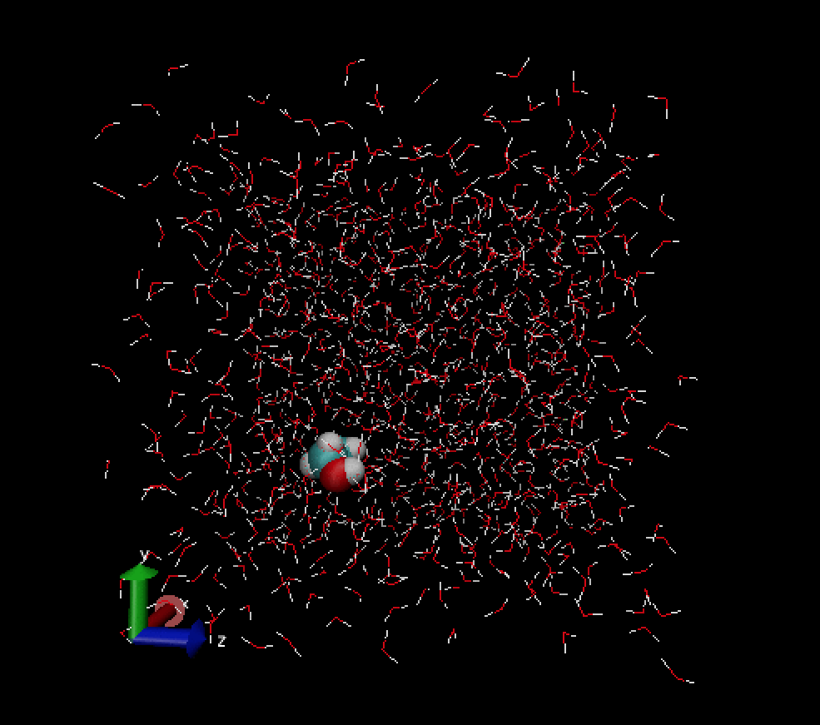

**5. Summary**

In this review, we introduced a simple example for the MD calculation of ethanol in water by using GROMACS. If you are interested in more examples using GROMACS, you should refer to GROMACS Tutorials, which can be found in the website: http://www.mdtutorials.com/gmx/index.html.