  ., | [  Guidance Navigation and Control  Flight Software Math Library  User’s Guide  Flight Software Branch – Code 582  Version 1.0 – 06/18/07  582-2007-014
document control and update History
This document is a Flight Software (FSW) Branch Library controlled document. Proposed changes shall be submitted to FSW Library Configuration Control Board (CCB).

Version | Date | Description | Affected Pages
1.0 | 02/13/07 | Prior to LRO and SDO a branch effort was made to produce a project independent math library. The library was created but branches processes and tools were not in place to manage the library. This Initial version Is based on SDO’s math library specification which in turn is based on the notes and memos from the math library creation process. | All

Contents
1.0 Introduction 1
1.1 Document Organization 1
1.2 Relevant Documents 1
2.0 Math Library Design 2
2.1 Directory structure 3
3.0 Math Library Unit Tests 5
3.1 Math Constants Unit Test 5
3.2 Matrix Unit Test 5
3.3 Quaternion Unit Test 5
3.4 Scalar Unit Test 7
3.5 Vector Unit Test 7
Appendix A Design Policies 8

1.0 Introduction
The math library is a collection of reusable math components that provide typical math utilities required by spacecraft flight software. These utilities are intended to increase flight software quality, reusability, and maintainability by providing a set of consistent, well documented and tested math utilities.

This document only describes the math utilities and does describe the general Guidance Navigation and Control (GN&C) Flight Software (FSW) development environment. Refer to the GN&C FSW Developer’s Guide for an overview that provides the context for the math library.

1.1 Document Organization
This document is organized into the following additional sections and appendices:
Section 2 describes the design of the math library.
Section 3 describes the unit tests for the math library.
Appendix A contains design policies (based on FSB heritage analysis effort) that were used to design the library.

1.2 Relevant Documents
Number | Title | Rev | Date
582-2000-005 | FSB C Coding Standards | 1.1 | 11/29/05
582-2007-016 | GN&C FSW Module Developer’s Guide | 1.0 | 08/31/07
582-2007-017 | GN&C FSW Unit Test Tool User’s Guide | 1.0 | 08/31/07
ISBN  9789027709592 | Spacecraft Attitude and Control by James R. Wertz | 1 | 6/1/1978
2.0 Math Library Design
This section describes the math library design. Appendix A provides a list of general design policies with rationale that were defined based on heritage FSW and branch meetings.

Figure 2-1 identifies the components of the math library and their dependencies. An arrow indicates a unidirectional dependency between two components. For example Quaternion depends upon MathConstants. The library’s only external dependency is the ANSI C math library.

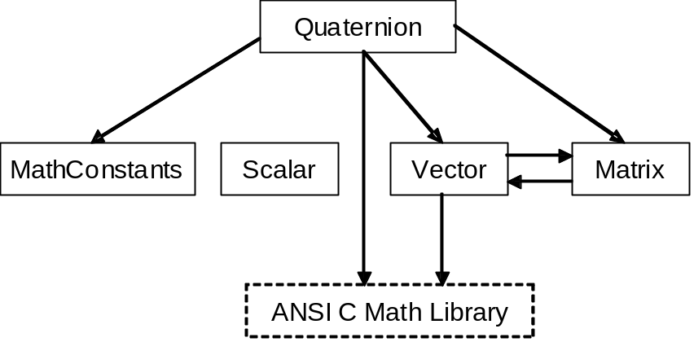

Figure 2-1 Math Library Units

Table 2-1 lists the files used to implement the components. The vector and matrix components define units with explicit dimensions. These units define a type that is used by their functions which allows a compiler to perform type checking during compilation. Matrix also defines an unbounded unit that can be used for any sized vector or matrix. The matmxn unit is used to implement the explicitly dimensioned units.

Unit | Public Header Files | Source Code Files | API
mathconstants | mathconstants.h | None | html\group__math__const.html
scalar | scalar.h | scalar.c | html\group__math__scalar.html
matrix | matrix3x3d.h  matrix3x4d.h  matrix4x3d.h  matrix6x6d.h  matrixmxnd.h | matrix3x3d.c  matrix3x4d.c  matrix4x3d.c  matrix6x6d.c  matrixmxnd.c | html\group__math__matrix.html
vector | vector3d.h  vector4d.h | vector3d.c  vector4d.c | html\group__math__vector.html
quaternion | quaternion.h | quaternion.c | html\group__math__quat.html

Table 2-1 Math Library Units

2.1 Directory structure
Figure 2-2 shows the math library’s source and documentation directory structure. Currently, the math library is a subset of the gnc-fsw library. Non-GN&C applications can use the math libraries but it is contained within the gnc-fsw library because GN&C applications are the primary user and they typically determine what is needed in the library. Including the math library as a subset of the gnc-fsw allows the math library unit tests to use the gnc-fsw unit test tools so they have a consistent structure. At the time of this writing the Core Flight System (CFS) is being developed. The math library may eventually become a shared library within the CFS.

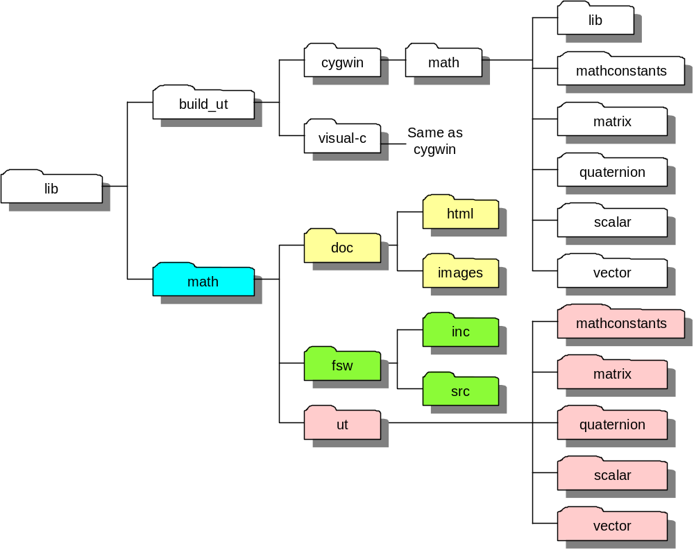

Figure 2-2 gnc-fsw Math Library Directory Structure

The doc folder contains the math library documentation which is where this document is contained. This document contains hyperlinks to the html folder which contains the math library Application Programmer’s Interface (API). The files in the html folder are automatically generated from the code using doxygen. The fsw folder contains the make file for building the math library for the Core Flight System (CFS) and it has two sub-folders inc and src that contain the header include files and C source code respectively. The ut (unit test) folder contains five folders (mathconstants, matrix, quaternion, scalar, and vector) that contain unit test source code, input data files (if applicable), and expected results.

The build_ut directory contains one directory tree for each supported compiler; currently GNU and Visual C. Within each compiler directory is a math folder that has a lib folder and one folder for math unit test source folder. There are other library modules within each compiler directory that are not shown in Figure 2-2. The lib folder is used to build a math object library for the specific compiler. This math object library is linked with the each math library unit test to create the unit test executables and it is also available for other gnc-fsw unit testing. The unit test folders are used for building and running the unit tests. Refer to the GN&C FSW Module Developer’s Guide (582-2007-016) and the GN&C FSW Unit Test Tool User’s Guide (582-2007-017) for details on how to build and execute the unit test.

3.0 Math Library Unit Tests
All of the math unit tests use the utdriver and utassert unit test tools so they have a similar style. The test driver file names are ut_XXX.c where XXX is the name of the unit being and the output file is named ut_XXX.log. All log files textually indicate whether the test passed and each test driver’s main() function returns either UTDRIVER_PASS or UTDRIVER_FAIL as defined in utdriver.h. The tests are intended to be self-documented. This section identifies the test files and provides any additional information that helps in understanding the tests.

3.1 Math Constants Unit Test

Even though mathconstants.h only contains C macro, a unit test was written to ensure that the constants are correct.

Unit Test File | Description
ut_mathconstants.c | Test C macros defined in mathconstants.h.

3.2 Matrix Unit Test

The fixed dimensioned matrix units use matrixmxnd.c to implement their functions. Therefore matrixmxnd.c does not require its own unit test because all of its function have been tested by testing the fixed dimensioned units.

Unit Test File | Description
ut_matrix3x3d.c | Test the functions defined in matrix3x3d.c.
ut_matrix3x4d.c | Test the functions defined in matrix3x4d.c.
ut_matrix4x3d.c | Test the functions defined in matrix4x3d.c.
ut_matrix6x6d.c | Test the functions defined in matrix6x6d.c.

3.3 Quaternion Unit Test
In general each function was tested from both an algorithmic point of view (that it produced the correct output for a range of input data) and an implementation point of view (that it did not modify its input parameters, that it was capable of using the same variable for input and output, etc.)

For most of the tests below a range of quaternions was created by using nested loops to create a series of vectors that ranged from –1 to +1 in each of their three axes (for example: (-1 ,-1 ,-1), (-1, -1, -0.9) … (1, 1, 0.9), (1, 1, 1)). See figure below.

Then each vector was normalized so that it could be used as an eigenvector to build a quaternion. If needed quaternions could then be created from these eigenvectors with angular magnitudes ranging from –Pi to +Pi. For some tests requiring a range of vectors, the same method was used to construct the test vectors.

Unit Test File | Description
ut_quaternion.c | Test functions defined in quaternion.h. The following input files must be in the same directory as the unit test executable. If they are not present an error message is output to the screen.  - QuatDcmColumnwise.inp  - QuatQuatMult.inp  - QuatVecMult.inp

3.4 Scalar Unit Test
Unit Test File | Description
ut_scalar.c | Test C macros defined in scalar.h and the scalar functions defined in scalar.c.

The Scalar_Limit() test includes trhe following checks:

 | Input |  |  | Output
 | Input Value | Lower Limit | Upper Limit | Limited Value | Status
Both limits negative | -20 | -10 | -5 | -10 | -1
Both limits negative | -7 | -10 | -5 | -7 | 0
Both limits negative | -4.9 | -10 | -5 | -5 | 1
1 negative and 1 positive limit | -6 | -2 | 4.5 | -2 | -1
1 negative and 1 positive limit | -1.9999 | -2 | 4.5 | -1.9999 | 0
1 negative and 1 positive limit | 4.55 | -2 | 4.5 | 4.5 | 1
Both limits positive | -5 | 100 | 110 | 100 | -1
Both limits positive | 101 | 100 | 110 | 101 | 0
Both limits positive | 1000 | 100 | 110 | 110 | 1
input equal to a limit | 100 | 100 | 110 | 100 | 0
input equal to a limit | 110 | 100 | 110 | 110 | 0

3.5 Vector Unit Test

Unit Test File | Description
ut_vector3d.c | Test the functions defined in vector3d.c.
ut_vector4d.c | Test the functions defined in vector4d.c.
ut_vector6d.c | Test the functions defined in vector6d.c.

Appendix A Design Policies
Prior to the Lunar Reconnaissance Orbiter (LRO) and the Solar Dynamic Orbiter (SDO) missions the Flight Software Branch performed an analysis of recent mission’s math libraries to define a common feature set and to establish policies for the library’s design. These policies should be adhered to while maintaining the library. This appendix describes the math libraries design policies and the rationale for each policy.

Design Policy: Macro Definitions

Feature | Rationale
Naming Standard  - Add prefix to constants | Prefixes minimize namespace collisions.
Header file placement  - Keep an object’s (sun, moon, etc.) physical quantity definition in the object model’s header file | Some previous math libraries included attributes that described a particular object. To promote modularity and since the user of an object’s is the only one interested in the constants keep the definitions with the object.

Design Policy: Function Interface Standards

Feature | Rationale
Function Naming Standard  - Specify object/type first followed by the operation to perform on the object | This is the current standard that is readable, easy to learn, easy to remember, and less work to keep it as is. Two other assumptions are at work. First, the more complex type “owns” conversion to lower types. For example Quat_ToMatrix() and Quat_FromMatrix(). Second, vectors are column vectors. This removes the confusion of how to define the function for multiplying a row vector by a matrix and row vector times a column vector.
Parameter Order  - Result is always to the left. If it’s a scalar then it’s the return value. If it’s a non-scalar then it’s the first parameter.  - For new N-dimensional functions, pass dimensions after each operand using row-column ordering | Easy to learn and remember. For single operand functions such as Norm() both a Result and an Operand are passed in to provide greatest flexibility.
Parameter Passing  - Pass-by-reference  - Use const qualifier for operands | Probably more efficient but hard to tell with today’s compilers.
All functions are guaranteed not to modify their input parameters. | Makes utilities consistent and user friendly.
All functions are capable of using the same variable as an input and output parameter (with the exception of some of the matnxmd utitilites. See function documentation within source code) | Makes the utilities consistent and user friendly.

Design Policy: Data Representation

Feature | Rationale
Structure  - Define fixed dimensioned arrays within a structure | This is the approach MAP took and this interface will be retained. Allows compiler type checking. Needs separate source file for each dimension. This makes maintenance harder because multiple files are updated for each functional modification. To mitigate this maintenance issue, all of the functions using typedefed structures will use a common single function which works with arbitrary length arrays.
Arrays  - Define dimensionless arrays | There will be a set of vector and matrix utilities that operate on standard C arrays. These functions give the user the greatest flexibility, allowing him/her to work with arbitrary length arrays. In addition these standard C array utilities will serve as the “computational engine”
Objects  - Include dimension information with the data (done by increasing the vector size and encoding data such as dimension size in the extra elements) | This will not be supported. Objects require an additional initialization step each time an object is created. Since C does not automatically generate the code for this step the burden is placed on the user. In addition a prototype effort showed that tables containing vector and matrix objects may be harder to maintain on the ground.
Only double precision numbers are supported. | Recent spacecraft computers have used doubles for all computations. However table values have been stored as floats to save EEPROM. Instrument FSW has been a mixed bag. TBD – Need to perform an EEPROM analysis on percentage of floats and doubles defined in EEPROM tables and the impact of changing to all doubles.

Design Policy: File Management

Feature | Rationale
Macro Definitions  - Create mathconstants.h | This defines math macros but not function prototypes.
Math Functions  - Use a single header file for each type  - Define all related functions in a single source file  - Implement an arbitrary array length function and wrap it with a fixed length interface | Defining all related functions in one file should not be a problem since most current linkers can extract only the object files required. And even if the do all get linked, the functions are small and should only minimally increase the code size. Once the libraries are developed a size analysis will be performed to determine the potential penalty.  The extra call incurred by wrapping N-dimensional functions is minimal and may be eliminated if the compiler supports the inline switch.

Design Policy: Error Handling

Feature | Rationale
Dimension Checks | Dimension checking is not supported. Unit testing should catch these errors. The user also has the option of using the structure representation that allows the compiler to type check.
Numerical Protection | Do not protect against divide-by-zero prior to a divide and don't perform any numerical "corrections." The agreed upon philosophy is to not mask a problem at the application level. This approach results in platform-specific behavior for mathematical exceptions. This may seem undesirable from a “consistent execution across platforms” perspective. However it is consistent from an application development perspective. All mathematical exceptions are handled the same. Many times a math library will check for divide-by-zero but not check for underflows and overflows because it’s either harder or impossible. Mathematical exception handlers must be defined for each platform so this approach does not create more work. In addition exception handlers can usually identify precisely where the error occurred.  It's the calling routine’s duty to protect against erratic numerical behavior and erratic program execution. These checks are easier to perform at the application level (see error code feature below). In addition a good unit test should prove that the application has provided adequate protection.
Do not return error codes | The libraries do not return error codes and they don't ensure numerical correctness if the caller provides bad input. This keeps the calling interface very simple and easy to use. Header file documentation must specify all error cases that need to be checked by the caller. The calling routine must be aware of the numerical situation and is in the position to do something about it as opposed to the math function. If the calling routine has to check an error status than it might as well check the numbers prior to calling the math utility.

Design Policy: Quaternion Management

Feature | Rationale
Normalize a returned quaternion in any function that can introduce errors that cause the output quaternion to be less normalized than the input quaternion(s). | If this isn’t done the calling code will end up calling the Quat_Norm() function after the first quaternion function.
Do not always force the 4’th element to be positive. | This flexibility must be determined during runtime as opposed to a global macro switch. This is because a mission may require both scenarios (enforced positive 4’th and an unrestricted 4’th element). A positive 4’th element is typically desirable in a controller to ensure that the shortest slew is always performed. However, quaternion-producing star trackers do not enforce a positive 4’th element and it may not be desirable to change the sign in the FSW. The “ensure 4’th element positive” option can be implemented either as flag to a single function or by defining wrapper functions for the positive 4’th element situations. It was decided to allow the “base” functions not to enforce a positive 4’th element and to provide a separate “make positive 4’th element” function.

