Research question: Does trust mediate the relationship between delay of gratification and behavioral success, and does this indirect effect vary depending on how consistently caregivers follow through on promises across both stages of the process?
Essentially, the question becomes: Does trust mediate the relationship between delay of gratification and behavioral success, and does this mediation process vary with caregiver consistency in following through on promises?
Variables
- X (Time):
Delay of gratification, operationalized as the number of minutes a child waits for a larger delayed reward instead of taking an immediate smaller reward.
- M (Trust):
Trust in reward reliability, defined as the extent to which a child believes that waiting will result in receiving the promised reward.
- Y (Success):
Behavioral success, measured as a composite score of task persistence and performance on problem-solving activities.
- W (Parents):
Parental support, defined as the extent to which caregivers provide consistent, responsive, and supportive follow-through on promises, creates a stable environment in which children can rely on outcomes.

Conceptual Model
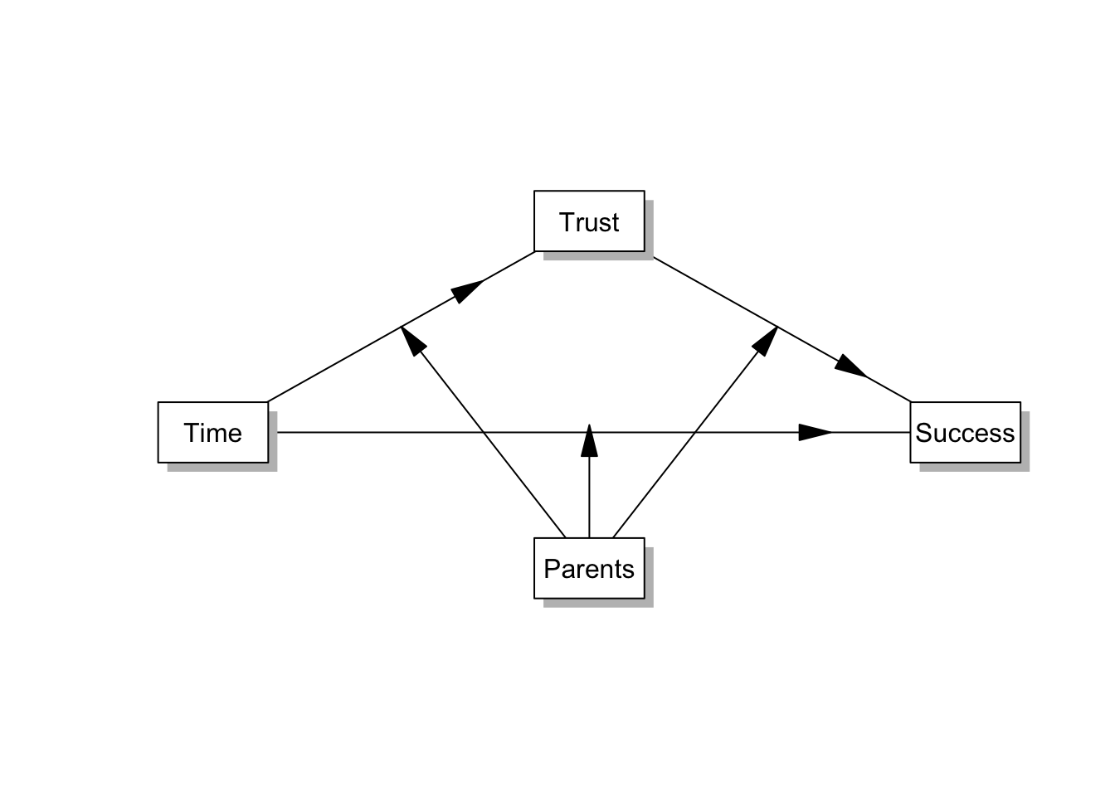
Statistical Model

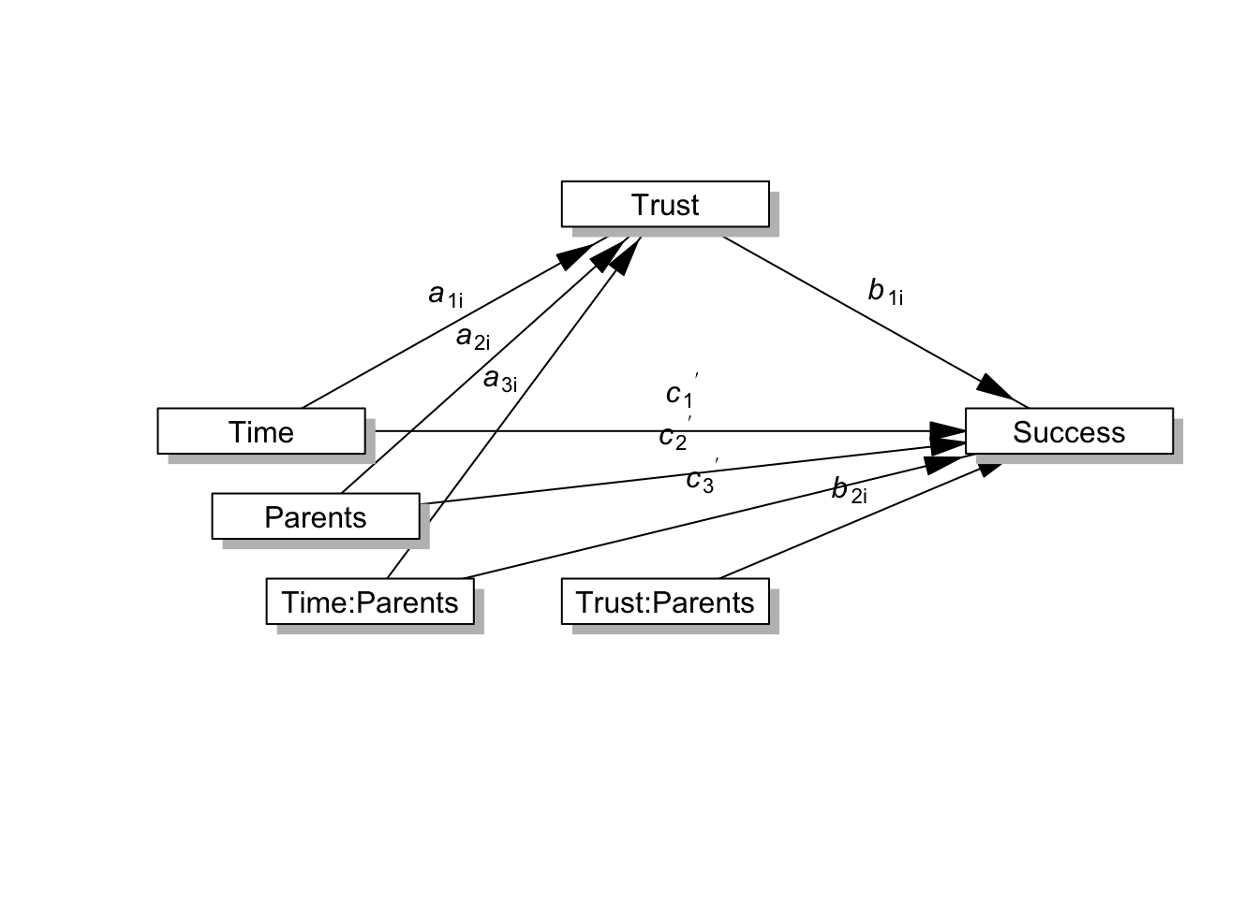

Reslts
 | Consequent
 | M(Trust) |  |  |  |  |  |  | Y(Success)
Antecedent | Coef | SE | t | p |  |  | Coef |  | SE | t | p
X(Time) | 0.060 | 0.184 | 0.328 | .743 |  |  | 0.092 |  | 0.494 | 0.186 | .852
W(Parents) | -0.122 | 0.296 | -0.413 | .680 |  |  | 0.523 |  | 0.744 | 0.702 | .483
X:W(Time:Parents) | 0.319 | 0.056 | 5.738 | <.001
M(Trust) |  |  |  |  |  |  | 0.222 |  | 0.277 | 0.801 | .424
M:W(Trust:Parents) |  |  |  |  |  |  | 1.028 |  | 0.079 | 13.050 | <.001
W:X(Parents:Time) |  |  |  |  |  |  | 0.100 |  | 0.167 | 0.597 | .551
Constant | -0.430 | 0.958 | -0.449 | .654 |  |  | -0.752 |  | 2.413 | -0.312 | .755
Observations | 300 |  |  |  |  |  |  | 300
R2 | 0.568 |  |  |  |  |  |  | 0.914
Adjusted R2 | 0.564 |  |  |  |  |  |  | 0.913
Residual SE | 3.004 ( df = 296) |  |  |  |  |  |  | 7.549 ( df = 294)
F statistic | F(3,296) = 129.919, p < .001 |  |  |  |  |  |  | F(5,294) = 626.344, p < .001

 | Indirect Effect  (a1+a3*W)*(b1+b3*Parents.mean) |  |  |  | Direct Effect  c1+c3*W
Parents(W) | estimate | 95% Bootstrap CI | p |  | estimate | 95% Bootstrap CI | p
1.289 | 0.729 | (0.336 to 1.317) | .003 |  | 0.221 | (-0.729 to 0.965) | .588
2.987 | 3.336 | (2.616 to 4.276) | <.001 |  | 0.391 | (-0.309 to 0.899) | .205
4.685 | 7.833 | (6.067 to 9.384) | <.001 |  | 0.561 | (-0.254 to 1.655) | .224
boot.ci.type = bca.simple

At low levels of caregiver support (W = 1.289), the indirect effect is positive and statistically significant (b = 0.729, 95% CI [0.336, 1.317], p = .003), but relatively modest in magnitude.
At the average level of caregiver support (W = 2.987), the indirect effect is considerably larger (b = 3.336, 95% CI [2.616, 4.276], p < .001).
At high levels of caregiver support (W = 4.685), the indirect effect becomes very large (b = 7.833, 95% CI [6.067, 9.384], p < .001), indicating a strong mediated relationship.

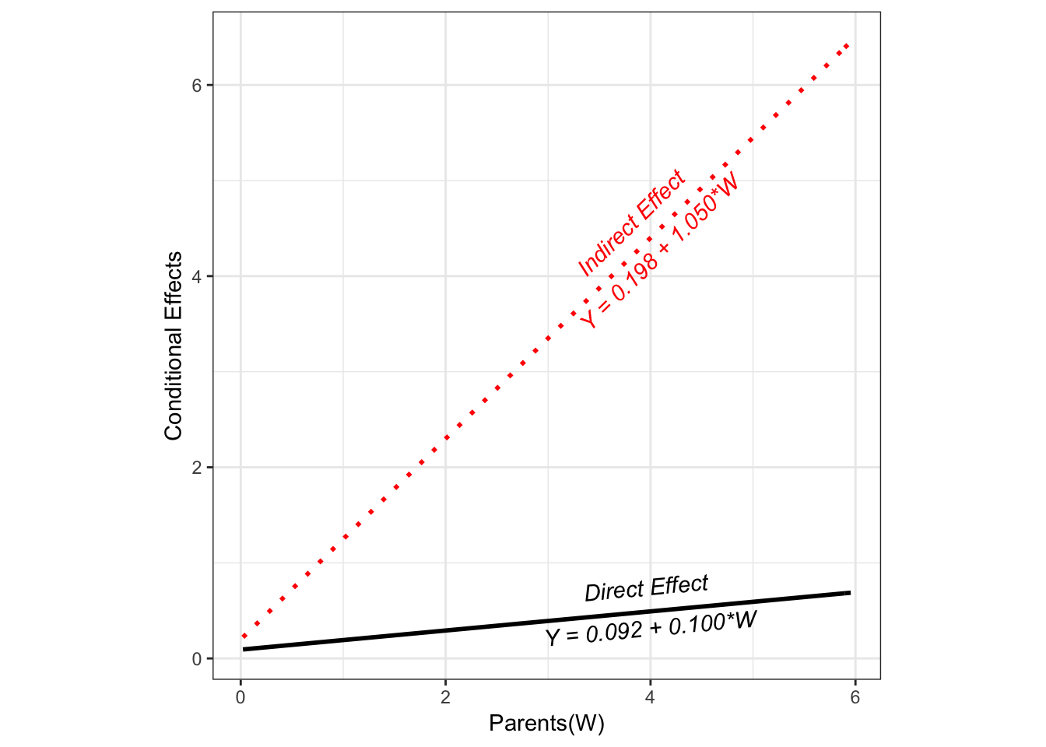
The index of moderated mediation indicates whether the indirect effect changes as the moderator changes, and in what direction. Here, it is statistically significant, Index = 0.33, SE = 0.05, 95% CI [0.24, 0.43]. In this example, it tells us whether—and how—the indirect effect of TRUST changes as W (caregiver support) changes.
Interpretation
The significant index of moderated mediation indicates that the indirect effect of delay of gratification on behavioral success through trust varies as a function of caregiver support.
Specifically, as caregiver support increases, the strength of the mediated pathway increases. This means that the process linking delay of gratification to success through trust is not constant, but becomes progressively stronger in environments where caregivers reliably follow through.
Substantively, this suggests that delay of gratification is most strongly associated with behavioral success through trust when children are in environments where waiting is reinforced by consistent caregiver support. In contrast, when caregiver follow-through is low, the mediating role of trust is substantially weaker.

