Geothermal Energy

**Definition:**

Geothermal energy is a renewable source of energy. Geothermal power plants have very low emissions because they don’t use fuel to generate the electricity, it is natural.

**How:**

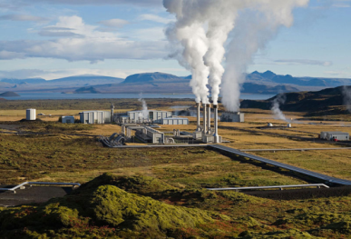It is made by cold water going down special pipes into the hot earth and rising up as steam. It helps produce electricity and heating. It comes from within the earth. We use the steam and hot water produced to create the energy. The heat within the earth never runs out so the water can always be heated.

**General Information:**

Main producers are Japan, New Zealand, Iceland and Hungary.

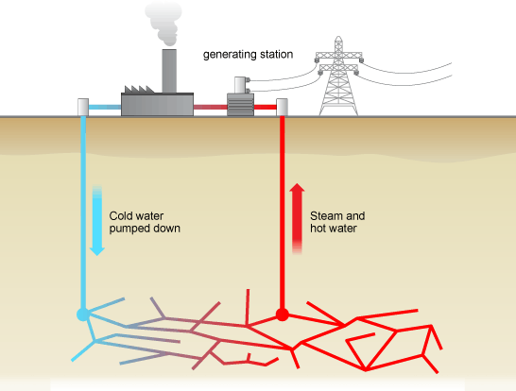

**Advantages and Disadvantages**:

Advantages are that it is available almost everywhere and that it is renewable but there are a few more disadvantages such as it is very expensive to build the power stations and to drill the earth, its maintenance is hard due to the high temperatures and the gases produced can be dangerous.