The main aims of Amos.

**Amos aims to help people in difficulties and who have been unemployed to get back into to work again.**

What we learnt

We learnt about sorting clothes and what should and should not be donated to Amos (clothes with holes in, frayed edges, stains should not be donated) why people work there. There was also a change in staff half way through our stage (work experience). This made us both have to adapt again to a new leader. He had a different system which was faster, however maybe not as efficient. but through this we learnt that everyone has a different method in doing something, including sorting out clothes!

What we enjoyed

We enjoyed it because it gave us both an insight into what happens to the clothes donated and why people work there. Also, we now understand why people volunteer to work for charities, Isabell thinks that it is ‘immensely satisfying knowing that you are doing something good’. We enjoyed sorting the clothes and Isabell learnt a few things about how to sort and fold! Francesca also learnt to pack things tidily in boxes and sorted clothes out into winter and summer wear.

How we adapted

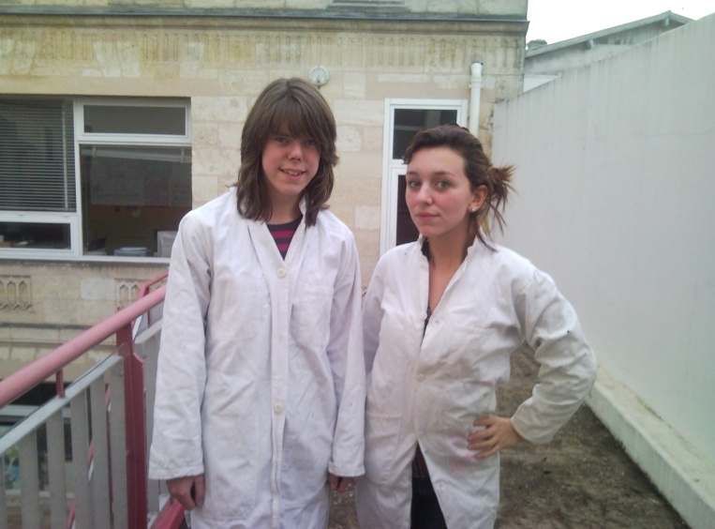Adapting actually was not that hard as we easily fitted in and found communication was not a problem. We gradually learnt the system which was something that we had to change because a new chief was appointed. Francesca felt that it was difficult to understand the new chiefs method of boxing, “I felt that the old method was more efficient”. Then, however, our three months service was finished so we had to leave. Isabell thought this was an incredible shame.