Smoking is very dangerous and bad for you.

## There are thousands of chemicals, some deadly and toxic, in cigarettes. The main ones include:

* 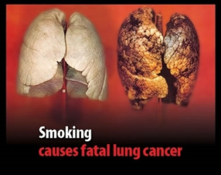Nicotine (affects your brain, is addictive)
* Carbon Monoxide (poisonous)
* Arsenic (very poisonous)

**Do you really want deadly chemicals in your body?**

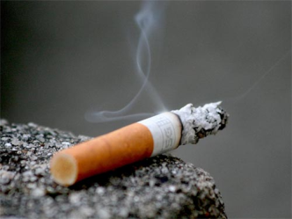**Risks of cancer are dramatically increased if you smoke!**

**Don’t succumb to peer pressure! Smoking is not good or cool; it just majorly damages your health.**