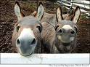

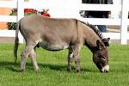
Friends of Cyprus Donkey Sanctuary

4772 Vouni Village
Phone: 357 2594 5488
E-mail: donkeycy@cytanet.com.cy

Member of the World Society for the Protection of Animals (WSPA)

