INFORMATION

Friends of the Cyprus Donkey Sanctuary was founded in 1994.
The Sanctuary occupies a number of fields around the village of Vouni and has 12 enclosures.

- It cares for old, sick and unwanted donkeys.
- It provides medical and animal welfare services to owners of working donkeys throughout Cyprus.
- It has a mobile clinic and employs a vet, dentists and a farrier.
- Members and Adopters can take their donkeys walking.
- Good grazing facilities.

ADOPTION

- Adopt a donkey for a year: cost ₤12 which provides 25 feeds.

Choose a donkey and get a certificate with photograph.

- Annual Membership: cost ₤12
per year; Family Membership ₤20 per year; Life Membership ₤80.

- Twice yearly newsletter for all Members and Adopters.

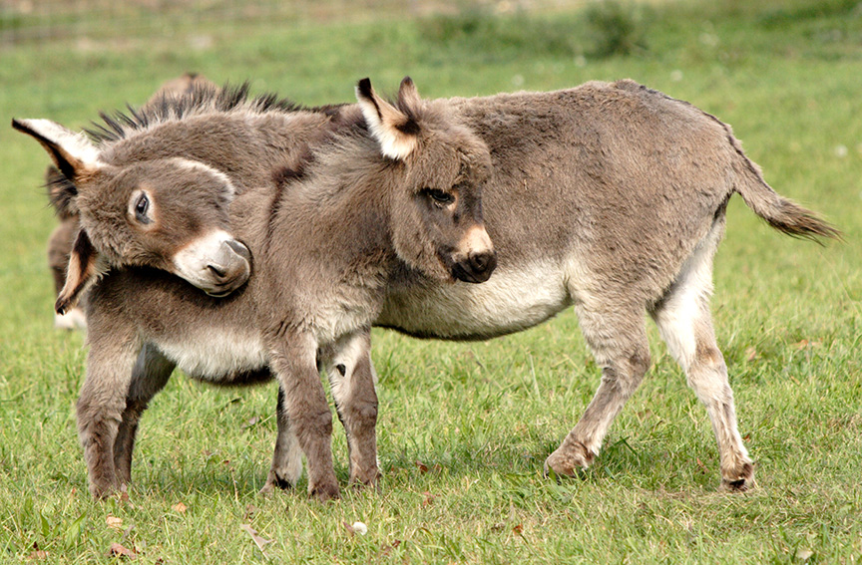

Visitor Centre has a shop, refreshments, donkey treats, hillside walk and picnic area.

Admission: Adults and Children over 12: C₤1; Members, Adopters and Children under 12: free.

Opening hours: Monday to Saturday 10.00am to 4.00pm.

