What I need from a computer.
- Browsing the internet (for e-mails, Wikimedia, Wikipedia, etc.)
- Other internet work (for IRC, Wikimedia, Wikipedia, etc.)
- Word processing (for typing documents, homework, etc.)
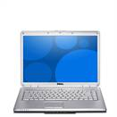 | DELL Inspiron 1525 N | Ubuntu Linux 8.04 Hardy Heron | 2GB RAM  250GB HDD | Intel Pentium Core Duo | Intel Graphics Media Accelerator X3100 | $599
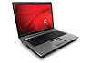 | Compaq Presario F700 | Windows Vista Home Premium | 2GB RAM  160GB HDD | AMD Athalon 64 X2 | NVIDIA GeForce 8600M GT | $399
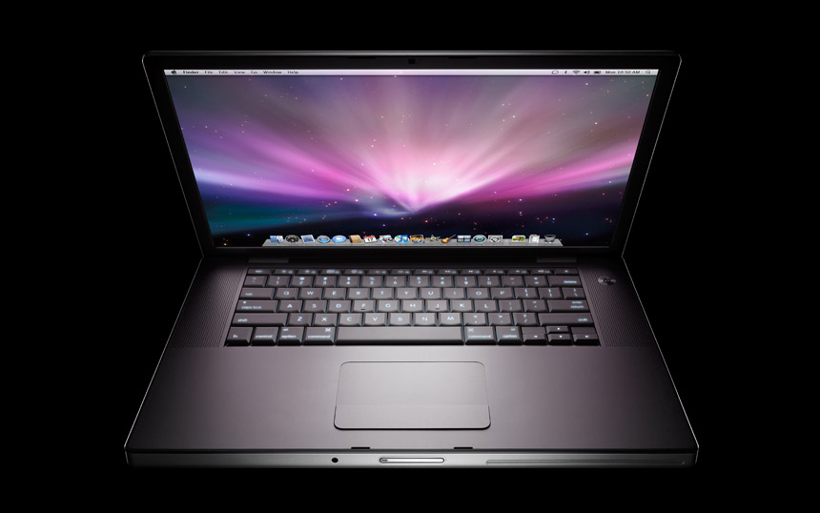 | Apple Macbook Pro | Mac OS X v10.5 Leopard | 2GB RAM  250GB HDD | Intel Core 2 Duo | NVIDIA GeForce 8600M GT | $1999

Of these three laptops, I would choose the first one because, although it is a DELL, it has Linux and therefore does what I need it to do and looks good.

