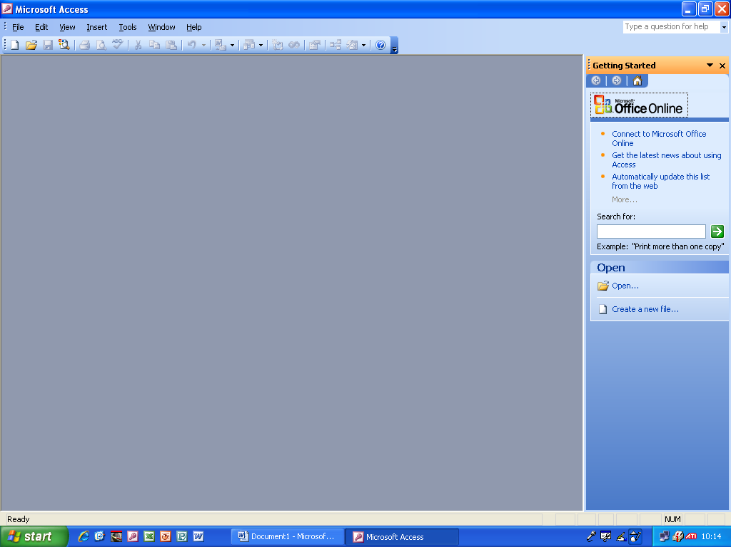

I opened Microsoft Access and clicked ‘Create a new file’

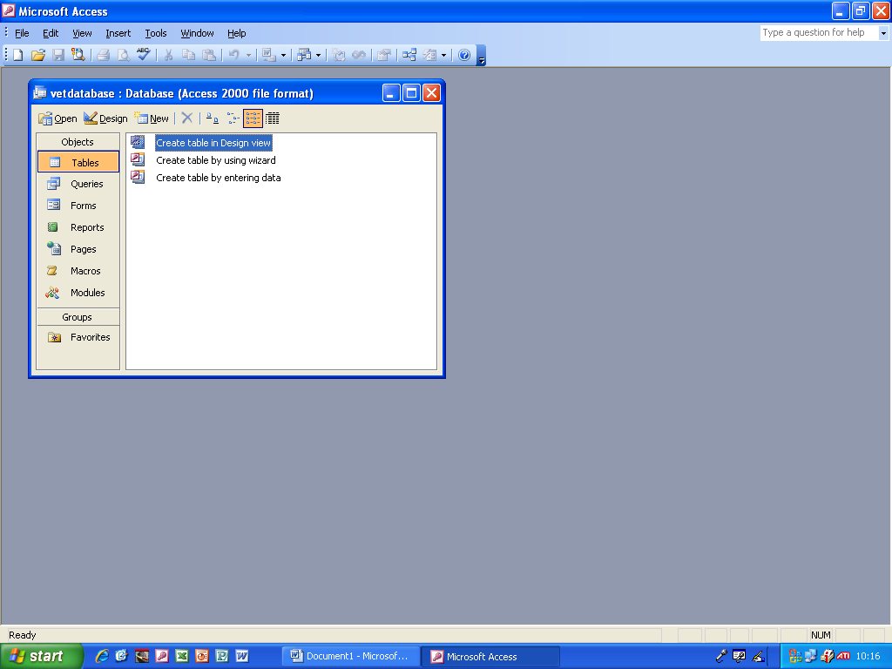

Then the table screen came up.

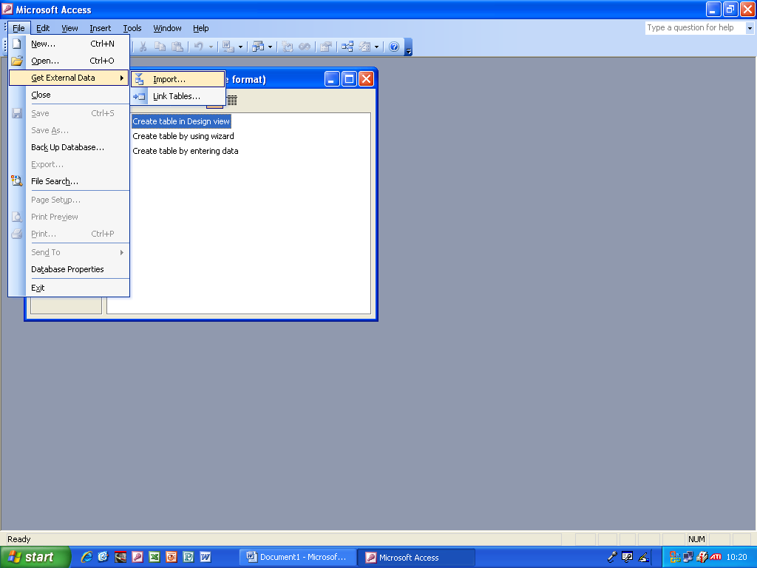

Then I went to Get External Data and then Import to get the data I needed from another file.

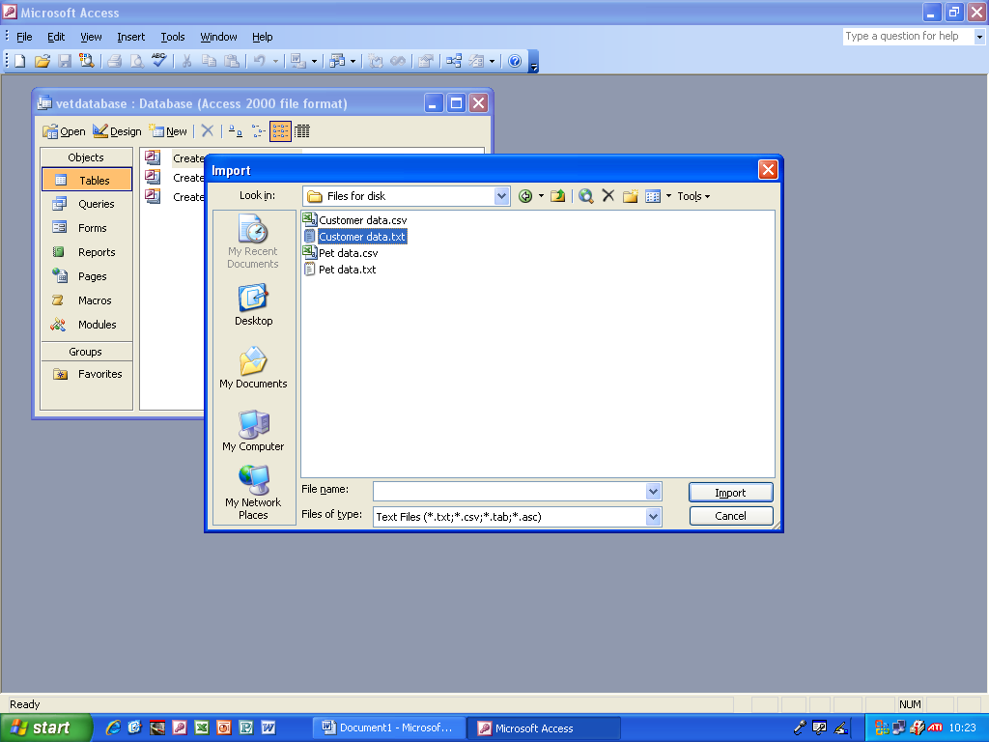

I navigated to the file where the external data was stored (S:\I C T\ALW\Year 10 GCSE\Mock Set Assignment Files\Files For Disk\Customer data.txt) and imported it.

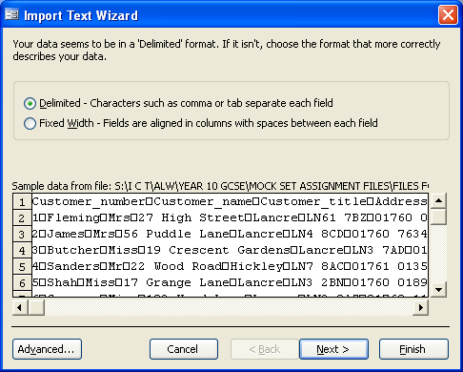

I selected the Delimited data format and pressed Next in the wizard.

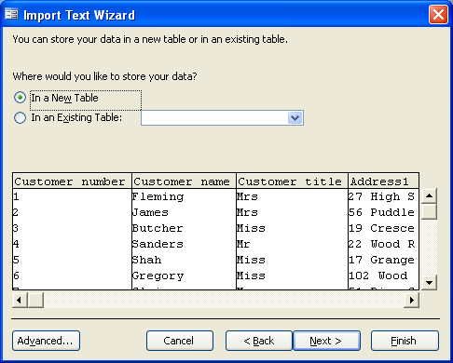

I wanted to store the new data in a new table, so I selected this option and pressed Next in the wizard.

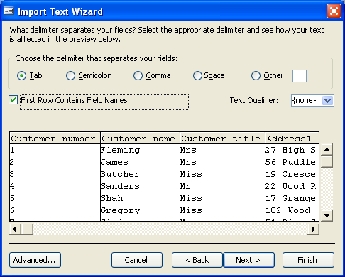

I chose the delimiter that separated the fields, in this case it was Tab. I pressed Next in the wizard.

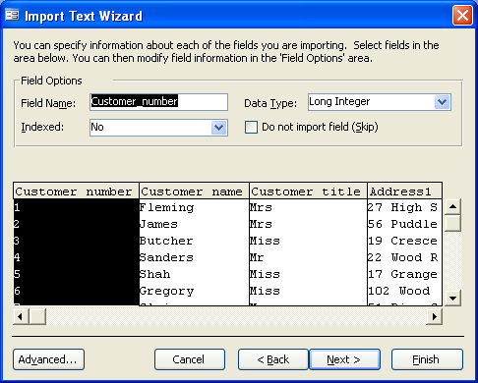

Then it asked me if I wanted to give extra information for one of the fields. I selected Customer Number and made the data type Long Integer and pressed Next in the wizard.

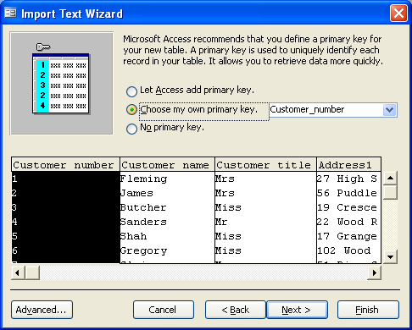

I selected ‘choose my own primary key’ from the list and the primary key I chose in this case was Customer Number. I then pressed Next in the wizard.

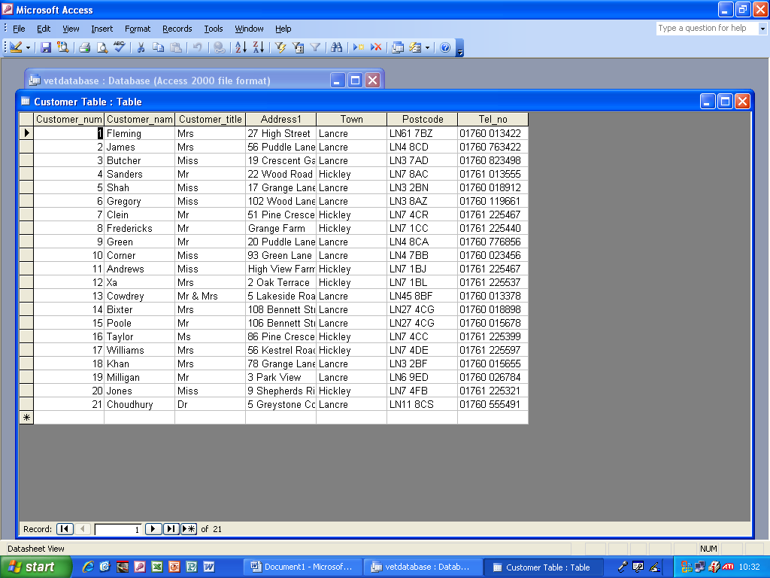

Then the customer table data was imported and displayed in a new table.

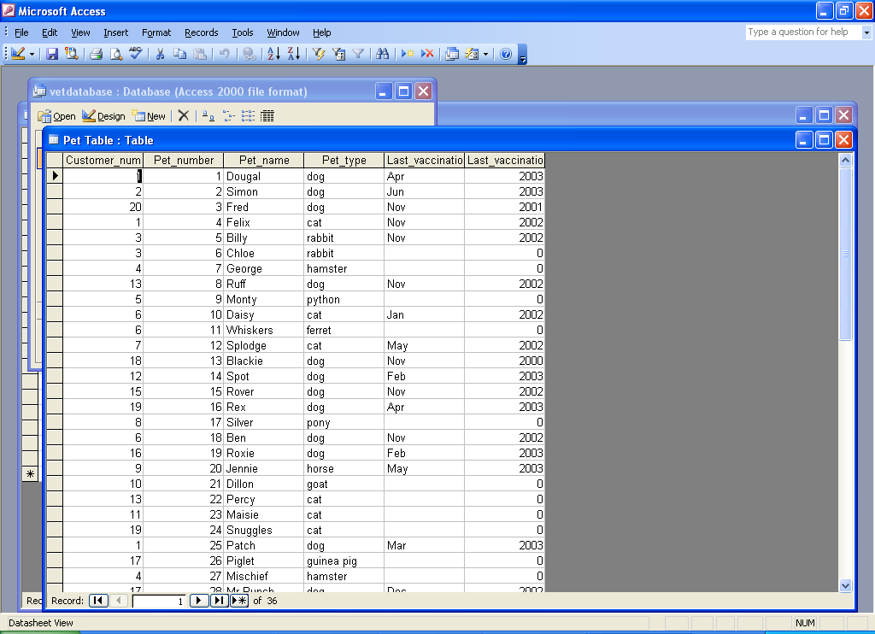

Then it displayed the pet table in a new table after I had successfully imported it.

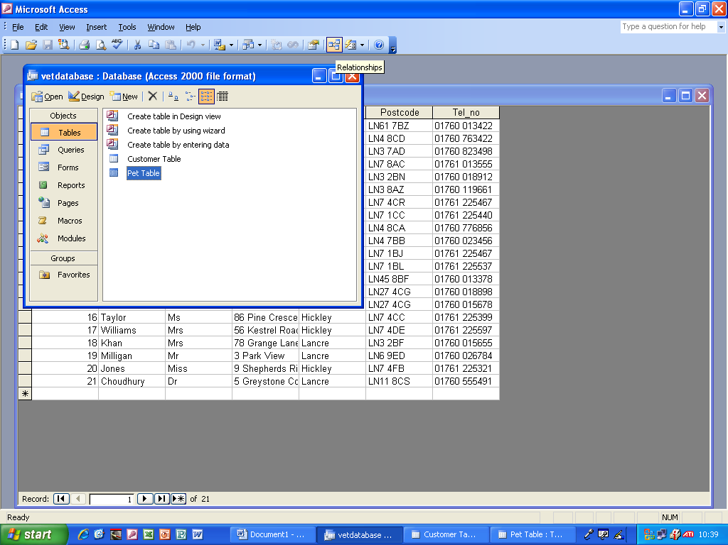

I then selected that I wanted to see the pet table.

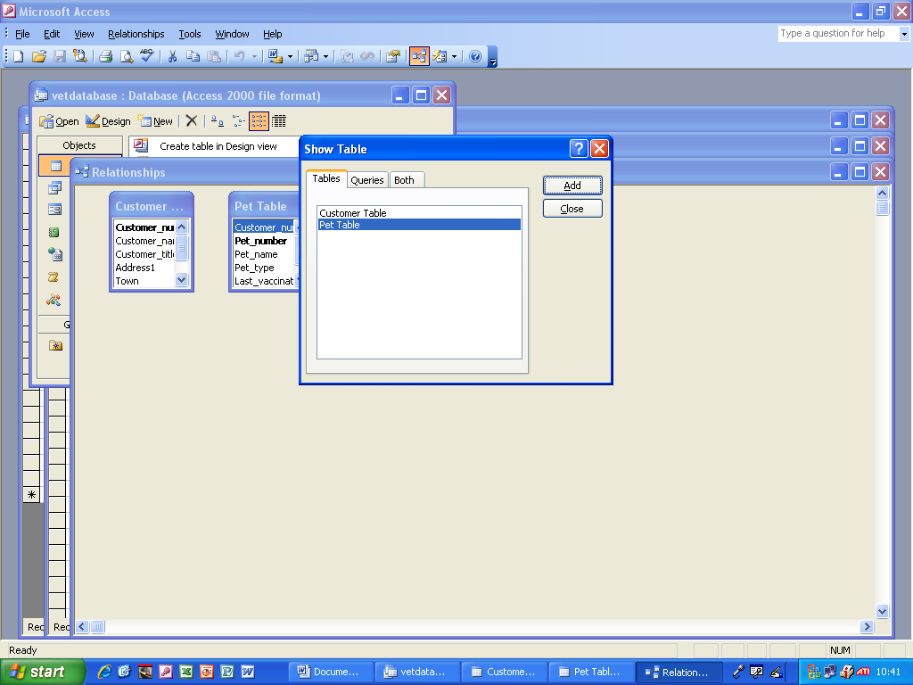

Then I went to Relationships and it asked me whether there were any more tables. There weren’t, so I pressed Close.

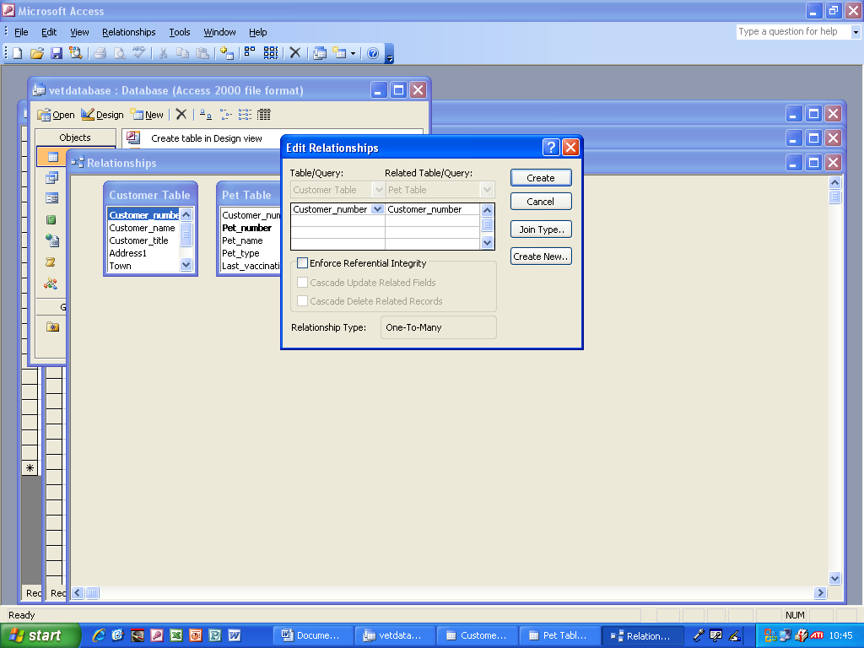

Then I added the Relationship for the two tables.

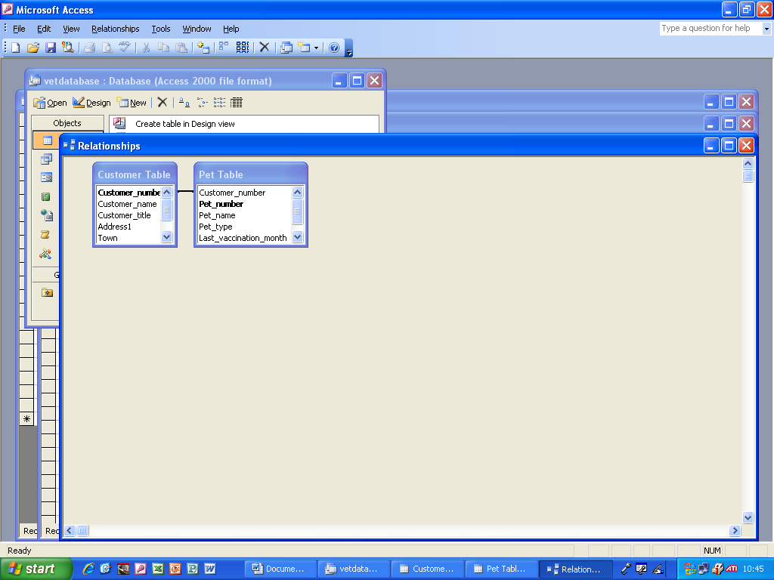

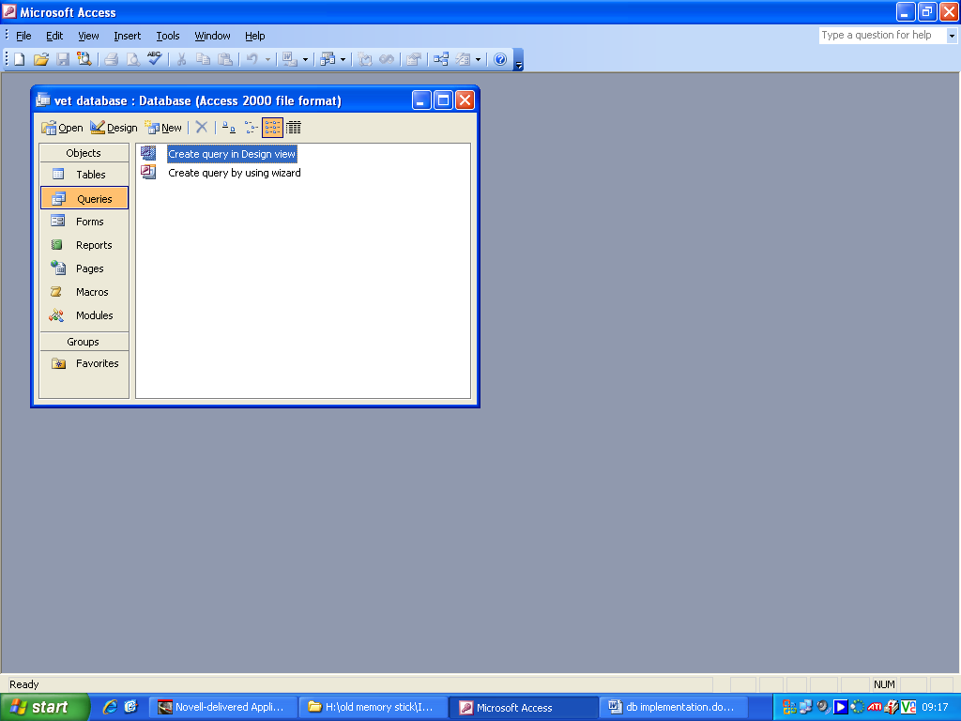
The relationship between the two tables of Customer Number and Pet Number was successfully shown.

I clicked on Query.

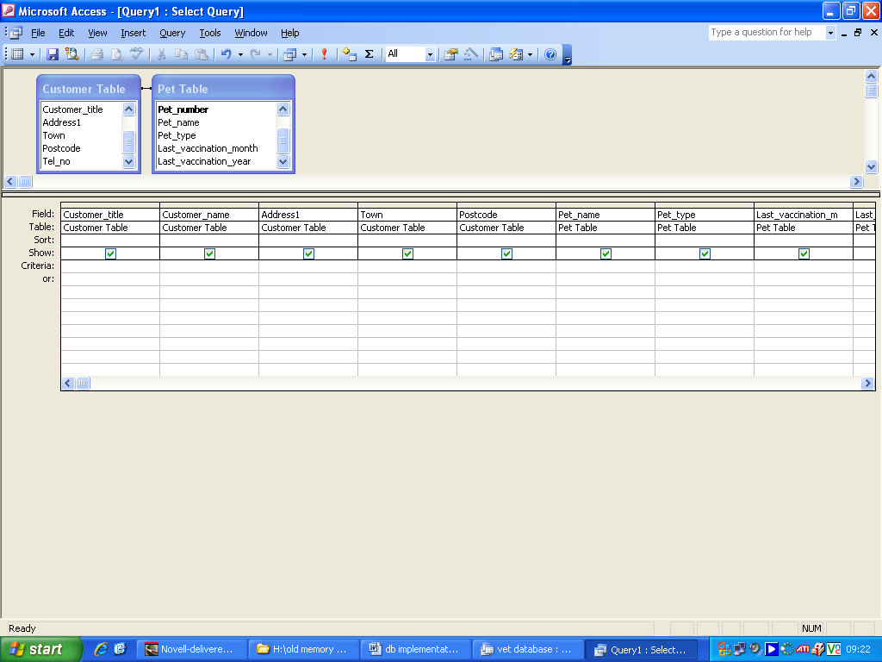
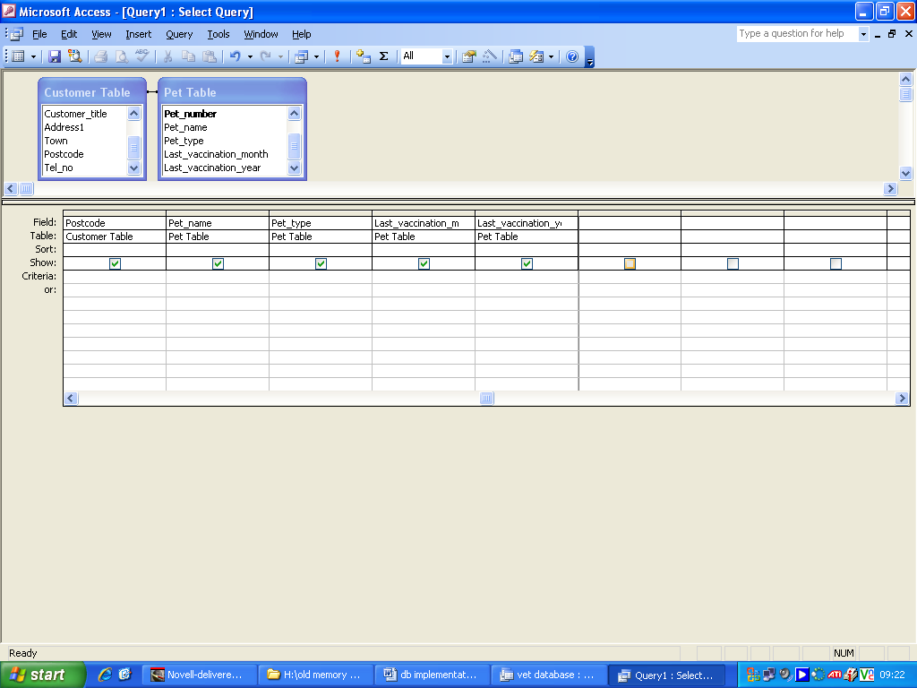
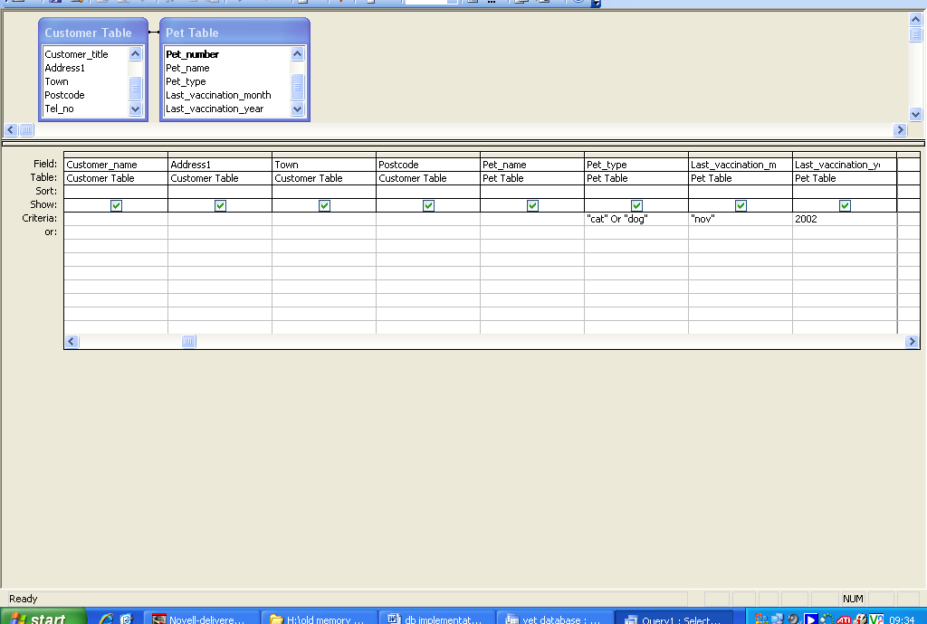
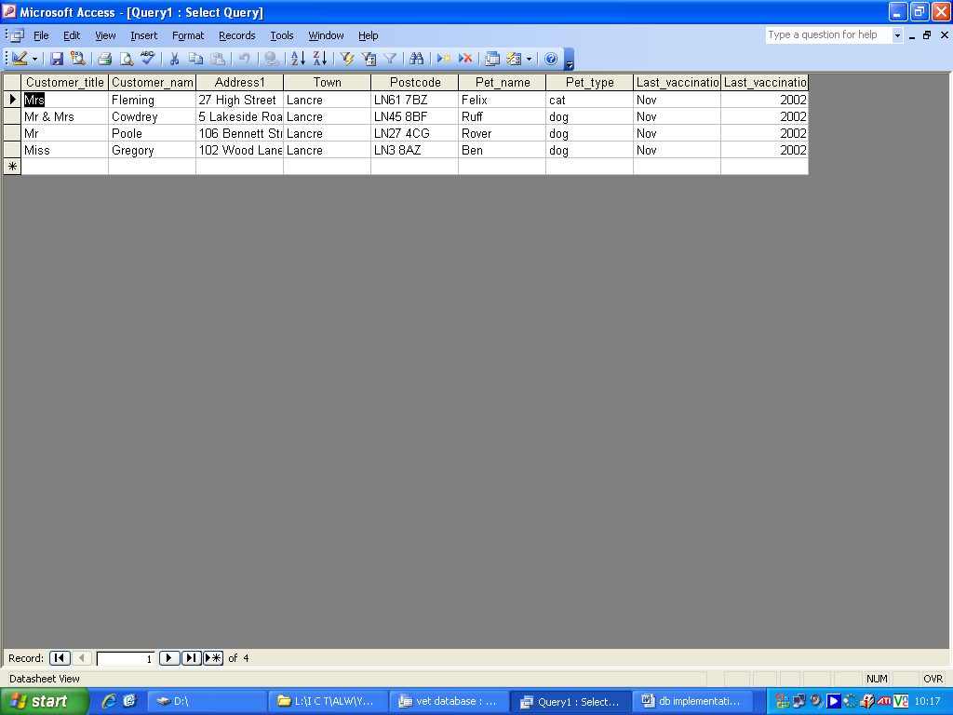
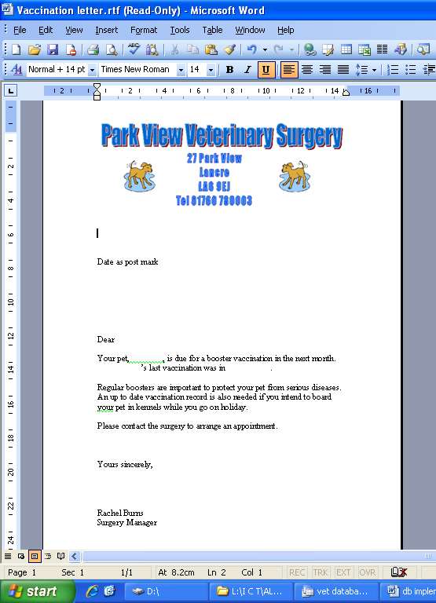
A table came up and I went through it and selected everything there I needed to include.

I carried on going through the table clicking the parts I wanted to show.

I then ran the query and it displayed the results it was supposed to display, proving it works.

I then made the letter from the file Rachel said.
I then made the letter from the file Rachel said.

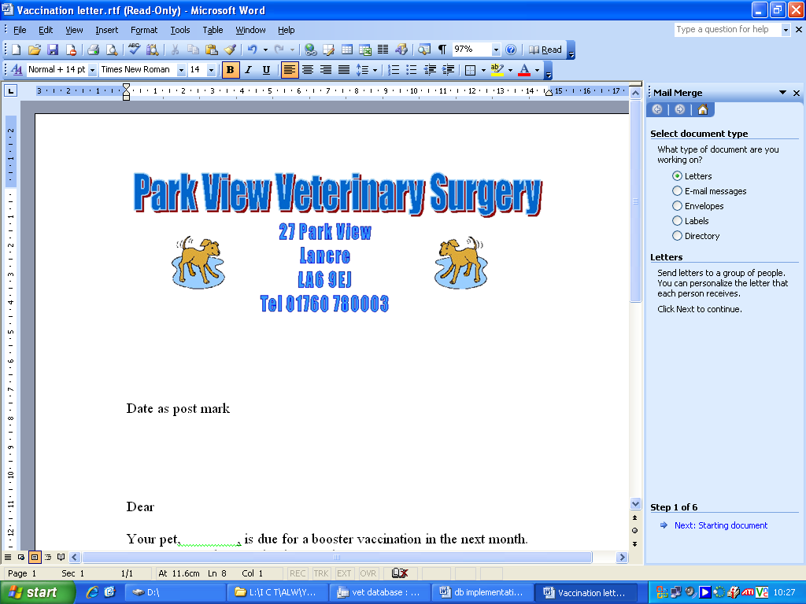
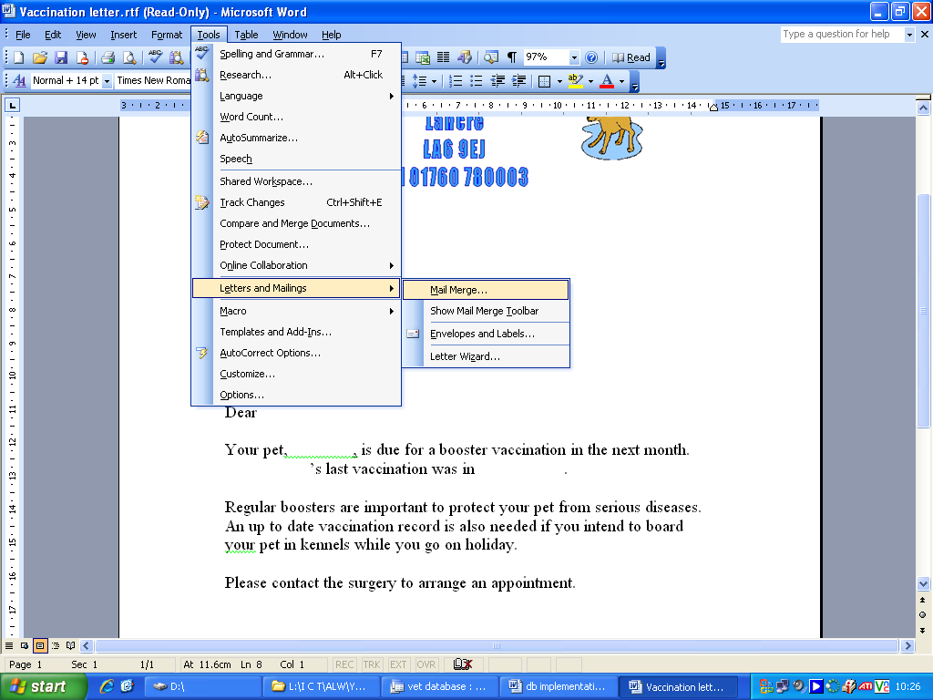
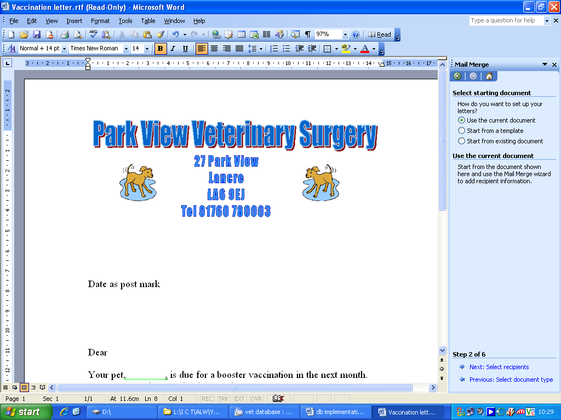
Then I made Mail Merge work by first selecting the Letters point.

Then I went to Tools, Letters and Mailings, Mail Merge and selected that.

Then more options came up and I selected ‘Use current documents’

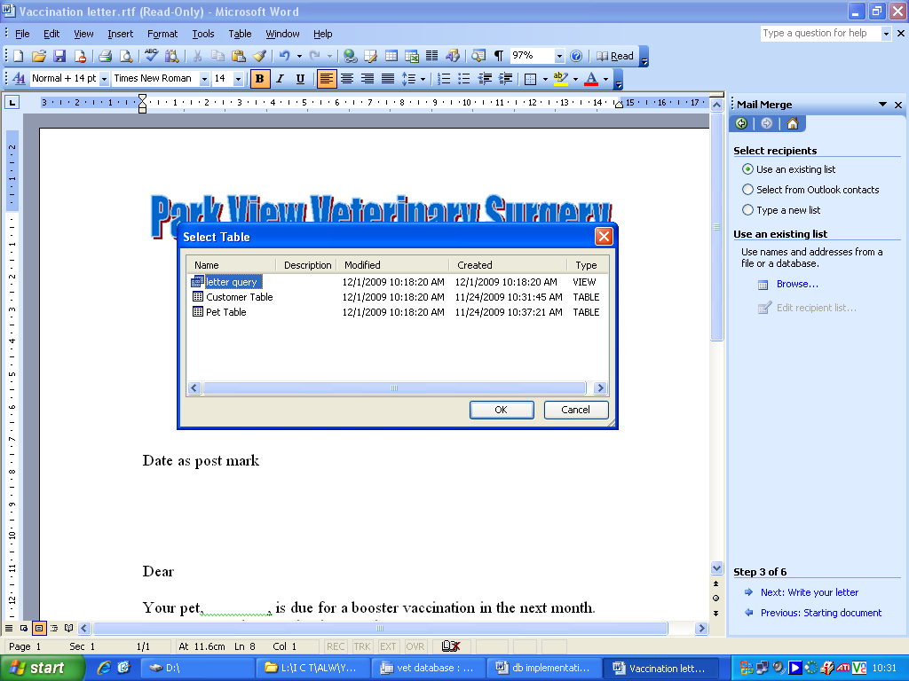
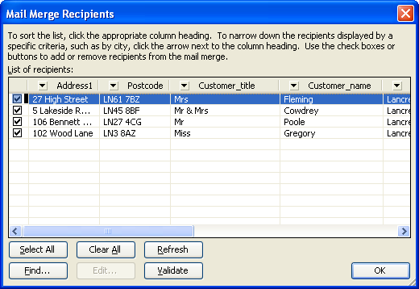
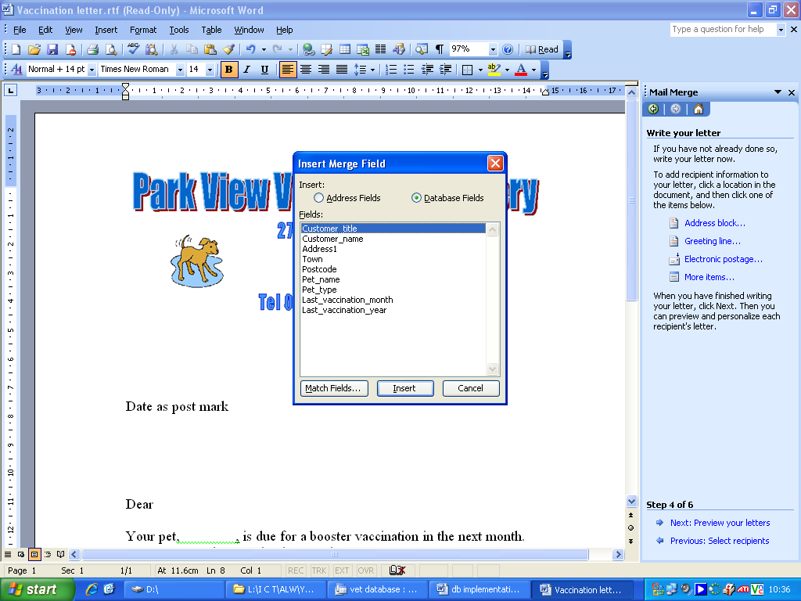

A table selector came up and then I selected the Query one.

The recipients of the letters were selected.

Then I inserted merge fields to choose which database fields I wanted to include in the letter.

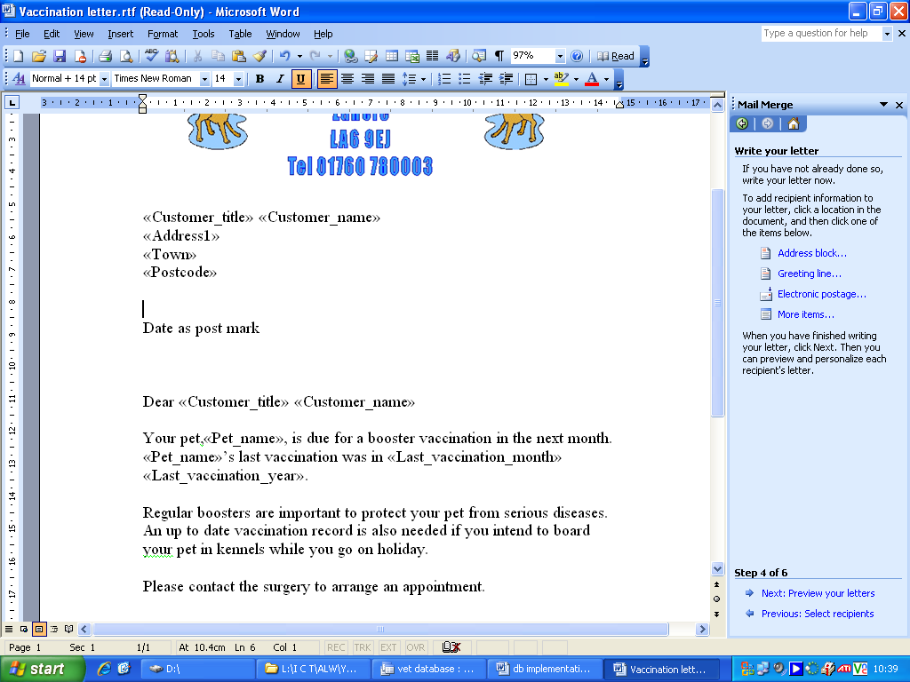
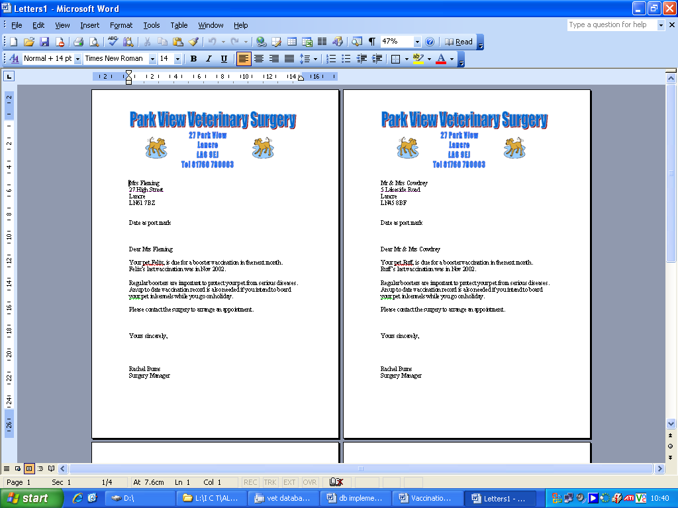
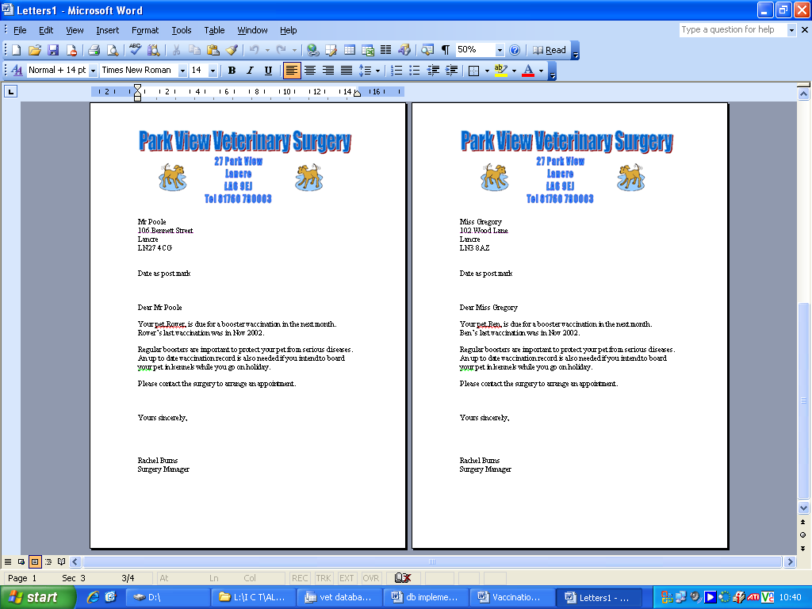
More letters were produced and displayed.
The letters were correctly displayed
Then the correct fields came up so I knew it was going to work.

