IMPLEMENTATION

I opened the basic data spreadsheet that I was given.

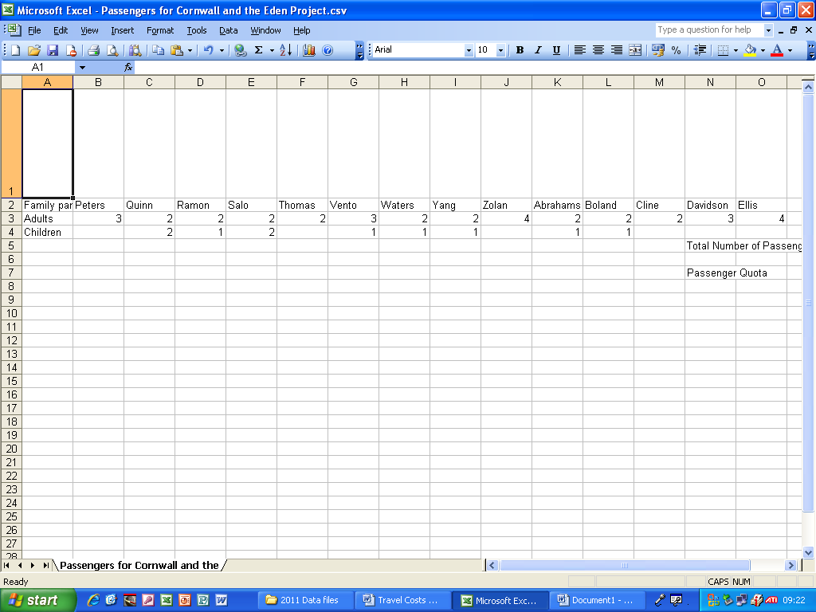
I made the first row of cells longer by clicking the bottom of the first cell and dragging it down.

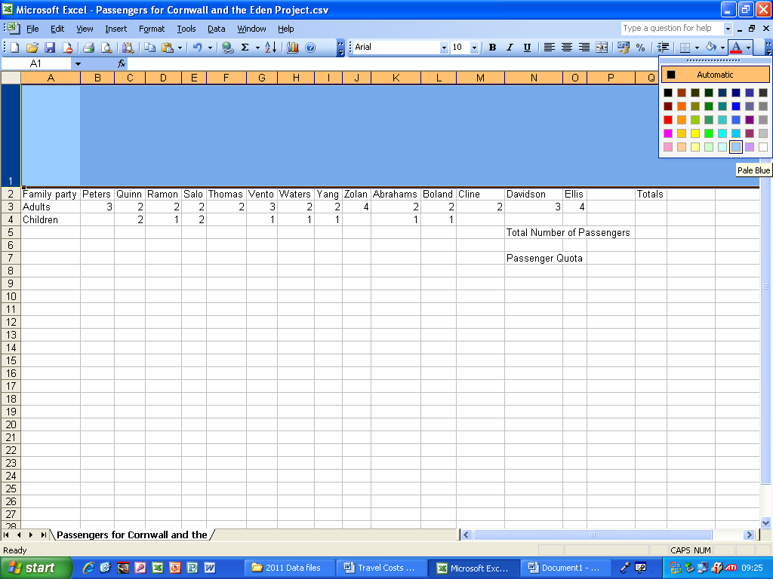
I made the background of the first row blue by clicking the colour chooser and clicking the appropriate shade of blue.

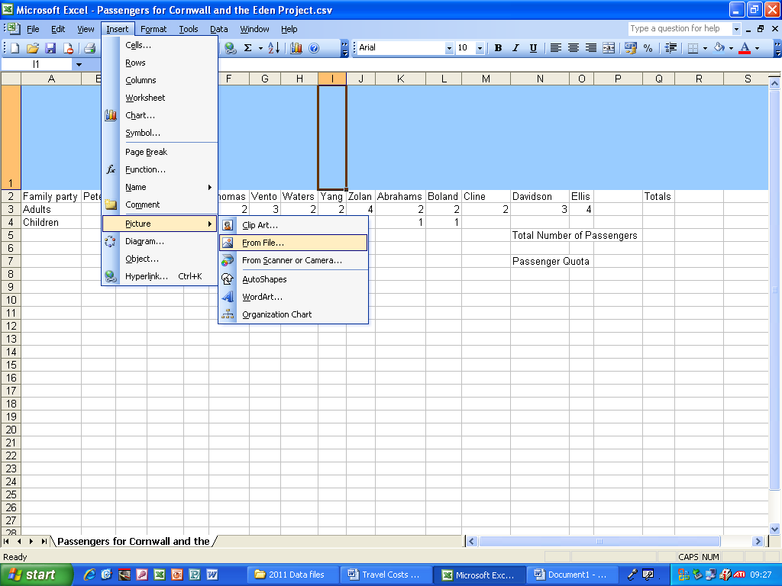
I clicked Insert > Picture > From File to insert a picture.
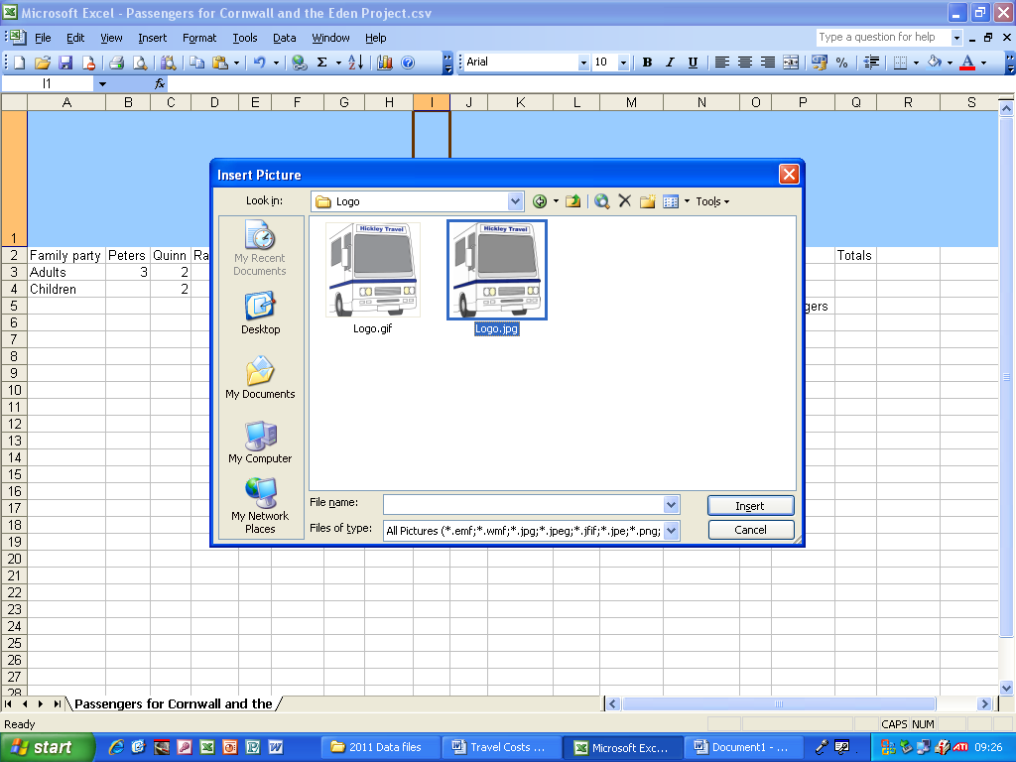
I clicked on Logo.jpg, the correct image, and clicked Insert.

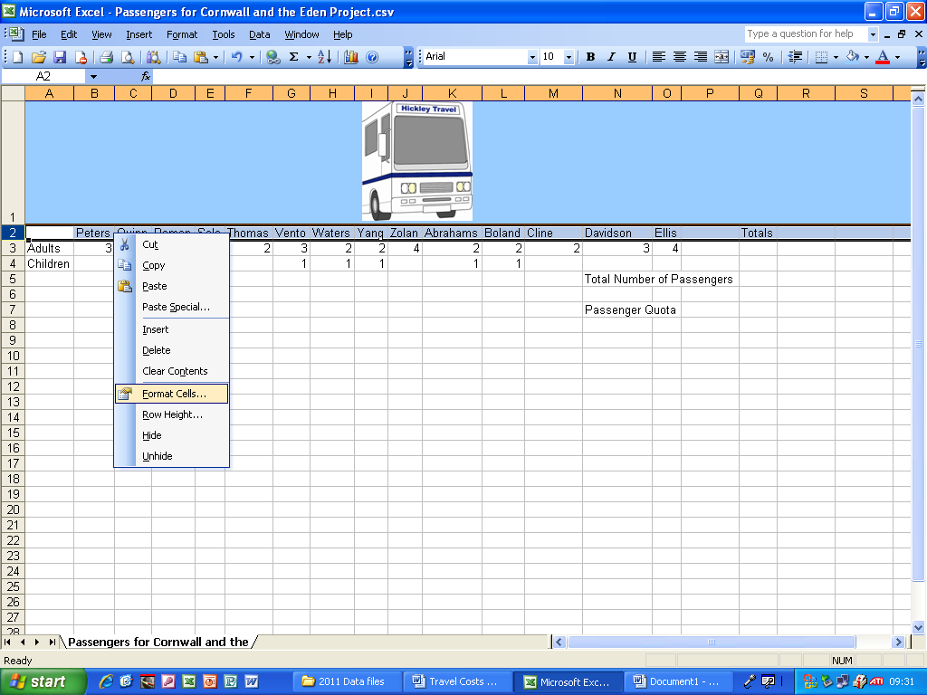
I highlighted the second row of cells and right clicked and clicked Format Cells.

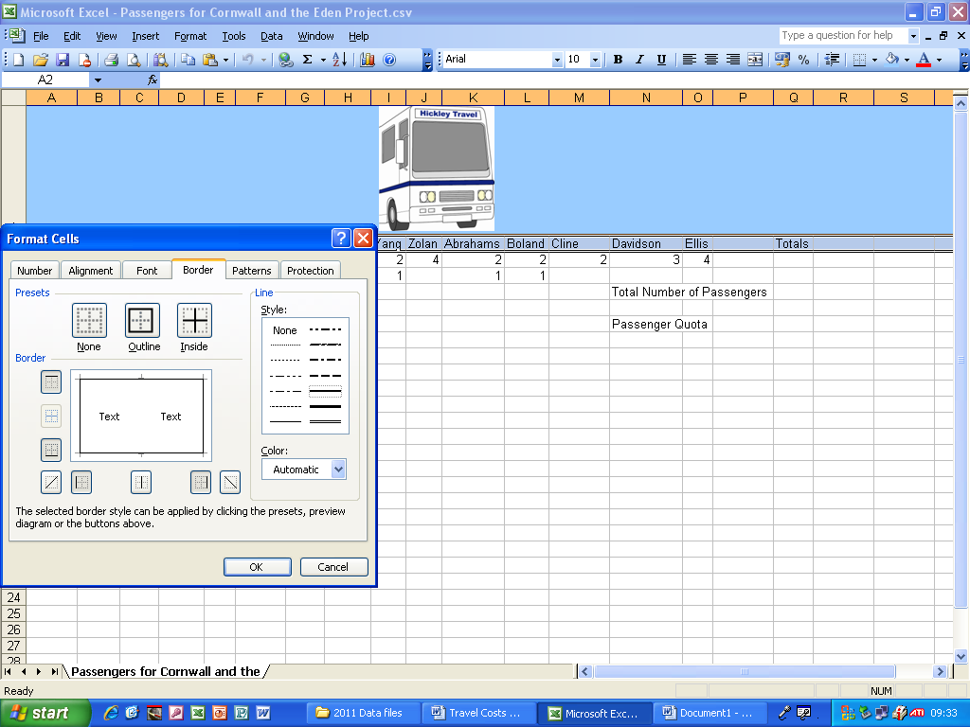
I went to Border in the Format Cells box and clicked outline and selected the border type I wanted, then clicked OK.

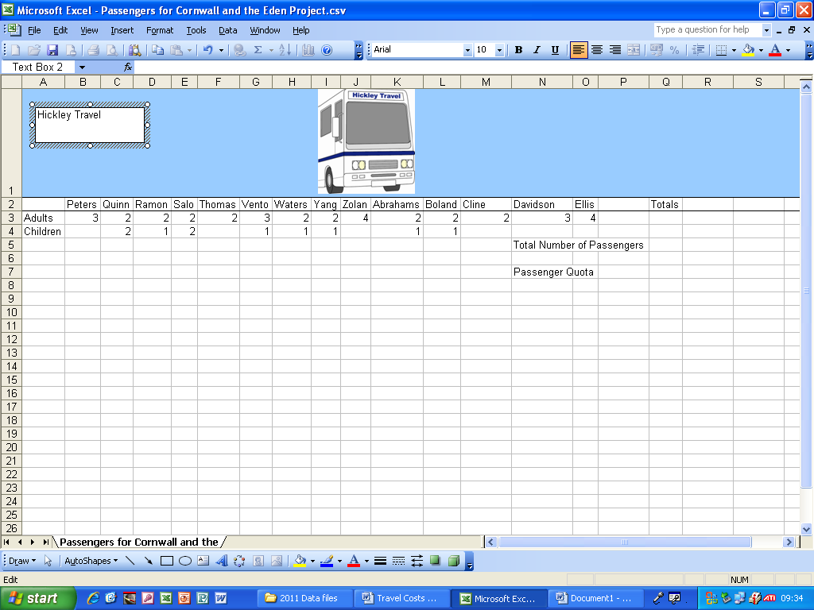
I inserted a text box to include the text “Hickley Travel”.

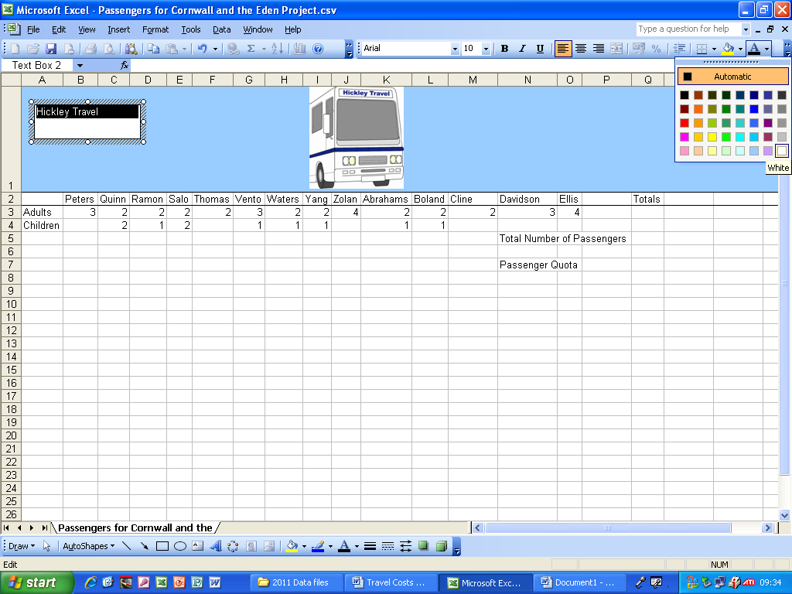
I clicked the colour tab and changed the “Hickley Travel” text colour to white.

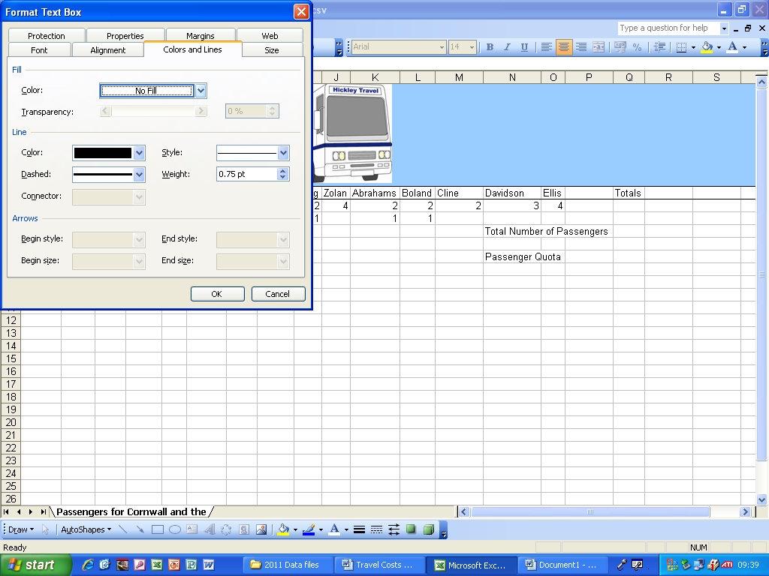
I then right clicked on the text box formatting and selected No Fill in the Colours and Lines tab, then clicked OK.

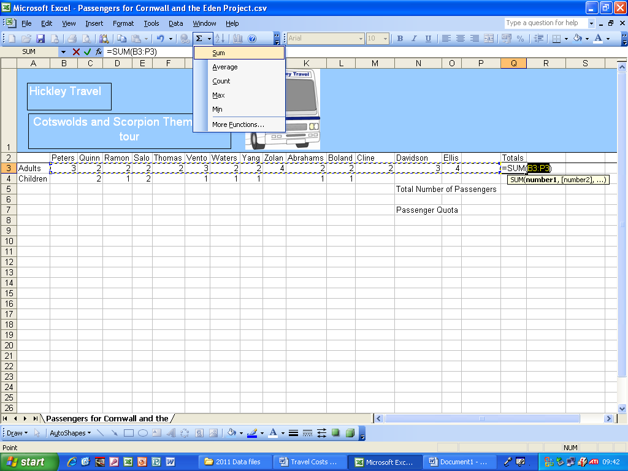
I added the SUM formula so the contents of cells B3 to P3 will be added up to provide the total.

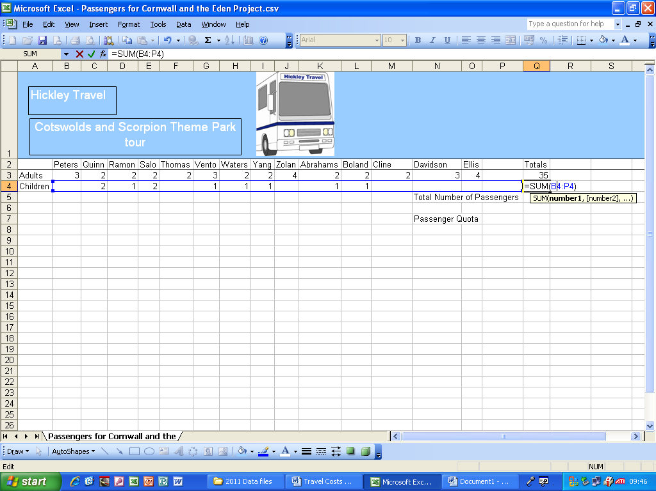
I made the SUM formula add up the contents of cells B4 to P4 to give the total.

I clicked Format > Conditional Formatting.

I clicked on Format > Conditional Formatting to add in some conditional formulae.

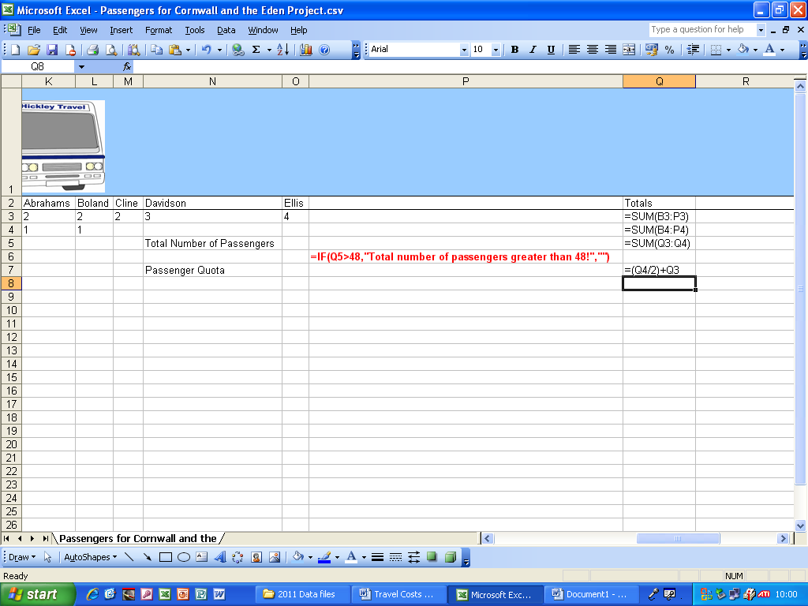
This is formula view. It shows all the formulae I have used.

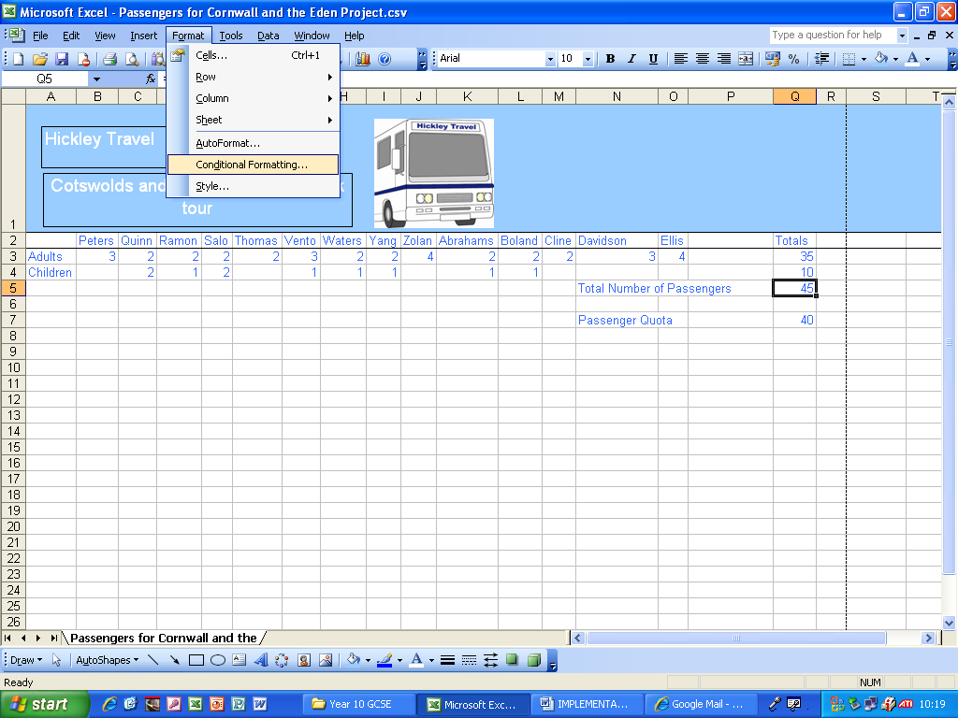
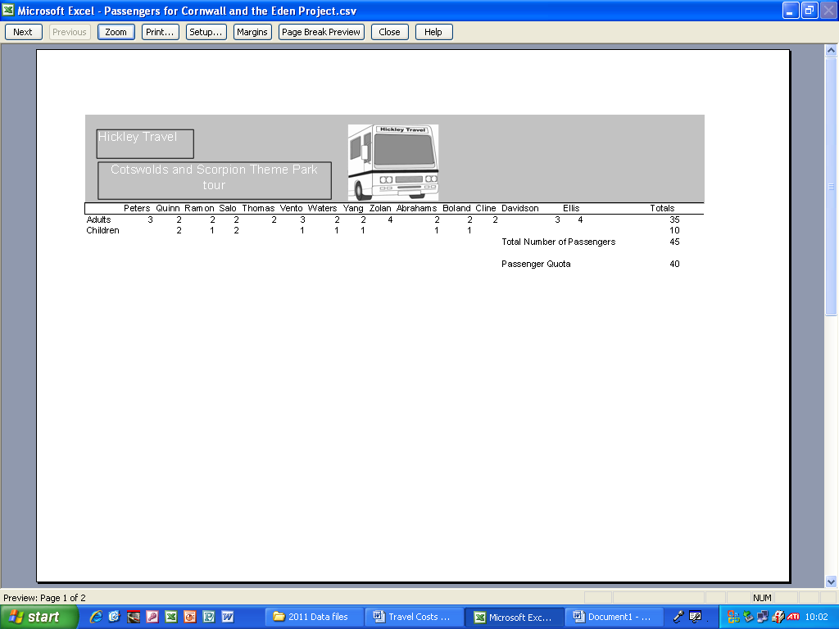
This is print preview. By using this I can be sure it will fit on one A4 landscape page.

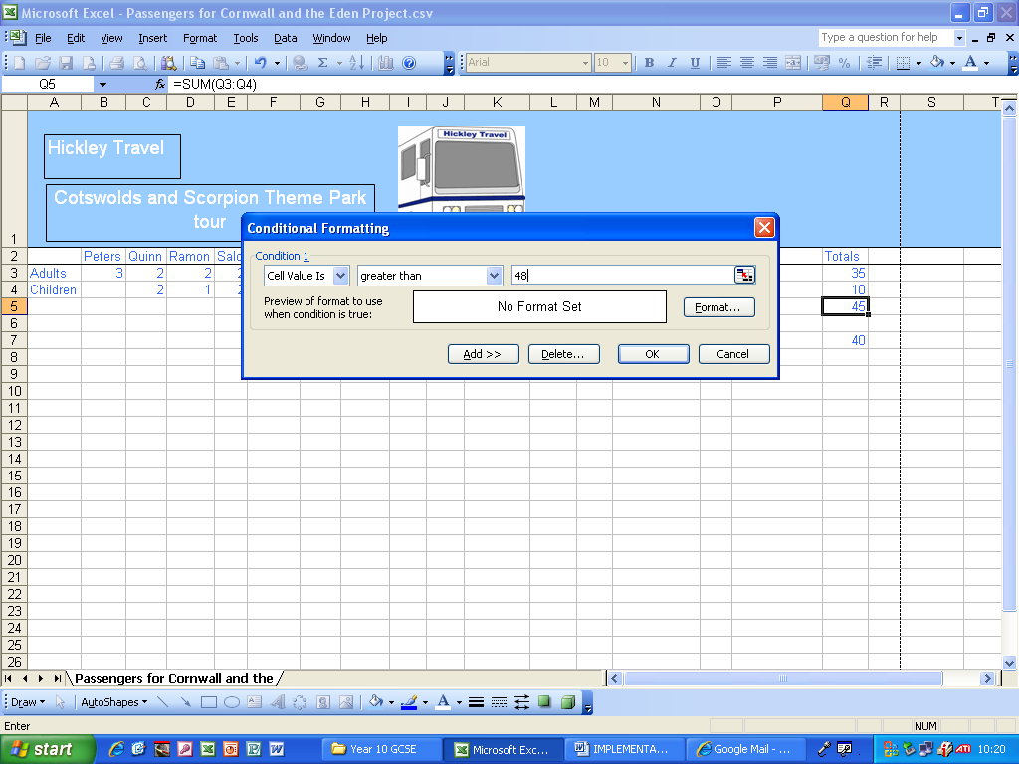
I went back to the conditional formulae screen and I selected the “cell value” is “greater than” “48” and then clicked Format.

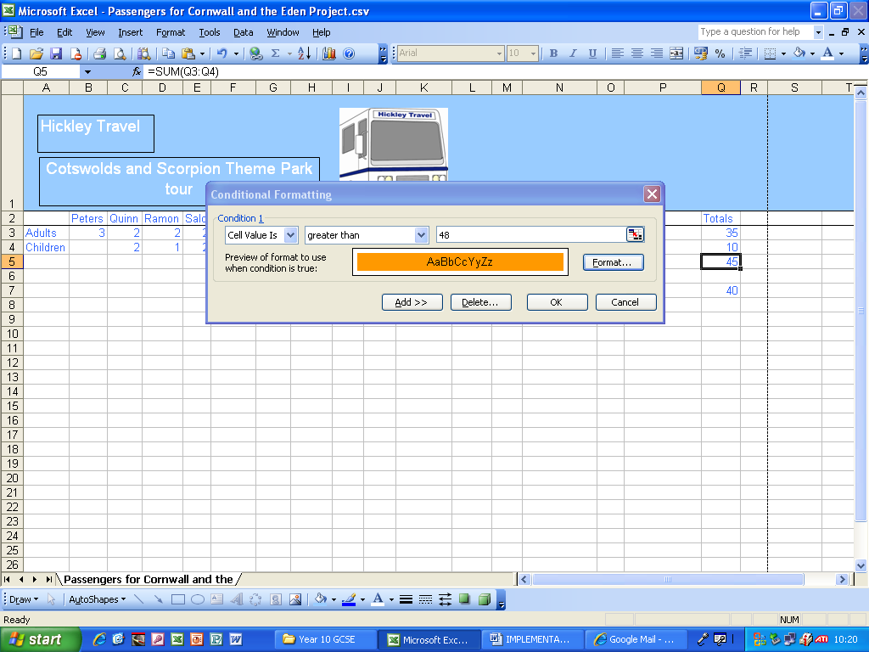
The original information I put in has been retained and now the colour is set to orange like I wanted it to be, so I clicked OK.

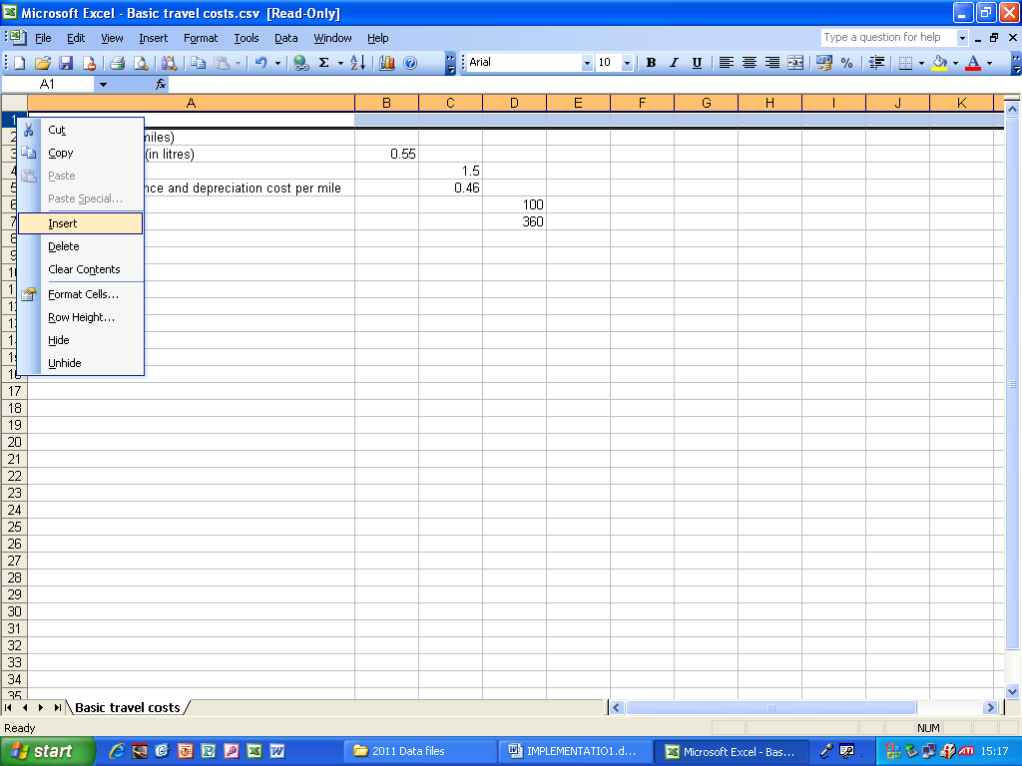
I opened the spreadsheet we were given and I right clicked and clicked Insert and then a new row of cells appeared in row 1.

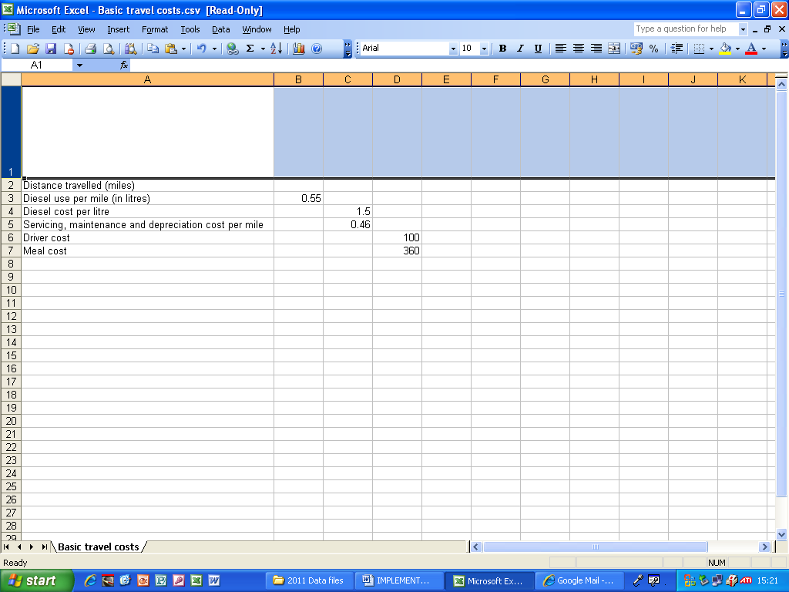
I made the first row of cells longer by clicking the bottom of the first cell and dragging it down.

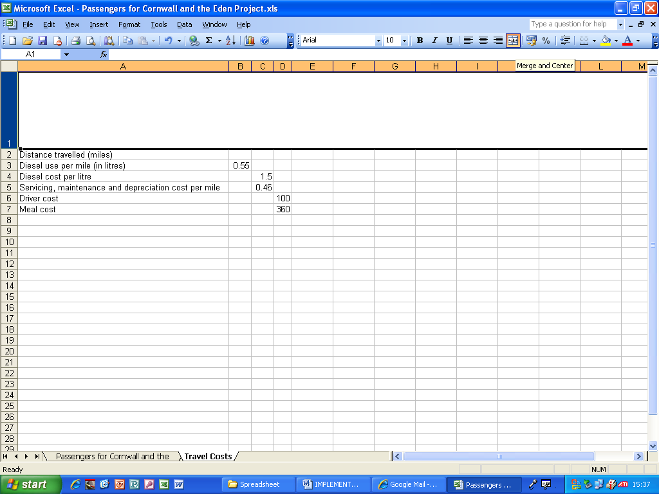
I clicked the Merge cells button to merge all the cells in row 1.

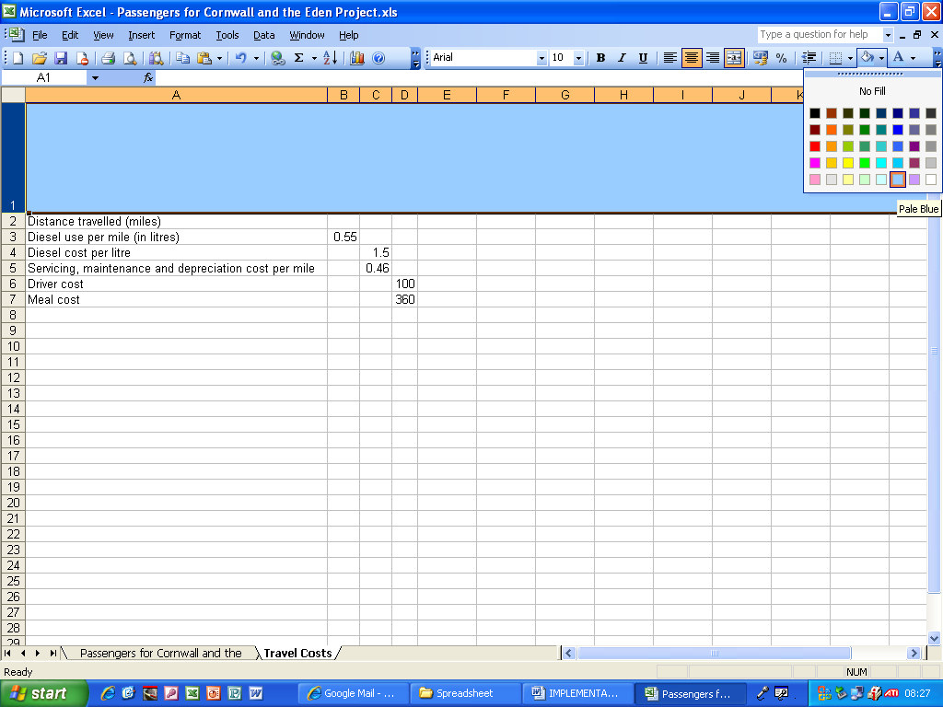
I clicked the colour fill button and selected pale blue as the colour for the first row of cells.

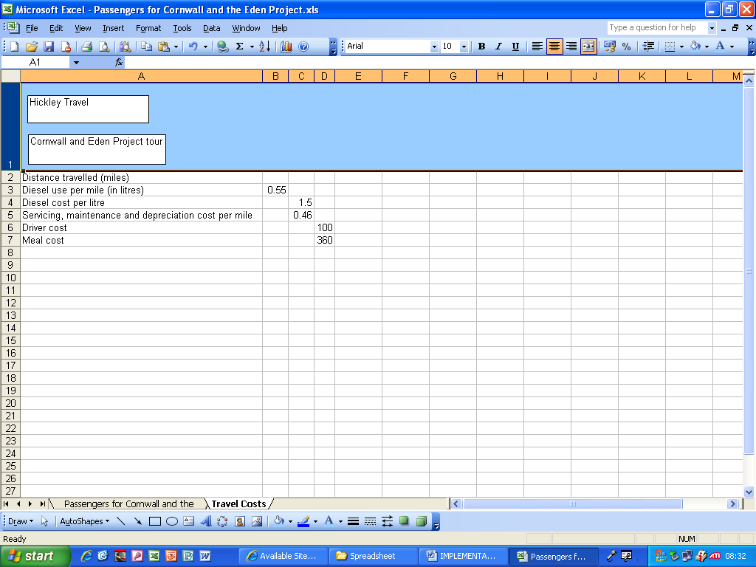
I added two text boxes and wrote Hickley Travel and the tour name in each of them.

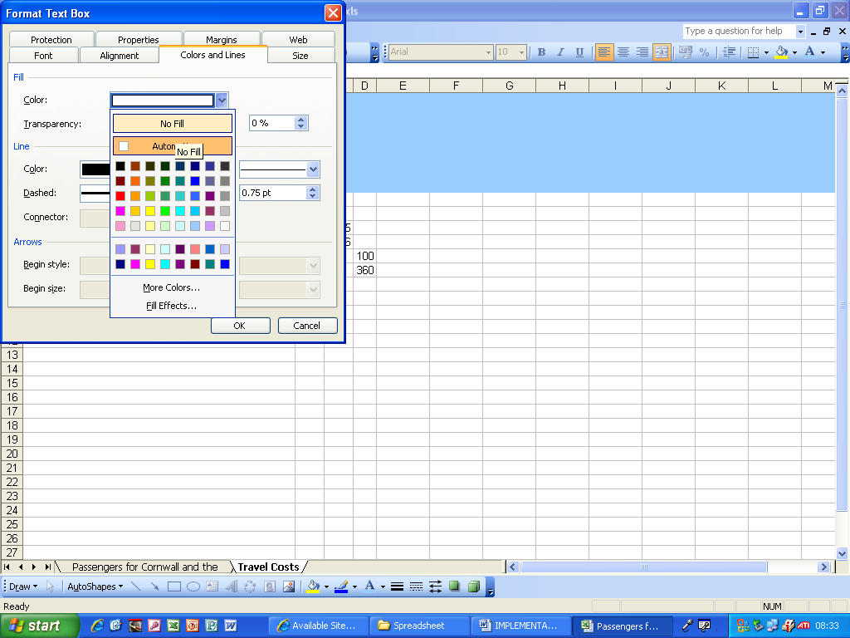
I right clicked on each of the text boxes, selected the Colours and Lines tab and then I selected No Fill for each of the text boxes.

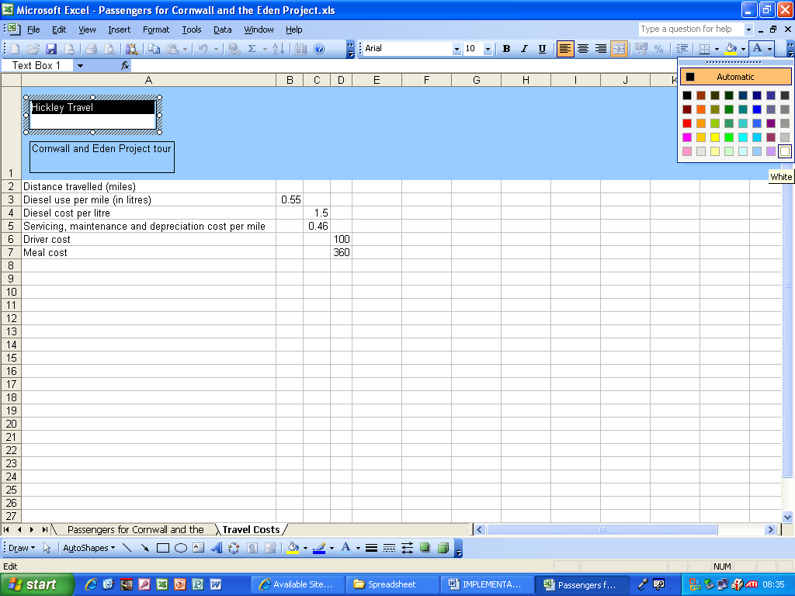
I selected the text in the text box and set its colour to white.

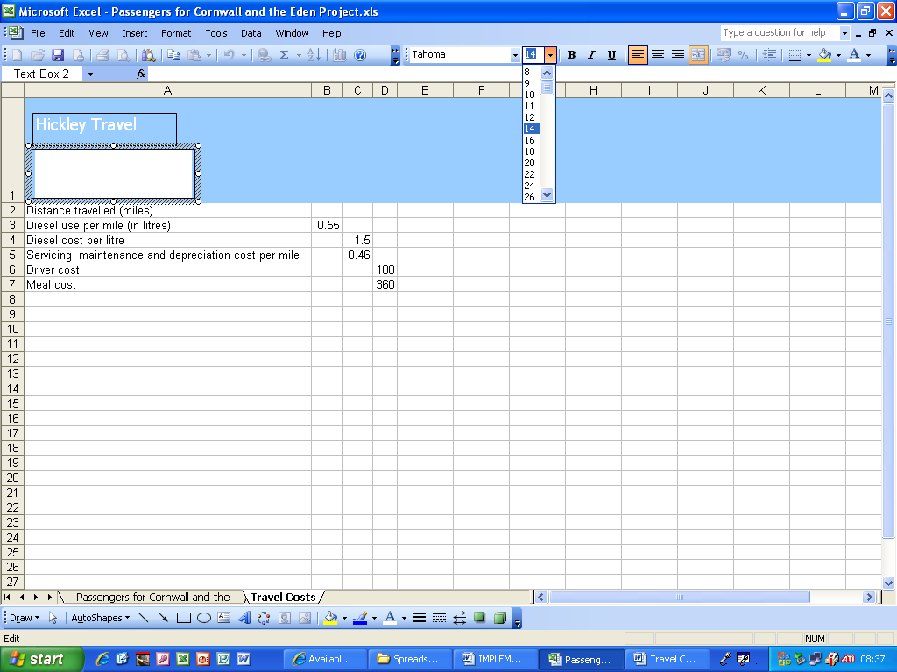
I set the font size and style of each of the text boxes to Tahoma, size 14, as you see in this screenshot.

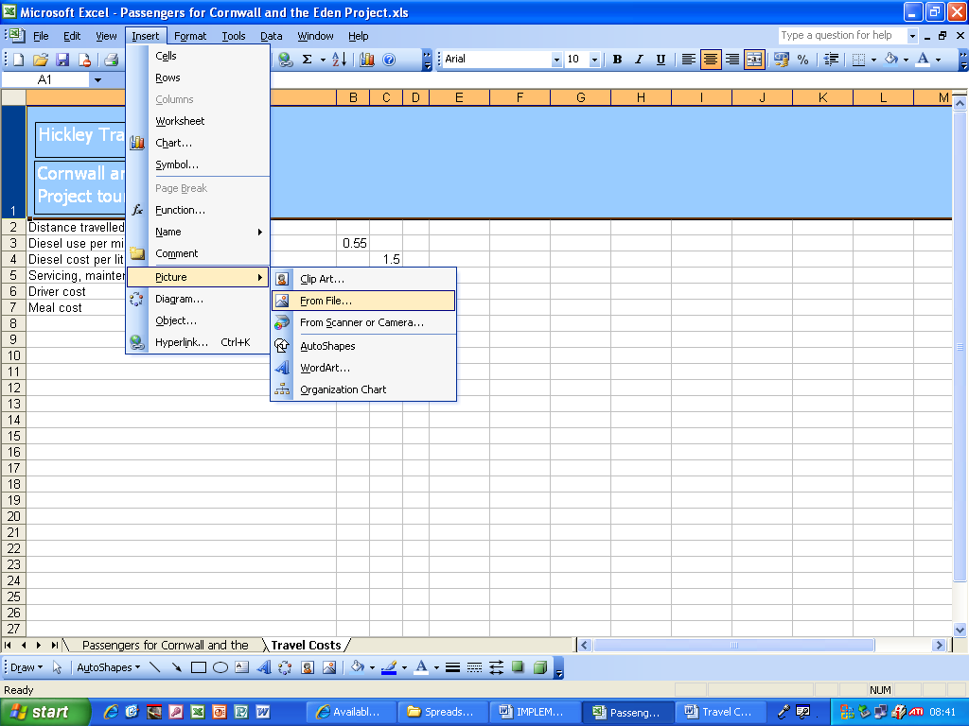
I wanted to insert the logo, so I clicked Insert > Picture > From File.

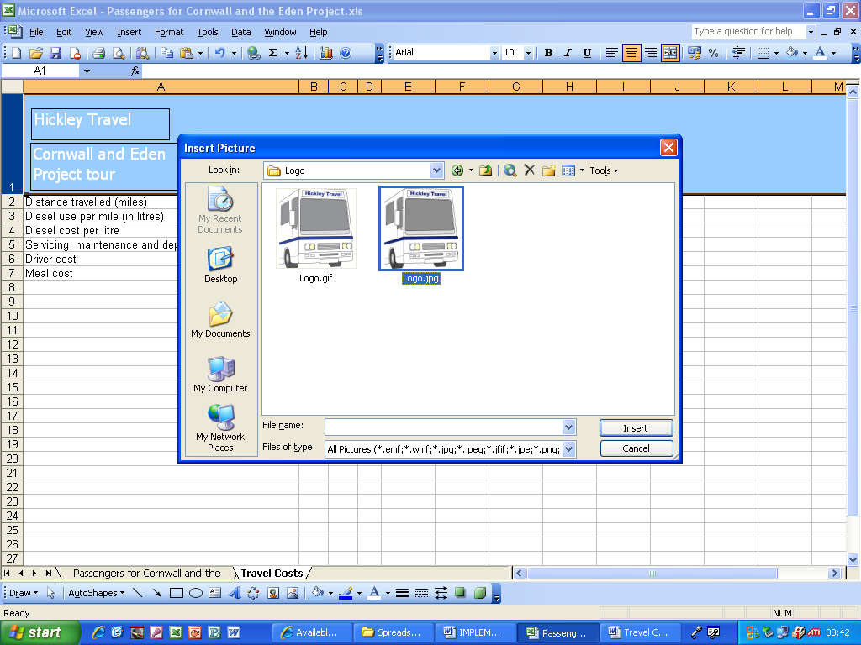
I browsed to the location of the logo and clicked on Logo.jpg and clicked Insert.

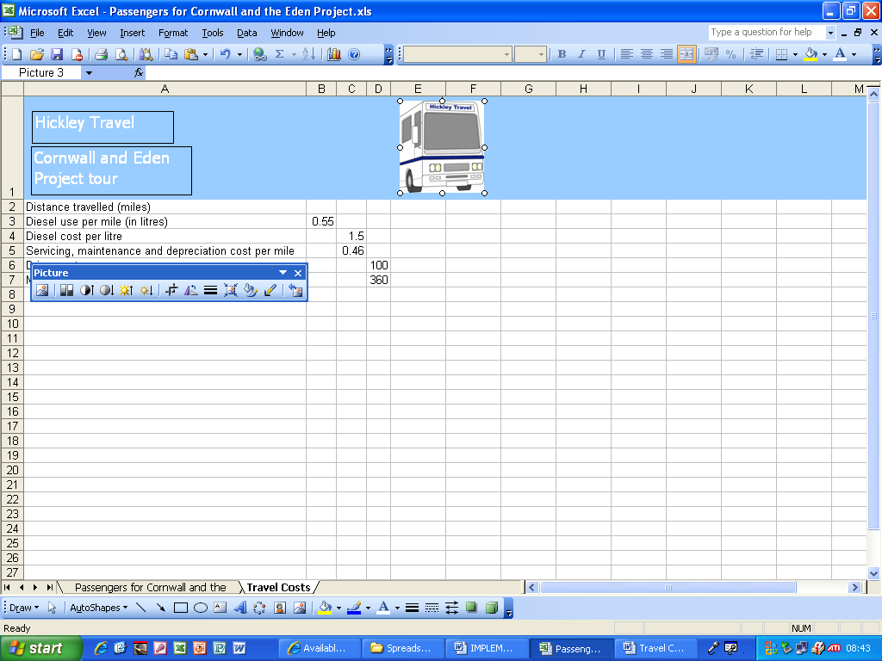
There is the logo inserted and centred on the spreadsheet.

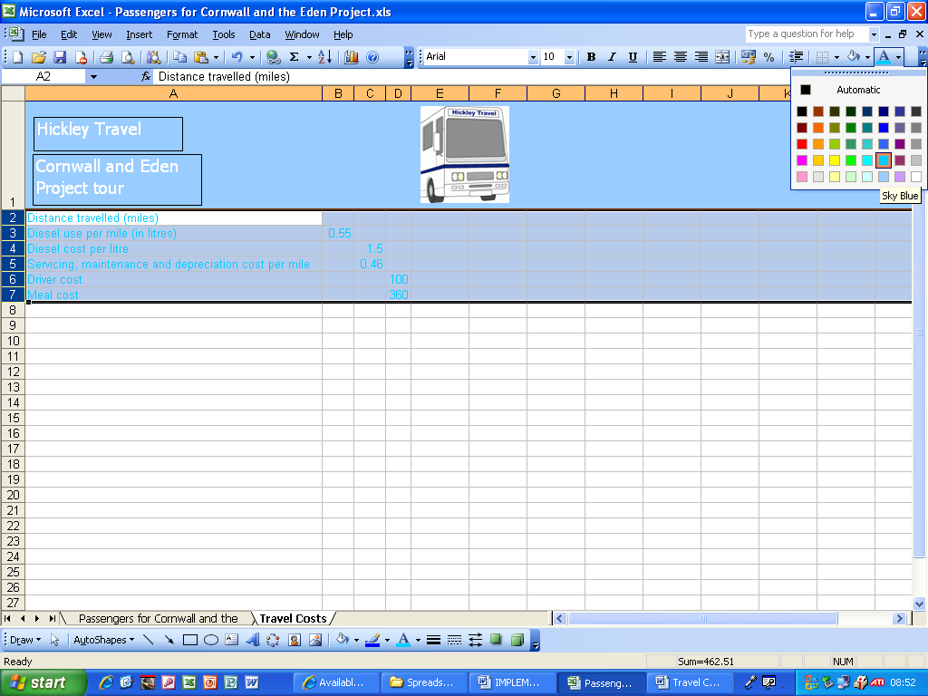
I selected the cells with text in and I changed the colour to blue.

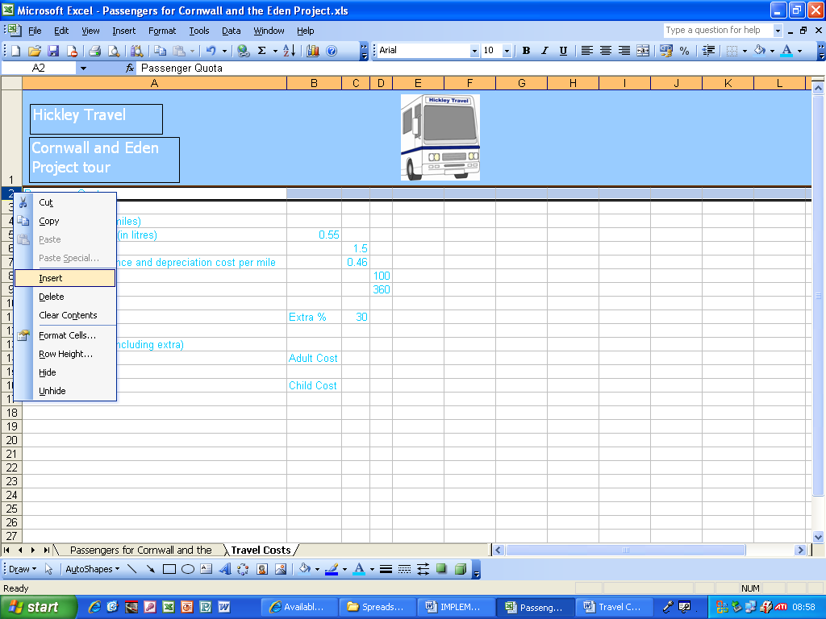
I inserted a few cells and added the required elements of Passenger Quota, Overall Total Cost, Extra (30%), Adult Cost and Child Cost. I changed the text colour to blue.

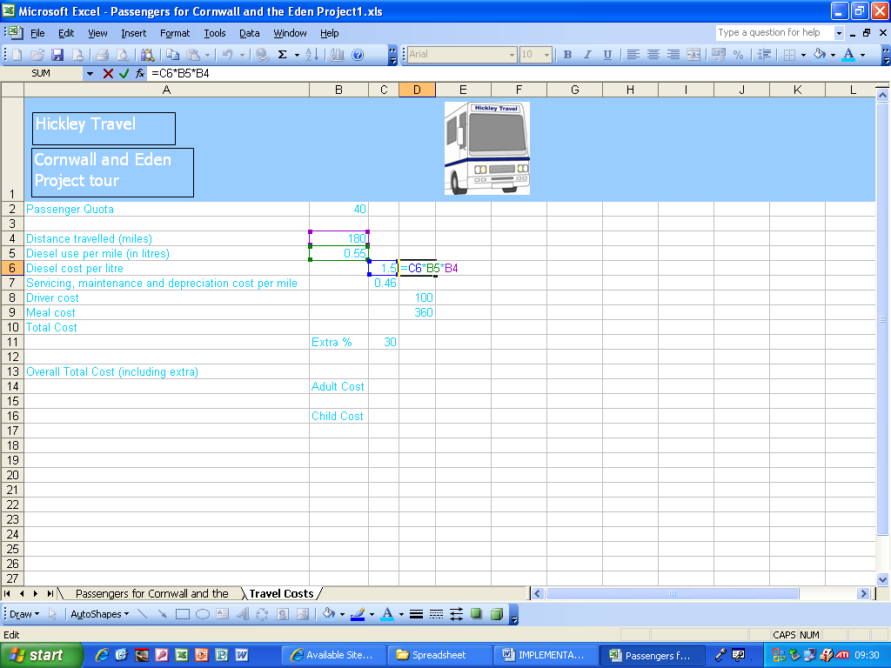
I added a formula which multiplies the diesel cost, distance travelled and diesel use per mile which comes to a total of £148.50

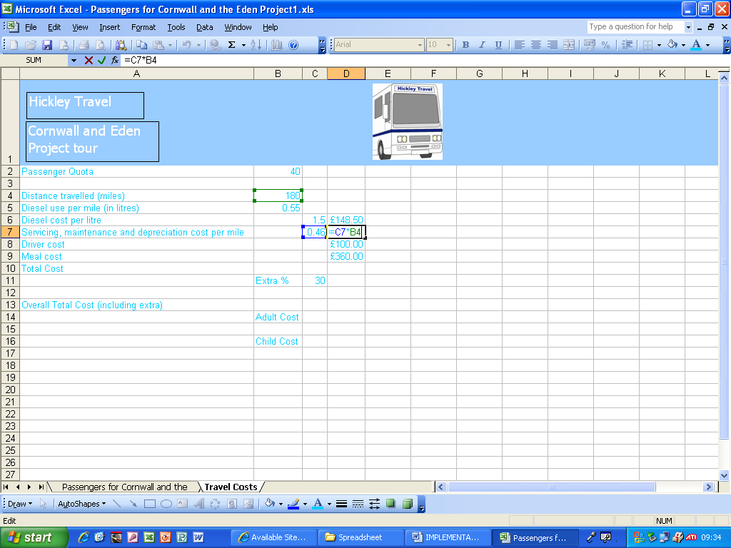
I added another formula which multiplies the servicing cost by the distance travelled to give a total of £82.80

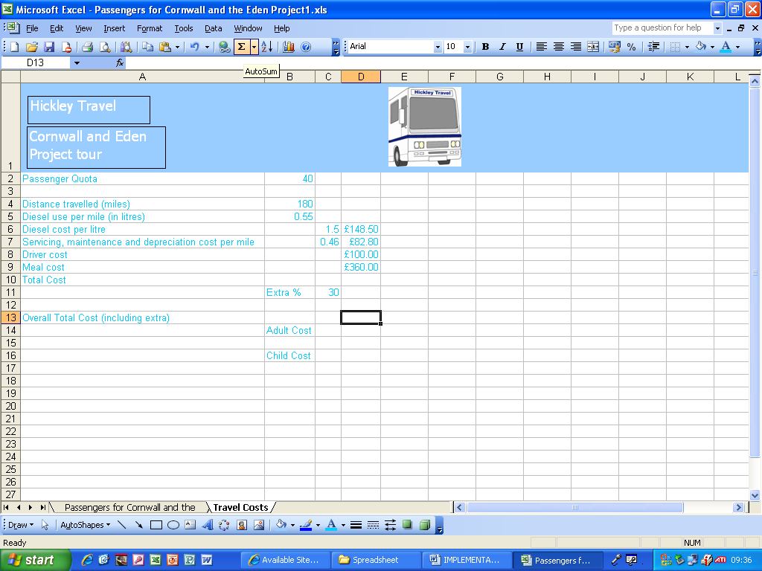
I clicked the autosum button and ended up with the correct total of ……….

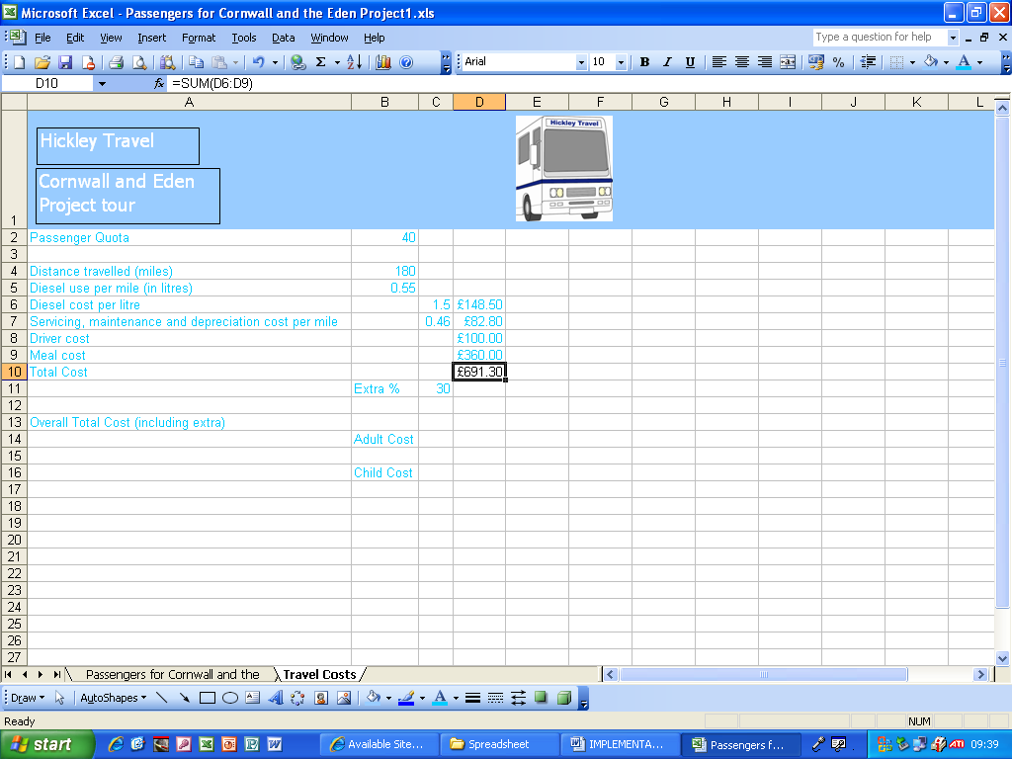
……… £691.30

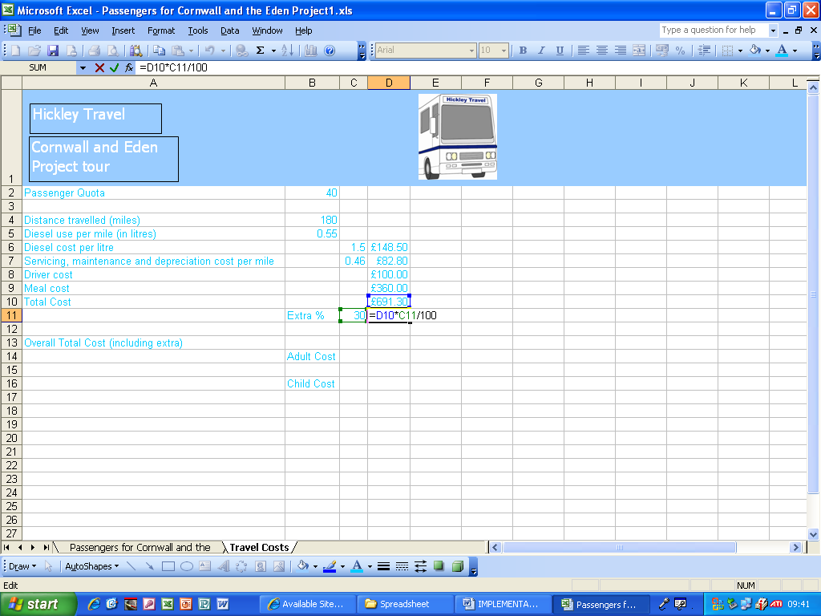
I added a formula that works out the 30% of the total cost.

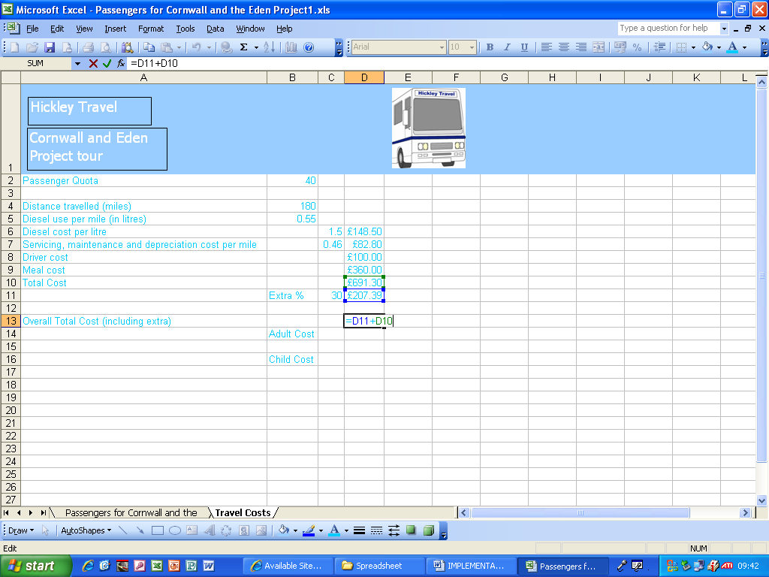
I added a formula which calculates the overall total cost by adding the total cost and the cost with 30% extra.

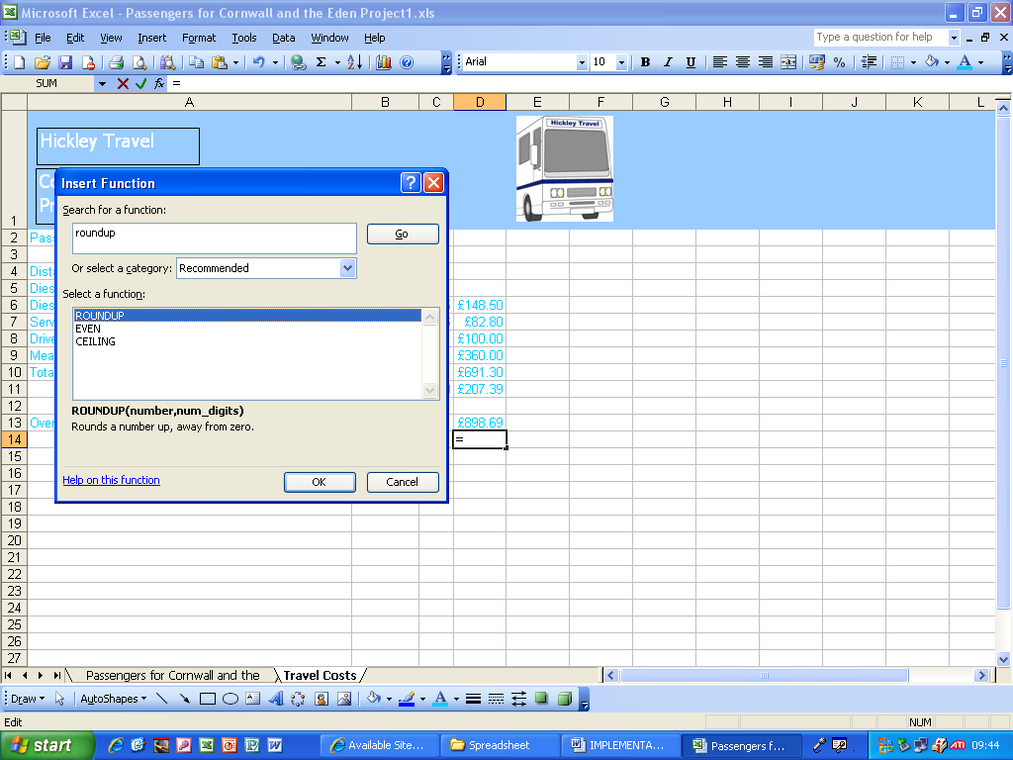

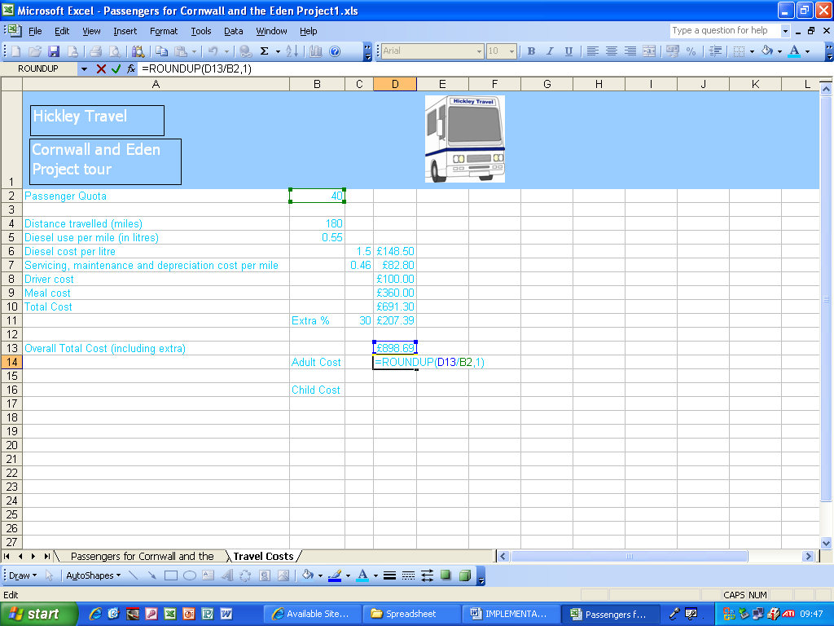

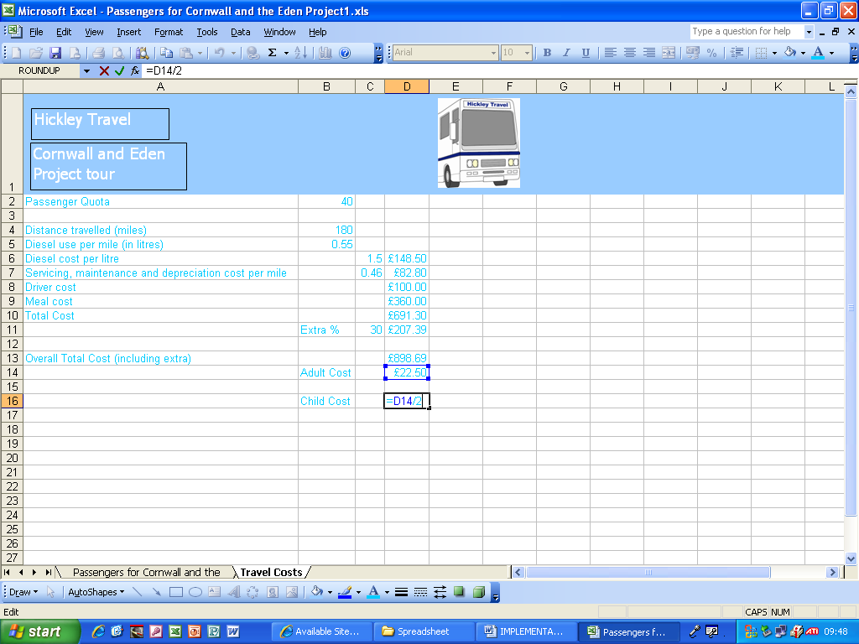
I calculated the child cost by dividing the adult cost by two.

