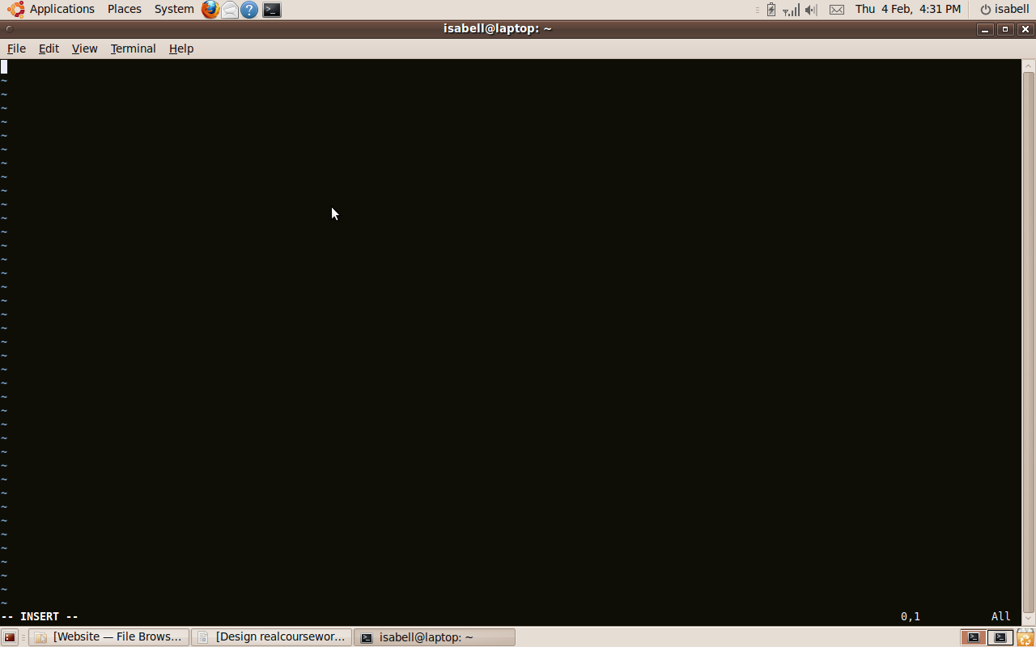

I opened vim to create the website.

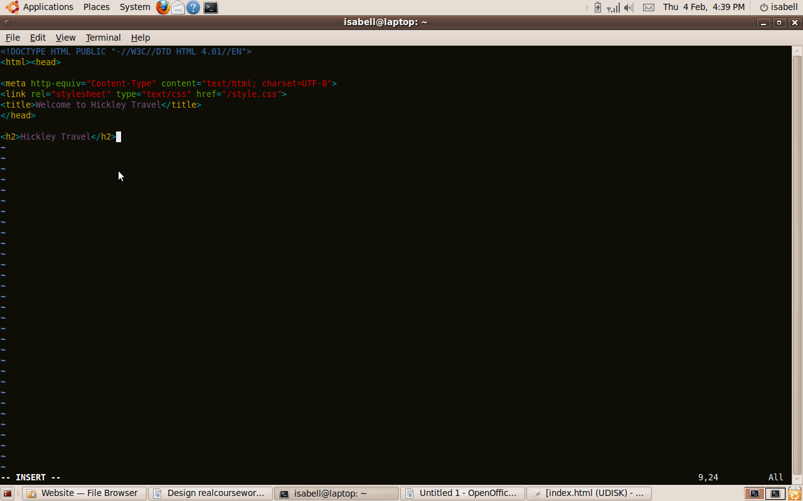

I created the Hickley Travel home page.

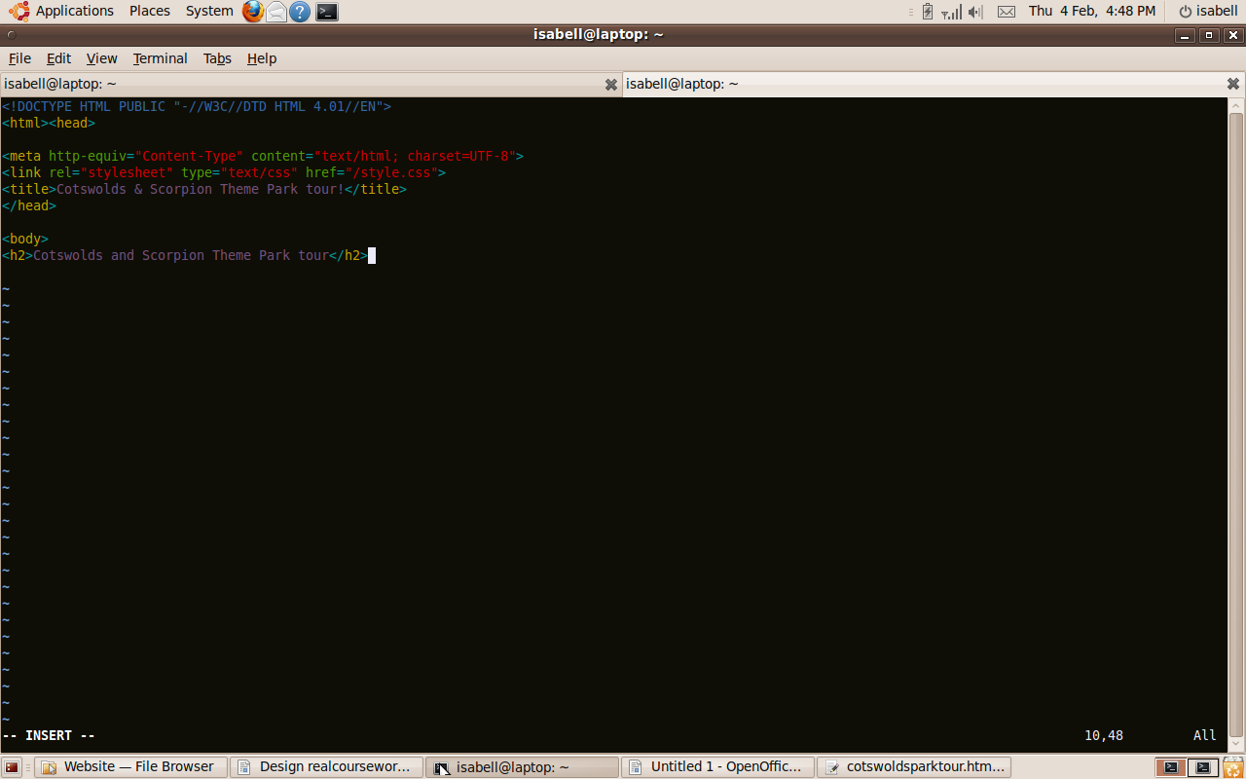
I created the Cotswolds and Scorpion Theme Park page

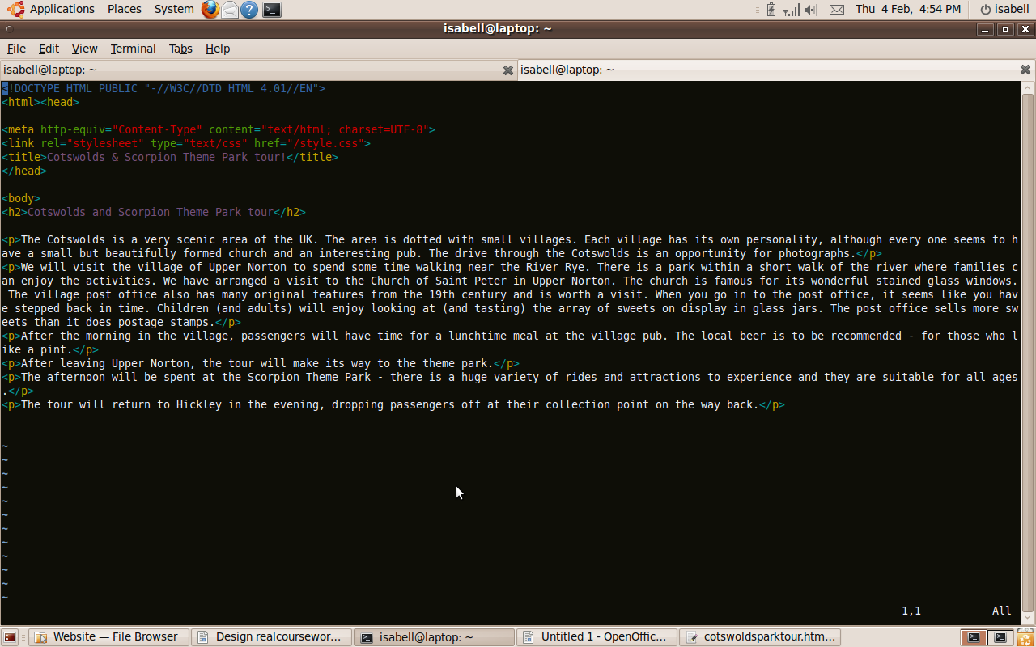
I added text to the Cotswolds Theme Park Tour page.

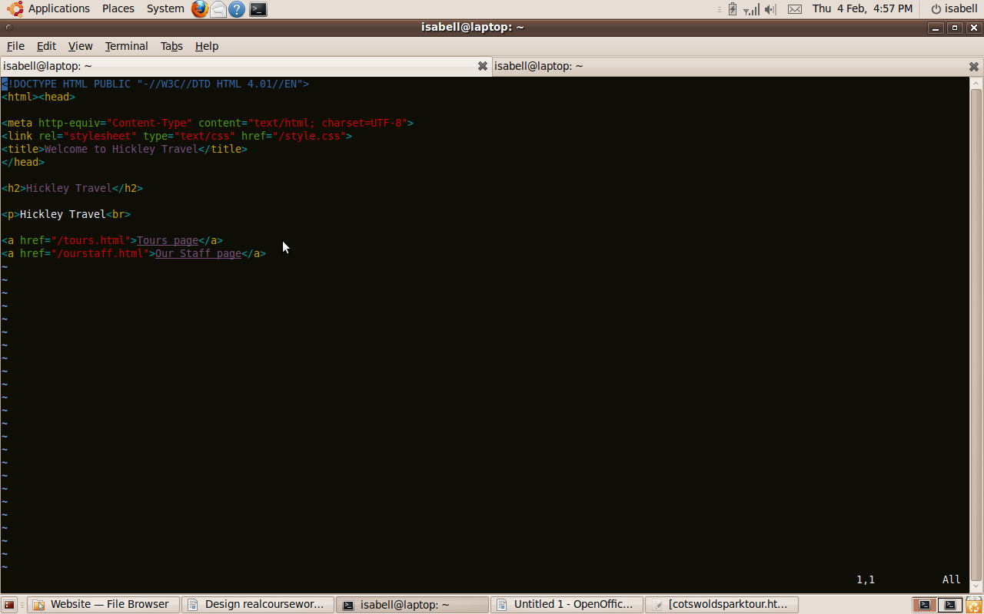
I added links to the Our Staff and Tours pages from the Home page.

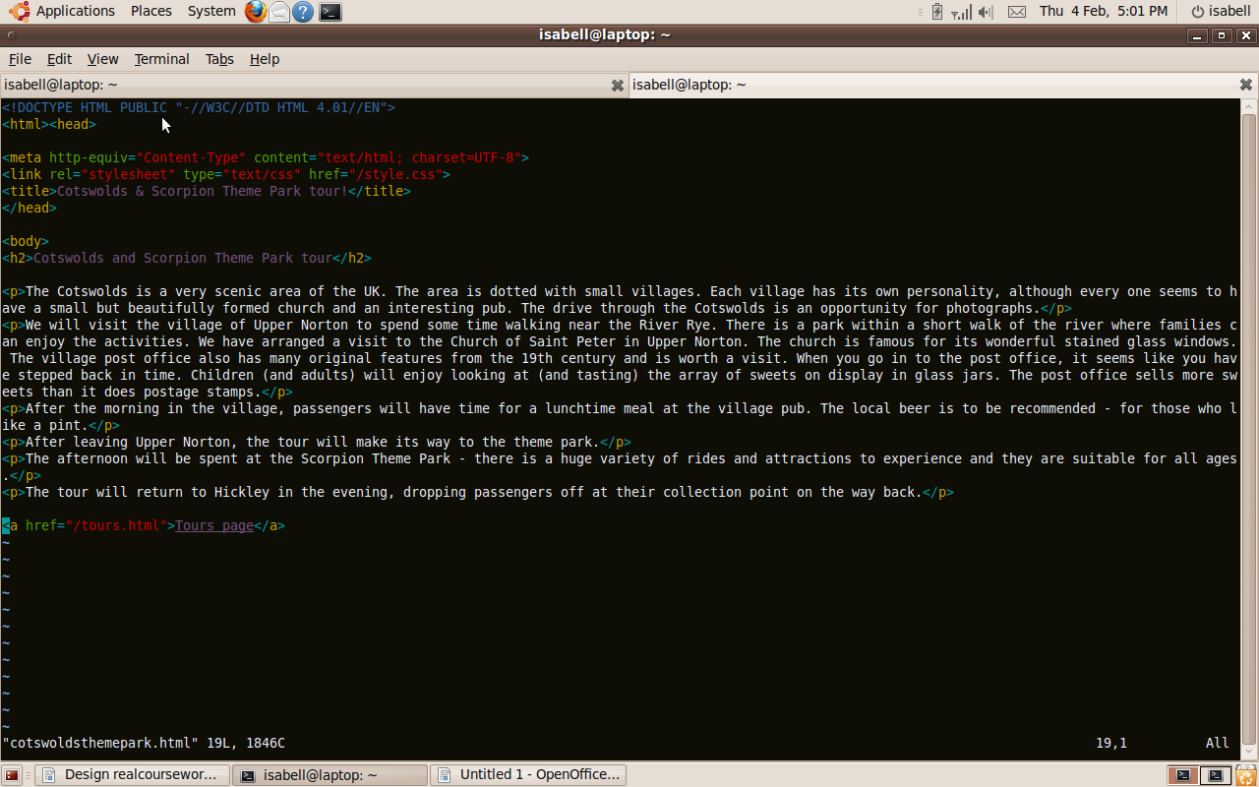
I added a link back to the Tours page on the Cotswolds and Scorpion Theme Park page,

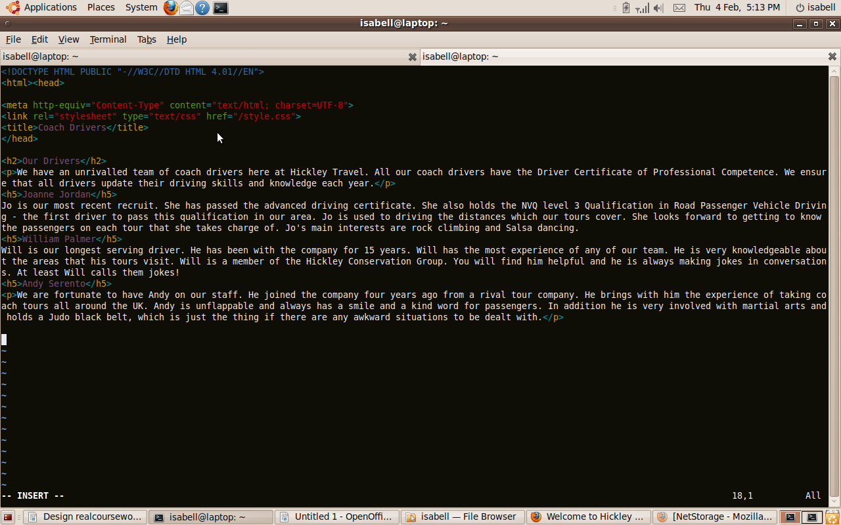
I added text to the Coach Drivers page.

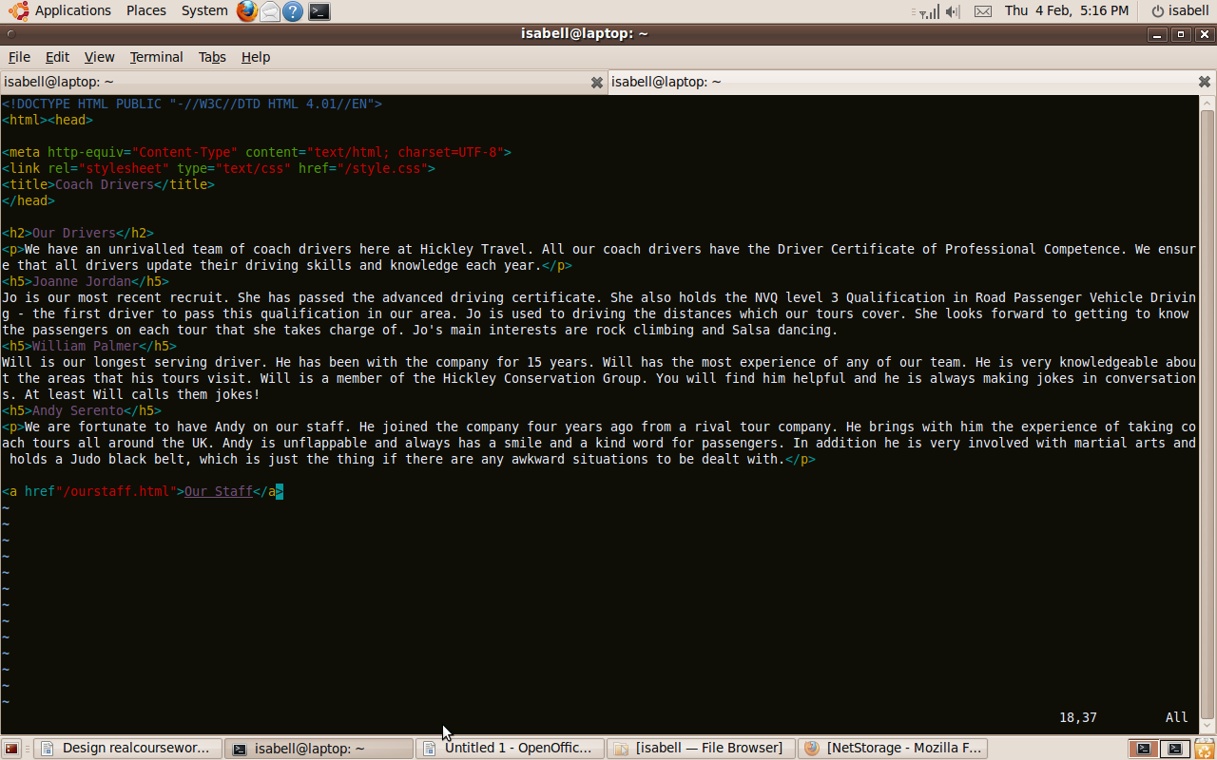
I added a link back to the Our Staff page from the Coach Drivers page.

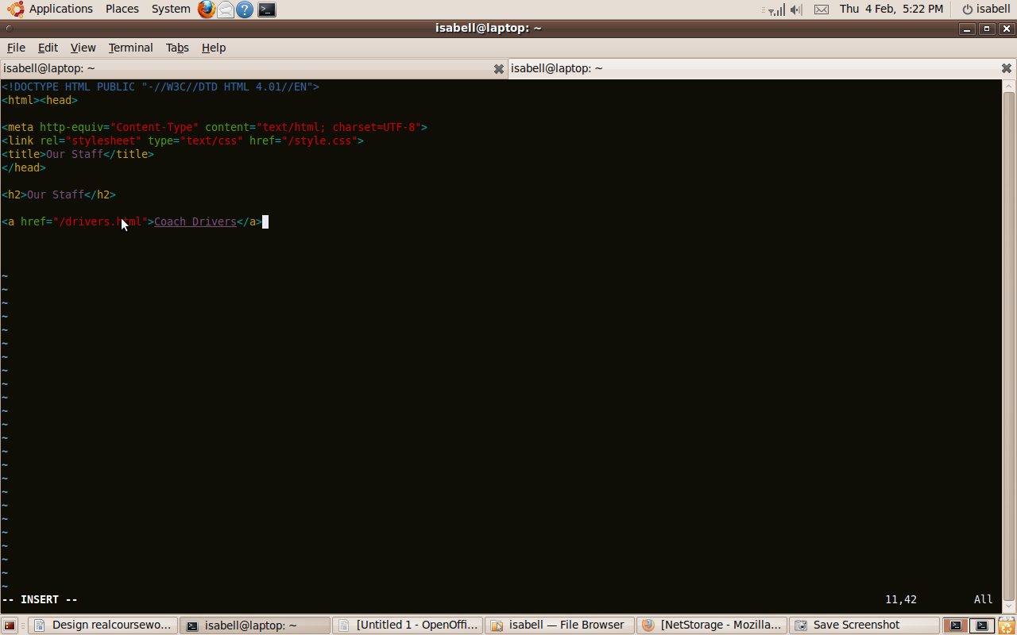
I created the Our Staff page and added a link to the Coach Drivers page.

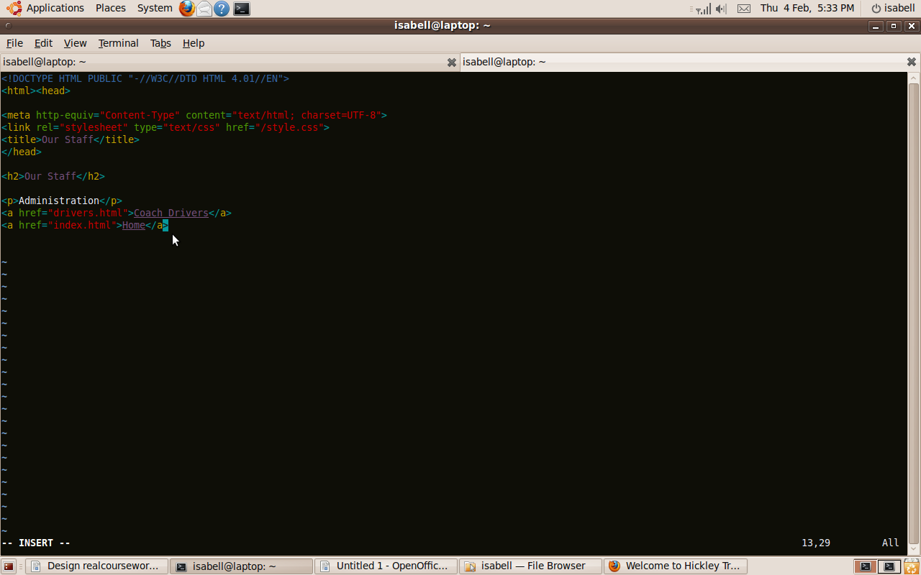
I added return links to all the pages back to the page it came from, this example is from the Tours page.

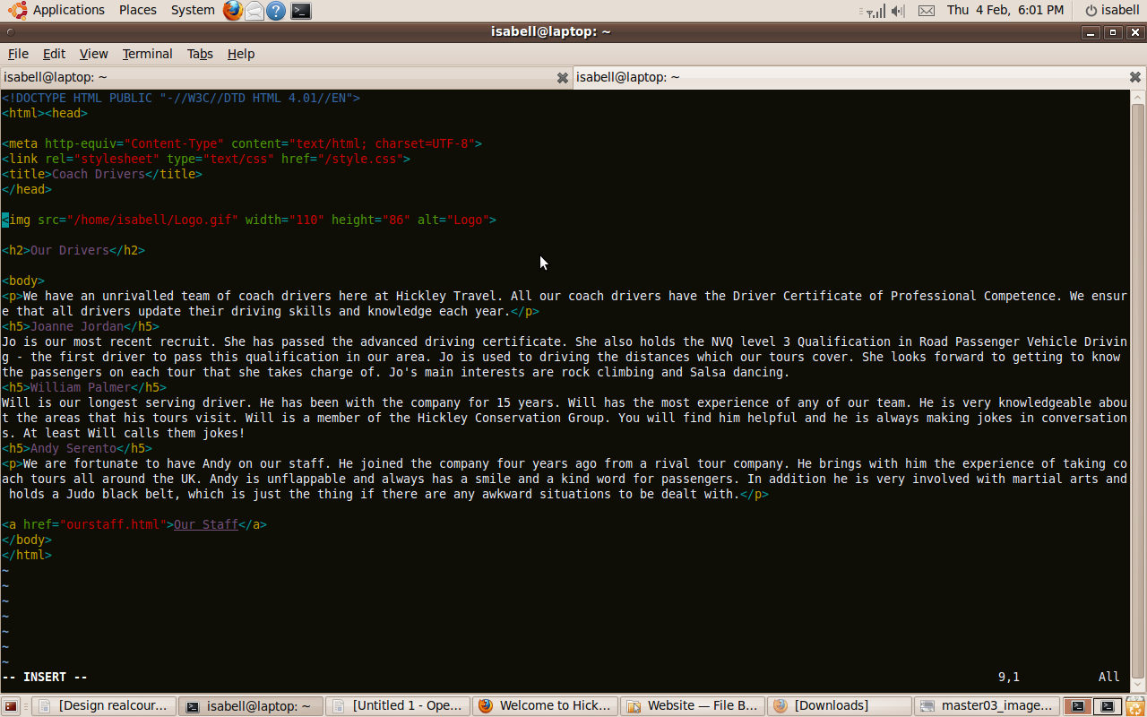

I added the logo to each of the pages, this example is the Coach Drivers page.

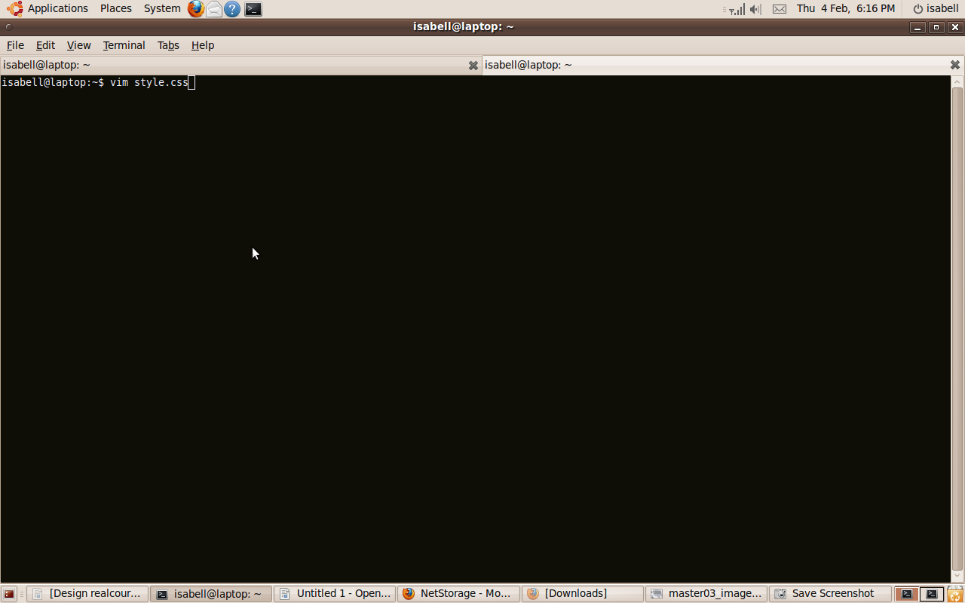
I created a CSS file, style.css, for the styling of the website.

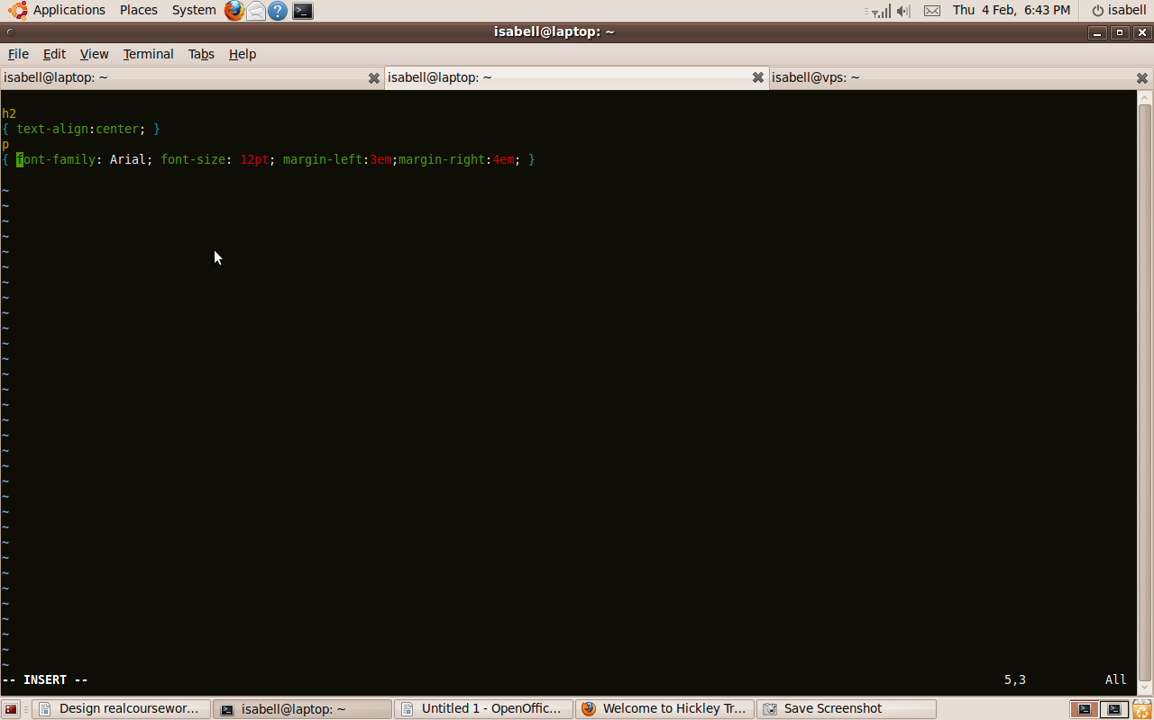

I specified font Arial and font size 12 pt.

