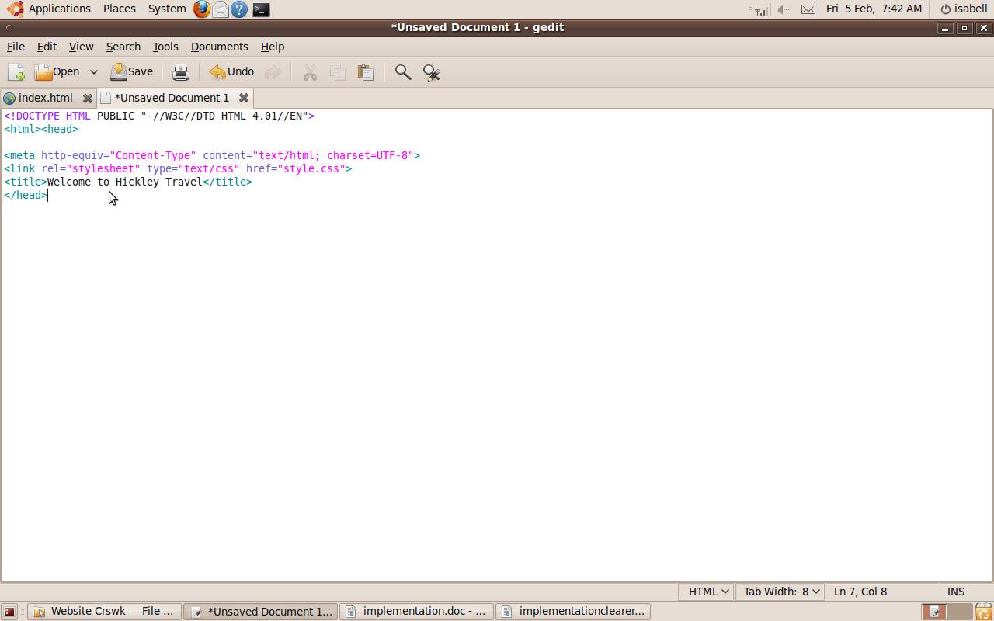

I opened Gedit, a text editor, and created the home page.

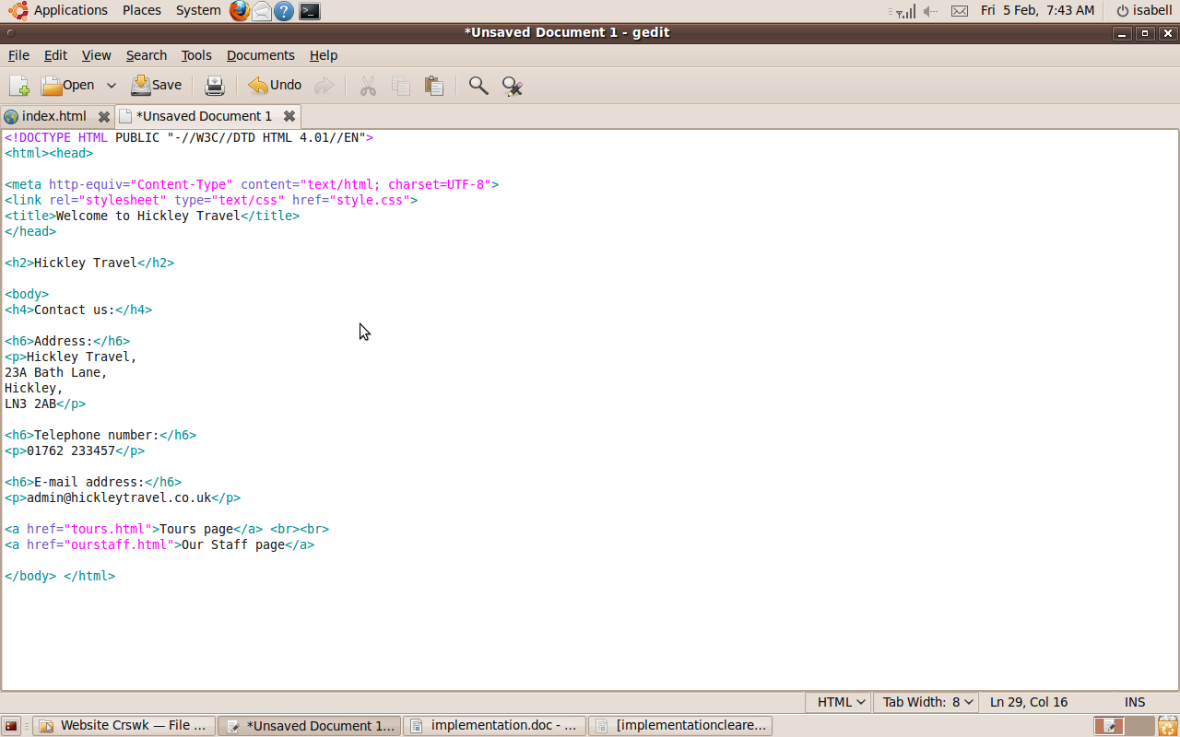

I added text (the contact details) to the home page.

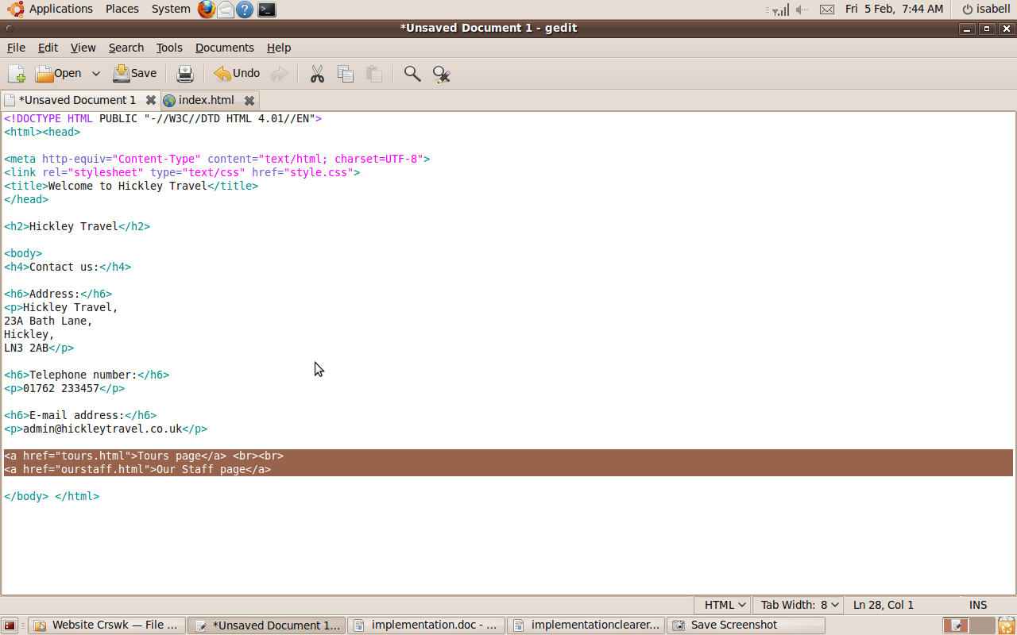

I added return links and a link to the next page to the home page.

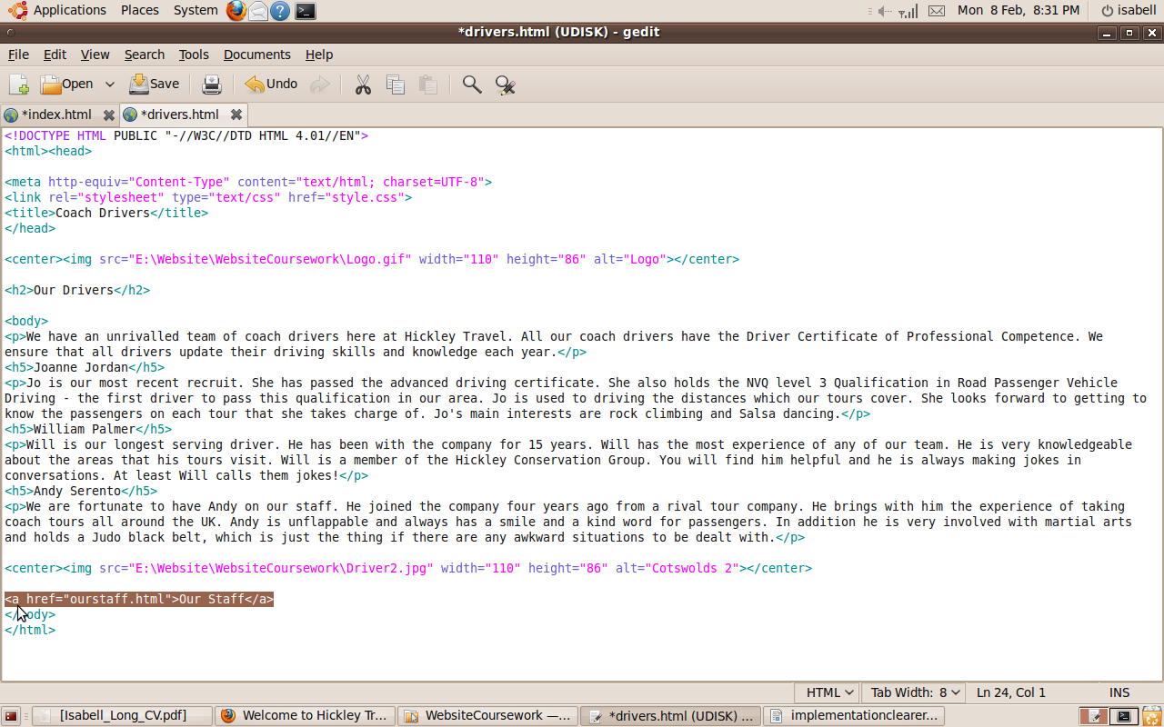

I added a return link to the other page it links back to on the Coach Drivers page and then to all the other pages.

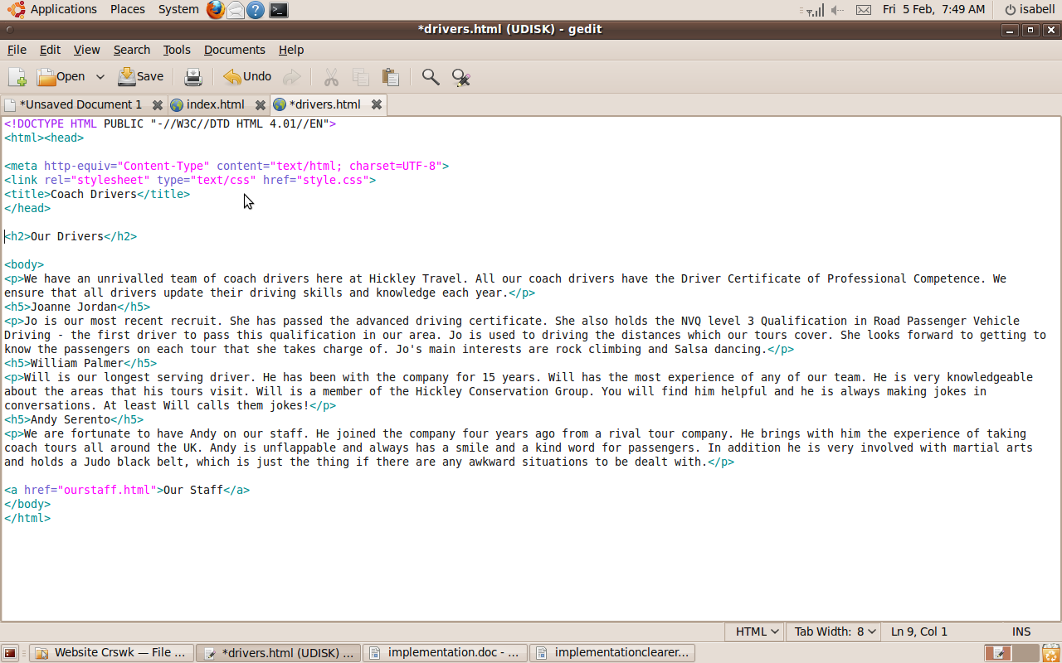

I created the Coach Drivers page and added text to it.

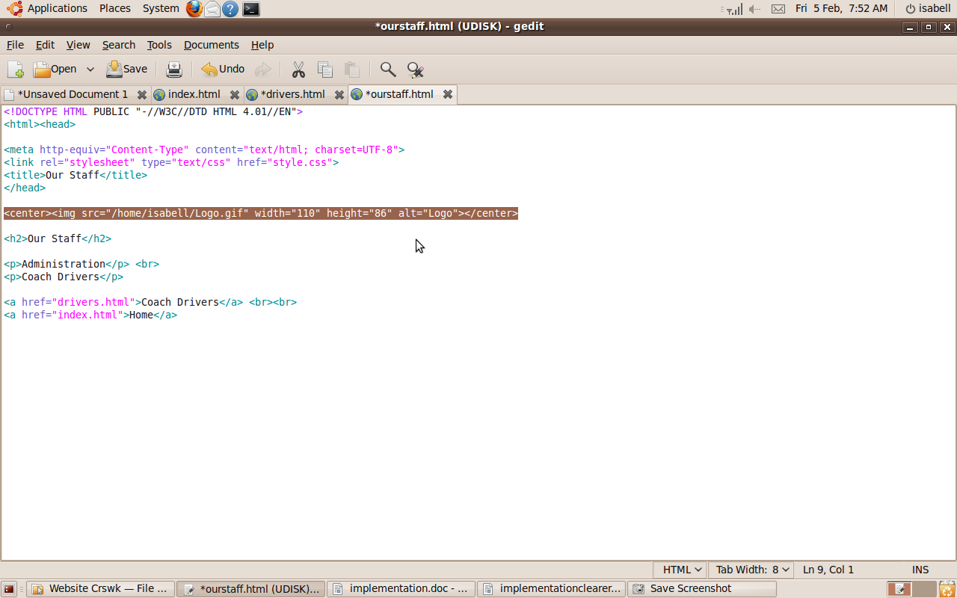

I added an image, the logo, to the our staff page and all the other subsequent pages.

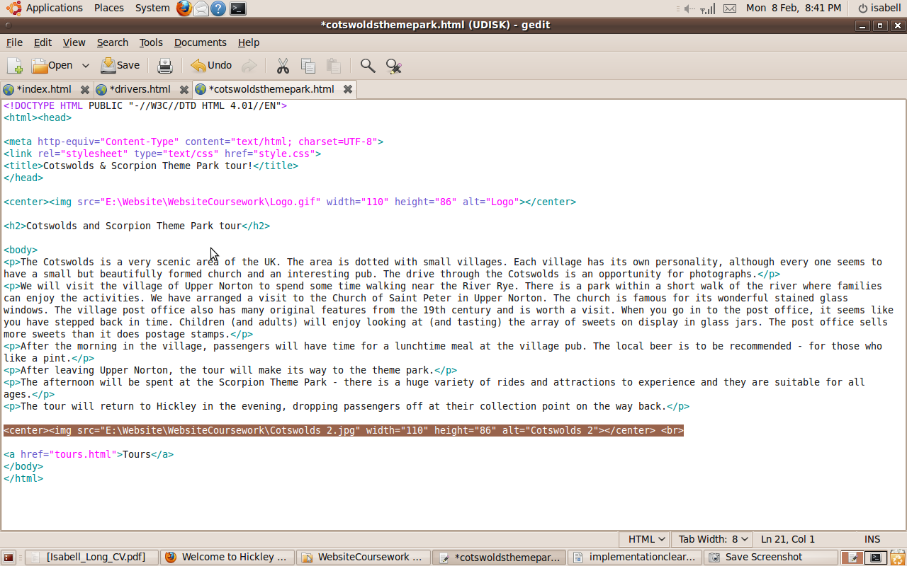

I added a link to an image, “one relevant image”, to the Cotswolds Theme Park Tour page.

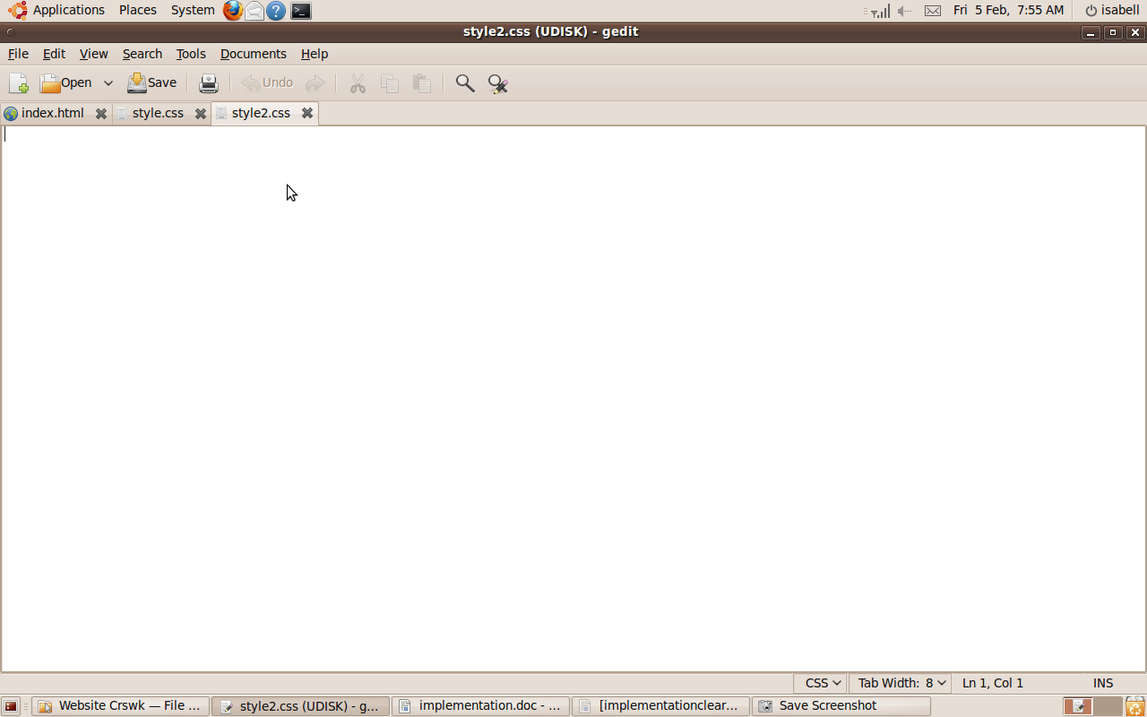

I created a CSS file in order to style the website.

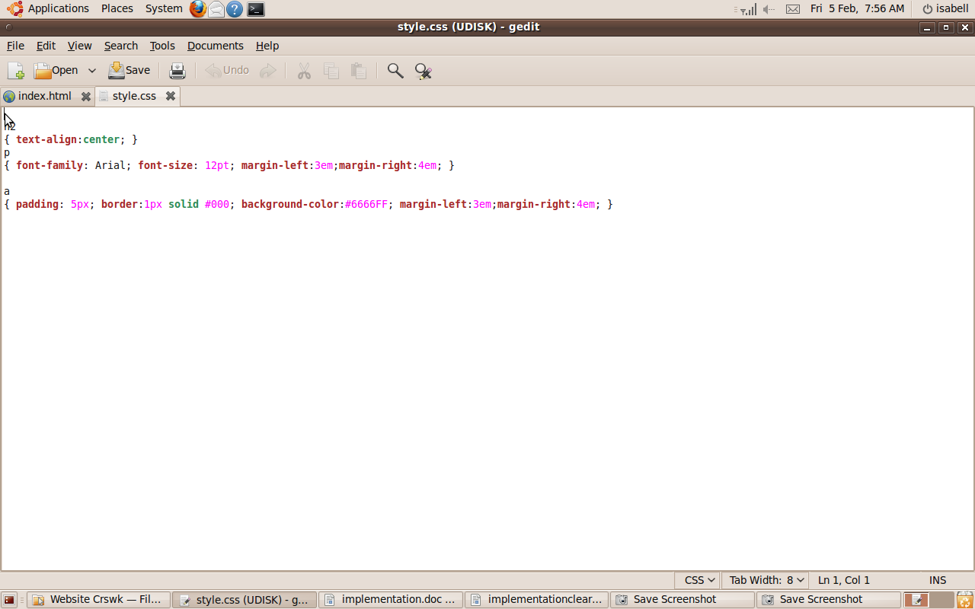
This is my current CSS stylesheet. It specifies that the headers go to the centre of the page, that the paragraphs have Arial font size 12, and it specifies the page margins.

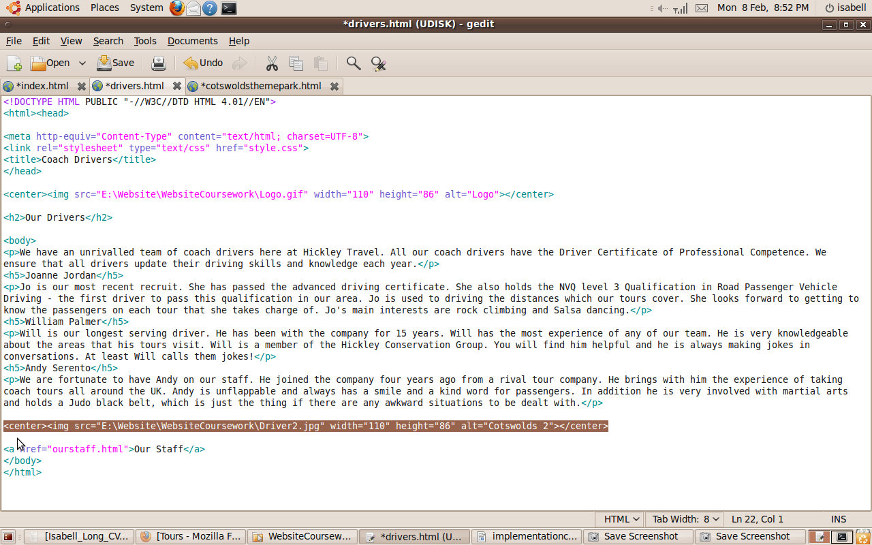

I added a link to a relevant image to the Coach Drivers page.

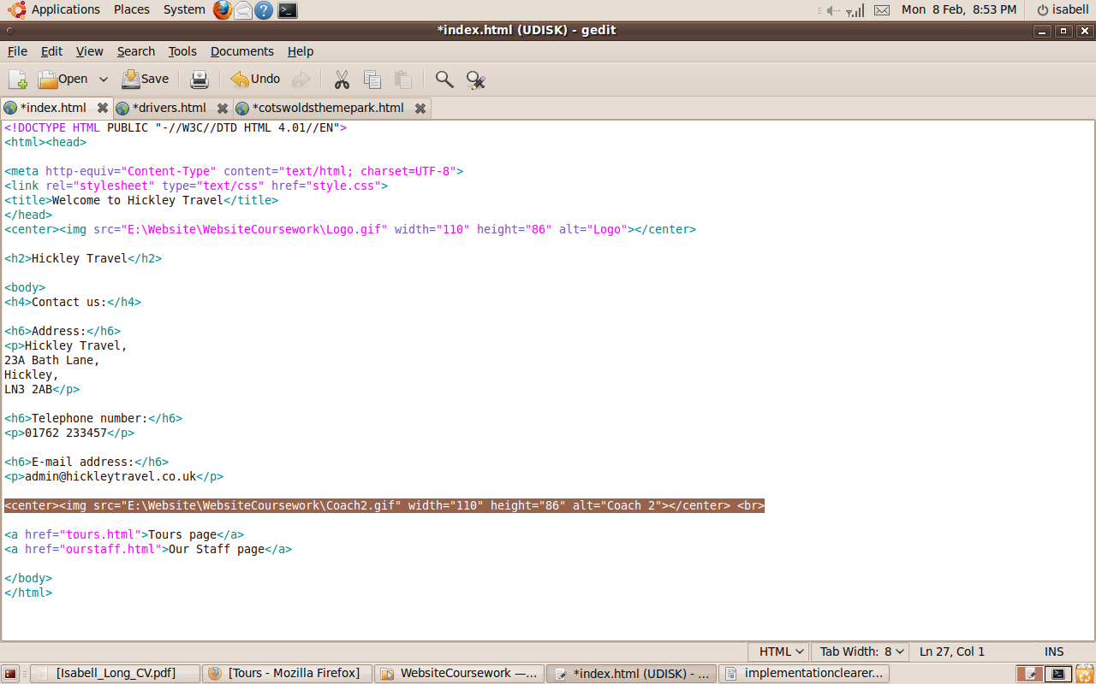

I added an image to the home page and the tours page.

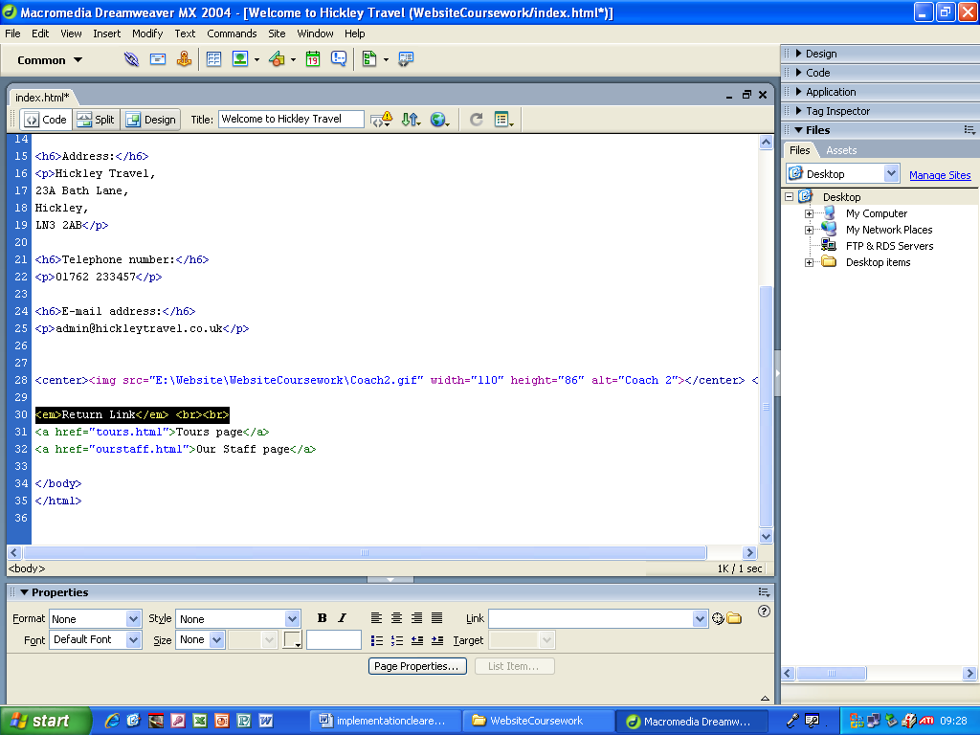
I added the words return link to above the return link.

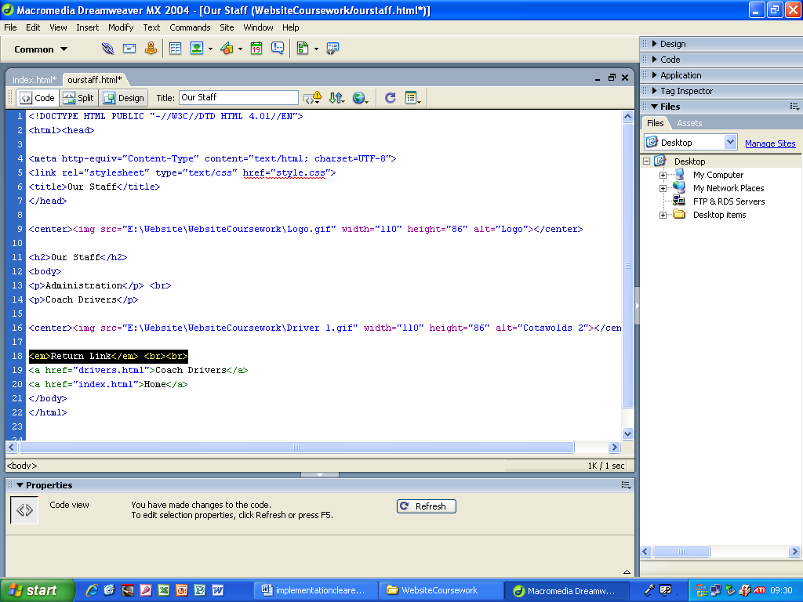
I added the words return link to above the return link.

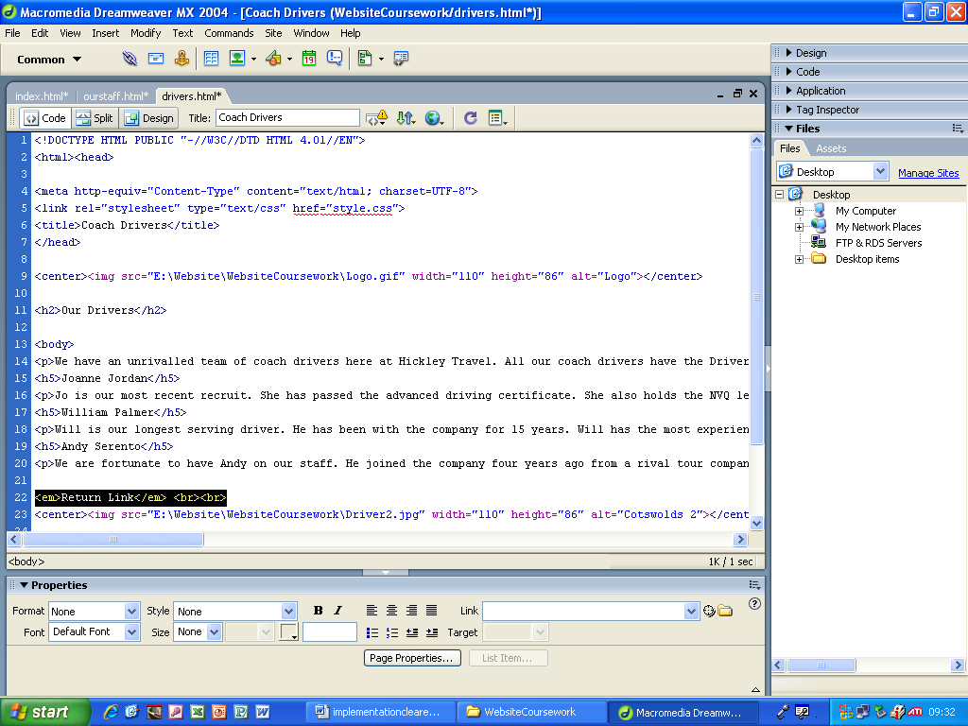
I added the words return link to above the return link.

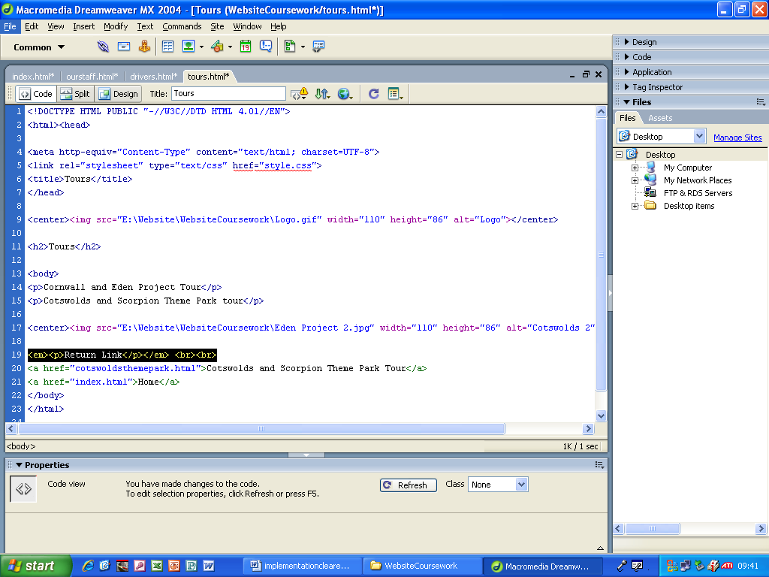
I added the words return link to above the return link.

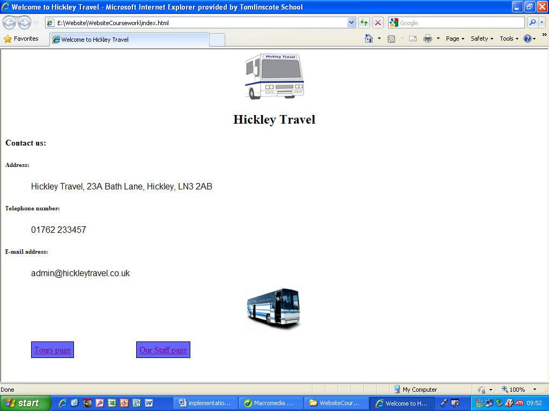
This is the finished Home page.

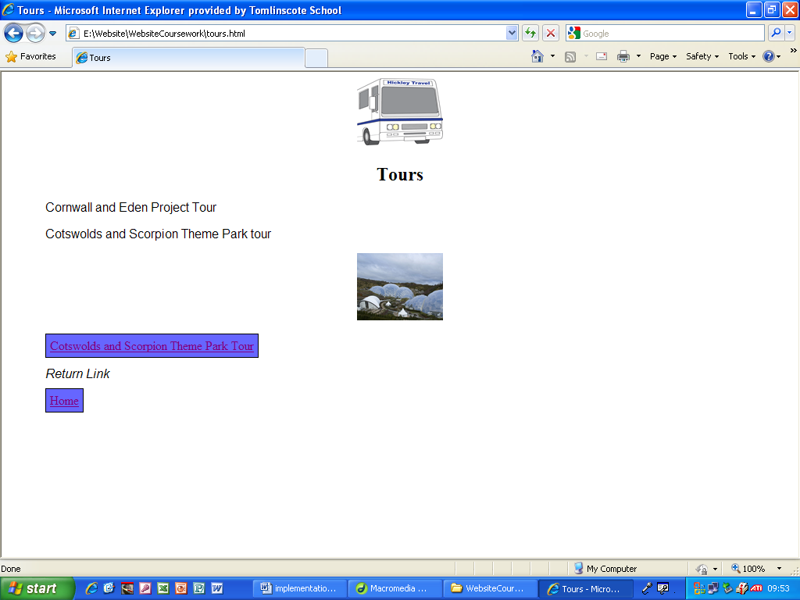
This is the finished version of the Tours page.

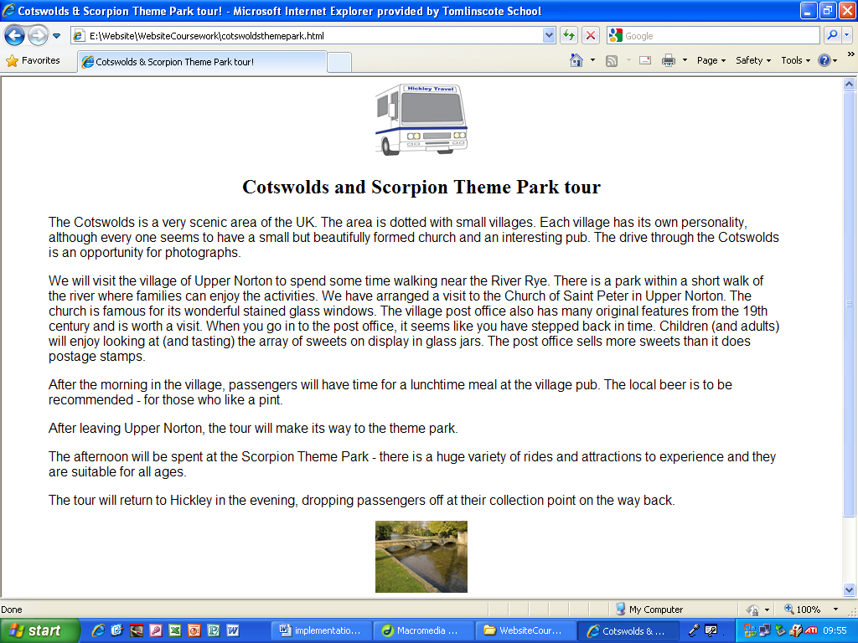
This is the finished Cotswolds theme park tour page.

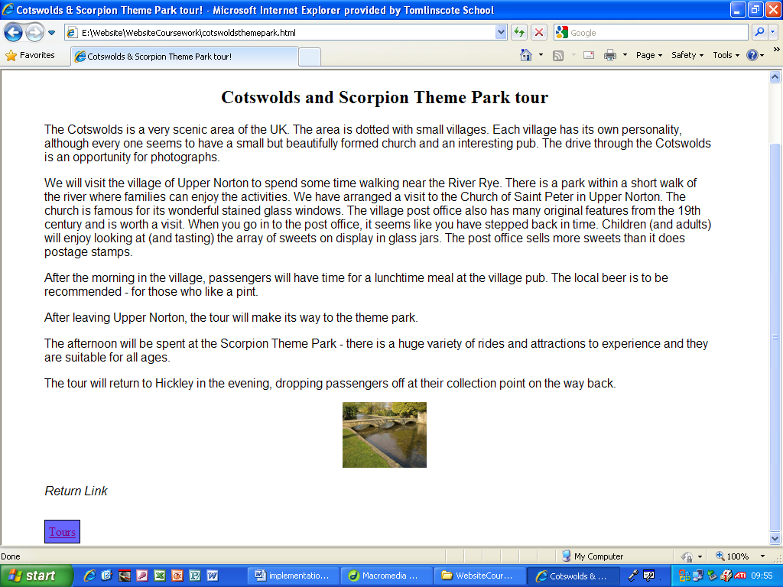
This is the rest of the finished Cotswolds and Scorpion Theme Park page.

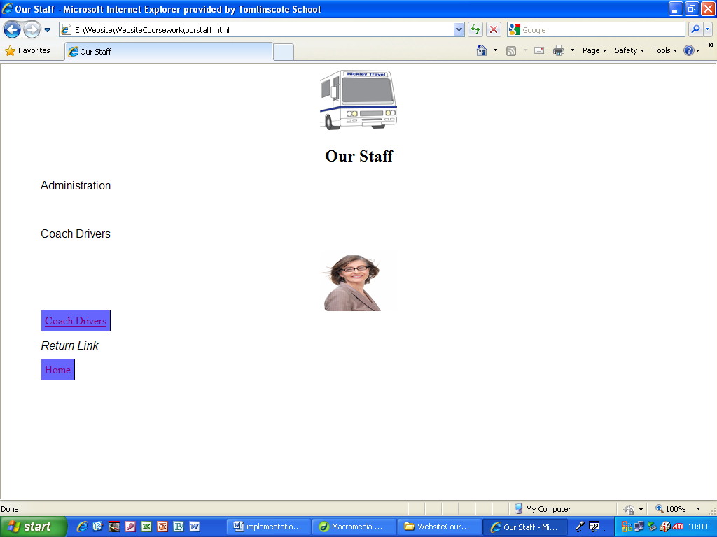
This is the finished Our Staff page.

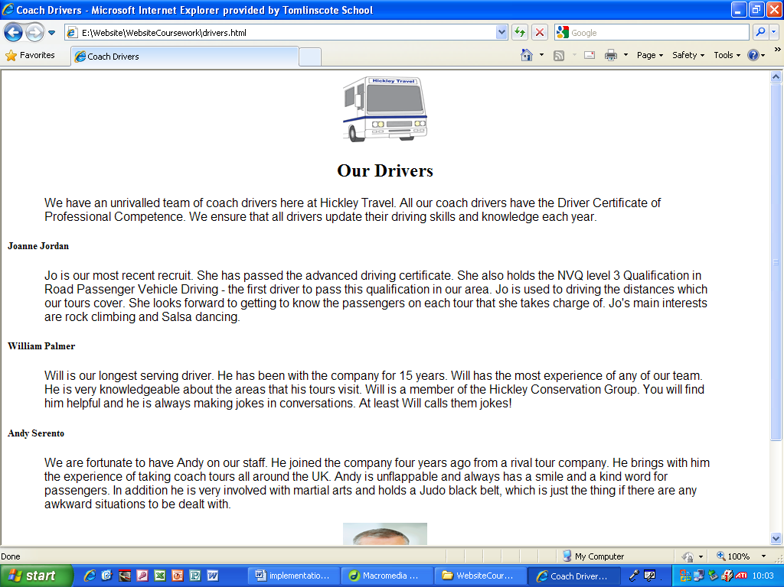
This is the finished Our Drivers page.

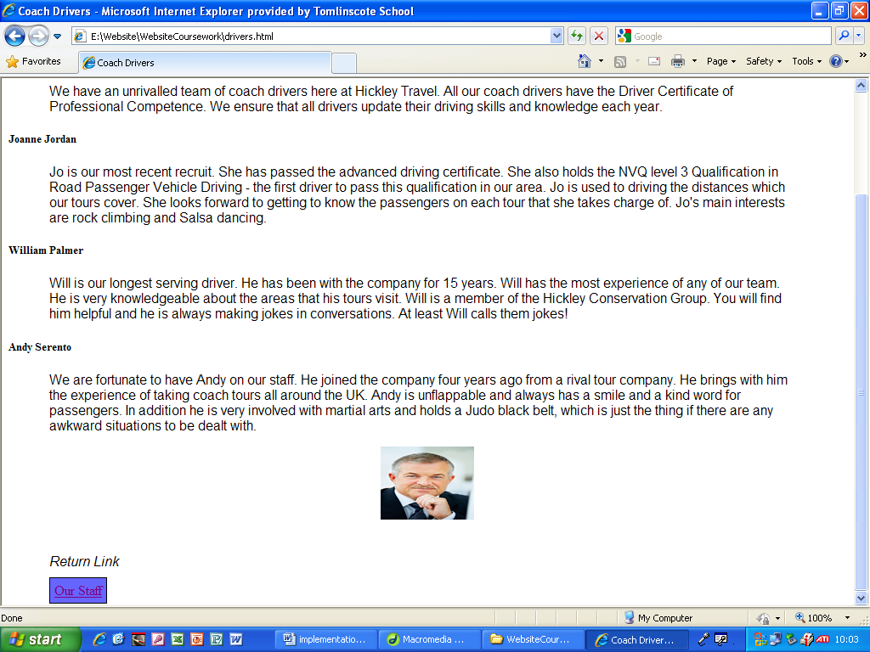
This is the rest of the finished Our Drivers page.

