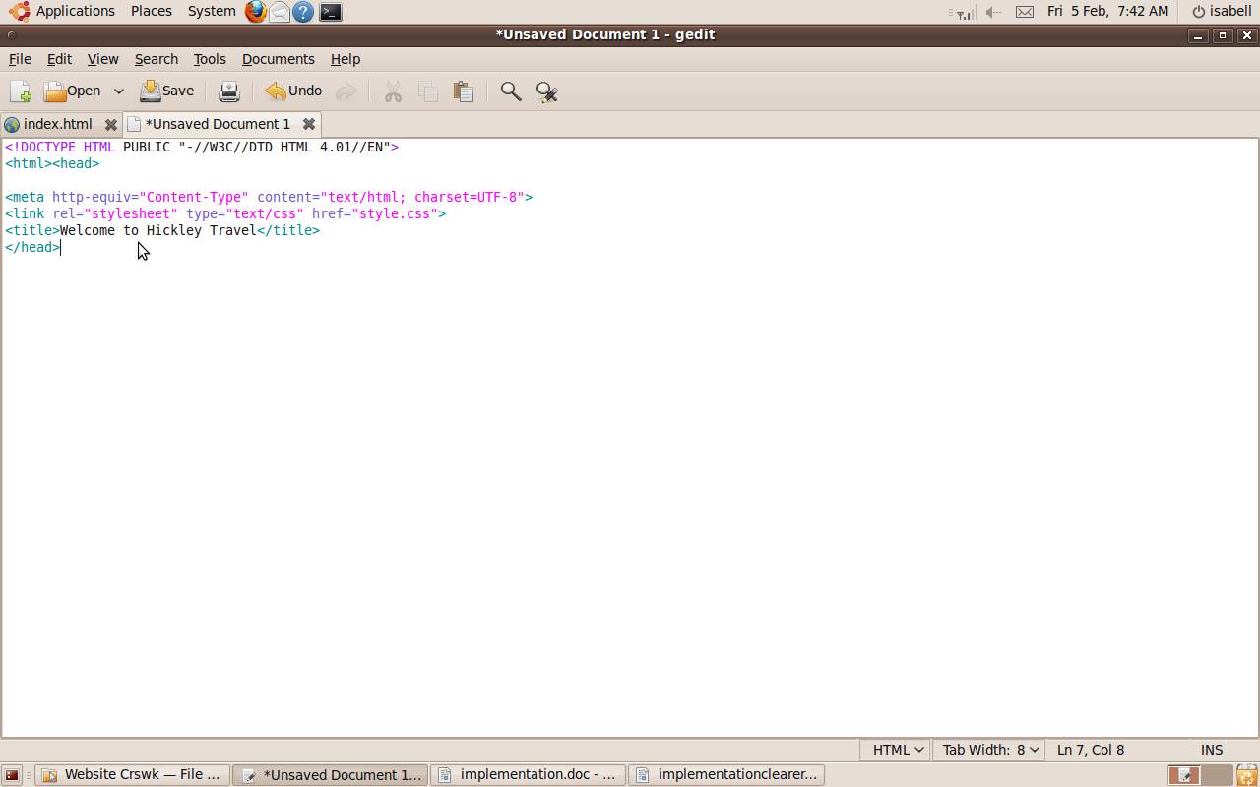
I opened Gedit, a text editor, and it opened a new document. I set the code to HTML and created the basic code for the home page which defines the title of the page, that it is text, and that it will try to validate HTML 4.01.

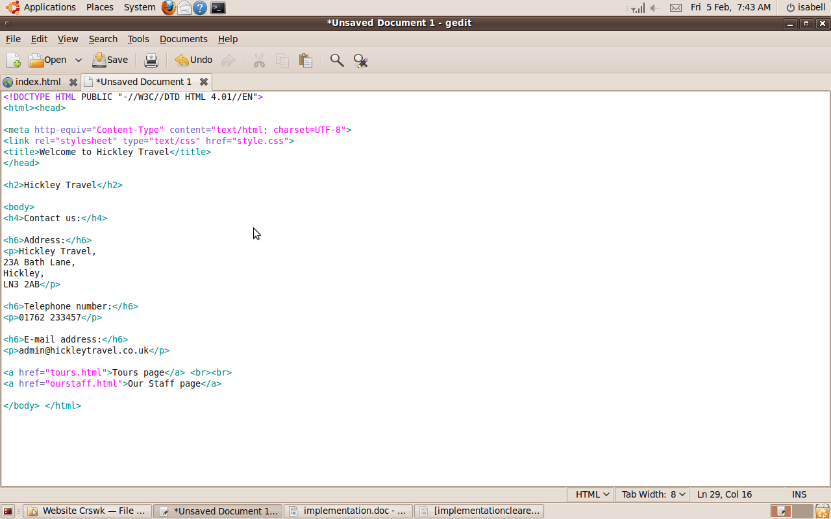

I added text (the contact details) to the home page. I got these contact details from the information I was given in the booklet.

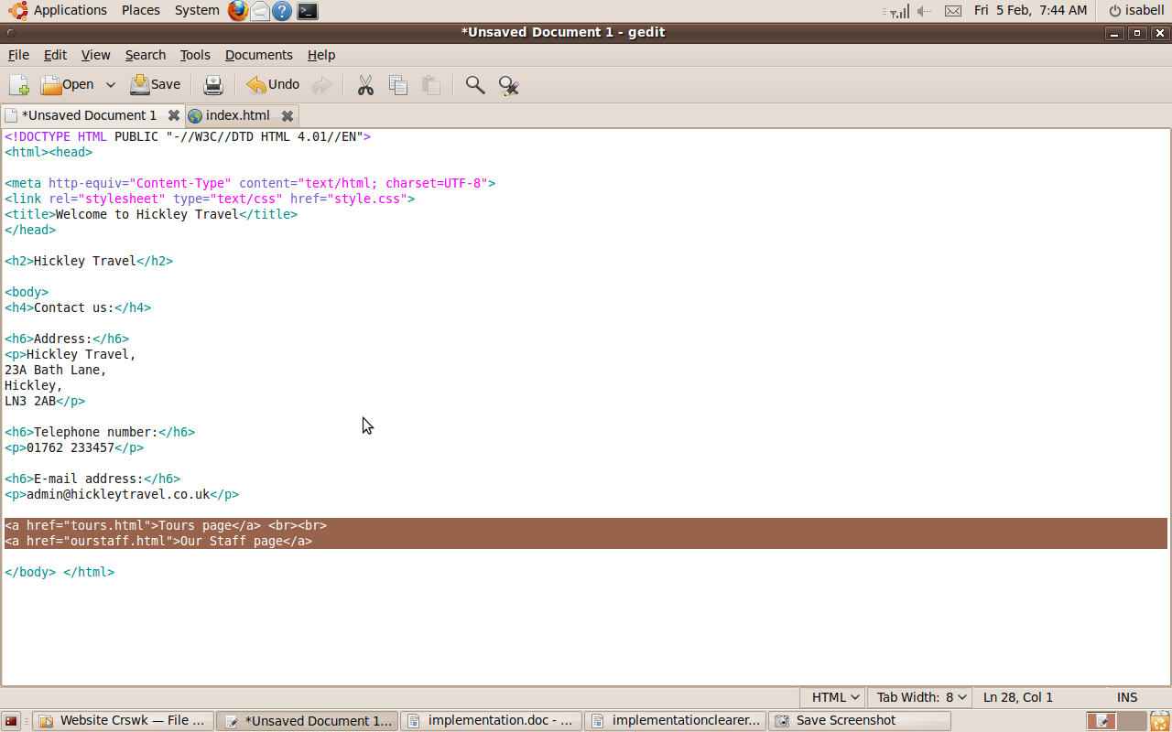

I added return links and a link to the next page to the home page.
The link code is <a href=”tours.html”> for example and then the text that displays instead of just “tours” is Tours page, defined by the next HTML tags after >, “Tours Page</a>”.

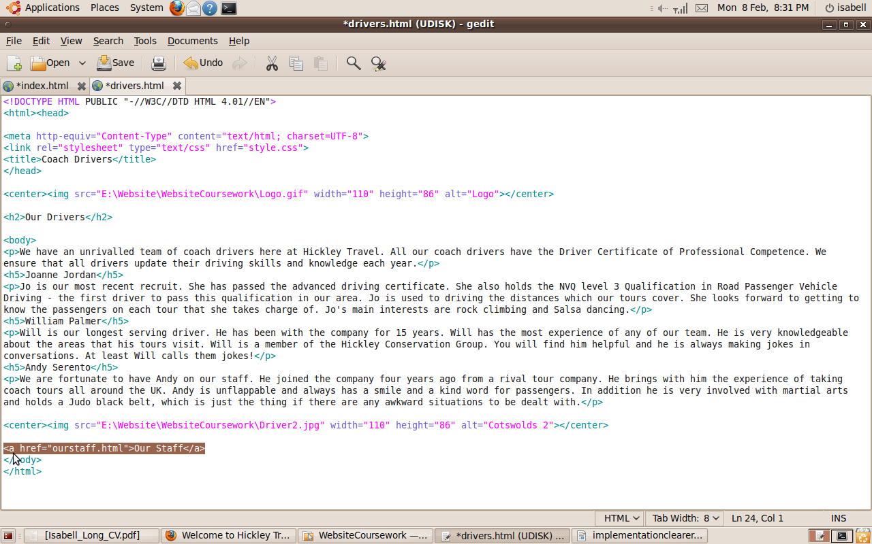
I added a return link to the other page it links back to on the Coach Drivers page and then to all the other pages.
Return links take the same format as I described above, as they too are links.

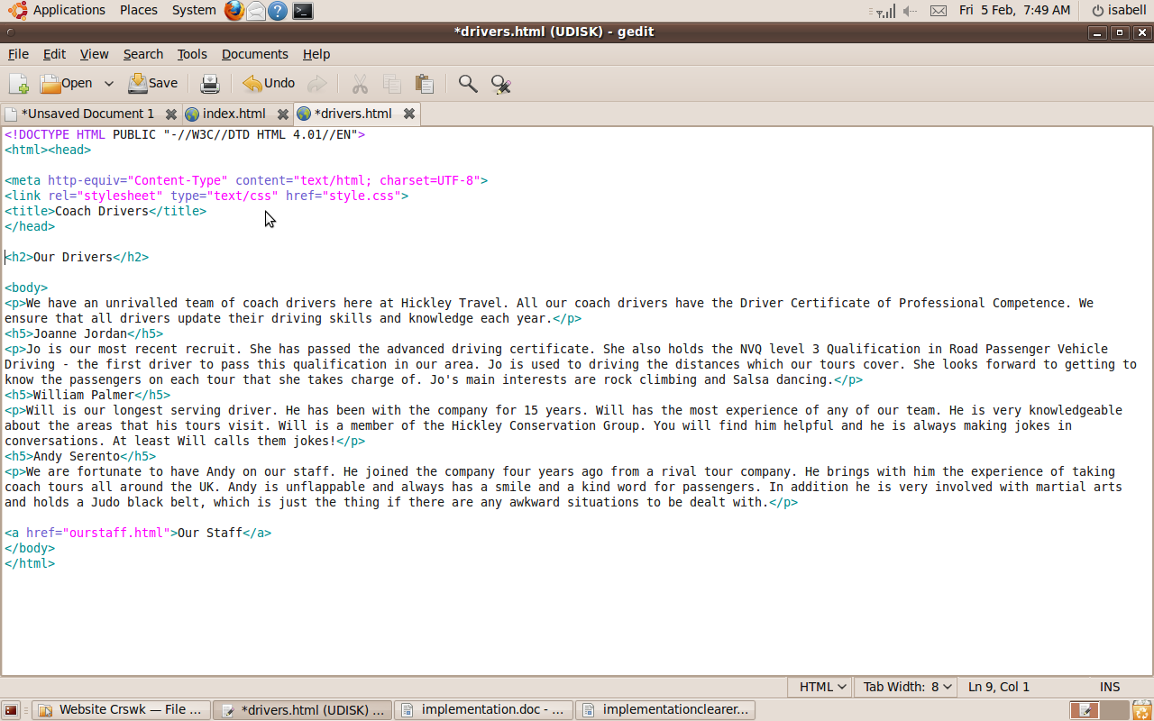

I created the Coach Drivers page and added text to it.
I copied and pasted this text from the file I was given with all the relevant text for the page.

I added an image, the logo, to the Our Staff page and all the other subsequent pages. I added the code <img src="Logo.gif" width="110" height="86" alt="Logo">. This code makes the logo height and width a certain size and specifies the file that the image is coming from, in this case Logo.gif. I then centred the logo with <center> tags.
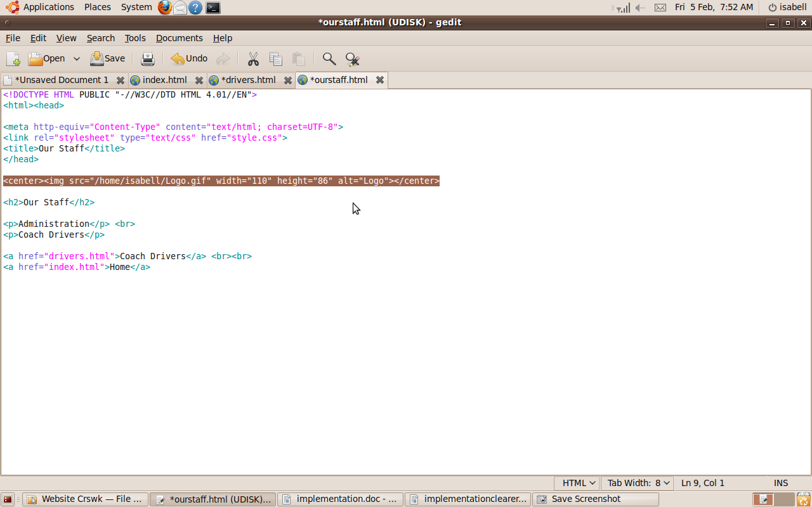

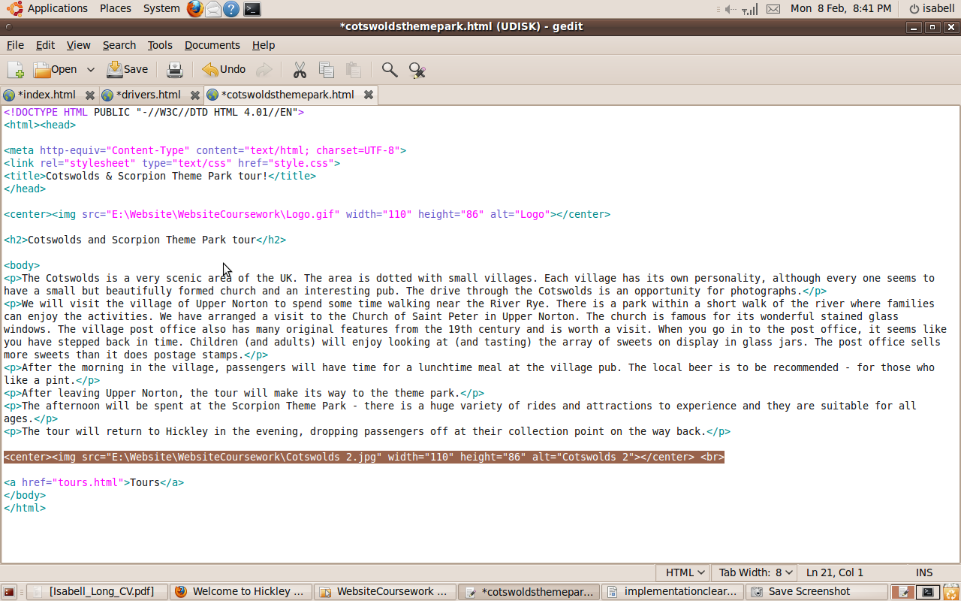

I added a link to an image, “one relevant image”, to the Cotswolds Theme Park Tour page.

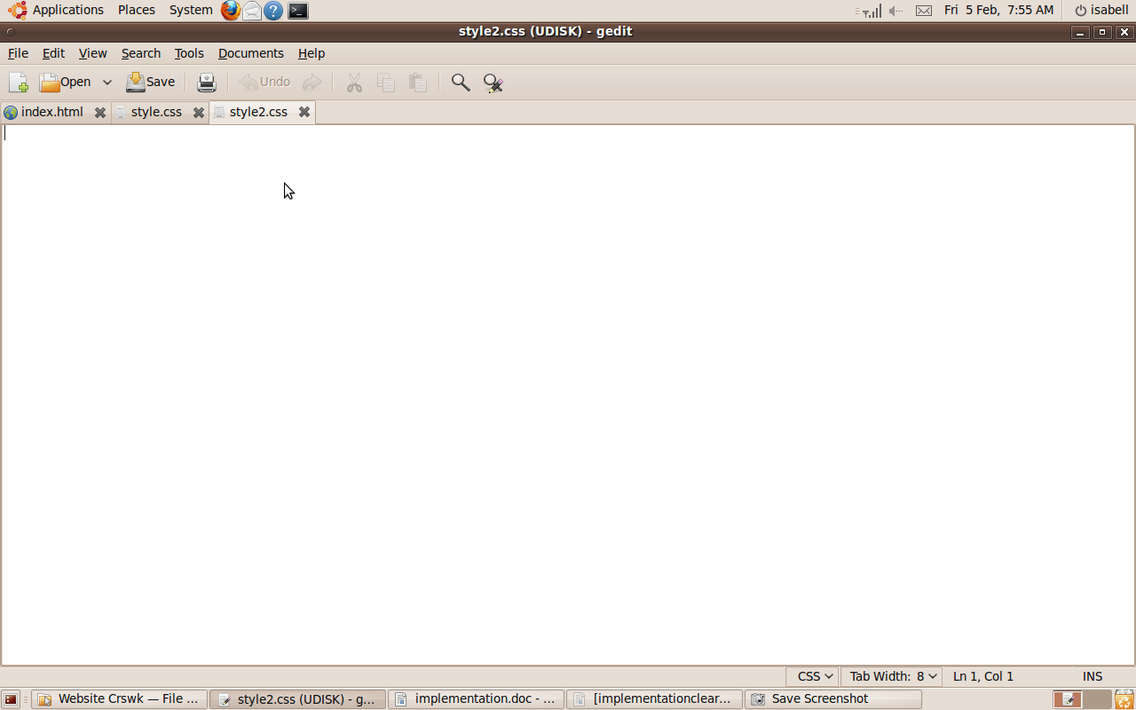
I created a CSS file by clicking the new page icon and saved it as style.css, in order to style the website.

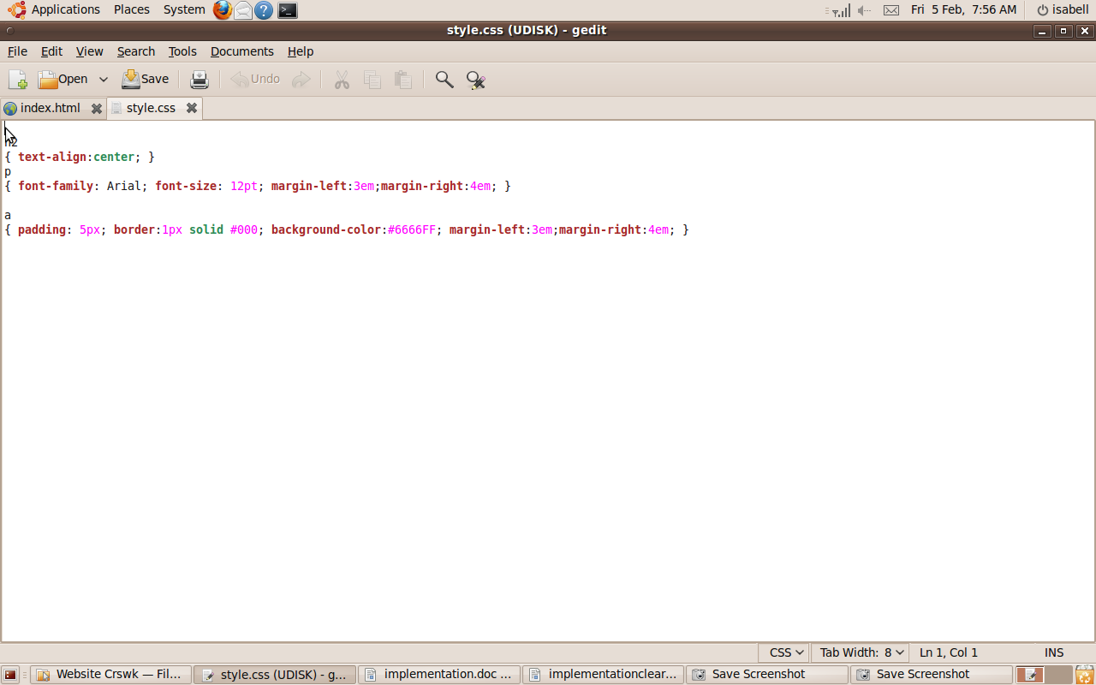
This is my current CSS stylesheet. It specifies that the headers go to the centre of the page, that the paragraphs have Arial font size 12, and it specifies the page margins. Also it displays the colours for the hyperlinks to make the background colour blue.

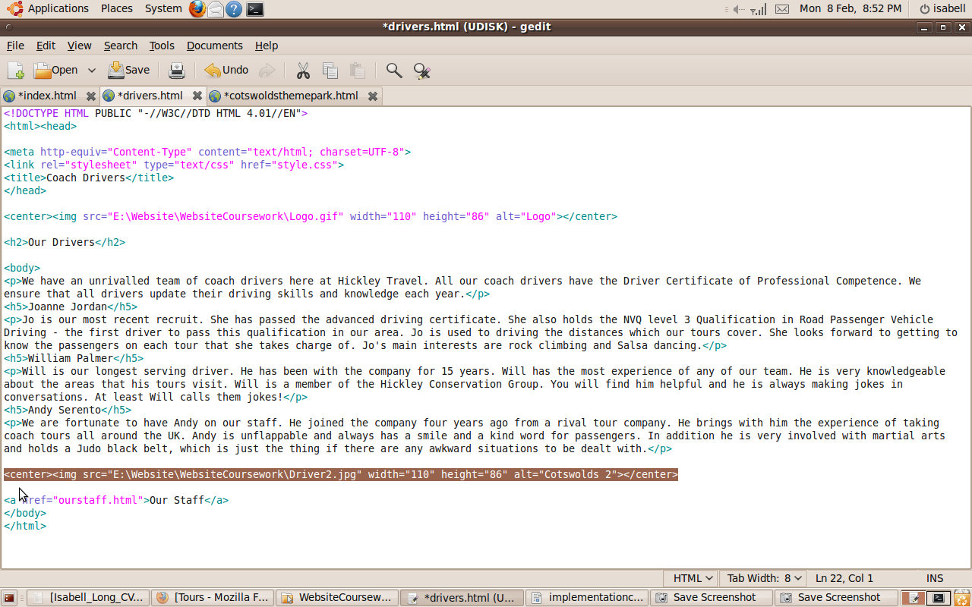
I added a link to a relevant image to the Coach Drivers page, using the same syntax as the first hyperlink.

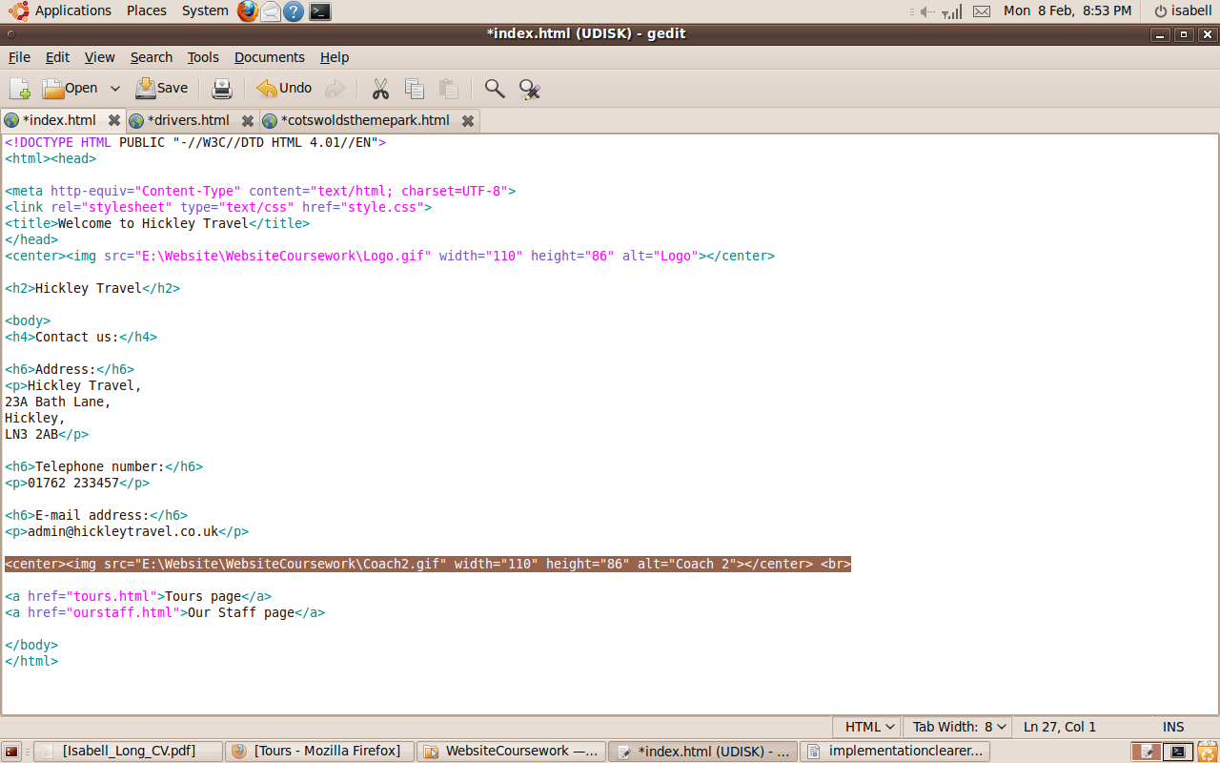
I added an image to the home page and the tours page, using the same code as I used for the other images, but just changing the filename of the image.

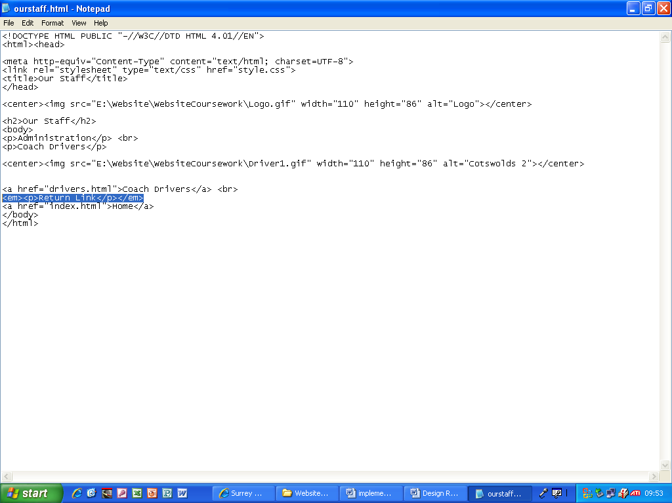
This is Notepad in Microsoft Windows. I opened the files by clicking on them in Windows Explorer
I added the words return link to above the return link.

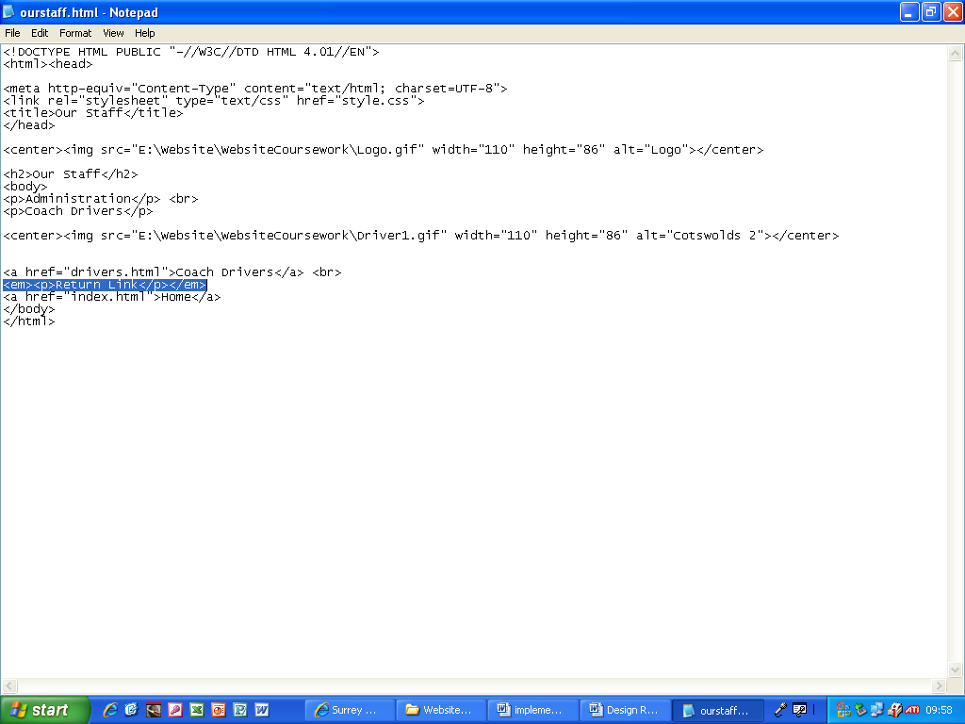
I added the words return link to above the return link to the Our Staff page.

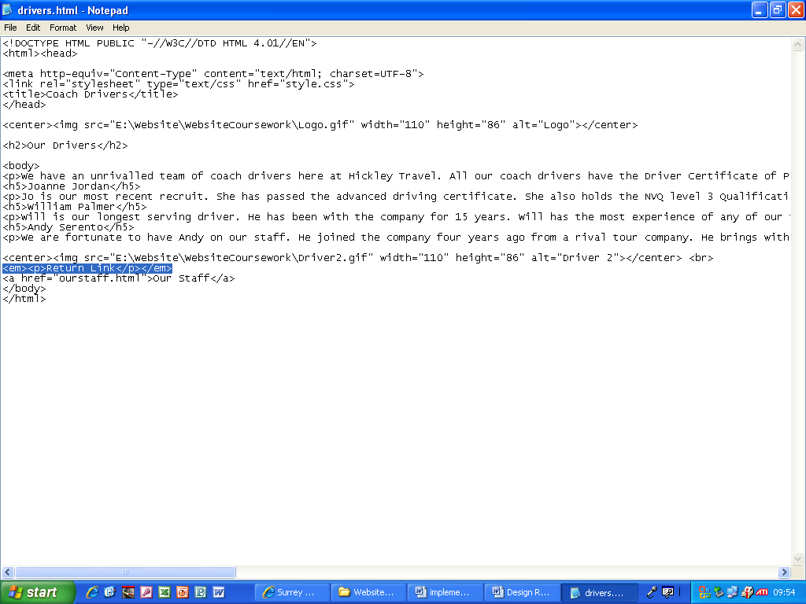
I added the words return link to above the return link to the Coach Drivers page.

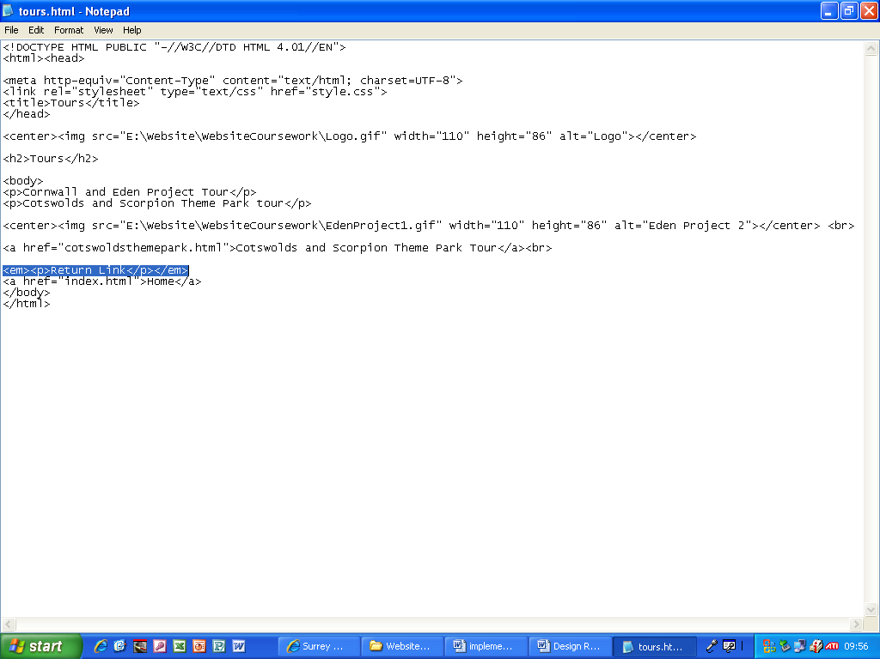
I added the words return link to above the return link to the Tours page.

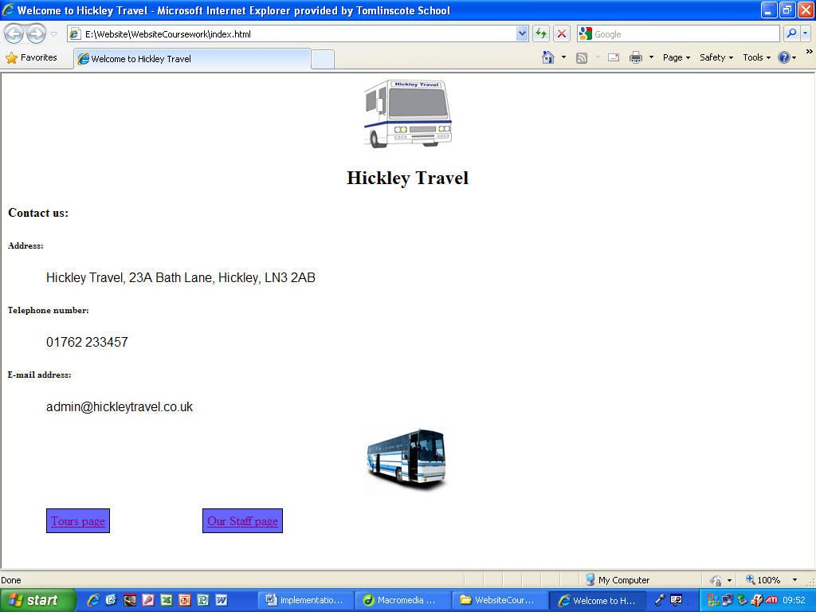
This is the finished Home page.

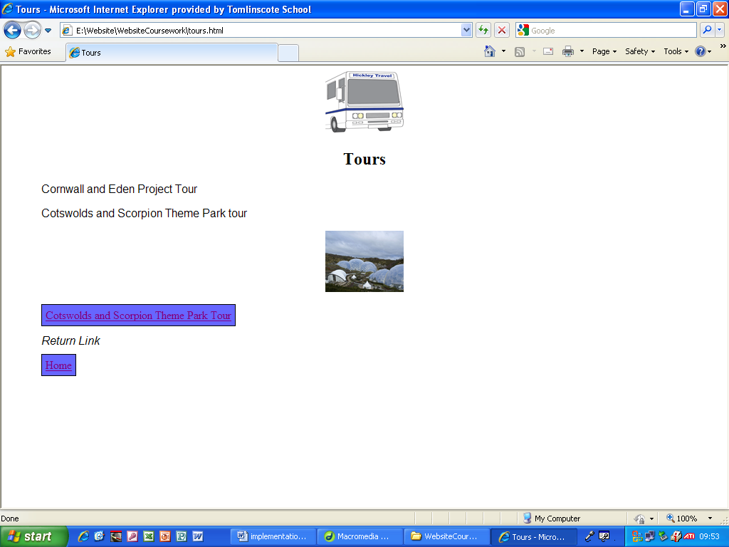
This is the finished version of the Tours page.

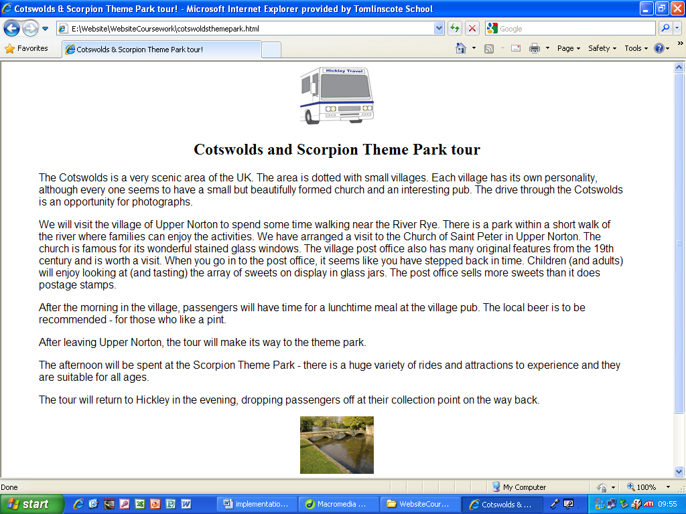
This is the finished Cotswolds theme park tour page.

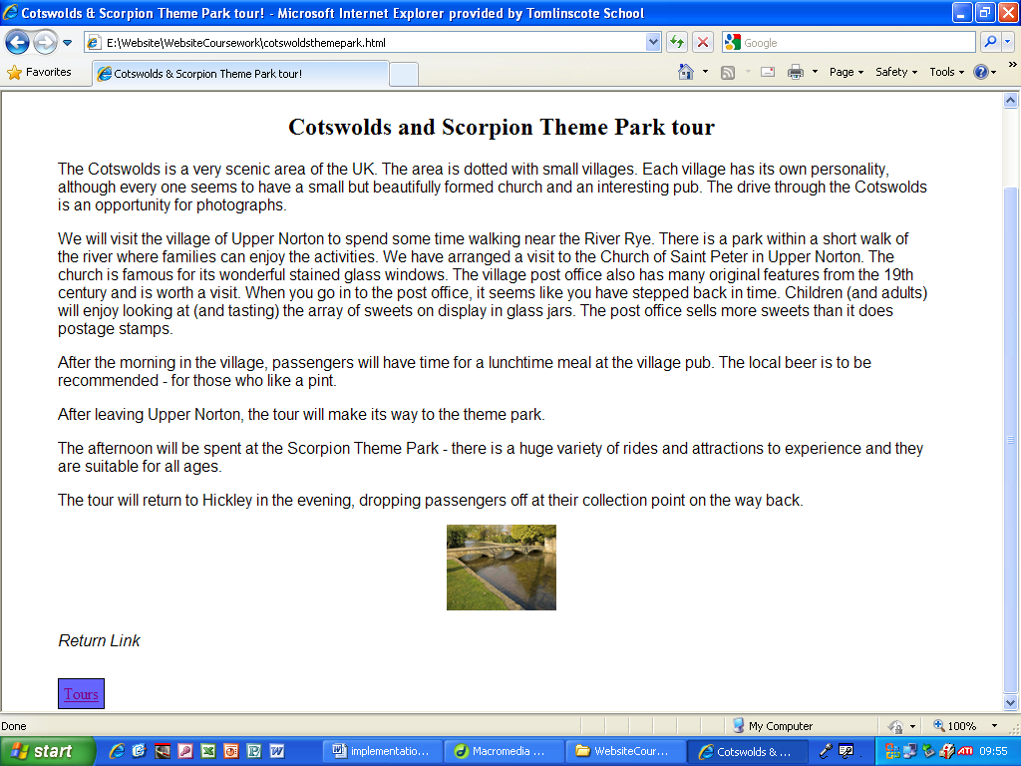
This is the rest of the finished Cotswolds and Scorpion Theme Park page.

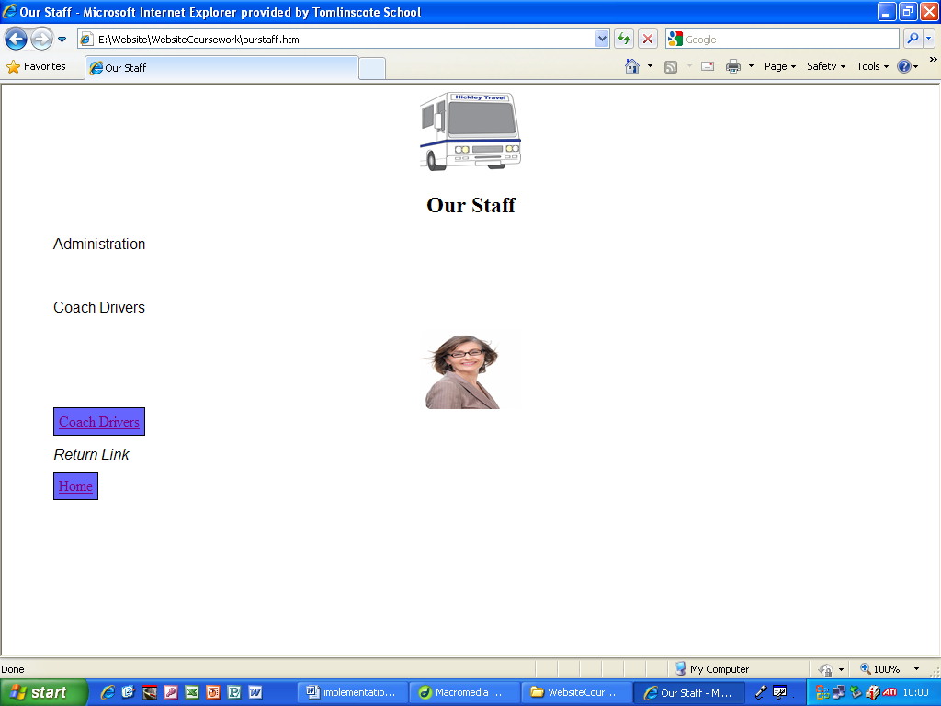
This is the finished Our Staff page.

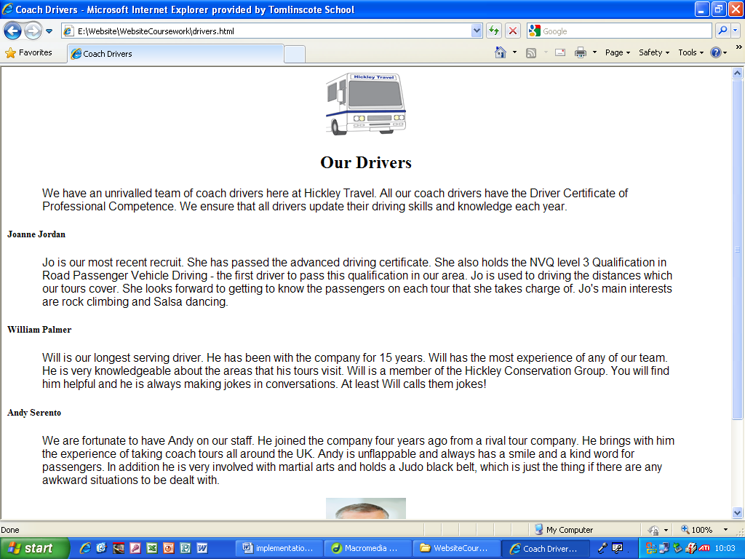
This is the finished Our Drivers page.

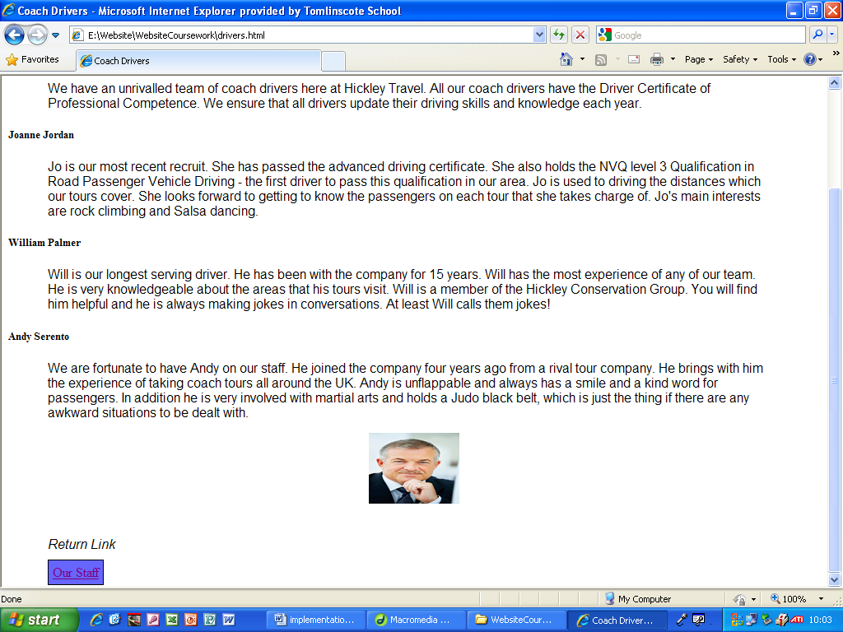
This is the rest of the finished Our Drivers page.

