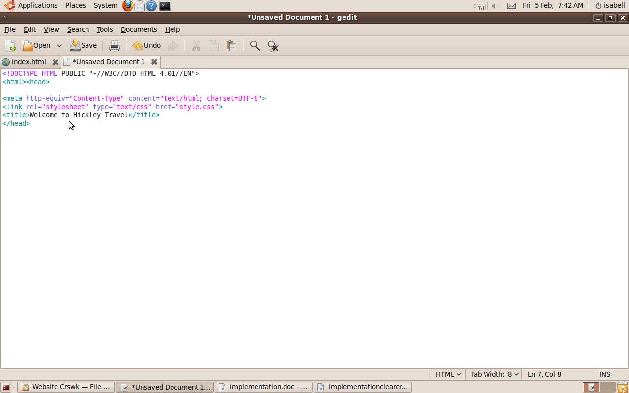

I opened Gedit, a text editor, and created index.html

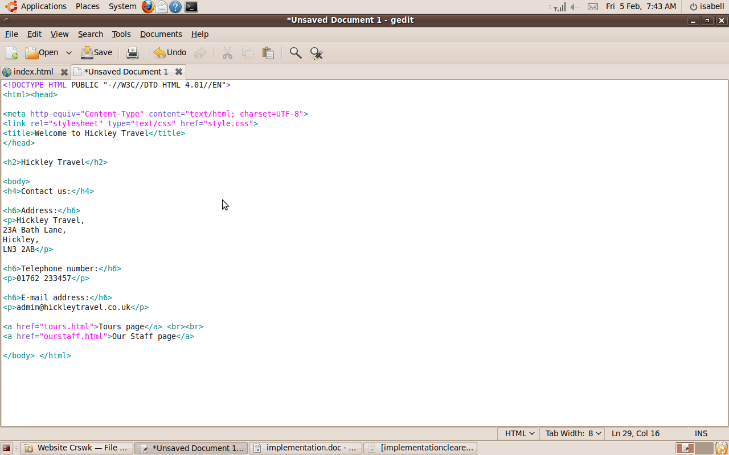

I added text (the contact details) to the home page.

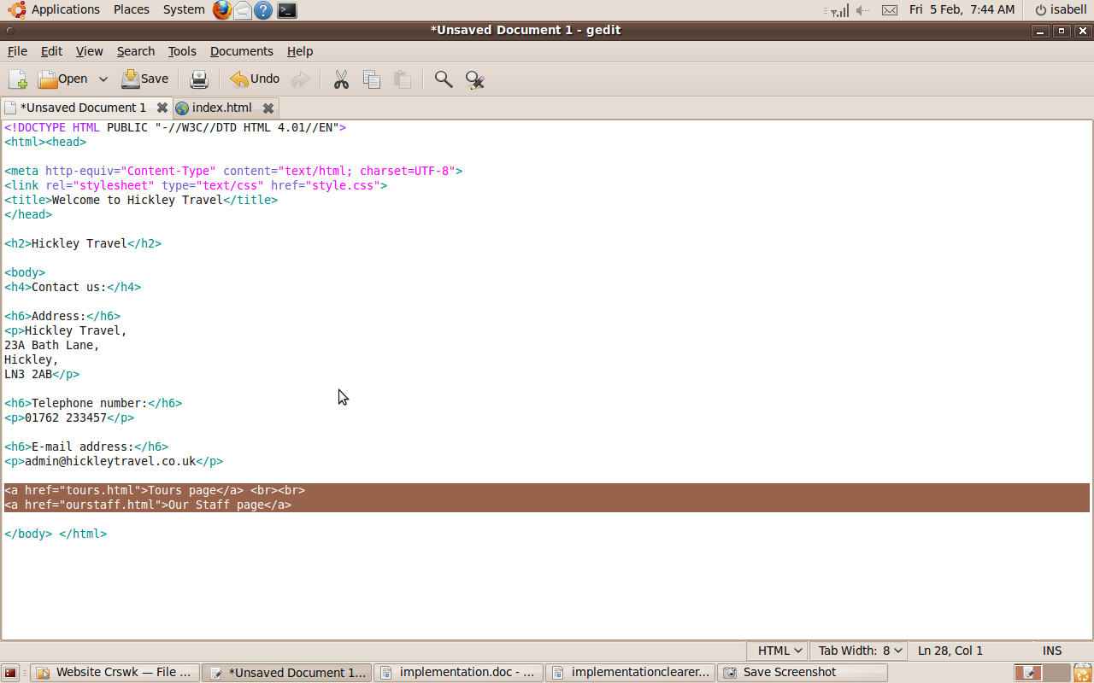

I added return links and links to the next page on every page, shown here on the home page.

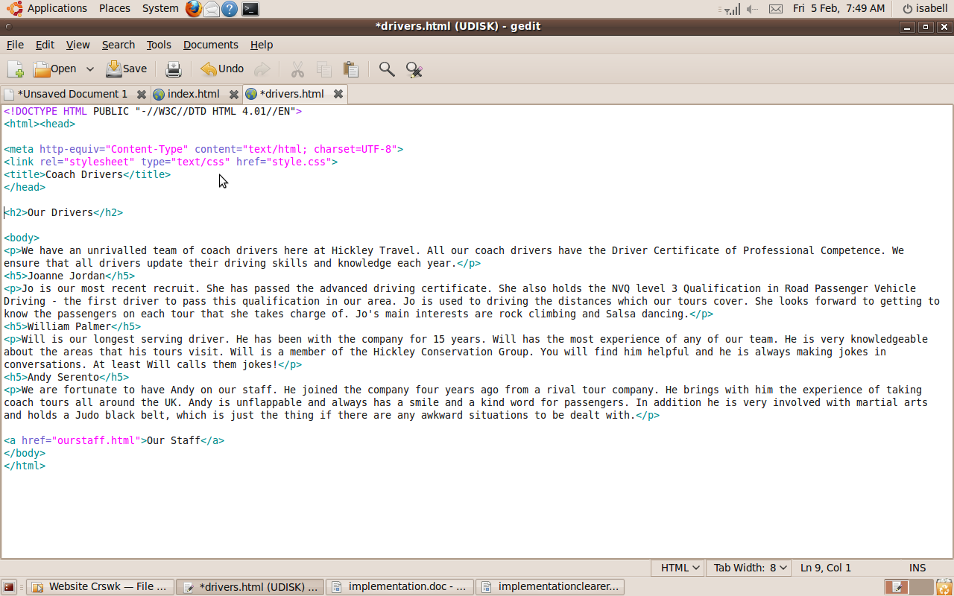
I created all the other pages and added text and links to them. This is the Coach Drivers page.

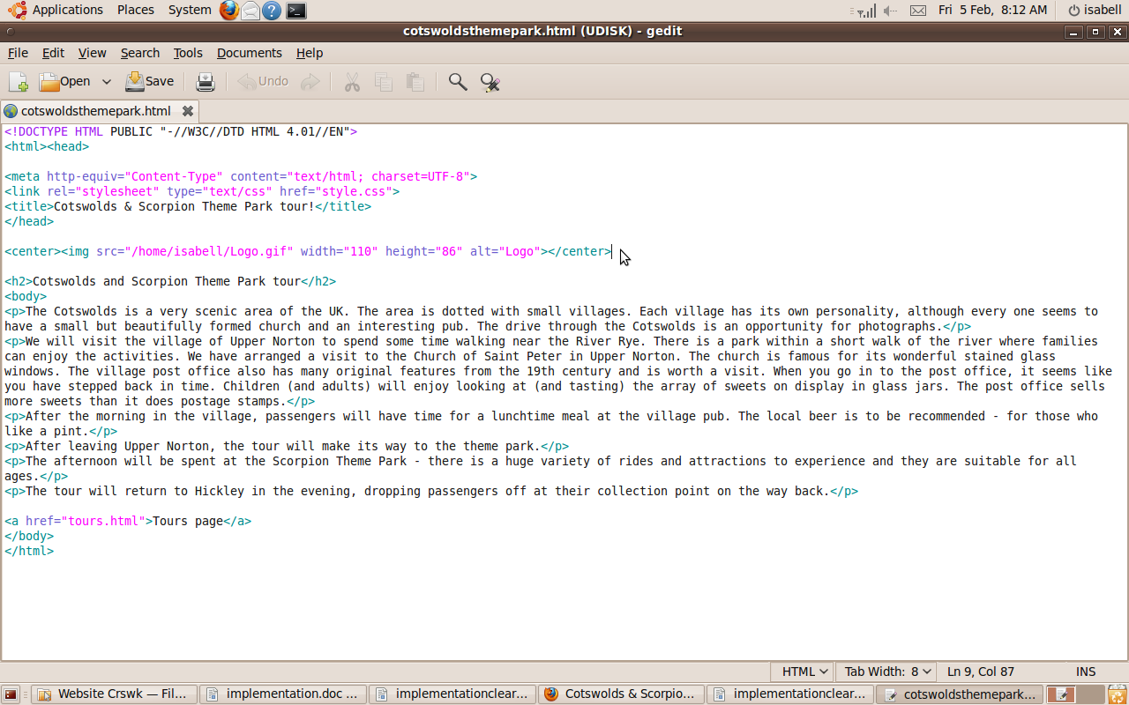

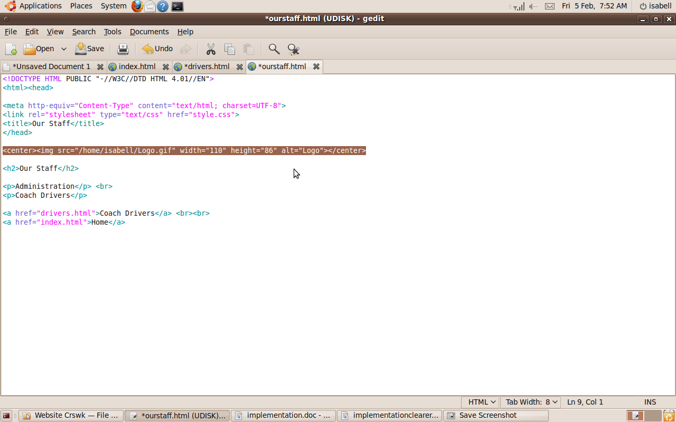

I added a link to the logo and tags to make it centred to every page. This is the Our Staff page.

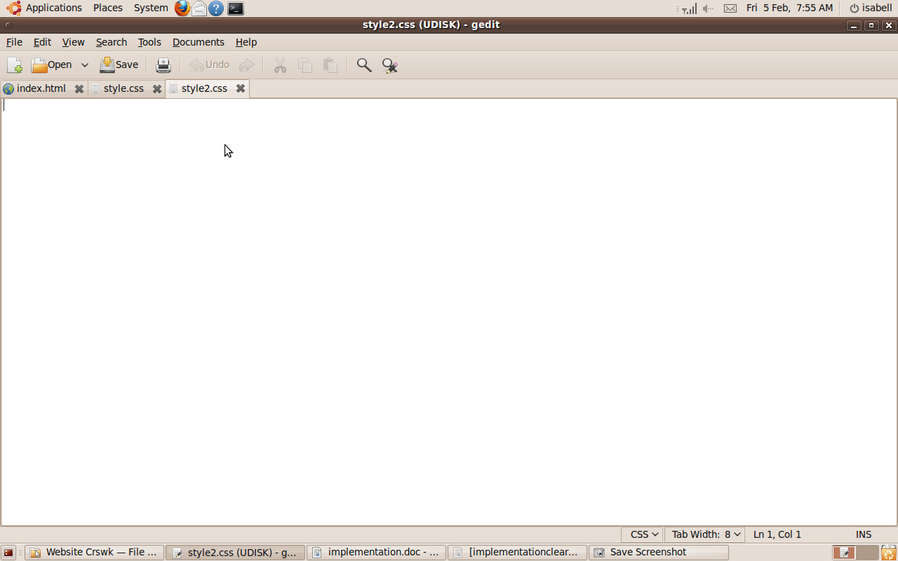

I created a CSS file in order to style the website.

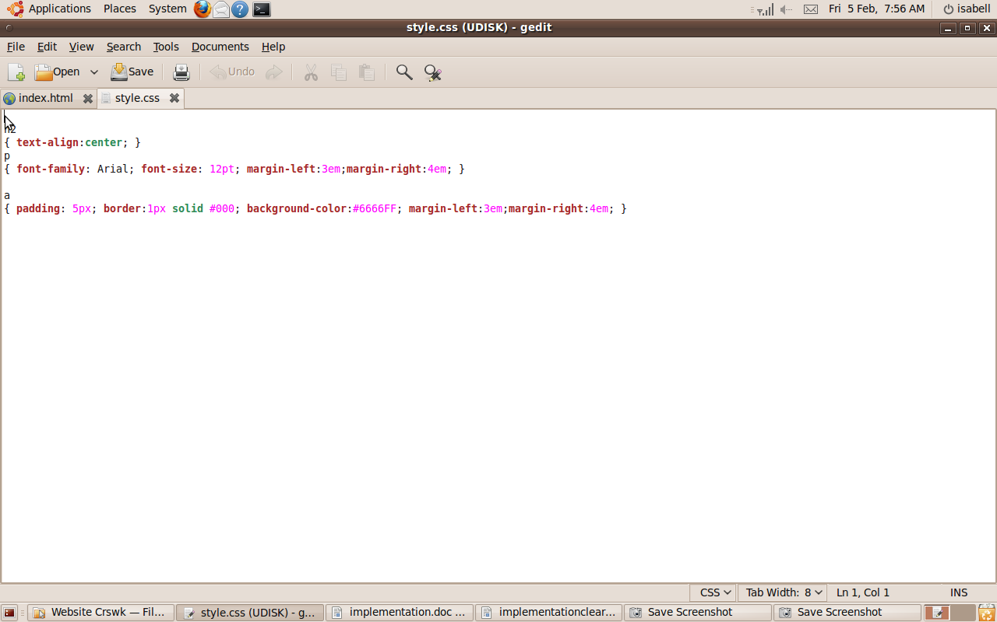
This is my current CSS stylesheet. It specifies that the headers go to the centre of the page, that the paragraphs have Arial font size 12, and it specifies the page margins.

