
forensics summative assignment
Hussein Technical University

Abdullah Istanbuli | (21110366)
Forensics - lab
Safaa Hriez

COC
Field | Details
Agency / Institution | Abdullah Istanbuli
Department | Digital Forensics / Cybersecurity
Case Number | 10203361
Investigator | Abdullah Istanbuli
Nature of Case | Digital Forensics Laboratory Assignment

Field | Information
Location Obtained | Received directly from Prof. Safaa Hriez
Date & Time Obtained | 15/11/2025
Item ID | #001 & #002
Evidence Description | Two images 1. Tom's Laptop 2. Stephanie's USB Flash Drive
Vendor / Model | Virtual Images

Date & Time | Relinquished By | Received By | Purpose / Disposition
15/11/2025 | Prof. Safaa Hriez | Abdullah Istanbuli | Evidence handover for analysis; initial images received.
15/11/2025 – 26/01/2026 | Abdullah Istanbuli | HTU Digital Lab | Verification of MD5/SHA-1 hashes and Bit-stream imaging.
26/01/2026 | Abdullah Istanbuli | Secure Storage | Analysis complete; final forensic report submitted.

Acknowledgement
Note on Visual Documentation: Please note that while personal identifiers were unintentionally absent from the screenshots, I testify that all images within this report were captured directly from my personal laptop and represent my original, individual work for this assignment.

Executive summary
In both the USB and the PC we find the embezzlement evidence indicating both there guilt in the USB we found evidence of tamper or hiding evidence which shows intent.
In addition to that in the PC we found what looks like a kidnap victim (a photo of a women written the next victim on it) which is evidence of another crime that should definitely be reported

USB forensics

Hash comparison
To make sure everything is correct and right we created an image of the original file image of the USB to make sure in FTK imager that the files match hashes and no edit has been made for them

File system and environment
The first step of this investigation after matching the hashes is looking at the structure of the USB
When opening the VHD in FTK one of the partitions seem to be either broken or manipulated with
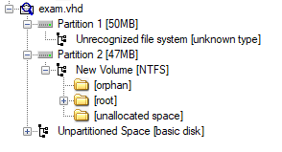
After inspection in HxD we can notice that the VBR section is nulled
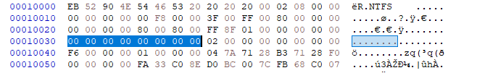
After putting the right values in this part on an image copy we can see the right content of the partitions
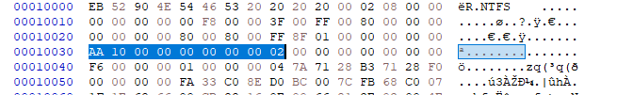
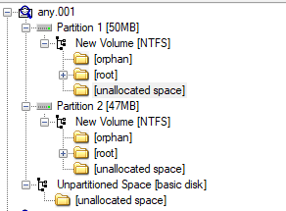
Now after finding all the files we need to inspect the title to not violate the suspect’s rights
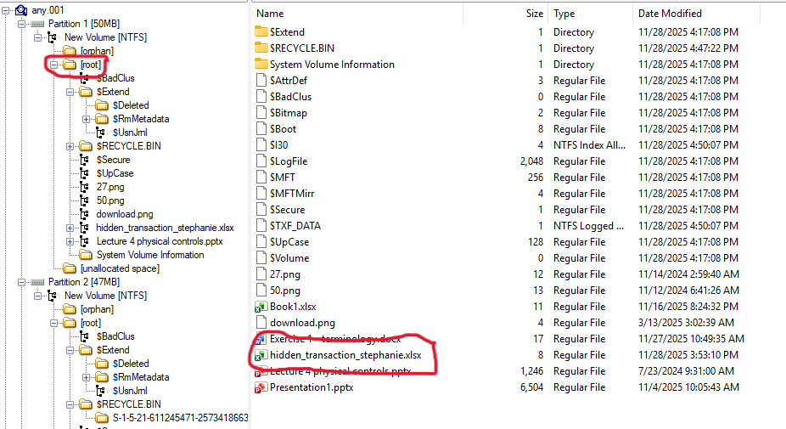
After opening the root folder we can clearly notice that there is an excel sheet named “hidden_transaction_stephanie” which is very suspicious name of a file especially after finding it in the broken partition which gives us a legal reason to look through the files
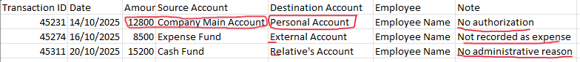
In this excel sheet we can clearly see 3 transactions with violations such as no authorization to a payment to personal account and cash payment to “relative’s account” without administrative reason

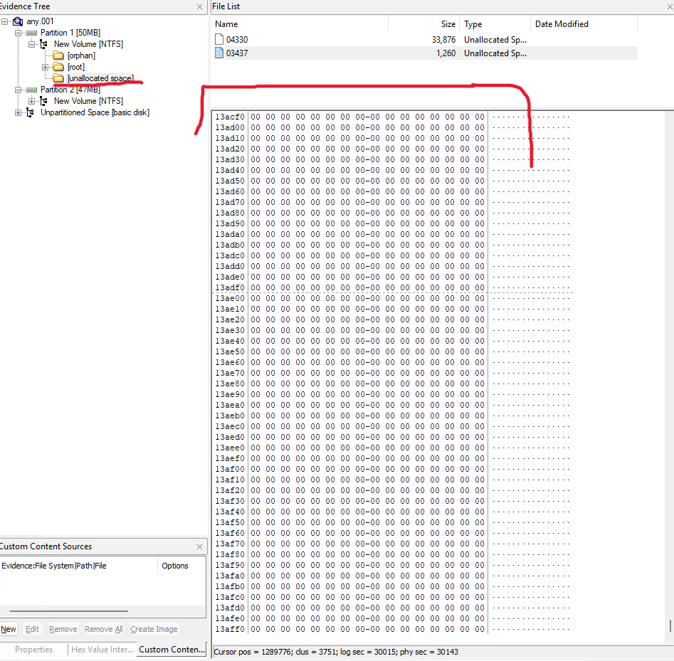
Looking at the first patient, we notice that there is unallocated space as part of our investigation we did bit by bit analysis making sure there isn’t any hidden data there

Partition 1 files inspection
Now we start searching in each file if it’s the right extension and if that extension trailer matches the trailer of the files to make sure there isn’t two files attached together

27.png
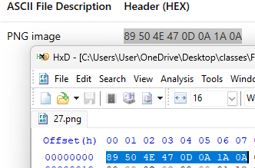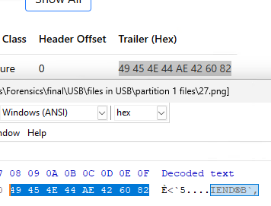

50.png
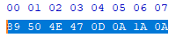
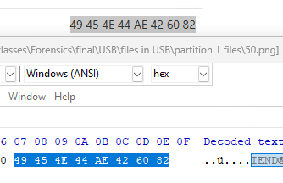

Download.png
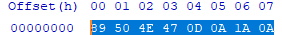

Book1.xlsx
For an office file i found a trick since we cant find a footer to make sure that there isn’t other files appended in this file is to turn a copy of the file into .zip and seeing if there is more then the usual files that comes inside an office file
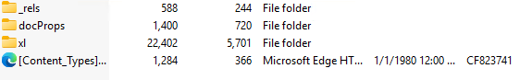
Those are the normal files inside an office file so this appear to be empty of any other files attached to the footer of it

Hidden_transation_stephanie.xlsx
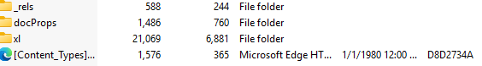
Just to be in the safe side there isn’t any appended files here either

Terminology.docx
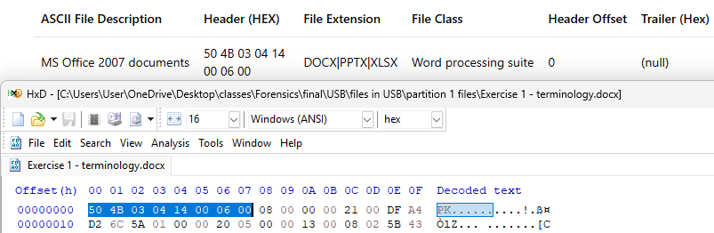
Now we will use the same method we used in the last 2 files here
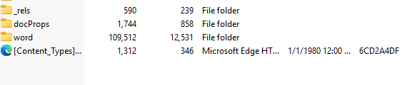
Everything seems normal

Presentation1.pptx
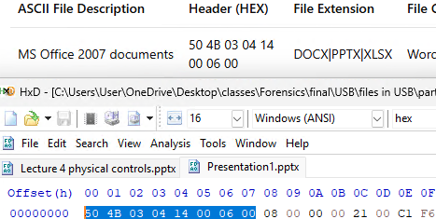
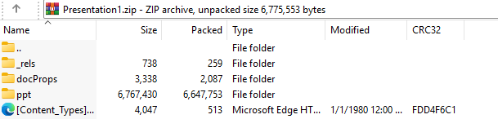

Lecture 4 physical controls.pptx
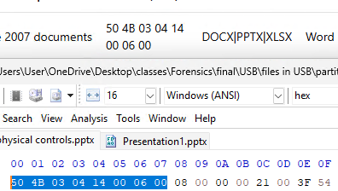
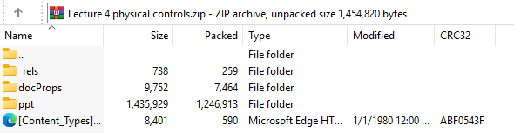

Conclusion
After analyzing all the files in this partition we can come to the conclusion that the only relevant file here is hidden_transaction_stephanie that is in the file system and environment section I talked about

Partition 2 files inspection
Unallocated & Orphan Space: Performed a scan of the unallocated space and orphan folders across the volume to identify data fragments not indexed by the Master File Table (MFT).

Lecture 1.pptx
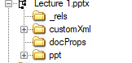
As we can see there isn’t any hiddin data in this lecture 1.pptx file or embedded file in it

$RECYCLE.BIN
I have investigated this folder and the user SID folder I have identified the desktop .ini configuration file but there no active recovery files $I or $R in the folders

$extend/deleted
NTFS Meta-Artifact Inspection: Analyzed the $Extend\$Deleted system folder. Hex inspection of entries (specifically File 130 and its slack) confirmed these areas contained null (00) bytes, indicating no recoverable residue of recently deleted indexing data.

Tom laptop

Hash comparison
The first step is always make sure the integrity of the file is not compromised so we are going to compare the image we have hash values with the original image taken
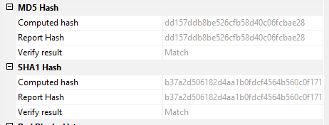

$recycle.bin
Going into this folder it contains 3 folder named:
- S-1-5-18 [empty]
- S-1-5-21-2109228371-2460004946-564488000-500 [empty]
- S-1-5-21-2438091095-2145614545-1550777442-1000
Going through the third one we find some interesting images
There we find 4 images 2 of them we can open and another two we cant
Note: After analyzing those findings I remembered that there is $R is the data of files deleted and $I the meta data of those files but that was after I wrote my analysis

Inspecting the two images we can open

$R7VROMS.jpg
Looking at this image we identify a person in this photo

When inspecting the hex data we find that the image extension is normal
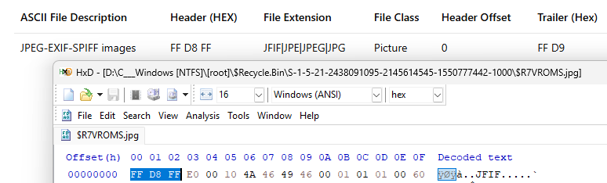
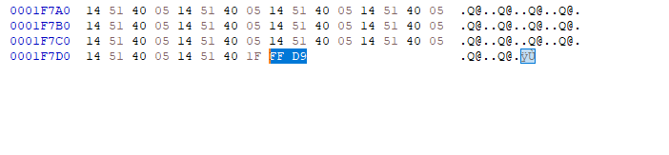
And the trailer is as it should be and there isn’t another trailer in the hex so we can tell there isn’t another file

$RPDHJUO.jpg

The next photo we find is the same one form before but with the text “next kidnapped person” which is highly suspicious lets see if there is anything embedded here
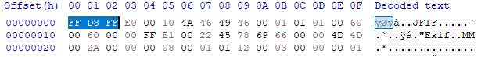
And the we find nothing the same as the last one those images maybe suspicious but nothing embedded in them lets take a look at the more suspicious images that cant be opened

$IPDHJUO.jpg
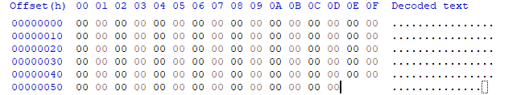
Opening this image in the hex editor reveals nothing since all the data is empty the entire file is nothing but it reavles that there was a file here that got wipped completely which is highly suspicious

$I7VROMS.jpg
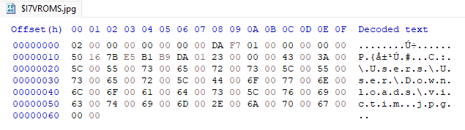
Looking at this file I realize that its meta data file for the image of the victim above the original name of the photo is: victim.jpg as we can see in the last line with the path it used to be C:\Users\User\Downloads\victim.jpg

downlaods
in the downloads we find multiple photos but they seem to be random photos form browsers but those one’s might be related to the kindapping


Windows artifacts

Browsing history
we can find all the files history in their respective locations and we can see a lot of data here in the files
If we sort them based on duration we can clearly see the top two are just emails but if we take a look at the two after they are forensics links and pages where this suspect (or criminal based on the kidnapping evidence) has been learning about forensics maybe they tried to hide something
Additionally we can see clearly that some of the normal images we found in the download file are downloaded form google like we suspected by seeing the url of the searched items for example we have “google.com/search?q=comfortable+chairs” and iPhone
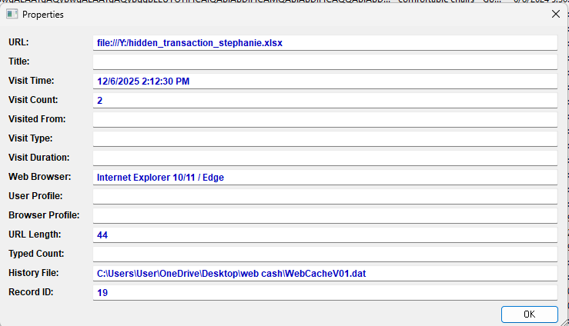
And there is another hit so not only this person is envolved in the kidnapping of the person above he is also involved in the embezzlement but the only thing left to prove both crimes on this person is to prove he is the only one who had access to this computer additionally we can see the drive latter in the url: file://y:/hidden_transations_stephanie which leads us to believe that the user either had another hard drive or the usb was attached to this pc

Jump list
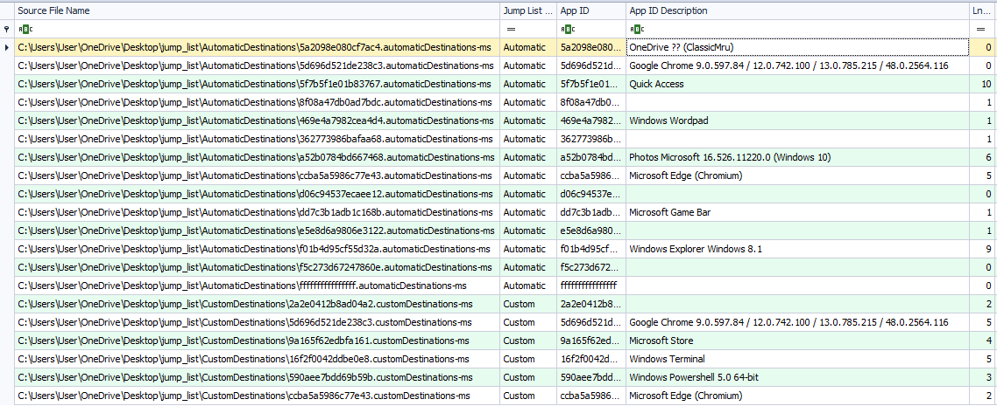
Here we find both automatic and custom jump list but nothing useful really exept this where we can see in the quick access that hidden transations file has been opened and some data about it and the victim unedited photo here:
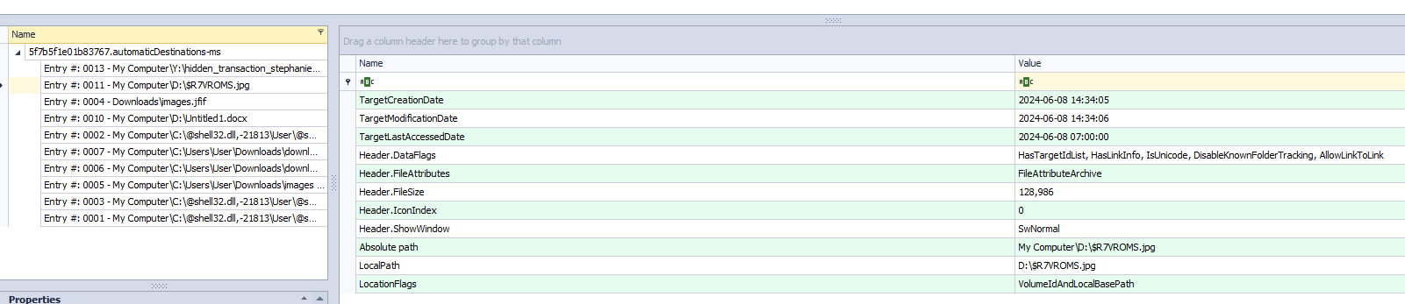

LECmd
Using LECmd on the recent LNKs files we can find those information about the victim picture
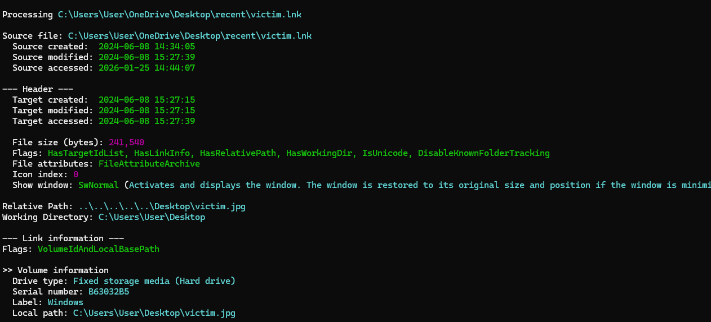
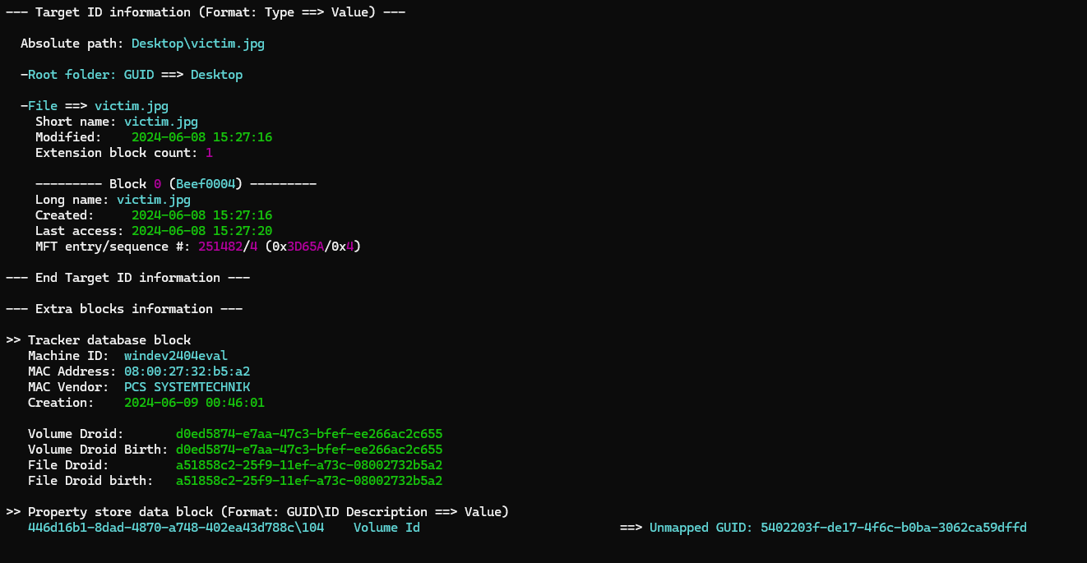
And we can find this maybe it’s the same USB
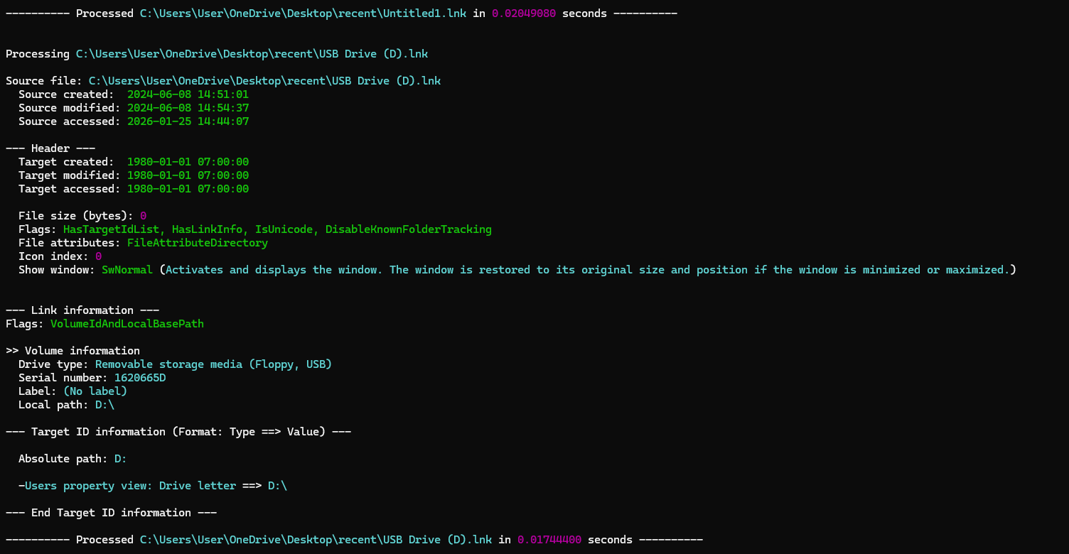

And this about the hidden transaction sheet
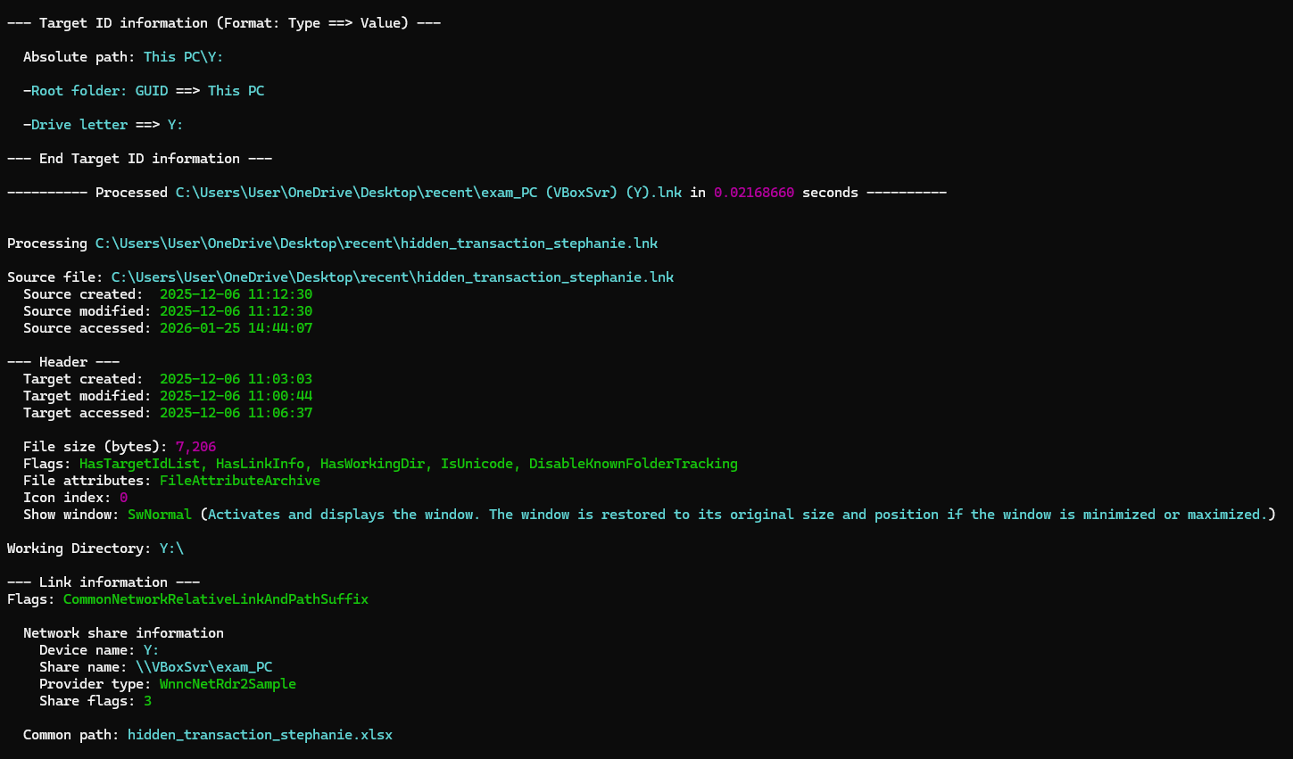

And those are the cages picture information 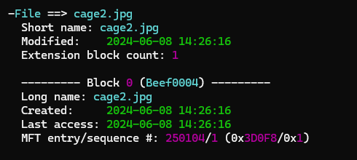

Prefetch files
Looking at the prefetch file of the nothing seems out of place the only theird party apps are chrome
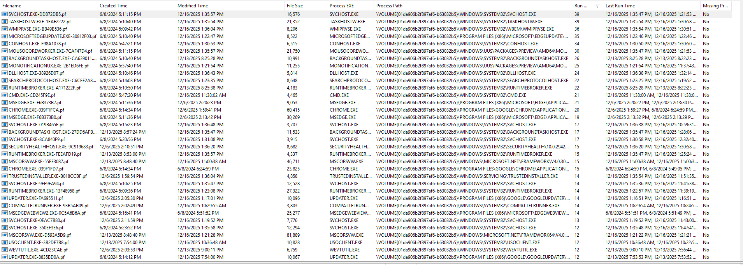

Tools used:
Tool: | Browsing historyview | Hashmy files | Jump list explorer | LECmd | winprefetchview | FTK imager | HxD editor
Usage: | To look at the browser history and see all the websites suspect has visited | To make sure the images integrity is preserved | To look at recent files used | To get information about files(gave us the id for the usb that downloaded transactions file) | Lets us see the services used in the computer | Take copies of the devices images and take a look at their structure | Look at the hex code of file, drives and let us fix broken partition

