INX FUTURE INC.

*An Analytical report that shares insights on Employee performance.*

***This report is prepared by Stephin Sebastian for INX Future Inc.***

***Business Objectives :***

1. ***To identify causes of Employee Performance Issues. This will help the company to mitigate challenges faced by well performing employees.***
2. ***To identify clear indicators of non-performing employees for their development and other consequences if required.***

***Data Pre-processing :-***

***We have cleaned the data by dropping the marital status column since it is not relevant. We will consider only Sales, Development and R&D department for our analysis since other departments are not relevant to escalations and have a much smaller population. Null values or missing values haven’t seen in the data.***

***Strategy Framework :***

1. ***Identifying areas of investigation basis discussion with INX Future team.***
2. ***Analysis on areas of investigation.***
3. ***Insights Review***
4. ***Recommendation***

***Areas of Investigation :-***

1. ***Management Issues***
2. ***Service Delivery Quality***
3. ***Travel***
4. ***Number of working hours***
5. ***Employee satisfaction***
6. ***Employee education***
7. ***Learning and development***
8. ***Rewards and Recognition***
9. ***Employee relationship***

***Sales Team Analysis - Team Distribution***

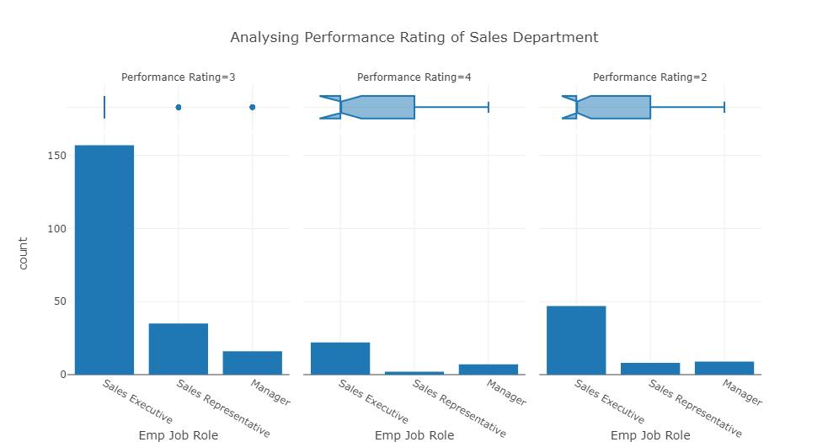

***It is observed that Sales Executive constitute maximum of the Sales team. Therefore, issues related to sales executives could have made a major impact on the overall Sales department.***

***Management Issues :-***

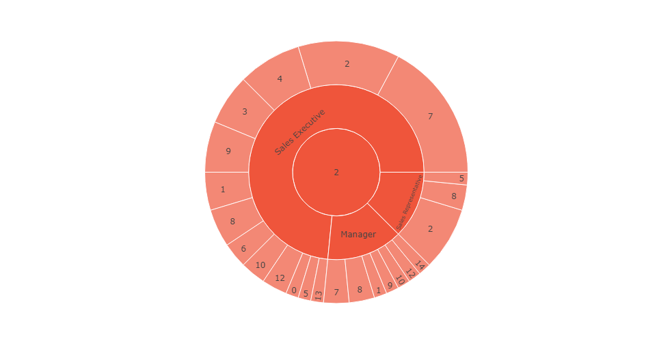

***It is observed that :***

* ***47 Sales Executive showing underlying performance have 2 & 7 years of experience with current manager***
* ***8 Sales Representative showing underlying performance have 2 years of experience with current manager***
* ***9 Sales Manager showing underlying performance have 7 years of experience with current manager.***

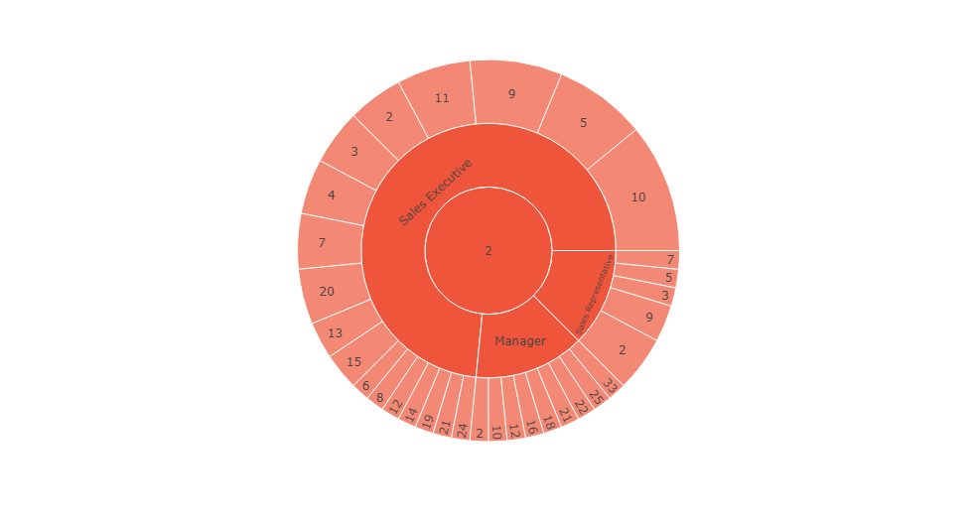

***47 Sales Executive showing underlying performance have between 2-24 years of experience at current company***

***8 Sales Representative showing underlying performance have 2 - 7 years of experience at current company***

***9 Sales Manager showing underlying performance have between 10 - 33 years of experience at current company***

***Service Delivery Quality - No need to check as Sales Team doesn't deliver any service.***

***Issues faced due to Travel (for sales team)***

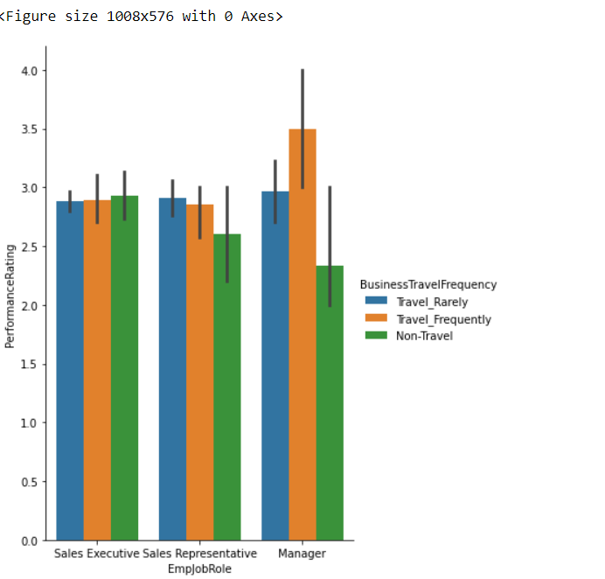

***It is observed that maximum employees of Sales department travel frequently in spite of having an underlying performance rating.***

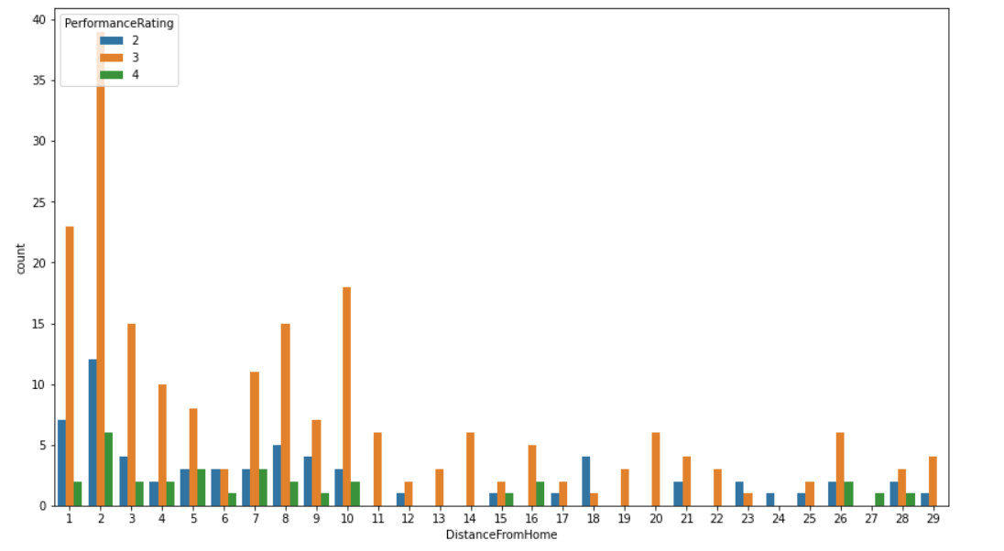

***It is observed that maximum employees of Sales department showing underlying performance stay nearby to office.***

***Number of working hours:-***

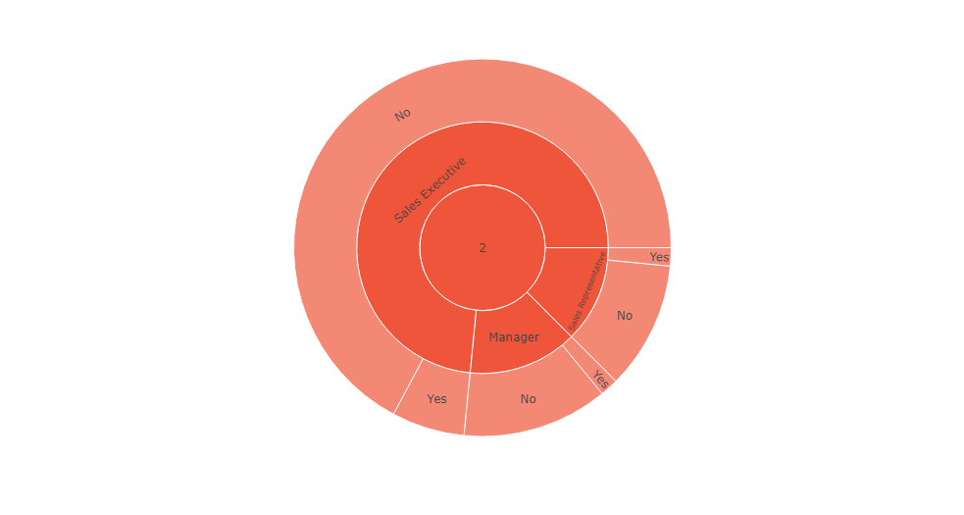

***It is observed that Among 64 under-performing employees of Sales Dept. 43 sales executives, 8 sales manager and 7 sales representatives DO NOT DO OVERTIME.***

***Employee Satisfaction :***

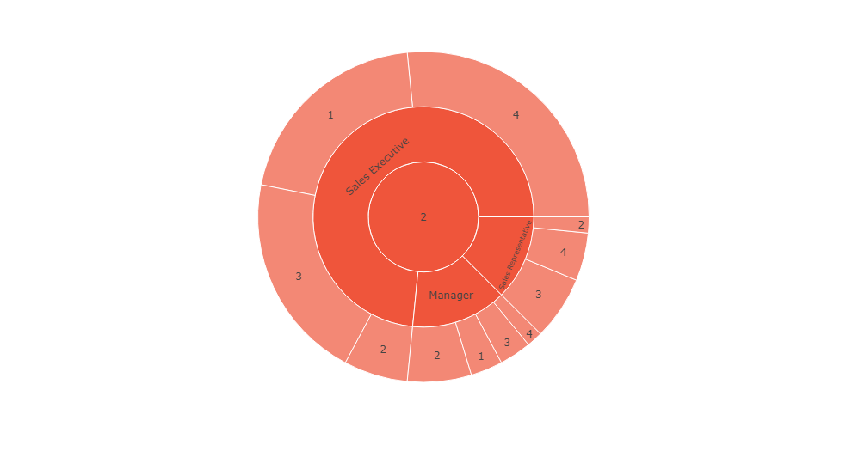

***13 Sales Executive showing underlying performance doesn't have job satisfaction.***

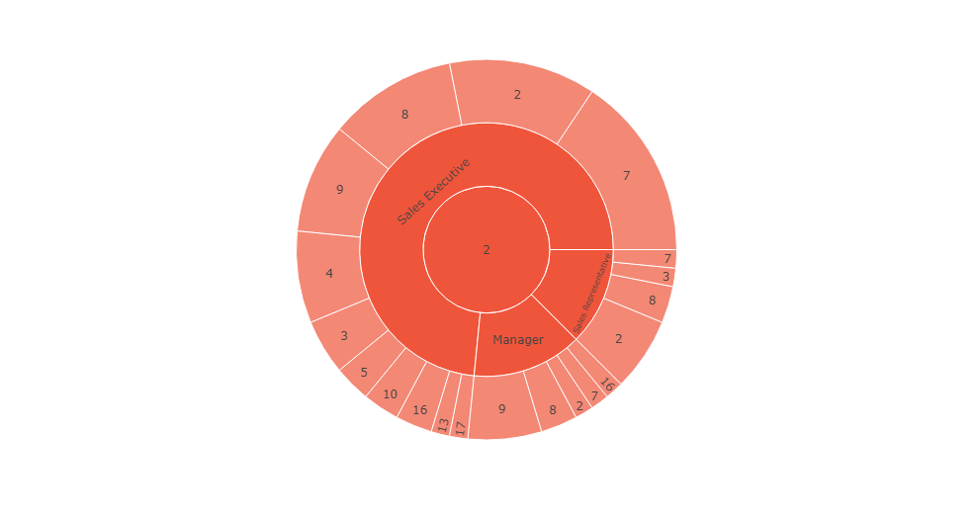

***47 underperforming employees from Sales Executive have 7-9 years experience in current role***

***8 underperforming employees from Sales Representative have 8 years experience in current role***

***9 underperforming employees from Sales Manager have 9 years experience in current role***

***Employee Education : -***

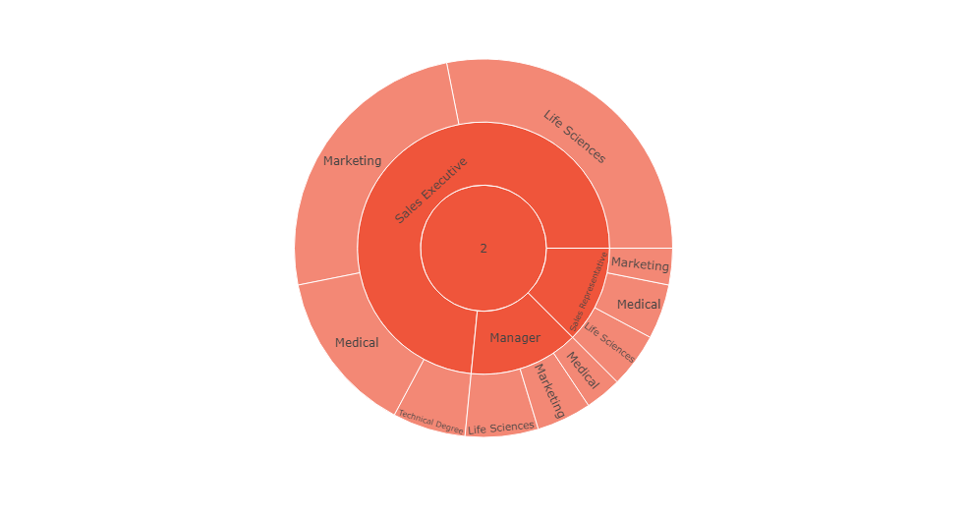

***Out of 47 sales executives, 27 sales executive have education background other than marketing***

***Out of 8 sales representatives, 6 sales representatives have education background other than marketing***

***Out of 9 sales managers, 6 sales managers have education background other than marketing.***

***Learning and Development :-***

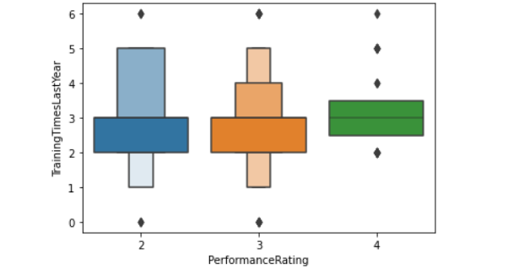

***Employees who attended more trainings have higher performance.***

***Rewards and Recognition :-***

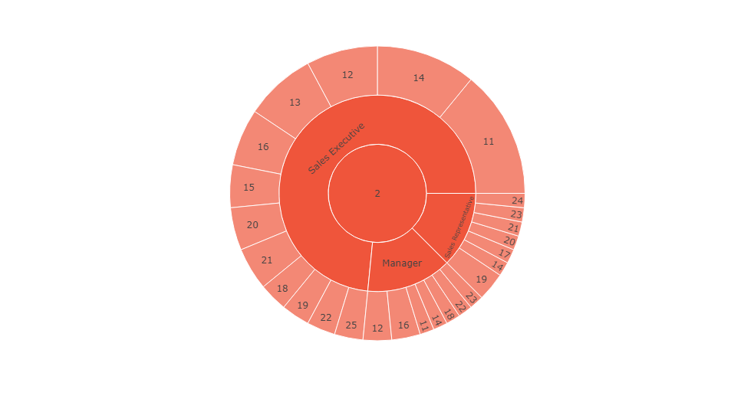

***Maximum Sales Executive showing underlying performance lies between 11-16% percent salary hike***

***Maximum Sales Representative showing underlying performance lies between 11-25% percent salary hike***

***Maximum Sales Manager showing underlying performance lies between 12-23% percent salary hike***

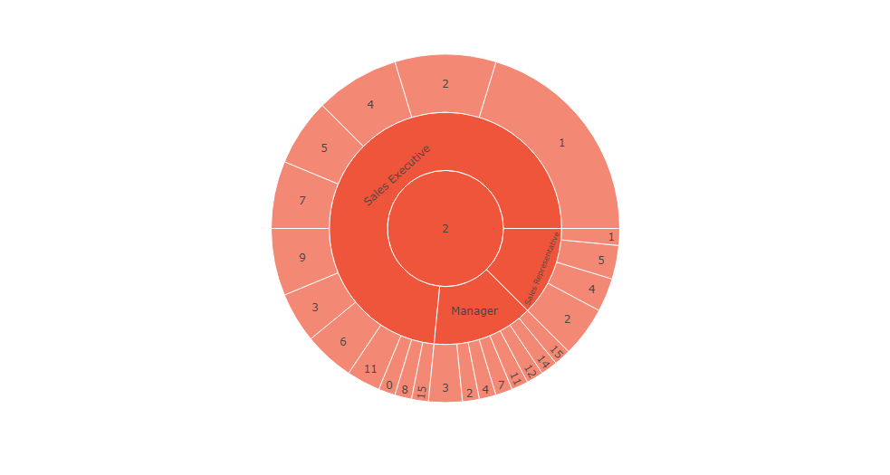

***Maximum Sales Executive showing underlying performance lies between 0-1 year since last promotion***

***Maximum Sales Representative showing underlying performance lies between 2-5 years since last promotion***

***Maximum Sales Manager showing underlying performance lies between 7-15 years since last promotion.***

***Employee Relationship Satisfaction:-***

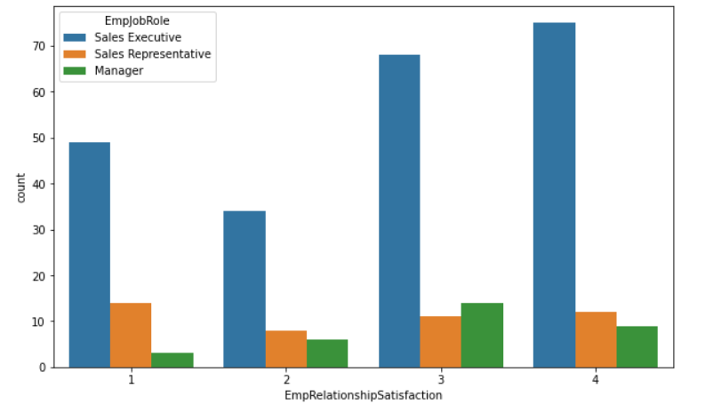

***Sales Executives are seen to have Employee Satisfaction Level : 1***

***Analysis of Development Department:***

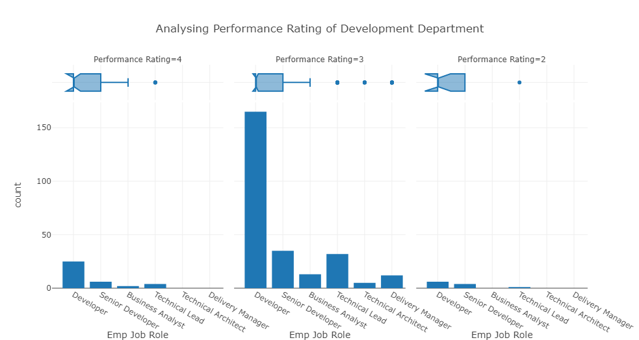

***It is observed that maximum employees of Development department have Performance rating 3.***

***Analysis of Management Issues in the Development Department with various correlated parameter***

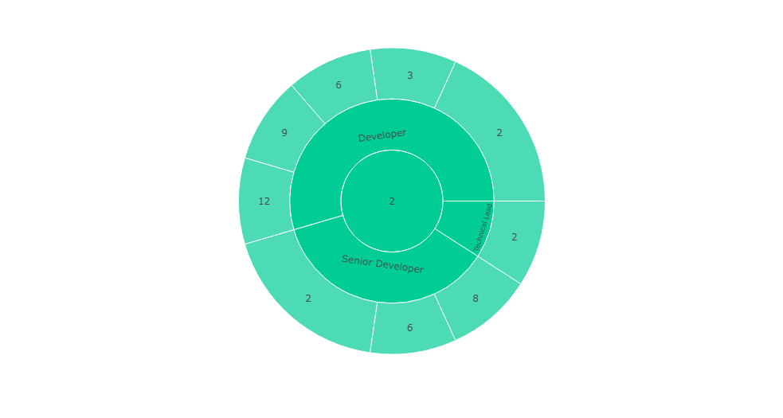

***6 Developers showing underlying performance have 2 -12 years of experience with current manager***

***4Senior Developers showing underlying performance have 2-8 years of experience with current manager***

***Technical Leads showing underlying performance have 2 years of experience with current manager***

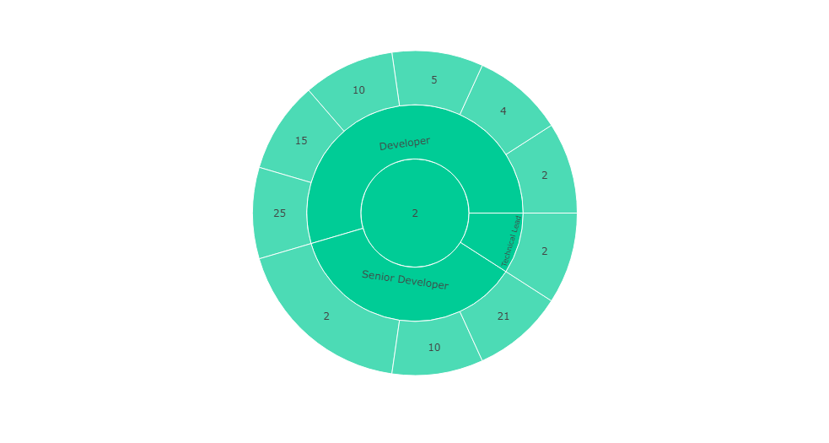

***6 Developers showing underlying performance have 2 -25 years of experience with current manager***

***4Senior Developers showing underlying performance have 2 of experience with current manager***

***1 Technical Leads showing underlying performance have 2 years of experience with current manager.***

***Service Delivery Quality:-***

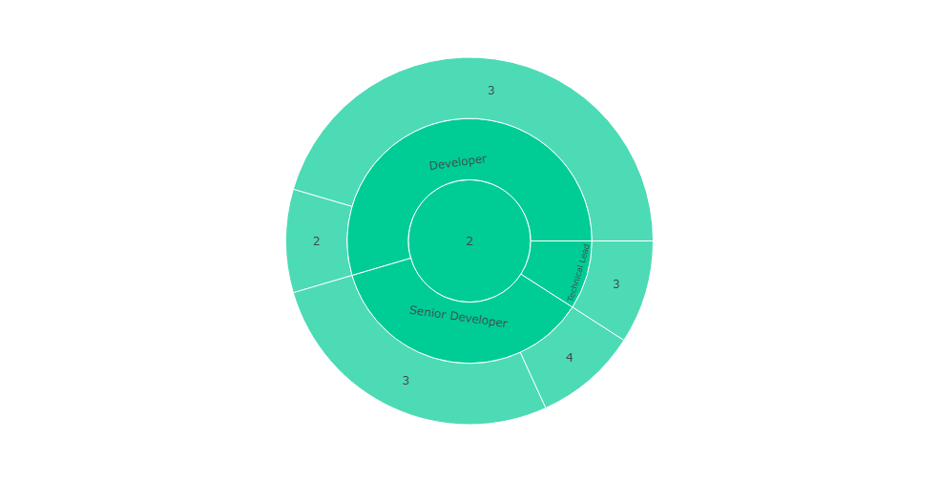

***Surprisingly, only 1 developer among 11 employees from Development dept. who under-performed have shown Job Involvement level 2.***

***Issues faced due to Travel (for development team) - Home to office distance:***

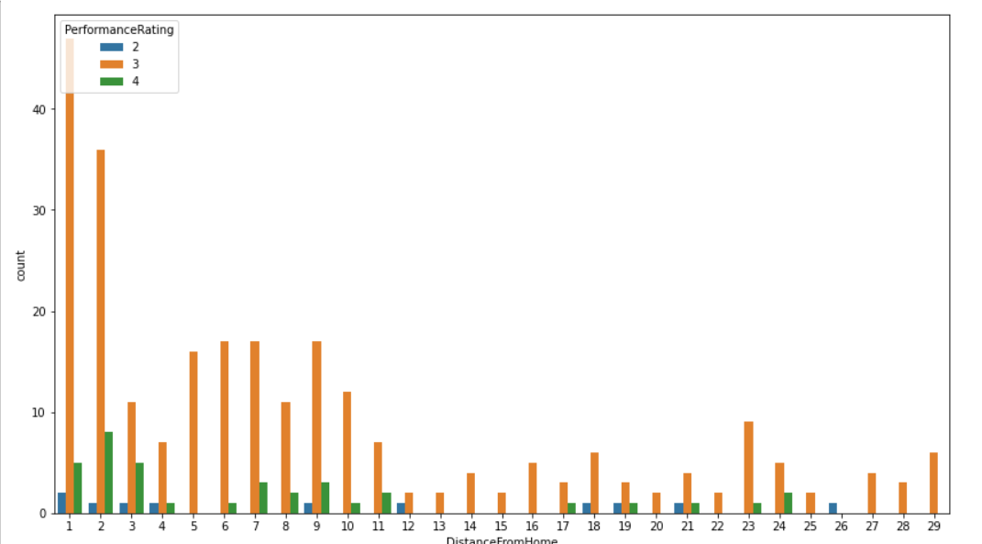

***It is observed that maximum employees of Development team have no travel issues due to distance from home to office.***

***Number of working hours :***

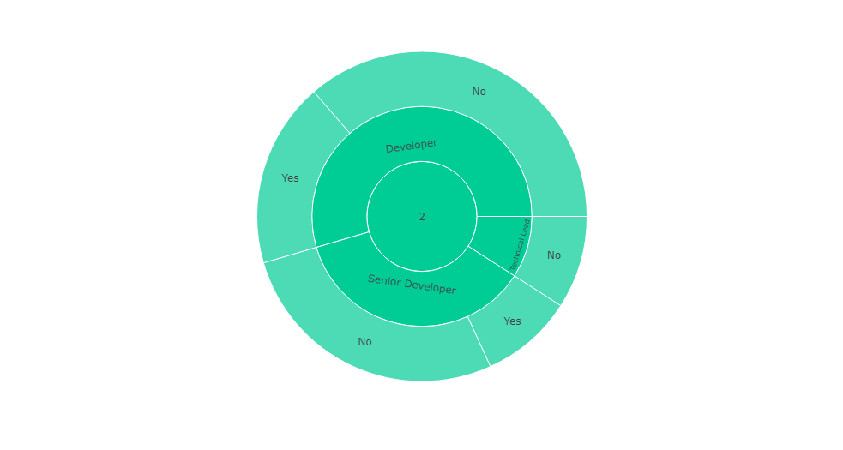

***It is observed that Among 11 under-performing employees of Dev. Dept. 4 developers, 3 senior developers and 1 TL “DO NOT DO OVERTIME”.***

***Employee Satisfaction :***

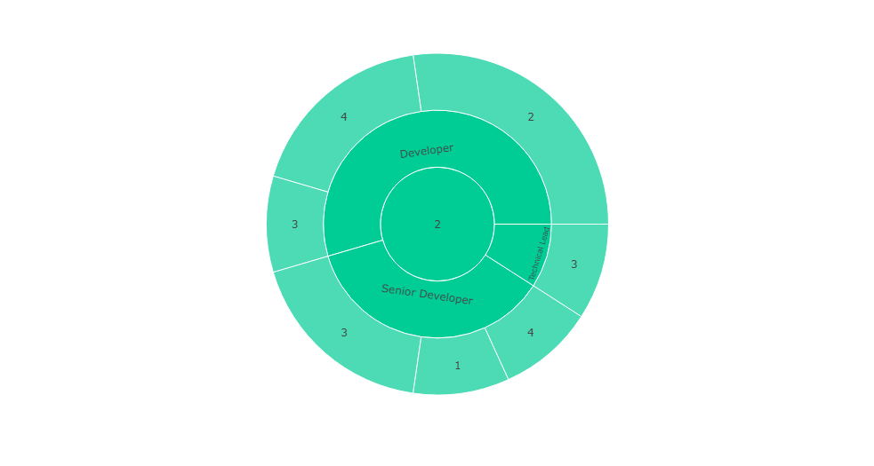

***only 1 sr. developer have low employee satisfaction***

***Employee Education :***

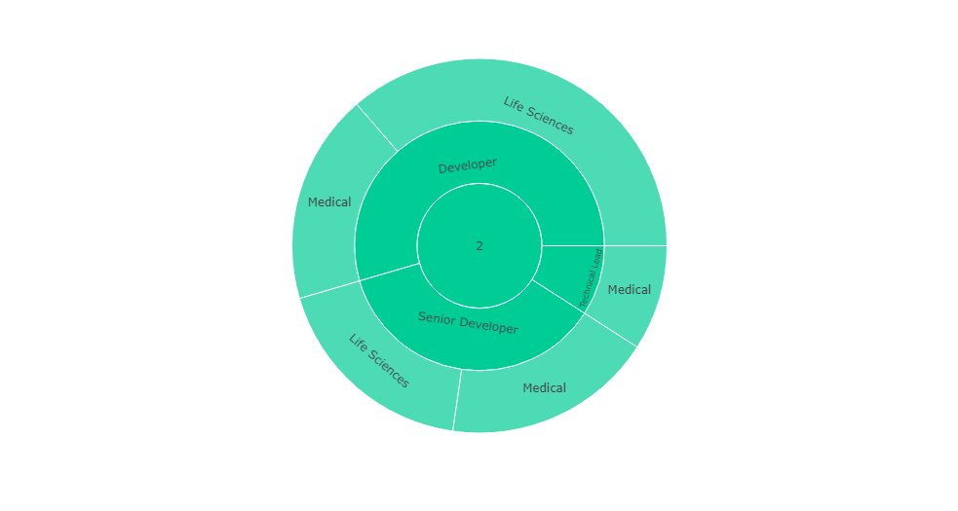

***Only 11 employees who shown underlying performance have different educational background.***

***Learning and Development***

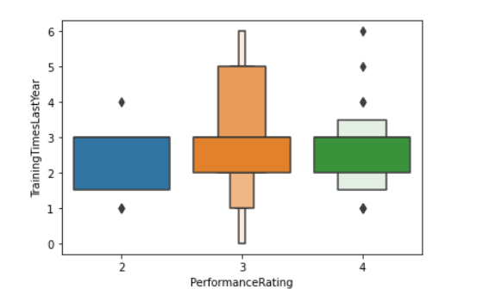

***Employees who attended more trainings have higher performance***

***Rewards and Recognition :-***

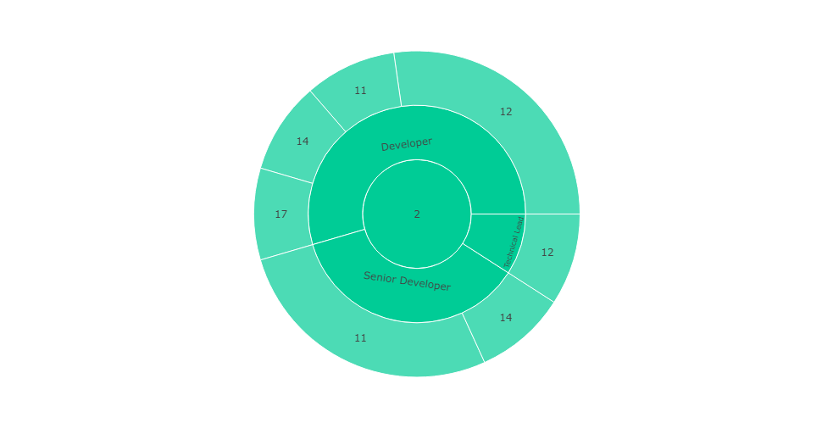

***6 Developers showing underlying performance got between 11-17% salary hike***

***4Senior Developers showing underlying performance got between 11-14% salary hike***

***1 Technical Leads showing underlying performance got between 12% salary hike.***

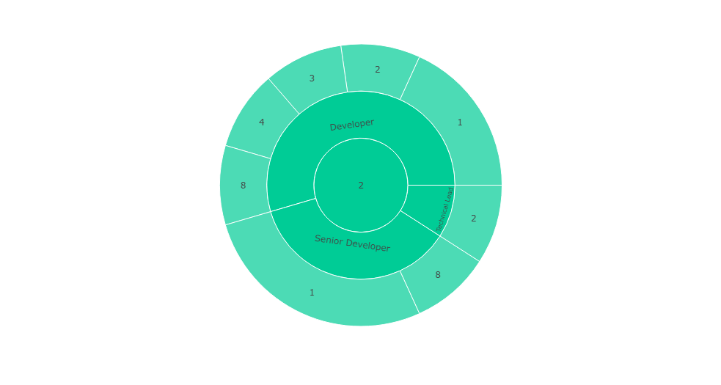

***6 Developers showing underlying performance lies between 1-8 years.***

***4Senior Developers showing underlying performance lies between 1-8 years.***

***1 Technical Leads showing underlying performance is 2 years***

***Employee Relationship Satisfaction:-***

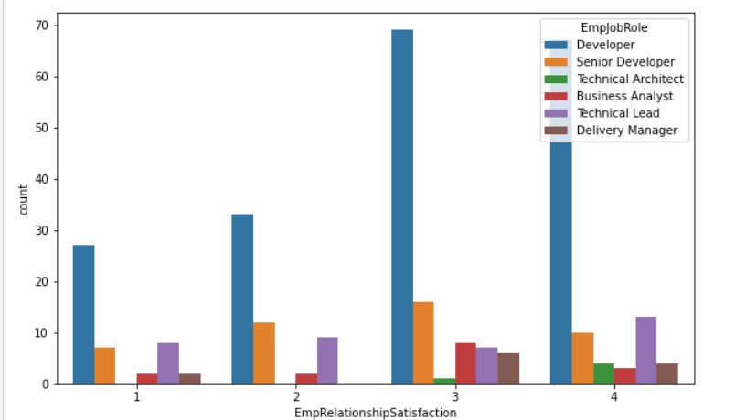

***Developers are seen to have Employee Satisfaction Level : 1***

**Analysis of R&D department:**

**R&D-Team distribution :-**

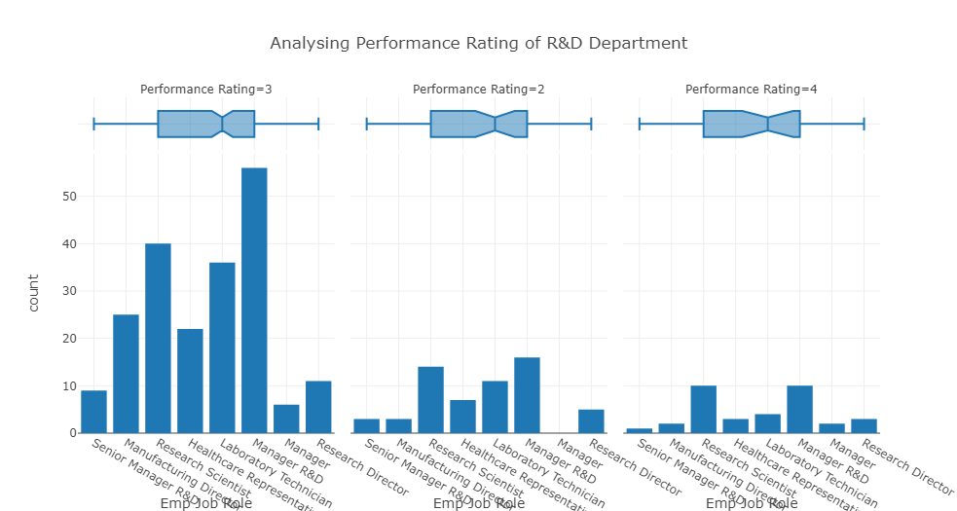

**It is observed that maximum employees of Development department have Performance rating is 3**

**Analysis of Management Issues in the R&D Department with various correlated parameter**

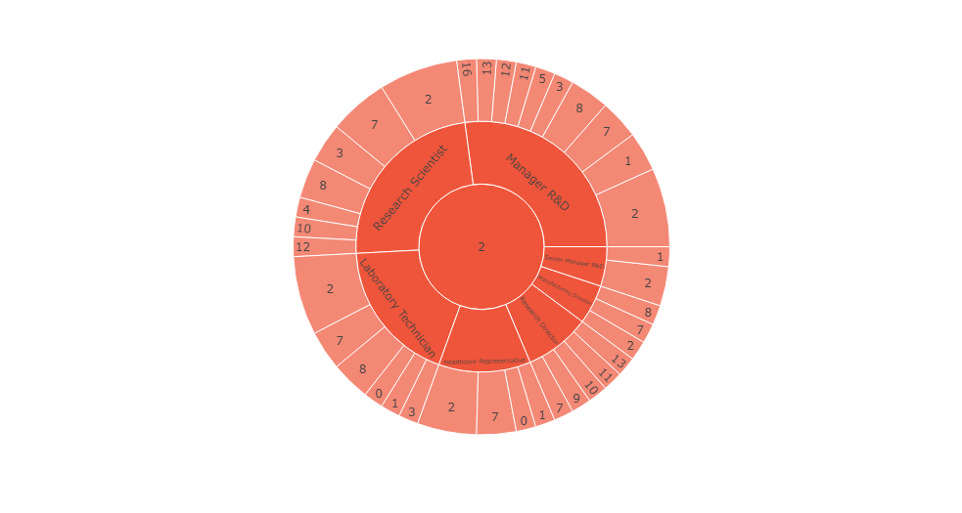

**14 Research Scientist showing underlying performance have 2 -12 years of experience with current manager**

**11 Laboratory Technicians showing underlying performance have 0-7 years of experience with current manager**

**7 Health-care representatives showing underlying performance have 7-10 years of experience with current manager**

**5 Research Director showing underlying performance have 8-13 years of experience with current manager**

**7 Health care representatives showing underlying performance have 7-10 years of experience with current manager**

**3 Manufacturing Director representatives showing underlying performance have 7-10 years of experience with current manager**

**3 Senior Manager R&D representatives showing underlying performance have 1-2 years of experience with current manager**

**16 Manager R&D representatives showing underlying performance have 11-16 years of experience with current manager.**

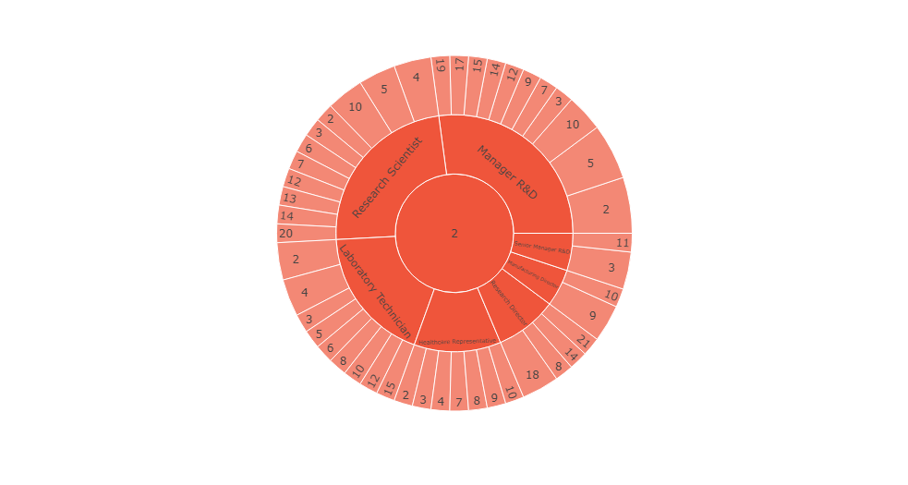

**14 Research Scientist showing underlying performance have 2 -20 years of experience with current company**

**11 Laboratory Technicians showing underlying performance have 3-15 years of experience with current company**

**7 Health-care representatives showing underlying performance have 2-10 years of experience with current company**

**5 Research Director showing underlying performance have 8-21 years of experience with current company**

**7 Health care representatives showing underlying performance have 7-10 years of experience with current company**

**3 Manufacturing Director representatives showing underlying performance have 9-10 years of experience with current company**

**3 Senior Manager R&D representatives showing underlying performance have 11 years of experience with current company**

**16 Manager R&D representatives showing underlying performance have 10-19 years of experience with current company.**

***Service Delivery Quality :-***

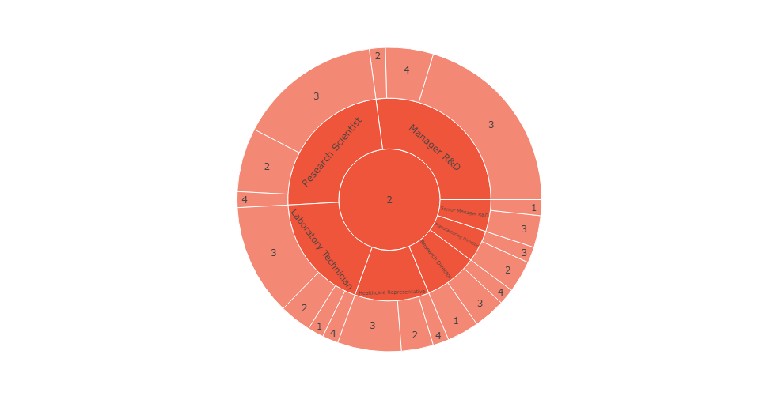

***1 Lab Technician, 1 research director, 1 senior manager R&D have shown job involvement level as 1.***

***Issues faced due to Travel (for R&D team) - Home to office distance***

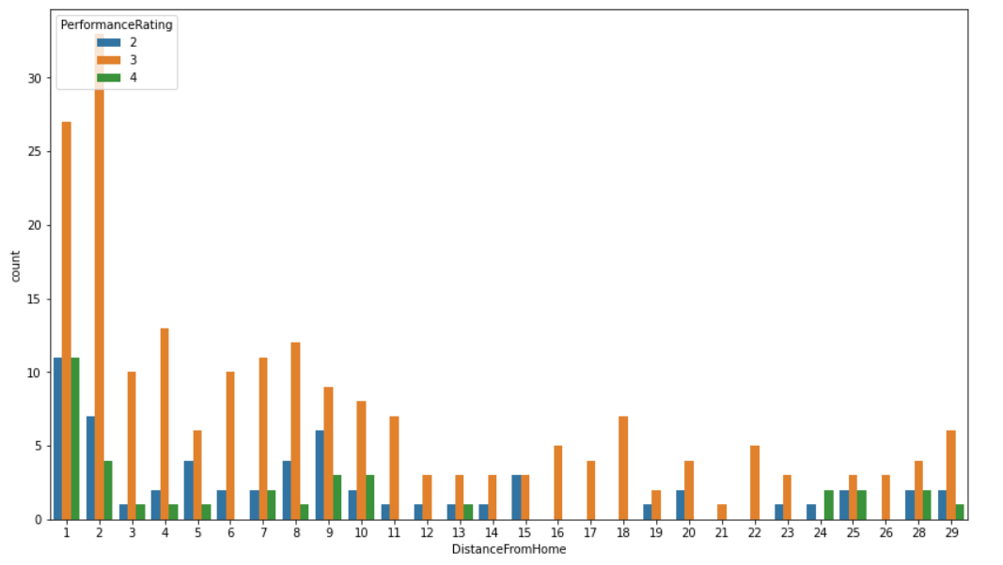

***It is observed that maximum employees of R&D team who are staying nearby to office are showing underlying performance.***

***Number of working hours :***

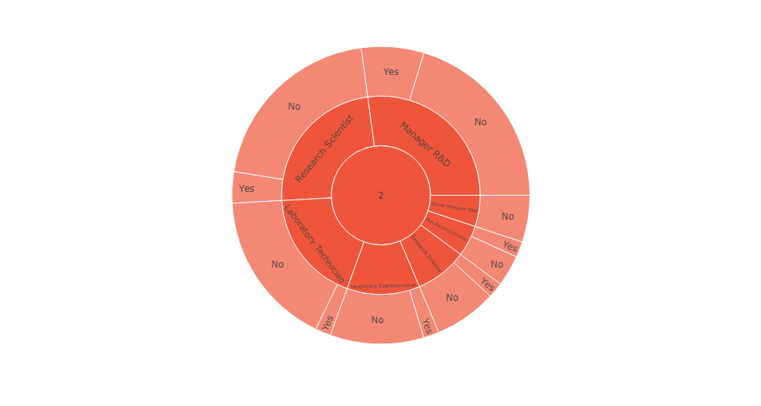

***It is observed that Among 59 under-performing employees of R&D Dept. 12 Research Scientist, 10 lab technicians, 7 healthcare representative, 4 research director 2 manufacturing director, 3 senior manager and 12 manager r&d DO NOT DO OVERTIME.***

***Employee Satisfaction :***

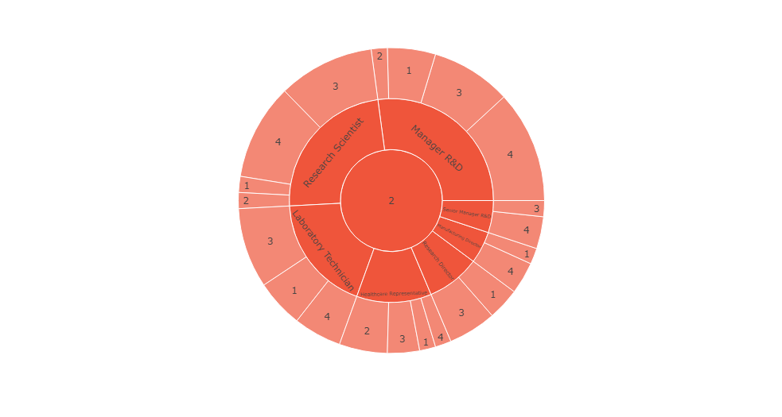

***It is observed that Among 59 under-performing employees of R&D Dept. 1 Research Scientist, 3 lab technicians, 1 healthcare representative, 2 research director, 1 manufacturing director and 3 manager r&d are NOT SATISFIED WITH THEIR JOB.***

***Employee Education :***

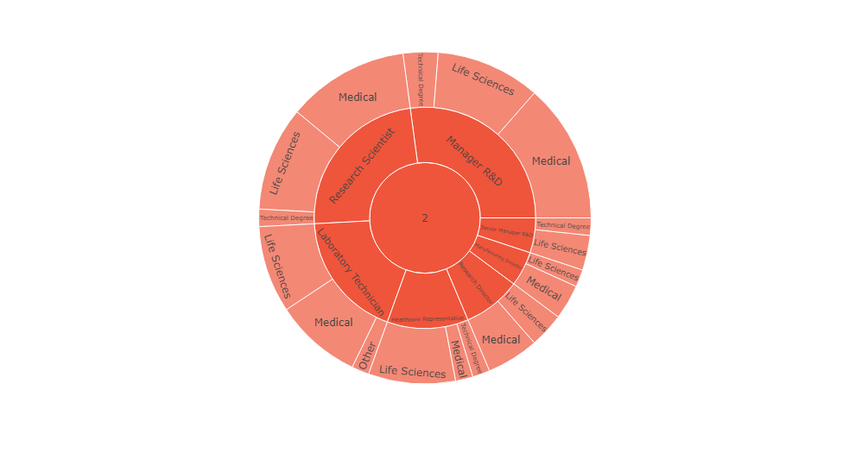

***Maximum employees who shown underlying performance have educational background related to their field.***

***Learning and Development :***

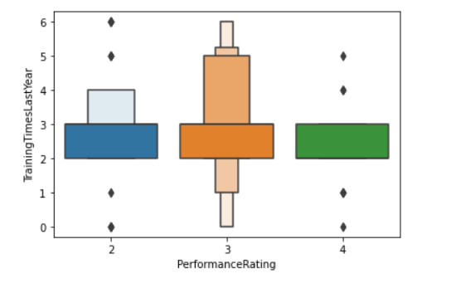

***Employees who attended more trainings have higher performance***

***Rewards and Recognition***

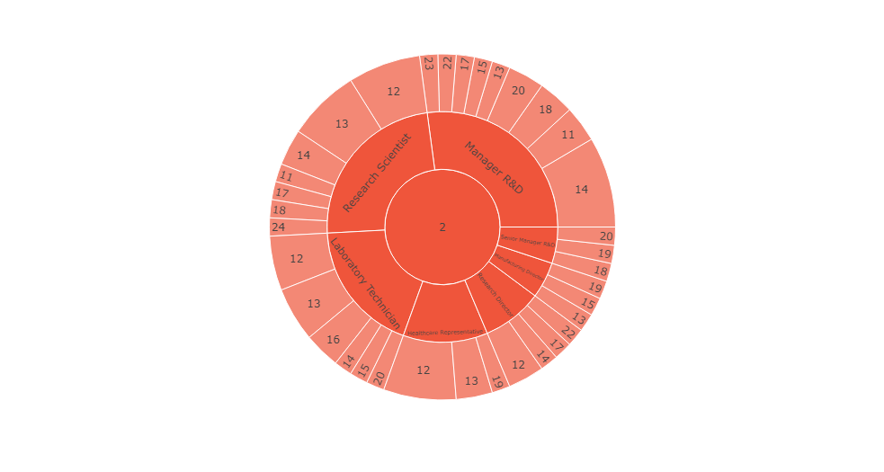

***59 employees of R&D department who shown underlying performance have got hikes between 11-23%.***

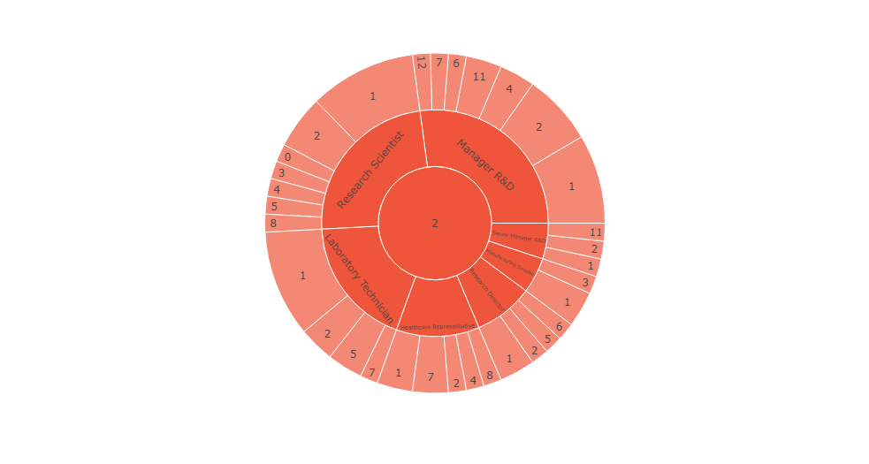

***59 employees of R&D department who shown underlying performance have got promoted between 11-12 years.***

***Employee Relationship Satisfaction :-***

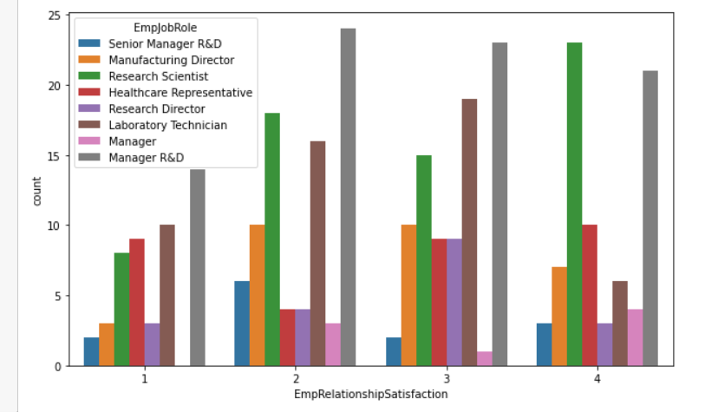

***Manager R&D are seen to have Employee Satisfaction Level : 1***