<http://localhost:5000/api/comments>

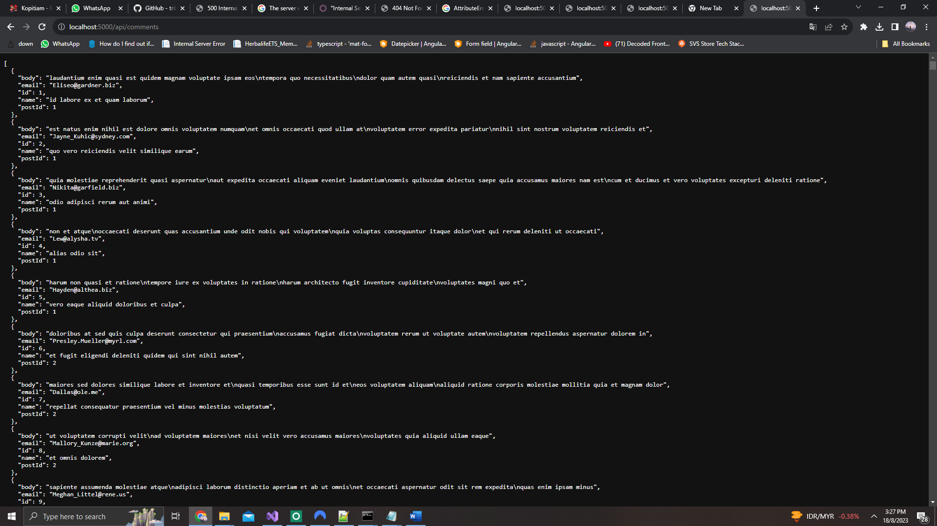

<http://localhost:5000/api/posts/>1

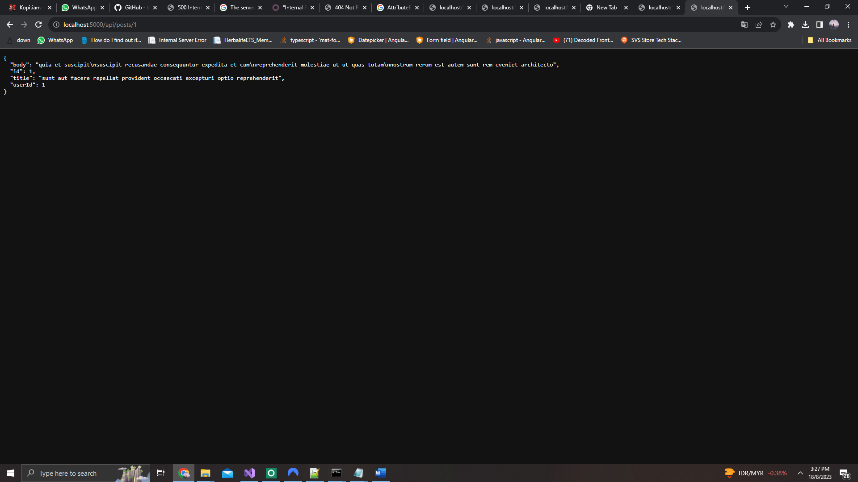

<http://localhost:5000/api/posts>

