<http://localhost:5000/api/search_comments?postId=1>

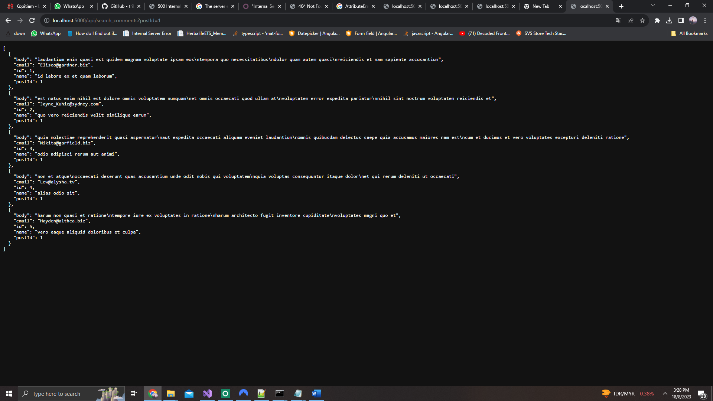

<http://localhost:5000/api/search_comments?email=Nikita@garfield.biz>

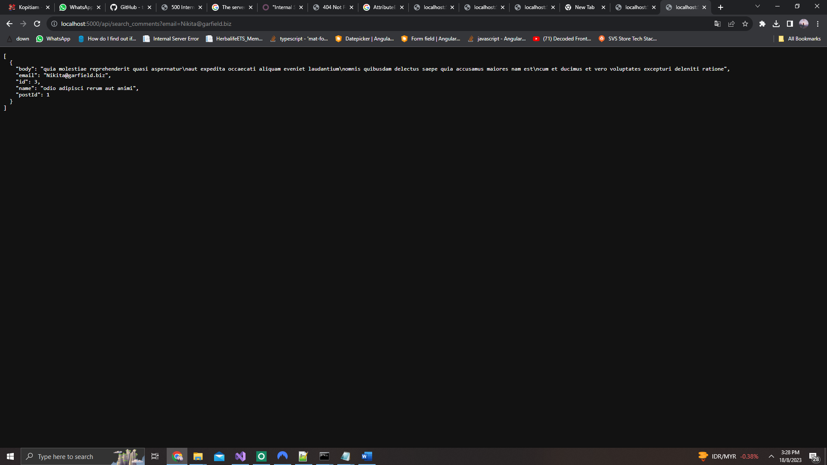

<http://localhost:5000/api/search_comments?postId=1&name=alias%20odio%20sit>

