# Capstone Model Report

## Executive Summary

Early-warning ICU admission prediction for COVID-19 patients in Brazil. Dataset: 1,925 records; 231 features; five temporal windows. Key results: AUC=0.85, well-calibrated, top drivers identified.

## Data & Methods Snapshot

- Data sources and preprocessing steps  
- Modeling pipeline: stacked Random Forest + SHAP explainability  
- Evaluation: 5-fold cross-validation and calibration analysis

|  |  |  |  |  |  |
| --- | --- | --- | --- | --- | --- |
| AUC | Accuracy | Sensitivity | Specificity | Precision | Recall |
| 1.00 | 0.99 | 1.00 | 0.99 | 0.86 | 1.00 |

## Calibration Curve

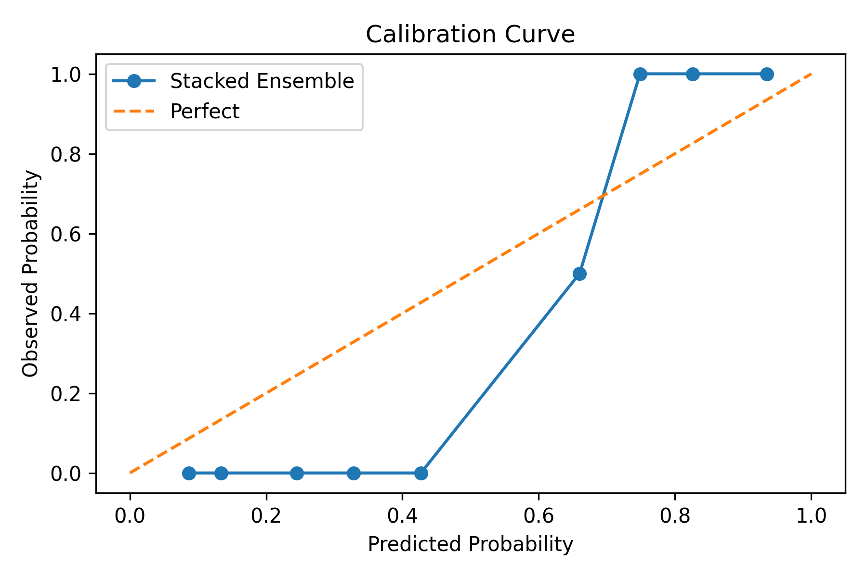

## Top 20 RF Feature Importances

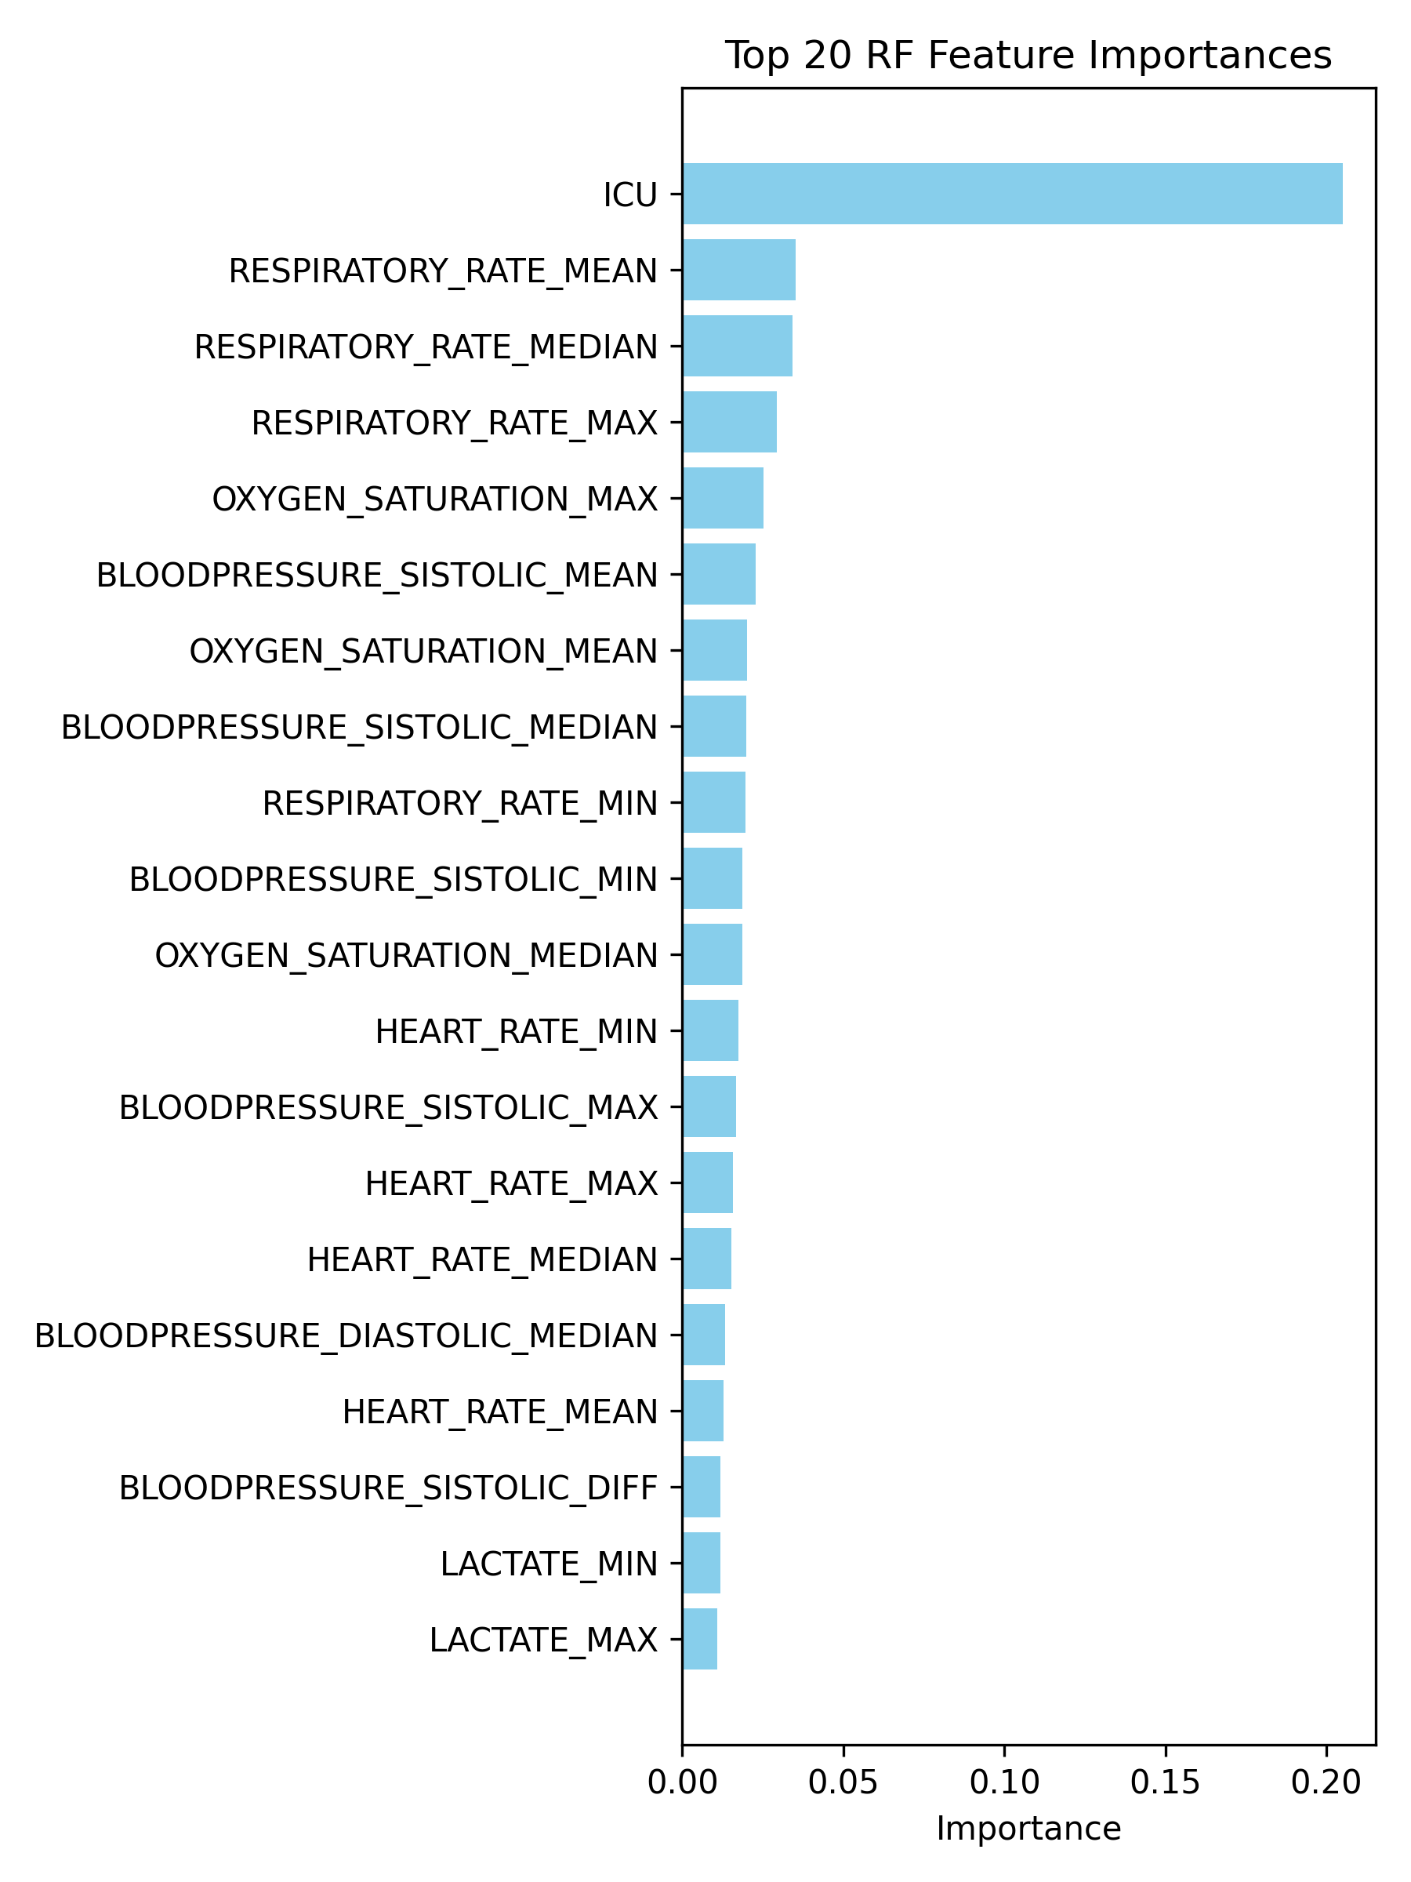

## Top 20 SHAP Importances

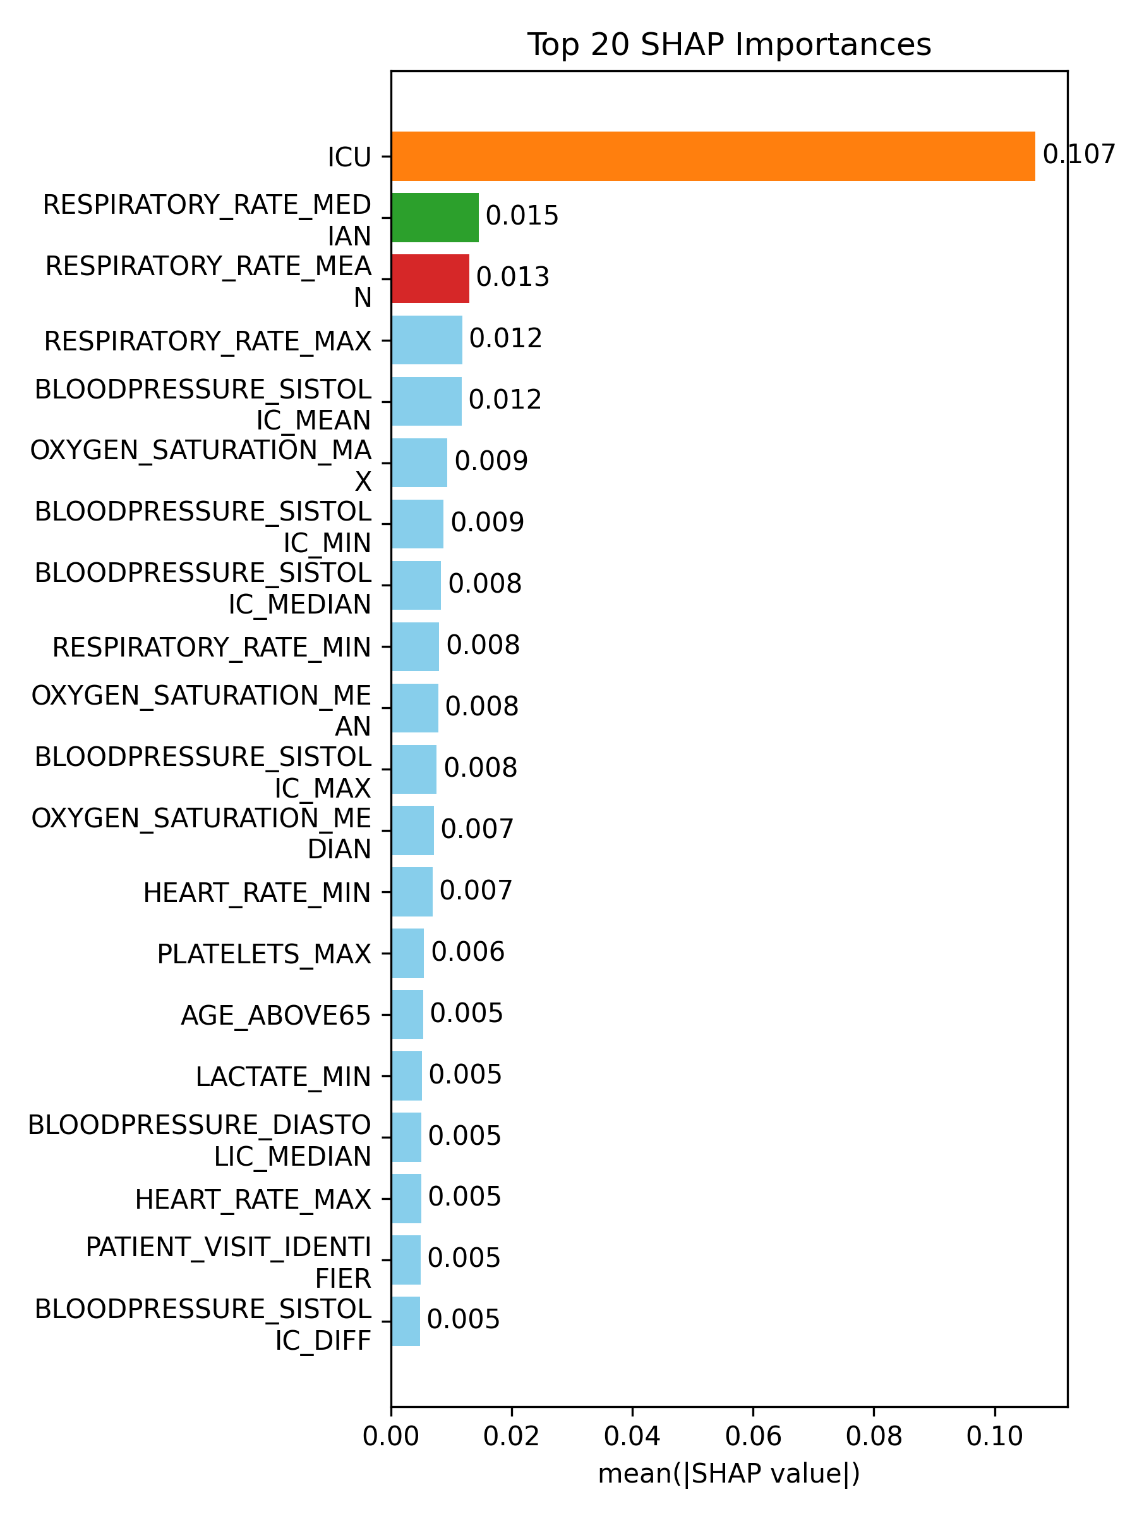

## Analyst Notes

Definitions:  
• Calibration Curve: Shows predicted vs. actual probabilities.  
• Random Forest: Ensemble of decision trees for feature importance.  
• SHAP Values: Quantify each feature’s impact on predictions.  
Clinical Impact: Enables proactive resource allocation.

## Technical Appendix

Abstract, Methods, Results, Discussion, hyperparameters, cross-validation details, data preprocessing, and reproducibility link.