Out-of-Step (OOS) Risk Prediction for GR1
Comprehensive mathematical model, scenario interpretation, and current results.
1. Problem Definition
The objective is to predict whether a static operating point for generator GR1 is stable or out-of-step. The target is binary: 0 means stable and 1 means OOS/unstable.
Symbol | Column | Meaning
T | Tag_rate | disturbance/acceleration proxy
I | Ikssmin_kA | grid strength proxy
S | Sgn_eff_MVA | stress/loading proxy
H | H_s | inertia constant
y | Out_of_step | binary target
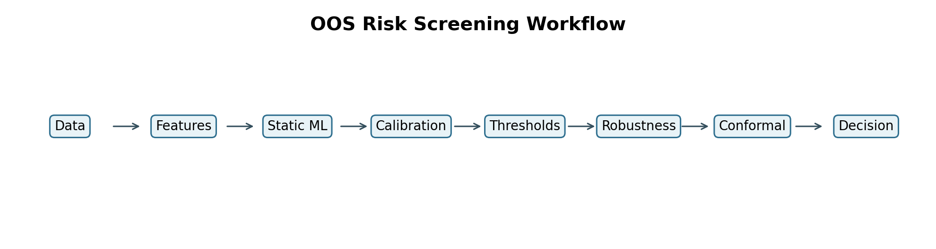
2. Mathematical Model
Dataset definition
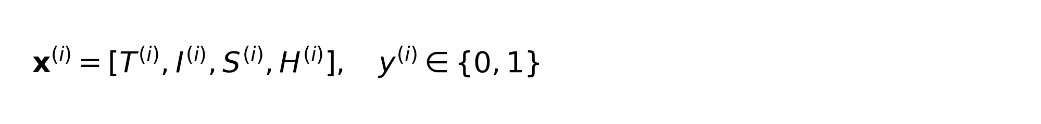
Physics-aware engineered ratios
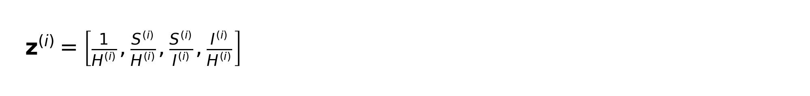
Swing-equation motivation
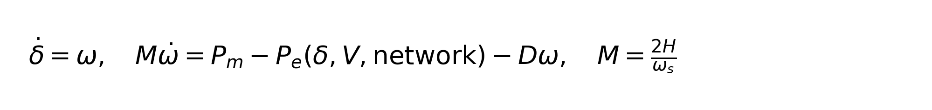
Probabilistic classifier
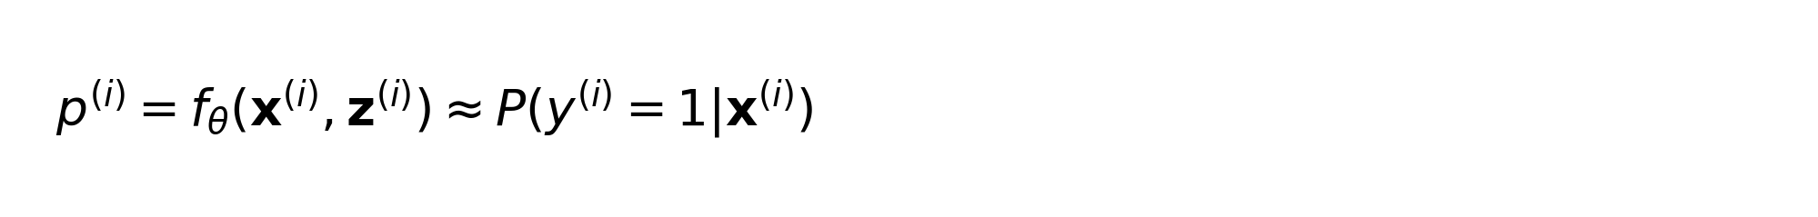
Imbalance-aware binary cross-entropy
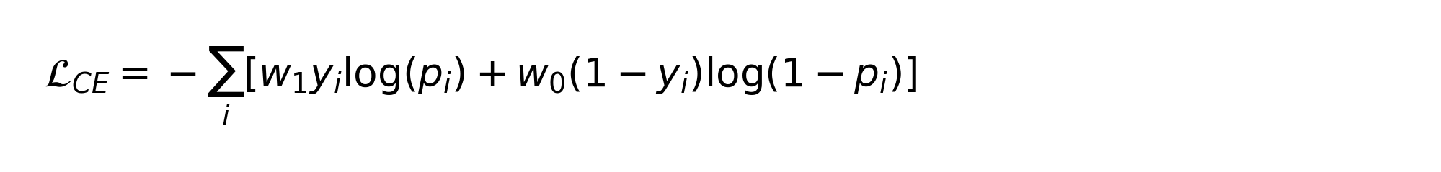
Monotonic physical priors
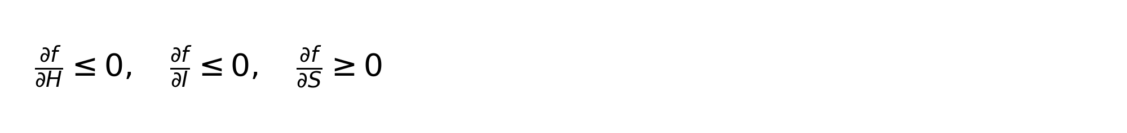
Total objective
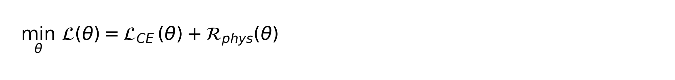
Cost-sensitive threshold
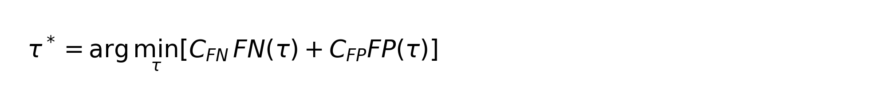
Counterfactual correction
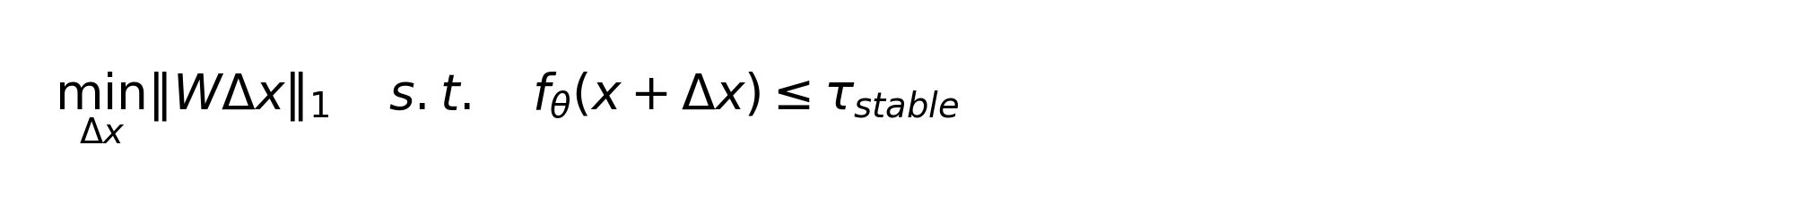
3. Scenario Design
S1-S5 build the model step by step. S6-S8 evaluate operational readiness. S9 is the compact final row that carries the predictive result from S5 and adds robustness, counterfactual, drift, and conformal uncertainty summaries.
Scenario | Meaning
S1 | raw baseline
S2 | raw + engineered physics ratios
S3 | S2 + monotonic priors
S4 | S2 + imbalance handling + cost threshold
S5 | S4 + calibration
S6 | robustness evaluation
S7 | counterfactual evaluation
S8 | deployment/drift evaluation
S9 | compact final summary
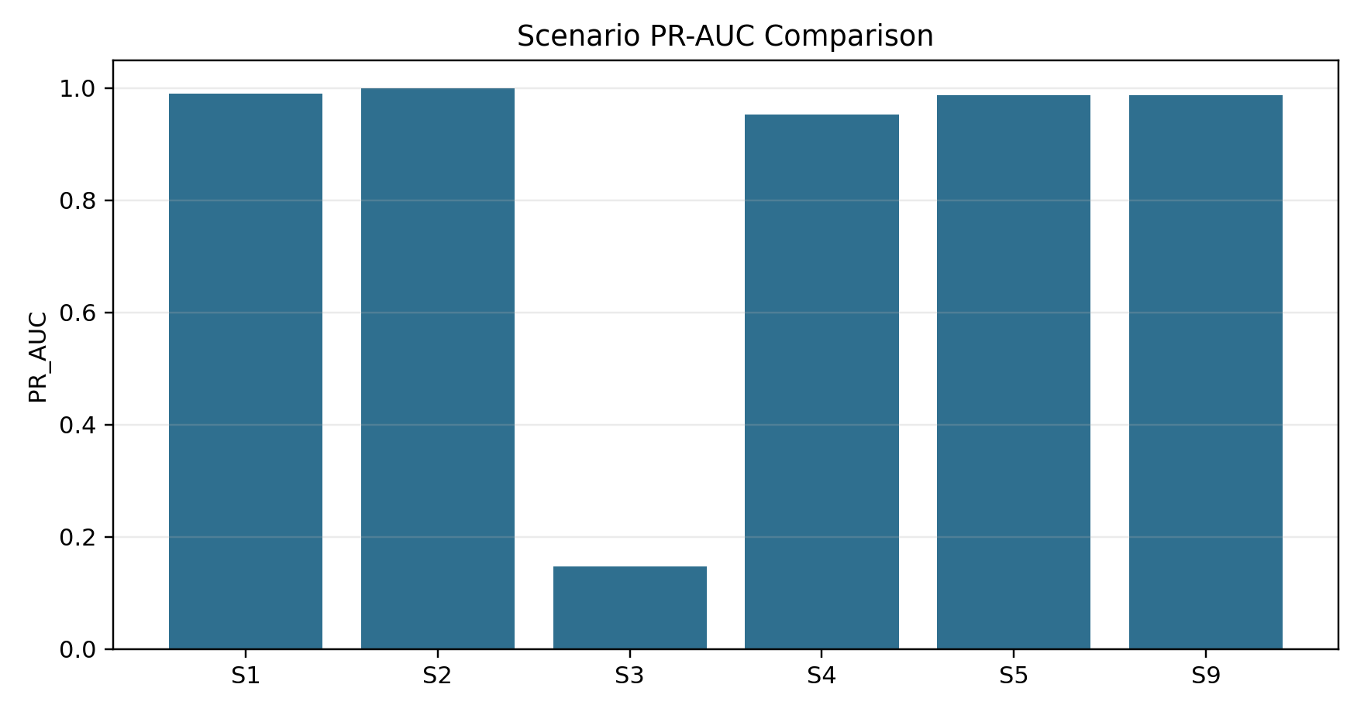
4. Current Scenario Results
Scenario | PR-AUC | ROC-AUC | Recall | FNR | ECE
S1 | 0.9895 | 0.9984 | 1.0000 | 0.0000 | 0.0534
S2 | 0.9996 | 1.0000 | 1.0000 | 0.0000 | 0.0075
S3 | 0.1477 | 0.4867 | 0.0260 | 0.9740 | 0.0193
S4 | 0.9520 | 0.9986 | 0.9983 | 0.0017 | 0.0905
S5 | 0.9877 | 0.9992 | 0.9983 | 0.0017 | 0.0033
S9 | 0.9877 | 0.9992 | 0.9983 | 0.0017 | 0.0033
Interpretation: S2 is the strongest pure static classifier. S5 and S9 are better for deployment interpretation because they include calibration and operational summaries. S3 currently underperforms, which means the current monotonic implementation should be improved with a more flexible monotonic boosting approach.
5. Combination Search Results
Rank | Combo | Meaning | PR-AUC | Recall | FNR | ECE
1 | 1+2 | raw + engineered | 0.9996 | 1.0000 | 0.0000 | 0.0075
2 | 1+2+5 | raw + engineered + calibrated | 0.9929 | 0.9983 | 0.0017 | 0.0014
3 | 1+2+4+5 | raw + engineered + imbalance+cost + calibrated | 0.9877 | 0.9983 | 0.0017 | 0.0033
4 | 1 | raw | 0.9895 | 1.0000 | 0.0000 | 0.0534
5 | 1+5 | raw + calibrated | 0.9878 | 0.9619 | 0.0381 | 0.0030
6 | 1+2+4 | raw + engineered + imbalance+cost | 0.9520 | 0.9983 | 0.0017 | 0.0905
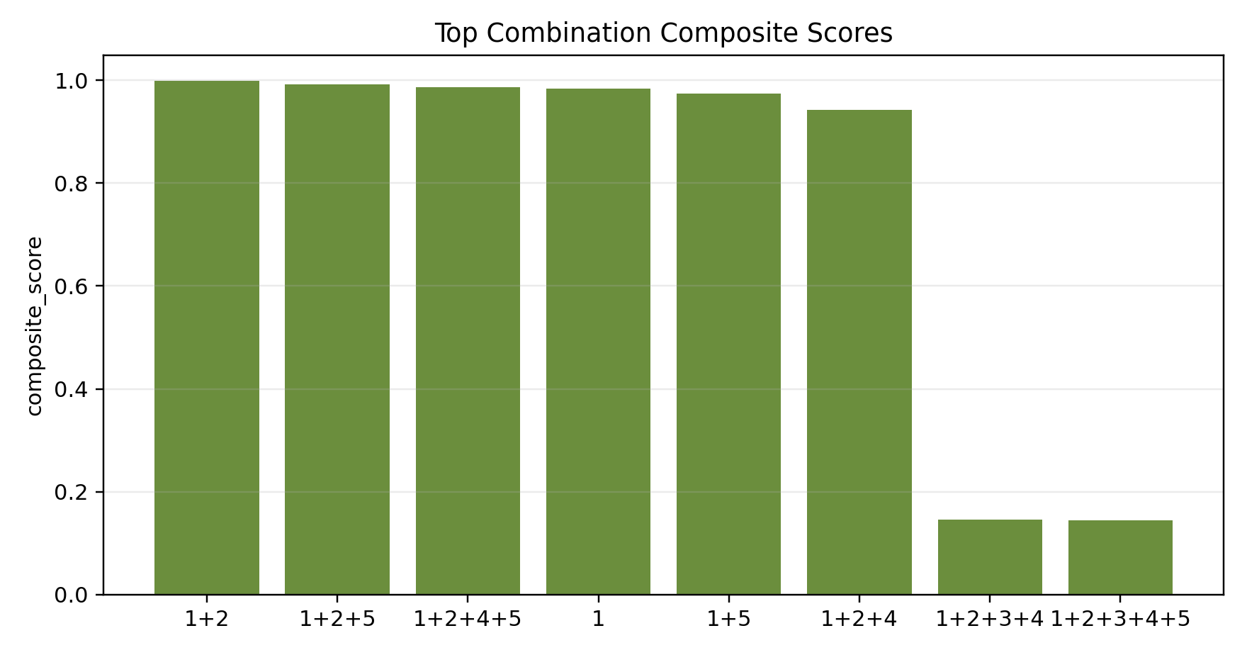
Best composite combination: 1+2 (raw + engineered).
6. Robustness and Drift
Shift | PR-AUC | Recall | FNR | PR-AUC drop
clean | 0.9877 | 0.9983 | 0.0017 | 0.0000
noisy | 0.9877 | 0.9983 | 0.0017 | 0.0000
missing_features | 0.9877 | 0.9983 | 0.0017 | 0.0001
unseen_regime | 0.9739 | 1.0000 | 0.0000 | 0.0138
group_shift | 0.9777 | 0.9912 | 0.0088 | 0.0100
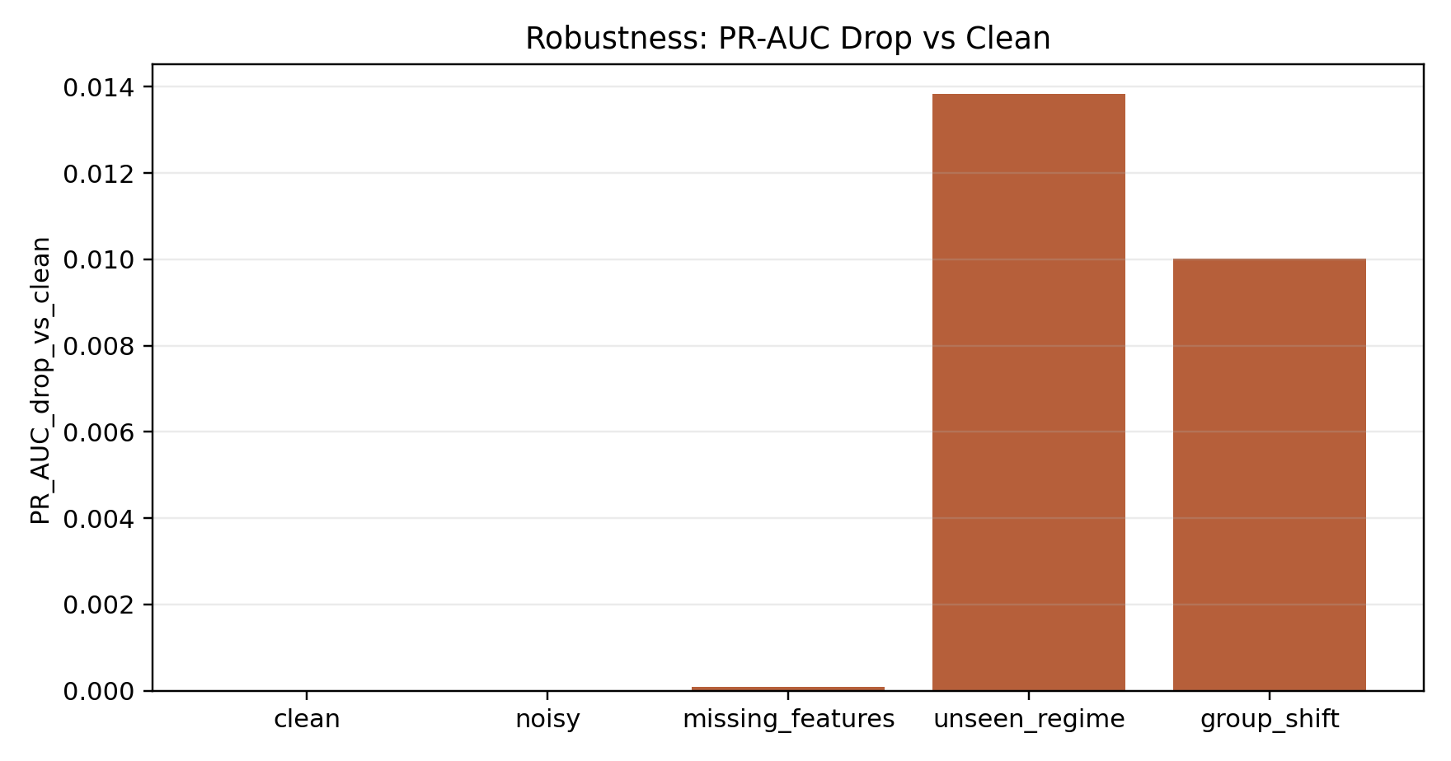
S9 drift summary: max PSI = 3.2349. A high PSI suggests the incoming operating distribution has shifted and should trigger review or retraining policy.
7. Conformal Uncertainty
Metric | Value
coverage | 0.9667
OOS coverage | 0.9584
average set size | 0.9678
ambiguous rate | 0.0000
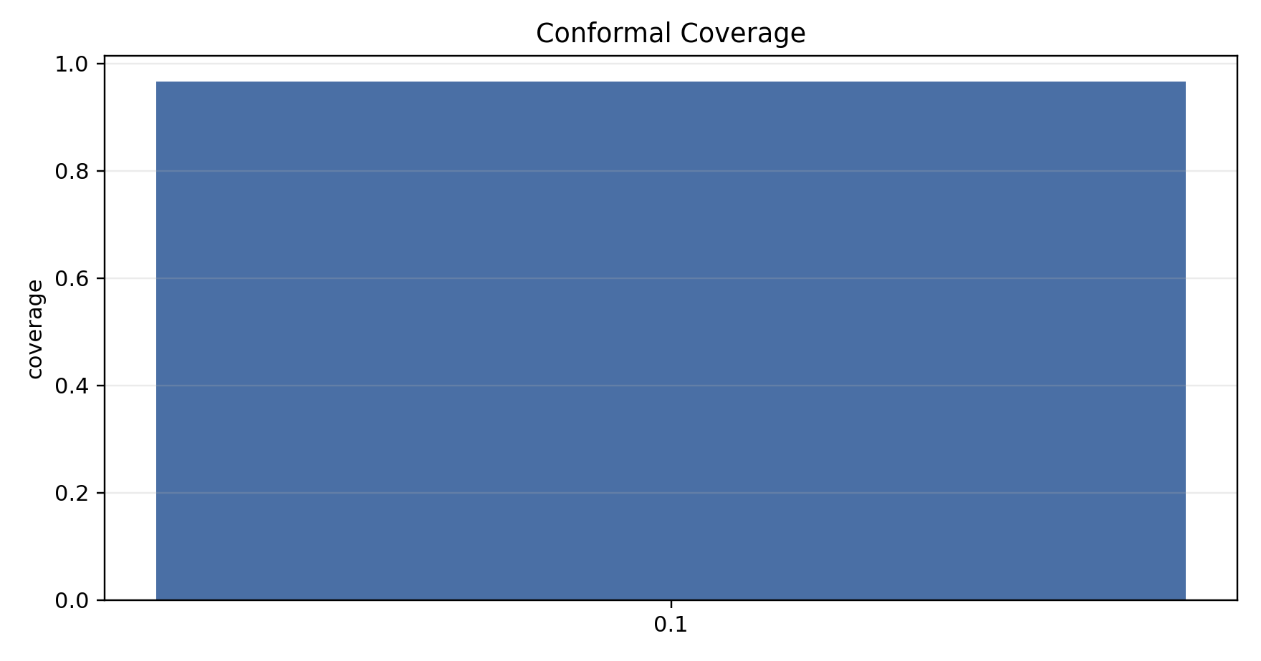
Conformal prediction is a safety layer: uncertain cases can be routed to operator review or future dynamic PMU-window refinement.
8. Evaluation Matrix
Axis | Metric | Direction | Reason
Discrimination | PR-AUC | higher | primary for imbalanced OOS data
Discrimination | ROC-AUC | higher | general separability
Safety | FNR | lower | missed OOS is dangerous
Calibration | ECE / Brier | lower | risk probabilities should be reliable
Robustness | PR-AUC drop | lower | survives noise and regime shift
Actionability | counterfactual success | higher | operator mitigation support
Uncertainty | conformal coverage | near target | safer decisions under uncertainty
Deployment-oriented score used in the combination table:
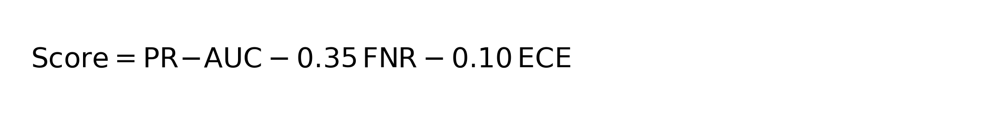
9. Bottom Line
- Best pure static screening: 1+2 = raw + engineered physics ratios.
- Best calibrated static model: 1+2+5 = raw + engineered + calibration.
- Best conservative deployment-style stack: 1+2+4+5.
- Best compact reporting scenario: S9.
- Main research target: improve monotonic modeling with MonoGBM-OOS and improve physics-constrained counterfactual recourse.

