How to Create an Assessment
This guide walks through the full assessment-creation flow in Career-Nine: creating a section, adding questions to it, building a questionnaire, and finally creating the assessment that students take.
Note: The four steps must be done in order. A questionnaire needs sections and questions to exist first, and an assessment wraps a questionnaire.
Step 1 — Create a Section
Sections group related questions inside a questionnaire (e.g. 'Aptitude', 'Interest', 'Personality'). Every question belongs to exactly one section.
Navigation
1. Open the left-hand menu and click Question Sections.
2. Click the Create Section button in the top-right.
3. The Add Section page opens at /question-sections/create.
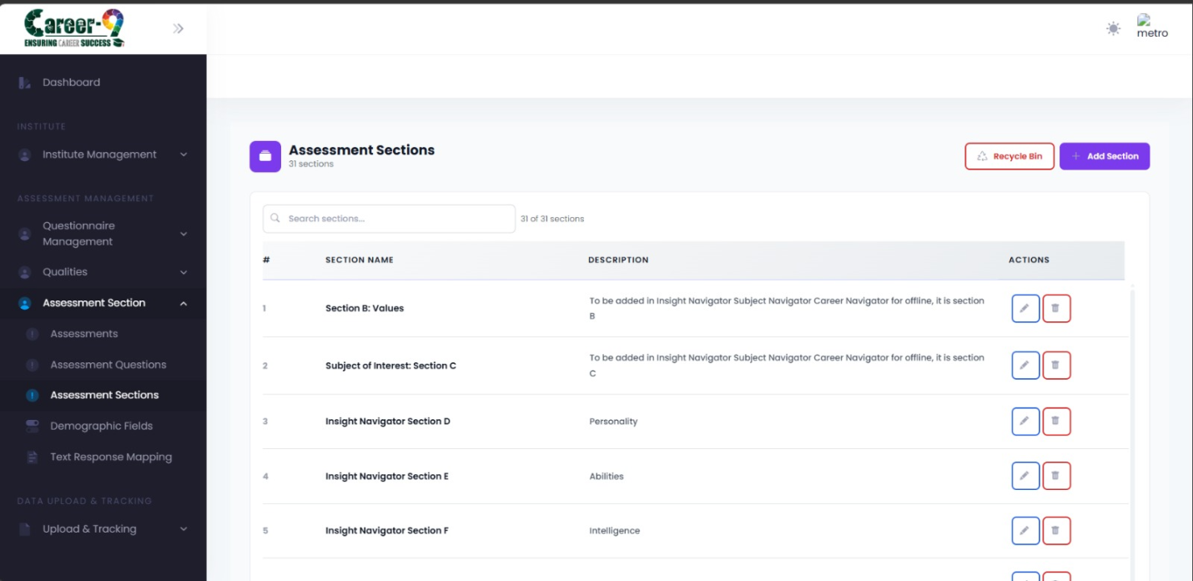Question Sections list page showing the Add Section button in the top-right.
Fill the form
• Section Name — short label, required (e.g. 'Numerical Aptitude').
• Section Description — one-line description, required.
4. Click Submit. You will be redirected back to /question-sections and the new section appears in the table.
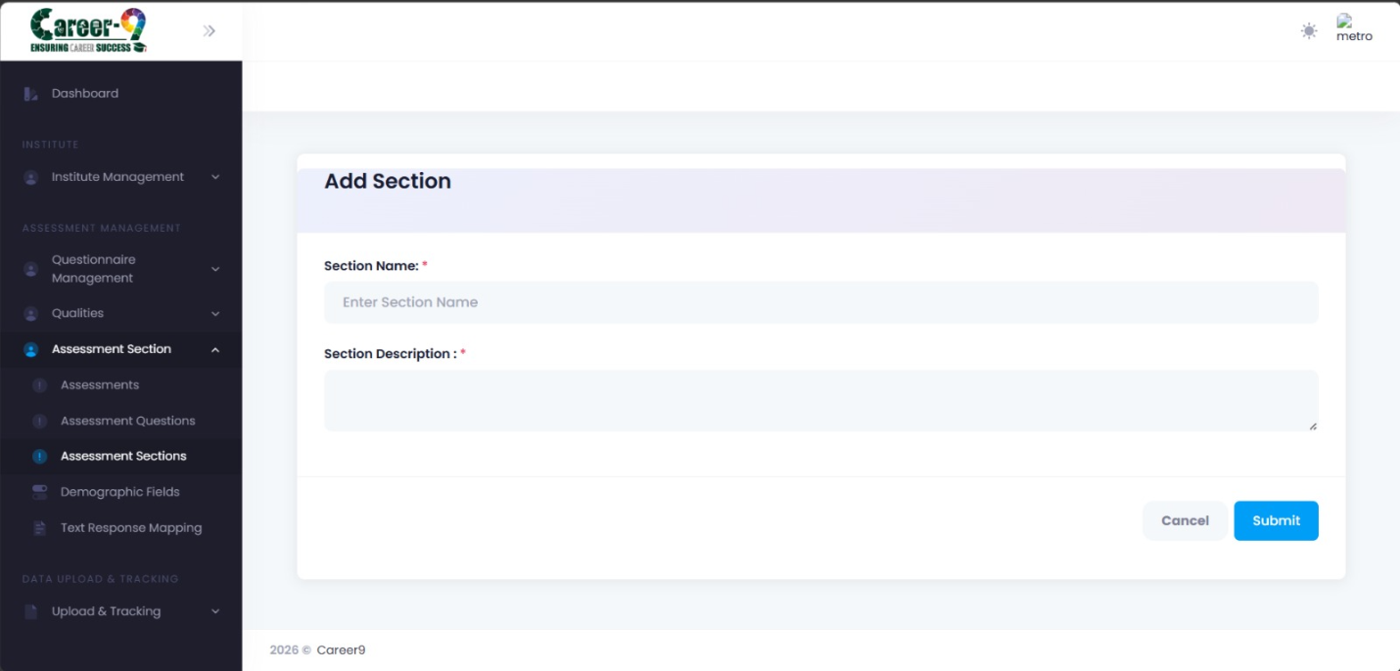 Section form filled with Section Name and Section Description.
Step 2 — Create Questions
Once the section exists, add questions to it. Each question has options, and each option can carry scores against one or more Measured Quality Types (MQTs).
Navigation
1. Open Assessment Questions from the menu.
2. Click Create Question (or use Bulk Upload for Excel imports — see below).
3. The Create Question page opens at /assessment-questions/create.
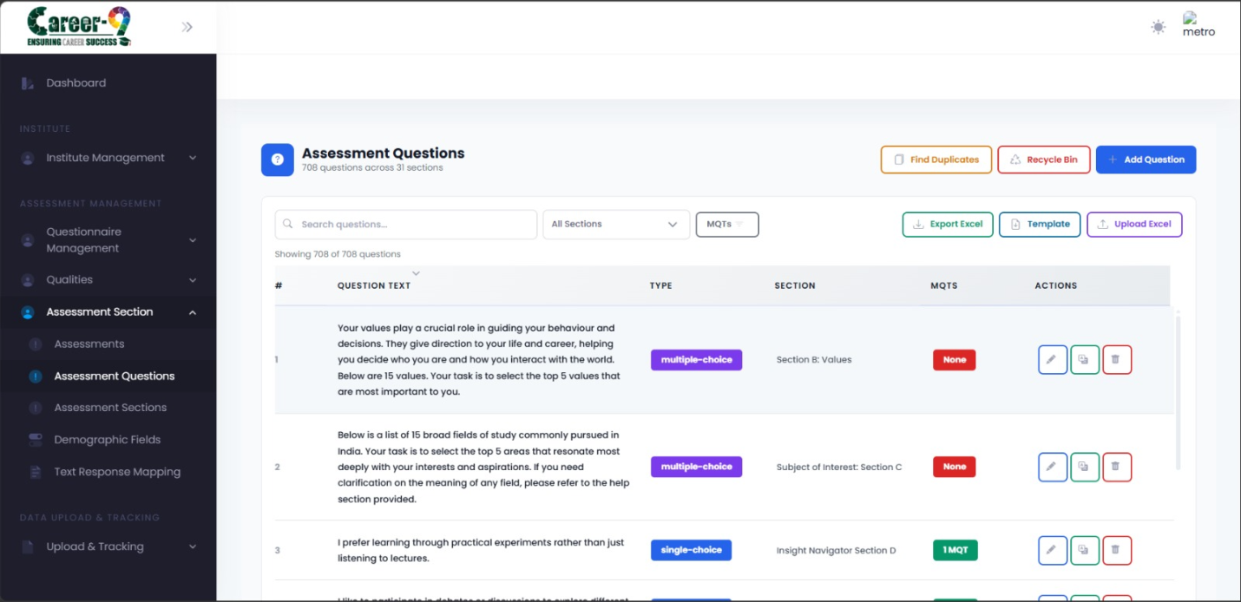Assessment Questions table with Create Question and Bulk Upload buttons.
Fill the form
• Question Text — the actual question shown to students.
• Question Type — e.g. single choice, multiple choice.
• Section — select the section created in Step 1.
• Max Options Allowed — how many options a student may select.
• Options — add at least two. For each option, optionally attach MQT scores (e.g. Analytical:10, Creativity:5).
4. Click Save. The question appears in the Assessment Questions table.
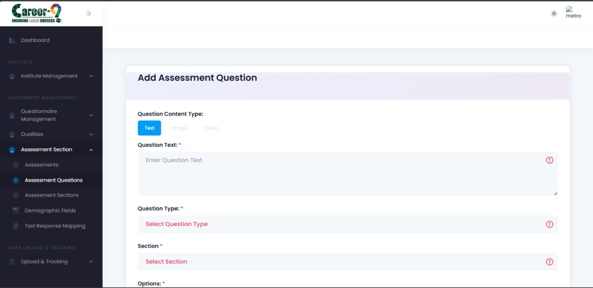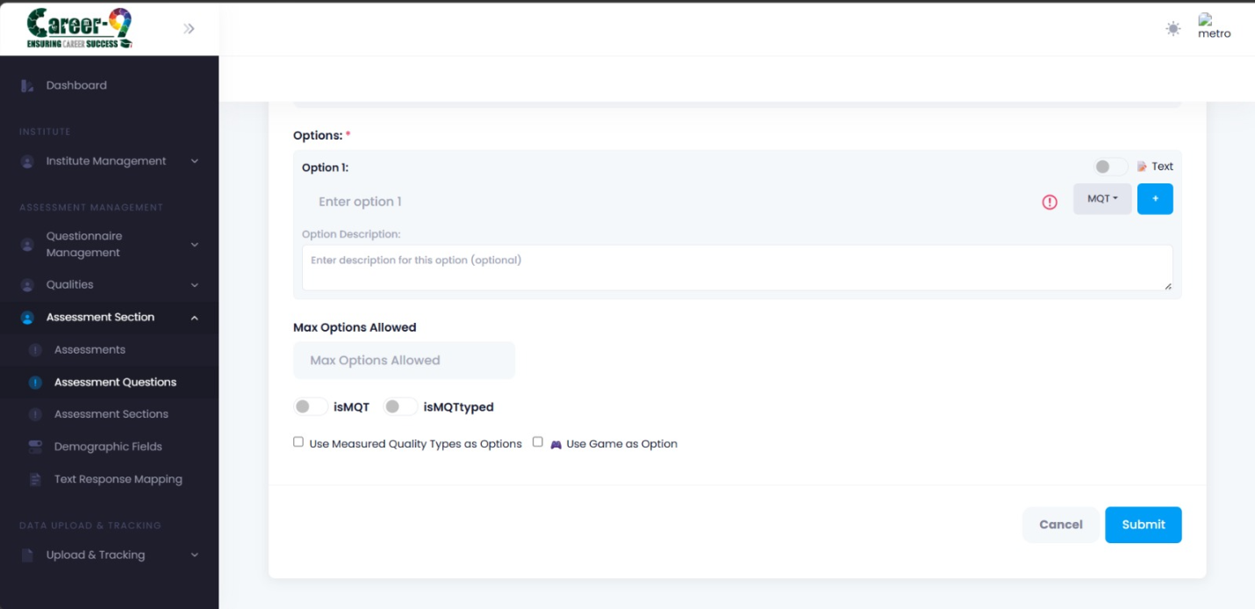Create Question form showing question text, section dropdown, options list, and MQT score inputs on each option.
Bulk upload (optional)
For large question banks, click Bulk Upload on the Assessment Questions page to open the upload modal.
1. Click Download Template to get an Excel file with the expected columns.
2. Fill one row per question: Question Text, Question Type, Section ID, Max Options Allowed, Option 1–6 (Text, Description, Is Correct, MQTs).
3. Upload the file. The modal parses it and shows a preview — use Next/Previous to walk through each parsed question, edit if needed, then click Submit.
Note: MQT format inside the Excel cell is 'Name:Score,Name:Score' — e.g. 'Analytical:10,Creativity:5'. Images are not supported in the Excel import; add them manually afterwards.
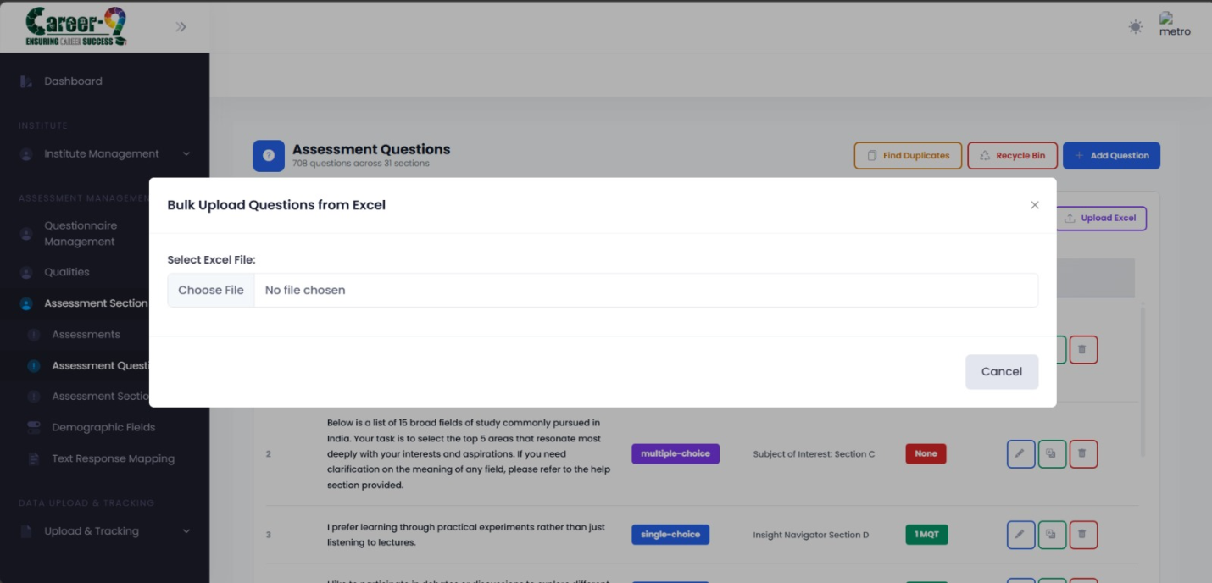Bulk Upload Excel modal
Step 3 — Create a Questionnaire
A questionnaire binds sections and questions together into a structured ordered flow with optional multi-language support.
Navigation
1. Open Questionnaires from the menu.
2. Click Create Questionnaire.
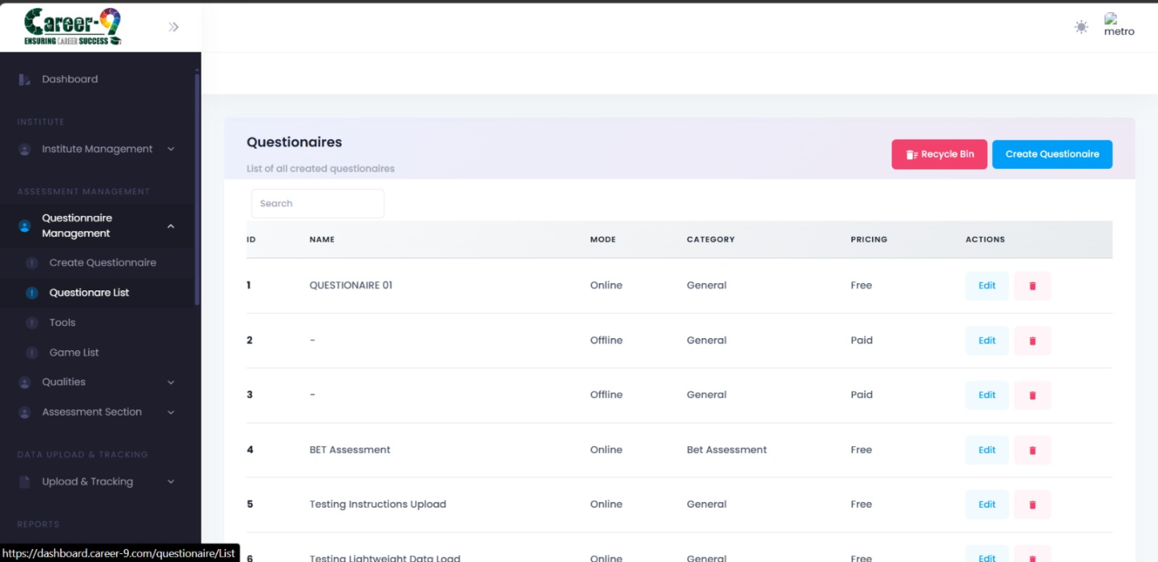Questionnaire list page with Create Questionnaire button.
Fill the form
• Questionnaire Name and Description.
• Add one or more sections (from Step 1). For each section, pick the questions (from Step 2) to include and their order.
• Optionally add supported languages for translations.
3. Click Save — the questionnaire is now reusable across multiple assessments.
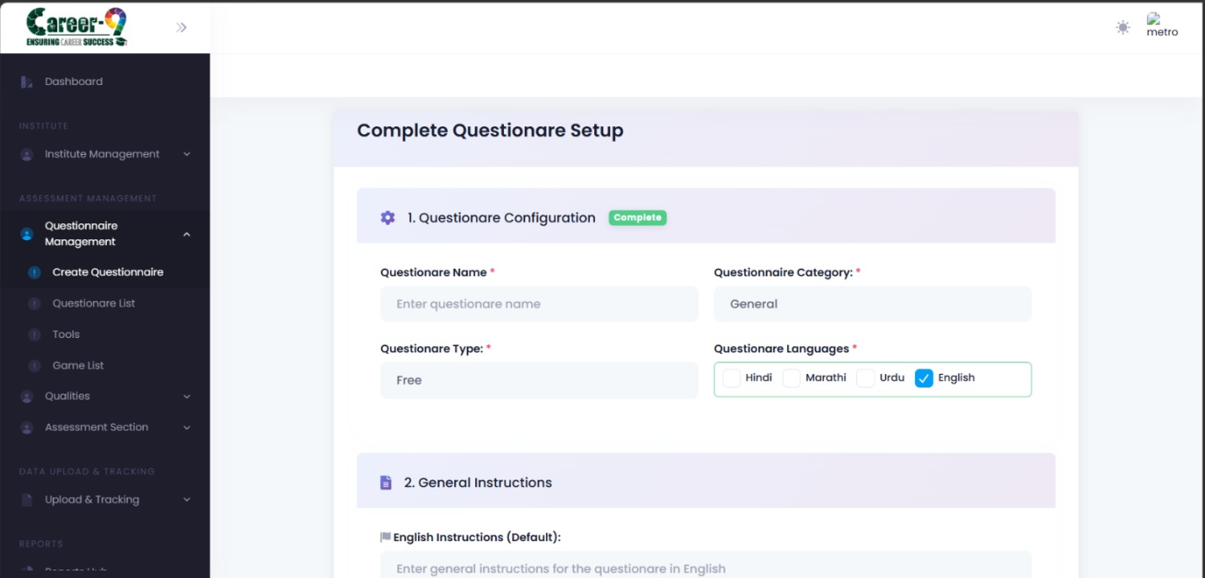Questionnaire builder
Step 4 — Create the Assessment
The assessment is what a student actually launches. It wraps a questionnaire and adds run-time settings (timing, visibility, pricing, tools, reports).
Navigation
1. Open Assessments from the menu.
2. Click the green Create Assessment button in the top-right. You land on /assessments/create.
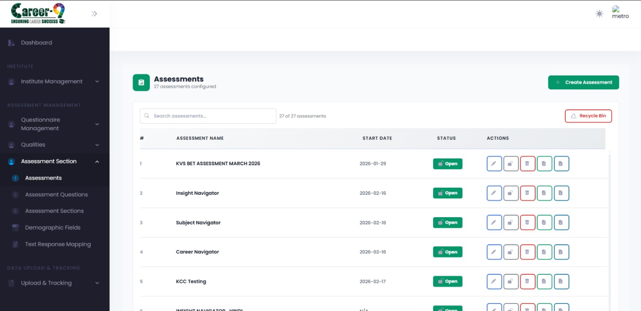Assessments list page with the Create Assessment button highlighted in the header.
Wizard steps
The create-assessment flow is a multi-step wizard. Each step is its own URL — you can go back with the browser back button or the wizard's Previous button.
• /assessments/create — basic details (name, description, questionnaire selection).
• /assessments/create/step-2 — scoring / measured quality setup.
• /assessments/create/step-3 — tools and report configuration.
• /assessments/create/step-4 — preview / validation.
• /assessments/create/step-5 — final review and publish.
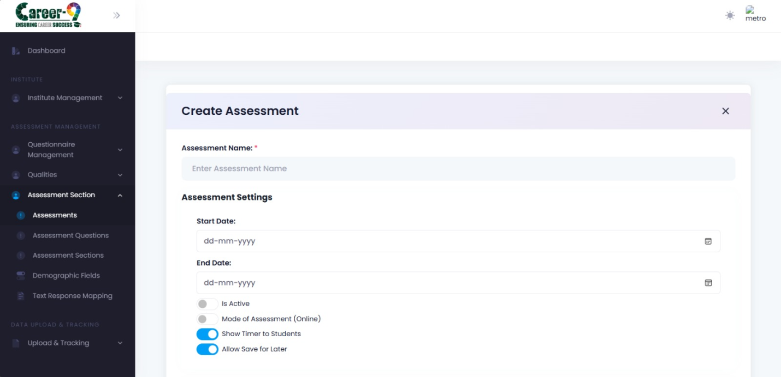Assessment wizard step 1 showing name, description, and questionnaire dropdown.
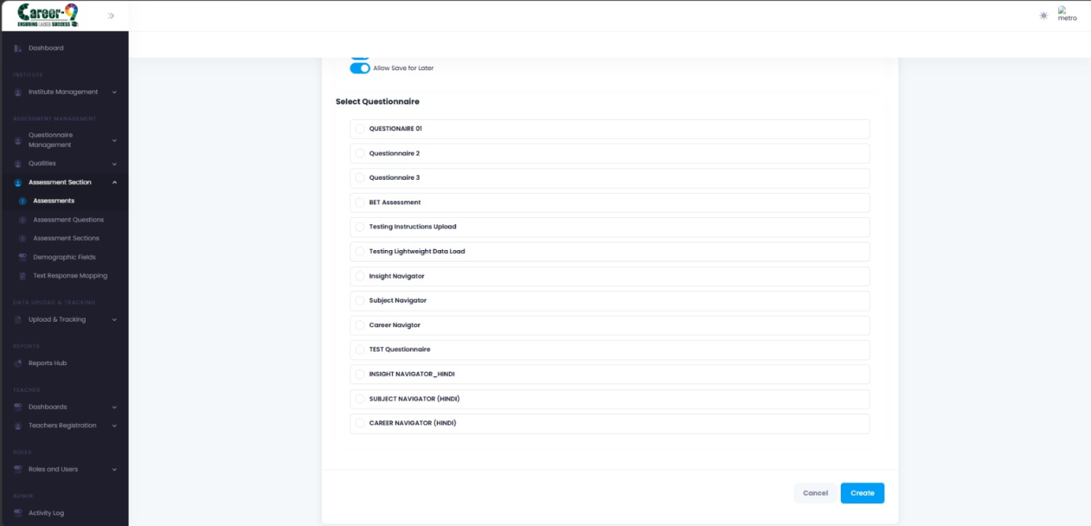Assessment wizard final step with Publish/Save button and a summary of the assessment.
After creation
The new assessment appears in the Assessments table. Use Assessment Mapping (see the Institute guide) to make it available to specific students, classes, or sessions in an institute.
Note: Assessments are inactive until mapped. Creating one does not automatically assign it to any students.

