How to Create an Institute
An institute (school or college) in Career-Nine holds a hierarchy of sessions → grades/classes → sections, and is the scope under which students enroll and take assessments. This guide covers creating the institute, adding its academic structure, and mapping assessments to it.
Step 1 — Create the Institute
Navigation
1. Open Institutes (Colleges) from the left menu.
2. Click the Create Institute button in the top-right of the Institutes table.
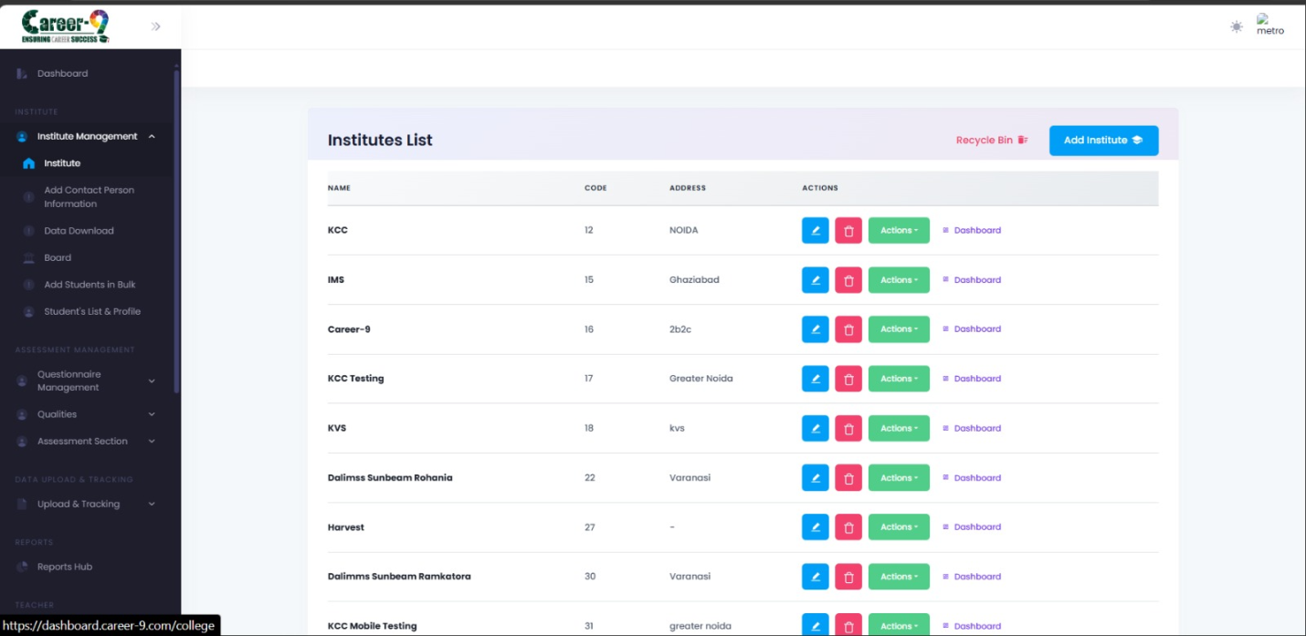Institutes list page with the Add Institute button visible.
Fill the Create Institute modal
• Institute Name — required. Display name shown across the app.
• Institute Address — required.
• Institute Code — required, unique identifier. Used as the foreign key everywhere.
• Maximum Students — required. Upper cap on the number of enrolled students.
• Maximum Contact Persons — required. Cap on assigned contact persons/counsellors.
• Logo — optional image upload. Max size 1 MB. Stored as base64 on the institute record.
3. Click Save. The modal closes and the new institute appears in the table.
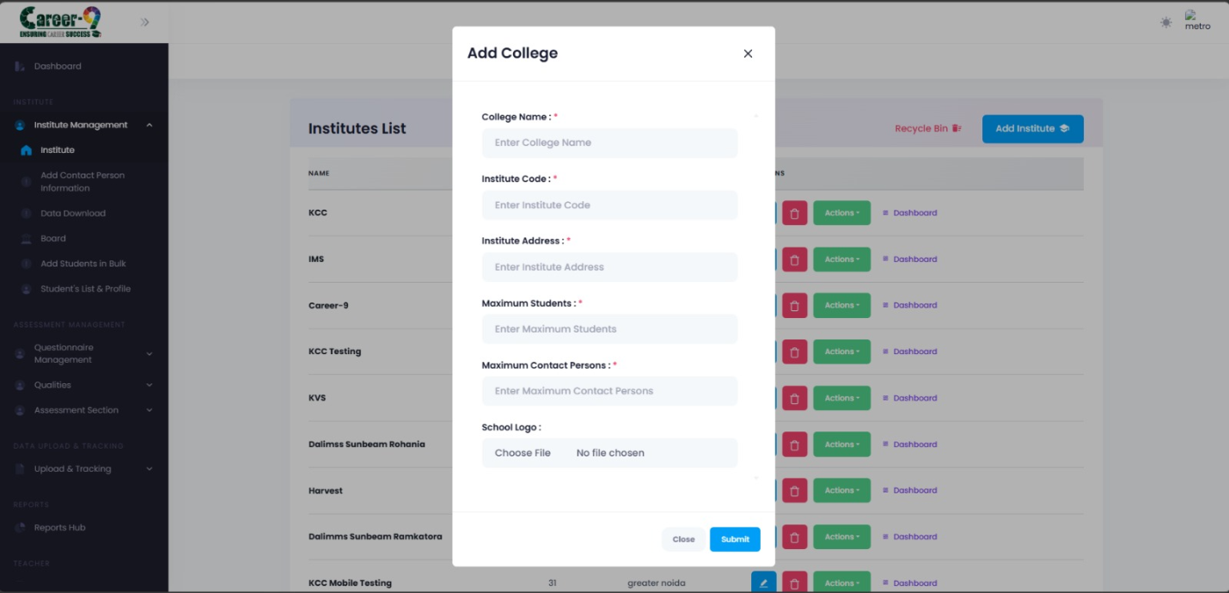Create Institute modal with all fields filled and logo preview visible.
Note: Institute Code must be unique. If you pick a value that already exists, the backend rejects the save.
Step 2 — Add Sessions, Grades and Sections
A fresh institute has no academic structure. You now add one or more sessions (e.g. '2025-26'), add grades/classes inside each session, and add sections inside each grade.
Open the structure editor
1. In the Institutes table, find the row for the institute you just created.
2. Click the row's action menu and choose Manage Sessions / Grades / Sections.
3. The Session–Grade–Section modal opens. Existing data (if any) loads from the backend for this institute code.
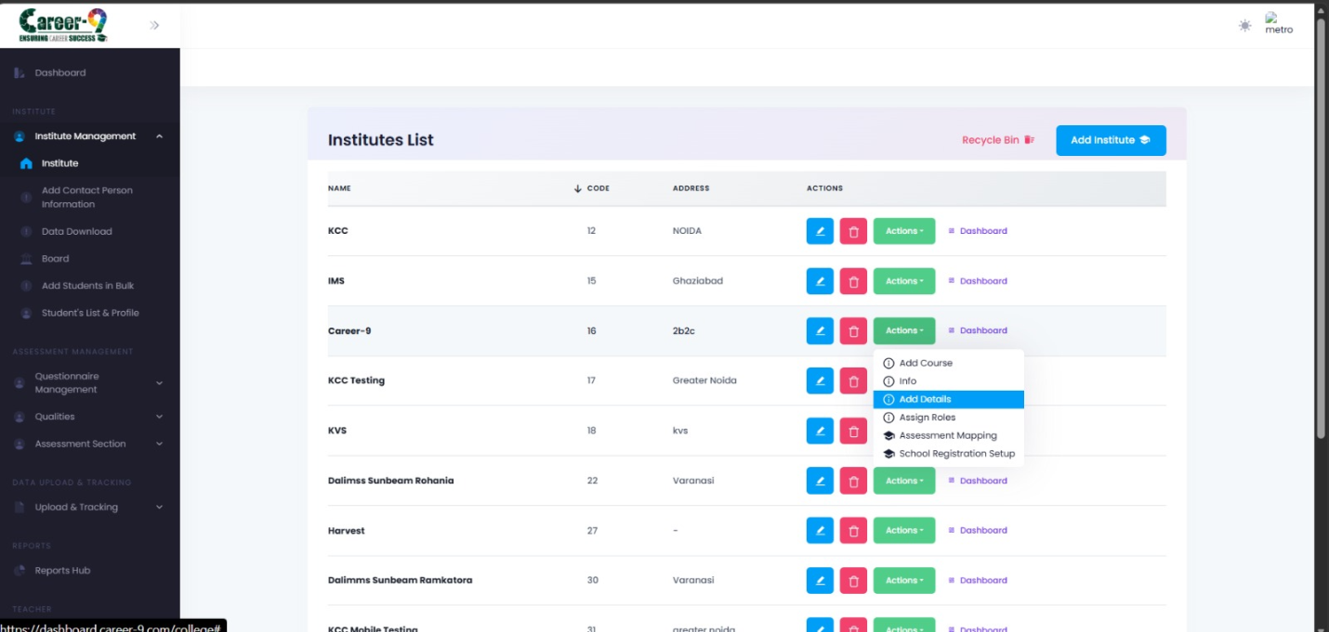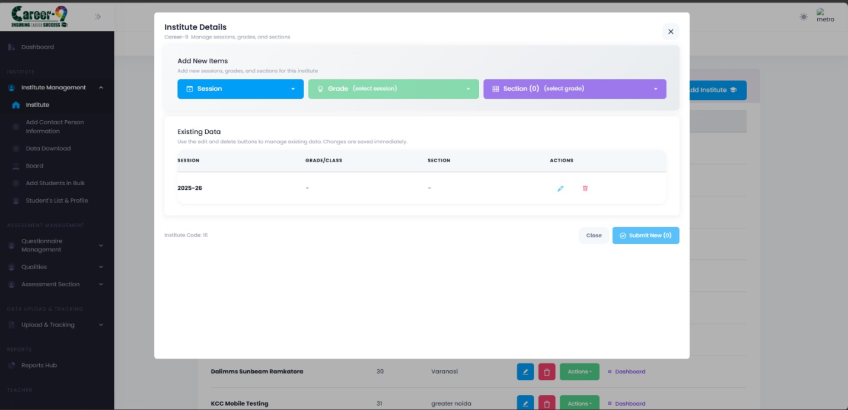Institute row action menu open with the 'Manage Sessions / Grades / Sections' option highlighted.
Add a session
1. In the Session dropdown area, type a session name (e.g. '2025-26') and click Add.
2. The new session appears below. Select it — it becomes the 'current session' for adding grades.
Add a grade
3. With a session selected, type a grade name (e.g. '10', '11', 'FY BSc') and click Add.
4. Select the grade to make it the current grade for adding sections.
Add a section
5. With a grade selected, type a section name (e.g. 'A', 'B', 'Commerce-1') and click Add.
6. Repeat as needed. Existing entries can be edited or deleted from the same panel (pencil / trash icons).
7. When done, click Save. All new sessions, grades, and sections are persisted in one call.
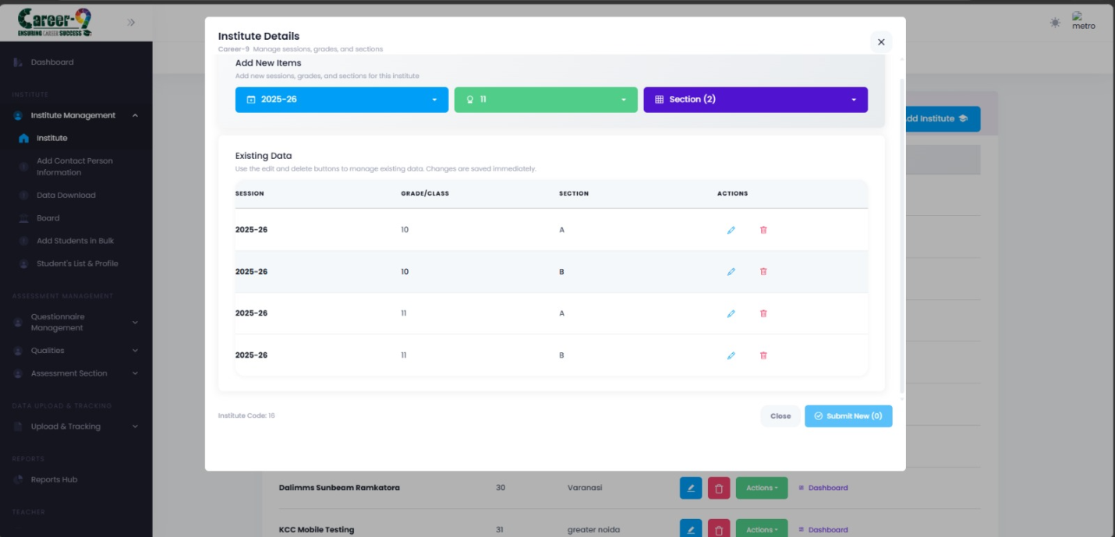Session–Grade–Section modal showing a session expanded with grades and sections beneath it.
Note: Editing or deleting an existing grade/section affects students already mapped to it — check usage before deleting anything created in a prior term.
Step 3 — Assessment Mapping
Mapping attaches an assessment to the institute at one of three scopes: an entire session, a specific class (grade) within a session, or a specific section within a class.
Open the mapping modal
1. In the Institutes table, open the row action menu for your institute.
2. Click Assessment Mapping. The modal loads the institute's sessions, the list of active assessments, and any existing mappings.
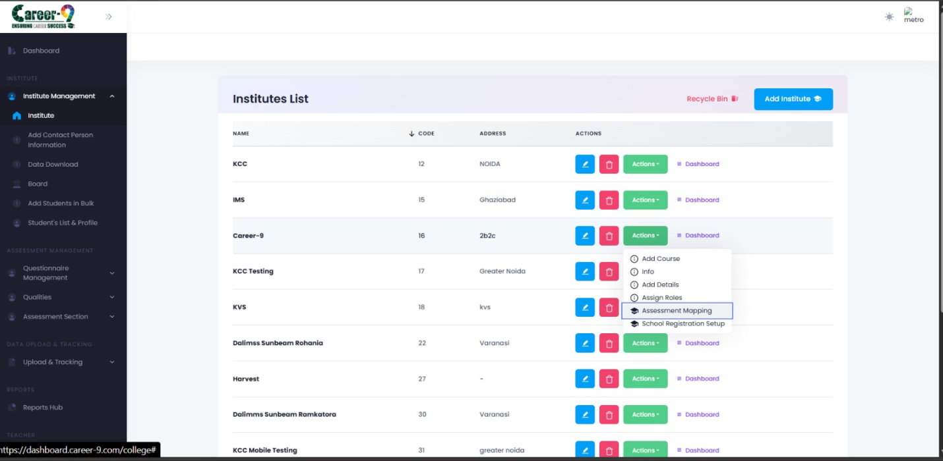Assessment Mapping modal, fresh open state, showing Assessment dropdown and mapping level selector.
Create a mapping
1. Pick an Assessment from the dropdown.
2. Pick a Mapping Level:
• SESSION — the assessment is available to every student in the chosen session.
• CLASS — restricted to a specific class within a session.
• SECTION — restricted to a single section within a class.
3. Based on the level, pick Session → then Class → then Section as applicable.
4. Optionally set an Amount (for paid assessments).
5. Click Create Mapping.
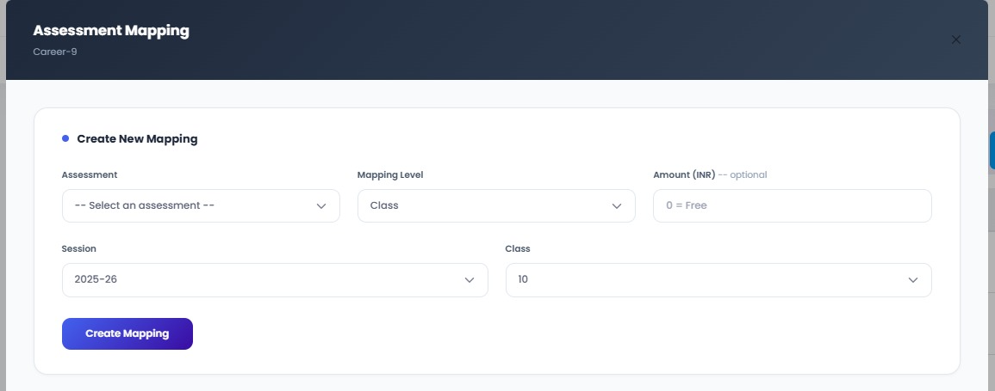Assessment Mapping modal with level set to CLASS and session + class selected.
Share links with students
Once a mapping exists, the modal shows the generated assessment link and a QR code. Students can open the link or scan the QR to launch the assessment.
• Click the copy icon next to a mapping to copy its link to the clipboard.
• Click the QR icon to preview the QR code, and Download to save it as an image.
• Click the trash icon on an existing mapping to remove it.
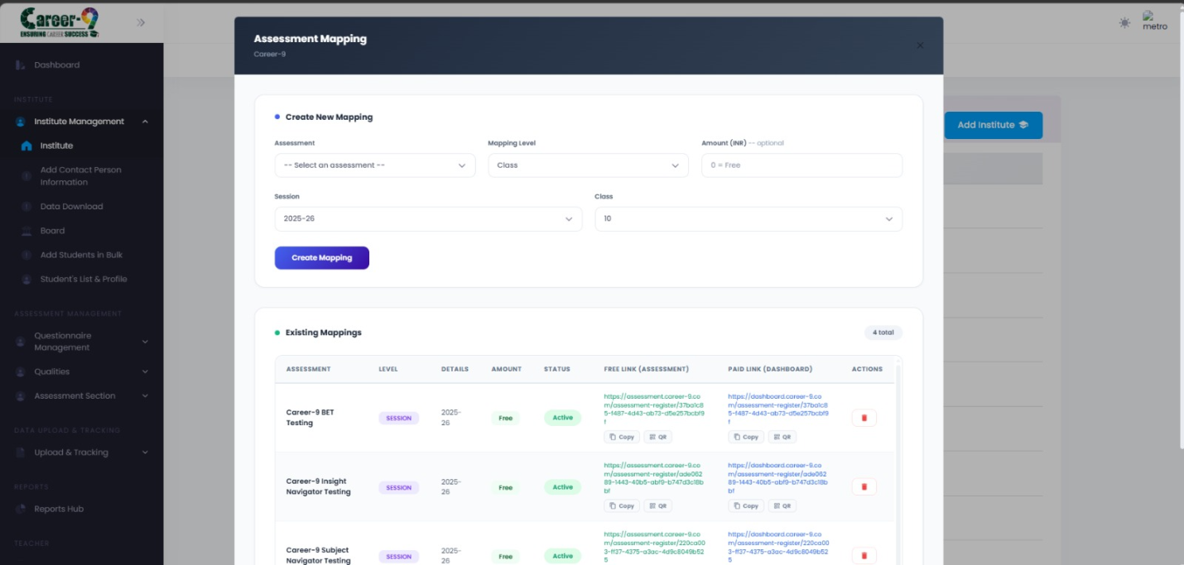Assessment Mapping modal showing an existing mapping row with Copy, QR, Download, and Delete actions.
Note: Only assessments with isActive != false show up in the dropdown. Inactive or archived assessments are filtered out.

