How to Upload Students in Bulk
Career-Nine supports bulk student creation via Excel/CSV, scoped to an institute. This avoids entering each student one-by-one through the Create Student modal.
Note: Before uploading, the target institute must exist and must have at least one session, grade, and section configured (see the 'Create an Institute' guide, Step 2).
Step 1 — Prepare the Spreadsheet
Create an Excel (.xlsx / .xls) or CSV file with one row per student. The first row must contain column headers.
Required / recommended columns
• name — full name of the student.
• email — student email address.
• rollNo (or schoolRollNumber) — institute-side roll number.
• phoneNumber — optional contact number.
• dob — date of birth (DD-MM-YYYY recommended).
• session / class / section — names must match the ones you created for the institute.
Note: Column names are case-sensitive. If the upload silently skips rows, open the uploaded file and verify headers match what the backend expects.
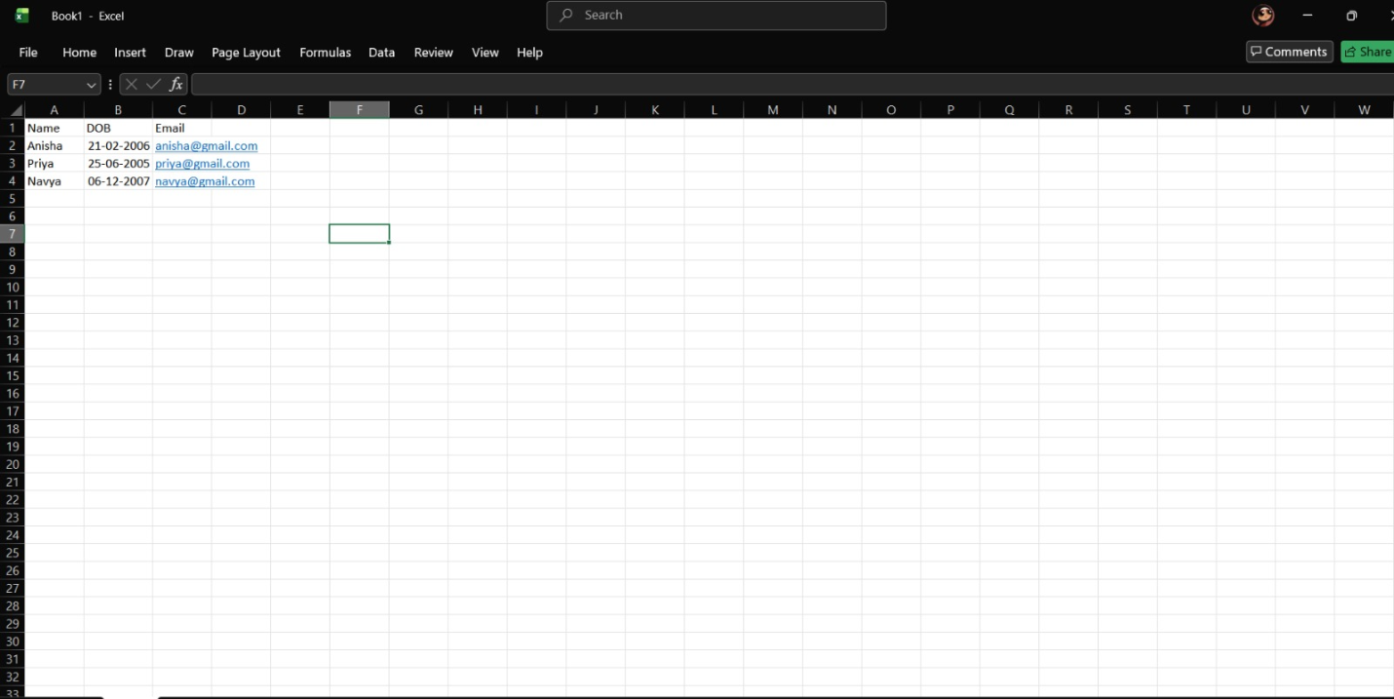Sample students.xlsx opened in Excel showing header row and 3–5 example student rows.
Step 2 — Open the Upload Dialog
1. Open Institutes from the left menu.
2. Find the target institute in the table.
3. Open the row action menu and click Upload Students.
4. The Upload Students modal opens and displays the institute name at the top so you can confirm the target.
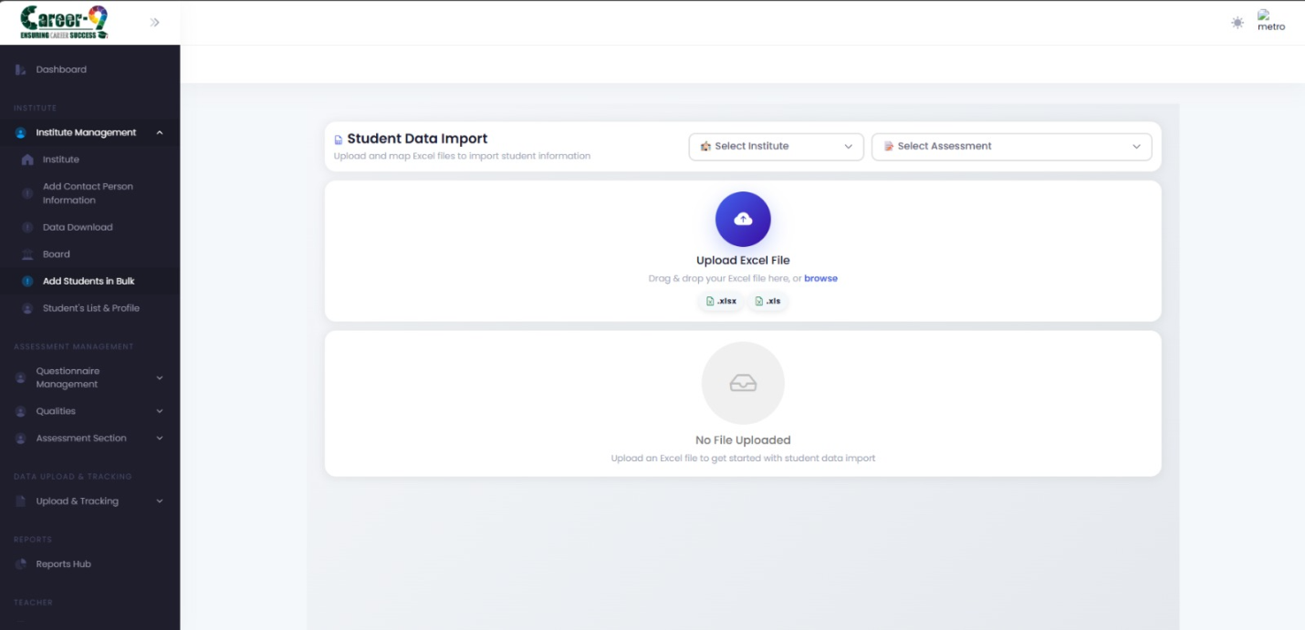Institute row action menu with 'Upload Students' highlighted.
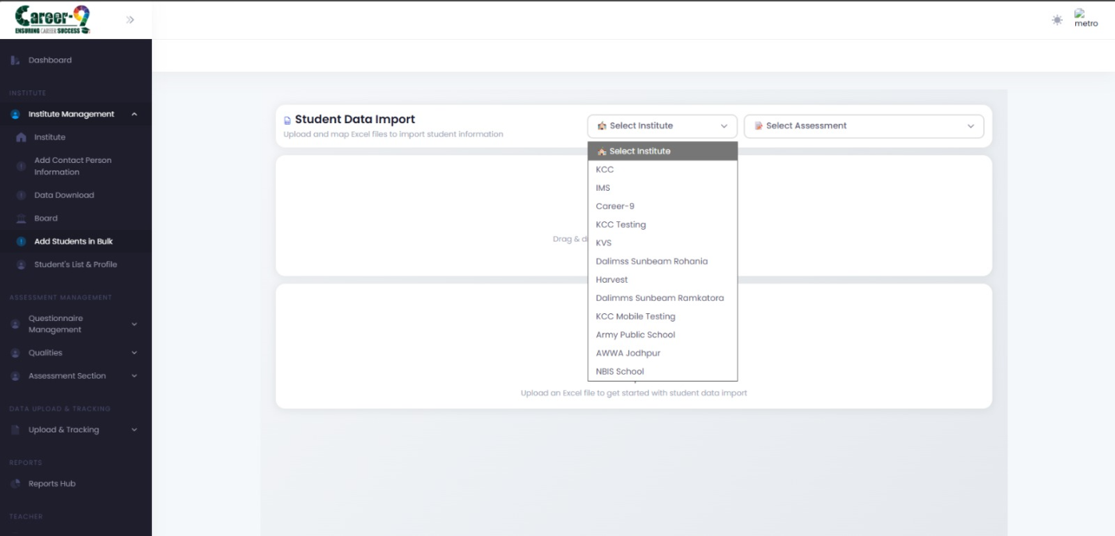Upload Students modal showing the institute name and the file picker.
Step 3 — Upload the File
1. Click Choose File and select the prepared .xlsx / .xls / .csv file.
2. Confirm the correct file appears in the picker.
3. Click Upload.
4. Wait for the success message. The modal reports row-level results when available.
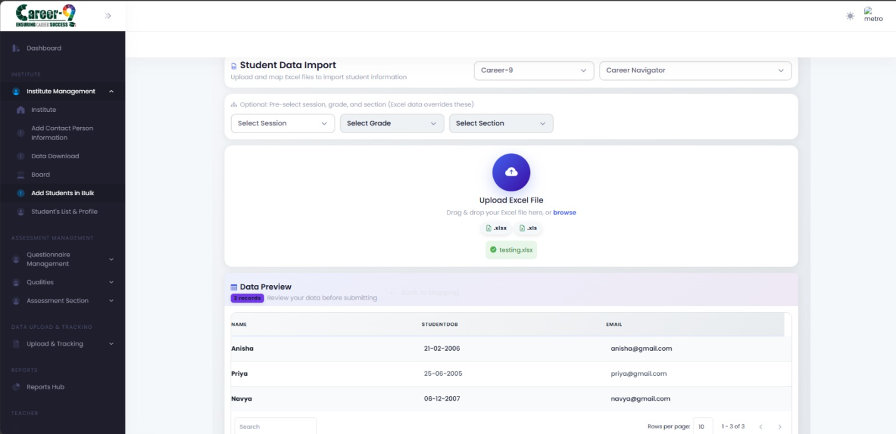Upload Students modal with a file selected and the 'Uploaded successfully' confirmation.
Step 4 — Verify the Results
1. Close the upload modal.
2. Open Student Information (or the institute's student list) from the menu.
3. Filter by institute / session / class / section and confirm the newly uploaded students are present with the expected fields.
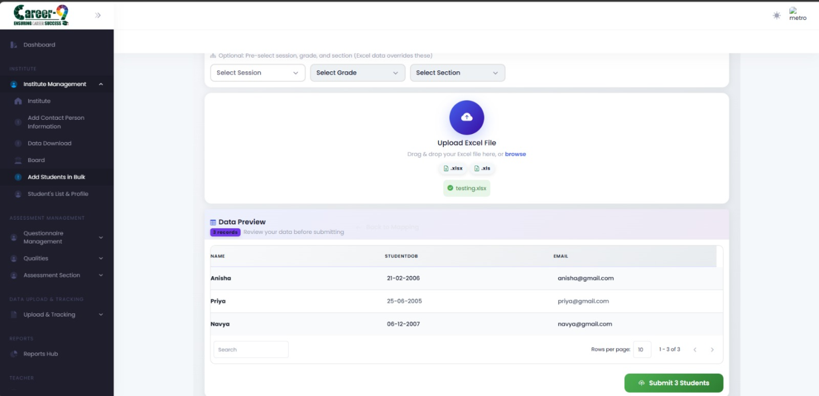Student Information list filtered to the target institute showing the Submit students button.
Common issues
• Session/Class/Section name mismatch — rows are rejected because the hierarchy lookup fails. Fix the spreadsheet or add the missing entries in the institute structure editor.
• Duplicate email or roll number — the backend enforces uniqueness; duplicates fail while valid rows still succeed.
• Date format — prefer DD-MM-YYYY. ISO (YYYY-MM-DD) is also accepted by most fields but mixing formats in the same column causes parse errors.
• File too large — split into multiple files (e.g. 500 rows each) if the upload times out.
Note: Students uploaded in bulk are not auto-assigned to any assessment. Use Assessment Mapping on the institute to make assessments available to them, or assign them per-student from the Student Information page.

