How to Generate Reports from the Reports Hub
The Reports Hub is the one-stop page to generate, preview, download, release, and send student reports for a given assessment. It lives at /reports-hub in the app.
Step 1 — Select Institute and Assessment
1. Open Reports Hub from the left menu.
2. At the top of the page, select a School / Institute from the first dropdown.
3. The Assessment dropdown becomes enabled and is filtered to assessments mapped to that institute. Select an assessment.
4. The page loads the student list and existing report data for that combination.
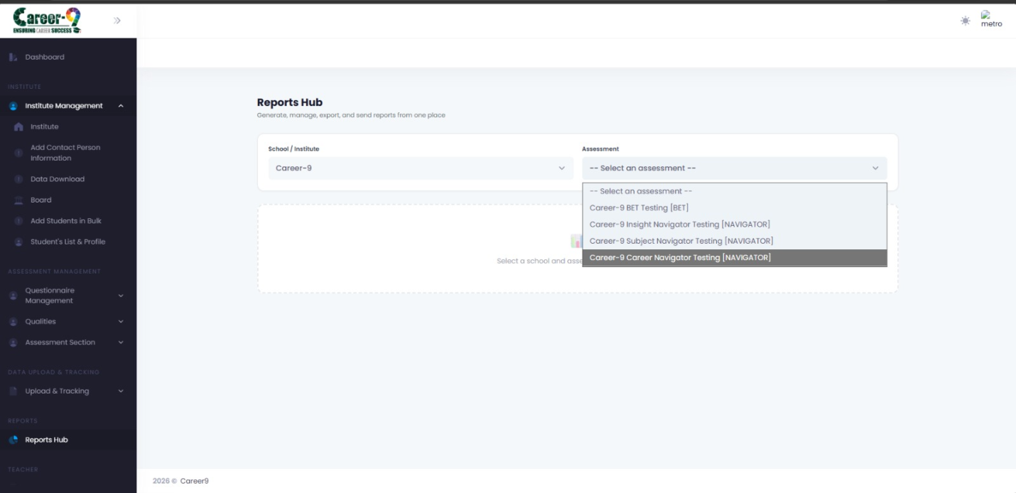Reports Hub header with School/Institute and Assessment dropdowns both filled.
Note: If the Assessment dropdown is empty, there is no Assessment Mapping for this institute yet. Create one from the Institutes page first.
Step 2 — Filter the Student List
Once a student list loads, use the filter bar to narrow down who you are generating for.
• Search — by name, roll number, email, or DOB.
• Grade / Class — dropdown of grades present on this institute.
• Section — dropdown of sections present on this institute.
• Pagination — bottom of the table; adjust page size for large cohorts.
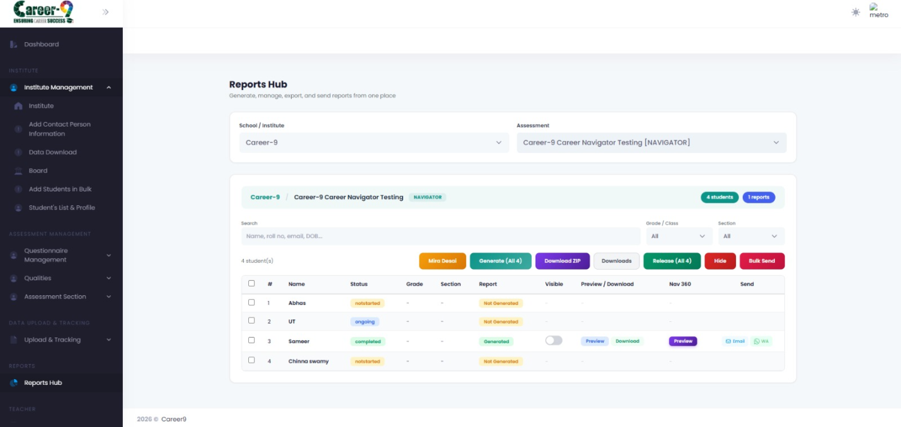Reports Hub student table with Search, Grade, and Section filters applied.
Step 3 — Select Students
Reports Hub operates in two modes: all displayed students, or an explicit selection.
• Header checkbox — select/deselect every student on the current page.
• Row checkbox — select an individual student.
• The action button count label shows '(N)' when students are selected, or '(All X)' when nothing is explicitly picked.
 Student table with several rows selected, showing the count label next to the Generate button.
Step 4 — Generate Reports
1. Click the Generate button (green gradient).
2. A progress bar appears below the action bar showing the current step and processed-count.
3. When generation finishes, each processed student's Report column flips from 'Not Generated' to 'Generated'.
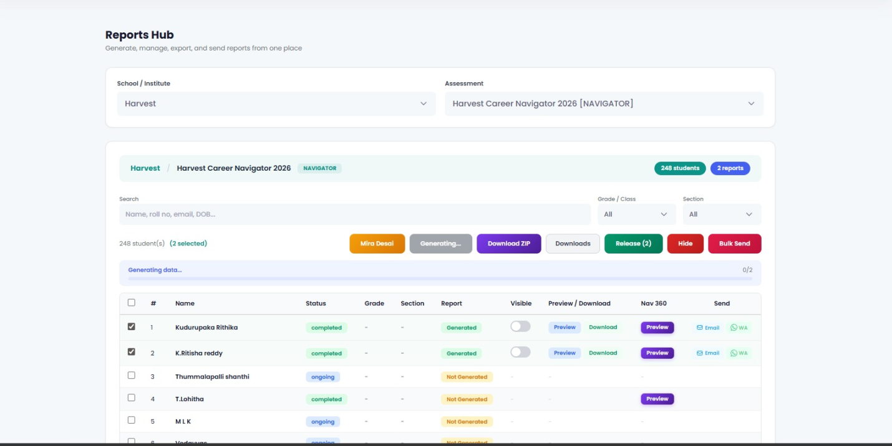Reports Hub with the Generate progress bar mid-run.
Note: Generation is incremental — re-running it only processes students whose reports are missing or have been invalidated.
Step 5 — Preview and Download
Per-student
• Preview — opens the report in a new tab.
• Download — downloads a PDF named '{student}_Career_Navigator.pdf' (or '{student}_BET_Report.pdf' for BET assessments).
• Nav 360 — where available, opens the Navigator 360 preview for the student.
Single row in the Reports Hub table with Preview, Download, and Nav 360 buttons visible.
Bulk download (ZIP)
1. Click Download ZIP. You will be prompted for a zip name.
2. The ZIP job starts in the background. Click Downloads to open the Downloads Manager modal.
3. The Downloads Manager shows progress, lets you delete old jobs, and provides a final download link when the job completes.
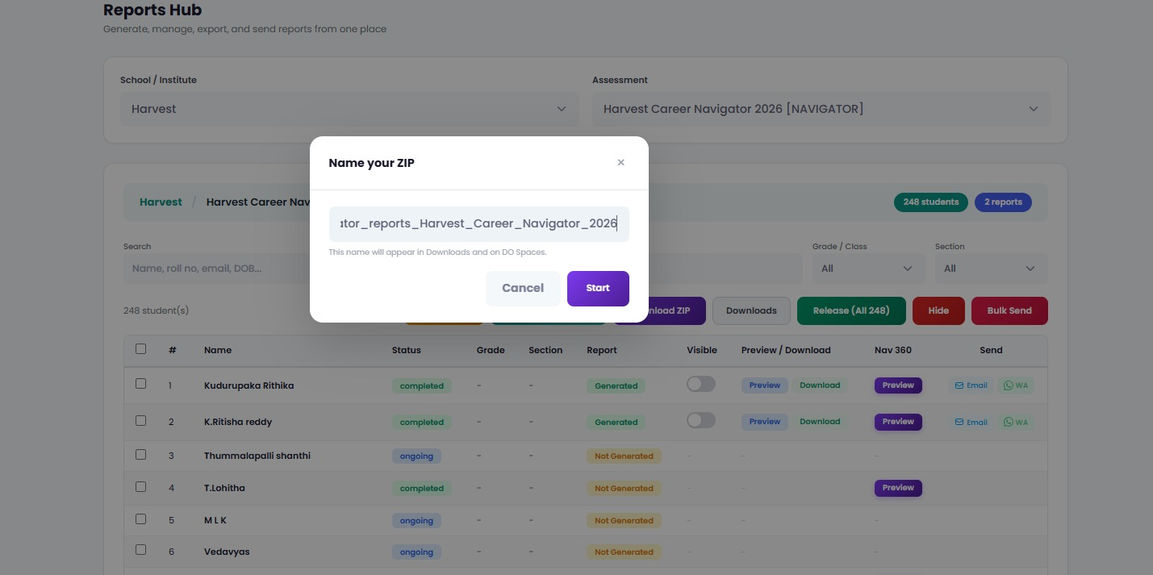Downloads Manager modal listing one in-progress ZIP job and one completed job with a Download link.
Step 6 — Release or Hide Reports
Reports are hidden from students by default after generation. You must explicitly release them.
• Release — flips the Visible toggle ON for the selected (or all displayed) students. They can now see their own report in the student portal.
• Hide — flips the toggle OFF. Use this if a report needs correction or should be pulled back.
• Per-row toggle — the Visible column has a switch to release/hide a single student without touching the bulk action.
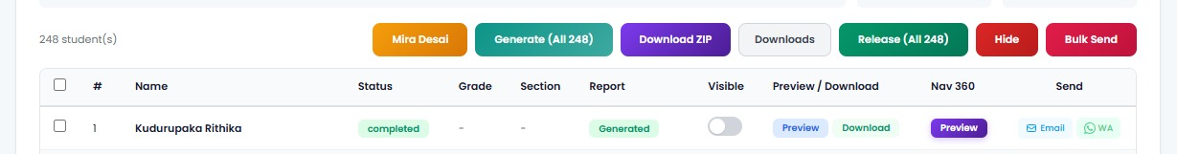Reports Hub action bar with the Release and Hide buttons, plus per-row Visible toggles in the table.
Step 7 — Send Reports to Students
Bulk Send
1. Click Bulk Send (pink gradient).
2. The Bulk Send modal opens. Choose the delivery channel (email / WhatsApp) and confirm the recipient list.
3. Click Send. The modal reports per-recipient success and failure counts.
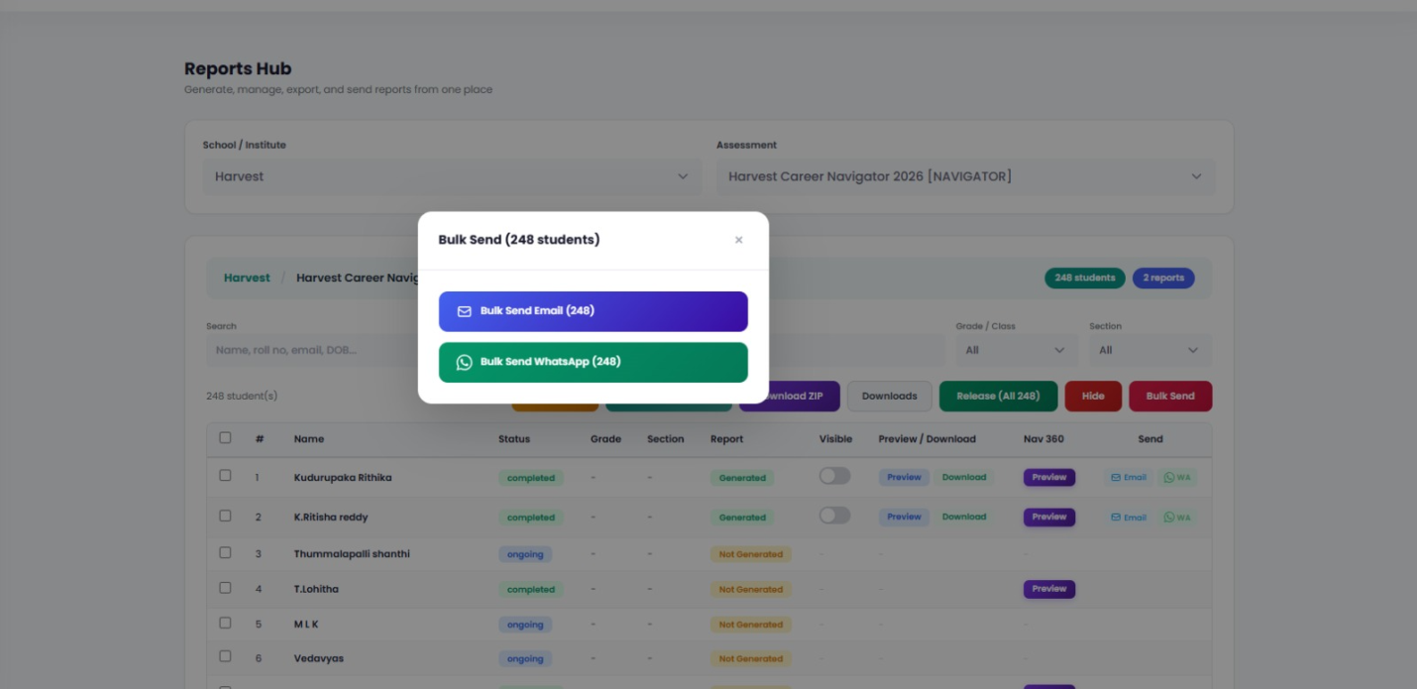Bulk Send modal showing channel selection and a preview of the recipient list.
Email Compose
From the compose flow you can customize the subject and body. Template variables {{student_name}} and {{report_link}} are replaced per-student automatically.
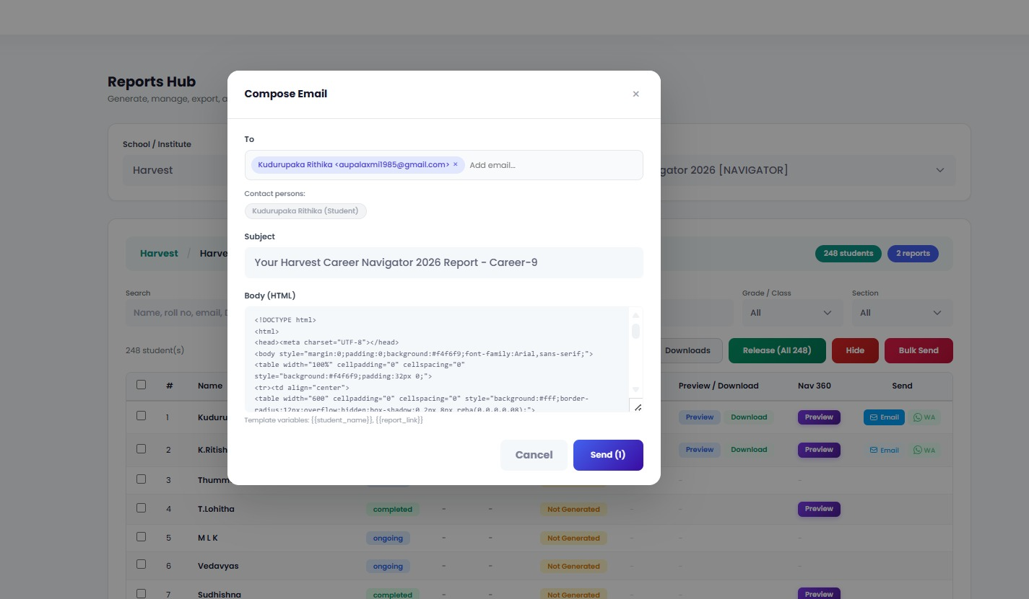Email Compose modal with subject/body fields and template variables visible.
WhatsApp
Bulk WhatsApp uses a pre-approved template ('report_notification') with parameters [student name, assessment name, report URL]. Only students with a saved phone number and a generated report are included.
Additional Actions
• Mira Desai — opens the Mira Desai modal for that assessment (special report variant).
• Nav 360 Preview — per-row button, only shown when the student's assessment status is 'completed'.
• School Report — opens the school-level (aggregated) report modal.
Status Reference
Assessment status badges
• notstarted — student has not opened the assessment yet (yellow).
• ongoing — student has started but not submitted (blue).
• completed — submitted; eligible for report generation (green).
Report status badges
• Not Generated — no report file exists yet (yellow).
• Generated — report file exists and is ready to preview/download/release (green).
Note: A student with status 'ongoing' or 'notstarted' can still have Generate clicked on their row, but the backend will skip them — only 'completed' students produce a report.

