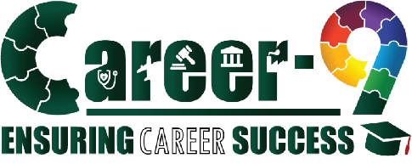


{{ f_name }}’S
CAREER
NAVIGATOR
REPORT


{{ school }}
{{ class }}
{{ name }}
School Name
Grade
Name
Student Details:

Career-9:

A Paradigm Shift in the Realm of Career Selection:

Congratulations {{ f_name }}, on embarking on this exciting journey of career exploration! It's a significant step, and we're thrilled to support you in navigating the path ahead. Your personalized report will offer valuable insights and help illuminate the career pathways that align with your unique skills and interests. Welcome aboard!

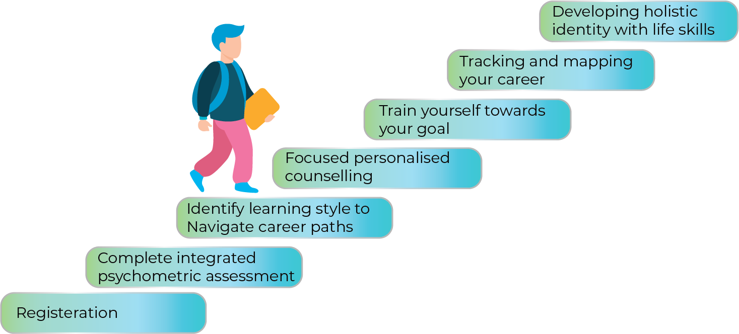

The insights you find in this report have been meticulously crafted using Career9's Proprietary Career Selection Model, which stems from our extensive research and expertise. The specific scores you see here are the driving force behind the suggested career options for each individual. However, it's imperative to realise that personal preferences and talents can evolve over time. Therefore, consider this report ONLY as an early indicator/a guide to the most suitable career choices, as assessed at this moment.
.

NAVIGATOR 360:

Dear {{ f_name }},
NAVIGATOR 360, Career-9's proprietary tool takes your career exploration to the next level. With unmatched precision, this tool evaluates you across six critical pillars, ensuring a deep understanding of your strengths, interests, and potential. It's not just about finding a job; it's about discovering the career that truly fits you. Career-9 is proud to offer this cutting-edge tool, designed to give you a clear and confident path forward. With NAVIGATOR 360, you're not just navigating your career, you’re mindfully mastering it. Let Career-9 guide you to a future that's as ambitious and dynamic as you are.

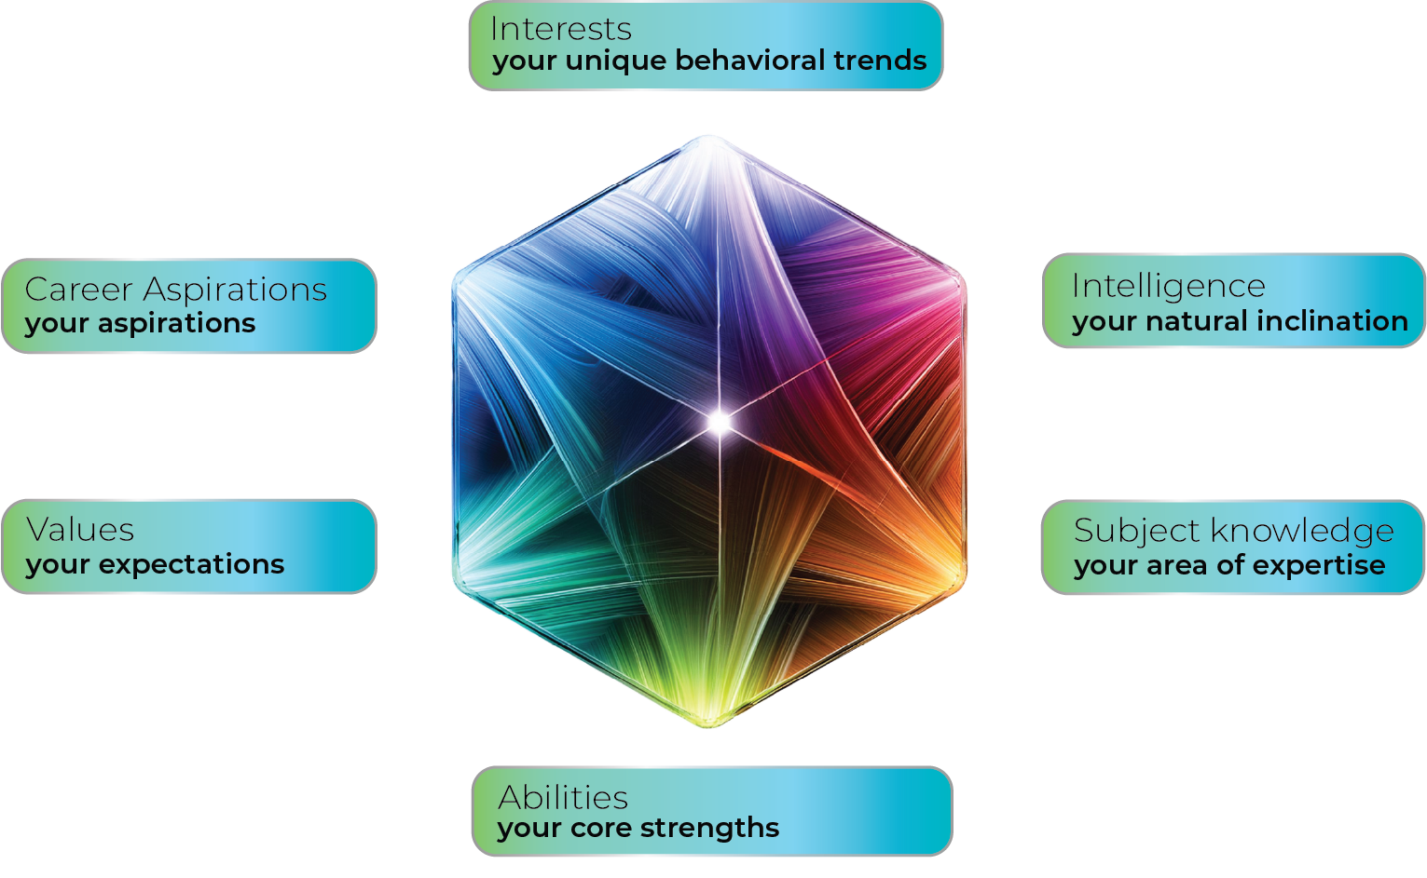

Everyone has preferences like their favourite subjects, strong abilities, firm beliefs that they hold close to their heart and start to dream and aspire for a successful career. The four pillars of NAVIGATOR 360 are dedicated to understanding your ‘Preferences’. However, every student has a treasure of abilities unexplored; and NAVIGATOR 360 with its AI technology finds your unique ‘Personality’ and ‘Intelligence’ as well and helps it shine by aligning it with your ‘Preferences’. Together, the 6 Pillars of Career-9’s NAVIGATOR 360 help you become the best version of yourself!

Report Synopsis:



{{ summary }}


{{ page_break }}

{{ f_name }}’s Profile:

Your Innate Attributes comprise of Personality and Intelligence. These attributes are then aligned with your preferences to identify the most suitable career options for you.


Personality:
{{ name_caps }}’S PERSONALITY PROFILE
{{ personality_graph }}

Your personality is the vibrant splash of colours on the canvas of life, a dynamic blend of behaviours, emotions, and patterns that make you unmistakably you! It's the signature tune that plays in the background of your life's story, setting you apart from the crowd. Your strongest temperaments are:

{{ personality_1_image }}
{{ personality_1_text }}

{{ personality_2_image }}
{{ personality_2_text }}

{{ personality_3_image }}
{{ personality_3_text }}

Intelligence:
{{ name_caps }}’S INTELLIGENCE PROFILE
{{ intelligence_graph }}

Intelligence is the vibrant energy that fuels our curiosity and drives our quest for knowledge. It shapes how we absorb and process new information, tailoring a learning style that's as unique as our fingerprints. Your top three intelligence types are:

{{ intelligence_1_image }}
{{ intelligence_1_text }}

{{ intelligence_2_image }}
{{ intelligence_2_text }}

{{ intelligence_3_image }}
{{ intelligence_3_text }}
{{ page_break }}

{{ f_name }}’s Learning Style


{{ learning_style_3 }}
{{ learning_style_1 }}
{{ learning_style_2 }}

- {{ struggles_with_1 }}
- {{ struggles_with_2 }}
- {{ struggles_with_3 }}
- {{ enjoys_with_1 }}
- {{ enjoys_with_2 }}
- {{ enjoys_with_3 }}
You enjoy studies with
You struggle with


Learning Style:

{{ learning_style }}
{{ page_break }}

{{ f_name }}’s Preferences
Over a period of time, we acquire knowledge, interests, abilities and certain values. Together they strongly influence our career decision. Below is a list of preferences selected by you as your strengths.
Subjects of Interest
There are some topics that we find more interesting over others. Knowing about them and learning is always fascinating. Following is the list of subjects of your interest.
- {{ soi_1 }}
- {{ soi_2 }}
- {{ soi_3 }}
- {{ soi_4 }}
- {{ soi_5 }}
Abilities
With exposure and practice we master certain skill sets called ‘abilities’. These abilities are your core strengths.
- {{ ability_1 }}
- {{ ability_2 }}
- {{ ability_3 }}
- {{ ability_4 }}
- {{ ability_5 }}
Values are principles and beliefs we hold close to us. They define our expectations
from a ‘Career’.
Values
  - {{ values_1 }}
  - {{ values_2 }}
  - {{ values_3 }}
  - {{ values_4 }}
  - {{ values_5 }}
Career Aspirations
Career Aspiration is a long-term professional goal that you aim to achieve in your future career path, based on your interest and strengths.
- {{ career_asp_1 }}
- {{ career_asp_2 }}
- {{ career_asp_3 }}
- {{ career_asp_4 }}

{{ f_name }}’s Career Suitability Index:

Let’s explore the horizons of various career choices and identify the most suitable that fits your unique career personality and intelligence.
Least Suited
Moderate Suited
Most Suited
{{ pathway_1 }}
{{ pathway_2 }}
{{ pathway_3 }}
{{ pathway_4 }}
{{ pathway_5 }}
{{ pathway_6 }}
{{ pathway_7 }}
{{ pathway_8 }}
{{ pathway_9 }}

Top 3 Career Pathways for {{ f_name }}

Strengths matched - Potential unleashed! Expertly crafted pathways, powered by
cutting-edge tech, guide you to success. Embrace the adventure and see where
your potential can take you!

Pathway 1 - {{ pathway_1 }}

{{ pathway_1_text }}
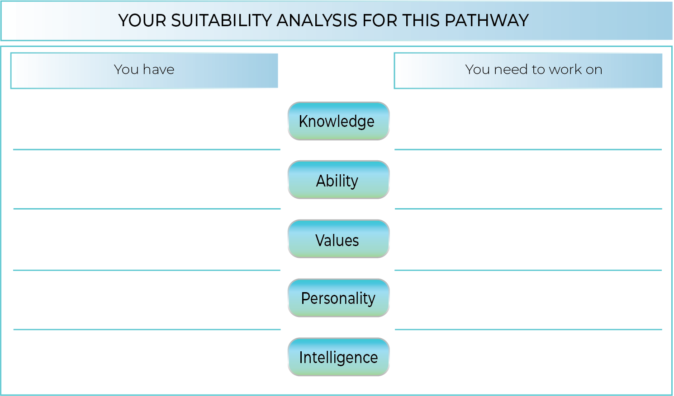
{{ cp1_soi_has }}
{{ cp1_ability_has }}
{{ cp1_values_has }}
{{ cp1_personality_has }}
{{ cp1_intelligence_has }}
{{ cp1_soi_lacks }}
{{ cp1_ability_lacks }}
{{ cp1_values_lacks }}
{{ cp1_personality_lacks }}
{{ cp1_intelligence_lacks }}

The pathway of {{ pathway_1 }} requires following skills and subject and includes following occupations

{{ cp1_exams }}
{{ cp1_courses }}
{{ cp1_skills }}
{{ cp1_subjects }}


Pathway 2 – {{ pathway_2 }}


{{ pathway_2_text }}


{{ cp2_soi_has }}
{{ cp2_ability_has }}
{{ cp2_values_has }}
{{ cp2_personality_has }}
{{ cp2_intelligence_has }}
{{ cp2_soi_lacks }}
{{ cp2_ability_lacks }}
{{ cp2_values_lacks }}
{{ cp2_personality_lacks }}
{{ cp2_intelligence_lacks }}
The pathway of {{ pathway_2 }} requires following skills and subject and includes following occupations

{{ cp2_subjects }}
{{ cp2_skills }}
{{ cp2_courses }}
{{ cp2_exams }}


Pathway 3 – {{ pathway_3 }}


{{ pathway_3_text }}


{{ cp3_intelligence_lacks }}
{{ cp3_personality_lacks }}
{{ cp3_values_lacks }}
{{ cp3_ability_lacks }}
{{ cp3_soi_lacks }}
{{ cp3_intelligence_has }}
{{ cp3_personality_has }}
{{ cp3_values_has }}
{{ cp3_ability_has }}
{{ cp3_soi_has }}

The pathway of {{ pathway_3 }} requires following skills and subject and includes following occupations

{{ cp3_subjects }}
{{ cp3_skills }}
{{ cp3_courses }}
{{ cp3_exams }}

Future Suggestions

Here are some activities tailored specifically for you. Like we try various styles of clothing or food, try each of them and make a note of what suits you the best

{{ can_at_home }}
{{ can_at_school }}

Recommendations

Considering all the three pathways, we would love to assist you in improving your {{ weak_ability }} skills that are essential to help you shine in any field of your choice.

Here are some tips for you:
{{ recommendations }}

These activities not only sharpen your {{ weak_ability }} skills but also prepare you for real-life challenges you may encounter in the future.
{{ page_break }}

Which Career pathways align to your aspirations?

NAVIGATOR 360 has crunched the numbers, aligning your unique personality and intelligence with your skills and values to unveil the top three career paths where you'll shine. Now let’s compare your aspirations with your most suited career paths.

{{ name_caps }}’S CAREER PATHWAYS
{{ name_caps }}’S ASPIRATIONS
{{ pathway_1 }}
{{ career_asp_1 }}

{{ pathway_2 }}
{{ career_asp_2 }}

{{ pathway_3 }}
{{ career_asp_3 }}

{{ career_asp_4 }}

{{ result }}
{{ page_break }}
Frequently Asked Questions

- What if my pathway does not match with my subject knowledge?
{{ f_name }}, there can be various reasons for a lack of subject knowledge in one's aspired career. It could be due to a rapid pace of technological advancements outpacing one's current knowledge, or even a lack of exposure to relevant career activities that build such knowledge. Additionally, self-efficacy, which is the belief in one's ability to succeed, plays a significant role. Studies have shown that individuals with higher self-efficacy are more likely to acquire and apply career-related knowledge effectively. Therefore, addressing these factors through targeted education, training, and confidence-building activities can help bridge the knowledge gap.
- What if my pathway does not match with ability?
Common factors include a mismatch of skills, lack of exposure, or not having a clear understanding of the career's requirements. It's important to assess one's strengths and weaknesses, seek feedback, and consider additional training or education. Sometimes, it's also about gaining more hands-on experience or finding a mentor to guide you through the industry. Remember, career paths are rarely linear, and it's never too late to acquire new skills or change direction.
- What if my pathway does not match with my values?
Sometimes, a lack of clarity about personal values or how they can influence professional environment can lead to uncertainty in career direction. It's important to reflect on what you find meaningful and fulfilling, whether it's materialistic achievements, people-oriented needs, making a positive societal impact, or seeking a sense of purpose. Understanding these core values can guide you towards a career that resonates with your beliefs and goals. If you're experiencing a disconnect, it might be beneficial to explore various aspects of your life and career to pinpoint values that are truly important to you.
- What if there is no dominant personality trait?
Don’t worry! not having a dominant personality trait can be due to various factors. One possible reason could be that you may exhibit ‘traits’ from ‘multiple traits’ which are not fully explored, which makes a single category less definitive. Additionally, cultural and environmental factors can influence your preferences, which the model might not fully account for. Or sometimes there are other personal or mental health challenges that make it difficult to shine in one area.

Our expert psychologist and a team of career counselors is just a call away to help you reach your full potential and become the best version of yourself.

