Isaac St Hubert
Module 1.2

https://github.com/isthubert/csd-325.git

Verified Directory
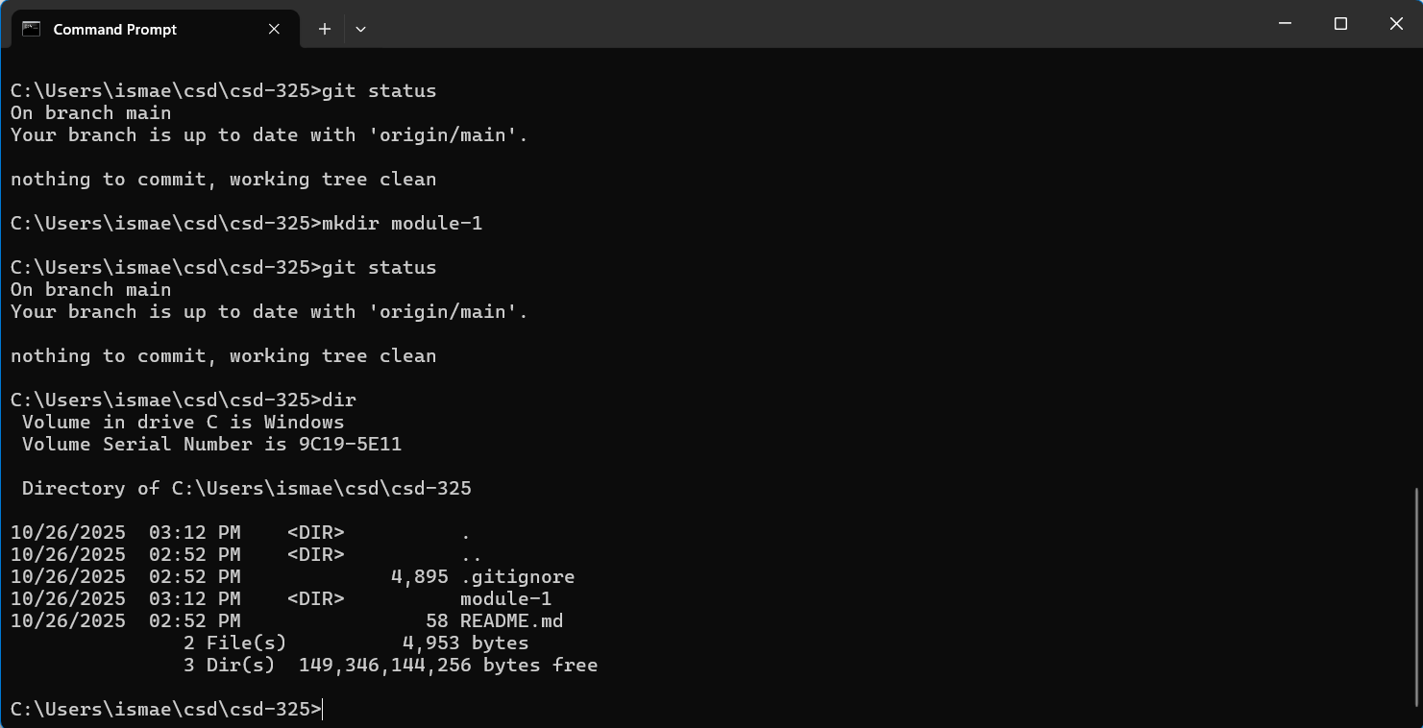

GitHub Repository
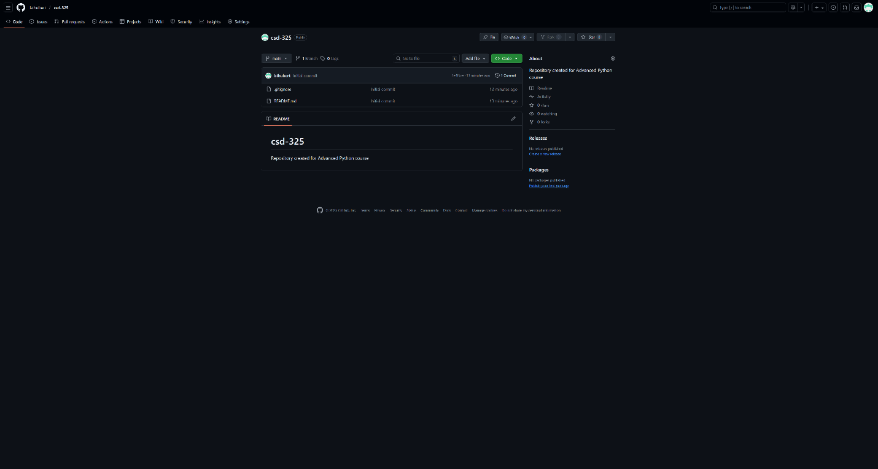

Local Directory
