http://api.open-notify.org/astros.json
No formatting
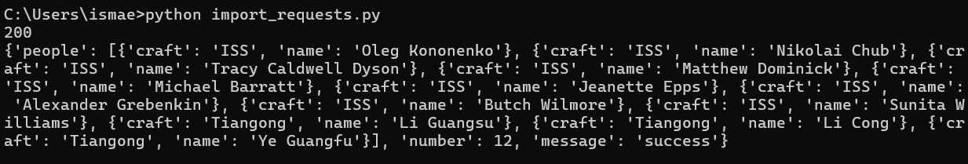

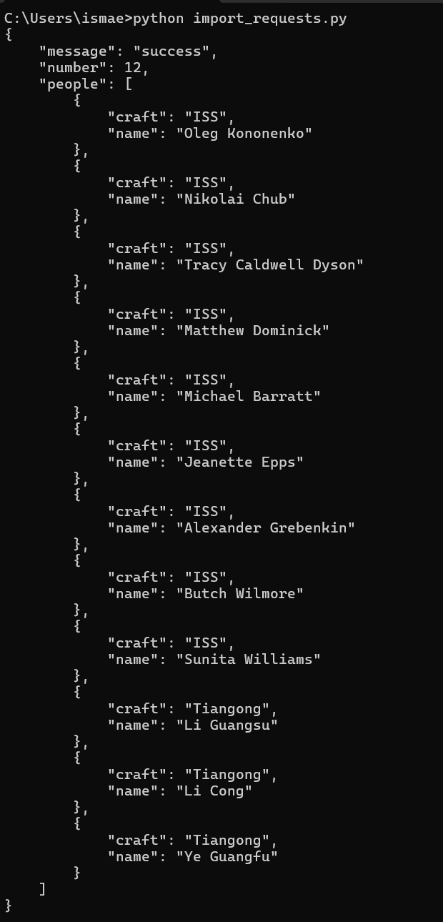
Formatting

https://anapioficeandfire.com/api/characters/583
