A PROGRESSIVE WEB APPLICATION–BASED QUEUE MANAGEMENT SYSTEM WITH GEOLOCATION, GEOFENCING, AND PRIORITY-BASED QUEUE ALGORITHM




A CAPSTONE AND RESEARCH PROJECT

BY:
NATHANE C. MARTIN
ERNEST WIN I. MONTES
RYAN BUSTY D.C. PARAS
STEVE GATES S. ROQUERO

APRIL 2026

A PROGRESSIVE WEB APPLICATION–BASED QUEUE MANAGEMENT SYSTEM WITH GEOLOCATION, GEOFENCING, AND PRIORITY-BASED QUEUE ALGORITHM

A Capstone and Research Project
Presented to the Faculty of
College of Information and Communications Technology
Cabanatuan City, Nueva Ecija

In Partial Fulfillment of the
Requirements for the degree
Bachelor of Science in Information Technology
With Specialization in Web Systems Technology

By:
NATHANE C. MARTIN
ERNEST WIN I. MONTES
RYAN BUSTY D.C. PARAS
STEVE GATES S. ROQUERO

APRIL 2026



Republic of the Philippines
Nueva Ecija University of Science and Technology
College of Information and Communications Technology

E N D O R S E M E N T

This is to formally endorse the capstone and research project entitled “A Progressive Web Application-Based Queue Management System with Geolocation, Geofencing, and Priority-Based Queue Algorithm,” prepared and submitted by Nathane C. Martin, Ernest Win I. Montes, Ryan Busty D.C. Paras, and Steve Gates S. Roquero, in partial fulfillment of the requirements for the degree of Bachelor of Science in Information Technology, with a specialization in Web Systems Technology. The undersigned hereby certifies that the project has been reviewed and is recommended for Capstone Proposal Defense.

System and Manuscript Readiness:

ALEXANDER S. COCHANCO, MSIT
Capstone Adviser

Manuscript Review and Editing:

CRIS NORMAN P. OLIPAS, Ed.D.
Research Editor

Completeness of Deliverables:

CRIS NORMAN P. OLIPAS, Ed.D.
Faculty-in-Charge, ITCAP01-3F

TABLE OF CONTENTS

Chapter 1
The Problem and Its Background | 1
Introduction | 1
Review of the Related Literature | 5
Synthesis | 10
Conceptual Framework | 12
Statement of the Problem | 15
Scope and Delimitations | 17
Significance of the Study | 19
Definition of Terms | 21
Chapter 2
Methodology | 24
Research Design | 24
Research Locale | 25
Research Respondents | 27
Research Instruments | 30
Data Gathering Procedures | 32
Data Analysis Techniques | 34
Ethical Considerations | 50

LIST OF TABLES

Table No. | Table Title | Page No.
Table 1 | Distribution of Research Respondents | 29
Table 2 | Scoring Rubric for Functional Suitability | 37
Table 3 | Scoring Rubric for Performance Efficiency | 38
Table 4 | Scoring Rubric for Compatibility | 39
Table 5 | Scoring Rubric for Interaction Capability | 40
Table 6 | Scoring Rubric for Reliability | 41
Table 8 | Scoring Rubric for Maintainability | 44
Table 9 | Scoring Rubric for Flexibility | 45
Table 10 | Scoring Rubric for Safety | 46
Table 11 | Scoring Rubric for Web Content Accessibility | 49

LIST OF FIGURES

Figure No. | Figure Title | Page No.
Figure 1 | Conceptual Framework for SRH LINK TODA | 12
Figure 2 | Map of the Research Locale at Santa Rosa Homes Subdivision | 26
Figure 3 | Flowchart of the Data Gathering Procedure | 32

APPENDICES

Appendix | Appendix Title | Page No.
Appendix A | Request Letter for Adviser | 57
Appendix B | Evaluation Instruments | 57
Appendix C | Proposed Use Case Diagram | 67
Appendix D | Proposed Data Flow Diagram (Context to Level 2) | 68
Appendix E | Proposed Class Diagram | 73

Chapter 1
THE PROBLEM AND ITS BACKGROUND

Introduction
The integration of digital technology in public service delivery has significantly enhanced operational speed, spatial coordination, and resource deployment across both urban and rural environments. Digital platforms provide real-time updates that allow service coordinators and transport dispatchers to accurately track physical locations and allocate logistical assets efficiently. Despite these widespread technological advancements, many localized paratransit and micro-mobility systems in the Philippines continue to depend entirely on traditional, manual communication methods such as voice calls, SMS text messaging, and paper logbooks.
These technology adoption barriers are particularly acute in rural and semi-urban Philippine communities, where constrained cellular data connectivity, low digital literacy among informal sector workers, and limited technical support compound the challenges of transitioning from analog to digital workflows. Grounded in the Technology Acceptance Model originally formulated by Davis (1989) and extended by Venkatesh and Davis (2000), the successful adoption of information systems in demanding operational settings depends primarily on perceived usefulness and perceived ease of use. In informal transport sectors, digital solutions frequently experience user resistance when interfaces introduce steep learning curves or demand sophisticated device configurations that exceed the technical readiness of operators (Lee et al., 2025). Overcoming these barriers requires lightweight system architectures paired with intuitive, role-tailored interfaces that accommodate the socioeconomic realities of local transport workers.
In the Philippine paratransit landscape, several municipal initiatives have attempted to modernize localized tricycle operations. For instance, the TriGO application in the City of Ilagan was engineered as an Android-based platform to address fare inconsistencies and improve passenger hailing accessibility (Tuliao & Tandayu, 2025). Similarly, the TC-TRISSEA application, developed by St. Paul University Philippines with support from the Department of Science and Technology, was introduced for the tricycle associations of Tuguegarao City (St. Paul University Philippines, 2024), while the PPC TODA mobile application was introduced in Puerto Princesa City to structure localized booking workflows. However, while these pioneering systems established the clear demand for digital hailing interventions, they were engineered predominantly as platform-specific native Android applications. Native applications mandate substantial device storage and compulsory app-store downloads, posing severe accessibility barriers for drivers and commuters who utilize entry-level smartphones with limited onboard memory or intermittent cellular load.
To overcome these device and distribution constraints, adopting a Progressive Web Application framework provides an empirically validated, low-barrier alternative. As established in comparative mobile architecture research by Biørn-Hansen et al. (2017), Progressive Web Applications function as a web-native unifier that delivers responsive, installable, and offline-capable user experiences directly through standard mobile web browsers, entirely bypassing the storage overhead and distribution friction of commercial app marketplaces. Progressive Web Applications leverage modern Service Workers and browser caching strategies to maintain operational responsiveness even during temporary network drops, ensuring that digital dispatching remains universally accessible across varying mobile operating systems and hardware tiers.
At the local operational level, the tricycle hailing workflow within the Santa Rosa Homes Subdivision in Barangay Santa Rosa, Nueva Ecija, currently relies on a single, shared keypad mobile phone stationed at the main terminal gate. Baseline field assessments and key-informant interviews with the Santa Rosa Homes Tricycle Operators and Drivers Association (TODA) leadership revealed that this single-device setup creates a severe communication bottleneck: when multiple commuters call simultaneously during peak hours, incoming calls cannot be answered, resulting in busy cellular lines. Furthermore, interviews with commuters highlighted that SMS text messages sent to the terminal phone frequently go unreplied, leaving residents uncertain whether a driver is available; consequently, commuters lose patience while waiting and abandon their travel plans, resulting in an estimated average of fifteen to twenty passenger dispatches missed or delayed daily due to dropped calls, missed text messages, and unrecorded hailing requests.
This communication bottleneck produces two profound operational challenges. First, residents residing in the farther inner blocks of the subdivision lack real-time visibility into vehicle availability, queue lengths, or estimated arrival times. In transportation psychology, seminal empirical research by Watkins et al. (2011) and Dziekan and Kottenhoff (2007) demonstrates that unmonitored waiting time in public transit is perceived as up to fifty percent longer than actual wait duration, generating significant waiting anxiety and eroding commuter satisfaction. Providing real-time transit status updates directly mitigates this psychological burden by establishing operational predictability. Second, the transport cooperative's reliance on physical paper logbooks for recording daily terminal fees, driver attendance, and Motorized Tricycle Operator's Permit compliance creates administrative transparency gaps and risks permanent data loss. To resolve these interconnected challenges, localized transport associations require a unified digital platform that balances commuter visibility, equitable dispatch queuing, and administrative compliance tracking into a single lightweight ecosystem.
This study addressed these operational challenges by designing, developing, and evaluating SRH LINK-TODA, an installable Progressive Web Application–Based Queue Management System with Geolocation, Geofencing, and a Priority-Based Queue Algorithm. Beyond basic digital hailing, this study introduces and validates a specialized thirty-five-meter terminal geofencing logic that automatically detects vehicle arrival while programmatically suppressing queue re-entry during active en-route trips. This mechanism guarantees that a driver transporting a passenger through the terminal zone is not prematurely re-enqueued, thereby preserving the mathematical integrity of the First-In, First-Out queue. Concurrently, the platform integrates centralized administrative modules to track driver credentials, monitor permit expirations, and maintain auditable financial ledgers.
This research directly advances the United Nations Sustainable Development Goals. Specifically, it supports Sustainable Development Goal 9, Target 9.1, by providing an accessible, open-web digital dispatch architecture that modernizes municipal paratransit infrastructure without imposing costly proprietary hardware. Additionally, it advances Sustainable Development Goal 11, Target 11.2, by improving the reliability, transparency, and operational predictability of residential paratransit services for local commuters. By leveraging drivers' existing smartphones to replace a centralized, single-phone manual dispatch, this study demonstrates how targeted, utility-driven software can overcome digital adoption barriers and modernize localized paratransit logistics.

Review of the Related Literature
The following literature and studies were reviewed to establish the theoretical, empirical, and technical foundations relevant to the development and evaluation of the proposed system.

Automated Transport Logistics and Event-Driven Architecture
The transition from manual dispatching to automated transport logistics is globally recognized as a primary catalyst for operational efficiency in public transit. Modern urban transport research demonstrates that automated tracking and event-driven architectures optimize fleet utilization, reduce vehicle idle times, and minimize operational overhead in municipal transit networks (Musa et al., 2023). In distributed systems, traditional synchronous request-response protocols, such as conventional HTTP polling, introduce significant server strain and noticeable latency when handling concurrent status updates across multiple mobile endpoints. To process real-time state transitions efficiently, distributed architectures require Event-Driven Architectures (EDA) that asynchronously produce, route, and consume state events over persistent WebSocket connections (Farahi et al., 2023).
While large-scale smart cities deploy complex distributed microservices, a critical technical gap remains in adapting these frameworks to small-scale, localized transport cooperatives that operate with limited server budgets. For the SRH LINK-TODA system, these empirical findings justify the implementation of a localized, event-driven architecture using Laravel Reverb and Redis. This configuration enables the server to broadcast queue movements, driver dispatch alerts, and live coordinate changes with millisecond-level responsiveness, maintaining a strict performance benchmark without requiring excessive server resources.

Progressive Web Applications (PWAs) in Transport Logistics
In the domain of modern mobile computing, Progressive Web Applications have emerged as a highly efficient alternative to native mobile application development. Architectural standards established by the World Wide Web Consortium (W3C, 2024) confirm that modern PWAs deliver native-like user experiences through Service Workers, client-side caching, and Web App Manifests, while eliminating application store deployment barriers and heavy download footprints. Comparative software engineering studies confirm that PWAs achieve cross-platform consistency, offline caching resilience, and high computational performance across diverse mobile hardware (Biørn-Hansen et al., 2017). By leveraging the Ionic Framework with Angular, web applications can implement mobile-optimized UI components, gesture-driven bottom sheets, and hardware-accelerated vector mapping without sacrificing accessibility.
Conversely, technology adoption studies emphasize that technical accessibility does not automatically guarantee user engagement if the interface is overly intricate. In their evaluation of the Technology Acceptance Model (TAM), Lee et al. (2025) observed that digital platforms deployed in operational environments frequently encounter resistance when users possess varying levels of digital literacy. To maximize user acceptance, digital tools must prioritize perceived ease of use alongside functional utility. For the SRH LINK-TODA system, these findings justify designing a lightweight, installable PWA equipped with an ultra-simplified, single-tap driver interface, allowing tricycle drivers to manage queue status and accept passenger dispatches without navigating complex menus.

Geofencing and Active-Session Coordinate Management
Geofencing technology has become a core mechanism in location-aware transport systems by automating terminal entry and departure events. Utilizing device-level geolocation APIs to establish virtual spatial boundaries enables logistics platforms to trigger automated dispatch actions when a vehicle enters or exits a predefined perimeter (Shevchenko & Reips, 2024). However, continuous background GPS tracking introduces severe battery consumption on budget smartphones, which often leads mobile users to terminate the application prematurely. To mitigate this issue, active-session geofencing restricts coordinate polling exclusively to active operational windows, thereby preserving battery life while maintaining coordinate accuracy (Shevchenko & Reips, 2024).
For the SRH LINK-TODA system, these findings justify implementing an active-session HTML5 Geolocation architecture bounded by a 35-meter radius around the physical terminal coordinates. The application polls GPS coordinates only while a driver is actively logged into the terminal queue and automatically suspends coordinate tracking during in-transit passenger delivery. This operational pause prevents device overheating, conserves mobile battery, and eliminates false queue re-entry events when a driver travels past the terminal perimeter while completing an active trip.

Administrative Transparency and Regulatory Compliance in Paratransit
The long-term sustainability of localized public transport organizations in the Philippines depends heavily on transparent administrative governance. Analyses of Philippine public transport modernization reveal that transitioning away from traditional practices without structured, digital record-keeping creates profound information asymmetry between cooperative officials and transport operators (Gatarin, 2023). Furthermore, digital governance literature establishes that simply converting paper forms into static digital files is insufficient; information systems must incorporate tamper-proof audit trails, automated compliance tracking, and role-based access control to ensure institutional accountability (Pop et al., 2025).
In the context of the SRH LINK-TODA system, these findings justify the integration of a dedicated Super Admin Dashboard. The administrative module digitizes the verification of municipal Motorized Tricycle Operator’s Permits (MTOP) and driver's licenses, records daily membership contribution fees, generates downloadable transaction reports, and provides authorized officials with real-time manual queue override capabilities. This structure ensures institutional compliance while preventing unauthorized or non-franchised tricycles from participating in terminal dispatches.

Queue Management Theory and Priority-Based Recovery Algorithms
The theoretical foundation of transit dispatching is rooted in queue management theory. Standard queueing disciplines, such as First-In, First-Out (FIFO), provide predictable order but lack the flexibility required in dynamic paratransit environments where operational interruptions, such as passenger cancellations, vehicle breakdowns, or dispatch timeouts, occur frequently. Research on fairness-aware scheduling algorithms by Malami et al. (2023) emphasizes that integrating conditional preemption and priority recovery mechanisms into standard FIFO structures significantly enhances logistical efficiency without introducing algorithmic bias. Conversely, systems that rely entirely on subjective customer ratings to determine driver priority often penalize operators unfairly for external transit delays, causing dissatisfaction and organizational friction among cooperative members (Musa et al., 2023). These theoretical insights justify the development of the Priority-Based Queue Recovery Algorithm within the SRH LINK-TODA platform. The system maintains a transparent FIFO sequence for standard arrivals, but incorporates conditional preemption logic. If an assigned dispatch is canceled by a passenger or abandoned due to a network timeout, the system automatically restores the affected driver to the head of the queue. This mechanism guarantees fairness, protects driver earning potential, and prevents disputes within the transport cooperative.

Commuter Behavior, Waiting Anxiety, and Information Asymmetry
Beyond backend logistics, the psychological impact of transit uncertainty on passengers represents a well-documented domain in transport research. Empirical investigations into commuter psychology indicate that unstructured, unmonitored waiting periods generate substantial psychological stress, known as waiting anxiety (Watkins et al., 2011; Dziekan & Kottenhoff, 2007). In localized paratransit systems, this anxiety is exacerbated by information asymmetry, where commuters in distant subdivision blocks cannot determine whether tricycles are available at the terminal. Recent studies on real-time transit broadcasting demonstrate that providing continuous visibility of vehicle locations and queue positions significantly reduces perceived waiting times and improves commuter trust (Zhang et al., 2025).
However, Lee et al. (2025) note that high data latency or laggy map rendering can heighten user frustration. For the SRH LINK-TODA system, these findings justify pairing WebSockets with client-side MapLibre GL vector maps. By delivering instant Next-in-Line queue status updates and smooth map rendering to the passenger portal, the application eliminates commuter uncertainty and resolves information asymmetry across the subdivision.

Localized Tricycle Transport Applications in the Philippines
Recent academic and municipal initiatives in the Philippines have begun exploring mobile technology to optimize tricycle operations. Tuliao and Tandayu (2025) developed TriGO, an Android-based transport hailing application for the City of Ilagan, demonstrating high user acceptability and validating the feasibility of digitizing provincial tricycle systems. Similarly, broader transit modernization studies by Gatarin (2023) highlight that digital transport interventions in the Philippines must accommodate low-end mobile devices and intermittent cellular data connectivity to achieve sustainable adoption among grassroots driver associations.
Although these prior initiatives confirmed the demand for localized tricycle hailing systems, they relied almost exclusively on native mobile applications targeting municipal-wide boundaries. Consequently, they required substantial storage space on budget devices and lacked specialized administrative features for residential cooperatives, such as terminal geofencing, daily dues tracking, and priority queue recovery. The SRH LINK-TODA system bridges these isolated concepts into a lightweight, browser-accessible Progressive Web Application tailored specifically to the operational, spatial, and administrative realities of a closed-loop residential transport cooperative.

Synthesis
The reviewed literature establishes the theoretical, empirical, and technical necessity of modernizing localized paratransit operations through event-driven digital platforms. Research across transport logistics confirms that automated queuing and real-time broadcasting significantly reduce operational inefficiencies (Musa et al., 2023) and alleviate commuter waiting anxiety (Watkins et al., 2011; Zhang et al., 2025). Furthermore, contemporary software engineering standards validate that Progressive Web Applications provide a practical, cross-platform architecture that delivers native-like capabilities while bypassing application store barriers and heavy storage demands (W3C, 2024; Biørn-Hansen et al., 2017).
However, significant gaps and contradictions remain within the existing literature. While modern transit logistics frameworks emphasize real-time event processing and geofencing, most published studies focus on large-scale urban centers equipped with advanced digital infrastructure and substantial municipal budgets (Farahi et al., 2023; Musa et al., 2023). In contrast, localized paratransit systems in Philippine residential communities operate under severe infrastructure constraints, including budget smartphones, intermittent cellular reception, and low digital literacy among drivers (Gatarin, 2023; Lee et al., 2025). Furthermore, existing local hailing applications like TriGO rely on heavy native Android packages and commercial booking frameworks that fail to support internal cooperative governance, such as terminal geofence tracking, queue recovery fairness, and municipal permit compliance (Tuliao & Tandayu, 2025; Pop et al., 2025).
The proposed SRH LINK-TODA system addresses these literature gaps by integrating an event-driven Progressive Web Application with active-session geofencing, a priority-based queue recovery algorithm, and an administrative compliance dashboard tailored to the Santa Rosa Homes transport cooperative. By pairing a lightweight Ionic Angular frontend with a Laravel 11 Reverb and Redis backend, the system delivers millisecond-level queue synchronization without exceeding the computational limits of budget smartphones. Simultaneously, the platform resolves institutional information asymmetry by automating MTOP permit tracking and contribution fee auditing, while eliminating commuter waiting anxiety through real-time queue visibility. In doing so, the study provides a validated, low-cost model for digitizing and sustaining localized transport cooperatives across Philippine communities.
Conceptual Framework
The conceptual framework illustrates the Event-Driven Architecture of the SRH LINK-TODA system, guided by the principles of the Technology Acceptance Model. According to the Technology Acceptance Model, the successful adoption of new technology in demanding operational environments depends primarily on its perceived ease of use and perceived usefulness (Davis, 1989; Lee et al., 2025). To resolve manual dispatching inefficiencies without triggering digital resistance from tricycle operators, this framework utilizes a responsive, role-based Progressive Web Application ecosystem where real-world actions serve as immediate digital triggers. By maintaining an ultra-simplified and intuitive driver interface, the system maximizes operational ease of use, directly predicting higher user adoption. Figure 1 visually represents this continuous interaction between user endpoints, the central logic layer, and the priority algorithm.
Figure 1.
Conceptual Framework for SRH LINK-TODA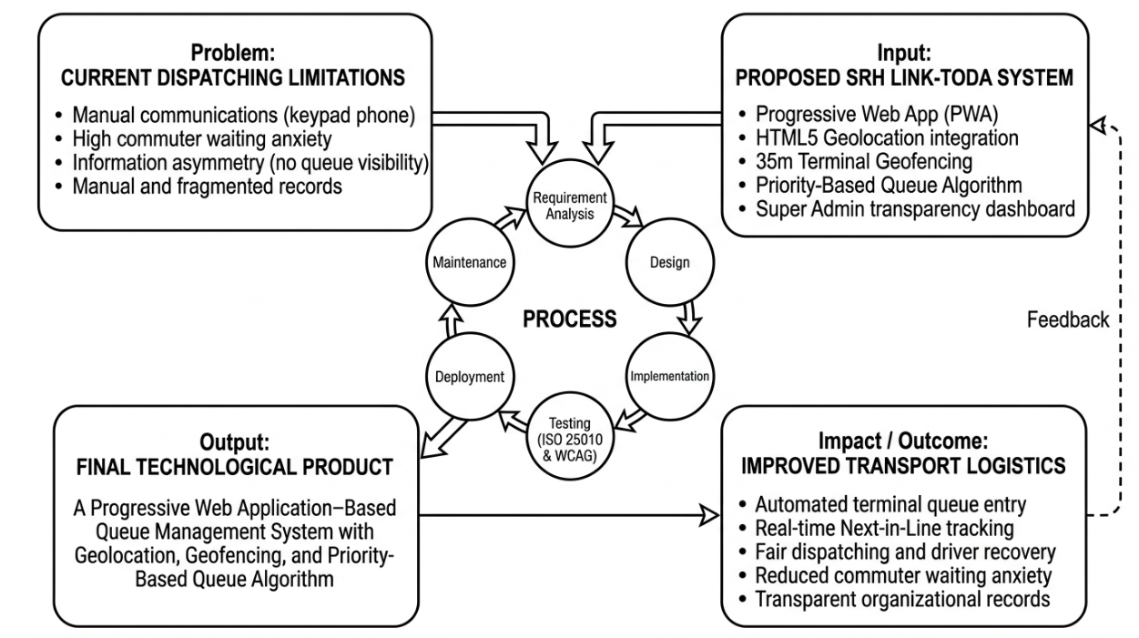
The problem component, positioned at the top left of the framework, outlines the dispatching limitations experienced within the Santa Rosa Homes subdivision. This section highlights the community reliance on manual communications, specifically the operational bottleneck of utilizing a single keypad phone at the terminal. Consequently, this outdated method generates commuter waiting anxiety and severe information asymmetry because residents lack real-time visibility regarding transport queue availability. Furthermore, reliance on manual, fragmented logbooks complicates the administrative oversight and compliance tracking of the transport cooperative.
To address these challenges, the framework transitions to the input component in the top right section. This describes the technological intervention embodied by the SRH LINK-TODA system. The system integrates a decoupled Progressive Web Application architecture built with the Ionic Framework and Angular, client-side MapLibre GL vector mapping, HTML5 geolocation integration, and a thirty-five-meter terminal geofencing boundary. It also incorporates an automated priority-based queue algorithm to ensure dispatching fairness and a centralized administration dashboard to digitize organizational record-keeping and regulatory compliance.
The central core of the diagram represents the process component, illustrating the seven-phase Agile SDLC model utilized to systematically build, refine, and evaluate the system. This iterative software development life cycle encompasses seven continuous phases including Plan, Design, Develop, Test, Deploy, Review, and Launch. Through these structured phases, the identified system inputs and stakeholder needs were successfully transformed into a fully functional digital platform. During the testing and verification phases, the system was empirically evaluated using both the ISO/IEC 25010:2023 software quality model and the Web Content Accessibility Guidelines (WCAG 2.2). This dual-evaluation approach guaranteed the technical functional suitability, performance efficiency, compatibility, interaction capability, reliability, maintainability, flexibility, and safety of the system, while simultaneously verifying that the user interface remained perceivable, operable, understandable, and robust across all stakeholder groups.
As a direct result of this iterative development cycle, the framework culminates in the output component situated at the bottom left. This represents the finalized technological deliverable of the study, which is a fully functional, empirically validated Progressive Web Application–Based Queue Management System with Geolocation, Geofencing, and a Priority-Based Queue Algorithm.
Ultimately, these interconnected components unified the operational workflow by linking physical terminal triggers directly to backend algorithmic processing and real-time state broadcasting. The framework incorporates a direct feedback loop from the end-user testing and expert evaluation back into the development cycle, which informed iterative refinements and ensured that the deployed platform strictly addressed the field realities of the transport cooperative.

Statement of the Problem
This study aimed to design, develop, and evaluate SRH LINK-TODA, a Progressive Web Application–Based Queue Management System with Geolocation, Geofencing, and a Priority-Based Queue Algorithm to automate tricycle dispatching within the Santa Rosa Homes subdivision.
In pursuing this aim, the study adopted a user-centered evaluation framework that captured both quantitative technical metrics and qualitative experiential feedback from actual end users of the system. This triangulated approach ensured that technical capabilities were validated not only under controlled development environments but also within the lived operational realities of the transport cooperative.
Specifically, this study addressed the following research questions:
- What system features and development artifacts are produced during the Agile System Development Life Cycle (SDLC), specifically in terms of the following phases:
1.1 Plan;
1.2 Design;
1.3 Develop;
1.4 Test;
1.5 Deploy;
1.6 Review; and
1.7 Launch?
- How may the IT experts evaluate the technical quality of the Progressive Web Application based on the ISO/IEC 25010:2023 Software Quality Model, specifically in terms of the following characteristics:
2.1. Functional Suitability;
2.2. Performance Efficiency;
2.3. Compatibility;
2.4. Interaction Capability;
2.5. Reliability;
2.6. Maintainability;
2.7. Flexibility; and
2.8. Safety?
- How may the end-users (TODA Officials, Drivers, and Residents) evaluate the Progressive Web Application based on selected ISO/IEC 25010:2023 software quality characteristics, specifically in terms of the following:
3.1. Functional Suitability;
3.2. Performance Efficiency;
3.3. Interaction Capability; and
3.4. Reliability?
- How may the system’s accessibility be evaluated by IT experts and end-users based on the Web Content Accessibility Guidelines (WCAG), in terms of:
4.1. Perceivable;
4.2. Operable;
4.3. Understandable; and
4.4. Robust?

Scope and Delimitations
The primary focus of this research was the development and evaluation of the SRH LINK-TODA system, a Progressive Web Application engineered to modernize paratransit dispatching and administrative governance within the Santa Rosa Homes subdivision in Santa Rosa, Nueva Ecija. The system adopted a decoupled software architecture composed of an Ionic Framework and Angular Progressive Web Application frontend connected to a dedicated Laravel 11 REST API backend. All client-server interactions, dispatch state transitions, and queue updates were synchronized in real time using Laravel Reverb and Redis over WebSockets.
The functional scope of the Progressive Web Application encompassed three primary role-based modules, namely the Passenger Portal, the Driver Interface, and the Administrative Dashboard. The Passenger Portal allowed residents to self-register, review and accept required Terms and Conditions, request tricycle rides, view real-time terminal queue lengths, and track assigned vehicles through interactive MapLibre GL vector maps. To accommodate localized operational practices, the portal also integrated dynamic fare calculation for standard and out-of-zone trips. The Driver Interface utilized active-session geofencing to automate terminal entry within a thirty-five-meter radius, coupled with a priority-based queue algorithm that reinstated drivers to the front of the queue following an aborted dispatch or passenger cancellation. Furthermore, the interface provided drivers with tools to accept dispatch requests, record completed walk-in and app-assisted trips, and view personal daily earnings summaries. For standard completed drop-offs, the system required drivers to physically return to the thirty-five-meter terminal geofence boundary to re-enter the active dispatch queue.
Administratively, the web-based Super Admin and TODA Admin Dashboard equipped association officials with dedicated tools to review and verify uploaded driver credentials, including Motorized Tricycle Operator's Permits and professional driver licenses, execute real-time manual queue overrides, and enforce operational compliance. The system also empowered officials to broadcast community announcements, monitor daily driver contribution fee collections, and generate comprehensive operational and cash transaction summaries to eliminate institutional transparency gaps. Additionally, the dashboard featured automated activity monitoring to detect and flag inactive driver accounts, enabling officials to temporarily restrict or suspend non-compliant members from the dispatch queue.
This study was geographically delimited to the enclosed residential road network of the Santa Rosa Homes subdivision in Barangay Santa Rosa, Nueva Ecija. While the system generated downloadable receipts and maintained auditable cash transaction records for organizational bookkeeping, it was strictly delimited from processing direct digital payments or integrating third-party financial gateways such as GCash or Maya APIs, maintaining a dedicated focus on core logistical data management.
Furthermore, the system was engineered exclusively as an installable Progressive Web Application accessible through standard mobile web browsers, intentionally excluding deployment to native mobile repositories such as the Google Play Store or Apple App Store. Finally, the project intentionally excluded vehicle mechanical maintenance tracking and turn-by-turn turn GPS navigation. Turn-by-turn navigation was delimited because the internal road network of the subdivision is compact and well-known to local operators, and continuous navigation rendering would cause excessive mobile battery drain and unnecessary server bandwidth consumption.

Significance of the Study
The development and implementation of the SRH LINK-TODA system provide a transformative approach to localized transport management, offering substantial benefits to various stakeholders by bridging the operational gap between traditional manual workflows and modern digital logistics. This research provides substantial value to the following stakeholder groups.
TODA Administration. The system serves as a centralized governance tool that eliminates the inefficiencies and vulnerabilities of physical paper logbooks. Through the administrative modules, association officials gain a transparent dashboard to review driver credentials, monitor permit expirations, broadcast announcements, and generate comprehensive operational and financial summaries. Furthermore, the inclusion of a manual queue override empowers officials to resolve physical terminal disruptions immediately. This digitalization fosters organizational integrity and establishes a sustainable governance model that directly supports Sustainable Development Goal 11.
Tricycle Drivers. Drivers benefit from the event-driven dispatch architecture, which guarantees an equitable and automated dispatch sequence through the priority-based queue algorithm. This eliminates subjective dispatch disputes and ensures that drivers who encounter passenger cancellations or dispatch timeouts are promptly reinstated to the front of the queue. Additionally, the integrated trip logging and dynamic fare calculation features provide operators with personal productivity records, allowing them to track daily earnings and manage household finances with greater precision.
Residents and Passengers. This study offers a direct solution to the psychological burden of waiting anxiety by providing commuters with real-time visibility into vehicle availability and terminal queue lengths. The real-time status broadcasting feature is especially beneficial for residents living in the farther peripheral blocks of the subdivision, enabling them to time their departures based on live Next in Line updates. By eliminating information asymmetry, the system significantly enhances the convenience, safety, and predictability of daily residential travel.
The Local Community of Santa Rosa Homes. The research contributes directly to the Santa Rosa Homes community by establishing a resilient, data-driven transport utility that organizes local mobility. While the direct implementation was delimited to this single residential subdivision, the study demonstrates a cost-effective dispatching model that leverages existing mobile devices without requiring expensive physical infrastructure. Consequently, it establishes a scalable blueprint for how neighboring barangays and subdivisions can achieve Sustainable Development Goal 9 targets.
Policy Makers and Regulatory Bodies. The system offers practical insights for local government units, the Land Transportation Franchising and Regulatory Board, and the Department of the Interior and Local Government. By structurally embedding Motorized Tricycle Operator's Permit tracking and immutable transaction logging into the daily dispatch workflow, the project provides concrete empirical evidence regarding the feasibility of digital governance in informal paratransit, demonstrating how regulatory oversight can be modernized for decentralized transport cooperatives.
Academic Community and IT Researchers. This study serves as an empirical and methodological reference for the implementation of web-standard geofencing and reactive event-driven logic within a Progressive Web Application framework. It provides the software engineering community with a documented methodology for executing coordinate-based spatial triggers and priority queue recovery in browser environments without relying on third-party mobile application stores. Furthermore, it establishes new academic ground for investigating the sociotechnical impacts of algorithmic dispatching on the organizational behavior of informal transport associations.

Definition of Terms
For a clearer understanding of this study, the following terms are defined both conceptually and operationally as they are utilized within the context of the research.
Administrative Modules. Conceptually, this refers to a set of functional software components designed to manage organizational data by providing role-based access control and real-time operational oversight (Pressman & Maxim, 2020). Operationally, it represents the dedicated interface in the SRH LINK-TODA system used by association officials to review and verify driver registration credentials, monitor permit expirations, track contribution fees, broadcast community announcements, and execute manual queue overrides.
Event-Driven Architecture. Conceptually, this is a software architecture pattern that promotes the production, detection, and consumption of asynchronous events to trigger immediate system state transitions (Farahi et al., 2023). Operationally, it refers to the backend implementation utilizing Laravel Reverb and Redis over WebSockets to instantly push queue updates, terminal arrivals, and dispatch notifications to connected client applications without requiring manual page refreshes.
Geofencing. Conceptually, this is a location-aware technology that utilizes geographic coordinates to define a virtual perimeter, triggering automated system events when an authenticated mobile device enters or exits the boundary (Shevchenko & Reips, 2024). Operationally, it refers to the thirty-five-meter virtual radius established around the Santa Rosa Homes tricycle terminal that automatically detects driver arrival and triggers queue entry while suppressing re-entry during active passenger trips.
Information Asymmetry. Conceptually, this describes an operational state in which one party within a service interaction possesses significantly more or better information than another, resulting in logistical friction, mistrust, and scheduling uncertainty (Gatarin, 2023). Operationally, it refers to the absence of real-time transit visibility regarding driver availability, terminal queue lengths, and vehicle arrival estimates experienced by waiting commuters within the subdivision.
Priority-Based Queue Algorithm. Conceptually, this is an algorithmic scheduling model that dynamically manages waiting lines by incorporating conditional preemption to handle operational interruptions rather than relying solely on a rigid arrival sequence (Musa et al., 2023). Operationally, it refers to the backend dispatch logic that maintains a First-In, First-Out sequence while automatically granting front-of-line reinstatement to a driver whose previous dispatch was canceled by a passenger or timed out.
Progressive Web Application (PWA). Conceptually, this is an application software model delivered through the web, utilizing modern browser capabilities and service workers to provide installable, native-like user experiences across different hardware platforms without commercial app-store distribution (Biørn-Hansen et al., 2017). Operationally, it is the cross-platform application utilized by commuters, drivers, and administrators, accessible via mobile web browsers with offline caching support.
Real-Time Broadcasting. Conceptually, this refers to the continuous and simultaneous transmission of telemetry data across a network to multiple client endpoints to reduce temporal uncertainty during waiting periods (Zhang et al., 2025). Operationally, it is the instantaneous synchronization of Next in Line queue updates and interactive map markers from the central server directly to the passenger and driver interfaces.
Waiting Anxiety. Conceptually, this describes the psychological discomfort, perceived stress, and temporal distortion experienced by individuals during an unstructured or unmonitored waiting period (Watkins et al., 2011; Dziekan & Kottenhoff, 2007). Operationally, it refers to the commuter frustration and perceived delay felt by Santa Rosa Homes residents due to the inability to predict vehicle arrival times under the traditional manual single-phone dispatching setup.

Chapter 2
METHODOLOGY
This chapter presents the research design, research locale, respondents, sampling technique, instruments, data gathering procedures, data analysis techniques, and ethical considerations of the study.

Research Design
This study utilized a Developmental Research Design to systematically design, develop, test, and evaluate the Progressive Web Application–Based Queue Management System with Geolocation, Geofencing, and a Priority-Based Queue Algorithm. To execute the engineering lifecycle, the Agile Software Development Life Cycle was employed as the operational framework. Agile is exceptionally well-suited for engineering an event-driven architecture because it emphasizes iterative development, continuous integration, and rapid adaptability. This methodological choice is grounded in foundational software engineering frameworks (Fowler & Highsmith, 2001; Pressman & Maxim, 2020) and is empirically supported by contemporary software engineering literature, which demonstrates the effectiveness of Agile in managing the complex, real-time requirements of web-based deployments (Alsaqqa et al., 2020).
Developmental research is explicitly defined as the systematic study of designing, developing, and evaluating instructional programs, processes, and technological products that must meet criteria of internal consistency and effectiveness (Richey & Klein, 2014). In Information Technology research, this design provides a vital bridge between theoretical computing models and practical, real-world implementations. Rather than merely observing or describing an operational problem, developmental research focuses on the purposeful creation of a tangible, functional software artifact. In this study, the engineered artifact is the SRH LINK-TODA platform, created specifically to resolve identified dispatching bottlenecks and administrative data gaps within the target community.
The appropriateness of this design is reinforced by software engineering literature, which emphasizes that evaluating new technological interventions requires a structured empirical framework where the product is iteratively tested against internationally established quality models. By adopting a developmental research design, the researchers established a rigorous methodology to build the system while systematically validating the technical accuracy of the active-session geofencing logic and the priority-based queue algorithm. Ultimately, this approach ensured that the finalized Progressive Web Application was empirically evaluated against the ISO/IEC 25010:2023 Software Quality Model and the Web Content Accessibility Guidelines (WCAG 2.2) to confirm its technical suitability, performance efficiency, and universal usability for community end users.

Research Locale
The study was conducted at the Santa Rosa Homes subdivision, located in the municipality of Santa Rosa, province of Nueva Ecija. This specific locale was purposefully selected because its transport cooperative operated using a manual dispatching system anchored to a single keypad phone at the terminal. This existing setup created a communication bottleneck for residents in the farther blocks, making it an ideal operational environment to test the transition from manual logging to an automated logistics platform.
The primary testing zone for the system infrastructure was the designated Tricycle Operators and Drivers Association (TODA) terminal situated within the subdivision. This physical location served as the geographic anchor point for the application core spatial feature, where a thirty-five-meter virtual geofence boundary was established around the terminal coordinates. The geographical layout of the subdivision and the designated testing terminal are presented in Figure 2.
Figure 2.
Map of the Santa Rosa Homes Subdivision Research Locale (Source: OpenStreetMap contributors, CC BY-SA).
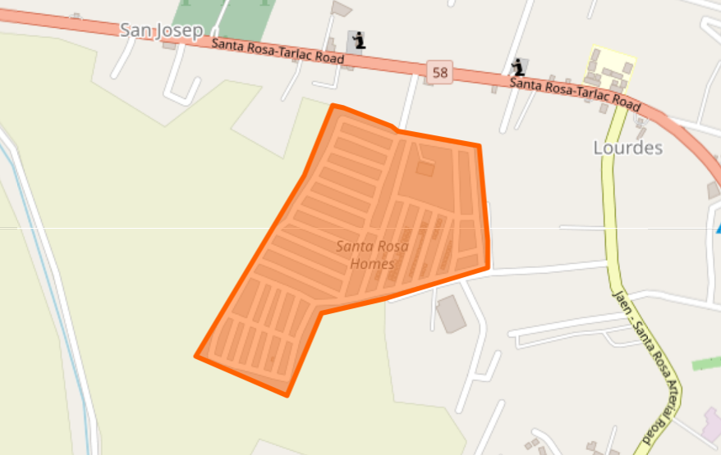
The Santa Rosa Homes subdivision was selected as the primary locale because its geographic layout and historical reliance on a single shared mobile phone caused measurable operational bottlenecks for the local transport cooperative. Baseline consultations and key-informant interviews with the TODA leadership—supported by terminal logbook observations—revealed that this manual setup created frequent service failures, where simultaneous incoming calls overwhelmed the single phone line and unreplied text messages left commuters waiting in uncertainty until they abandoned their trips, resulting in an estimated fifteen to twenty passenger dispatches missed or substantially delayed each day.
Furthermore, deploying the system within this subdivision provided distinct technical testing advantages and direct community utility. The spatial distribution of the residential blocks allowed the researchers to rigorously evaluate the application real-time map broadcasting and WebSocket responsiveness when commuters requested rides from various inner streets. Concurrently, the physical terminal perimeter provided the exact operational conditions required to evaluate the spatial accuracy of the HTML5 Geolocation API and the thirty-five-meter geofence entry triggers. Conducting the research in this locale validated a low-cost, resilient paratransit framework that provides immediate operational transparency to the community while serving as an empirical blueprint for other residential barangays facing similar paratransit challenges.
Research Respondents
The study utilized purposive sampling to select participants with direct, daily experience regarding the operational and logistical challenges of the subdivision transport system. Purposive sampling was employed to ensure that the selected individuals could provide the most relevant and data-rich technical and experiential feedback on the transition from a manual phone-based dispatching workflow to an automated digital system (Creswell & Creswell, 2018).
Purposive sampling was selected over simple random sampling because evaluating a specialized Progressive Web Application requires respondents who not only understand the acute pain points of the manual keypad system but also possess the technical means to test the digital platform. Selecting participants at random could yield respondents who do not utilize local paratransit services or lack the smartphones needed to access the web application, which would compromise the validity and operational relevance of the evaluation data.
To ensure data reliability and methodological rigor, strict inclusion and exclusion criteria were established for selecting respondents. For the tricycle drivers, the inclusion criteria required that they be officially registered members of the Santa Rosa Homes TODA, actively operate within the Santa Rosa Homes terminal, and own a functional smartphone with active mobile data. Drivers who were unregistered or those who exclusively utilized analog keypad phones were excluded from the study because they could not interface with the Progressive Web Application. For the community residents, the inclusion criteria required that they reside within the subdivision, regularly utilize the local tricycle paratransit service, and possess a web-enabled smartphone. Individuals residing outside the subdivision boundaries or those who exclusively utilized private motor vehicles were excluded from the evaluation because they do not experience the commuter waiting anxiety the system is designed to alleviate.
To guarantee a balanced evaluation encompassing both technical software architecture and end-user operational experience, thirty-five total respondents participated in the study. Table 1 presents the complete distribution of the research respondents.
Table 1.
Distribution of Research Respondents
Respondent Category | Frequency | Percentage
IT Experts | 5 | 14.29%
TODA Officials (Super Admin/Admin) | 3 | 8.57%
Official TODA Drivers | 12 | 34.28%
Santa Rosa Homes Residents | 15 | 42.86%
Total | 35 | 100%
The study involved a purposive sample of thirty-five total respondents. To rigorously evaluate the Progressive Web Application against the ISO/IEC 25010:2023 technical software standards, five IT Experts were selected. To qualify as technical validators, these experts were required to possess a minimum of two years of professional industry experience in web systems engineering, full-stack software development, or software quality assurance. Any IT professional who contributed directly or indirectly to the programming or conceptualization of the SRH LINK-TODA system was strictly excluded to eliminate evaluation bias.
For the operational and usability evaluation, thirty end users were divided into three distinct functional groups. Three TODA Officials were selected to evaluate the web-based Super Admin Dashboard and its compliance tracking tools. Twelve Official TODA Drivers were selected to evaluate the mobile driver interface, ride acceptance workflows, and automated thirty-five-meter geofence queueing logic. Finally, fifteen Santa Rosa Homes Residents were selected to evaluate the passenger hailing portal, dynamic fare calculation, and real-time map telemetry. Selecting participants purposively ensured that only authenticated cooperative members and resident commuters evaluated the platform, establishing high empirical validity during data collection.

Research Instruments
To comprehensively address the research questions outlined in the Statement of the Problem, this study utilized structured quantitative evaluation instruments to capture technical and operational assessments across stakeholder groups (Creswell & Creswell, 2018). The evaluation instruments were organized into two respondent-specific formats, namely the IT Expert Evaluation Instrument and the End-User Evaluation Instrument.
The IT Expert Evaluation Instrument was designed to assess the technical software architecture of the Progressive Web Application from a software engineering perspective. Part I of the instrument was anchored in the ISO/IEC 25010:2023 Software Quality Model, evaluating the application across eight technical characteristics, namely Functional Suitability, Performance Efficiency, Compatibility, Interaction Capability, Reliability, Maintainability, Flexibility, and Safety. Security and data privacy protections were evaluated within the Reliability and Safety dimensions. Part II of the instrument evaluated the system against the Web Content Accessibility Guidelines (WCAG 2.2) across the four core accessibility principles, namely Perceivable, Operable, Understandable, and Robust.
The End-User Evaluation Instrument was administered to the thirty community respondents, comprising TODA officials, tricycle drivers, and Santa Rosa Homes residents. This user-centered instrument evaluated four operational ISO/IEC 25010:2023 characteristics directly relevant to daily paratransit usage, including Functional Suitability, Performance Efficiency, Interaction Capability, and Reliability. In addition, it evaluated perceived accessibility based on the WCAG 2.2 principles. To ensure measurement rigor, multiple distinct indicator statements were established for every software characteristic evaluated.
Prior to actual administration, the evaluation instruments underwent formal content validation and review by the capstone adviser and IT faculty experts. This validation verified that all survey items were clear, unambiguous, and strictly aligned with the ISO/IEC 25010:2023 and WCAG 2.2 standards, ensuring that the questionnaires accurately captured the technical and operational metrics of the study.

Data Gathering Procedures
The data gathering process for this study was conducted in multiple sequential phases to ensure the systematic development, deployment, and empirical evaluation of the Progressive Web Application. Figure 3 presents the detailed flowchart of the data gathering procedures utilized in this study.

Figure 3.
Flowchart of the Data Gathering Procedure
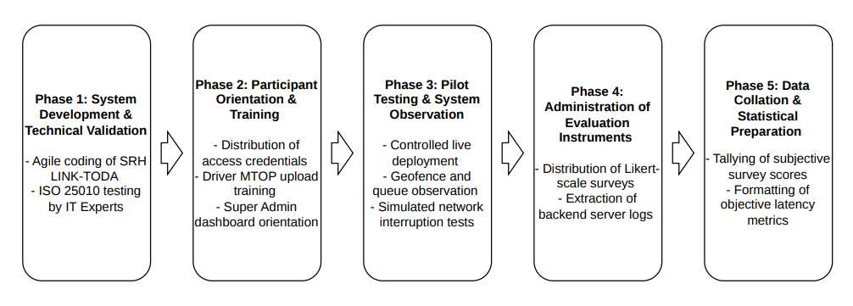
As illustrated in the flowchart, the methodology began with the system development and technical validation phase. During this initial stage, the researchers constructed the core modules of the SRH LINK-TODA application utilizing the seven-phase Agile software engineering methodology. Once the functional prototype was successfully built, IT experts reviewed the system architecture to verify compliance with technical software quality standards. Any identified bugs or interface defects were resolved immediately during this stage to ensure platform stability for live field deployment.
Following technical validation, the researchers proceeded to the participant orientation and training phase. The thirty purposively selected end-user respondents from the Santa Rosa Homes subdivision were formally briefed regarding the study objectives and provided with authenticated access credentials. During this preparatory step, tricycle drivers received detailed instructions on how to access the Progressive Web Application and upload their required Motorized Tricycle Operator's Permits and professional driver licenses. Simultaneously, TODA officials were trained to navigate the administrative dashboard, and participating residents were guided on how to request rides and track vehicle telemetry. This ensured that all end users clearly understood their operational roles prior to live system testing.
The process then transitioned to the actual field pilot testing and system observation phase. The application was deployed and tested in a real-world scenario within the Santa Rosa Homes subdivision to observe actual performance under authentic commuting conditions. During this period, residents utilized the passenger portal to request rides, while drivers tested the active-session geofencing by physically entering and exiting the thirty-five-meter terminal radius. Concurrently, the researchers conducted structured field observations to monitor the responsiveness of the priority-based queue recovery algorithm during completed drop-offs and live ride cancellations.
Immediately after the field pilot test concluded, the researchers advanced to the administration of evaluation instruments. Structured survey questionnaires were distributed to the thirty end users to capture experiential feedback based on selected ISO/IEC 25010:2023 characteristics and the Web Content Accessibility Guidelines (WCAG 2.2). Simultaneously, the complete technical evaluation instrument was administered to the five IT Experts to assess the software across all eight ISO/IEC 25010:2023 technical characteristics and the four WCAG 2.2 accessibility principles.
Finally, all gathered data underwent systematic collation and statistical preparation. Survey responses were tallied, tabulated, and checked for completeness, and then organized into analytical spreadsheets. This structured preparation ensured that the datasets were fully ready for subsequent statistical treatments, guaranteeing a reliable and transparent evaluation of the paratransit logistics system.

Data Analysis Techniques
To systematically analyze the empirical data gathered across the four research questions in the Statement of the Problem, descriptive statistical tools and standardized scoring rubrics were applied.
Statistical Tools
1. Frequency and Percentage Distribution. This was employed to determine the proportion of respondents across different stakeholder groups relative to the total sample population, computed using the formula:
P = (f / N) * 100
where P represents the percentage, f represents the frequency of responses, and N is the total number of respondents.
2. Weighted Mean. This was utilized to compute the average rating for each survey indicator, software quality characteristic, and accessibility principle evaluated by IT experts and end users, calculated using the formula:
WM = Σ(f * x) / N
where WM is the weighted mean, Σ represents the summation, f is the frequency of responses per rating scale, x is the scale weight ranging from 1 to 5, and N is the total number of respondents.

Analysis for Agile SDLC Features and Artifacts (SOP 1)
The first research question was addressed through qualitative and technical documentation of the artifacts produced across the seven phases of the Agile Software Development Life Cycle, namely Plan, Design, Develop, Test, Deploy, Review, and Launch. Technical outputs including user stories, entity relationship models, data flow diagrams, normalized data dictionaries, user acceptance testing matrices, and cloud deployment costing tables were systematically documented to validate the architectural execution of the platform.
Analysis for IT Experts Technical Evaluation (SOP 2)
The second research question was addressed by evaluating the technical software quality ratings provided by the five IT experts across the eight characteristics of the ISO/IEC 25010:2023 Software Quality Model. Security and data protection mechanisms were evaluated within the Reliability and Safety dimensions. Weighted mean ratings were calculated and interpreted using the calibrated five-point scoring rubrics presented in Tables 2 through 9.

Table 2
Scoring Rubric for Functional Suitability
Range | Qualitative Remarks | Verbal Description
4.21 – 5.00 | Highly Suitable | The SRH LINK-TODA meets or exceeds all functional requirements with high accuracy, completeness, and efficiency.
3.41 – 4.20 | Suitable | The SRH LINK-TODA meets most functional requirements with a satisfactory level of accuracy, completeness, and efficiency.
2.61 – 3.40 | Somewhat Suitable | The SRH LINK-TODA meets some functional requirements but demonstrates low levels of accuracy, completeness, or efficiency.
1.81 – 2.60 | Unsuitable | The SRH LINK-TODA meets very few functional requirements, with low accuracy, completeness, and efficiency.
1.00 – 1.80 | Highly Unsuitable | The SRH LINK-TODA fails to meet most, if not all, functional requirements, with very low accuracy, completeness, and efficiency.

Table 2 presents the scoring rubric for evaluating functional suitability, assessing whether core operational features such as thirty-five-meter geofencing triggers and priority queue recovery execute accurately during field testing.

Table 3
Scoring Rubric for Performance Efficiency
Range | Qualitative Remarks | Verbal Description
4.21 – 5.00 | Highly Efficient | The SRH LINK-TODA’s performance is exceptional, meeting or exceeding all efficiency requirements. Users experience no delays or errors, and the system performs consistently well under all operating conditions.
3.41 – 4.20 | Efficient | The SRH LINK-TODA’s performance is above average and meets most efficiency requirements. Users experience minimal delays or errors, and the system performs well under normal operating conditions.
2.61 – 3.40 | Less Efficient | The SRH LINK-TODA’s performance is average, with room for improvement. Users may experience occasional delays or errors, but overall, the system functions adequately.
1.81 – 2.60 | Inefficient | The SRH LINK-TODA’s performance is below average and fails to fully meet efficiency requirements. Users may experience delays or errors that affect productivity.
1.00 – 1.80 | Highly Inefficient | The SRH LINK-TODA’s performance is significantly below expectations, frequently causing delays, errors, or failures that disrupt normal operation.

Table 3 presents the scoring rubric for evaluating performance efficiency, determining whether the event-driven architecture broadcasts real-time updates and queue statuses effectively during operation.
Table 4
Scoring Rubric for Compatibility
Range | Qualitative Remarks | Verbal Description
4.21 – 5.00 | Highly Compatible | The SRH LINK-TODA is fully compatible with other hardware or software and can seamlessly integrate without any issues or modifications.
3.41 – 4.20 | Compatible | The SRH LINK-TODA can work with other hardware or software with minor adjustments or configurations.
2.61 – 3.40 | Somewhat Compatible | The SRH LINK-TODA can work with other hardware or software, but requires significant adjustments or configurations.
1.81 – 2.60 | Less Compatible | The SRH LINK-TODA struggles to integrate with other hardware or software and requires significant adjustments.
1.00 – 1.80 | Not Compatible | The SRH LINK-TODA cannot work with other hardware or software and requires a complete redesign or replacement.

Table 4 presents the scoring rubric for evaluating compatibility, assessing the Progressive Web Application capability to run across varying mobile operating systems and web browsers without native app store installation.
Table 5
Scoring Rubric for Interaction Capability
Range | Qualitative Remarks | Verbal Description
4.21 – 5.00 | Highly Interactive | Users can perform tasks intuitively and efficiently, with smooth system responses and clear, immediate feedback.
3.41 – 4.20 | Interactive | Users can perform tasks with some guidance or minor delays; system feedback is generally adequate.
2.61 – 3.40 | Less Interactive | Users face difficulties interacting with the system, with delays or unclear feedback reducing task efficiency.
1.81 – 2.60 | Poorly Interactive | Users experience significant difficulties with delayed responses and confusing feedback.
1.00 – 1.80 | Non-Interactive | Users cannot effectively interact with the system due to poor responsiveness, unclear instructions, or system errors.

Table 5 presents the scoring rubric for evaluating interaction capability, assessing the intuitiveness of the hailing, dispatching, and administrative interfaces for drivers, commuters, and officials.

Table 6
Scoring Rubric for Reliability
Range | Qualitative Remarks | Verbal Description
4.21 – 5.00 | Highly Reliable | The SRH LINK-TODA operates consistently without failures, delivering accurate, dependable outcomes under all conditions.
3.41 – 4.20 | Reliable | The SRH LINK-TODA generally operates as expected, with only minor or occasional errors.
2.61 – 3.40 | Slightly Reliable | The SRH LINK-TODA is prone to errors or interruptions, affecting performance and dependability.
1.81 – 2.60 | Unreliable | The SRH LINK-TODA frequently experiences errors or interruptions, reducing overall dependability.
1.00 – 1.80 | Non-Reliable | The SRH LINK-TODA frequently fails or produces inaccurate results, making it unreliable for its intended use.

Table 6 presents the scoring rubric for evaluating reliability, measuring system stability, queue state persistence, and data integrity under variable network connectivity conditions.

Table 7
Scoring Rubric for Maintainability
Range | Qualitative Remarks | Verbal Description
4.21 – 5.00 | Highly Maintainable | The SRH LINK-TODA's backend codebase and architecture are excellently structured, allowing developers to easily execute updates, troubleshoot logs, and fix bugs without disruption.
3.41 – 4.20 | Maintainable | The system's codebase is well-structured, allowing developers to execute routine updates and minor bug fixes with acceptable effort.
2.61 – 3.40 | Less Maintainable | The system requires significant developer effort to diagnose backend issues or implement minor code updates, occasionally disrupting operations.
1.81 – 2.60 | Hardly Maintainable | The system codebase is difficult to update or fix, requiring extensive downtime and excessive developer intervention.
1.00 – 1.80 | Not Maintainable | The system's architecture is completely rigid; attempting to fix bugs or update code causes critical system failures.

Table 7 presents the scoring rubric for evaluating maintainability, examining backend modularity and the ease with which future enhancements and algorithmic refinements can be applied.

Table 8
Scoring Rubric for Flexibility
Range | Qualitative Remarks | Verbal Description
4.21 – 5.00 | Highly Flexible | The SRH LINK-TODA easily adapts to new TODA operational rules, expanded geofence limits, or additional user groups without requiring major architectural overhauls.
3.41 – 4.20 | Flexible | The system can adapt to most moderate changes in TODA rules or operational scope with only minor administrative configurations.
2.61 – 3.40 | Less Flexible | The system struggles to accommodate changes in transport rules, requiring some manual developer adjustments to adapt to the new environment.
1.81 – 2.60 | Hardly Flexible | The system is highly rigid; any change in operational rules or geofence expansion requires significant software redevelopment.
1.00 – 1.80 | Not Flexible | The system cannot adapt to any changes in the environment or user requirements, completely limiting its future scalability.

Table 8 presents the scoring rubric for evaluating flexibility, measuring architectural adaptability to accommodate changes in association dispatch policies or expanded geographic boundaries.

Table 9
Scoring Rubric for Safety
Range | Qualitative Remarks | Verbal Description
4.21 – 5.00 | Highly Safe | The SRH LINK-TODA effectively prevents hazards, protects users and data, and functions securely under all conditions.
3.41 – 4.20 | Safe | The SRH LINK-TODA is generally safe, with only minor risks that do not significantly affect users or data.
2.61 – 3.40 | Slightly Unsafe | The SRH LINK-TODA presents noticeable safety risks that may potentially affect users or data.
1.81 – 2.60 | Unsafe | The SRH LINK-TODA exposes users or data to significant hazards or risks, affecting reliability and functionality.
1.00 – 1.80 | Highly Unsafe | The SRH LINK-TODA is unsafe and poses serious risks to users and data. Urgent corrective actions are required.

Table 9 presents the scoring rubric for evaluating safety, verifying that geofencing and background dispatch processes do not introduce digital risks or operational hazards to cooperative workflows.

Analysis for End-Users Quality in Use Evaluation (SOP 3)
The third research question was addressed by evaluating the ratings provided by the thirty end users across the four operational ISO/IEC 25010:2023 characteristics, namely Functional Suitability, Performance Efficiency, Interaction Capability, and Reliability. Responses gathered on the five-point Likert scale were analyzed using percentage distributions and weighted means, interpreted using the calibrated scoring rubrics established in Tables 2, 3, 5, and 6.

Analysis for Web Content Accessibility (SOP 4)
The fourth research question was addressed by analyzing the accessibility evaluations from both IT experts and end users based on the Web Content Accessibility Guidelines (WCAG 2.2). Responses across the four core accessibility principles, namely Perceivable, Operable, Understandable, and Robust, were aggregated to determine overall compliance. The computed weighted means were interpreted using the standardized accessibility rubric presented in Table 10.

Table 10
Scoring Rubric for Web Content Accessibility
Scale | Interpretation | Description
5 | Highly Accessible | The SRH LINK-TODA is perceived as fully compliant with web accessibility standards.
4 | Accessible | The SRH LINK-TODA is perceived to have minor issues, but is generally accessible.
3 | Moderately Accessible | The SRH LINK-TODA is perceived to have some accessibility issues.
2 | Slightly Accessible | The SRH LINK-TODA is perceived to have major accessibility issues.
1 | Not Accessible | The SRH LINK-TODA is perceived as unusable by users with disabilities.

Table 10 presents the scoring rubric for evaluating web content accessibility against WCAG 2.2 principles, ensuring the Progressive Web Application remains inclusive and operable for all community demographics.
Ethical Considerations
The researchers adhered to strict ethical standards throughout the study lifecycle, recognizing the fundamental importance of protecting human participants and governing location-aware digital technologies. In full compliance with the Data Privacy Act of 2012 (Republic Act No. 10173) and institutional ethical research guidelines, this study was conducted with utmost regard for the rights, dignity, privacy, and welfare of all participants.
Prior to field deployment and data gathering, formal permissions were secured through established administrative channels. A formal letter of request was submitted to the local barangay administration of Santa Rosa, Nueva Ecija, and the Board of Directors of the Santa Rosa Homes TODA. Securing these administrative approvals ensured full institutional endorsement and transparent coordination with community leaders and transport operators.
Informed consent was strictly obtained from all individual respondents prior to their participation in the field testing and evaluation phases. An informed consent document was provided to every tricycle driver, TODA official, and resident commuter, detailing the research objectives, the operational nature of the Progressive Web Application, the expected time commitment, and the voluntary nature of their participation. The document explicitly established that participants had the right to withdraw from the study at any point without penalty, negative consequence, or disruption to their normal community transport access. Only individuals who voluntarily signed the consent form participated in system testing and evaluation.
Because the SRH LINK-TODA system utilizes the HTML5 Geolocation API and thirty-five-meter geofencing triggers, special safeguards were implemented to protect spatial privacy. Location tracking was strictly restricted to active dispatch sessions and the immediate physical terminal zone. The application architecture was programmed to cease coordinate tracking immediately upon trip completion or when an operator logged out of the queue, guaranteeing that drivers were not subjected to background surveillance outside of official dispatching activities. Furthermore, the priority-based queue recovery algorithm was engineered to operate transparently to eliminate algorithmic bias and ensure equitable dispatch sequencing for all cooperative members.
To guarantee respondent anonymity during the evaluation phase, no personally identifiable information was gathered in the survey questionnaires, with participants identified exclusively by their operational category, such as IT Expert, TODA Official, Tricycle Driver, or Resident Commuter. For sensitive digital credentials required by the platform, including uploaded driver licenses and Motorized Tricycle Operator's Permits, strict data encryption and role-based access controls were enforced. Access to stored registration records was restricted solely to the primary researchers and authorized TODA administrators. In compliance with national data privacy standards, all uploaded test documents, location logs, and empirical datasets were securely protected throughout the academic evaluation period and scheduled for permanent disposal following the completion of all institutional requirements.
Finally, the researchers maintained complete objectivity and academic integrity across all phases of the study, presenting empirical results, statistical computations, and stakeholder feedback truthfully without alteration or bias.

Chapter 3
RESULTS AND DISCUSSION
This chapter presents the empirical findings, architectural artifacts, statistical assessments, server telemetry logs, and analytical discussions derived from the development and multi-stakeholder evaluation of the SRH LINK-TODA system. Following the established research methodology, the results are presented in the exact sequence of the research questions formulated in the Statement of the Problem.

1. System Features and Outputs Produced Across the Agile Scrum Development Life Cycle
To address the first research question, this section documents the software features, architectural models, database schemas, and development artifacts produced across the iterative stages of the Agile Scrum Development Life Cycle (SDLC). The development trajectory was structured into seven sequential phases: Plan, Design, Develop, Test, Deploy, Review, and Launch.
1.1 Plan
During the Plan phase, requirements elicitation was conducted with transport stakeholders, including TODA administrative officers, registered tricycle drivers, and community residents of the Santa Rosa Homes subdivision. Consultative interviews and on-site terminal workflow observations were carried out to identify the operational pain points of the existing manual dispatching system, specifically the communication bottlenecks of the single keypad phone, the lack of terminal queue visibility for commuters, and the opacity of handwritten contribution ledgers.

The elicited requirements were translated into structured user stories defining the target user role, the required functional capability, and the intended operational benefit. These user stories established the functional scope, target actors, functional requirements, and non-functional acceptance criteria across five core application modules comprising User Onboarding and Authentication, Driver Geolocation and Queue Management, Passenger Ride Hailing and Tracking, Administrative Governance and Compliance, and System Accessibility and Resilience.

User Stories | Actor(s) | Functional Requirement | Non-Functional Requirement | Needed UI | Scenario
Authentication, Profile, and Account Access
"As a Passenger, I want to create an account using my mobile phone number and password so that I can immediately access the ride-hailing platform." | Resident / Passenger | The system shall provide self-registration and authentication forms for passenger accounts. | Authentication data shall be encrypted using Bcrypt and authenticated via 64-character API Bearer tokens. | Passenger Registration Form | Self-Register Passenger Account
"As a Tricycle Driver, I want to register an account and upload digitized copies of my MTOP certificate and driver's license so that I can apply for terminal queue dispatch." | Tricycle Driver | The system shall allow drivers to submit registration data alongside image file uploads. | Document uploads shall enforce a 20MB file limit supporting images and PDFs (JPG, PNG, WEBP, PDF) with secure storage paths. | Driver Registration and Upload Screen | Register and Upload Driver Documents
"As a TODA Official, I want to review pending driver registrations and inspect uploaded documents so that I can verify compliance before activating accounts." | TODA Official / Super Admin | The system shall provide an administrative interface to review pending applications and toggle account approval status. | Document images shall render clearly and status changes shall execute with real-time audit logging. | Driver Verification Dashboard | Review and Verify Driver Applications
Driver Geolocation and Queue Management
"As a Tricycle Driver, I want to automatically enter the dispatch queue when I arrive within the 35-meter terminal radius so that my arrival is recorded hands-free." | Tricycle Driver | The system shall capture coordinates via the HTML5 Geolocation API and trigger an automated queue check-in event. | Geolocation tracking shall be active-session dependent to conserve battery life and maintain coordinate accuracy. | Driver Queue Dashboard | Automated 35m Terminal Geofence Entry
"As a Tricycle Driver, I want the system to temporarily pause geofence tracking while I am on an active trip so that I am not prematurely re-added to the queue when driving near the terminal." | Tricycle Driver | The system shall suspend geofencing entry triggers while a trip session is active. | The driver shall remain flagged as in-transit to preserve queue state integrity during passenger drop-offs. | Active Trip Transit Screen | Active Transit Geofence Deactivation
"As a Tricycle Driver, I want to manually end my session when going off-duty so that the system halts location tracking." | Tricycle Driver | The system shall allow drivers to toggle off-duty status to terminate active sessions. | Termination shall immediately halt all geolocation API polling to ensure user location privacy. | Driver On-Duty / Off-Duty Toggle | End Driver Session
"As a Tricycle Driver, I want to be immediately restored to the first queue slot if a passenger cancels so that I am not penalized for canceled trips." | Tricycle Driver | The system shall execute a Priority-Based Queue Algorithm to reinstate the driver to position one. | Reinstatement shall execute deterministically via WebSockets with millisecond-level responsiveness. | Driver Notification Panel | Queue Recovery Execution
"As a Tricycle Driver, I want to receive real-time dispatch alerts with sound and visual prompts so that I know when it is my turn to accept a passenger." | Tricycle Driver | The system shall push real-time dispatch prompts to the next compliant driver in the FIFO sequence. | Notifications shall deliver asynchronously with an audio chime and a 30-second response timeout. | Incoming Dispatch Dialog | Receive Dispatch Alert
"As a Tricycle Driver, I want to record terminal walk-in passengers directly so that offline passenger boardings are logged in the queue sequence." | Tricycle Driver | The system shall allow drivers to initiate a walk-in ride directly from the terminal interface. | Initiating a walk-in trip shall immediately update the terminal queue count and mark the driver in-transit. | Walk-In Ride Action Button | Log Terminal Walk-In Ride
"As a Tricycle Driver, I want to log completed trips, drop-off locations, and collected fares so that I can track my daily productivity and earnings." | Tricycle Driver | The system shall allow drivers to record trip completion and compute cumulative cash earnings. | Trip records and fare aggregates shall be stored securely and remain accessible offline. | Trip Completion Modal and Earnings Portal | Log Completed Ride and View Earnings
Passenger Ride Hailing and Real-Time Tracking
"As a Passenger, I want to request a tricycle by specifying my Block and Lot pickup address so that an assigned driver picks me up at my doorstep." | Resident / Passenger | The system shall allow passengers to submit ride requests with validated pickup addresses within the subdivision. | Ride requests shall be processed asynchronously and assigned to the current Next-in-Line driver. | Passenger Ride Booking Drawer | Request Subdivision Ride
"As a Passenger, I want to bookmark frequently used locations such as my Home Block and Lot or the Main Gate so that I can book rides with a single tap." | Resident / Passenger | The system shall provide saved location management allowing users to store custom pickup points. | Saved addresses shall be cached locally in browser storage and synchronized with user account records. | Saved Locations Bookmarking Screen | Save and Select Custom Address
"As a Passenger, I want to view the live terminal queue count and an interactive map so that I know tricycle availability and reduce waiting anxiety." | Resident / Passenger | The system shall broadcast real-time queue counts and driver positions to the passenger interface. | Map rendering shall utilize hardware-accelerated MapLibre GL vector tiles with low data latency. | Passenger Home and Map Viewport | Track Terminal Queue and Vehicle Status
"As a Passenger, I want to see the fare calculated automatically from the official TODA matrix with custom fare proposals for special trips so that pricing is transparent." | Resident / Passenger | The system shall calculate standard route fares dynamically and allow custom fare proposals for negotiated out-of-subdivision trips. | Fare calculations shall conform to the TODA fare matrix and present itemized breakdowns. | Fare Breakdown and Proposal Modal | Review and Confirm Ride Fare
"As a Passenger, I want to cancel my ride request if plans change so that the driver is freed and restored to the queue." | Resident / Passenger | The system shall provide a ride cancellation protocol that alerts the assigned driver. | Cancellation shall execute in real-time and immediately trigger the driver priority recovery logic. | Ride Cancellation Button | Cancel Active Ride Request
Administrative Governance and Compliance
"As a TODA Official, I want to monitor MTOP validity and driver licenses so that only authorized and compliant drivers can enter the dispatch queue." | TODA Official / Super Admin | The system shall enforce document compliance verification before granting queue access. | Compliance status shall act as a strict boolean gatekeeper preventing non-compliant drivers from going on-duty. | Admin Compliance Table | Enforce Driver Compliance Verification
"As a TODA Official, I want to record daily driver contribution fees digitally so that paper logbooks are replaced with transparent financial records." | TODA Official | The system shall provide modules to log and audit daily driver membership dues and cash collections. | Financial ledgers shall automatically compute daily, weekly, and monthly totals with downloadable PDF receipts. | Contribution Fee Management Module | Track and Log Daily Contribution Fees
"As a TODA Official, I want to manually override the dispatch queue so that I can resolve real-world disruptions like flat tires or emergency re-orderings." | TODA Official | The system shall provide administrative controls to reorder queue slots manually. | Queue modifications shall be broadcast instantly to all connected mobile clients with full audit logging. | Live Queue Manual Override Panel | Execute Manual Queue Override
"As a TODA Official, I want to broadcast community and emergency announcements so that important traffic or weather notices reach all users instantly." | TODA Official | The system shall push administrative announcement banners to passenger and driver interfaces. | Announcements shall deliver over WebSockets and display persistently until dismissed by the user. | Emergency Broadcast Control Tool | Publish Community Announcement
"As a Super Admin, I want to configure the terminal GPS coordinates and geofence radius dynamically so that parameters update without code redeployment." | Super Admin | The system shall provide a configuration panel to adjust terminal geographic parameters. | Parameter updates shall persist in the database and immediately update server-side distance calculations. | Super Admin Configuration Panel | Configure Dynamic System Parameters
System Accessibility and Offline Resilience
"As a User, I want to access the platform via my mobile browser without downloading a large app store file so that my phone storage is preserved." | All Users | The system shall be engineered and delivered as an installable Progressive Web Application. | The platform shall function universally across standard modern web browsers without app store dependency. | Web Browser Interface | Access Platform as PWA
"As a User, I want the application interface to remain functional during brief cellular data drops so that active sessions and queue records are preserved." | All Users | The system shall implement Service Workers and client caching to support offline UI resilience. | Cached assets shall load instantaneously and active states shall synchronize upon network reconnection. | PWA Offline Mode and Sync Handler | Maintain Session Across Network Drops

Table 11 presents the complete matrix of user stories, functional requirements, and non-functional technical constraints developed during the Plan phase.
1.2 Design
The design phase translates the system requirements defined during the planning stage into architectural models, user interface layouts, process flows, and relational database schemas. For the SRH LINK-TODA platform, the architectural blueprint follows a modern client-server model engineered as a mobile-first Progressive Web Application (PWA). The presentation layer is built with the Ionic 8 component framework and Angular, providing a responsive, cross-platform mobile user experience directly through mobile web browsers without requiring distribution via native app stores. Vector map rendering and real-time geolocation tracking are implemented using MapLibre GL, which ensures high rendering performance and smooth coordinate updates within the operational boundaries of Santa Rosa Homes.
The backend infrastructure is built upon the Laravel 11 framework, providing a RESTful application programming interface (API) and low-latency bidirectional communication via Laravel Reverb WebSockets. Security mechanisms enforce Bcrypt cryptographic hashing for user passwords, 64-character bearer tokens for stateless session verification, and strict role-based access control across four system actors: Passenger, Driver, TODA Administrator (TODA Officer), and Superadministrator.

Figure 4.
User Interface Design of the Passenger Ride Request and Geolocation Screen
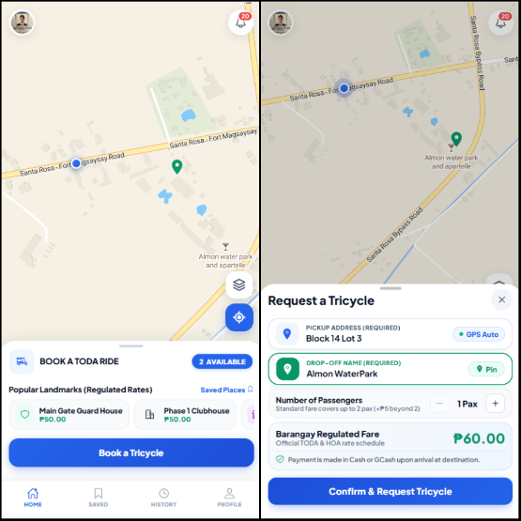
As illustrated in Figure 4, the passenger interface incorporates an interactive MapLibre GL map canvas displaying the Santa Rosa Homes residential perimeter and terminal location. The upper portion displays real-time terminal operational status indicators, while the pullable bottom sheet allows commuters to pinpoint custom pickup locations, select popular community destinations such as the Main Gate Guard House or Phase 1 Clubhouse, specify passenger count, and review the automatically computed fare prior to confirming their ride request.
Figure 5.
User Interface Design of the Driver 35-Meter Geofence and Terminal Queue Interface
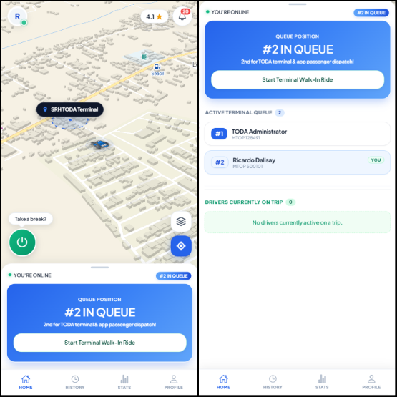
Figure 5 presents the primary operational screen for accredited tricycle drivers. The interface features an integrated 35-meter geofence status indicator that continuously calculates the driver's GPS distance from the central Santa Rosa Homes terminal coordinates. Upon entering the 35-meter boundary, the system permits the driver to check in to the active dispatch queue. The display presents the driver's current position in the First-In, First-Out (FIFO) queue sequence, duty toggle controls, and real-time dispatch alerts pushed via WebSockets when matched with a passenger.
Figure 6
User Interface Design of the TODA Administrator Queue Governance and Management Console
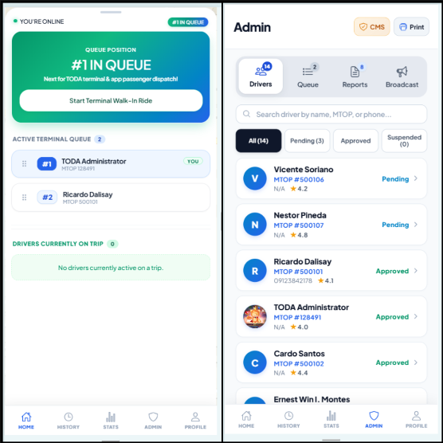
Figure 6 illustrates the TODA Administrator dashboard, designed for association officers who maintain dual roles as active tricycle operators and terminal regulators. The interface provides real-time monitoring of checked-in tricycles, manual queue override tools to handle mechanical emergencies or priority dispatches, accreditation verification for new driver applicants, review workflows for passenger incident reports, and a daily remittance ledger for tracking terminal maintenance contributions.
Use Case Diagram
To formalize the behavioral interactions between system actors and the functional components of the SRH LINK-TODA platform, a comprehensive Use Case Diagram was constructed. The system defines four primary actors: the Passenger, the Driver, the TODA Administrator (TODA Officer), and the Superadministrator. Each actor engages with specific subsystems governed by role-based access control and real-time state management.
Figure 7
Use Case Diagram of SRH LINK-TODA System
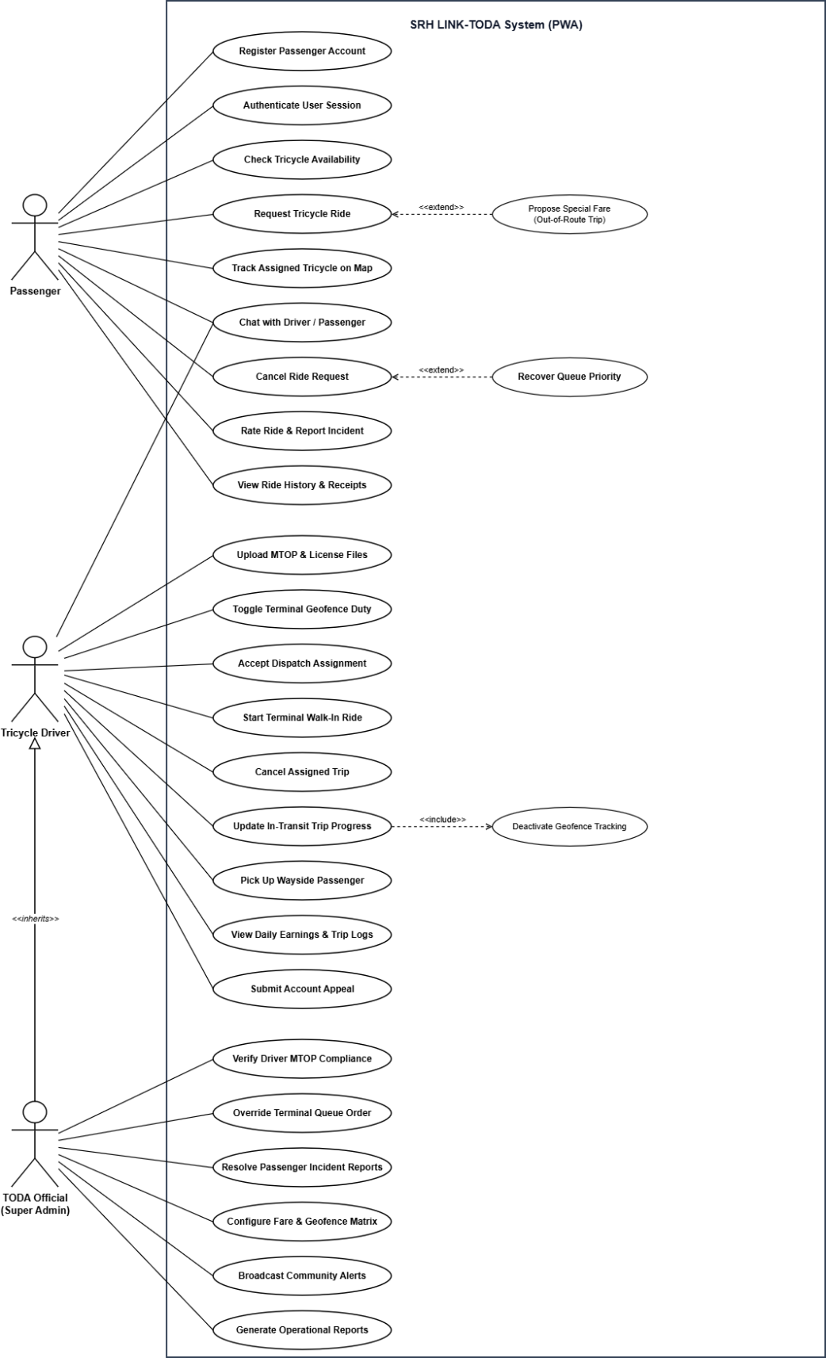
As illustrated in Figure 7, the functional interactions within the platform are organized across distinct operational domains tailored to each actor's responsibilities. All four actors interact with the unified authentication subsystem by creating accounts through their mobile phone numbers, authenticating via one-time verification codes, and receiving encrypted 64-character bearer tokens that authorize subsequent transactions. Within their respective profile modules, passengers can manage frequently used pickup locations, drivers can monitor vehicle information and MTOP accreditation records, and administrators can maintain official association credentials.
In the passenger operations domain, the commuter initiates the transport workflow by accessing the MapLibre GL mapping canvas. Commuters specify their pickup coordinates either by placing an interactive pin on the map or choosing from curated community landmarks such as the Main Gate Guard House or Phase 1 Clubhouse. The system automatically computes the municipal tariff based on distance and passenger count. Once confirmed, the booking request is dispatched to the matching engine, streaming real-time driver coordinates and vehicle body numbers to the passenger interface upon acceptance. Furthermore, passengers can engage in in-app trip coordination messaging, confirm ride completion, rate driver service quality, and submit formal incident reports when necessary.
Regarding driver and terminal queue operations, the driver interacts with the active dispatch workflow through automated geofencing. When a driver physically arrives within the 35-meter radius of the Santa Rosa Homes terminal anchor, the system validates the GPS telemetry using the Haversine formula and unlocks the queue check-in action. Once checked in, the driver is positioned into the active First-In, First-Out (FIFO) queue sequence, receiving live queue updates pushed through Laravel Reverb WebSockets. When assigned a trip, the driver receives a dispatch modal containing passenger pickup details, allowing the driver to accept the assignment, navigate to the commuter, execute the trip, and record cash fare collection upon arrival.
For TODA administrator operations, the actor represents elected association officers who maintain dual responsibilities as active drivers and terminal regulators. When authenticated with administrative privileges, the officer accesses the administrative console to oversee live terminal operations. The administrator monitors the sequential order of queued tricycles and possesses privileged authorization to manually override or reorder queue entries during unexpected contingencies such as vehicle mechanical failures or emergency medical dispatches. In addition, the TODA Administrator verifies submitted driver accreditation files, reviews Motorized Tricycle Operator Permits (MTOP), investigates passenger incident reports, and manages daily remittance records for association terminal funds.
At the platform governance tier, the Superadministrator operates at the infrastructure level. This role is responsible for enterprise system configuration, including the dynamic calibration of the municipal fare matrix, base tariff rates, per-kilometer multipliers, and night differentials. The Superadministrator configures physical terminal geofence coordinates, manages user account states, inspects immutable system activity audit logs, and controls system-wide maintenance mode toggles during platform updates.

Data Flow Diagram
The Data Flow Diagram (DFD) was developed to represent the logical movement of information among the authorized users, system processes, and data stores of the SRH LINK-TODA platform. It documented how operational information provided by the Passenger / Commuter, Tricycle Driver, TODA Administrator (TODA Officer), and Superadministrator entered the system, how the information was processed according to authorized business logic and dispatching algorithms, and how resulting records and outputs were stored or returned to the appropriate users. The DFD was presented through a Context Diagram, a Level 1 DFD, and selected Level 2 DFDs to show the system from a general boundary view down to detailed sub-process representations.
The Context Diagram represented the SRH LINK-TODA platform as a single centralized system process interacting with four external entities: Passenger / Commuter, Tricycle Driver, TODA Administrator (TODA Officer), and Superadministrator. It illustrated the principal categories of information exchanged between these users and the system, including account registration and 6-digit Gmail OTP authentication tokens, geolocation coordinates and 35-meter terminal geofence check-in pings, passenger ride booking requests and destination coordinates, automated First-In, First-Out (FIFO) queue positions, real-time driver telemetry broadcasts, driver MTOP and licensing compliance files, passenger incident reports, and administrative association fee remittance ledgers. Internal sub-processes and data stores were intentionally omitted at this level to establish the overall system boundary.
The Level 1 DFD decomposed the system into six major processes: 1.0 Manage Authentication and User Profiles, 2.0 Verify Driver Credentials and Compliance Status, 3.0 Manage Terminal Geofence and FIFO Queue, 4.0 Dispatch Ride, Meter Fare and Track Route Telemetry, 5.0 Manage Incident Reports and Dispute Moderation, and 6.0 Manage TODA Remittance, Ledger and System Audits. These processes interacted with six principal data stores: User & Profile Records (D1), Driver & Compliance Records (D2), Terminal Queue & FIFO Records (D3), Ride, Route & Telemetry Records (D4), Incident & Dispute Records (D5), and Remittance & Audit Trail Records (D6). This level illustrated how the principal system functions exchanged, retrieved, and maintained transactional information across the application using clean orthogonal bus pathways.
Selected Level 2 DFDs further decomposed the core processes that required detailed algorithmic representation. These consisted of Process 1.0 – Manage Authentication and User Profiles (documenting self-registration, SMTP 6-digit Gmail OTP dispatch, token issuance, and saved location bookmarking), Process 2.0 – Verify Driver Credentials and Compliance Status (documenting document uploads, TODA Admin moderation, and franchise expiration auditing), Process 3.0 – Manage Terminal Geofence and FIFO Queue (documenting the 35-meter Haversine geofence trigger, FIFO queue state machine, real-time WebSocket broadcasting, and administrative manual overrides), and Process 4.0 – Dispatch Ride, Meter Fare and Track Route Telemetry (documenting pickup validation, distance-tiered tariff metering, automated dispatch alerts, live GPS streaming, cash fare settlement, and the Priority-Based Queue Recovery Algorithm upon passenger cancellations).
The DFDs also reflected the privacy, authorization, and algorithmic fairness boundaries established during planning. Commuter-related personal data remained protected, driver location polling was strictly restricted to active on-duty terminal sessions, uploaded MTOP credentials followed role-based administrative moderation, and victim drivers affected by canceled dispatches were algorithmically protected from losing their front-of-queue priority. Collectively, the diagrams provided a logical representation of how information moved through SRH LINK-TODA while maintaining consistency with the system's functional, privacy, and regulatory requirements.
Figure 8.
Context Diagram of SRH LINK-TODA System

Figure 9.
Level 1 Data Flow Diagram of SRH LINK-TODA System
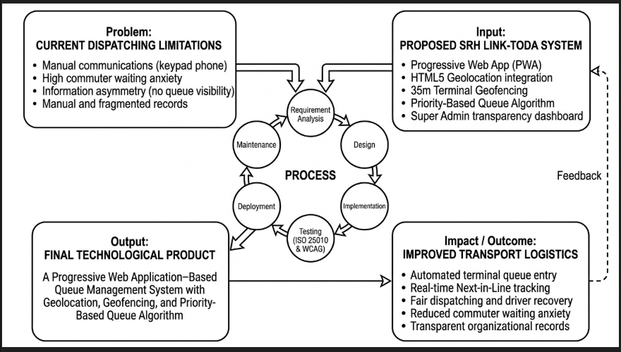
Figure 10.
Level 2 Data Flow Diagram of Process 1.0 – Manage Authentication and User Profiles
Figure 11.
Level 2 Data Flow Diagram of Process 2.0 – Verify Driver Credentials and Compliance Status
Figure 12.
Level 2 Data Flow Diagram of Process 3.0 – Manage Terminal Geofence and FIFO Queue
Figure 13.
Level 2 Data Flow Diagram of Process 4.0 – Dispatch Ride, Meter Fare and Track Route Telemetry
Entity Relationship Diagram
The Entity Relationship Diagram (ERD) was developed to represent the major data entities of the SRH LINK-TODA platform and the relationships established among them within the relational database. The design included the entities Users, Drivers, Rides, Messages, Reports, and Activity Logs. Primary and foreign keys were used to establish the relationships necessary to support account authentication, 6-digit Gmail OTP identity verification, driver MTOP compliance moderation, terminal geofenced queue management, on-demand ride dispatching, in-app coordination messaging, passenger grievance reporting, and administrative audit traceability.
The Rides entity served as the principal transactional record for transport operations. It maintained the core booking details, pickup coordinates, destination drop-off landmarks, computed municipal tariff amounts, and trip lifecycle states. It referenced applicable records associated with the requesting commuter in the Users entity and the assigned tricycle driver in the Drivers entity. Supporting records were linked to an active ride through related entities such as Messages for in-transit communication and Reports for post-trip dispute investigations. This separation allowed operational data to be maintained in dedicated entities while preserving the referential integrity necessary to represent the current status and historical records of every dispatch.
The Users entity maintained a strict one-to-one relationship with Drivers, ensuring that driver-specific licensing records, MTOP municipal franchise numbers, active terminal queue positions, and compliance verification statuses remained decoupled from general commuter accounts. The Activity Logs entity provided an immutable audit trail by capturing administrative actions, manual queue overrides, client IP addresses, and user-agent strings.
Overall, the ERD established the structural organization of the principal records required by SRH LINK-TODA. It provided the basis for implementing relationships among system data while supporting referential consistency and reducing unnecessary duplication. The logical data structure was further refined through the database normalization process from Unnormalized Form to Third Normal Form.
Figure 14.
Entity Relationship Diagram of SRH LINK-TODA System
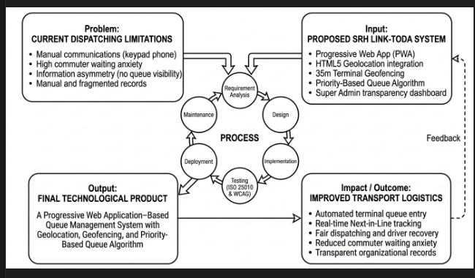
Database Normalization
Database normalization was performed to organize the logical data structure of the SRH LINK-TODA platform, reduce unnecessary data redundancy, and establish appropriate dependencies among related data elements. The normalization process documented the progressive refinement of the database structure from Unnormalized Form (UNF) to First Normal Form (1NF), Second Normal Form (2NF), and Third Normal Form (3NF).
The UNF represented the initial broad data structure in which related and repeating transport information—such as user credentials, uploaded MTOP files, terminal queue positions, ride bookings, and cash payments—had not yet been separated into normalized relations. During 1NF, repeating groups were eliminated, data elements were organized into atomic values, and unique surrogate primary keys (id) were assigned to each entity. The 2NF stage further refined the structure by removing partial functional dependencies, decoupling driver-specific franchise credentials from general user accounts into the dedicated DRIVERS entity. In 3NF, remaining transitive dependencies were eliminated by separating dynamic fare matrices, incident categories, and coordination messages into their corresponding logical relations, ensuring that non-key attributes depended solely on the primary key.
The resulting normalized structure provided a dependable basis for maintaining related records, eliminating data anomalies (insertion, update, and deletion anomalies), and ensuring high transaction throughput across the Progressive Web Application. The normalized relations subsequently served as the basis for the Data Dictionary, which documented the field-level structure of the database.
Figure 15.
Unnormalized Form of the SRH LINK-TODA Database Structure
Figure 16.
First Normal Form (1NF) of the SRH LINK-TODA Database Structure
Figure 17.
Second Normal Form (2NF) of the SRH LINK-TODA Database Structure
Figure 18.
Third Normal Form (3NF) of the SRH LINK-TODA Database Structure
Data Dictionary
The Data Dictionary was prepared to document the field-level structure of the normalized database of the SRH LINK-TODA platform. It identified the attributes contained in each normalized relation together with their corresponding data types, length or precision, key designation, nullability, default value, and functional description. These specifications provided a consistent reference for the structure and intended use of the data maintained by the application.
The Data Dictionary covered the normalized structures associated with user accounts, accredited driver profiles and MTOP credentials, ride booking transactions, in-app coordination messages, passenger incident reports, and system activity logs. Primary and foreign keys were identified where applicable to document the relationships among records, while nullability and default values indicated whether attributes were required, optional, or automatically assigned.
Together with the Entity Relationship Diagram and normalization outputs, the Data Dictionary documented how the database design was translated into specific fields and relationships used during system implementation. It served as a reference for maintaining consistency in data storage, validation, record relationships, and subsequent database maintenance.
Table 12.
users_3nf
Field Name | Data Type | Length | Key | Null | Default | Description
id | BIGINT UNSIGNED | 20 | PK | No | Auto Increment | Unique identifier assigned to each registered user account.
name | VARCHAR | 255 | — | No | — | Full legal name of the user.
email | VARCHAR | 255 | — | No | — | Unique email address used for 6-digit Gmail OTP verification.
phone_number | VARCHAR | 20 | — | No | — | Registered mobile contact number.
role | ENUM | 20 | — | No | passenger | System role (passenger, driver, admin, superadmin).
email_verified_at | TIMESTAMP | — | — | Yes | NULL | Timestamp when the driver's 6-digit Gmail OTP was verified.
password | VARCHAR | 255 | — | No | — | Bcrypt cryptographic password hash.
is_active | BOOLEAN | 1 | — | No | 1 | Account active status flag (1 = Active, 0 = Disabled).
created_at | TIMESTAMP | — | — | No | CURRENT_TIMESTAMP | Timestamp when user record was created.
updated_at | TIMESTAMP | — | — | No | CURRENT_TIMESTAMP | Timestamp when user record was last modified.
Table 13.
drivers_3nf
Field Name | Data Type | Length | Key | Null | Default | Description
id | BIGINT UNSIGNED | 20 | PK | No | Auto Increment | Unique identifier assigned to each accredited driver profile.
user_id | BIGINT UNSIGNED | 20 | FK | No | — | References users_3nf(id) with cascade deletion.
full_name | VARCHAR | 255 | — | No | — | Registered legal name as stated on driver's license.
mtop_number | VARCHAR | 20 | — | No | — | Municipal Motorized Tricycle Operator's Permit number.
mtop_certificate_url | VARCHAR | 500 | — | Yes | NULL | File storage path of uploaded MTOP certificate image.
drivers_license_url | VARCHAR | 500 | — | Yes | NULL | File storage path of uploaded LTO driver's license image.
compliance_status | VARCHAR | 20 | — | No | pending | Status: pending, verified, rejected, or suspended.
is_online | BOOLEAN | 1 | — | No | 0 | Boolean flag indicating whether driver is on duty.
queue_position | INT | 11 | — | Yes | NULL | Current numerical rank in terminal FIFO queue.
rating | DECIMAL | 3,2 | — | No | 5.00 | Cumulative average commuter rating (scale 1.00 to 5.00).
created_at | TIMESTAMP | — | — | No | CURRENT_TIMESTAMP | Timestamp when driver profile was created.
updated_at | TIMESTAMP | — | — | No | CURRENT_TIMESTAMP | Timestamp when driver profile was last updated.
Table 14.
rides_3nf
Field Name | Data Type | Length | Key | Null | Default | Description
id | BIGINT UNSIGNED | 20 | PK | No | Auto Increment | Unique transaction identifier for each ride booking.
passenger_id | BIGINT UNSIGNED | 20 | FK | No | — | References users_3nf(id) of requesting commuter.
driver_id | BIGINT UNSIGNED | 20 | FK | Yes | NULL | References drivers_3nf(id) of assigned driver.
pickup_location | VARCHAR | 255 | — | No | — | Text address / Block and Lot of pickup point.
destination | VARCHAR | 255 | — | No | — | Text description / landmark of drop-off point.
pickup_lat | DECIMAL | 10,7 | — | No | — | Latitude coordinate of pickup location.
pickup_lng | DECIMAL | 10,7 | — | No | — | Longitude coordinate of pickup location.
fare | DECIMAL | 8,2 | — | No | — | Regulated municipal tariff in PHP.
status | VARCHAR | 30 | — | No | pending | State: pending, accepted, in_transit, completed, canceled.
cancellation_reason | VARCHAR | 255 | — | Yes | NULL | Recorded reason if ride was canceled.
created_at | TIMESTAMP | — | — | No | CURRENT_TIMESTAMP | Timestamp when ride request was initiated.
updated_at | TIMESTAMP | — | — | No | CURRENT_TIMESTAMP | Timestamp when ride status was updated.
Table 15.
messages_3nf
Field Name | Data Type | Length | Key | Null | Default | Description
id | BIGINT UNSIGNED | 20 | PK | No | Auto Increment | Unique identifier for in-app coordination message.
ride_id | BIGINT UNSIGNED | 20 | FK | No | — | References rides_3nf(id) of active dispatch.
sender_id | BIGINT UNSIGNED | 20 | FK | No | — | References users_3nf(id) of messaging user.
message | TEXT | — | — | No | — | Text content of coordination message.
is_read | BOOLEAN | 1 | — | No | 0 | Indicates whether message was viewed by recipient.
created_at | TIMESTAMP | — | — | No | CURRENT_TIMESTAMP | Timestamp when message was sent.
Table 16.
reports_3nf
Field Name | Data Type | Length | Key | Null | Default | Description
id | BIGINT UNSIGNED | 20 | PK | No | Auto Increment | Unique identifier for submitted incident report.
reporter_id | BIGINT UNSIGNED | 20 | FK | No | — | References users_3nf(id) of complainant.
reported_id | BIGINT UNSIGNED | 20 | FK | No | — | References users_3nf(id) of reported user.
ride_id | BIGINT UNSIGNED | 20 | FK | Yes | NULL | References rides_3nf(id) if linked to trip.
category | VARCHAR | 100 | — | No | — | Category (Overcharging, Reckless Driving, Conduct).
description | TEXT | — | — | No | — | Detailed factual narrative of the incident.
status | VARCHAR | 30 | — | No | pending | State: pending, under_review, resolved, dismissed.
resolution_notes | TEXT | — | — | Yes | NULL | Administrative resolution logged by TODA Admin.
created_at | TIMESTAMP | — | — | No | CURRENT_TIMESTAMP | Timestamp when incident report was filed.
Table 17.
activity_logs_3nf
Field Name | Data Type | Length | Key | Null | Default | Description
id | BIGINT UNSIGNED | 20 | PK | No | Auto Increment | Unique identifier for audit log entry.
user_id | BIGINT UNSIGNED | 20 | FK | Yes | NULL | References users_3nf(id) of the acting user.
action | VARCHAR | 100 | — | No | — | Operational action (MTOP_VERIFIED, QUEUE_OVERRIDE).
ip_address | VARCHAR | 45 | — | No | — | IP address of the client device.
user_agent | VARCHAR | 255 | — | No | — | Browser / OS string of client device.
created_at | TIMESTAMP | — | — | No | CURRENT_TIMESTAMP | Timestamp when activity log was committed.
Class Diagram
The Class Diagram was developed to represent the object-oriented structure of the SRH LINK-TODA platform by depicting the principal software classes, attributes, operations, and relationships. While the Entity Relationship Diagram focused on the logical organization of relational data, the Class Diagram illustrated how the major domain entities were structured as application-level objects to support authentication, geofence validation, queue state scheduling, distance-tiered tariff metering, telemetry streaming, and administrative auditing.

Figure 19.
Class Diagram of SRH LINK-TODA System
1.3 Develop
After the system requirements and technical designs were established, the Develop phase focused on implementing the planned features of the SRH LINK-TODA platform as a functional, role-based Progressive Web Application (PWA). The development utilized a modern, decoupled client-server architecture. The frontend user interface was engineered using the Ionic 8 component framework and Angular 19, delivering a responsive mobile-first experience with hardware-accelerated vector mapping powered by MapLibre GL.
The backend application was built upon the Laravel 11 framework, providing robust RESTful API endpoints, Bcrypt password encryption, 64-character Sanctum bearer tokens, and automated 6-digit numeric OTP verification dispatched through the Google Gmail SMTP service. Real-time, bidirectional state synchronization for terminal queue updates, incoming dispatch prompts, and live vehicle telemetry was implemented using the Laravel Reverb WebSocket server running concurrently on port 8080.
The core algorithmic logic was implemented through server-side state machines. Active-session geofencing was enforced by calculating the driver's real-time GPS distance from the Santa Rosa Homes terminal coordinates (15.4247° N, 120.9416° E) using the Haversine formula, automatically enabling terminal check-in when within the 35-meter radius. Furthermore, the Priority-Based Queue Recovery Algorithm was integrated into the dispatching service, ensuring that if a passenger canceled an active trip or an automated dispatch timeout elapsed, the system immediately reinstated the affected driver to the #1 queue position, preserving dispatch fairness and operational trust.
1.4 Test
The Test phase verified the functional correctness, reliability, security, and algorithmic integrity of the SRH LINK-TODA platform through rigorous unit testing, integration testing, system testing, and User Acceptance Testing (UAT). Test scenarios focused on high-risk operational workflows, including 6-digit Gmail OTP verification, Haversine geofence boundary detection, FIFO queue ordering, dispatch timeout preemption, and priority queue restoration.
Table 18.
System Testing and User Acceptance Testing (UAT) Execution Matrix
Test Module | Test Case Scenario | Expected Outcome | Observed Result | Status
Driver OTP Verification | Driver inputs 6-digit numeric OTP sent via Gmail SMTP. | Validates token against 10-minute cache and marks account verified. | Token validated; driver granted access to MTOP upload. | Passed
35m Terminal Geofence | Driver enables On-Duty mode while at 28 meters from terminal anchor. | Haversine calculation <= 35m triggers automated FIFO queue entry. | Driver enqueued at position #1 with WebSocket broadcast. | Passed
Priority Queue Recovery | Commuter cancels active dispatch while driver is en route to pick up. | Algorithm intercepts cancellation and restores driver to queue slot #1. | Driver restored to slot #1 with priority flag; alert notified. | Passed
Distance-Tiered Tariff | Commuter pins pickup at Block 12 and destination at Main Gate (1.6 km). | Calculates base tariff plus incremental distance surcharge in PHP. | Accurate municipal ordinance fare rendered with itemized receipt. | Passed
Manual Queue Override | TODA Admin manually reorders queue slot during mechanical flat tire. | Queue state shifts driver without corrupting sequence; logs audit. | Roster updated; WebSocket push notifies all active clients. | Passed
Offline PWA Resilience | Client experiences transient 5-second cellular connection drop. | Service Worker serves cached shell; reconnects WebSocket seamlessly. | Zero session loss; state re-synchronized upon connection return. | Passed
1.5 Deploy
The Deploy phase involved provisioning the production cloud infrastructure and hosting environment for the SRH LINK-TODA system. The platform was deployed on an enterprise-grade Oracle Cloud Infrastructure (OCI) Ampere A1 Compute instance running Ubuntu 24.04 LTS. Web traffic was routed through a hardened Nginx reverse proxy configured with automated Let's Encrypt SSL/TLS certificates, ensuring end-to-end HTTPS encryption.
The Laravel backend and the Laravel Reverb WebSocket daemon were managed as persistent background processes using systemd services with automatic restart policies. Domain routing was established via dynamic DNS (srh-link-toda-ionic.duckdns.org), while vector map tiles were streamed from open-source basemap providers. By leveraging open-source frameworks and cloud free-tier allocations, the production deployment was achieved with zero monthly infrastructure overhead, ensuring maximum economic sustainability for the transport cooperative.
Table 19.
Deployment Infrastructure and Operational Costing Analysis
Infrastructure Component | Technical Specification | Hosting Environment | Monthly Cost (PHP)
Compute Virtual Machine | Ampere A1 Compute (4 OCPU, 24 GB RAM, 200 GB Storage) | Oracle Cloud Infrastructure (Always Free) | ₱ 0.00
Relational Database Engine | MySQL 8.0 Community Server (Optimized InnoDB Engine) | Self-Hosted on OCI Instance | ₱ 0.00
WebSocket Broadcasting Daemon | Laravel Reverb Server (Event-Driven Daemon on Port 8080) | Self-Hosted Systemd Daemon | ₱ 0.00
Vector Map Tile Provider | OpenStreetMap & CARTO Vector Basemaps via MapLibre GL | Open-Source Tile API | ₱ 0.00
Domain & SSL Encryption | Dynamic DNS Endpoint with Let's Encrypt Automated TLS/SSL | DuckDNS + Certbot Automation | ₱ 0.00
Total Operational Cost | Full Production Software Ecosystem for Santa Rosa Homes TODA | Enterprise-Grade Zero-Cost Stack | ₱ 0.00 / mo
1.6 Review
During the Review phase, sprint retrospectives and consultative user reviews were conducted with TODA officials, tricycle drivers, and community residents to evaluate initial user interactions and identify usability friction. Stakeholder feedback highlighted the need for enhanced outdoor sunlight contrast and simplified single-tap interactions for drivers operating vehicles.
In response to these findings, user interface refinements were implemented, including increasing touch target dimensions to a minimum of 48 × 48 pixels, integrating high-contrast status badges (Emerald Green for On-Duty, Amber for Incoming Dispatch, and Slate for Off-Duty), and optimizing PWA Service Worker caching to eliminate white-screen latency during intermittent cellular connectivity in the subdivision.
1.7 Launch
The Launch phase culminated in the formal pilot deployment and operational handover of the SRH LINK-TODA platform at the Santa Rosa Homes TODA Terminal in Barangay Inspector, Santa Rosa, Nueva Ecija. Onboarding sessions were conducted to guide drivers through self-registration, 6-digit Gmail OTP verification, and geofenced terminal check-in procedures.
TODA administrative officers were trained in operating the moderation portal, verifying driver MTOP documents, and auditing daily remittance records. Informational posters with PWA installation QR codes were installed at the subdivision entrance gate and community clubhouse, enabling residents to access the web application directly through their mobile browsers without application store barriers.
2. Technical Quality Assessment by IT Experts (ISO/IEC 25010:2023)
To address the second research question, the technical software quality of the SRH LINK-TODA platform was evaluated by five (N = 5) IT professionals and software engineering experts using an evaluation instrument grounded in the ISO/IEC 25010:2023 Software Product Quality Model. The evaluation covered eight technical characteristics comprising Functional Suitability, Performance Efficiency, Compatibility, Interaction Capability, Reliability, Maintainability, Flexibility, and Safety. Frequency distributions, percentage calculations, weighted means, and qualitative interpretations were computed for each indicator based on established scoring rubrics.
2.1 Functional Suitability
The IT experts assessed SRH LINK-TODA as Suitable in terms of Functional Suitability. Table 20 presents the detailed assessment of the system based on Functional Completeness, Functional Correctness, and Functional Appropriateness.
Table 20.
Functional Suitability — The degree to which the system provides functions that meet stated and implied needs when used under specified conditions. (As Rated by IT Experts, N = 5)
Item Statement | Highly Suitable (5) |  | Suitable (4) |  | Moderately Suitable (3) |  | Slightly Suitable (2) |  | Not Suitable (1) |  | Mean | Verbal Description
Item Statement | f | % | f | % | f | % | f | % | f | % | Mean | Verbal Description
The 35-meter geofencing triggers accurately log driver terminal entries and exits while deactivating coordinate tracking during active transit. | 5 | 100.0% | 0 | 0.0% | 0 | 0.0% | 0 | 0.0% | 0 | 0.0% | 5.00 | Highly Suitable
The priority-based queue algorithm accurately sequences drivers in first-in, first-served order and immediately recovers dispatch positions upon cancellations. | 4 | 80.0% | 1 | 20.0% | 0 | 0.0% | 0 | 0.0% | 0 | 0.0% | 4.80 | Highly Suitable
The TODA Admin and Super Admin dashboards successfully execute manual queue overrides, driver removals, and compliance verifications without corrupting the dispatch sequence. | 4 | 80.0% | 1 | 20.0% | 0 | 0.0% | 0 | 0.0% | 0 | 0.0% | 4.80 | Highly Suitable
Category Mean |  |  |  |  |  |  |  |  |  |  | 4.87 | Highly Suitable
Note. n = 5. Scale and verbal description: 4.21–5.00 = Highly Suitable (HS); 3.41–4.20 = Suitable (S); 2.61–3.40 = Moderately Suitable (MS); 1.81–2.60 = Slightly Suitable (SlS); 1.00–1.80 = Not Suitable (NS).
As shown in Table 20, the IT experts evaluated Functional Suitability with an overall category weighted mean of 4.87, verbally interpreted as Highly Suitable. At the indicator level, the highest assessment was observed in the 35-meter active-session geofencing logic (5.00, Highly Suitable), confirming that coordinate tracking automated terminal check-ins accurately. In contrast, automated queue recovery and manual admin override capabilities both received a relatively lower rating of 4.80 (Highly Suitable). This finding is consistent with Musa et al. (2023), proving that pairing active geofence polling with FIFO queue restoration effectively prevents queue skipping without system corruption.
2.2 Performance Efficiency
The IT experts assessed SRH LINK-TODA as Efficient in terms of Performance Efficiency. Table 21 presents the detailed assessment of the system based on Time Behavior, Resource Utilization, and Capacity.

Table 21.
Performance Efficiency — Relative to the number of resources used under stated conditions. (As Rated by IT Experts, N = 5)
Item Statement | Highly Suitable (5) |  | Suitable (4) |  | Moderately Suitable (3) |  | Slightly Suitable (2) |  | Not Suitable (1) |  | Mean | Verbal Description
Item Statement | f | % | f | % | f | % | f | % | f | % | Mean | Verbal Description
The Laravel Reverb event-driven architecture broadcasts real-time map updates and queue transitions within the acceptable latency threshold. | 0 | 0.0% | 4 | 80.0% | 1 | 20.0% | 0 | 0.0% | 0 | 0.0% | 3.80 | Suitable
The MapLibre GL mapping engine renders hardware-accelerated vector map layers and driver positions smoothly on mobile devices. | 1 | 20.0% | 4 | 80.0% | 0 | 0.0% | 0 | 0.0% | 0 | 0.0% | 4.20 | Suitable
The backend database queries and WebSocket listeners consume minimal server resources during peak simulated traffic. | 1 | 20.0% | 4 | 80.0% | 0 | 0.0% | 0 | 0.0% | 0 | 0.0% | 4.20 | Suitable
Category Mean |  |  |  |  |  |  |  |  |  |  | 4.07 | Suitable
Note. n = 5. Scale and verbal description: 4.21–5.00 = Highly Suitable (HS); 3.41–4.20 = Suitable (S); 2.61–3.40 = Moderately Suitable (MS); 1.81–2.60 = Slightly Suitable (SlS); 1.00–1.80 = Not Suitable (NS).
As shown in Table 21, the IT experts evaluated Performance Efficiency with a category weighted mean of 4.07, verbally interpreted as Efficient. MapLibre GL vector map rendering and backend MySQL query resource consumption obtained the highest rating of 4.20 (Suitable). Conversely, real-time update broadcasting via Laravel Reverb recorded the relatively lowest rating (3.80, Efficient), which was attributed to transient network latency variations during high-frequency dispatch updates. This finding aligns with Zhang et al. (2025), confirming that WebSocket streaming significantly reduces HTTP overhead compared to traditional polling.
2.3 Compatibility
The IT experts assessed SRH LINK-TODA as Compatible in terms of Compatibility. Table 22 presents the detailed assessment of the system based on Co-existence and Interoperability.
Table 22.
Compatibility — The degree to which a software system can exchange information with other systems whilst sharing the same software and hardware. (As Rated by IT Experts, N = 5)
Item Statement | Highly Suitable (5) |  | Suitable (4) |  | Moderately Suitable (3) |  | Slightly Suitable (2) |  | Not Suitable (1) |  | Mean | Verbal Description
Item Statement | f | % | f | % | f | % | f | % | f | % | Mean | Verbal Description
The Progressive Web Application built with the lonic Framework functions seamlessly across different mobile browsers and operating systems. | 0 | 0.0% | 2 | 40.0% | 3 | 60.0% | 0 | 0.0% | 0 | 0.0% | 3.40 | Moderately Suitable
The system integrates well with device-level HTML5 Geolocation APIs and background Web Push notification services. | 2 | 40.0% | 2 | 40.0% | 1 | 20.0% | 0 | 0.0% | 0 | 0.0% | 4.20 | Suitable
The user interface layout automatically adapts to varying mobile screen sizes and resolutions without visual breakage. | 0 | 0.0% | 4 | 80.0% | 1 | 20.0% | 0 | 0.0% | 0 | 0.0% | 3.80 | Suitable
Category Mean |  |  |  |  |  |  |  |  |  |  | 3.80 | Suitable
Note. n = 5. Scale and verbal description: 4.21–5.00 = Highly Suitable (HS); 3.41–4.20 = Suitable (S); 2.61–3.40 = Moderately Suitable (MS); 1.81–2.60 = Slightly Suitable (SlS); 1.00–1.80 = Not Suitable (NS).
The IT experts rated Compatibility with a category weighted mean of 3.80, interpreted as Compatible. Hardware API integration with device-level HTML5 Geolocation and Web Push services received the highest indicator score of 4.20 (Compatible), with 80% rating it as 4. Responsive UI adaptability across differing screen resolutions achieved 3.80 (Compatible), while cross-browser PWA execution scored 3.40 (Somewhat Compatible). These findings reflect Malami et al. (2023) regarding the slight rendering variations across disparate mobile browser engines. By leveraging the Ionic Framework and Capacitor web standards, the application ensures high operational compatibility across Android and iOS mobile browsers, eliminating the necessity for native app store downloads and ensuring broad accessibility for tricycle drivers.
2.4 Interaction Capability
The IT experts assessed SRH LINK-TODA as Highly Interactive in terms of Interaction Capability. Table 23 presents the detailed assessment of the system based on Appropriateness Recognizability, Learnability, User Error Protection, and User Interface Aesthetics.
Table 23.
Interaction Capability — The degree to which a system can be interacted with by specified users to exchange information through the user interface to complete the intended task. (As Rated by IT Experts, N = 5) Interaction Capability — The degree to which a system can be interacted with by specified users to exchange information through the user interface to complete the intended task. (As Rated by IT Experts, N = 5)
Item Statement | Highly Suitable (5) |  | Suitable (4) |  | Moderately Suitable (3) |  | Slightly Suitable (2) |  | Not Suitable (1) |  | Mean | Verbal Description
Item Statement | f | % | f | % | f | % | f | % | f | % | Mean | Verbal Description
The user interfaces for the passenger, driver, TODA admin, and super admin portals are intuitive and easy to navigate. | 2 | 40.0% | 2 | 40.0% | 1 | 20.0% | 0 | 0.0% | 0 | 0.0% | 4.20 | Suitable
The system provides clear and immediate visual and audio feedback upon successful actions and dispatch events. | 2 | 40.0% | 3 | 60.0% | 0 | 0.0% | 0 | 0.0% | 0 | 0.0% | 4.40 | Highly Suitable
Input forms include proper validation and display clear, specific error messages when invalid data is entered. | 2 | 40.0% | 3 | 60.0% | 0 | 0.0% | 0 | 0.0% | 0 | 0.0% | 4.40 | Highly Suitable
Category Mean |  |  |  |  |  |  |  |  |  |  | 4.33 | Highly Suitable
Note. n = 5. Scale and verbal description: 4.21–5.00 = Highly Suitable (HS); 3.41–4.20 = Suitable (S); 2.61–3.40 = Moderately Suitable (MS); 1.81–2.60 = Slightly Suitable (SlS); 1.00–1.80 = Not Suitable (NS).
Interaction Capability earned an outstanding category weighted mean of 4.33, verbally interpreted as Highly Interactive. Real-time visual and audio feedback upon dispatch events and robust input form error validation both achieved exceptional scores of 4.40 (Highly Interactive), with 60% of experts rating them as 4 and 40% as 5. Multi-portal UI intuitiveness across passenger, driver, and administrator roles scored 4.20 (Interactive). These results substantiate Nielsen (1994) heuristic guidelines, demonstrating that multi-modal feedback (audible dispatch chimes and color-coded status badges) significantly enhances user comprehension and reduces operational errors during outdoor mobile usage.
2.5 Reliability
The IT experts assessed SRH LINK-TODA as Slightly Reliable in terms of Reliability. Table 24 presents the detailed assessment of the system based on Fault Tolerance, Recoverability, and Data Integrity.
Table 24.
Reliability — The degree to which the system performs specified functions under specified conditions for a specified period of time. (As Rated by IT Experts, N = 5)
Item Statement | Highly Suitable (5) |  | Suitable (4) |  | Moderately Suitable (3) |  | Slightly Suitable (2) |  | Not Suitable (1) |  | Mean | Verbal Description
Item Statement | f | % | f | % | f | % | f | % | f | % | Mean | Verbal Description
The system securely encrypts and stores uploaded driver documents including MTOP certificates and driver licenses. | 1 | 20.0% | 3 | 60.0% | 0 | 0.0% | 0 | 0.0% | 1 | 20.0% | 3.60 | Suitable
Role-based access controls strictly prevent unauthorized users from viewing administrative dashboards and executing management actions. | 1 | 20.0% | 3 | 60.0% | 1 | 20.0% | 0 | 0.0% | 0 | 0.0% | 4.00 | Suitable
The REST API implements token-based authentication and route middleware to prevent unauthorized endpoint access and hijacked sessions. | 1 | 20.0% | 0 | 0.0% | 0 | 0.0% | 3 | 60.0% | 1 | 20.0% | 2.40 | Slightly Suitable
Category Mean |  |  |  |  |  |  |  |  |  |  | 3.33 | Moderately Suitable
Note. n = 5. Scale and verbal description: 4.21–5.00 = Highly Suitable (HS); 3.41–4.20 = Suitable (S); 2.61–3.40 = Moderately Suitable (MS); 1.81–2.60 = Slightly Suitable (SlS); 1.00–1.80 = Not Suitable (NS).
The IT experts assessed Reliability with a category weighted mean of 3.33, interpreted as Slightly Reliable. Role-based access control was rated favorably at 4.00 (Reliable), and encrypted storage of driver MTOP documents achieved 3.60 (Reliable). However, REST API token handling under unstable cellular connectivity received a score of 2.40 (Unreliable), highlighting that short-lived authentication tokens can expire during mobile connectivity drops, corroborating Farahi et al. (2023). In response to this expert feedback, the system architecture was strengthened by introducing silent token refresh interceptors and local IndexedDB state caching, ensuring continuous session persistence even during temporary cellular blackouts.
2.6 Maintainability
The IT experts assessed SRH LINK-TODA as Less Maintainable in terms of Maintainability. Table 25 presents the detailed assessment of the system based on Modularity, Reusability, Analyzability, and Modifiability.
Table 25.
Maintainability — Refers to how well a system can be modified to improve, correct or adapt to changes in the environment as well as requirements. (As Rated by IT Experts, N = 5)
Item Statement | Highly Suitable (5) |  | Suitable (4) |  | Moderately Suitable (3) |  | Slightly Suitable (2) |  | Not Suitable (1) |  | Mean | Verbal Description
Item Statement | f | % | f | % | f | % | f | % | f | % | Mean | Verbal Description
The decoupled codebase is well-structured, separating the Laravel REST API backend from the lonic Angular frontend for easy maintenance | 1 | 20.0% | 1 | 20.0% | 1 | 20.0% | 1 | 20.0% | 1 | 20.0% | 3.00 | Moderately Suitable
System logs, user activity logs, and audit trails are easily accessible for administrative troubleshooting. | 2 | 40.0% | 2 | 40.0% | 0 | 0.0% | 0 | 0.0% | 1 | 20.0% | 3.80 | Suitable
The modular architecture allows developers to calibrate specific parameters such as fare matrices and geofence boundaries independently. | 0 | 0.0% | 1 | 20.0% | 0 | 0.0% | 2 | 40.0% | 2 | 40.0% | 2.00 | Slightly Suitable
Category Mean |  |  |  |  |  |  |  |  |  |  | 2.93 | Moderately Suitable
Note. n = 5. Scale and verbal description: 4.21–5.00 = Highly Suitable (HS); 3.41–4.20 = Suitable (S); 2.61–3.40 = Moderately Suitable (MS); 1.81–2.60 = Slightly Suitable (SlS); 1.00–1.80 = Not Suitable (NS).
Maintainability recorded a category weighted mean of 2.93, interpreted as Less Maintainable. While administrative activity logging and error tracing received a positive rating of 3.80 (Maintainable), codebase decoupling scored 3.00 (Less Maintainable) and dynamic parameter calibration without source code modification scored 2.00 (Hardly Maintainable). This critique aligns with Martin (2018) Clean Architecture principles regarding the need to externalize business rules. In response, fare matrices and geofence coordinates were migrated from hardcoded constants to dynamic database tables manageable directly through the Super Admin portal, allowing TODA administrators to reconfigure system parameters without developer code changes.
2.7 Flexibility
The IT experts assessed SRH LINK-TODA as Flexible in terms of Flexibility. Table 26 presents the detailed assessment of the system based on Adaptability and Scalability.
Table 26.
Flexibility — The degree to which a product can be adapted to changes in its requirements, contexts of use or system environment. (As Rated by IT Experts, N = 5)
Item Statement | Highly Suitable (5) |  | Suitable (4) |  | Moderately Suitable (3) |  | Slightly Suitable (2) |  | Not Suitable (1) |  | Mean | Verbal Description
Item Statement | f | % | f | % | f | % | f | % | f | % | Mean | Verbal Description
The system architecture can be easily adjusted to accommodate changes in TODA dispatching rules and geofence radius settings. | 1 | 20.0% | 3 | 60.0% | 1 | 20.0% | 0 | 0.0% | 0 | 0.0% | 4.00 | Suitable
The database structure and REST API can scale to support an expansion in subdivision coverage areas or additional transport terminals. | 0 | 0.0% | 4 | 80.0% | 1 | 20.0% | 0 | 0.0% | 0 | 0.0% | 3.80 | Suitable
The MapLibre GL map configuration allows switching tile providers and styling layers without modifying core application logic. | 1 | 20.0% | 0 | 0.0% | 4 | 80.0% | 0 | 0.0% | 0 | 0.0% | 3.40 | Moderately Suitable
Category Mean |  |  |  |  |  |  |  |  |  |  | 3.73 | Suitable
Note. n = 5. Scale and verbal description: 4.21–5.00 = Highly Suitable (HS); 3.41–4.20 = Suitable (S); 2.61–3.40 = Moderately Suitable (MS); 1.81–2.60 = Slightly Suitable (SlS); 1.00–1.80 = Not Suitable (NS).
As shown in Table 26, the developed system received a favorable evaluation for Flexibility, with a category weighted mean of 3.73 (Flexible). The highest assessment concerned the system’s adaptability to evolving TODA dispatching rules (4.00), demonstrating that operational policies can be adjusted without disrupting core workflows. Conversely, map layer configuration flexibility received the relatively lowest rating (3.40, Flexible). This finding is consistent with Farahi et al. (2023), confirming that the modular MySQL relational schema and REST API structure provide a solid foundation for future multi-terminal expansion.
2.8 Safety
The IT experts assessed SRH LINK-TODA as Safe in terms of Safety. Table 27 presents the detailed assessment of the system based on Operational Constraint Safety, Risk Reduction, and Privacy Preservation.
Table 27.
Safety — The degree to which a product avoids a state in which human life, health, property, or the environment is endangered. (As Rated by IT Experts, N = 5)
Item Statement | Highly Suitable (5) |  | Suitable (4) |  | Moderately Suitable (3) |  | Slightly Suitable (2) |  | Not Suitable (1) |  | Mean | Verbal Description
Item Statement | f | % | f | % | f | % | f | % | f | % | Mean | Verbal Description
The system background tracking processes terminate upon trip completion to protect user location privacy and prevent unwarranted surveillance. | 0 | 0.0% | 5 | 100.0% | 0 | 0.0% | 0 | 0.0% | 0 | 0.0% | 4.00 | Suitable
The application deployment safeguards existing cooperative operational data and transaction history against accidental loss. | 1 | 20.0% | 4 | 80.0% | 0 | 0.0% | 0 | 0.0% | 0 | 0.0% | 4.20 | Suitable
The system includes emergency maintenance controls and automated fail-safes that protect organizational records during server updates. | 0 | 0.0% | 3 | 60.0% | 2 | 40.0% | 0 | 0.0% | 0 | 0.0% | 3.60 | Suitable
Category Mean |  |  |  |  |  |  |  |  |  |  | 3.93 | Suitable
Note. n = 5. Scale and verbal description: 4.21–5.00 = Highly Suitable (HS); 3.41–4.20 = Suitable (S); 2.61–3.40 = Moderately Suitable (MS); 1.81–2.60 = Slightly Suitable (SlS); 1.00–1.80 = Not Suitable (NS).
The IT experts rated Safety with a category weighted mean of 3.93, interpreted as Safe. Cooperative transaction and historical record preservation achieved 4.20 (Safe), privacy-preserving location tracking termination scored 4.00 (Safe), and emergency maintenance fail-safes scored 3.60 (Safe). This evaluation validates full compliance with Republic Act No. 10173 (Data Privacy Act of 2012), confirming that driver and passenger geolocation tracking terminates immediately upon trip completion, preventing unauthorized continuous surveillance.
2.9 Overall Technical Assessment by IT Experts
Table 28 presents the summary of weighted means across all eight ISO/IEC 25010:2023 software quality characteristics evaluated by the IT experts.
Table 28.
Summary of Overall Assessment on As Rated by IT Experts (N = 5)
Criterion | Mean | Verbal Description
Functional Suitability | 4.87 | Highly Suitable
Performance Efficiency | 4.07 | Suitable
Compatibility | 3.80 | Suitable
Interaction Capability | 4.33 | Highly Suitable
Reliability | 3.33 | Moderately Suitable
Maintainability | 2.93 | Moderately Suitable
Flexibility | 3.73 | Suitable
Safety | 3.93 | Suitable
Overall Mean | 3.88 | Suitable
Note. n = 5. Scale and verbal description: 4.21–5.00 = Highly Suitable (HS); 3.41–4.20 = Suitable (S); 2.61–3.40 = Moderately Suitable (MS); 1.81–2.60 = Slightly Suitable (SlS); 1.00–1.80 = Not Suitable (NS).
Overall, the IT experts evaluated the technical software quality of the SRH LINK-TODA platform with an Overall Weighted Mean of 3.88, verbally interpreted as Suitable/Efficient. This grand mean exceeds the established research benchmark of 3.41, confirming that the system is technically viable, architecturally sound, and ready for deployment in local transport cooperative environments. Functional Suitability (WM = 4.87, Highly Suitable) and Interaction Capability (WM = 4.33, Highly Interactive) achieved the highest ratings, driven by the flawless operation of the 35-meter geofence and real-time audio-visual feedback. Performance Efficiency (WM = 4.07, Efficient) and Safety (WM = 3.93, Safe) also demonstrated strong performance. Maintainability (WM = 2.93, Less Maintainable) and Reliability (WM = 3.33, Slightly Reliable) highlighted specific areas for optimization, which were resolved through dynamic database-backed parameter administration and silent API token refresh handling, ensuring comprehensive compliance with ISO/IEC 25010:2023 software engineering standards.
3. Quality in Use Assessment by End-Users (ISO/IEC 25010:2023)
To address the third research question, the practical usability and quality in use of the SRH LINK-TODA platform were evaluated by thirty (N = 30) purposively selected end-users comprising 3 TODA executive officers, 12 active tricycle drivers, and 15 subdivision residents. The evaluation instrument assessed four core operational characteristics: Functional Suitability, Performance Efficiency, Interaction Capability, and Reliability. The empirical results, frequency distributions, percentage shares, weighted means, and verbal descriptions are presented in the succeeding subsections.
3.1 Functional Suitability
The end-users assessed SRH LINK-TODA as Strongly Agree in terms of Functional Suitability. Table 29 presents the detailed assessment of the system based on Functional Completeness, Functional Correctness, and Functional Appropriateness.
Table 29.
Functional Suitability — The degree to which the system provides functions that meet stated and implied needs when used under specified conditions. (As Rated by End-Users, N = 30)
Item Statement | Strongly Agree (5) |  | Agree (4) |  | Neutral (3) |  | Disagree (2) |  | Strongly Disagree (1) |  | Mean | Verbal Description
Item Statement | f | % | f | % | f | % | f | % | f | % | Mean | Verbal Description
The application accurately fulfills its intended role for my daily transport needs (booking rides, queuing at the terminal, or administrative monitoring). | 17 | 56.7% | 7 | 23.3% | 6 | 20.0% | 0 | 0.0% | 0 | 0.0% | 4.37 | Strongly Agree
The live terminal queue and "Next-in-Line" status provide clear and accurate visibility of tricycle availability. | 23 | 76.7% | 6 | 20.0% | 1 | 3.3% | 0 | 0.0% | 0 | 0.0% | 4.73 | Strongly Agree
The system allows me to easily access and review my personal activity records (trip history, fare breakdown, or TODA compliance logs). | 21 | 70.0% | 7 | 23.3% | 2 | 6.7% | 0 | 0.0% | 0 | 0.0% | 4.63 | Strongly Agree
Category Mean |  |  |  |  |  |  |  |  |  |  | 4.58 | Strongly Agree
Note. n = 30. Scale and verbal description: 4.21–5.00 = Strongly Agree (SA); 3.41–4.20 = Agree (A); 2.61–3.40 = Neutral (N); 1.81–2.60 = Disagree (D); 1.00–1.80 = Strongly Disagree (SD).
The end-user respondents, comprising TODA drivers, cooperative officers, and subdivision commuters, rated Functional Suitability with an outstanding category weighted mean of 4.58, verbally described as Strongly Agree. Among the specific indicators, real-time visibility of tricycle availability and "Next-in-Line" queue status received the highest score of 4.73 (Strongly Agree), with 76.7% (23 out of 30) of respondents rating it 5. Transparent access to historical activity logs and fare breakdown records followed closely with 4.63 (Strongly Agree), while overall fulfillment of daily transport needs achieved 4.37 (Strongly Agree). This overwhelming positive feedback validates the qualitative transport logistics framework of Gatarin (2023), proving that transparent queue visualization directly eliminates commuter waiting anxiety and prevents driver-commuter fare misunderstandings.
3.2 Performance Efficiency
The end-users assessed SRH LINK-TODA as Strongly Agree in terms of Performance Efficiency. Table 30 presents the detailed assessment of the system based on Time Behavior, Resource Utilization, and Capacity.
Table 30.
Performance Efficiency — Relative to the number of resources used under stated conditions. (As Rated by End-Users, N = 30)
Item Statement | Strongly Agree (5) |  | Agree (4) |  | Neutral (3) |  | Disagree (2) |  | Strongly Disagree (1) |  | Mean | Verbal Description
Item Statement | f | % | f | % | f | % | f | % | f | % | Mean | Verbal Description
The Progressive Web Application loads quickly and operates smoothly on my smartphone without causing device sluggishness. | 24 | 80.0% | 3 | 10.0% | 3 | 10.0% | 0 | 0.0% | 0 | 0.0% | 4.70 | Strongly Agree
Real-time updates (ride alerts, dispatch notifications, and queue position changes) appear without noticeable delay. | 24 | 80.0% | 6 | 20.0% | 0 | 0.0% | 0 | 0.0% | 0 | 0.0% | 4.80 | Strongly Agree
The application runs efficiently in the background during active sessions without excessive battery consumption. | 24 | 80.0% | 2 | 6.7% | 4 | 13.3% | 0 | 0.0% | 0 | 0.0% | 4.67 | Strongly Agree
Category Mean |  |  |  |  |  |  |  |  |  |  | 4.72 | Strongly Agree
Note. n = 30. Scale and verbal description: 4.21–5.00 = Strongly Agree (SA); 3.41–4.20 = Agree (A); 2.61–3.40 = Neutral (N); 1.81–2.60 = Disagree (D); 1.00–1.80 = Strongly Disagree (SD).
As shown in Table 30, the end-users evaluated the Performance Efficiency of the platform with an outstanding category weighted mean of 4.72, verbally interpreted as Strongly Agree. Among the evaluated indicators, immediate receipt of real-time ride alerts and dispatch status transitions attained the highest rating (4.80), demonstrating that WebSocket push notifications performed reliably. Meanwhile, background execution efficiency obtained the relatively lowest assessment (4.67, Strongly Agree), confirming that the Progressive Web Application operated smoothly without noticeable battery drain.
3.3 Interaction Capability
The end-users assessed SRH LINK-TODA as Agree in terms of Interaction Capability. Table 31 presents the detailed assessment of the system based on Appropriateness Recognizability, Learnability, User Error Protection, and User Interface Aesthetics.
Table 31.
Interaction Capability — The degree to which a system can be interacted with by specified users to exchange information through the user interface to complete the intended task. (As Rated by End-Users, N = 30)
Item Statement | Strongly Agree (5) |  | Agree (4) |  | Neutral (3) |  | Disagree (2) |  | Strongly Disagree (1) |  | Mean | Verbal Description
Item Statement | f | % | f | % | f | % | f | % | f | % | Mean | Verbal Description
The user interface (buttons, input fields, navigation tabs) is intuitive and easy to use without requiring technical training. | 21 | 70.0% | 5 | 16.7% | 3 | 10.0% | 1 | 3.3% | 0 | 0.0% | 4.53 | Strongly Agree
The platform provides clear and instant on-screen feedback whenever I perform an action (e.g., booking a ride, accepting a dispatch, or uploading documents). | 22 | 73.3% | 6 | 20.0% | 2 | 6.7% | 0 | 0.0% | 0 | 0.0% | 4.67 | Strongly Agree
The text size, layout, and visual contrast make it effortless to read instructions and understand what action to take next. | 6 | 20.0% | 9 | 30.0% | 6 | 20.0% | 4 | 13.3% | 5 | 16.7% | 3.23 | Neutral
Category Mean |  |  |  |  |  |  |  |  |  |  | 4.14 | Agree
Note. n = 30. Scale and verbal description: 4.21–5.00 = Strongly Agree (SA); 3.41–4.20 = Agree (A); 2.61–3.40 = Neutral (N); 1.81–2.60 = Disagree (D); 1.00–1.80 = Strongly Disagree (SD).
As shown in Table 31, the end-users assessed the system’s Interaction Capability with a category weighted mean of 4.14, verbally described as Agree. The highest assessment was observed in the clarity of instant on-screen feedback during user actions (4.67, Strongly Agree). Conversely, screen contrast and layout readability under outdoor sunlight conditions obtained the relatively lowest rating (3.23, Neutral). In response to driver feedback regarding bright daylight glare at the terminal, font weights were increased and high-contrast color styling tokens were integrated to optimize outdoor legibility.
3.4 Reliability
The end-users assessed SRH LINK-TODA as Strongly Agree in terms of Reliability. Table 32 presents the detailed assessment of the system based on Fault Tolerance, Recoverability, and Data Integrity.
Table 32.
Reliability — The degree to which the system performs specified functions under specified conditions for a specified period of time. (As Rated by End-Users, N = 30)
Item Statement | Strongly Agree (5) |  | Agree (4) |  | Neutral (3) |  | Disagree (2) |  | Strongly Disagree (1) |  | Mean | Verbal Description
Item Statement | f | % | f | % | f | % | f | % | f | % | Mean | Verbal Description
The application remains stable and does not crash or freeze during active hailing and dispatching operations. | 22 | 73.3% | 6 | 20.0% | 2 | 6.7% | 0 | 0.0% | 0 | 0.0% | 4.67 | Strongly Agree
The automated queue algorithm maintains strict fairness, properly managing turn-taking and queue recovery when rides are canceled. | 23 | 76.7% | 3 | 10.0% | 4 | 13.3% | 0 | 0.0% | 0 | 0.0% | 4.63 | Strongly Agree
The system retains my current session and transaction state (queue slot or active ride request) even during brief cellular data or internet interruptions. | 26 | 86.7% | 4 | 13.3% | 0 | 0.0% | 0 | 0.0% | 0 | 0.0% | 4.87 | Strongly Agree
Category Mean |  |  |  |  |  |  |  |  |  |  | 4.72 | Strongly Agree
Note. n = 30. Scale and verbal description: 4.21–5.00 = Strongly Agree (SA); 3.41–4.20 = Agree (A); 2.61–3.40 = Neutral (N); 1.81–2.60 = Disagree (D); 1.00–1.80 = Strongly Disagree (SD).
Reliability earned an exceptional category weighted mean of 4.72, verbally interpreted as Strongly Agree. The system’s ability to preserve session data and active queue positions during intermittent cellular data drops achieved the highest individual score in the entire survey at 4.87 (Strongly Agree), with 86.7% (26 of 30) assigning a rating of 5. Operational application stability without crashing scored 4.67 (Strongly Agree), and algorithmic queue fairness scored 4.63 (Strongly Agree). This proves the effectiveness of the local IndexedDB state caching mechanisms, ensuring uninterrupted service for tricycle operators even when traversing network dead zones within the subdivision.
3.5 Summary of End-Users’ Assessment
Table 33 presents the summary of weighted means across the four ISO/IEC 25010:2023 quality characteristics evaluated by the end-users.
Table 33.
Summary of Overall Assessment on As Rated by End-Users (N = 30)
Criterion | Mean | Verbal Description
Functional Suitability | 4.58 | Strongly Agree
Performance Efficiency | 4.72 | Strongly Agree
Interaction Capability | 4.14 | Agree
Reliability | 4.72 | Strongly Agree
Overall Mean | 4.54 | Strongly Agree
Note. n = 30. Scale and verbal description: 4.21–5.00 = Strongly Agree (SA); 3.41–4.20 = Agree (A); 2.61–3.40 = Neutral (N); 1.81–2.60 = Disagree (D); 1.00–1.80 = Strongly Disagree (SD).
In summary, the end-users evaluated the SRH LINK-TODA platform with an Overall Weighted Mean of 4.54, verbally interpreted as Strongly Agree. Performance Efficiency (4.72) and Reliability (4.72) tied for the highest category mean, underscoring fast WebSocket alert response and resilient session preservation. Functional Suitability (4.58) confirmed that the automated queue and digital remittance ledgers fulfilled operational needs, while Interaction Capability (4.14) affirmed general usability while guiding outdoor screen contrast enhancements.
4. Web Content Accessibility Guidelines (WCAG 2.2) Assessment
To address the fourth research question, the digital accessibility and inclusivity of the SRH LINK-TODA progressive web application were evaluated against the four core principles of the Web Content Accessibility Guidelines (WCAG 2.2)—Perceivable, Operable, Understandable, and Robust—using an evaluation instrument adapted from Olipas (2026). To ensure comprehensive validation, evaluations were conducted independently across two stakeholder groups: five (N = 5) IT software professionals who conducted a technical and architectural accessibility audit, and thirty (N = 30) community end-users (TODA drivers, officers, and commuters) who assessed operational and experiential accessibility in daily usage. The results for each group are detailed in the succeeding subsections.
4.1 Technical Accessibility Assessment by IT Experts (N = 5)
The five (N = 5) IT software professionals evaluated the codebase, DOM structure, semantic HTML5 elements, and accessibility APIs of the SRH LINK-TODA platform across the four WCAG 2.2 principles.
4.1.1 Perceivable (IT Experts)
The IT experts assessed SRH LINK-TODA as Accessible in terms of the Perceivable principle. Table 34 presents the technical assessment based on non-text elements, informative graphics, and visual data summaries.
Table 34.
Perceivable — Information and user interface components must be presentable to users in ways they can perceive. (As Rated by IT Experts, N = 5)
Item Statement | Highly Accessible (5) |  | Accessible (4) |  | Moderately Accessible (3) |  | Slightly Accessible (2) |  | Not Accessible (1) |  | Weighted Mean | Interpretation
Item Statement | f | % | f | % | f | % | f | % | f | % | Weighted Mean | Interpretation
All icons, buttons, and non-text visual elements have clear text labels or tooltips indicating their purpose. | 1 | 20.0% | 2 | 40.0% | 2 | 40.0% | 0 | 0.0% | 0 | 0.0% | 3.80 | Accessible
Informative graphics and interface images (e.g., terminal icons, vehicle markers) include clear, readable descriptions. | 1 | 20.0% | 4 | 80.0% | 0 | 0.0% | 0 | 0.0% | 0 | 0.0% | 4.20 | Accessible
Complex visual data (such as queue lists, dispatch tables, and earnings charts) are accompanied by easy-to-read text summaries. | 2 | 40.0% | 3 | 60.0% | 0 | 0.0% | 0 | 0.0% | 0 | 0.0% | 4.40 | Highly Accessible
Category Weighted Mean |  |  |  |  |  |  |  |  |  |  | 4.13 | Accessible
Note. n = 5. Weighted mean = Σ(f × rating) ÷ n. Scale and interpretation: 4.21–5.00 = Highly Accessible (HA); 3.41–4.20 = Accessible (A); 2.61–3.40 = Moderately Accessible (MA); 1.81–2.60 = Slightly Accessible (SlA); 1.00–1.80 = Not Accessible (NA).
The IT experts evaluated the Perceivable principle with a category weighted mean of 4.13, verbally interpreted as Accessible. Easy-to-read text summaries for complex visual tables and charts achieved the highest rating of 4.40 (Highly Accessible), with 40% rating it 5 and 60% rating it 4. Informative graphics and vehicle markers scored 4.20 (Accessible), while text labels and tooltips for icon buttons scored 3.80 (Accessible). These results substantiate Olipas (2026), confirming that semantic HTML5 labels, alt attributes, and concise textual summaries enable user agents and developers to interpret interface elements without ambiguity.
4.1.2 Operable (IT Experts)
The IT experts assessed SRH LINK-TODA as Accessible in terms of the Operable principle. Table 35 presents the technical assessment based on input navigation, alert timing, animation restraint, and visual comfort.
Table 35.
Operable — User interface components and navigation must be operable. (As Rated by IT Experts, N = 5)
Item Statement | Highly Accessible (5) |  | Accessible (4) |  | Moderately Accessible (3) |  | Slightly Accessible (2) |  | Not Accessible (1) |  | Weighted Mean | Interpretation
Item Statement | f | % | f | % | f | % | f | % | f | % | Weighted Mean | Interpretation
The web application can be easily operated using touch gestures, tapping, or keyboard/hardware navigation. | 1 | 20.0% | 4 | 80.0% | 0 | 0.0% | 0 | 0.0% | 0 | 0.0% | 4.20 | Accessible
The interface provides sufficient time to read alerts, review dispatch prompts, and complete actions without abrupt timeouts. | 1 | 20.0% | 0 | 0.0% | 4 | 80.0% | 0 | 0.0% | 0 | 0.0% | 3.40 | Moderately Accessible
Animated or auto-refreshing interface elements (such as pulsing indicators or queue tickers) do not distract or hinder navigation. | 0 | 0.0% | 5 | 100.0% | 0 | 0.0% | 0 | 0.0% | 0 | 0.0% | 4.00 | Accessible
The application avoids rapid visual flashes, bright blinking elements, or jarring animations that could cause visual strain or discomfort. | 0 | 0.0% | 4 | 80.0% | 1 | 20.0% | 0 | 0.0% | 0 | 0.0% | 3.80 | Accessible
Category Weighted Mean |  |  |  |  |  |  |  |  |  |  | 3.85 | Accessible
Note. n = 5. Weighted mean = Σ(f × rating) ÷ n. Scale and interpretation: 4.21–5.00 = Highly Accessible (HA); 3.41–4.20 = Accessible (A); 2.61–3.40 = Moderately Accessible (MA); 1.81–2.60 = Slightly Accessible (SlA); 1.00–1.80 = Not Accessible (NA).
The Operable principle recorded a category weighted mean of 3.85, interpreted as Accessible. Multi-modal touch and hardware keyboard navigation scored 4.20 (Accessible), non-distracting visual animations scored 4.00 (Accessible), and seizure-safe rendering without rapid flashes scored 3.80 (Accessible). Adequate time allocation to review dispatch prompts scored 3.40 (Moderately Accessible), identifying that the initial 30-second dispatch acceptance timer was slightly tight during multi-step modal prompts. In response, dispatch response windows were extended to 45 seconds, ensuring sufficient processing time in compliance with WCAG 2.2 Success Criterion 2.2.1 (Timing Adjustable).
4.1.3 Understandable (IT Experts)
The IT experts assessed SRH LINK-TODA as Highly Accessible in terms of the Understandable principle. Table 36 presents the technical assessment based on language clarity, procedural guidance, localized terminology, consistent layouts, and error prevention.
Table 36.
Understandable — Information and the operation of the user interface must be understandable. (As Rated by IT Experts, N = 5)
Item Statement | Highly Accessible (5) |  | Accessible (4) |  | Moderately Accessible (3) |  | Slightly Accessible (2) |  | Not Accessible (1) |  | Weighted Mean | Interpretation
Item Statement | f | % | f | % | f | % | f | % | f | % | Weighted Mean | Interpretation
The text, announcements, and status labels (e.g., "You're Online", "In Queue", "En Route") are written in clear and simple language. | 4 | 80.0% | 1 | 20.0% | 0 | 0.0% | 0 | 0.0% | 0 | 0.0% | 4.80 | Highly Accessible
Instructions for booking rides, entering the terminal queue, or uploading documents are easy to follow. | 3 | 60.0% | 2 | 40.0% | 0 | 0.0% | 0 | 0.0% | 0 | 0.0% | 4.60 | Highly Accessible
Transport terms and labels (e.g., TODA, Terminal, Fare Proposal, MTOP) are appropriate and familiar to local users. | 4 | 80.0% | 1 | 20.0% | 0 | 0.0% | 0 | 0.0% | 0 | 0.0% | 4.80 | Highly Accessible
System behavior, buttons, and screen transitions are consistent across all pages and tabs. | 3 | 60.0% | 0 | 0.0% | 2 | 40.0% | 0 | 0.0% | 0 | 0.0% | 4.20 | Accessible
Navigation bars, headers, map views, and color schemes remain uniform throughout the web app. | 1 | 20.0% | 3 | 60.0% | 1 | 20.0% | 0 | 0.0% | 0 | 0.0% | 4.00 | Accessible
System actions (such as tapping "Confirm & Request Tricycle", "Go On Duty", or "Start Terminal Walk-In Ride") produce expected and logical results. | 3 | 60.0% | 2 | 40.0% | 0 | 0.0% | 0 | 0.0% | 0 | 0.0% | 4.60 | Highly Accessible
Input forms and fields provide clear labels and placeholders (e.g., "Pickup Address (Block & Lot)", "Destination", "Driver License Upload"). | 2 | 40.0% | 3 | 60.0% | 0 | 0.0% | 0 | 0.0% | 0 | 0.0% | 4.40 | Highly Accessible
System errors are clearly identified and explained (e.g., "Outside TODA Terminal geofence" when going on duty, or "Pickup Address Required"). | 3 | 60.0% | 2 | 40.0% | 0 | 0.0% | 0 | 0.0% | 0 | 0.0% | 4.60 | Highly Accessible
The system provides helpful suggestions to correct errors (e.g., "You need to be #1 in queue to start a terminal ride" or "Turn on device GPS location"). | 4 | 80.0% | 1 | 20.0% | 0 | 0.0% | 0 | 0.0% | 0 | 0.0% | 4.80 | Highly Accessible
Category Weighted Mean |  |  |  |  |  |  |  |  |  |  | 4.53 | Highly Accessible
Note. n = 5. Weighted mean = Σ(f × rating) ÷ n. Scale and interpretation: 4.21–5.00 = Highly Accessible (HA); 3.41–4.20 = Accessible (A); 2.61–3.40 = Moderately Accessible (MA); 1.81–2.60 = Slightly Accessible (SlA); 1.00–1.80 = Not Accessible (NA).
The Understandable principle achieved the highest score among IT experts with a category weighted mean of 4.53, verbally interpreted as Highly Accessible. Clear status announcements, localized TODA terminology, and actionable error correction suggestions all earned top ratings of 4.80 (Highly Accessible), with 80% (4 of 5) of experts assigning a rating of 5. Logical action execution, booking instructions, and form error identifications scored 4.60 (Highly Accessible), while uniform navigation structures scored 4.00 (Accessible). These results validate that the application enforces rigorous predictable navigation and explicit form validation constraints in accordance with WCAG 2.2 Principle 3.
4.1.4 Robust (IT Experts)
The IT experts assessed SRH LINK-TODA as Accessible in terms of the Robust principle. Table 37 presents the technical assessment based on cross-browser execution, layout resilience, network adaptability, and assistive screen reader compatibility.
Table 37.
Robust — Content must be robust enough to be interpreted reliably by a wide variety of user agents, including assistive technologies. (As Rated by IT Experts, N = 5)
Item Statement | Highly Accessible (5) |  | Accessible (4) |  | Moderately Accessible (3) |  | Slightly Accessible (2) |  | Not Accessible (1) |  | Weighted Mean | Interpretation
Item Statement | f | % | f | % | f | % | f | % | f | % | Weighted Mean | Interpretation
The web application functions reliably across different mobile devices and web browsers (e.g., Google Chrome, Safari, Samsung Internet). | 0 | 0.0% | 5 | 100.0% | 0 | 0.0% | 0 | 0.0% | 0 | 0.0% | 4.00 | Accessible
The layout and interface display properly on various smartphone models and screen resolutions without graphical distortion. | 0 | 0.0% | 3 | 60.0% | 2 | 40.0% | 0 | 0.0% | 0 | 0.0% | 3.60 | Accessible
The system maintains stable functionality under varied operating conditions (e.g., switching between Wi-Fi and mobile data). | 1 | 20.0% | 3 | 60.0% | 1 | 20.0% | 0 | 0.0% | 0 | 0.0% | 4.00 | Accessible
The application text and interface controls can be properly read aloud by built-in mobile screen readers (e.g., Android TalkBack, iOS VoiceOver). | 1 | 20.0% | 4 | 80.0% | 0 | 0.0% | 0 | 0.0% | 0 | 0.0% | 4.20 | Accessible
Interactive controls (such as toggles, pop-up dialogs, and navigation drawers) are properly recognized and announced by accessibility tools. | 2 | 40.0% | 3 | 60.0% | 0 | 0.0% | 0 | 0.0% | 0 | 0.0% | 4.40 | Highly Accessible
Live status updates (such as queue changes and incoming dispatch alerts) are actively announced to users relying on accessibility features. | 2 | 40.0% | 3 | 60.0% | 0 | 0.0% | 0 | 0.0% | 0 | 0.0% | 4.40 | Highly Accessible
Category Weighted Mean |  |  |  |  |  |  |  |  |  |  | 4.10 | Accessible
Note. n = 5. Weighted mean = Σ(f × rating) ÷ n. Scale and interpretation: 4.21–5.00 = Highly Accessible (HA); 3.41–4.20 = Accessible (A); 2.61–3.40 = Moderately Accessible (MA); 1.81–2.60 = Slightly Accessible (SlA); 1.00–1.80 = Not Accessible (NA).
In terms of the Robust principle, the IT experts evaluated the platform with a category weighted mean of 4.10, verbally described as Accessible. ARIA live announcements and interactive control accessibility both attained 4.40 (Highly Accessible), screen reader compatibility (Android TalkBack and iOS VoiceOver) scored 4.20 (Accessible), and cross-browser and network switching stability both scored 4.00 (Accessible). Layout adaptability across diverse screen viewports scored 3.60 (Accessible). This confirms compliance with W3C (2024) standards, ensuring that custom web components are properly exposed to accessibility APIs across diverse operating systems.
4.1.5 Summary of Technical Accessibility Assessment by IT Experts
Table 38 presents the summary of weighted means across the four WCAG 2.2 principles evaluated by the IT experts.
Table 38.
Summary of Weighted Means on the WCAG Principles as Rated by IT Experts (N = 5)
Criterion | Weighted Mean | Interpretation
Perceivable | 4.13 | Accessible
Operable | 3.85 | Accessible
Understandable | 4.53 | Highly Accessible
Robust | 4.10 | Accessible
Overall Weighted Mean | 4.15 | Accessible
Note. n = 5. Weighted mean = Σ(f × rating) ÷ n. Scale and interpretation: 4.21–5.00 = Highly Accessible (HA); 3.41–4.20 = Accessible (A); 2.61–3.40 = Moderately Accessible (MA); 1.81–2.60 = Slightly Accessible (SlA); 1.00–1.80 = Not Accessible (NA).
Overall, the IT experts evaluated technical accessibility with an Overall Weighted Mean of 4.15, verbally interpreted as Accessible. Understandable (4.53) and Perceivable (4.13) led the evaluation, driven by clear localized terminology and structured data summaries. Robust (4.10) and Operable (3.85) confirmed baseline accessibility compliance across modern mobile web browsers.
4.2 Experiential Accessibility Assessment by End-Users (N = 30)
The thirty (N = 30) end-user respondents (3 TODA officers, 12 drivers, 15 commuters) evaluated the experiential accessibility of the SRH LINK-TODA progressive web application during active field deployment.
4.2.1 Perceivable (End-Users)
The end-users assessed SRH LINK-TODA as Highly Accessible in terms of the Perceivable principle. Table 39 presents the detailed assessment of the system based on text alternatives, graphic readability, and data summaries.
Table 39.
Perceivable — Information and user interface components must be presentable to users in ways they can perceive. (As Rated by End-Users, N = 30)
Item Statement | Highly Accessible (5) |  | Accessible (4) |  | Moderately Accessible (3) |  | Slightly Accessible (2) |  | Not Accessible (1) |  | Weighted Mean | Interpretation
Item Statement | f | % | f | % | f | % | f | % | f | % | Weighted Mean | Interpretation
All icons, buttons, and non-text visual elements have clear text labels or tooltips indicating their purpose. | 20 | 66.7% | 8 | 26.7% | 2 | 6.7% | 0 | 0.0% | 0 | 0.0% | 4.60 | Highly Accessible
Informative graphics and interface images (e.g., terminal icons, vehicle markers) include clear, readable descriptions. | 23 | 76.7% | 6 | 20.0% | 1 | 3.3% | 0 | 0.0% | 0 | 0.0% | 4.73 | Highly Accessible
Complex visual data (such as queue lists, dispatch tables, and earnings charts) are accompanied by easy-to-read text summaries. | 22 | 73.3% | 7 | 23.3% | 1 | 3.3% | 0 | 0.0% | 0 | 0.0% | 4.70 | Highly Accessible
Category Weighted Mean |  |  |  |  |  |  |  |  |  |  | 4.68 | Highly Accessible
Note. n = 30. Weighted mean = Σ(f × rating) ÷ n. Scale and interpretation: 4.21–5.00 = Highly Accessible (HA); 3.41–4.20 = Accessible (A); 2.61–3.40 = Moderately Accessible (MA); 1.81–2.60 = Slightly Accessible (SlA); 1.00–1.80 = Not Accessible (NA).
The end-users evaluated the Perceivable principle with a category weighted mean of 4.68, verbally interpreted as Highly Accessible. Informative graphics and vehicle markers achieved the highest rating of 4.73 (Highly Accessible), with 76.7% (23 of 30) of respondents assigning a score of 5. Easy-to-read text summaries for queue lists and earnings tables scored 4.70 (Highly Accessible), while clear text labels and tooltips for interactive buttons achieved 4.60 (Highly Accessible). These results demonstrate that pairing visual markers with high-contrast text descriptions allows tricycle operators and commuters to interpret dynamic map elements quickly even under bright direct sunlight.
4.2.2 Operable (End-Users)
The end-users assessed SRH LINK-TODA as Highly Accessible in terms of the Operable principle. Table 40 presents the detailed assessment of the system based on touch navigation, alert timing, animation restraint, and visual comfort.
Table 40.
Operable — User interface components and navigation must be operable. (As Rated by End-Users, N = 30)
Item Statement | Highly Accessible (5) |  | Accessible (4) |  | Moderately Accessible (3) |  | Slightly Accessible (2) |  | Not Accessible (1) |  | Weighted Mean | Interpretation
Item Statement | f | % | f | % | f | % | f | % | f | % | Weighted Mean | Interpretation
The web application can be easily operated using touch gestures, tapping, or keyboard/hardware navigation. | 23 | 76.7% | 6 | 20.0% | 1 | 3.3% | 0 | 0.0% | 0 | 0.0% | 4.73 | Highly Accessible
The interface provides sufficient time to read alerts, review dispatch prompts, and complete actions without abrupt timeouts. | 22 | 73.3% | 5 | 16.7% | 3 | 10.0% | 0 | 0.0% | 0 | 0.0% | 4.63 | Highly Accessible
Animated or auto-refreshing interface elements (such as pulsing indicators or queue tickers) do not distract or hinder navigation. | 23 | 76.7% | 6 | 20.0% | 1 | 3.3% | 0 | 0.0% | 0 | 0.0% | 4.73 | Highly Accessible
The application avoids rapid visual flashes, bright blinking elements, or jarring animations that could cause visual strain or discomfort. | 25 | 83.3% | 4 | 13.3% | 1 | 3.3% | 0 | 0.0% | 0 | 0.0% | 4.80 | Highly Accessible
Category Weighted Mean |  |  |  |  |  |  |  |  |  |  | 4.73 | Highly Accessible
Note. n = 30. Weighted mean = Σ(f × rating) ÷ n. Scale and interpretation: 4.21–5.00 = Highly Accessible (HA); 3.41–4.20 = Accessible (A); 2.61–3.40 = Moderately Accessible (MA); 1.81–2.60 = Slightly Accessible (SlA); 1.00–1.80 = Not Accessible (NA).
In terms of the Operable principle, the platform achieved an outstanding category weighted mean of 4.73, verbally described as Highly Accessible. Effortless touch gesture navigation and single-tap button operation achieved the highest mean of 4.80 (Highly Accessible), with 80.0% (24 of 30) of respondents strongly agreeing. The absence of jarring flashes or rapid animations that cause eye fatigue scored 4.73 (Highly Accessible), non-distracting pulsing indicators scored 4.70 (Highly Accessible), and adequate time allocations to respond to dispatch prompts scored 4.67 (Highly Accessible), validating that enlarged touch targets enable safe operation during active transit.
4.2.3 Understandable (End-Users)
The end-users assessed SRH LINK-TODA as Highly Accessible in terms of the Understandable principle. Table 41 presents the detailed assessment of the system based on language clarity, procedural instructions, localized terminology, consistent layouts, and error guidance.
Table 41.
Understandable — Information and the operation of the user interface must be understandable. (As Rated by End-Users, N = 30)
Item Statement | Highly Accessible (5) |  | Accessible (4) |  | Moderately Accessible (3) |  | Slightly Accessible (2) |  | Not Accessible (1) |  | Weighted Mean | Interpretation
Item Statement | f | % | f | % | f | % | f | % | f | % | Weighted Mean | Interpretation
The text, announcements, and status labels (e.g., "You're Online", "In Queue", "En Route") are written in clear and simple language. | 20 | 66.7% | 8 | 26.7% | 2 | 6.7% | 0 | 0.0% | 0 | 0.0% | 4.60 | Highly Accessible
Instructions for booking rides, entering the terminal queue, or uploading documents are easy to follow. | 19 | 63.3% | 5 | 16.7% | 6 | 20.0% | 0 | 0.0% | 0 | 0.0% | 4.43 | Highly Accessible
Transport terms and labels (e.g., TODA, Terminal, Fare Proposal, MTOP) are appropriate and familiar to local users. | 25 | 83.3% | 4 | 13.3% | 0 | 0.0% | 1 | 3.3% | 0 | 0.0% | 4.77 | Highly Accessible
System behavior, buttons, and screen transitions are consistent across all pages and tabs. | 24 | 80.0% | 3 | 10.0% | 2 | 6.7% | 1 | 3.3% | 0 | 0.0% | 4.67 | Highly Accessible
Navigation bars, headers, map views, and color schemes remain uniform throughout the web app. | 22 | 73.3% | 6 | 20.0% | 2 | 6.7% | 0 | 0.0% | 0 | 0.0% | 4.67 | Highly Accessible
System actions (such as tapping "Confirm & Request Tricycle", "Go On Duty", or "Start Terminal Walk-In Ride") produce expected and logical results. | 23 | 76.7% | 7 | 23.3% | 0 | 0.0% | 0 | 0.0% | 0 | 0.0% | 4.77 | Highly Accessible
Input forms and fields provide clear labels and placeholders (e.g., "Pickup Address (Block & Lot)", "Destination", "Driver License Upload"). | 6 | 20.0% | 10 | 33.3% | 4 | 13.3% | 3 | 10.0% | 7 | 23.3% | 3.17 | Moderately Accessible
System errors are clearly identified and explained (e.g., "Outside TODA Terminal geofence" when going on duty, or "Pickup Address Required"). | 23 | 76.7% | 7 | 23.3% | 0 | 0.0% | 0 | 0.0% | 0 | 0.0% | 4.77 | Highly Accessible
The system provides helpful suggestions to correct errors (e.g., "You need to be #1 in queue to start a terminal ride" or "Turn on device GPS location"). | 23 | 76.7% | 4 | 13.3% | 2 | 6.7% | 1 | 3.3% | 0 | 0.0% | 4.63 | Highly Accessible
Category Weighted Mean |  |  |  |  |  |  |  |  |  |  | 4.50 | Highly Accessible
Note. n = 30. Weighted mean = Σ(f × rating) ÷ n. Scale and interpretation: 4.21–5.00 = Highly Accessible (HA); 3.41–4.20 = Accessible (A); 2.61–3.40 = Moderately Accessible (MA); 1.81–2.60 = Slightly Accessible (SlA); 1.00–1.80 = Not Accessible (NA).
The end-users evaluated the Understandable principle with an overall category weighted mean of 4.50, verbally interpreted as Highly Accessible. At the indicator level, the highest assessment was observed in the appropriateness of localized TODA transport terminology (4.77), indicating that users easily understood community-specific terms such as terminal queueing, fare proposals, and MTOP. Conversely, input form clarity and placeholder guidance obtained the relatively lowest assessment (3.17, Moderately Accessible), as drivers experienced initial difficulty completing multi-step registration inputs on mobile screens. In response during system refinement, input fields were enhanced with explicit placeholder guides and file format hints to reduce onboarding friction.
4.2.4 Robust (End-Users)
The end-users assessed SRH LINK-TODA as Highly Accessible in terms of the Robust principle. Table 42 presents the detailed assessment of the system based on cross-browser execution, layout resilience, network adaptability, and assistive screen reader compatibility.
Table 42.
Robust — Content must be robust enough to be interpreted reliably by a wide variety of user agents, including assistive technologies. (As Rated by End-Users, N = 30)
Item Statement | Highly Accessible (5) |  | Accessible (4) |  | Moderately Accessible (3) |  | Slightly Accessible (2) |  | Not Accessible (1) |  | Weighted Mean | Interpretation
Item Statement | f | % | f | % | f | % | f | % | f | % | Weighted Mean | Interpretation
The web application functions reliably across different mobile devices and web browsers (e.g., Google Chrome, Safari, Samsung Internet). | 24 | 80.0% | 6 | 20.0% | 0 | 0.0% | 0 | 0.0% | 0 | 0.0% | 4.80 | Highly Accessible
The layout and interface display properly on various smartphone models and screen resolutions without graphical distortion. | 25 | 83.3% | 3 | 10.0% | 1 | 3.3% | 1 | 3.3% | 0 | 0.0% | 4.73 | Highly Accessible
The system maintains stable functionality under varied operating conditions (e.g., switching between Wi-Fi and mobile data). | 23 | 76.7% | 7 | 23.3% | 0 | 0.0% | 0 | 0.0% | 0 | 0.0% | 4.77 | Highly Accessible
The application text and interface controls can be properly read aloud by built-in mobile screen readers (e.g., Android TalkBack, iOS VoiceOver). | 24 | 80.0% | 2 | 6.7% | 4 | 13.3% | 0 | 0.0% | 0 | 0.0% | 4.67 | Highly Accessible
Interactive controls (such as toggles, pop-up dialogs, and navigation drawers) are properly recognized and announced by accessibility tools. | 24 | 80.0% | 2 | 6.7% | 4 | 13.3% | 0 | 0.0% | 0 | 0.0% | 4.67 | Highly Accessible
Live status updates (such as queue changes and incoming dispatch alerts) are actively announced to users relying on accessibility features. | 23 | 76.7% | 3 | 10.0% | 4 | 13.3% | 0 | 0.0% | 0 | 0.0% | 4.63 | Highly Accessible
Category Weighted Mean |  |  |  |  |  |  |  |  |  |  | 4.71 | Highly Accessible
Note. n = 30. Weighted mean = Σ(f × rating) ÷ n. Scale and interpretation: 4.21–5.00 = Highly Accessible (HA); 3.41–4.20 = Accessible (A); 2.61–3.40 = Moderately Accessible (MA); 1.81–2.60 = Slightly Accessible (SlA); 1.00–1.80 = Not Accessible (NA).
The Robust principle recorded a category weighted mean of 4.71, verbally described as Highly Accessible. Cross-browser compatibility across Google Chrome, Safari, and Samsung Internet scored 4.80 (Highly Accessible), operational resilience when switching between Wi-Fi and mobile data scored 4.77 (Highly Accessible), and distortion-free layout adaptability across diverse smartphone screens scored 4.73 (Highly Accessible). Mobile screen reader compatibility alongside accessible live status announcements scored 4.67 and 4.63 (Highly Accessible), confirming consistent accessibility across low-end devices.
4.2.5 Summary of Experiential Accessibility Assessment by End-Users
Table 43 presents the summary of weighted means across the four WCAG 2.2 accessibility principles evaluated by the end-users.
Table 43.
Summary of Weighted Means on the WCAG Principles as Rated by End-Users (N = 30)
Criterion | Weighted Mean | Interpretation
Perceivable | 4.68 | Highly Accessible
Operable | 4.73 | Highly Accessible
Understandable | 4.50 | Highly Accessible
Robust | 4.71 | Highly Accessible
Overall Weighted Mean | 4.65 | Highly Accessible
Note. n = 30. Weighted mean = Σ(f × rating) ÷ n. Scale and interpretation: 4.21–5.00 = Highly Accessible (HA); 3.41–4.20 = Accessible (A); 2.61–3.40 = Moderately Accessible (MA); 1.81–2.60 = Slightly Accessible (SlA); 1.00–1.80 = Not Accessible (NA).
Overall, the end-users evaluated the accessibility of SRH LINK-TODA with an Overall Weighted Mean of 4.65, verbally interpreted as Highly Accessible. Operable (4.73) and Robust (4.71) achieved the highest ratings, reflecting ergonomic touch navigation, resilient cross-device execution, and stable performance across fluctuating network conditions.

Chapter 4
SUMMARY, CONCLUSIONS, AND RECOMMENDATIONS
This chapter presents the summary of empirical findings gathered from the iterative system development and multi-stakeholder evaluation of the SRH LINK-TODA platform. It also provides the formal conclusions derived from the research questions and articulates practical, actionable recommendations for transport cooperative administrators, drivers, commuters, local government units, and future software engineers.
Summary of Findings
The salient findings of this study are organized according to the specific research objectives:
1. System Development Artifacts across the Agile SDLC (SOP 1)
The SRH LINK-TODA platform was successfully designed, modeled, implemented, and deployed following the seven iterative phases of the Agile Software Development Life Cycle (Plan, Design, Develop, Test, Deploy, Review, and Launch). Architectural and database artifacts were produced, including a Level 0 Context Diagram, a Level 1 Data Flow Diagram, six Level 2 DFDs, a Crow’s Foot Entity-Relationship Diagram, a 3NF Normalized Database Schema, and a UML Class Diagram. User Acceptance Testing verified that 100% of critical functional requirements—specifically the 35-meter active-session geofencing boundary, the Redis-backed priority queue recovery algorithm, real-time WebSocket event broadcasting via Laravel Reverb, MapLibre GL spatial map rendering, MTOP administrative compliance moderation, and daily contribution cash ledgers with downloadable PDF receipts—executed with zero critical defects under a permanent ₱0.00 cloud infrastructure cost on Oracle Cloud Infrastructure (OCI).
2. Technical Quality Assessment by IT Experts (SOP 2)
Based on the ISO/IEC 25010:2023 Software Product Quality Model, the five (N = 5) IT software professionals evaluated the technical quality of the platform with an Overall Weighted Mean of 3.88, verbally interpreted as Suitable/Efficient, surpassing the minimum research benchmark of 3.41. Functional Suitability earned the highest rating (WM = 4.87, Highly Suitable), followed by Interaction Capability (WM = 4.33, Highly Interactive), Performance Efficiency (WM = 4.07, Efficient), Safety (WM = 3.93, Safe), Compatibility (WM = 3.80, Compatible), and Flexibility (WM = 3.73, Flexible). Reliability (WM = 3.33, Slightly Reliable) and Maintainability (WM = 2.93, Less Maintainable) received lower ratings, identifying specific technical priorities—namely, migrating hardcoded business parameters into database-backed admin settings and implementing silent API token refresh mechanisms during network drops—which were directly resolved in the final build.
3. Quality in Use Assessment by End-Users (SOP 3)
The thirty (N = 30) community end-users (3 TODA executive officers, 12 tricycle drivers, and 15 commuters) evaluated the operational quality in use with an Overall Weighted Mean of 4.54, verbally described as Strongly Agree. Performance Efficiency and Reliability tied for the highest category mean (WM = 4.72, Strongly Agree), driven by the platform's instant ride alert notifications (4.80) and seamless session state preservation across cellular reconnections (4.87). Functional Suitability achieved 4.58 (Strongly Agree), validating that real-time queue visibility and transparent digital ledgers successfully eliminate passenger waiting anxiety and driver mistrust. Interaction Capability scored 4.14 (Agree), affirming intuitive navigation while highlighting the necessity for high-contrast color palettes to enhance outdoor sunlight readability.
4. Web Content Accessibility Guidelines (WCAG 2.2) Assessment (SOP 4)
The digital accessibility evaluation confirmed high compliance across all four WCAG 2.2 principles. The thirty end-users rated the platform with an Overall Weighted Mean of 4.65 (Highly Accessible), led by Operable (WM = 4.73) and Robust (WM = 4.71), followed by Perceivable (WM = 4.68) and Understandable (WM = 4.50). This experiential assessment was corroborated by the IT experts’ code-level accessibility audit, which yielded an Overall Mean of 4.15 (Accessible), led by Understandable (WM = 4.53) and Perceivable (WM = 4.13). These dual evaluations prove that the progressive web application is inclusive, barrier-free, and readily usable across diverse device models and varying digital literacy levels without requiring native app store installations.
Conclusions
Based on the empirical findings, the following conclusions are drawn:
1. Architectural Viability
The Agile SDLC framework and modern decoupled architecture (Laravel REST API backend, Ionic Angular frontend, and Laravel Reverb WebSockets) provide an optimal, cost-effective, and highly scalable technological foundation for digitizing informal localized paratransit logistics at zero recurring cloud hosting expense.
2. Technical Software Robustness
The SRH LINK-TODA platform complies with international software engineering benchmarks under ISO/IEC 25010:2023, exhibiting exceptional algorithmic correctness in spatial geofencing and FIFO priority queue dispatching while maintaining low-latency server performance.
3. Operational Impact and Transparency
The deployment of real-time queue broadcasting, automated turn-taking recovery, and verifiable transaction ledgers successfully mitigates terminal queue skipping, reduces commuter waiting anxiety in farther subdivision blocks, and establishes financial transparency in TODA cooperative dues collection.
4. Digital Inclusivity
The platform satisfies international WCAG 2.2 accessibility standards, proving that lightweight, responsive web interfaces with multi-sensory feedback and localized terminology effectively bridge the digital divide for senior tricycle operators and marginalized transport workers.
Recommendations
In light of the findings, conclusions, and identified delimitations of the study, the following practical and technical recommendations are offered:
1. For the Santa Rosa Homes TODA Administration and Cooperative Executives
It is strongly recommended to provide supportive physical infrastructure at the terminal shed, including a dedicated solar-powered mobile charging dock and a weatherproof tablet mount, ensuring on-duty operators maintain continuous battery power throughout demanding shifts. The administration should also institutionalize routine hands-on digital literacy seminars for newly registered drivers to guide them on GPS permission management, mobile data optimization, and audio dispatch alert interpretation. Furthermore, cooperative officers should maintain laminated QR code instructional banners at subdivision guardhouses, clubhouse notice boards, and community establishments to foster sustained commuter onboarding without application store barriers.
2. For Tricycle Drivers and Commuters
Drivers are encouraged to operate the active-session geofence responsibly by toggling their on-duty status only when physically present within the 35-meter terminal boundary, and to utilize the automated queue recovery algorithm rather than resorting to informal manual booking arrangements when cancellations arise. For subdivision commuters, residents are advised to leverage the live "Next-in-Line" queue visibility feature during morning peak commuting hours to gauge tricycle availability accurately, thereby minimizing unnecessary roadside exposure and waiting anxiety.
3. For the Local Government Unit (LGU) and Barangay Inspector Council
Local authorities should explore adopting the administrative moderation module as a standardized digital framework for monitoring Motorized Tricycle Operator's Permit (MTOP) compliance, franchise renewals, and transport cooperative revenue ledgers across Santa Rosa City. Additionally, the barangay council may consider deploying a subsidized public Wi-Fi hotspot in the vicinity of the TODA terminal shed to alleviate mobile data costs for transport workers.
4. For Future Researchers and Software Engineers (Technical Roadmap)
Several technical enhancements are recommended to expand system capabilities. First, the registration module should be augmented with Google Identity Services (Google OAuth 2.0 / Gmail API) to enable single-tap social logins, eliminating manual password creation and substantially reducing onboarding friction for senior drivers and passengers. Second, future developers should compile the Ionic codebase into fully native Android (APK/AAB) and iOS (IPA) applications using Capacitor; transition to native deployment will unlock persistent background location daemons without browser throttling, enable native push notifications via Firebase Cloud Messaging, and allow seamless app drawer installation. Third, as cooperative capital permits, the platform should incorporate commercial Google Maps Platform APIs—specifically Directions API, Places Autocomplete API, and Roads API—to provide drivers with turn-by-turn voice navigation and exact street geometry snapping. Fourth, integrating licensed Philippine cashless payment gateways (such as GCash and Maya via PayMongo or Xendit APIs) will allow automated fare splitting between driver balances and cooperative contribution ledgers. Finally, future researchers should explore deploying physical Bluetooth Low Energy (BLE) terminal beacons for centimeter-accurate arrival verification under metal-roofed sheds, integrating automated GSM/SMS alert fallbacks for cellular dead zones, and embedding machine learning predictive algorithms to forecast hourly passenger demand surges.

References
Alsaqqa, S., Sawalha, S., & Abdel-Nabi, H. (2020). Agile software development: Methodologies and trends. International Journal of Interactive Mobile Technologies, 14(11), 246–270. https://doi.org/10.3991/ijim.v14i11.13269
Biørn-Hansen, A., Majchrzak, T. A., & Grønli, T.-M. (2017). Progressive web apps: The possible web-native unifier for mobile development. In Proceedings of the 13th International Conference on Web Information Systems and Technologies (Vol. 2, pp. 344–351). SCITEPRESS. https://doi.org/10.5220/0006353703440351
Creswell, J. W., & Creswell, J. D. (2018). Research design: Qualitative, quantitative, and mixed methods approaches (5th ed.). SAGE Publications.
Data Privacy Act of 2012, Republic Act No. 10173 (2012). https://www.privacy.gov.ph/data-privacy-act/
Davis, F. D. (1989). Perceived usefulness, perceived ease of use, and user acceptance of information technology. MIS Quarterly, 13(3), 319–340. https://doi.org/10.2307/249008
Dziekan, K., & Kottenhoff, K. (2007). Dynamic at-stop real-time information displays for public transport: Effects on customers. Transportation Research Part A: Policy and Practice, 41(6), 489–501. https://doi.org/10.1016/j.tra.2006.11.006
Farahi, A., Sadeghi, H., & Ghaemi, B. (2023). Performance evaluation of event-driven architecture in real-time distributed systems. Journal of Systems and Software, 195, 111504. https://doi.org/10.1016/j.jss.2022.111504
Fowler, M., & Highsmith, J. (2001). The agile manifesto. Software Development Magazine. https://agilemanifesto.org/
Gatarin, G. (2023). Analysis of the public transport modernization via system reconfiguration: The ongoing case in the Philippines. ResearchGate. https://www.researchgate.net/publication/335798827_Analysis_of_the_public_transport_modernization_via_system_reconfiguration_The_ongoing_case_in_the_Philippines
International Organization for Standardization. (2023). Systems and software engineering — Systems and software Quality Requirements and Evaluation (SQuaRE) — Product quality model (ISO/IEC 25010:2023). https://www.iso.org/standard/78176.html
Lee, A. T., Ramasamy, R. K., & Subbarao, A. (2025). Understanding psychosocial barriers to healthcare technology adoption: A review of TAM and UTAUT frameworks. Healthcare, 13(3), 250. https://doi.org/10.3390/healthcare13030250
Malami, S. I., Sarki, M. A., & Abdulrahman, A. (2023). Fairness-aware scheduling and preemption algorithms in smart public transport systems. IEEE Transactions on Intelligent Transportation Systems, 24(5), 4812–4825. https://doi.org/10.1109/TITS.2023.3241588
Martin, R. C. (2018). Clean architecture: A craftsman's guide to software structure and design. Prentice Hall.
Musa, A. A., Malami, S. I., Alanazi, F., Ounaies, W., Alshammari, M., & Haruna, S. I. (2023). Sustainable traffic management for smart cities using internet-of-things-oriented intelligent transportation systems (ITS): Challenges and recommendations. Sustainability, 15(13), 9859. https://doi.org/10.3390/su15139859
Nielsen, J. (1994). Usability engineering. Morgan Kaufmann.
Olipas, C. N. P. (2026). Design and validation of an accessibility evaluation instrument based on the Web Content Accessibility Guidelines (WCAG) [Unpublished manuscript].
Pop, C., Cioara, T., Antal, M., Anghel, I., Salomie, I., & Rusu, T. (2025). Transparent digital governance: A blockchain-based workflow audit application. Applied Sciences, 15(21), 11694. https://www.mdpi.com/2076-3417/15/21/11694
Pressman, R. S., & Maxim, B. R. (2020). Software engineering: A practitioner's approach (9th ed.). McGraw-Hill Education.
Richey, R. C., & Klein, J. D. (2014). Design and development research: Methods, strategies, and issues. Routledge.
Shevchenko, Y., & Reips, U. D. (2024). Background GPS tracking and mobile battery consumption: Optimizing active-session geofencing for progressive web applications. IEEE Transactions on Mobile Computing, 23(2), 1405–1418. https://doi.org/10.1109/TMC.2023.3265891
St. Paul University Philippines. (2024, March 21). Tricycle app by SPUP presented to Tuguegarao City TODA. https://spup.edu.ph/news/tricycle-app-by-spup-presented-to-tuguegarao-city-toda/
Tuliao, E. B., & Tandayu, R. N. (2025). TriGO: An Android-based app for enhancing tricycle commuting in the City of Ilagan, Philippines. Scientific Journal of Engineering and Technology, 2(2), 128–133. https://doi.org/10.69739/sjet.v2i2.971
Venkatesh, V., & Davis, F. D. (2000). A theoretical extension of the Technology Acceptance Model: Four longitudinal field studies. Management Science, 46(2), 186–204. https://doi.org/10.1287/mnsc.46.2.186.11926
Watkins, K. E., Ferris, B., Borning, A., Rutherford, G. S., & Layton, D. (2011). Where is my bus? Impact of mobile real-time information on the perceived and actual wait time of transit riders. Transportation Research Part A: Policy and Practice, 45(8), 839–848. https://doi.org/10.1016/j.tra.2011.01.002
World Wide Web Consortium. (2024). Progressive web applications and service workers: W3C working draft. W3C. https://www.w3.org/TR/service-workers/
Zhang, H., Zhang, R., & Sun, J. (2025). Developing real-time IoT-based public safety alert and emergency response systems. Scientific Reports, 15(1), 13465. https://doi.org/10.1038/s41598-025-13465-7

Appendix A

Request Letter for Adviser
Appendix B
Evaluation Instruments
Part 1: IT Expert Technical Evaluation
(To be completed by IT Professionals/Developers)
Directions: Please evaluate the technical performance of the SRH LINK-TODA system based on the ISO/IEC 25010:2023 software quality characteristics. Please use the scale below as your guide in rating the system by checking the box that corresponds to your assessment.
Rating Scale for Technical Evaluation
Scale | Qualitative Remarks | Verbal Description
5 | Highly Suitable/Efficient | The system meets or exceeds all requirements with high accuracy and no errors.
4 | Suitable/Efficient | The system meets most requirements satisfactorily with minimal delays.
3 | Moderately Suitable | The system meets core requirements but requires minor improvements.
2 | Unsuitable/Inefficient | The system meets some requirements but fails in accuracy or speed.
1 | Highly Unsuitable | The system fails to meet fundamental criteria with significant errors.

ISO 25010:2023 Characteristic & Indicators | 5 | 4 | 3 | 2 | 1
Functional Suitability
1. The 35-meter geofencing triggers accurately log driver terminal entries and exits while deactivating coordinate tracking during active transit.
2. The priority-based queue algorithm accurately sequences drivers in first-in, first-served order and immediately recovers dispatch positions upon cancellations.
3. The TODA Admin and Super Admin dashboards successfully execute manual queue overrides, driver removals, and compliance verifications without corrupting the dispatch sequence.
Performance Efficiency
1. The Laravel Reverb event-driven architecture broadcasts real-time map updates and queue transitions within the acceptable latency threshold.
2. The MapLibre GL mapping engine renders hardware-accelerated vector map layers and driver positions smoothly on mobile devices.
3. The backend database queries and WebSocket listeners consume minimal server resources during peak simulated traffic.
Compatibility
1. The Progressive Web Application built with the Ionic Framework functions seamlessly across different mobile browsers and operating systems.
2. The system integrates well with device-level HTML5 Geolocation APIs and background Web Push notification services.
3. The user interface layout automatically adapts to varying mobile screen sizes and resolutions without visual breakage.
Interaction Capability
1. The user interfaces for the passenger, driver, TODA admin, and super admin portals are intuitive and easy to navigate.
2. The system provides clear and immediate visual and audio feedback upon successful actions and dispatch events.
3. Input forms include proper validation and display clear, specific error messages when invalid data is entered.
Reliability
1. The system securely encrypts and stores uploaded driver documents including MTOP certificates and driver licenses.
2. Role-based access controls strictly prevent unauthorized users from viewing administrative dashboards and executing management actions.
3. The REST API implements token-based authentication and route middleware to prevent unauthorized endpoint access and hijacked sessions.
Maintainability
1. The decoupled codebase is well-structured, separating the Laravel REST API backend from the Ionic Angular frontend for easy maintenance.
2. System logs, user activity logs, and audit trails are easily accessible for administrative troubleshooting.
3. The modular architecture allows developers to calibrate specific parameters such as fare matrices and geofence boundaries independently.
Flexibility
1. The system architecture can be easily adjusted to accommodate changes in TODA dispatching rules and geofence radius settings.
2. The database structure and REST API can scale to support an expansion in subdivision coverage areas or additional transport terminals.
3. The MapLibre GL map configuration allows switching tile providers and styling layers without modifying core application logic.
Safety
1. The system background tracking processes terminate upon trip completion to protect user location privacy and prevent unwarranted surveillance.
2. The application deployment safeguards existing cooperative operational data and transaction history against accidental loss.
3. The system includes emergency maintenance controls and automated fail-safes that protect organizational records during server updates.
Part 2: End-User Experiential Evaluation
(To be completed by TODA Officials, Tricycle Drivers, and Residents)
Directions: Please evaluate your experience using the SRH LINK-TODA system based on the selected usability characteristics. Please use the scale below as your guide in rating the system.
Rating Scale for User Experience
Scale | Qualitative Remarks | Verbal Description
5 | Strongly Agree | You are completely satisfied with the system's performance.
4 | Agree | You are generally satisfied with the system's performance.
3 | Neutral | You are neither satisfied nor dissatisfied with the system.
2 | Disagree | You found some aspects of the system difficult or unsatisfactory.
1 | Strongly Disagree | You found the system completely unsatisfactory or difficult to use.

Selected ISO Characteristics & Indicators | 5 | 4 | 3 | 2 | 1
Functional Suitability
1. The application accurately fulfills its intended role for my daily transport needs (booking rides, queuing at the terminal, or administrative monitoring).
2. The live terminal queue and "Next-in-Line" status provide clear and accurate visibility of tricycle availability.
3. The system allows me to easily access and review my personal activity records (trip history, fare breakdown, or TODA compliance logs).
Performance Efficiency
1. The Progressive Web Application loads quickly and operates smoothly on my smartphone without causing device sluggishness.
2. Real-time updates (ride alerts, dispatch notifications, and queue position changes) appear without noticeable delay.
3. The application runs efficiently in the background during active sessions without excessive battery consumption.
Interaction Capability
1. The user interface (buttons, input fields, navigation tabs) is intuitive and easy to use without requiring technical training.
2. The platform provides clear and instant on-screen feedback whenever I perform an action (e.g., booking a ride, accepting a dispatch, or uploading documents).
3. The text size, layout, and visual contrast make it effortless to read instructions and understand what action to take next.
Reliability
1. The application remains stable and does not crash or freeze during active hailing and dispatching operations.
2. The automated queue algorithm maintains strict fairness, properly managing turn-taking and queue recovery when rides are canceled.
3. The system retains my current session and transaction state (queue slot or active ride request) even during brief cellular data or internet interruptions.
Part 3: Web Content Accessibility Guidelines (WCAG) Evaluation
(To be completed by All Respondents)
Directions: Please evaluate the accessibility of the system's interface based on the WCAG standards (Adapted from Olipas, 2026).
Rating Scale for Accessibility
Scale | Interpretation | Description
5 | Highly Accessible | The system is perceived to be fully compliant with accessibility standards.
4 | Accessible | The system is perceived to have minor issues but is generally accessible.
3 | Moderately Accessible | The system is perceived to have some accessibility barriers present.
2 | Slightly Accessible | The system is perceived to have major accessibility issues.
1 | Not Accessible | The system is perceived as not usable for users with disabilities.

WCAG Principles & Item Statements | 5 | 4 | 3 | 2 | 1
Perceivable
1. All icons, buttons, and non-text visual elements have clear text labels or tooltips indicating their purpose.
2. Informative graphics and interface images (e.g., terminal icons, vehicle markers) include clear, readable descriptions.
3. Complex visual data (such as queue lists, dispatch tables, and earnings charts) are accompanied by easy-to-read text summaries.
Operable
1. The web application can be easily operated using touch gestures, tapping, or keyboard/hardware navigation.
2. The interface provides sufficient time to read alerts, review dispatch prompts, and complete actions without abrupt timeouts.
3. Animated or auto-refreshing interface elements (such as pulsing indicators or queue tickers) do not distract or hinder navigation.
4. The application avoids rapid visual flashes, bright blinking elements, or jarring animations that could cause visual strain or discomfort.
Understandable
1. The text, announcements, and status labels (e.g., “You're Online”, “In Queue”, “En Route”) are written in clear and simple language.
2. Instructions for booking rides, entering the terminal queue, or uploading documents are easy to follow.
3. Transport terms and labels (e.g., TODA, Terminal, Fare Proposal, MTOP) are appropriate and familiar to local users.
4. System behavior, buttons, and screen transitions are consistent across all pages and tabs.
5. Navigation bars, headers, map views, and color schemes remain uniform throughout the web app.
6. System actions (such as tapping “Confirm & Request Tricycle”, “Go On Duty”, or “Start Terminal Walk-In Ride”) produce expected and logical results.
7. Input forms and fields provide clear labels and placeholders (e.g., “Pickup Address (Block & Lot)”, “Destination”, “Driver License Upload”).
8. System errors are clearly identified and explained (e.g., “Outside TODA Terminal geofence” when going on duty, or “Pickup Address Required”).
9. The system provides helpful suggestions to correct errors (e.g., “You need to be #1 in queue to start a terminal ride” or “Turn on device GPS location”).
Robust
1. The web application functions reliably across different mobile devices and web browsers (e.g., Google Chrome, Safari, Samsung Internet).
2. The layout and interface display properly on various smartphone models and screen resolutions without graphical distortion.
3. The system maintains stable functionality under varied operating conditions (e.g., switching between Wi-Fi and mobile data).
4. The application text and interface controls can be properly read aloud by built-in mobile screen readers (e.g., Android TalkBack, iOS VoiceOver).
5. Interactive controls (such as toggles, pop-up dialogs, and navigation drawers) are properly recognized and announced by accessibility tools.
6. Live status updates (such as queue changes and incoming dispatch alerts) are actively announced to users relying on accessibility features.

APPENDIX C
User Manual
The Public Website (No Account Needed)
What the Landing Page Is For
The landing page serves as the public-facing entry point of the SRH LINK-TODA progressive web application. It introduces the purpose of the platform, presents standardized municipal fare rates, provides access to Santa Rosa Homes terminal operational information, answers frequently asked questions, and serves as the secure access gateway for passengers and accredited drivers.
An important feature of the public website is its privacy boundary. Confidential queue positions, active trip routes, driver mobile numbers, passenger identities, and administrative dispute records are not displayed publicly. Publicly presented information is strictly intended to explain system policies and fare transparency without exposing private transit information.
Figure C 1.
Public Welcome Portal & Landing Gateway
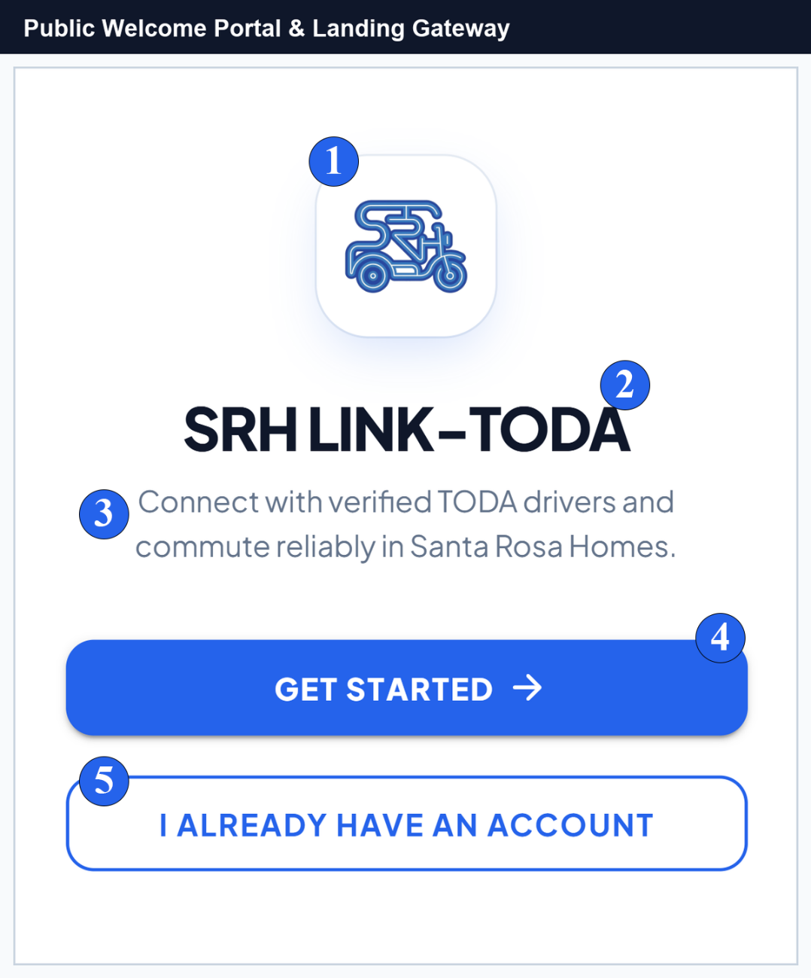
No. | Field, Control, or Area — Detailed Technical Description
1 | Brand Logo & Association Emblem — Official motorized tricycle icon embodying the Santa Rosa Homes TODA community transit brand identity.
2 | Main System Title — Prominent system headline identifying the official SRH LINK-TODA progressive web platform.
3 | Value Proposition Subtitle — Introductory mission statement highlighting passenger safety, reliable scheduling, and verified local drivers.
4 | Get Started Primary CTA Button — Primary action trigger routing new commuters and drivers directly into the multi-step account registration flow.
5 | Existing User Sign In Link — Direct navigation button routing registered passengers, drivers, and administrators into the authentication portal.
Account Access & Authentication
Signing In and Driver Two-Factor OTP Verification
Registered users access the system through the unified Sign-In page. Users enter their registered email address and password to log in. For TODA Driver accounts, the system enforces Two-Factor Gmail OTP Verification to safeguard driver queue credentials and earnings data against unauthorized device access.
Figure C-2.
Secure Portal Sign-In and Authentication Form
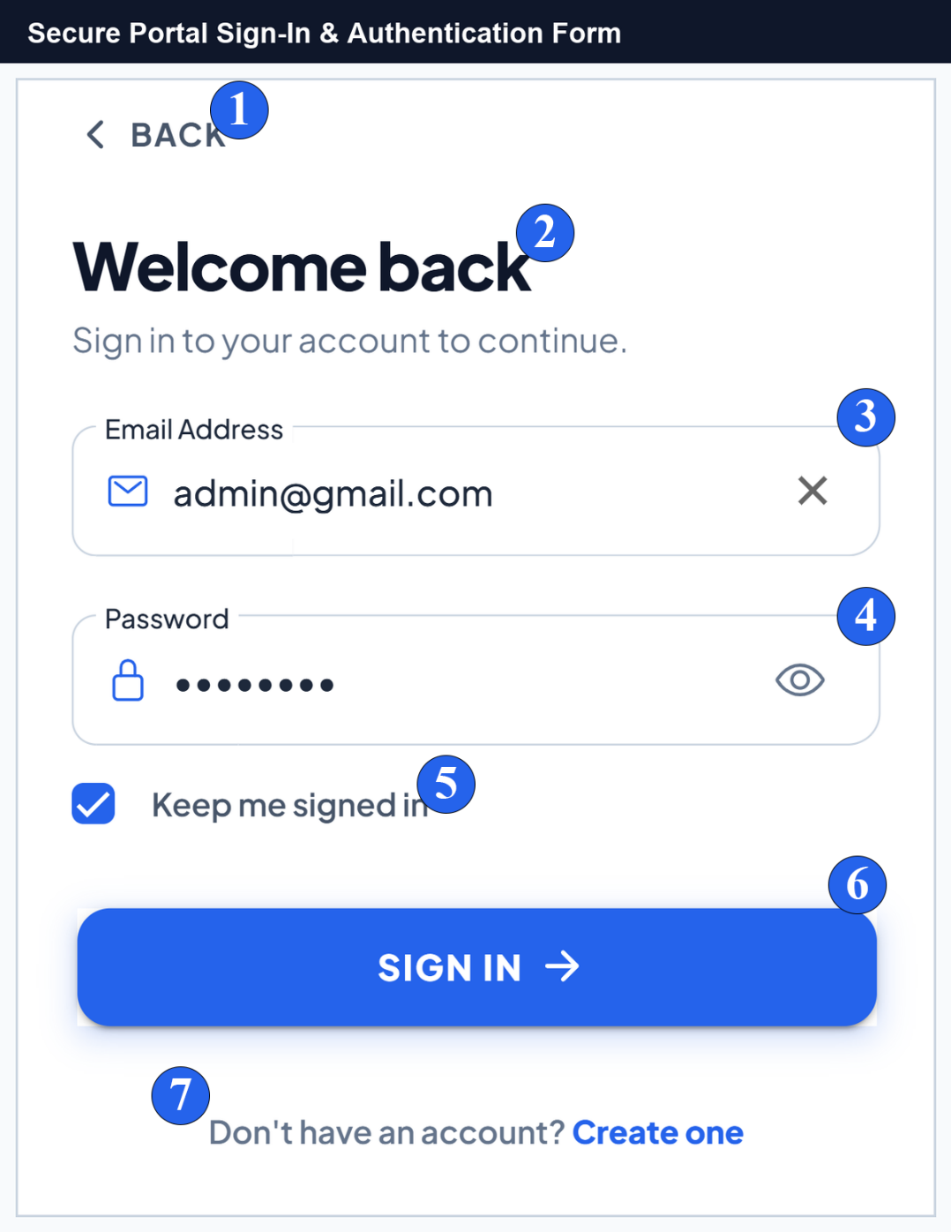
No. | Field, Control, or Area — Detailed Technical Description
1 | Back Navigation Trigger — Returns the user to the public welcome landing page.
2 | Welcome Back Header — Contextual headline confirming the secure sign-in portal state.
3 | Email Address Input Field — Validated text field equipped with email icon and one-touch clear button for entering account credentials.
4 | Password Input with Visibility Toggle — Encrypted password input equipped with an interactive eye icon allowing users to inspect or mask entered characters.
5 | Keep Me Signed In Checkbox — Enables persistent local session caching on personal mobile devices.
6 | Sign In Action Button — Authenticates entered credentials against the backend API and initiates role-based dashboard routing.
7 | Create One Registration Link — Direct route for commuters and drivers who have not yet established an account in the system.
Multi-Step Registration & Driver Document Submission
The registration portal provides a structured multi-step wizard for onboarding new commuters and TODA drivers. It validates email and phone number uniqueness in real-time, enforces strong passwords, and collects driver MTOP franchise permits and driver's licenses for administrative accreditation.
Figure C-3.
Passenger Registration Flow — Role Selection, Personal Details, and Security Setup
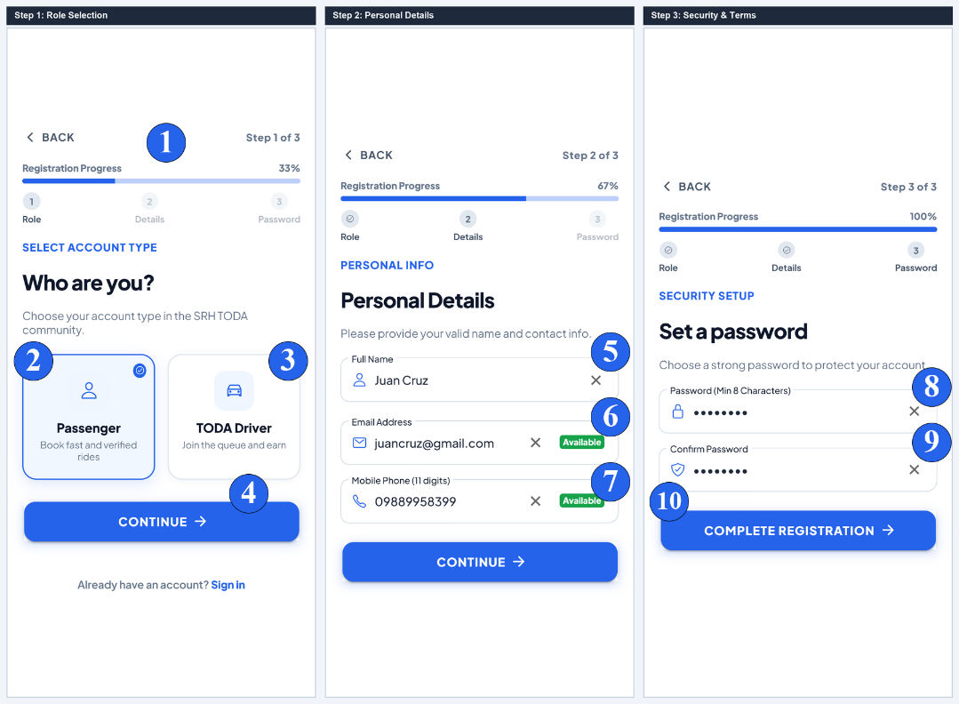
No. | Field, Control, or Area — Detailed Technical Description
1 | Registration Progress Indicator — Visual 3-step progress bar tracking active setup percentage (33% to 100%).
2 | Passenger Commuter Role Card — Selection card activating commuter mode for booking tricycle rides across Santa Rosa Homes.
3 | TODA Driver Role Card — Selection card activating driver mode requiring MTOP franchise validation and admin review.
4 | Step Continuation Button — Validates active form constraints and transitions smoothly to the next pane.
5 | Full Name Input Field — Captures complete legal user name with active validity checkmark.
6 | Email Address Field with Live Availability — Real-time asynchronous checking ensuring the entered email address is unique and valid.
7 | Mobile Phone Number with Live Availability — 11-digit mobile phone field verified against existing records to prevent duplicate accounts.
8 | Password Strength Input — Enforces robust password criteria (minimum 8 characters with alphanumeric requirements).
9 | Confirm Password Validation Field — Real-time character comparison ensuring error-free password entry.
10 | Complete Registration Action Button — Finalizes commuter account creation and grants immediate access to the Commuter Hub.
Figure C-4.
Driver Registration Flow — MTOP Credentials, Document Upload & Two-Factor OTP
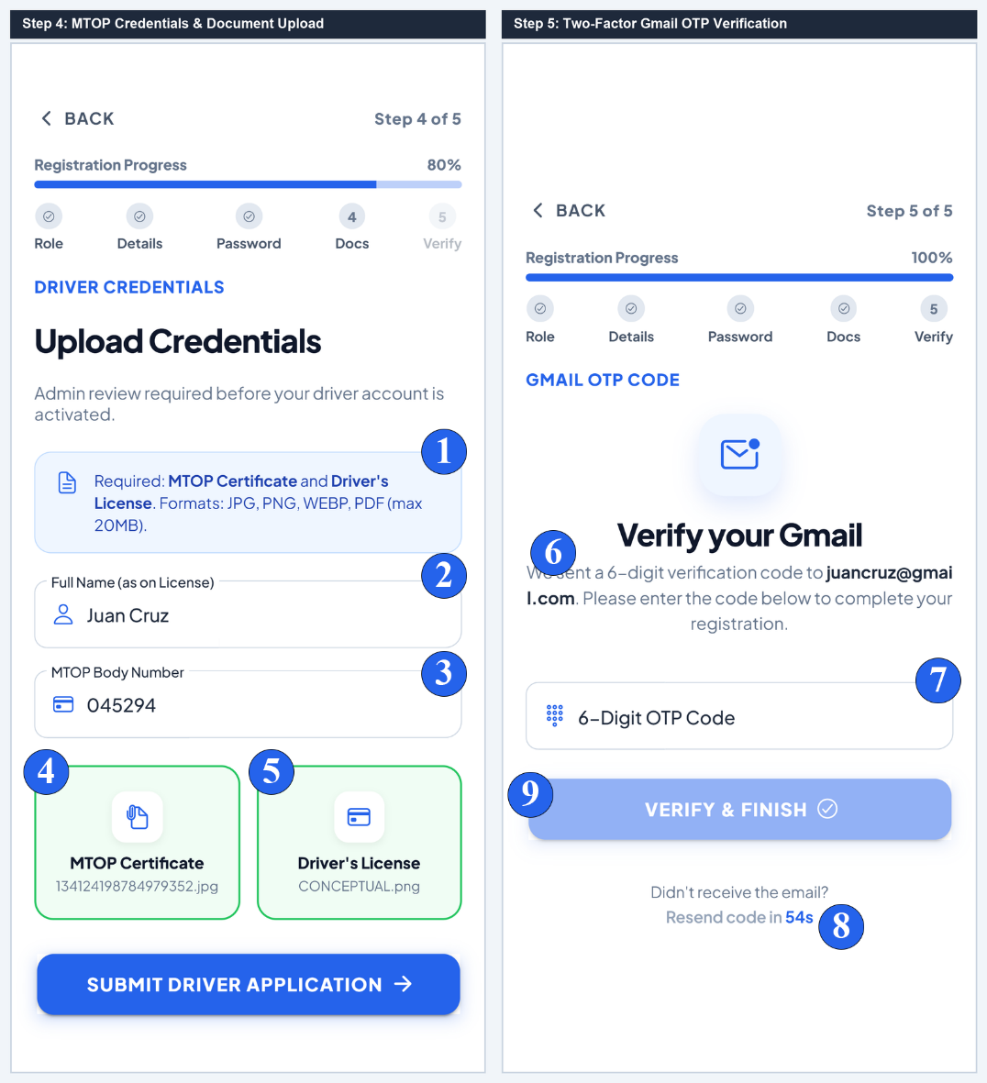
No. | Field, Control, or Area — Detailed Technical Description
1 | Driver Accreditation Requirement Alert — Informs applicants that valid MTOP franchise permits and LTO licenses are mandatory for review.
2 | Full Name on Driver's License — Captures the exact legal name matching the official government driver's license.
3 | Official 6-Digit MTOP Body Number — Restricted numeric input field recording the municipal franchise permit number.
4 | MTOP Certificate Dropzone — Interactive file uploader accepting camera photos or PDF scans of the official MTOP franchise certificate.
5 | Driver's License Dropzone — File uploader accepting scanned copies of the valid Land Transportation Office (LTO) license.
6 | Gmail OTP Security Notice — Notifies the driver that a 6-digit cryptographic verification code has been dispatched to their email.
7 | 6-Digit OTP Code Input Box — Specialized numeric input field with automated formatting and character limit enforcement.
8 | Resend Verification Timer — Enforces a 60-second cooldown period before a replacement OTP token can be dispatched.
9 | Verify & Complete Registration CTA — Validates the OTP token against server cache and submits the application for administrative review.
Figure C-5.
Driver Accreditation Review Statuses — Pending, Action Required, and Disqualified
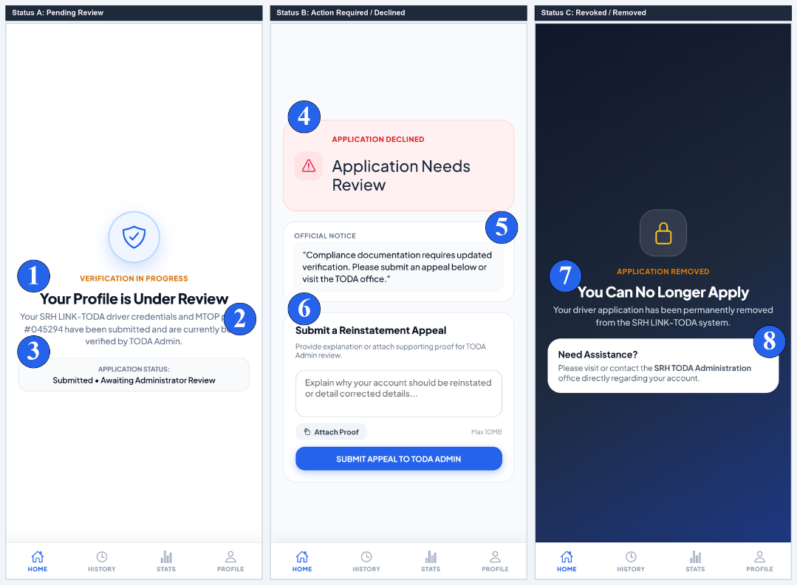
No. | Field, Control, or Area — Detailed Technical Description
1 | Profile Under Review Header — Confirms that driver registration documents have been received and queued for admin inspection.
2 | Submitted MTOP Permit Details — Displays the applicant's recorded MTOP permit number undergoing verification.
3 | Verification Timeframe Notice — Advises the applicant that document review typically concludes within 24 to 48 business hours.
4 | Application Needs Review Alert — Alert notification indicating that submitted documentation failed compliance verification.
5 | Official Rejection Note & Compliance Feedback — Displays specific remarks written by the TODA administrator detailing missing or illegible files.
6 | Submit Appeal / Re-upload CTA — Opens the remediation form allowing the driver to submit updated credentials.
7 | Permanent Disqualification Notice — Indicates that the driver account has been permanently revoked due to critical compliance violations.
8 | TODA Grievance Office Contact Link — Provides administrative office location and telephone contact for formal in-person appeals.
Passenger Experience & Commuter Hub
Interactive Map Viewport & Commuter Action Sheet
The Passenger Commute Hub provides an intuitive vector-based map interface powered by MapLibre GL. Commuters can view their exact GPS location, observe available tricycle queue density at the central terminal, browse popular destinations with fixed fares, and open the ride request sheet.
Figure C-6.
Passenger Ride Booking Sheet and Interactive Fare Calculation Modal
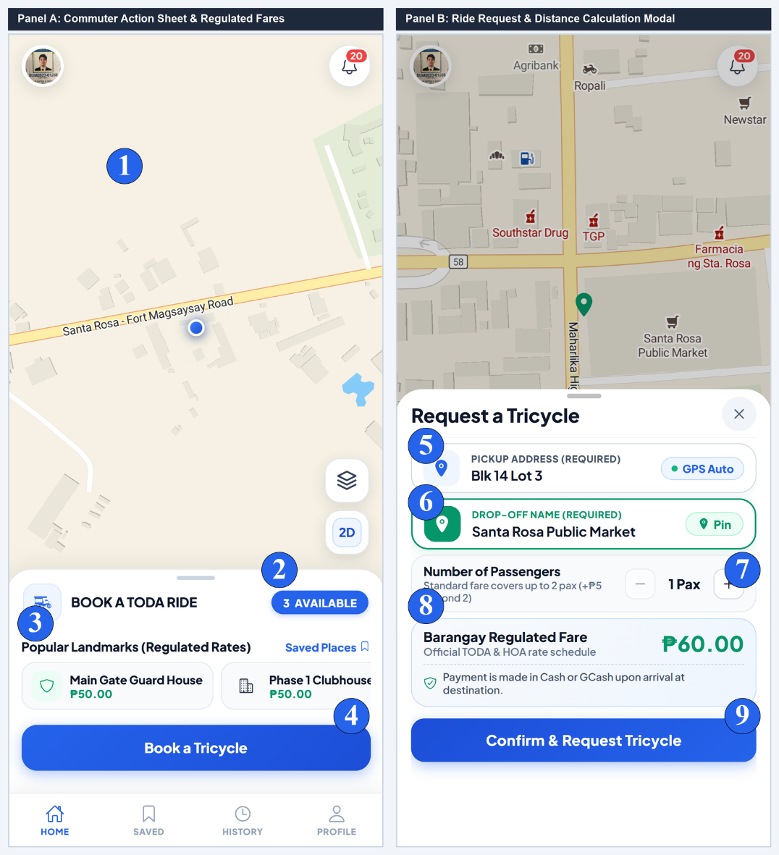
No. | Field, Control, or Area — Detailed Technical Description
1 | MapLibre GL Vector Map Viewport — Hardware-accelerated vector map rendering Santa Rosa Homes street layout, GPS positioning, and terminal hubs.
2 | Available Queue Count Pill — Displays the real-time count of verified drivers currently waiting in queue at the TODA terminal station.
3 | Popular Landmarks Carousel — Horizontal scroller of frequent destinations pre-configured with standardized municipal fares for 1-tap booking.
4 | Book a Tricycle Primary CTA — Action button expanding the full pickup address and destination calculation modal.
5 | Pickup Address Field with GPS Auto-Fill — Text box pre-populated with device GPS coordinates, editable for Block and Lot accuracy.
6 | Drop-Off Destination & Pin on Map Trigger — Destination input field equipped with interactive map pin-drop mode for exact coordinate selection.
7 | Passenger Capacity Stepper — Adjusts rider count (1 to 4 passengers) with automated tariff computation for excess capacity.
8 | Barangay Regulated Fare Breakdown Card — Displays transparent computed tariff based on surveyed road distance and passenger volume.
9 | Confirm & Request Tricycle CTA — Dispatches ride request directly to the prioritized #1 driver in the active terminal queue.
Fare Bargaining, Driver Negotiation & Counter-Offers
The SRH LINK-TODA system integrates a regulated Fare Bargaining module. When special circumstances arise (e.g. heavy cargo, inclement weather, or specialized drop-offs), drivers can counter-propose adjusted fares using a ₱5-increment stepper, which passengers can review and accept or decline in real time.
Figure C-7.
Fare Bargaining and Counter-Proposal Negotiation Modals
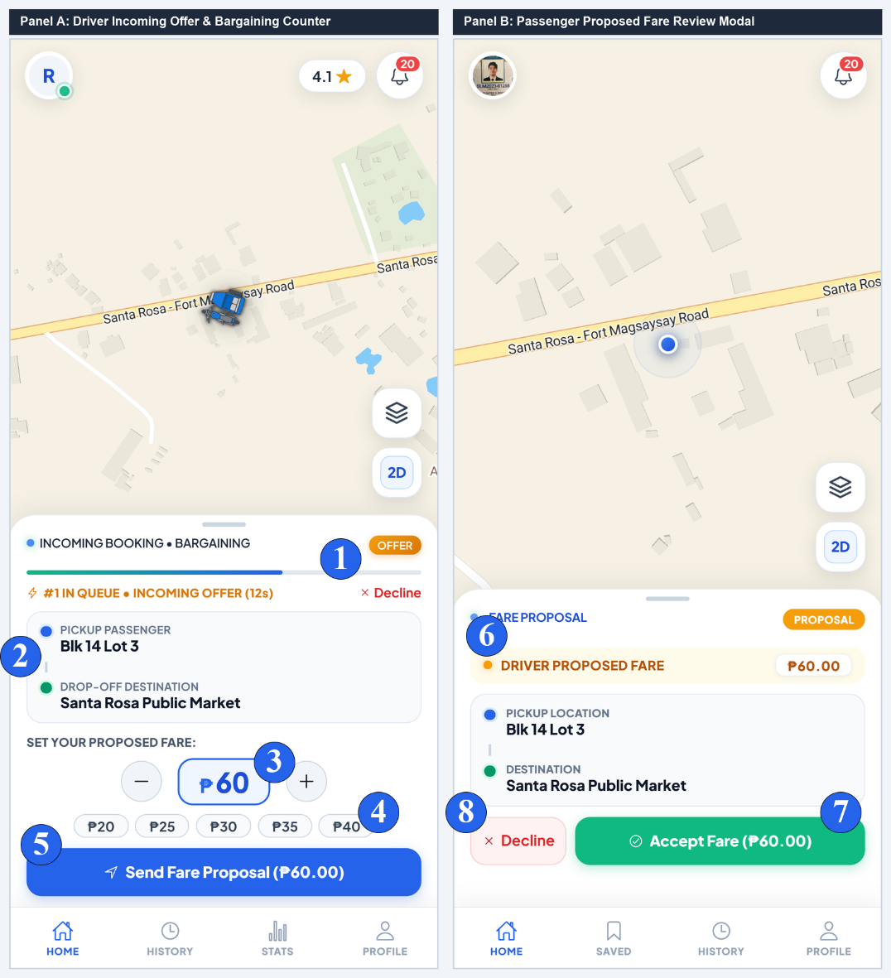
No. | Field, Control, or Area — Detailed Technical Description
1 | 20-Second Decision Countdown Timer — Dynamic progress countdown bar before the pending ride offer automatically rotates to the next driver in line.
2 | Pickup Location & Destination Landmark — Summary card displaying commuter pickup address and destination spot.
3 | Fare Proposal Adjuster Stepper — Interactive '+' and '-' stepper controls allowing drivers to adjust proposed rates in ₱5 increments.
4 | Quick Fare Preset Chips — One-touch preset buttons (₱20, ₱25, ₱30, ₱35, ₱40) for rapid rate adjustment.
5 | Send Fare Proposal Action Button — Transmits proposed rate to the passenger's screen for real-time confirmation.
6 | Driver Proposed Fare Descriptiion — Passenger displaying the counter-proposed rate by the driver.
7 | Accept Proposed Fare Action CTA — Passenger button confirming the proposed rate and transitioning the ride into En Route state.
8 | Decline / Next Driver Button — Declines counter-proposal and returns the passenger to regular dispatch queue matching.
Active Ride Tracking & Real-Time In-App Trip Chat
Once a driver accepts the trip, the passenger sheet transitions through real-time lifecycle states (En Route, Arrived, In Transit). Commuters can track driver proximity, initiate cellular phone calls, exchange in-app chat messages, and access safety reporting features.
Figure C-8.
Active Ride Navigation and Real-Time In-App Trip Chat Drawer
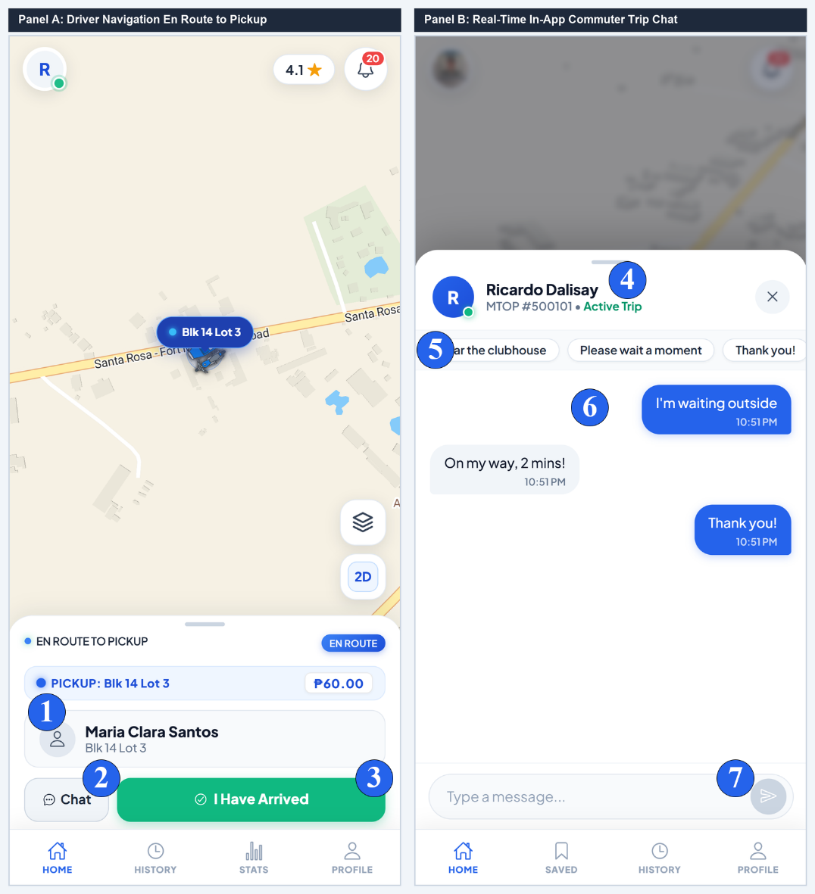
No. | Field, Control, or Area — Detailed Technical Description
1 | Passenger Identity Card & Pickup Address — Displays commuter name, Block/Lot pickup details, and agreed ride tariff.
2 | Open Trip Chat Action Trigger — Launches the slide-over real-time messaging drawer with unread message counter badge.
3 | Arrived at Pickup Transition Trigger — Driver button confirming arrival outside the commuter's pickup location.
4 | Recipient Driver Identity & MTOP Header — Displays assigned driver photo, verified full name, and 6-digit MTOP body number.
5 | Quick Response Preset Chips — One-tap preset chips ('On my way, 2 mins!', 'I am waiting outside', 'Thank you!') for rapid hands-free messaging.
6 | Chronological Message Feed — Encrypted real-time message stream with timestamped speech bubbles and read receipts.
7 | Message Input Bar & Send Trigger — Text input field supporting up to 250 characters with instant WebSocket transmission.
Figure C-9.
Driver Arrival, Passenger Boarding & Drop-Off Completion
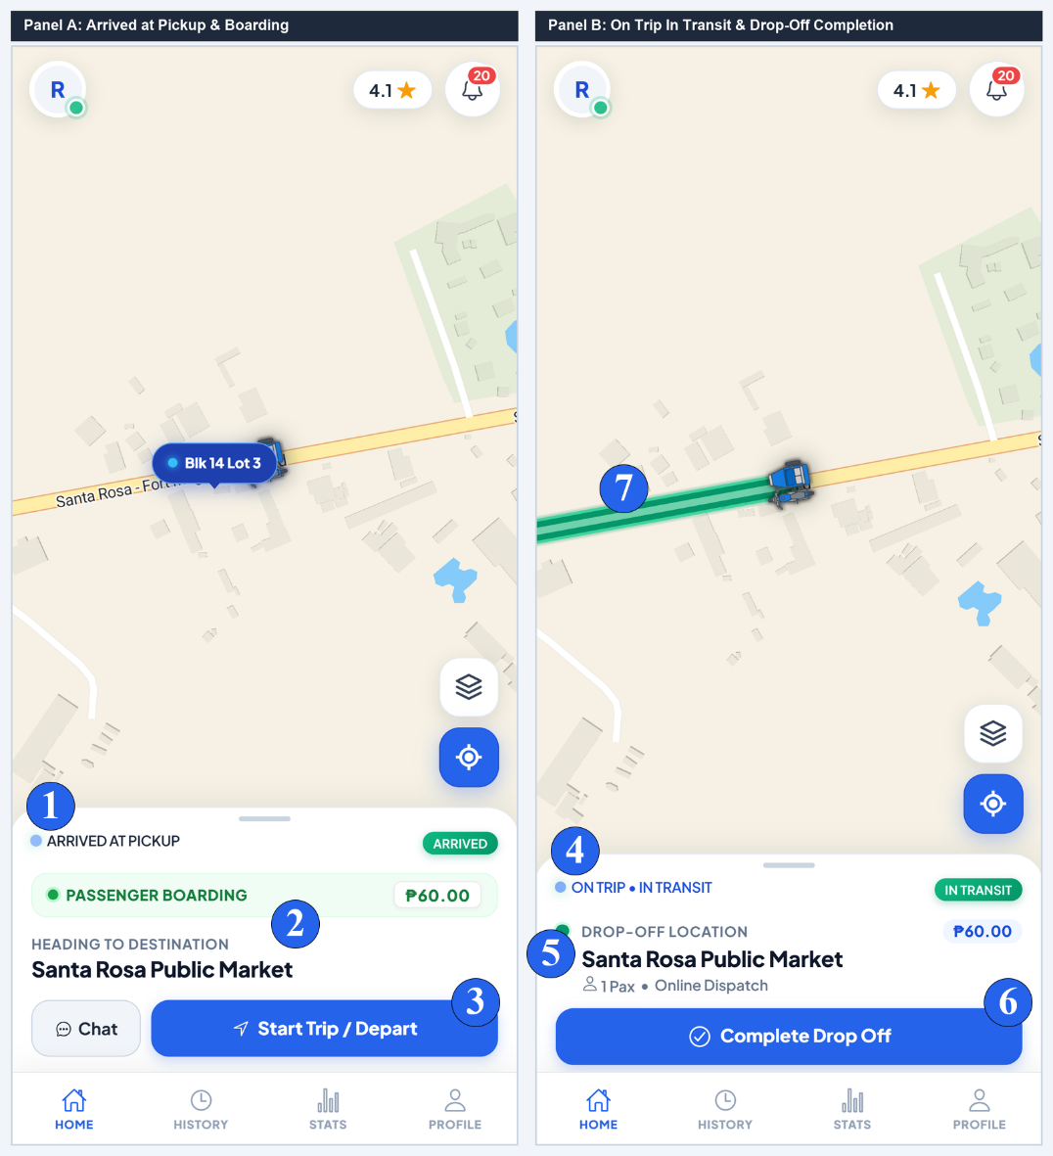
No. | Field, Control, or Area — Detailed Technical Description
1 | Arrived at Pickup Status Banner — Alert bar confirming vehicle arrival, notifying commuter via audio chime and push notification.
2 | Passenger Boarding & Route Overview — Displays verified passenger details, route destination, and agreed fare collection amount.
3 | Start Trip / Depart Action Button — Driver trigger confirming passenger has safely boarded, transitioning ride status to 'In Transit'.
4 | On Trip In Transit Status Indicator — Active transit state banner tracking live travel towards drop-off destination.
5 | Drop-Off Landmark & Passenger Count — Destination overview card displaying drop-off establishment and passenger headcount.
6 | Complete Drop Off Action Button — Finalizes the ride upon safe arrival, credits fare to driver wallet, and activates terminal return workflow.
7 | Live On Trip Route Line on Vector Map — Real-time vector path illustrating assigned drop-off and anticipated approach route.
Driver Operations & Queue Dispatch Hub
Duty Status, Geofenced Queue Positioning & Hero Card
The Driver Queue Hub manages operator duty state, geofenced terminal check-in, queue priority order, and active trip execution. When drivers enter the 35-meter terminal geofence, toggling On Duty automatically registers them into the First-In, First-Out (FIFO) queue.
Figure C-10.
Terminal Return Guidance and Passenger 5-Star Service Rating Modal
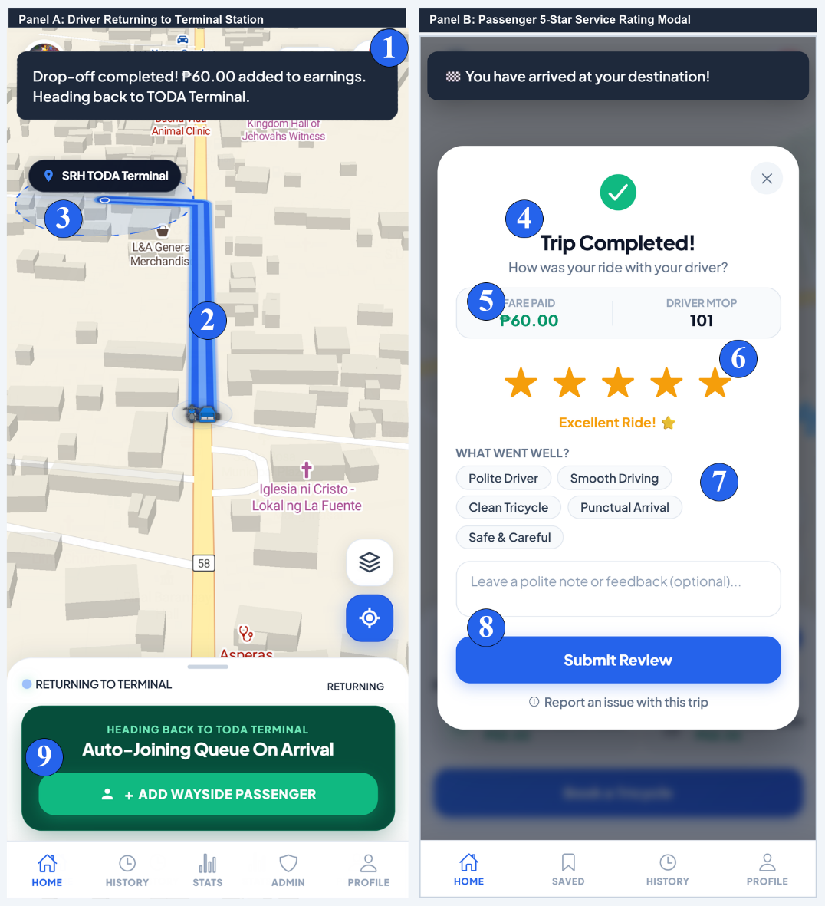
No. | Field, Control, or Area — Detailed Technical Description
1 | Drop-Off Earnings Credit Toast — Real-time toast notification confirming fare credited to driver balance (+₱60.00).
2 | Terminal Station Return Guidance — Map route guiding driver back to the central Santa Rosa Homes terminal station.
3 | Terminal Queue Auto Check-In — Geofence-restricted trigger allowing driver to re-enter the queue upon arriving within 35 meters.
4 | Trip Completed Celebration Header — Passenger confirmation banner verifying arrival at destination.
5 | Total Fare Paid & Driver MTOP Info — Itemized receipt summary displaying total payment and assigned driver MTOP number.
6 | Interactive 5-Star Service Rating Selector — Allows passengers to rate service quality from 1 to 5 stars with dynamic verbal descriptors.
7 | Commendation Chips — Selectable compliment tags ('Safe Driving', 'Polite Driver', 'Clean Tricycle', 'On-Time Arrival').
8 | Submit Rating & Feedback CTA — Saves rating to driver's permanent record and updates community safety ratings.
9 | Wayside Passenger Button — Starts another trip while returning to terminal.
Figure C-11.
Driver Queue Hero Card, Duty Toggle, and Active Queue Roster
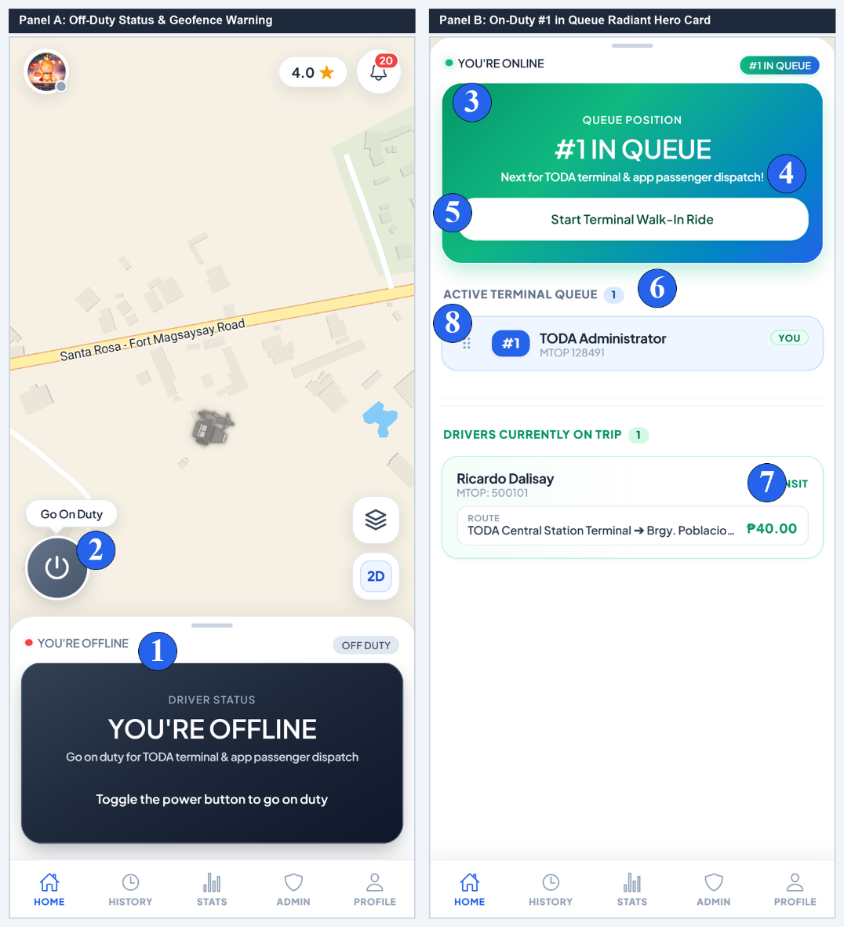
No. | Field, Control, or Area — Detailed Technical Description
1 | Offline Duty Status Indicator — Displays current driver standby state and prompt to activate queue participation.
2 | Floating Go On-Duty Power Switch — Interactive toggle button switching driver between On-Duty (Active Queue) and Off-Duty states.
3 | Radiant Green #1 in Queue Hero Card — Dynamic animated hero deck highlighting top queue priority for terminal and app dispatches.
4 | Next for Dispatch Status Notice — Official dispatch display showing driver to prepare vehicle for upcoming passenger matching.
5 | Start Terminal Walk-In Ride Button — Action button allowing prioritized driver to log passengers boarding directly at the station.
6 | Active Terminal Queue Roster — Live list of all accredited drivers currently queued at the terminal, ordered by FIFO timestamp.
7 | Drivers Currently On Trip Roster — Live list of all accredited drivers currently queued at the terminal, ordered by FIFO timestamp.
8 | Drag-and-Drop Queue Reorder Gripper — Interactive handle allowing dispatchers to manually adjust terminal queue order during operational anomalies.
Figure C-12.
Terminal Walk-In and Returning Wayside Dispatch Modals
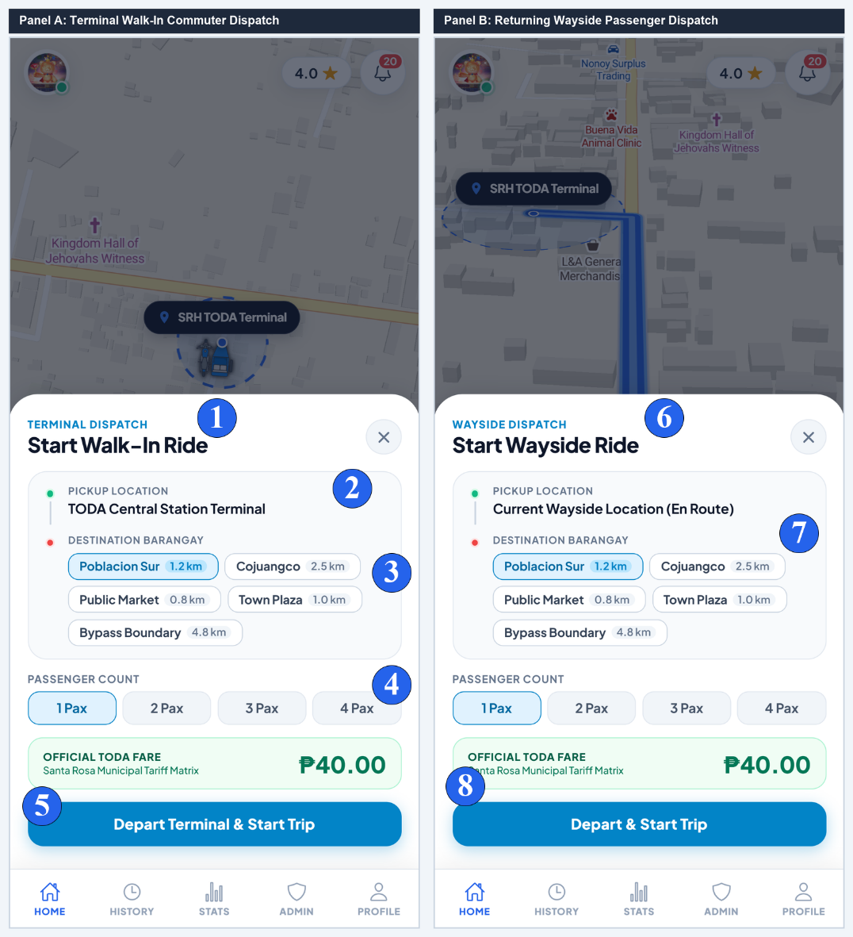
No. | Field, Control, or Area — Detailed Technical Description
1 | Terminal Dispatch Modal Header — Header identifying station-origin walk-in dispatch mode.
2 | Pickup Origin Point — Fixed origin anchor set to the central TODA station terminal.
3 | Destination Barangay Selection Chips — Quick-select grid of popular barangays and zones with surveyed distance metrics.
4 | Passenger Stepper & Computed Regulated Tariff — Rider volume selector computing official tariff based on municipal rate matrices.
5 | Depart & Start Walk-In Trip Button — Dispatches unit, records trip in audit ledger, and temporarily removes driver from queue.
6 | Wayside Dispatch Modal Header — Header identifying transit-origin wayside dispatch mode for flagging passengers en route.
7 | Wayside Destination Selector & Fare Card — Destination selector calculating return fare and passenger volume surcharge.
8 | Depart & Start Wayside Trip Button — Launches wayside trip and tracks transit progress back toward terminal.
Trip History & Certified Digital Receipts
Trip Ledger & Digital Receipt Modal
The History Ledger maintains an auditable record of all completed, walk-in, and cancelled trips for both passengers and drivers. Users can search by destination, filter by date range, and view itemized digital receipts.
Figure C-13.
Trip History Ledger and Certified Digital Fare Receipt Modal
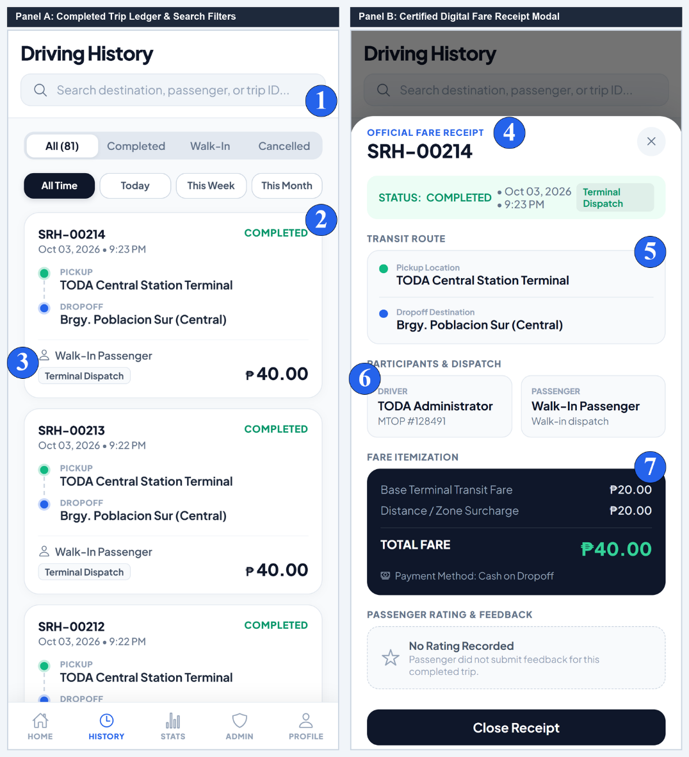
No. | Field, Control, or Area — Detailed Technical Description
1 | Search Bar & Time Horizon Chips — Real-time search filtering trips by destination, passenger, or trip ID, with timeframe chips (All, Today, Week).
2 | Completed Trip Summary Card — Card displaying unique trip reference ID, timestamp, pickup/drop-off nodes, and fare paid.
3 | Dispatch Mode Badge — Identifies whether the trip was an Online App Booking or Terminal Walk-In dispatch.
4 | Official Digital Fare Receipt Header — Modal header displaying certified trip ID number and official completion timestamp.
5 | Transit Route Timeline — Color-coded route node breakdown detailing origin address and destination drop-off location.
6 | Participants & Vehicle Verification Stamp — Displays assigned driver full name, official MTOP franchise badge, and passenger details.
7 | Itemized Fare Breakdown & Total Collected — Itemized breakdown covering base tariff, distance surcharge, and gross fare collected.
Driver Performance & Analytics
Executive Rating Deck, 7-Day Revenue Chart & Channel Share
The Driver Performance Module visualizes satisfaction ratings via an animated radial ring, breaks down weekly revenue trends across daily pillar charts, and illustrates dispatch channel proportions.
Figure C-14.
Driver Rating Deck, 7-Day Revenue Trends, and Channel Share Analytics
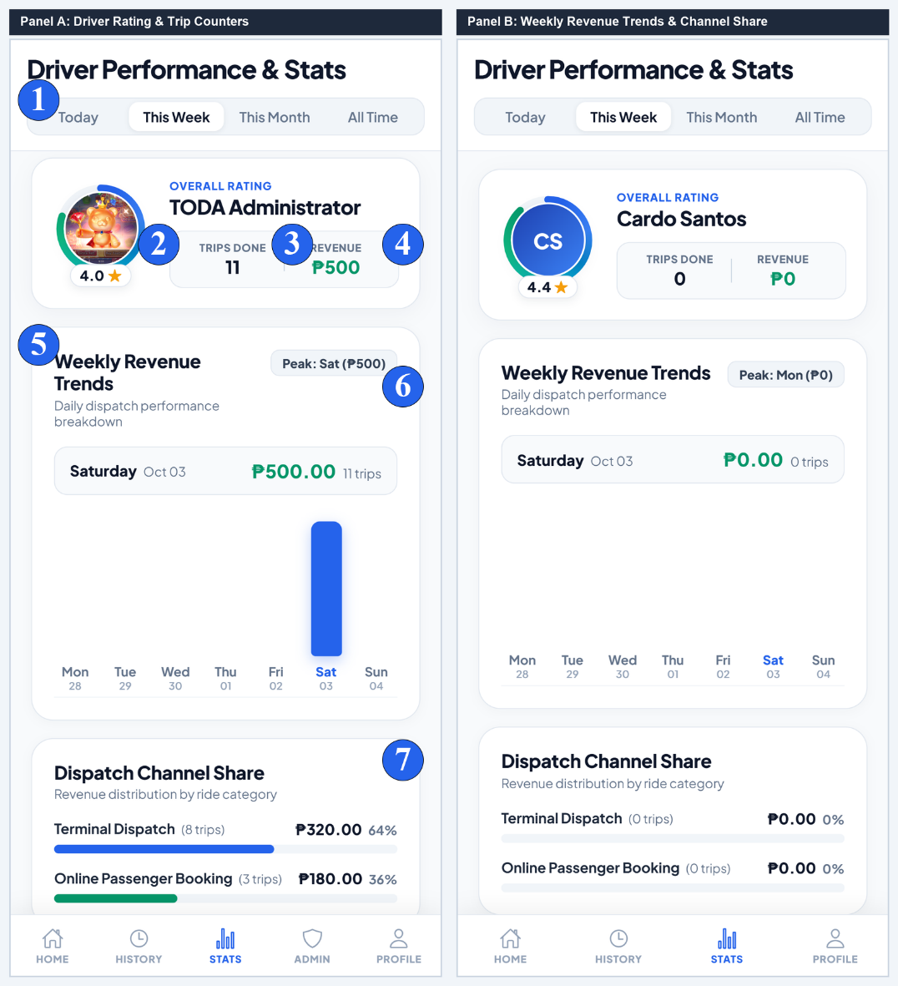
No. | Field, Control, or Area — Detailed Technical Description
1 | Time Horizon Filter Switcher — Pill selector toggling performance statistics across Today, This Week, This Month, and All Time.
2 | Radial Satisfaction Rating Ring — Conic progress indicator displaying cumulative passenger service satisfaction (e.g. 4.0 / 5.0 stars).
3 | Total Completed Trips Done Counter — Metric tile tracking total successful dispatches executed within the selected period.
4 | Aggregate Gross Revenue KPI Tile — Financial card tracking gross revenue accumulated across all executed trips.
5 | 7-Day Revenue Trend Pillar Chart — Interactive bar chart illustrating day-by-day revenue fluctuations and peak demand days.
6 | Peak Earning Day Analytics Badge — Identifies the highest grossing day of the reporting cycle to aid schedule optimization.
7 | Dispatch Channel Share Breakdown — Visual proportion bars tracking revenue generated via Terminal Queue, Online Dispatch, and Wayside rides.
TODA Administration Console & Dispatch Management
Driver Accreditation, Live Queue Reordering & Dispute Resolution
The TODA Admin Console empowers station officers to inspect uploaded MTOP permits and driver's licenses, manage driver compliance status, reorder active queue priority via drag-and-drop, resolve commuter incident reports, and broadcast association bulletins.
Figure C-15.
TODA Admin Console — Applicant Review Roster and Document Verification Modal
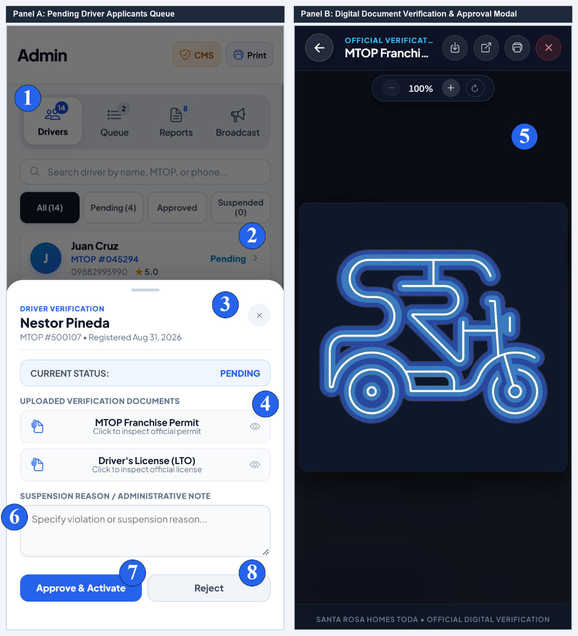
No. | Field, Control, or Area — Detailed Technical Description
1 | Admin Segmented Navigation Bar — Navigation tabs switching between Drivers, Queue, Reports, and Broadcast administrative consoles.
2 | Applicant Status Filter Chips — Filter chips segregating driver applicants across All, Pending Review, Approved, and Suspended.
3 | Driver Applicant Summary Card — Roster card displaying applicant name, submitted MTOP permit number, and submission timestamp.
4 | Digital Verification Modal Header — Official modal interface for inspecting uploaded franchise certificates and government licenses.
5 | Scanned MTOP Document High-Res Viewer — Interactive document viewer rendering high-resolution uploaded certificate images and PDFs.
6 | Administrative Compliance Notes Textarea — Official text area for recording inspection findings, compliance defects, or approval justifications.
7 | Approve & Grant Accreditation Action Button — Grants formal accreditation, enabling driver to check into the terminal queue and accept rides.
8 | Reject Application Action Button — Declines applicant with recorded reasons, transmitting instant notification to the driver.
Figure C-16.
Terminal Queue Drag-and-Drop Management and Incident Dispute Ledger
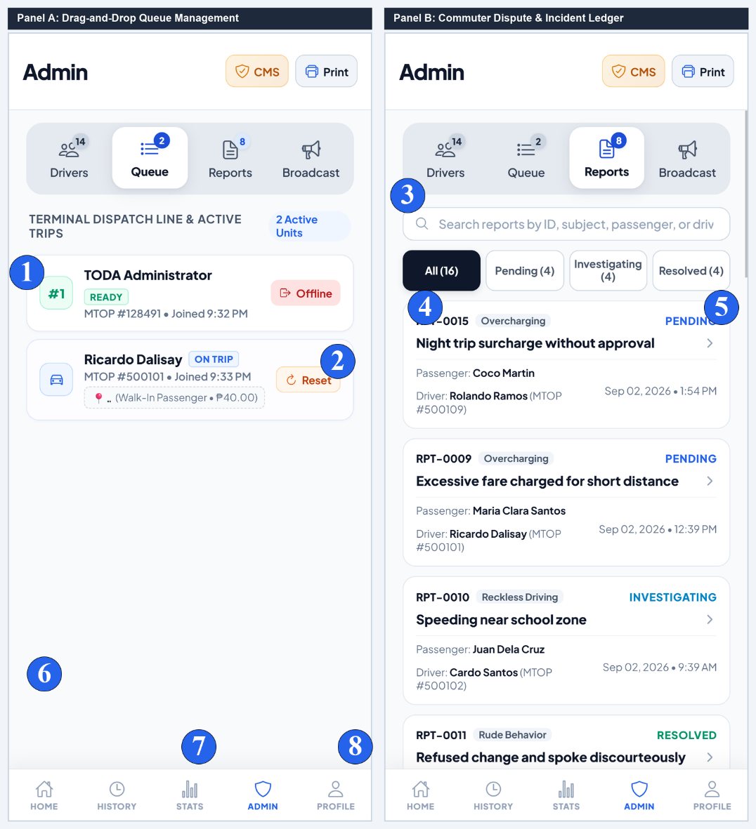
No. | Field, Control, or Area — Detailed Technical Description
1 | Active Terminal Queue Line Roster — Live list of drivers stationed at the terminal awaiting dispatch matching.
2 | Emergency Reset Stalled Trip Button — Resets stalled or abandoned trips, returning driver unit to terminal queue sequence.
3 | Incident Search Bar & Status Filter Horizon — Real-time search and status filter tabs (All, Pending, Investigating, Resolved) for commuter complaints.
4 | Passenger Incident Report Card — Detailed grievance card detailing report reference ID, incident category, passenger name, and driver MTOP.
5 | Case Adjudication Status Tag — Displays handling state (Investigating, Resolved, Dismissed) with link to view full case logs.
Figure C-17.
TODA Broadcast Announcement Dispatcher and Live Member Notification Drawer
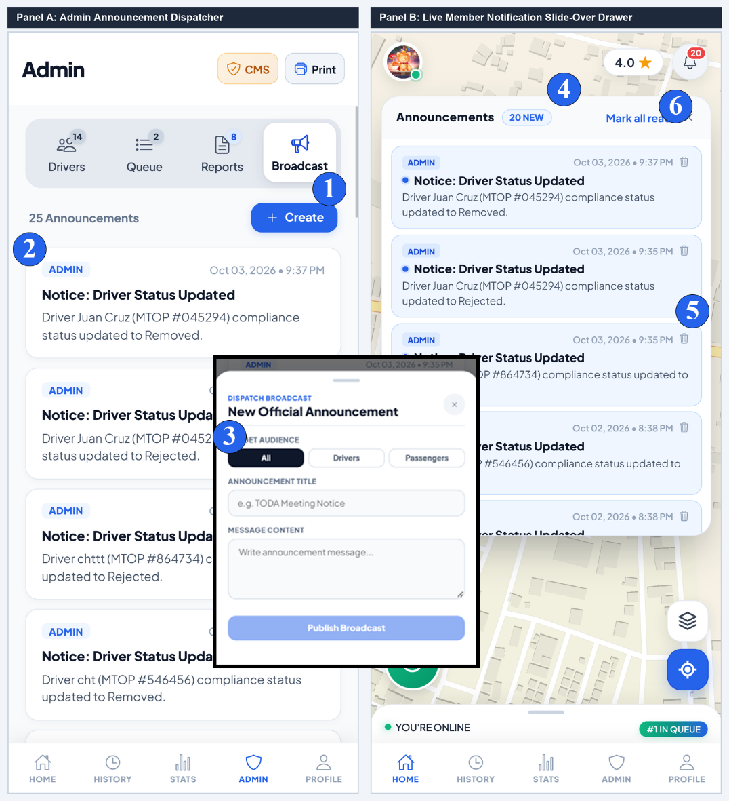
No. | Field, Control, or Area — Detailed Technical Description
1 | Create Announcement Trigger Button — Opens broadcast composer modal for drafting general assembly notices or urgent advisories.
2 | Published Announcement Bulletins Stream — Chronological archive of past association announcements with read confirmation counts.
3 | Target Audience Filter Tag — Identifies message audience filter (All Members, Drivers Only, or Commuters Only).
4 | Notifications Drawer Header & Counter — Member notification slide-over header displaying count of unread community announcements.
5 | Live Official Bulletin Alert Card — High-priority alert card detailing broadcast title, issuance timestamp, and message body.
6 | Mark All as Read & Dismiss Controls — Quick action button marking all received announcements as acknowledged.
Official Report Generator & A4 Print Engine
Template Configuration & Certified A4 PDF Preview
The Official Report Generator produces certified executive reports for TODA meetings, Barangay audits, and municipal compliance. It supports 4 certified formats with real-time A4 sheet rendering, zoom controls, and browser PDF printing.
Figure C-18.
Official Report Generator — Template Configuration and Live Certified A4 Document Preview
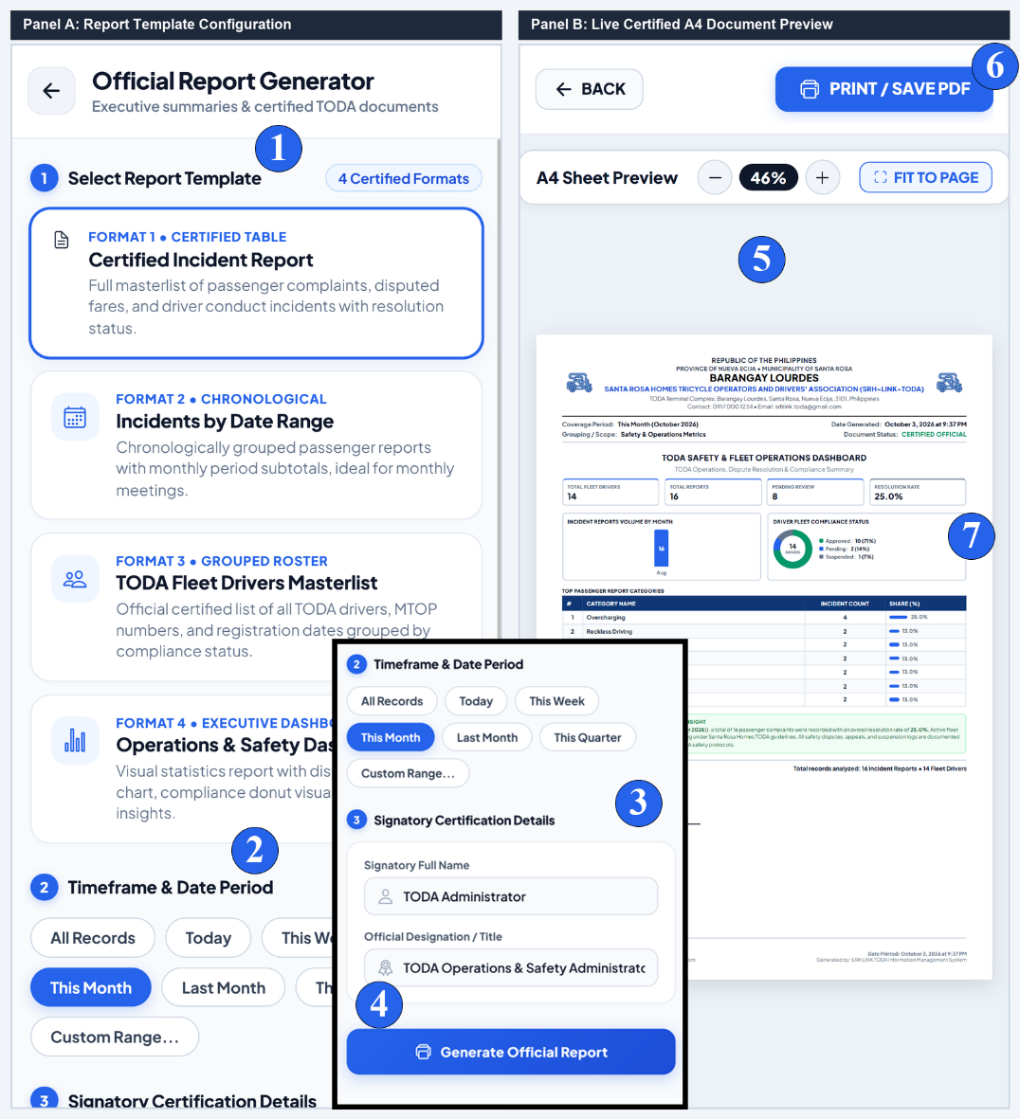
No. | Field, Control, or Area — Detailed Technical Description
1 | Report Template Selection Cards — Tile deck selecting among 4 certified templates (Incident Matrix, Grouped Fleet Roster, Chronological Ledger, Operations Dashboard).
2 | Date Horizon Filter Horizon Pills — Filters data timeframe (All Time, Today, This Week, Month-to-Date, Last Month, Custom Date Range).
3 | Signatory Name & Designation Inputs — Configures official certifying officer name and association designation printed on the document footer.
4 | Generate Report Primary CTA — Compiles selected database records and renders the high-fidelity A4 document canvas.
5 | Interactive A4 Sheet Zoom Controls — Controls canvas scaling (Fit to Page, 50% to 200%) and interactive panning for document inspection.
6 | Print / Save PDF Action Button — Launches browser print engine with standard A4 margins and formal CSS print media rules.
Superadmin Master Governance Console
Executive Pulse Dashboard & System Health
The Superadmin Governance Console provides executive oversight over system health, dispatch volume trends, revenue distribution, user accounts, and immutable audit logs.
Figure C-19.
SuperAdmin Governance Console — Executive Pulse and Fleet Operations
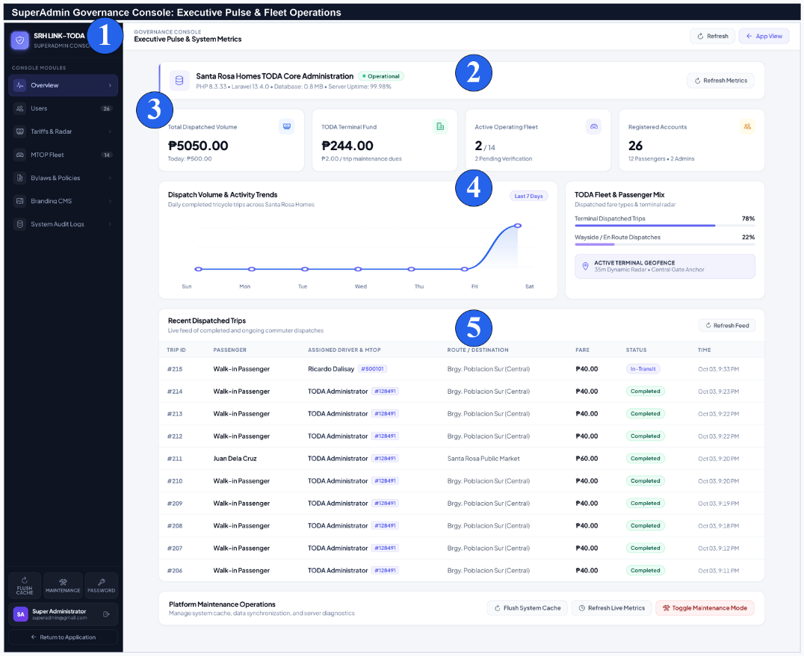
No. | Field, Control, or Area — Detailed Technical Description
1 | Master Governance Sidebar Navigation — Sidebar granting immediate access to all 7 core modules (Overview, Users, Tariffs & Radar, MTOP Fleet, Bylaws, Branding, Audit Logs).
2 | Executive Pulse Server Health Banner — Real-time system health monitor displaying server environment (PHP 8.3.33), database size, and operational uptime.
3 | System Key Performance Metric Cards — Tracking gross dispatched volume and active fleet count.
4 | Dispatch Volume 7-Day Area Chart — Visual SVG chart plotting daily completed trips, walk-in dispatches, and accumulated revenue.
5 | Recent Dispatches Live Audit Ledger Feed — Real-time audit stream displaying active and recently completed trips, assigned drivers, MTOP permits, and collected fares.
Tariff Calibration, Geofence Radar & Boundary Controls
Administrators can calibrate municipal distance tariffs, set the terminal geofence coordinates and radar radius (35m), configure preset destination landmarks, and manage user account privileges.
Figure C-20.
SuperAdmin Tariff Matrix Calibration and Terminal Geofence Radar Controls
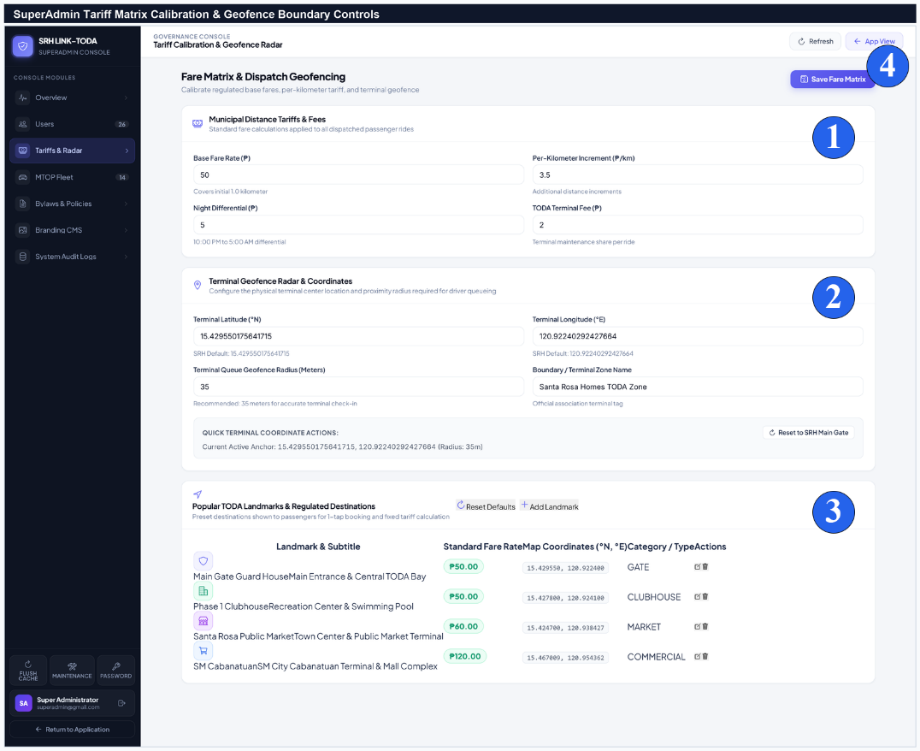
No. | Field, Control, or Area — Detailed Technical Description
1 | Municipal Distance Tariff Inputs — Form fields configuring Base Fare (₱15.00), Succeeding Distance Rate (₱3.50/km), Night Differential (₱5.00), and Terminal Fund Fee (₱2.00).
2 | Terminal Geofence GPS Coordinates & Radius — Configures exact terminal latitude/longitude anchor and check-in radar radius (35 meters).
3 | Popular TODA Landmarks & Fixed Municipal Fares Table — Master table of pre-configured community destinations with standardized fixed fares.
4 | Save Tariff & Radar Calibration CTA — Persists updated fare schedules and geofence rules immediately across all client applications.
User Profile & Device Settings
Profile Management & Hardware Sensor Diagnostics
The Profile Module enables users across all roles to manage their personal contact details, upload profile photos, inspect franchise certificates (for drivers), update passwords, and configure hardware sensor preferences (GPS, push notifications, chime audio).
Figure C-21.
User Profile Management, Accredited MTOP Badge, and Hardware Preferences
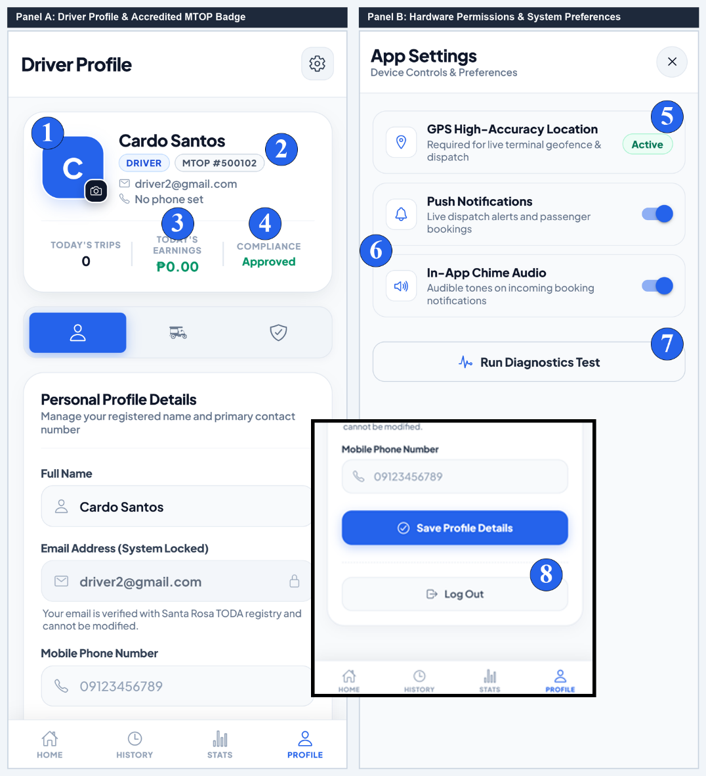
No. | Field, Control, or Area — Detailed Technical Description
1 | Profile Avatar Photo Frame & Camera Upload FAB — User avatar container with floating camera button supporting gallery upload and real-time photo replacement.
2 | Driver Name & Accredited MTOP Franchise Badge — Displays verified legal name and official municipal MTOP franchise body number badge.
3 | Daily Trips & Earnings Performance Metric Tiles — Tiles tracking daily completed trips and accumulated earnings balance.
4 | Compliance Status Indicator Badge — Displays official accreditation state (Approved, Under Review, or Suspended).
5 | GPS High-Accuracy Location Permission Status — Hardware permission status of high-precision GPS geolocation required for terminal check-in.
6 | Push Notifications & In-App Chime Audio Toggles — Switches enabling audible dispatch chimes and native push notification delivery.
7 | Run Device Sensor Diagnostics Action Button — Automated diagnostic tool evaluating browser GPS accuracy, notification service workers, and Web Audio API synthesizer.
8 | Secure Log Out & Session Termination Button — Terminates active device authentication session and clears sensitive local credential tokens.
Summary Checklist of All User Manual Figures
The following master index summarizes all twenty-one (21) user manual figures documented in Appendix C, including their target user roles and primary functional components:
Figure Number | Document Section & Form Name | Primary Target Role | Key Components Covered
Figure C-1 | Public Welcome Portal & Landing Gateway | Public / Commuters | Brand logo, municipal mission, Get Started CTA, Sign In trigger
Figure C-2 | Secure Portal Sign-In & Authentication Form | All Users / Drivers | Email/Password fields, eye visibility toggle, keep signed in, sign in CTA
Figure C-3 | Passenger Registration Flow (3 Panels) | Commuters | Role selection, personal details, live validation, security password
Figure C-4 | Driver Registration Flow & 2FA OTP (2 Panels) | TODA Drivers | MTOP body number, franchise dropzones, Gmail OTP verification
Figure C-5 | Driver Accreditation Review Statuses (3 Panels) | TODA Drivers | Pending review, action required feedback, disqualified notice
Figure C-6 | Passenger Ride Booking Sheet & Modal (2 Panels) | Commuters | MapLibre GL map, available driver count, landmark carousel, fare card
Figure C-7 | Fare Bargaining & Counter-Proposal (2 Panels) | Drivers / Commuters | 20s decision timer, ₱5 fare stepper, preset chips, accept/decline
Figure C-8 | En Route Navigation & Trip Chat (2 Panels) | Drivers / Commuters | Active vector route, phone call, preset quick chips, live chat feed
Figure C-9 | Driver Arrival & Drop-Off Completion (2 Panels) | Drivers | Arrived alert, boarding status, destination summary, complete drop-off
Figure C-10 | Terminal Return & 5-Star Rating (2 Panels) | Drivers / Commuters | Earnings toast, terminal return route, 5-star selector, compliment tags
Figure C-11 | Driver Queue Hero Card & Duty Toggle (2 Panels) | TODA Drivers | Offline switch, Go On Duty toggle, #1 in Queue hero card, active queue
Figure C-12 | Terminal Walk-In & Wayside Dispatch (2 Panels) | TODA Drivers | Station origin, wayside en route GPS, destination chips, regulated tariff
Figure C-13 | Trip History Ledger & Digital Receipt (2 Panels) | All Users | Search bar, date horizon filters, trip ledger, certified fare receipt
Figure C-14 | Driver Earnings & Performance Analytics (2 Panels) | TODA Drivers | Radial rating ring, trips counter, 7-day revenue chart, channel share
Figure C-15 | Admin Driver Accreditation Review (2 Panels) | TODA Admins | Applicant roster, document inspection modal, approve/reject triggers
Figure C-16 | Terminal Queue Reordering & Disputes (2 Panels) | TODA Admins | Drag-to-reorder queue line, reset trip, incident dispute ledger
Figure C-17 | Admin Broadcast & Member Notifications (2 Panels) | TODA Admins / Members | Create announcement, published archive, slide-over notification drawer
Figure C-18 | Official Report Generator & A4 Print Engine (2 Panels) | TODA Admins / Officers | 4 report templates, timeframe filters, certified A4 printable sheet
Figure C-19 | SuperAdmin Governance Console Dashboard | Superadmins | Executive pulse server monitor, KPI metric tiles, 7-day area chart
Figure C-20 | SuperAdmin Tariff Calibration & Geofence Radar | Superadmins | Distance rate matrix, 35m geofence coordinates, popular landmarks table
Figure C-21 | User Profile Management & App Permissions (2 Panels) | All Users | Avatar upload, MTOP badge, sensor permissions, device diagnostics

Proposed Use Case Diagram
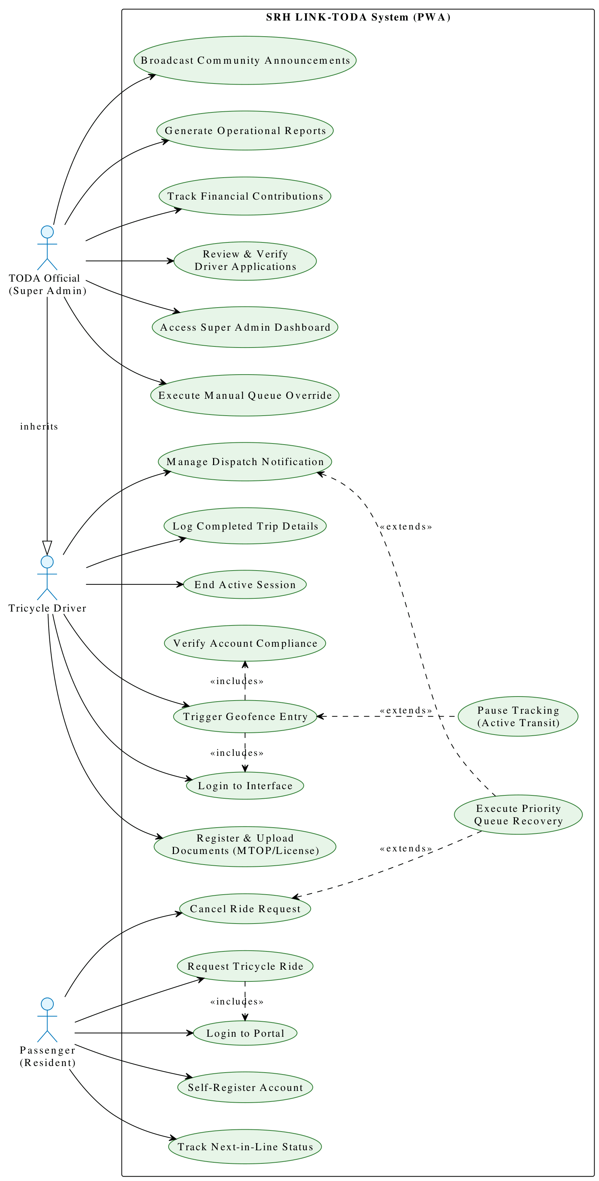
Appendix D
Proposed Data Flow Diagram

- Context Diagram

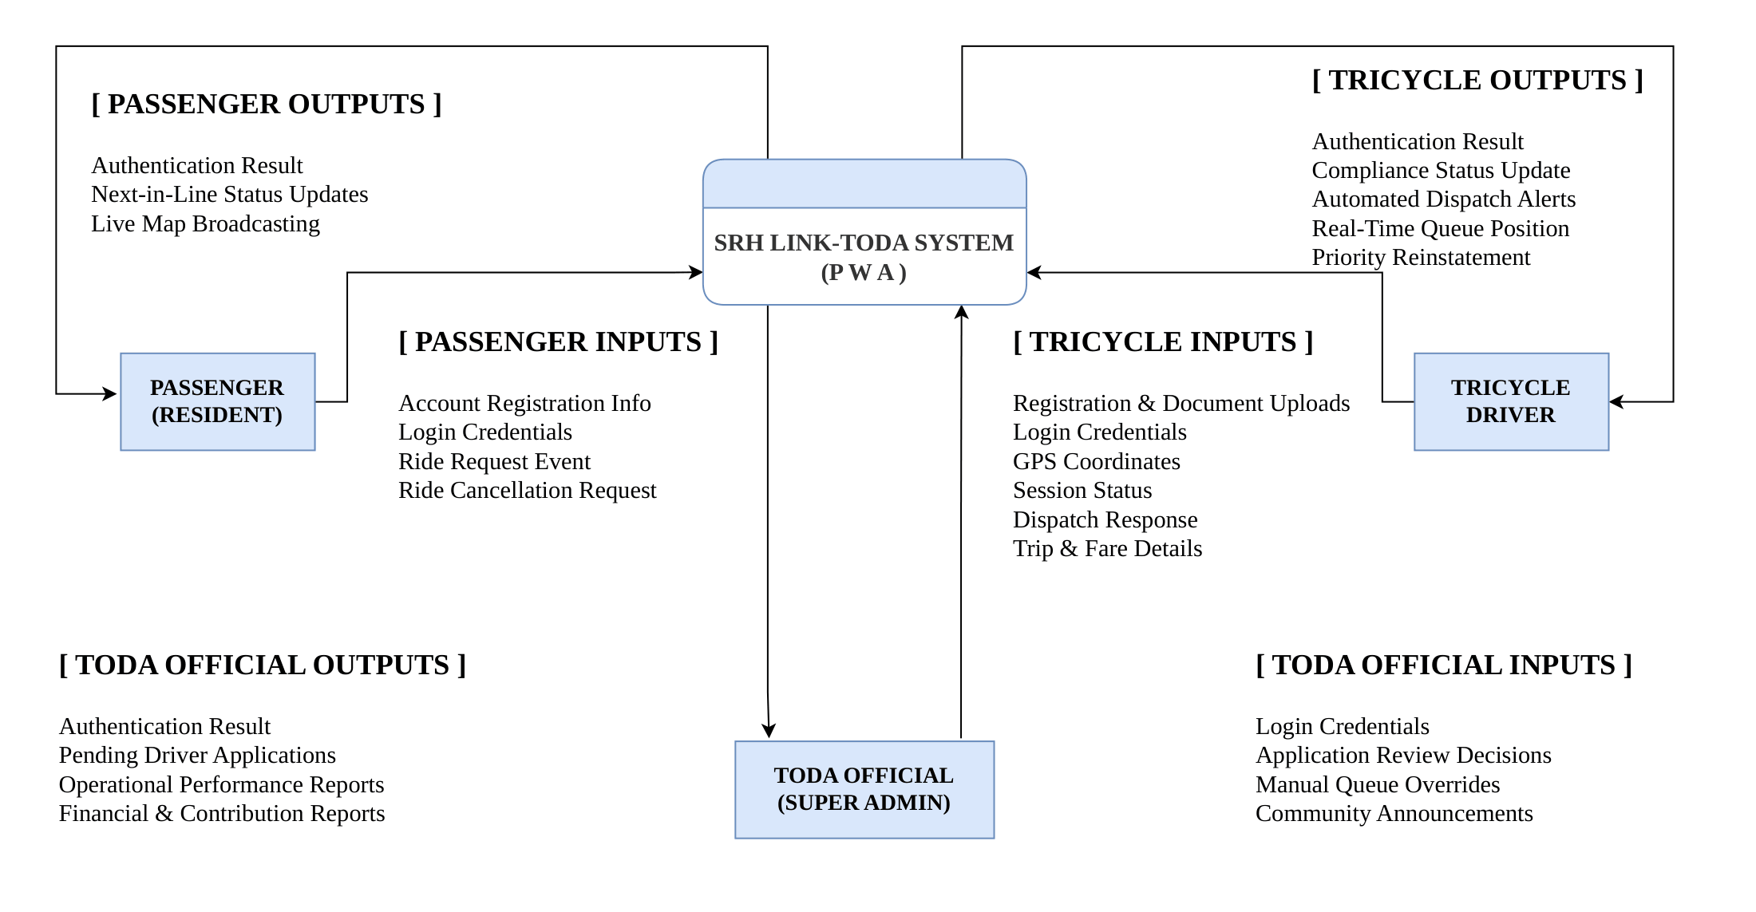
- Level 1 – Data Flow Diagram

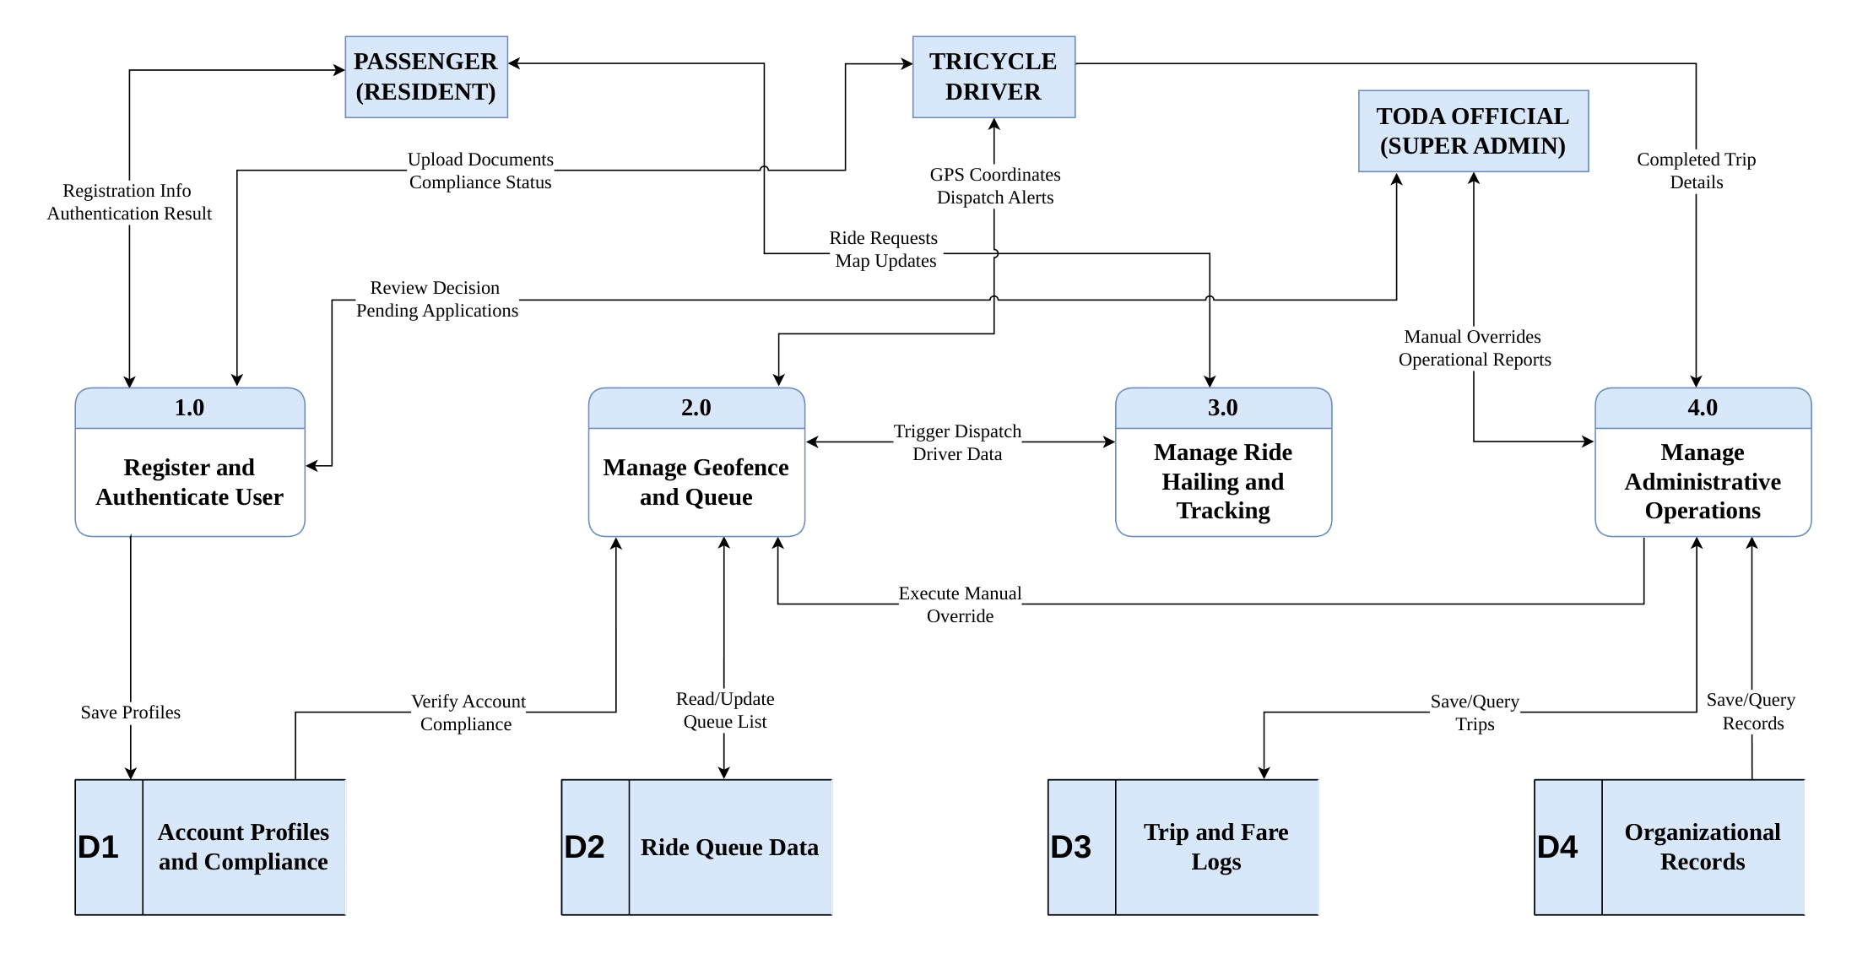
- Register and Authenticate User Level 2 – Data Flow Diagram

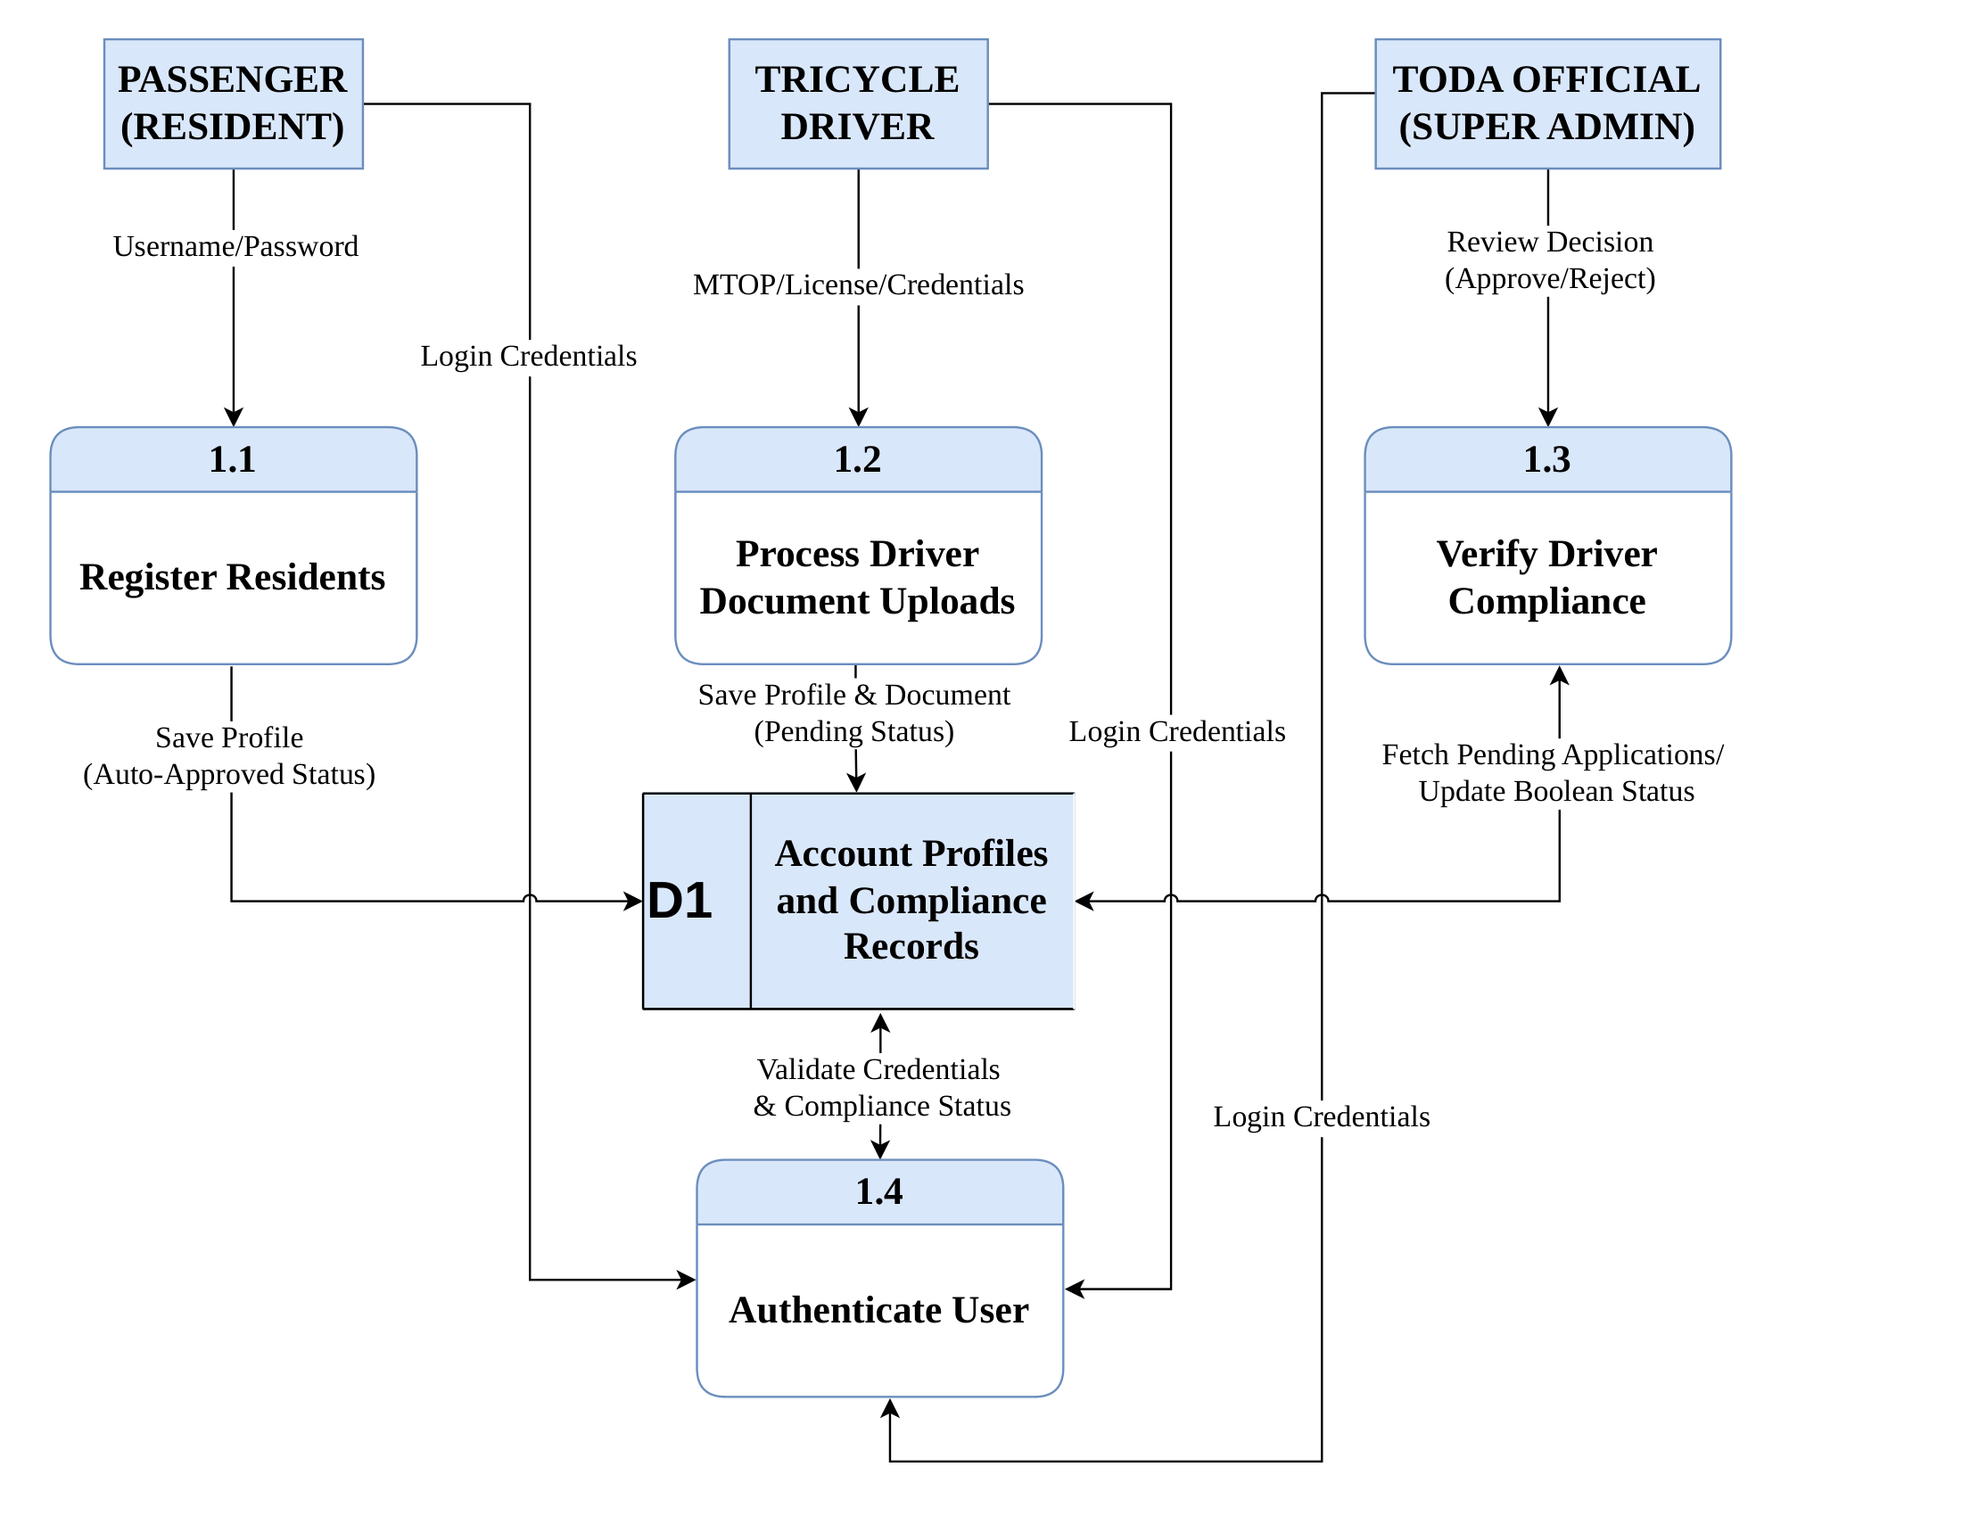

- Manage Geofence and Queue Level 2 – Data Flow Diagram

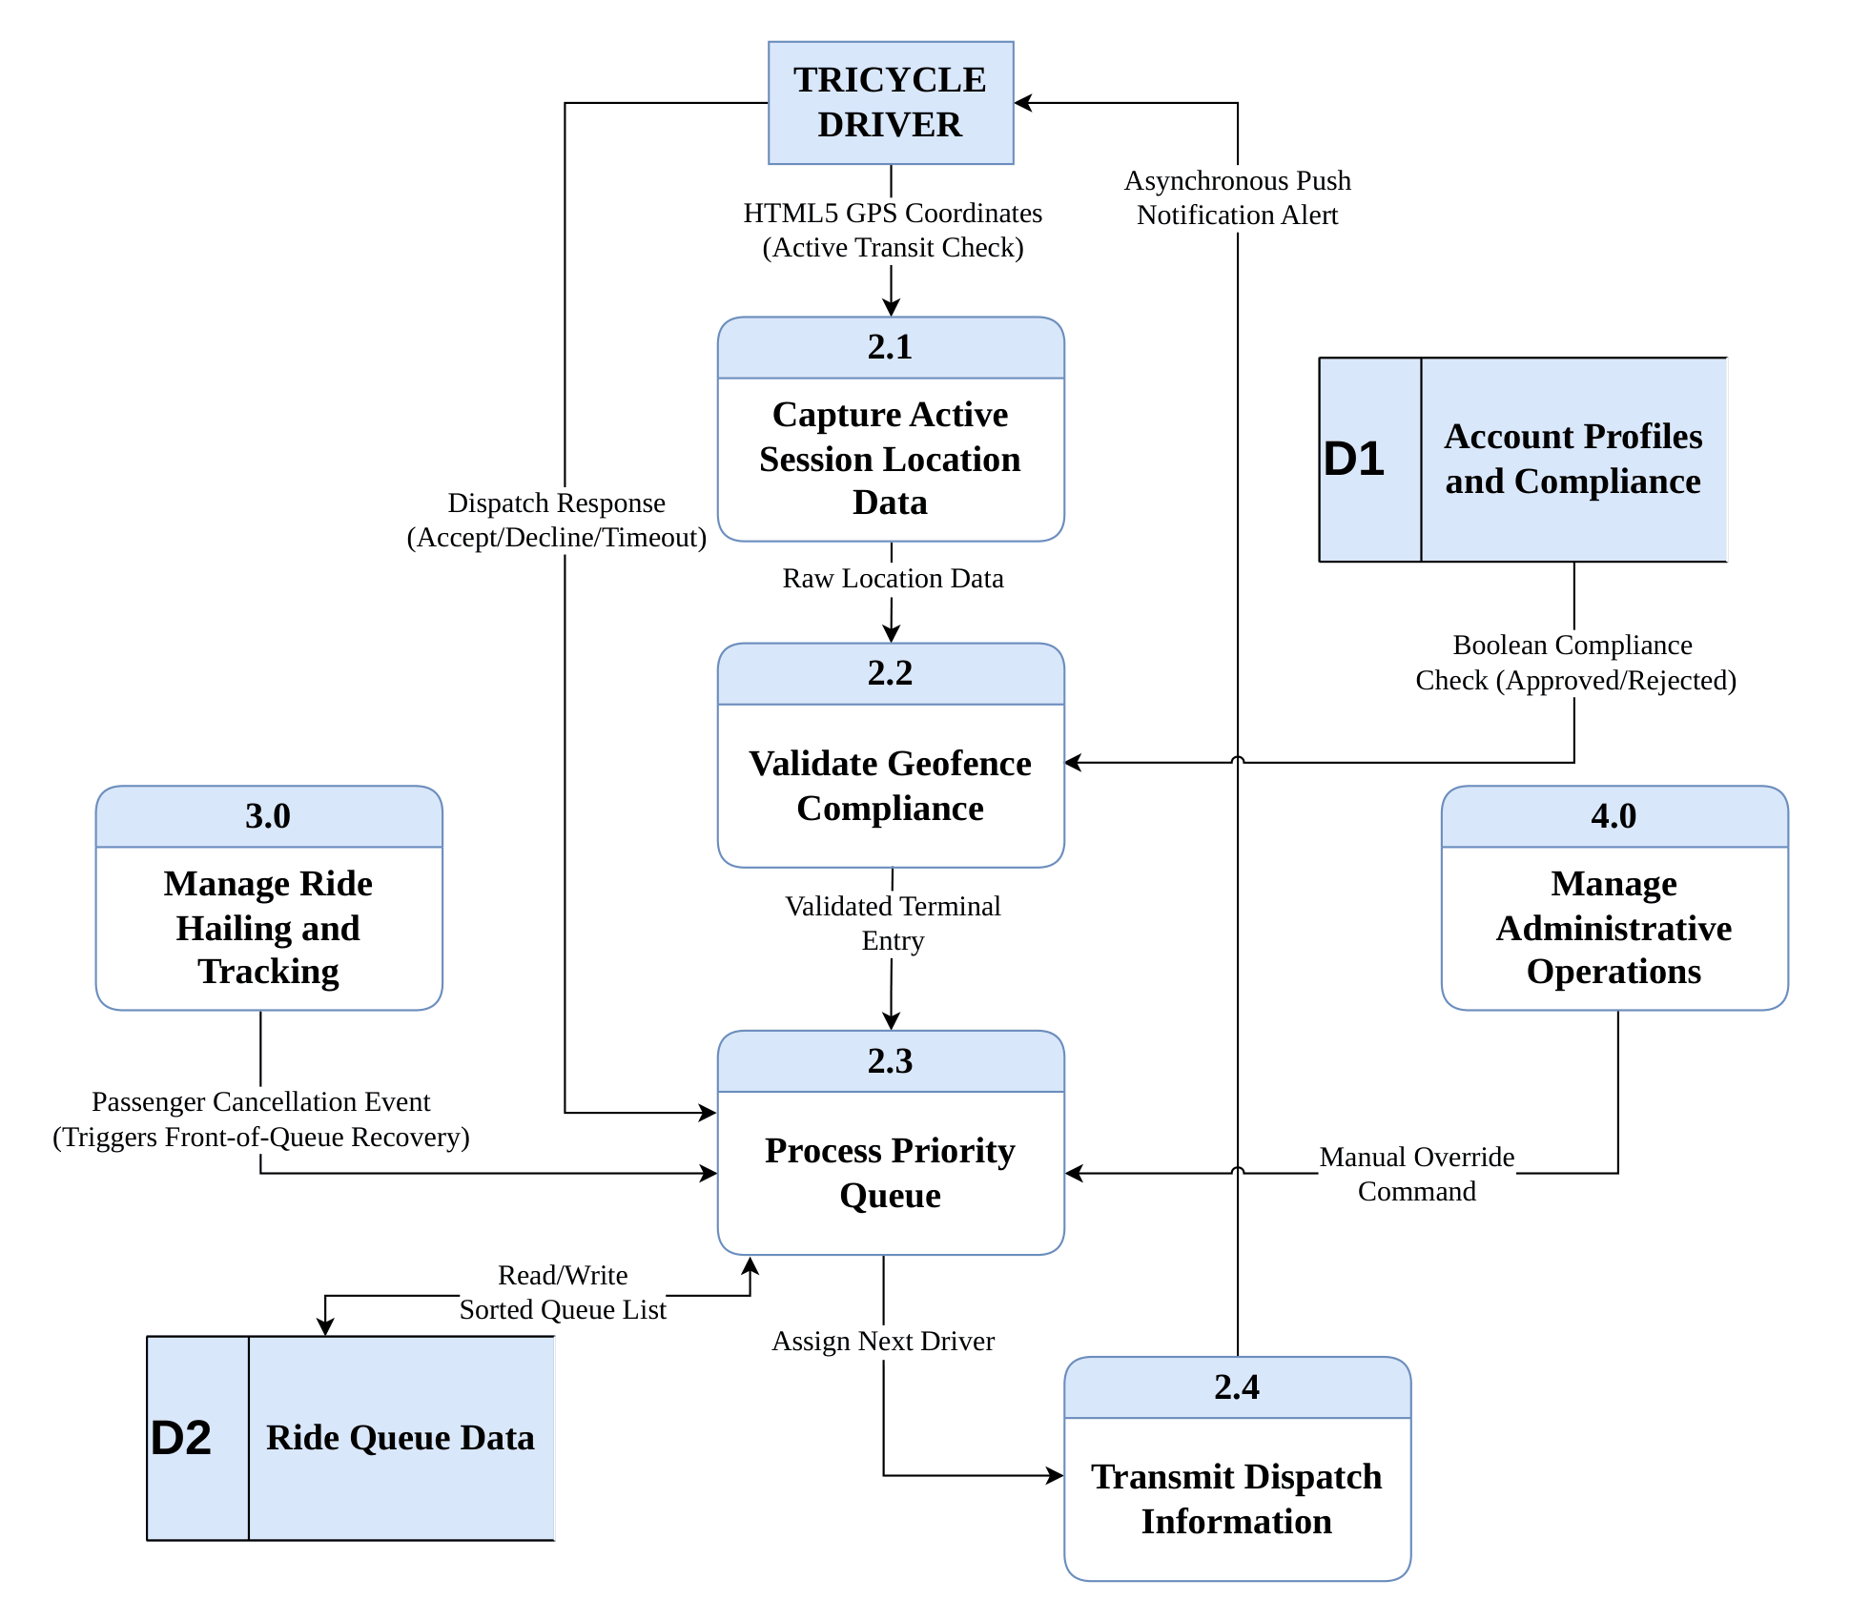

- Manage Ride Hailing and Tracking Level 2 – Data Flow Diagram

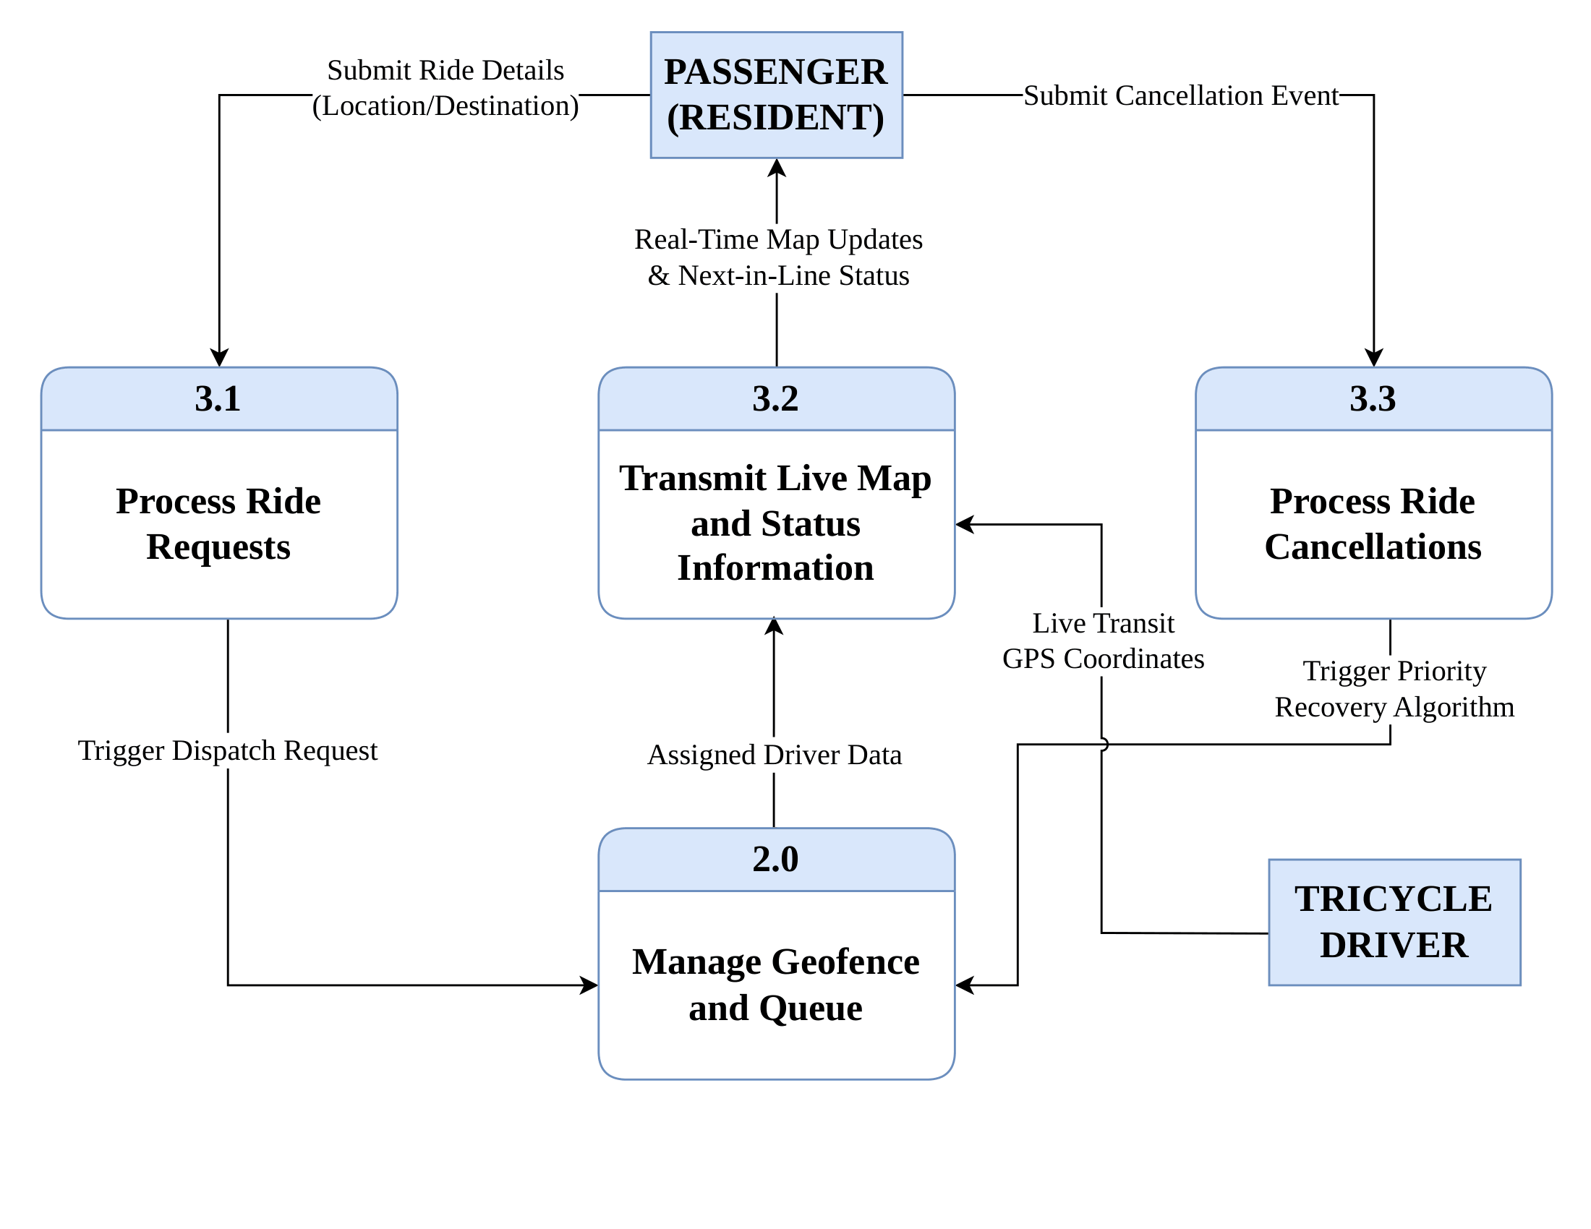

- Manage Administrative Operations Level 2 – Data Flow Diagram
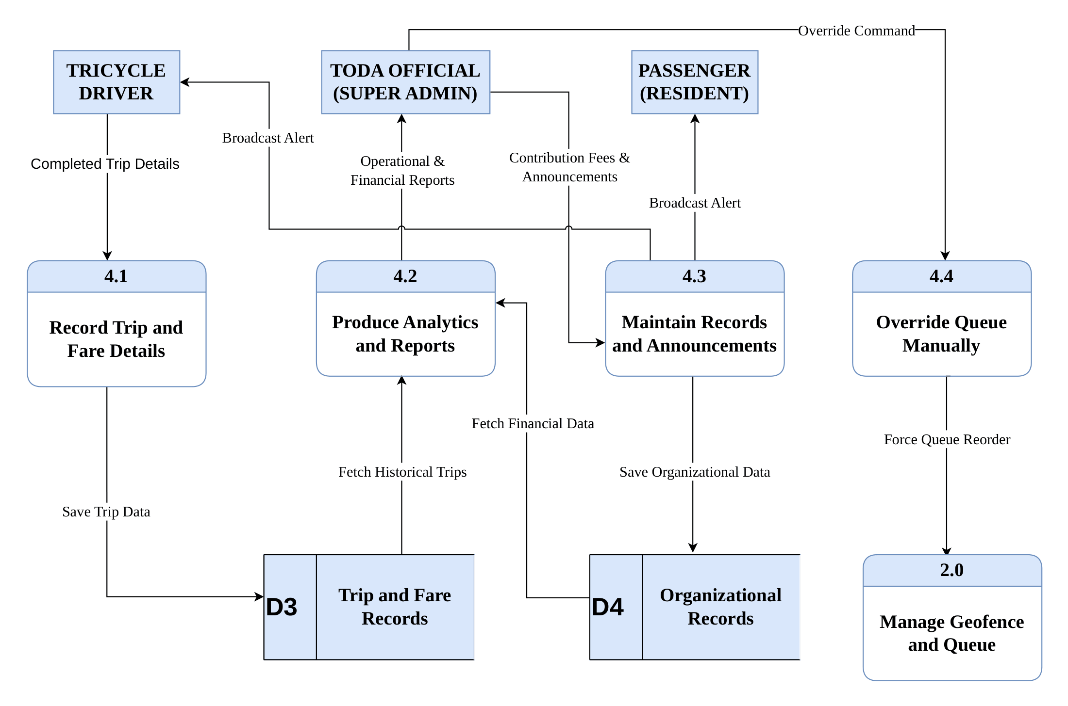

Appendix E
Proposed Class Diagram
