
ISLAMIC UNIVERSITY OF TECHNOLOGY

PROJECT REPORT
Team Name: Team Red Hell

Supervisor: Nadim Ahmed, Lecturer, Department of EEE

Group Members:
Name | Student Id
Abdullah Al Zayed | 210021108
Saadman Sakib abeer | 210021110
mohammed Ishrak abdullah | 210021120
Ashfaq ur Rahman Ifty | 210021217
Abrar mubasshir rahman | 210021230
ahmed atiq | 210021262
sayed istiuk raja | 210021337

Objective:
The objective of this project was to implement an 6-bit computer based on the architecture of SAP-1 (Simple-As-Possible) using combinational and sequential circuits.

Project Specifications:
The computer designed as the primary goal of this project has the attributes mentioned hereunder:
● A single -bit bus designed to transfer the address and data needed for the operation of the computer.
● 8x6 bit Random Access Memory (RAM) for storing programs and data.
● A Program Counter with the ability to count from 000 to 111 dictating the address of the successive instructions of the computer.
● An Input Unit for writing programs into the RAM before running the computer.
● A Memory Address Register (MAR) for accessing data stored in the RAM.
● An Arithmetic and Logic Unit (ALU) capable of addition and subtraction of 6-bit data. Two 6-bit registers named Accumulator (Register A) and Register B are required to store the data that would be used in the mathematical operations performed by the ALU.
● A Control Unit used to control all the modules designed to implement the computer.
● An Output Unit capable of showing the final output of the mathematical operations in binary form.
● Main clock signal driving the computer with two modes of operation-
(i) Auto
(ii) Manual

Design Phases: The final design of the 6-bit computer was completed in 5 phases. Each of the design phases and their corresponding sub-modules are stated below:

Phase – A:
▪ Clock Pulse generator
▪ Program Counter
▪ Input Unit
▪ Memory Address Register (MAR)

Phase – B: Memory Units
- Registers: i. Accumulator
ii. B Register
iii. Output Register
- Random Access Memory (RAM)

Phase – C:
1. Instruction register
2. Controller sequencer
Phase –D:
1. Arithmetic Logic Unit(ALU)
Phase – E:
1. Integration with 6-bit bus
2. Output Unit

PHASE – A

Clock Pulse Generator: To construct the circuit, we used three 555 timer IC. We used an astable , Monostable and Bistable clock. Astable clock generates oscillation when the simulation is started. Here we used a diode in order to maintain simultaneous flow of clock pulse. For a shorter period in the oscillation, we used small capacitance value. The monostable clock can be controlled manually. When pulse is given output toggles and it remains as it is until another pulse is given. Bistable clock is controlled manually using logic state 1 and 0. We used potentiometer to change the resistance value and control clock pulse as our requirements. All 3 output is taken as input in a demux alike circuit. If AUTO/MANUAL is high then bistable clock is turned on. Then manual clk is controlled to give pulse.
HLT refers to halt. When halt is 1, clock stops until reset is on.
Software Implementation: In the circuit the clock generator has select pin which is used to choose between automatic mode or manual mode of the clock pulse. When the switch is up it will be used as manual mode. When the push button is pressed a single clock pulse is generated. When the switch is down it will be used as automatic mode.
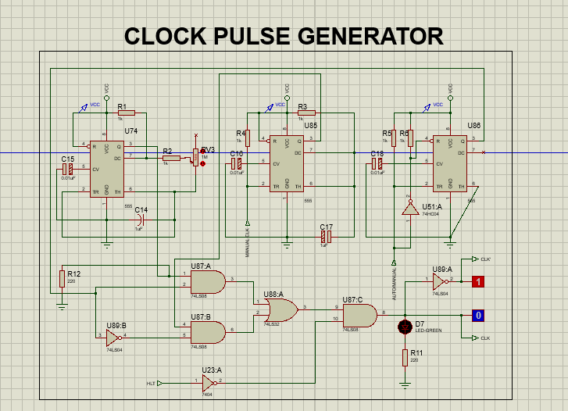
PCB Design:
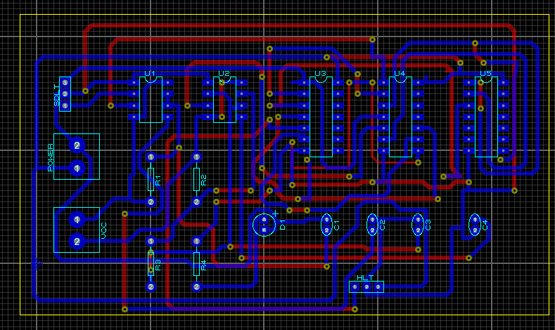

Program Counter
Input CE, CO, RESET, CLK and output CO1, CO2, CO3.
CE= Enables counter input.
CO= Enables counter output.
We used to 3 JK flip-flop. First flip-flop output is taken as input of second flip-flop and second flip-flop output is taken as the output of third flip-flop. We used three tristate buffer 74125. CO enables buffer and output goes to bus. 74125 is active low so we used a NOT gate with CO. We expect the counter to count from 000 to 111.
Pin | Type | Function
CE | IN | Program counter increments the value in the program counter after each cycle.
CO | IN | Program counter outputs the current program counter value on the bus. When the output value is low the counter output is disconnected.
Reset | IN | Resets the program counter to 000
CLK | IN | Clock Pulse input which enables the incrementation of the program counter.

Parent Sheet:
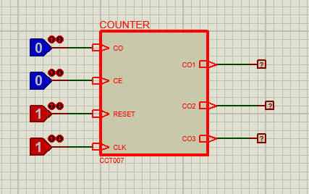
Circuit:
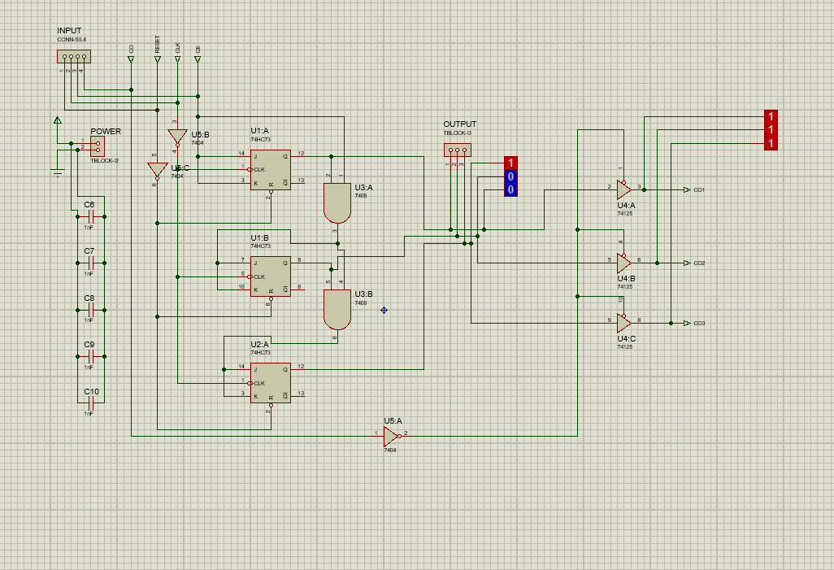
PCB Design:

Memory Address Register (MAR):
It's a 3-bit register.It stores the memory address of RAM from
which data will be fetched.
This 4-bit address is obtained via the bus from
the Program Counter and then stored.This stored address is sent to the RAM where data or instructions are read from.
Pin | Type | Function
MI | In | Stores the current of the bus into the MAR
CLK | In | Clock pulse input
Output | Out | 3-bit address data
Input | In | Takes input 3-bit data

Parent Sheet:
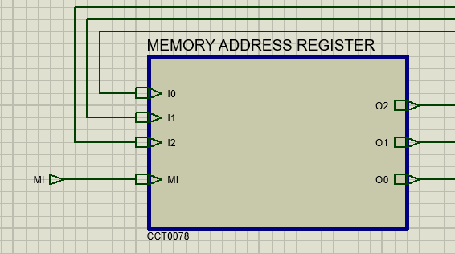
Circuit:
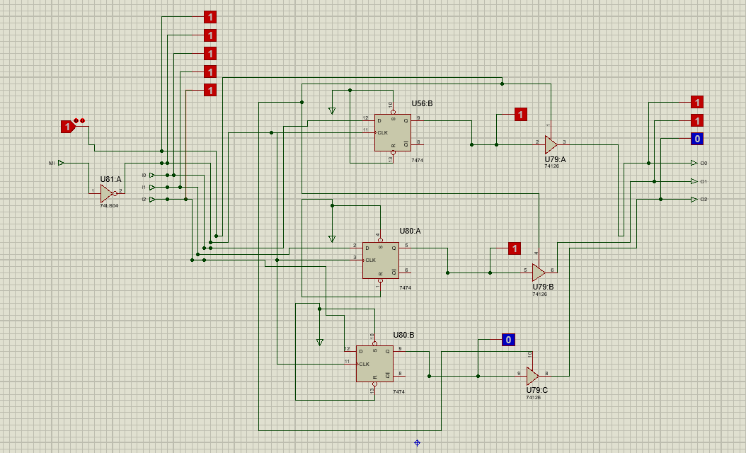

PCB Design:
Here, the IC - 74HC173 has been used for constructing the memory address register.

Operation of MAR: Memory Address Register is a combination of 3 D flip flops. The MI acts as the input enable for the MAR . The address of the input from the bus is given through the input pins and MAR stores the address and passes to RAM. The clock signal is given through the CLK input. At each positive trigger of the of the clock, the inputs are checked.
In case of a positive edge triggered D flip flop, the input is checked at each positive trigger of the clock. If the input D is 1, the output is 1 and if input D is 0, the output is 0.
Hence in case of MAR, if the Reset=0, CLK is positive triggered and MI=1, the output = input.
Input Unit:
Input unit is used for manually entering data by the user into the addresses of the
RAM when the computer is in PROG state. The data are the then stored in the
RAM and the computer can use them whenever required. Depending on the RUN /PROG state, the address selector selects either the outputs of MAR or the input unit respectively for giving input to RAM.
The Input Unit contains the following switches:
Switches | Description
Input Data  Switches | 6 switches from I5 to I0 for writing 6 bit data into specific address
Address  Switches | 3 switches A2 to A0 for accessing a particular address of RAM for writing
R/W switch | For switching between Read or Write Mode

Input Data Switches: The Input Unit has 6 switches for giving data into the addresses of the RAM. These switches are labeled as I0, I1, I2, I3, I4, I5. D0 is the LSB and D5 is the MSB.
Address Switches:
There are 3 address switches A0, A1, A2. A 0 is the LSB of the address and A2 is the MSB. When the computer is in PROGRAM mode, these address switches can be used to specify the address of the RAM.
Read/Write Switch:
The R/W switch is used to instruct the RAM as to whether the data should be read from a specific address or data should be written in a specific address
- When R/W =1, the RAM is in Read mode and can only read data from a certain address.
- When R/W=0, the RAM is in Write mode. Data can be written in the address specified while the RAM is in write mode.
The user should be cautious to change the Read/Write switch to 0 (write mode) before changing the address of the RAM so that no unintended value is stored in any of the addresses.
Clock Mode Switch: This switch is connected to the clock pulse generator’s select switch and can be used to change between automatic and manual clock pulse.
- When AUTO/MANUAL’= 0, the clock pulse generator produces an automatic clock pulse.
- When AUTO/MANUAL’= 1, the clock pulse generator can be used to produce a manual clock pulse.
RESET Switch:
The submodules are designed in such a way that when RESET=1 the submodules having a reset function will be reset. In other words, all the data in those submodules will be 0.

RUN/PROG switch:
The RUN/PROG’ switch of the Address Selector has also been included in the Input Unit. This switch can be used to change between the RUN mode or Program mode of the computer.
- When RUN/PROG’=0, the computer is in PROGRAM mode and the address is selected from the Input Unit.
- When RUN/PROG’=1 the computer is in RUN mode and the address is selected from the Memory Address Register (MAR).
While Programming the RAM of the computer, the user must select the PROGRAM mode so that the address selected is the one from the Input Unit. The user should also change the computer to RUN mode before starting the Clock Pulse.
Diagram:
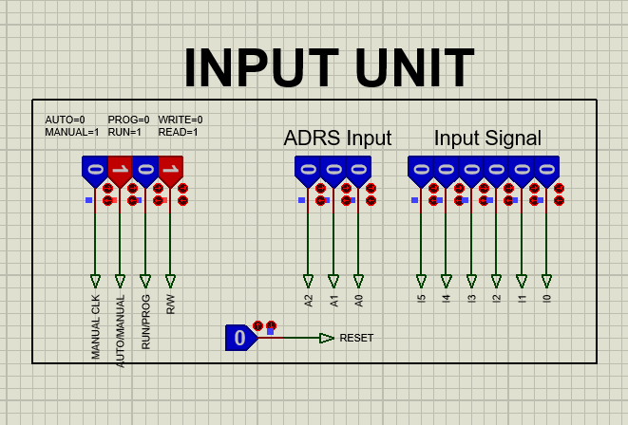

PHASE – B

Accumulator:
Accumulator is a 6-bit register which is also the A register used to store data from RAM and provide immediate output after every ALU operation. Accumulator is used to store 6 bit data and give input to the arithmetic logic unit. In construction of the accumulator two 74HC173 ic were used. This is a quad Dtype positive triggered flip-flop and works as a register. Since one register ic has four inputs, two ics were used as we had eight inputs coming from the bus. We also used 74HC245 ic which is the three-state bus transceiver and works as the buffer for the outputs going to the Bus.
Input pins:
Bus In pins: There are 6 input pins in the accumulator to take input from the bus, which are BUSIN0, BUSIN1, BUSIN2, BUSIN3, BUSIN4, BUSIN5.
AI pin: The AI pin or accumulator IN stores the current value of bus in the accumulator. It works as the input enable pin in the 74HC173 ic. When AI=1 input is taken from the bus into the accumulator using the 6 input pins. When AI=0 the output stays as it was in the previous cycle.
AO Pin: The AO pin or accumulator works as the output enable for the tri state buffer ic. .Whether the output will go to the bus or not depends on the value of the AO pin. When AO=1 the output stores in the accumulator will go into the bus. When AO=0 the bus will not get any output from the accumulator.
CLK Pin: The clk pin is connected to the clk input of the register ics. As it is negative triggered, the register will get activated at the negative clock pulse.
Output Pins:
Bus Out Pins: There are 6 bus output pins which are used to send data to the bus which are BUSOUT0, BUSOUT1, BUSOUT2, BUSOUT3, BUSOUT4, BUSOUT5.
ALU output pins: There are 6 output pins used to put the value stored in the accumulator delivered to the arithmetic logic unit. They are, ALU0, ALU1, ALU2, ALU3, ALU4, ALU5.
Operation of Accumulator: When the AI pin is HIGH the accumulator starts taking input from the pins coming from the bus and store in the register. The stored data is then passed to the Arithmetic logic unit in the next clock pulse. Whether the data will get passed on to the bus or not depends on the AO or the output enable pin. If the AO is activated the 6 output pins will provide the data to the bus.

SOFTWARE IMPLEMENTATION:
Parent Sheet:
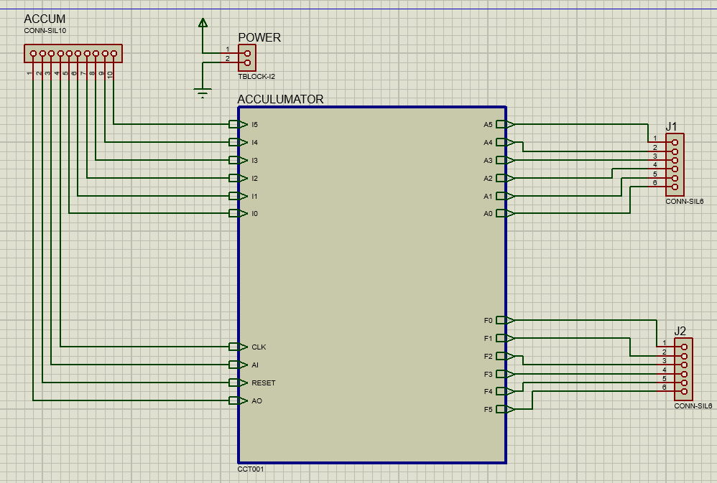
Circuit:
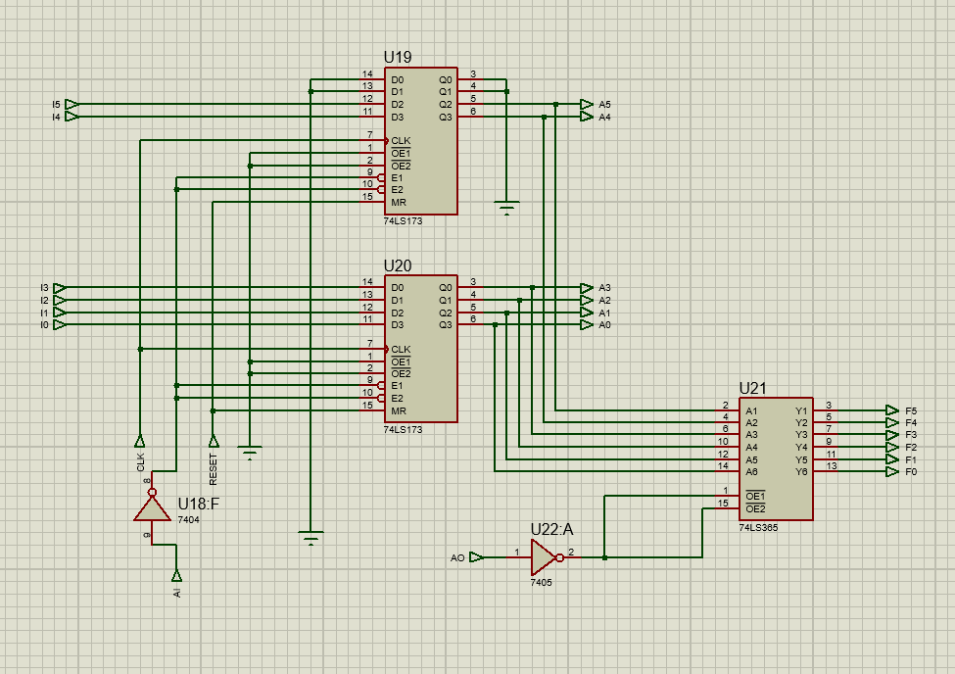

PCB design:
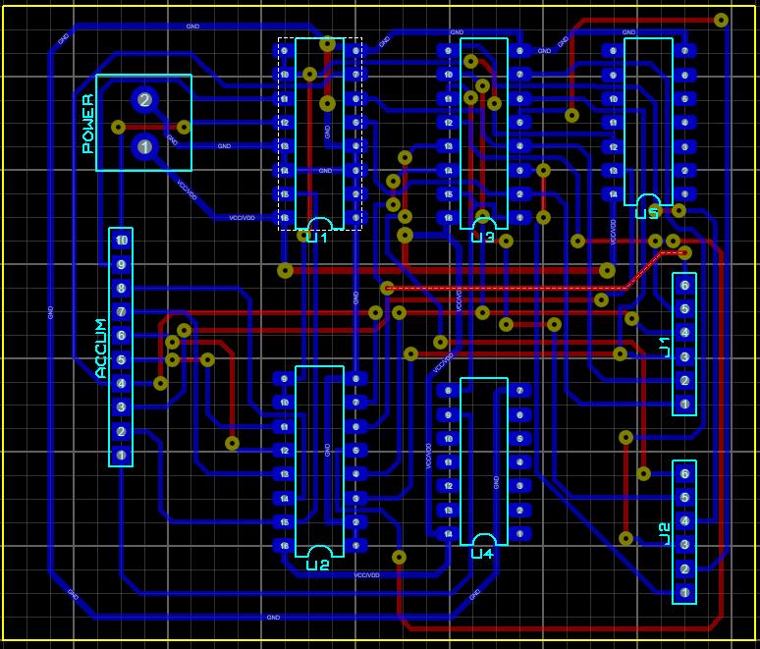

B Register:
The B register is another buffer register used in arithmetic operations. A low LB and positive clock edge load the word on the W bus into the B register. The twostate output of the B register drives the adder-subtractor, supplying the number to be added or subtracted from the contents of the accumulator.
In the child sheet we can see that there are two 74HC173 ICs which are known as 4-bit D registers. Each contains 4 input data pins as well as 4 output pins and these two are connected together to make an 6-bit B register.
BUS INPUT PINS:
There are 6 bus input pins. They are: D0, D1, D2, D3, D4, D5. These pins are used to take inputs from the bus.
BI: The B register starts functioning when BI is in active high mode.
B REGISTER TO ALU OUTPUT PINS:
There are 6 B to ALU output pins. They are Q0, D1, D2, D3, D4, D5. These pins are used to send data to the ALU from the B Register.
CLK: The CLK pin is connected to the clock inputs of each of the two D registers. This enables the flip-flops to be clocked by the clock pulse generated by the Clock Pulse Generator.

OPERATION OF THE B REGISTER:
In the two D registers, the input comes from the bus. There are a total of 6 inputs coming from the bus. The enable pins indicate whether the input will be coming from the bus or not. Since both the input and output enable pins are in ACTIVE
LOW state, so when the EI’ is 0,then input will be coming from the bus to the register.
When the R pin is in the state 0, then the D registers will work since it is in active high state. When the output enable pins are showing 0, we will get the outputs which will go to the ALU as inputs.
The outputs of these D registers are directly connected to the ALU output pins. The LSB of the output is taken from the D register that stores the LSB of the address data that was provided at the inputs of the subcircuit. Same order is maintained for all the other bits. This is done because the ALU can have direct inputs and instantly process the data once both the data from the Accumulator and B Register are present at the inputs.
SOFTWARE IMPLEMENTATION:
Parent Sheet:
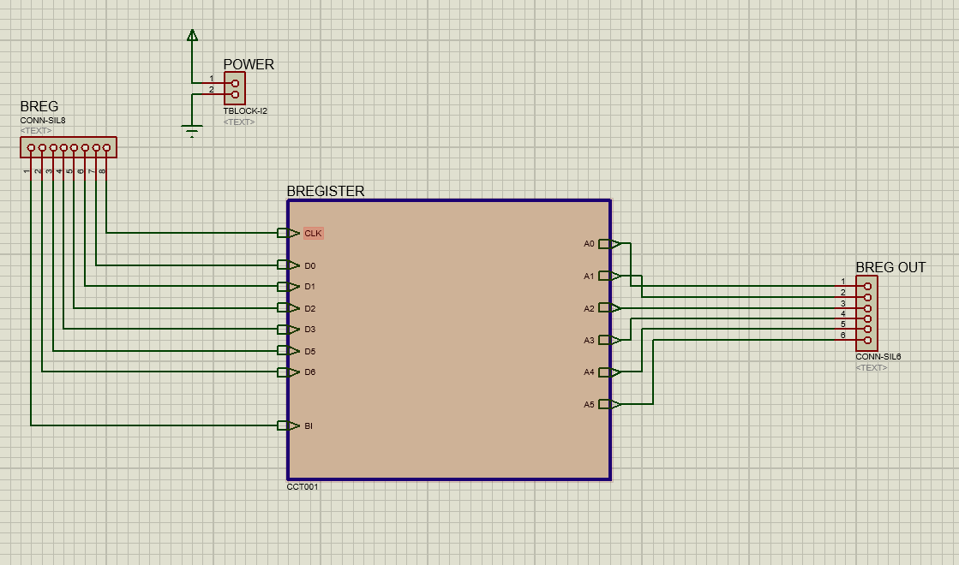

Circuit:

PCB design:

Output Register:
6 inputs and 6 outputs . 3 controlling inputs.
CLK: whenever clock pulse is high it activates the circuit. When it is 0, it holds the previous output.
OI: When OI is high output register is enabled otherwise it is not active. OI is controlled by controlling unit.
Reset: Reset clears the memory.
Output register stores the data and sends it to six seven-segment display. It is the last piece of SAP-1. It stores the ouput gained after all logical and arithmetic operations, and delivers it when given proper signals (CLK=high, OI=1).
Bus Input Pins: There are 6 bus input pins in output register. They are: I0, I1, I2, I3, I4, I5
OR Output Pins: There are 6 output pins in output register They are: Out0, Out1, Out2, Out3, Out4, Out5
CLK Pin: The CLK pin is connected to the clock inputs of each of the D flip-flops. This enables the flip-flops to be clocked by the clock pulse generated by the Clock Pulse Generator. This one is pin 7 of the ICs.
RESET Pin: The RESET pin is used to clearing the outputs.
When RESET =1, all the previous output will be 0.
OI Pin:
When OI=1, the inputs will show the output.
When OI=0, the inputs will not take further input and the output will be same as before.
Software Implementation:
Parent Sheet:
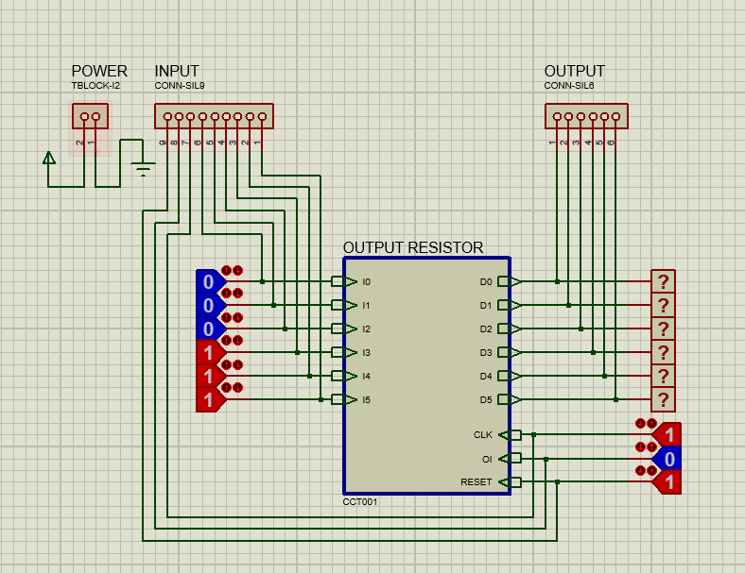
Circuit:
PCB design:

ADDRESS SELECTOR:

Schematic Diagram:
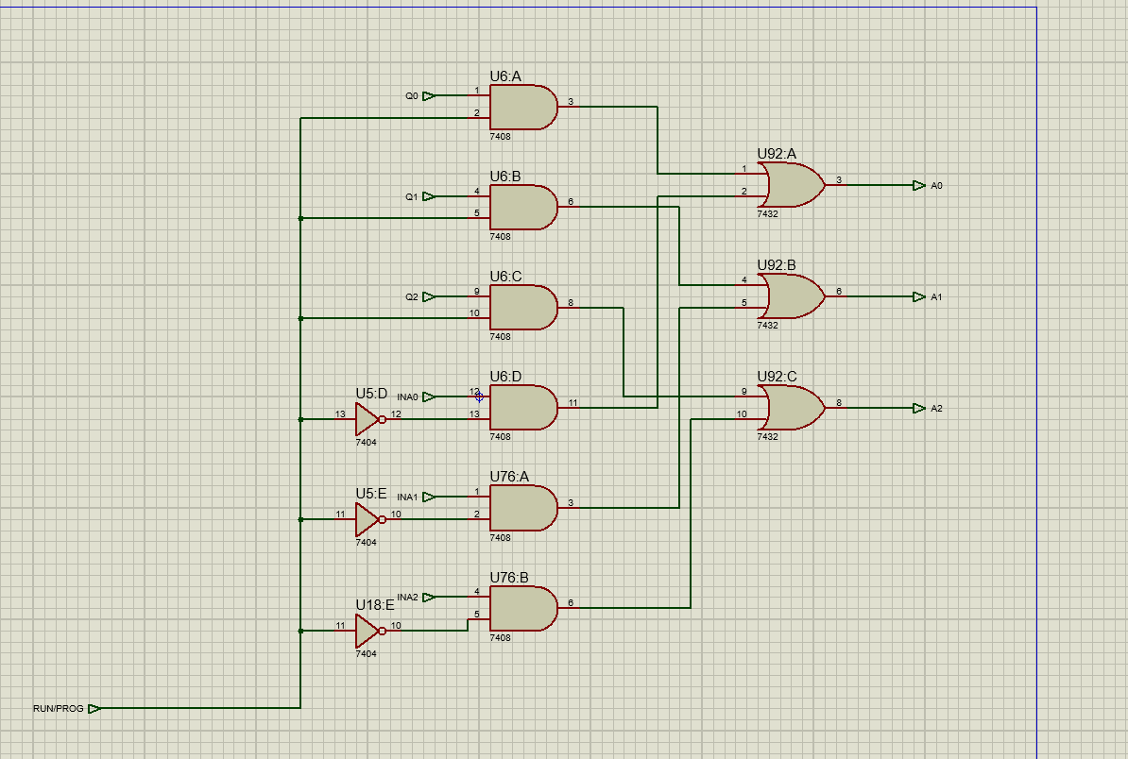

When run is on address selector takes input from Memory Address Register and returns the same output. When prog is on it takes input from input unit and returns the same output. It acts like a buffer which selects input using RUN/PROG command.

Random Access Memory:
We used 7489 IC to read and write data. We get active low output from the IC so we used NOT gates then took the output as buffer 74245 Input. RO enables the ram.
R/W: Read or write command enables the ram to read the stored data in a specific address and write command overwrites the data in that specific address.
While programming we enable write command and write the data in address 000 to 110.

Software implementation:
Parent Sheet:
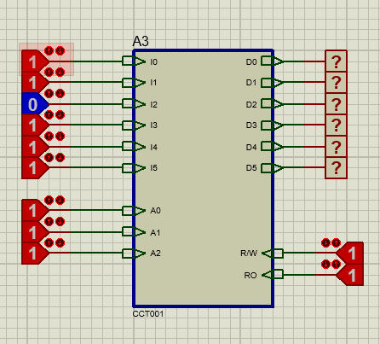
Circuit:
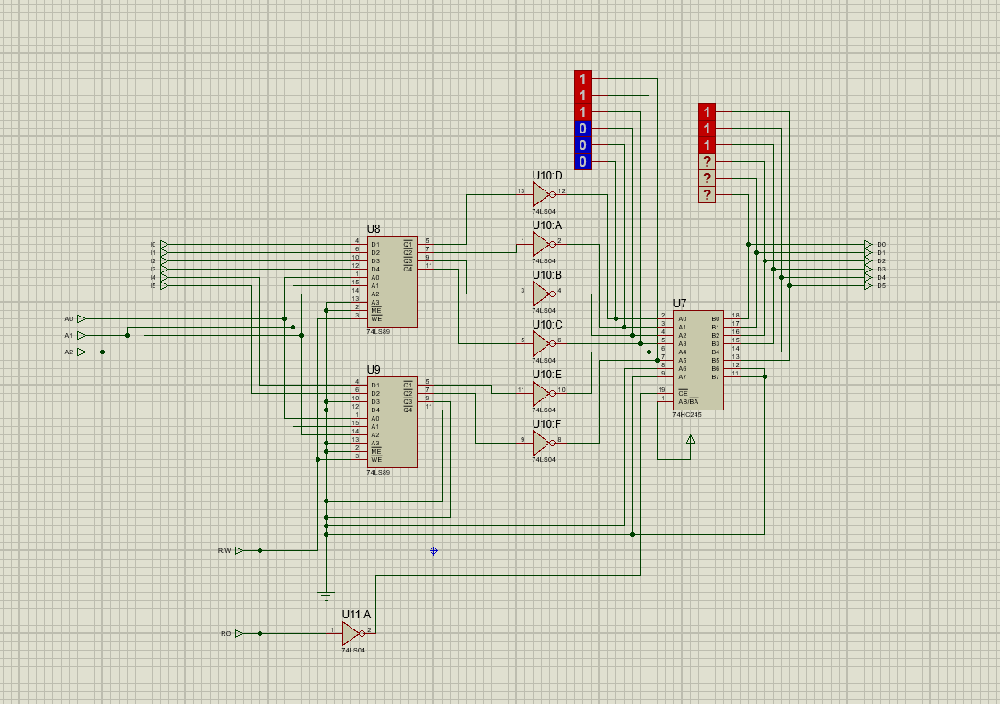
PCB design:

PHASE – C

Instruction Register:
Function of the instruction register is to receive and store the 6-bit instruction placed on the bus from the RAM. The contents of the instruction register are then split into two nibbles (here nibble means 3-bit). The upper nibble which contains the instruction to be performed goes into the controller-sequencer while the lower nibble containing the address of the instruction is sent to the bus. A reset pin is required for resetting the instruction register, when the computer starts. For constructing the Instruction Register, two positive edge triggered D flip-flops of 74HC173 ICs were used in the child sheet of the parent circuit. From the circuit the pins are described below:
Pin Diagram OF 74LS173 IC:
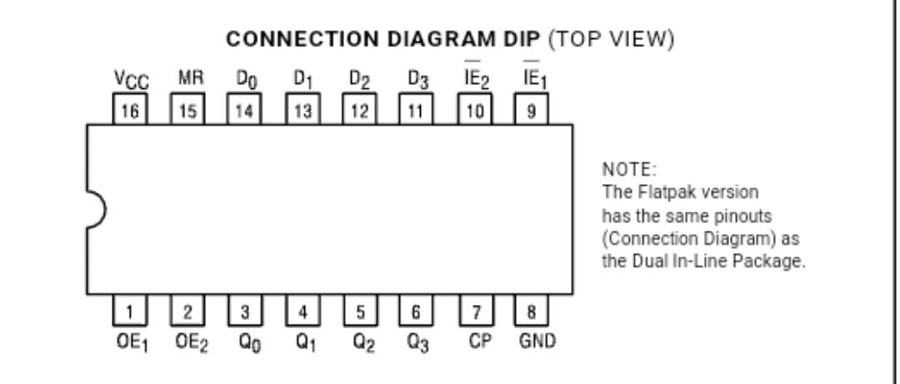
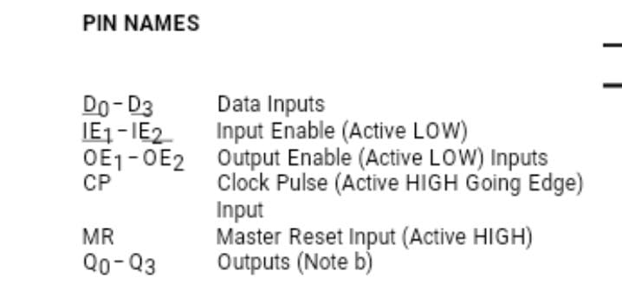
CLK Input: for giving edge triggering we used here a clock pulse generator. It connected to the pin number 7 of both IC.
Bus Input Pins: There are 4 bus in each ic but we need 6 input that’s why I used two 74HC173 IC. They are: I0,I1,I2,I3,I4,I5,. They take the input from the bus.
II(Enable input): when it is enable Instruction register will take 6bit data from the bus and will store inside it and then it will send upper 3bit data to the controller sequence. It is connected to the pin number of 10,15 in IC.
I0(Enable OUTPUT): When IO is enable it will send lower 3bit data directly to the bus. It is connected to 2,9 pin in IC.
RESET Input: If reset input is 0,then the circuit is working, Pin number of reset input in both ic’s are 15.
OUTPUT: Among the 6output upper 3 goes to the control sequencer and lower 3 goes to the bus-bar. The output pins are 3-6 in both ic.
Parent Sheet:
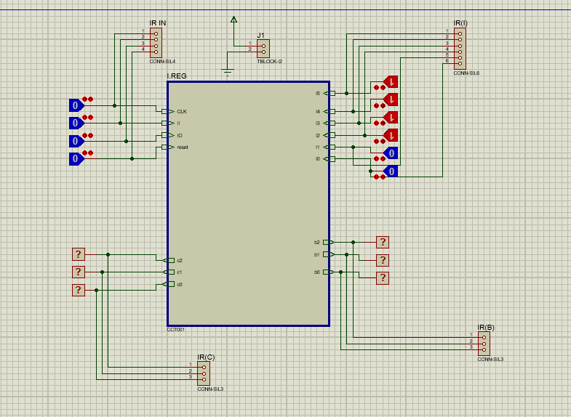

Circuit:
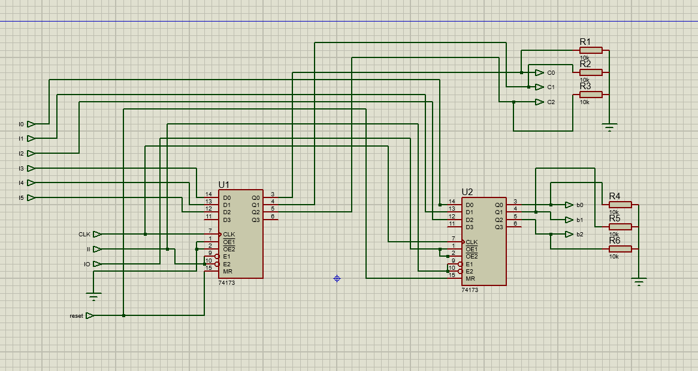

PCB design:
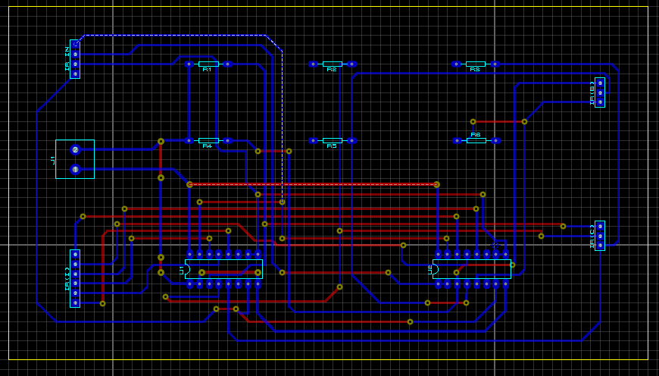

Controller-Sequencer:
Controller-sequencer generates necessary control signals for each block so that actions occur in a desired sequence. 12 control bits come out of the controller-sequencer block. These control bits determine how all other blocks will react to the next positive CLK edge. So, controller- sequencer must be designed in such a way so that correct control bits are already available to
all the blocks before the next positive CLK edge. 12 control bits are –
CON = CE CO MI RO II IO AI AO SU EO BI OI
Functions of all 12 control bits are already described. Besides these 12 signals, controller-
sequencer also generates a HLT (halt) signal, which can halt the process of computer by stopping the main clock.
Main Clock Signal:
Clock signals should be generated using a 555 timer IC. The clock module needs to have two modes of operation available- (i) Auto and (ii) Manual. In manual mode, pressing a switch/push button will advance each clock cycle.
Specification of Instruction Set:
An instruction in the SAP-1 architecture consists of 1 byte. The upper nibble of this byte (bits
5-3) is called “opcode” and it defines the instruction. The lower nibble (bits 2-0) can be used to pass parameters to the instruction (for example a RAM Address).
Instruction = XXX XXX
Instruction Field (Opcode) Address Field
The computer must be able to perform the following five instructions-

Instruction | Mnemonic | Opcode | Description
Load accumulator | LDA | 0000 | Load the value stored in a particular RAM address which is specified by the address field of the instruction, then store it in the accumulator.
Add | ADD | 0001 | Add the value
 |  |  | stored in a particular RAM address to the value in the accumulator. RAM address is given by address field of instruction.
Subtract | SUB | 0010 | Subtract value stored in a particular RAM address from the  value in the accumulator. RAM address is given by address field of instruction.
Output | OUT | 0011 | Load data from the accumulator and send that to the output register.
Halt | HLT | 1111 | Stop processing.

Instruction Cycle:
After each instruction is executed, program counter points to the next instruction stored in
RAM. But each instruction consists of several smaller instructions called microinstruction.
The time required by the CPU to execute one single instruction is called instruction cycle. For
SAP-1, length of this instruction cycle is 6 time states (T states), where T state is the time required to complete one microinstruction.
At the beginning of a T state, controller-sequencer modifies the value of 12 control bits depending on the microinstruction. During that T state, all control bits are kept unchanged. Then, at the start of next T state, control bits are again modified based on the requirement of next microinstruction. One important thing to mention here is that each T state starts at the negative edge of the clock pulse (Figure – 23), where all the submodules/blocks of the computer are triggered at the positive edge of clock pulse. This is required, so that correct control bits are already available to all the submodules/blocks before the submodules trigger. Instruction cycle can be further divided into two parts.
- Fetch cycle (First 3 T states: T1, T2, T3)
- Execution cycle (Last 3 T states: T4, T5, T6)
Fetch Cycle:
Fetch cycle (T1, T2, T3) is responsible for fetching the instruction from memory. Fetch cycle is exactly same for all instructions. So, register transfers (or microinstructions) during T1-T3 states will be always same for SAP-1 for any instruction
T-state | Name | Activated control bits | Function
T1 | Address state | CO MI | Address stored in the program counter (PC) is  transferred to the  Memory Address
 |  |  | Register (MAR).
T2 | Increment state | CE | Program counter  (PC) is  incremented.
T3 | Memory state | RO II | Instruction stored at the addressed location of RAM is transferred to the instruction register.

Execution Cycle:
During the execution cycle (T4, T5, T6) fetched instruction gets executed. Microinstructions during these three states can vary depending upon the instruction that was fetched. Execution
cycle for each instruction (LDA, ADD, SUB, OUT, HLT) are as follows-
LDA Routine
T-states | Activated control bits | Function
T4 | IO MI | Upper nibble of Instruction Register output (IR) goes to Controller-Sequencer. Lower nibble is loaded into MAR.
T5 | AI RO | Addressed data of RAM gets loaded into the
 |  | accumulator.
T6 |  | No operation.

ADD Routine

T States | Activated control bits | Function
T4 | IO MI | Upper nibble of Instruction Register output (IR) goes to Controller-Sequencer. Lower nibble is loaded into MAR.
T5 | RO BI | Addressed data of RAM gets loaded into the B Register.
T6 | EO AI | ALU output is loaded into the accumulator.

SUB Routine
T states | Activated control bits | Function
T4 | IO MI | Upper nibble of Instruction Register output (IR) goes to Controller-Sequencer.  Lower nibble is loaded
 |  | into MAR.
T5 | RO BI | Addressed data of RAM gets loaded into the B Register.
T6 | EO AI SU | subtraction
OUT Routine
T states | Activated control bits | Function
T4 | AO OI | Content of the accumulator is stored in the output register.
T5 |  | No operation.
T6 |  | No operation.
HLT Routine
HLT does not require any control routine because no registers are involved in execution of halt instruction. After HLT instruction is fetched, the controller-sequencer activates the HLT bit, which stops the main clock.
The following subcircuit of the Controller-Sequencer has been designed using Proteus:

The internal circuit diagram of the controller sequencer is shown below-
Parent Sheet:
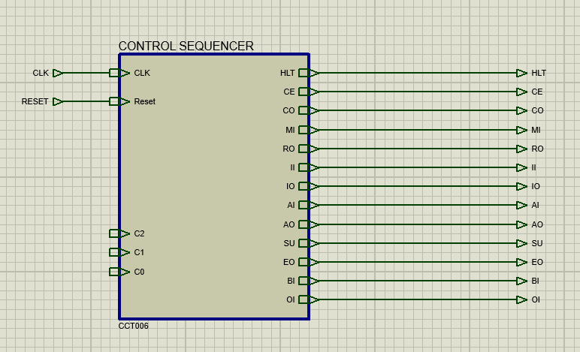
Circuit:
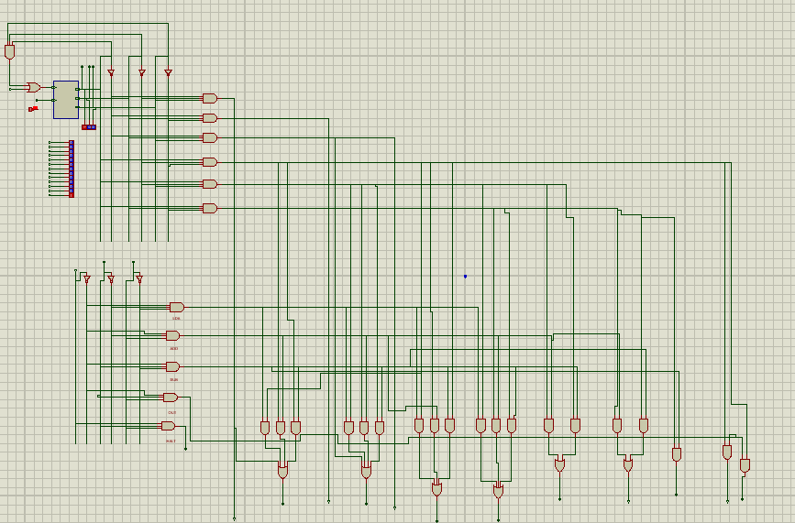

PCB design:
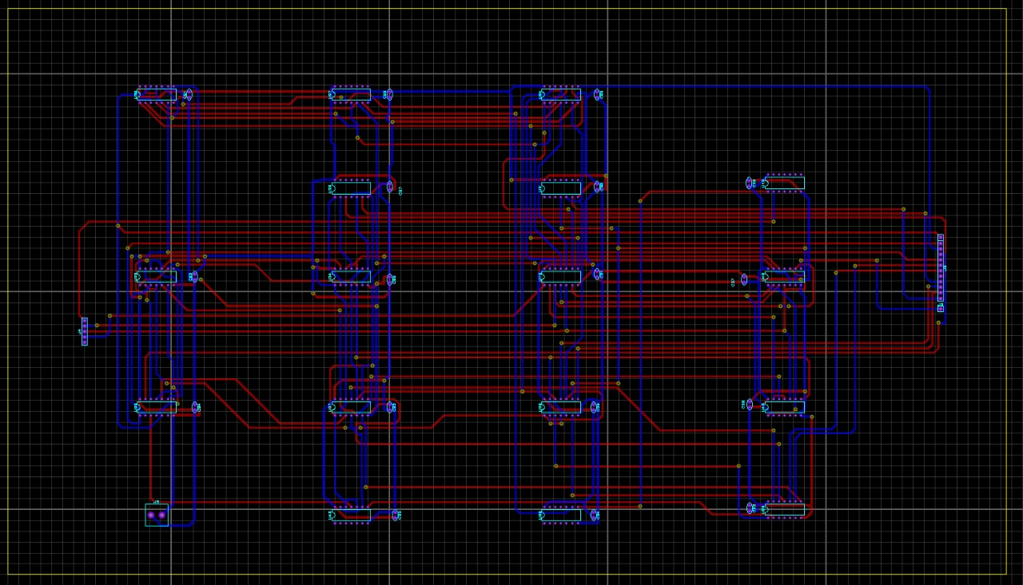

PHASE – D

ARITHMETIC LOGIC UNIT(ALU):
ALU is used for 6-bit addition and subtraction for which 2’s complement method should be used. There are 2 control bits used for the operation of ALU. the description of the two control bits are given below- SU:
The name of this pin is addition/subtraction select. The function of this pin is- when SU=0, addition and when SU=1,subtraction operation will be executed.
EO:
The name of this pin is ALU Out. The function of this pin is to send ALU output into the bus.
The subcircuit of ALU which is drawn using proteus is shown below-

Parent Sheet:
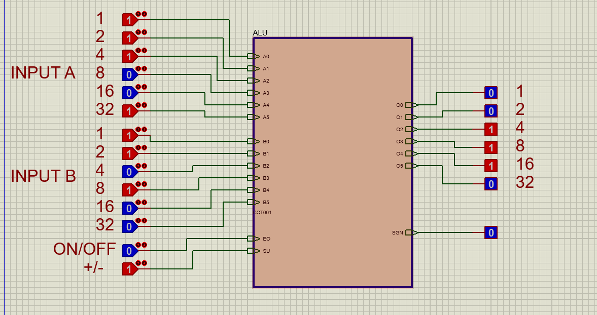
Circuit:
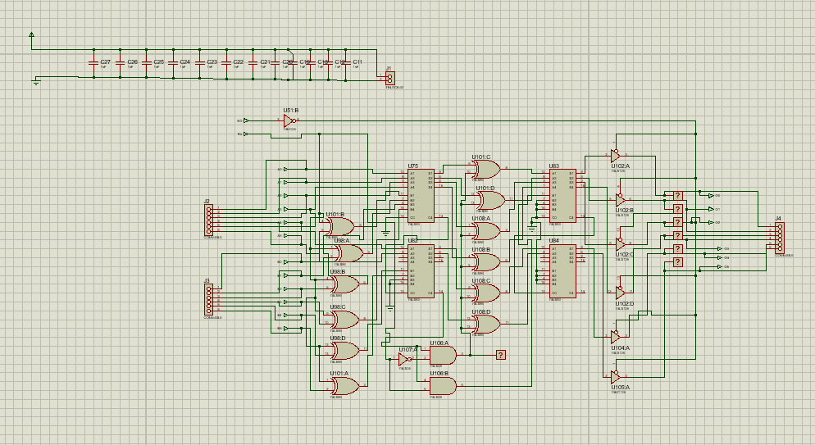

PCB design:
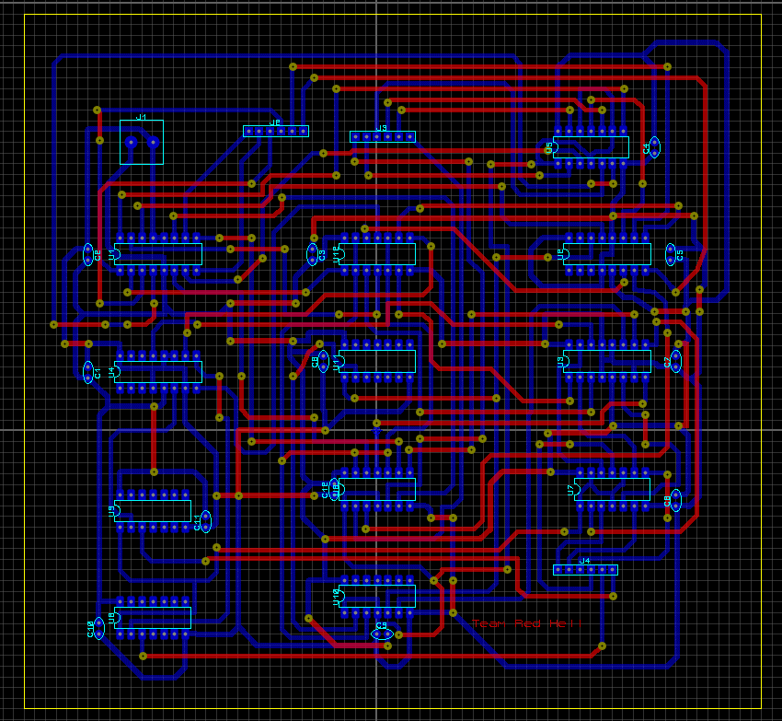

In order to construct the Arithmetic and Logic Unit (ALU), an 8-bit parallel adder using two 74LS283 4- bit binary adder ICs were used. Also, a 74HC245 IC which is a tri-state buffer is also used here.
ACCUMULATOR INPUT PINS:
There are 6 accumulator input pins. They are- AC0,AC1,AC2,AC3,AC4,AC5. These are used to take inputs from the accumulator to the ALU.
B INPUT PINS:
There are 6 input pins. They are- B0,B1,B2,B3,B4,B5. These are used to take inputs from the B register to the ALU.
ALU OUTPUT PINS:
There are 6 output pins of the ALU. They are-O0,O1,O2,O3,O4,O5. These are used to send data to the bus from the ALU.

SU PIN:
The SU pin is connected to six 2 input X-OR gates which have their other inputs connected to each of the B input pins.
EO PIN:
The EO pin is connected to a NOT gate and the output of that NOT gate is connected to the chip enable of a 74HC245 tristate buffer. The tristate buffer has an active LOW enable pin. That is why the EO pin is put through a NOT gate.
- When EO=0, chip enable gets a logic condition ‘1’ and that deactivates the outputs of the buffer
- When EO=1, chip enable gets a logic condition ‘0’ and that activates the buffer sending whatever data available at the inputs of the buffer to the output.
OPERATION OF THE ALU:
The IC on the right, gets the lower nibble input from both the Accumulator and the B register and performs its operations on the acquired data while the IC on the left gets the higher nibble input from both the Accumulator and the B register and performs its operation on the higher nibble of the data. The corresponding bits of the Accumulator and the B Register are grouped together. Meaning, the LSB of the Accumulator and the LSB of the B register are sent to the inputs of the adder that will produce the LSB of the result.
The carry input of the right IC is connected to the SU pin. The carry output of that right IC is connected to the carry input of the left IC. The carry output of the left IC is not utilized.
The data from the Accumulator is sent directly to the inputs of both of the ICs. But the data from the B Register is sent through an X-OR gate and the output of that X-OR gate is connected to the inputs of the IC. The other inputs of these X-OR gates are connected to the SU data pin.

ADDITION:
When SU=0, the ADD operation is performed by the ALU and the data present in the Accumulator and the B Register are added. SU=0 means one of the inputs of all the X-OR gates will be set to 0. This will result in the X-OR gates acting like a buffer. So, the B Register data will be present at the output of these X-OR gates. Then the adder ICs will process the data of the Accumulator and the B Register and produce the sum.
SUBTRACTION:
When SU=1, the SUB operation is performed by the ALU and the data present in the B Register is subtracted from the data present in the Accumulator. This is done using the 2’s complement method. That means, the bits of the data present in the B register are inverted and then 1 is added to them. Then the result is added to the data present in the Accumulator to generate the final result. If SU=1, the 6-bit parallel adder works as an 6-bit parallel subtractor. The X-OR gates have one input set at 1. This will make the X-OR gates work as inverters.
Whatever data present in the other input of the X- OR gates will be inverted. Producing the 1’s complement of the B Register data. Since SU is connected to the carry inputs of one of the adder ICs, SU=1 means 1 will be added with the result. So, the 2’s complement of the data of the B Register can be produced through this method. Now, the data present in the Accumulator and the 2’s complement of the data in the B Register are added using the 6-bit adder.
The output produced by the 6-bit parallel adder/subtractor circuit is sent to the inputs of a 74HC245 IC which is an 6-input tristate buffer IC. This IC has an active LOW enable pin. So, the EO pin is connected to a NOT gate and the output of that NOT gate is connected to the enable pin of the 74HC245 buffer IC. This was done because the EO control bit of this computer is active HIGH. When EO=1, the data should be sent to the bus from the ALU. Connecting the NOT gate means that when EO=0, the chip will be disabled and the output will not be available in the bus. When EO=1, the chip will be enabled and the output will be available in the bus.

PHASE – E

Integration with 6-bit Bus:
The 6-bit bus has the following characteristics:
- Bus has 6 lines for address and data transfer (BUS 0, BUS 1, BUS 2, BUS 3, BUS
4, BUS 5)
- It is designed in such a way, so that at a single time instance only one module will send data to the bus, and only one module will receive that data.
- Two modules can never send data to the bus at the same time (bus contention). When a module is sending data to the bus, all other modules’ outputs are disconnected.
The four lines of the bus that are to the right side (BUS 0, BUS 1, BUS 2 and BUS 3) are used to transfer the address data. All 6 bus lines are used to transfer any 6-bit data that will be processed using the computer.
  - The outputs of the Program Counter are connected to the address lines of the bus.
  - The inputs of the Memory Address Register (MAR) are also connected to the address lines of the bus.
  - The Accumulator has its inputs and outputs connected to the bus. The inputs of the B Register and the Output Register are connected to the bus.
  - The outputs of the Random Access Memory (RAM) are connected to the 6bit bus.
  - The outputs of the Arithmetic and Logic Unit (ALU) have been connected to the bus.
  - The Instruction Register has its inputs connected to the bus. Also, the lower nibble of the data stored in the Instruction Register contains address data. So, the output of the lower nibble is connected to the bus.

Output Display Unit:
The Output Display Unit can show the final output of the computer. In addition to this, this unit has the ability to show the data present in the bus, the data stored in the Accumulator and the B Register. The data stored in the selected address of the RAM can also be viewed using the Output Display Unit.

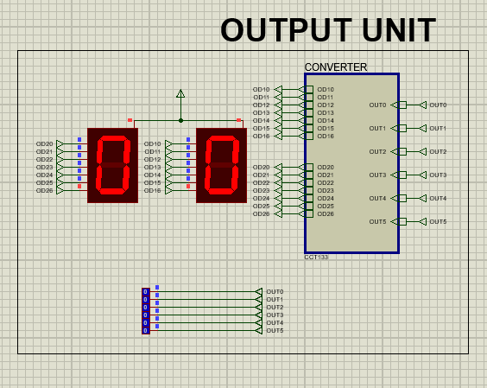

Complete SAP
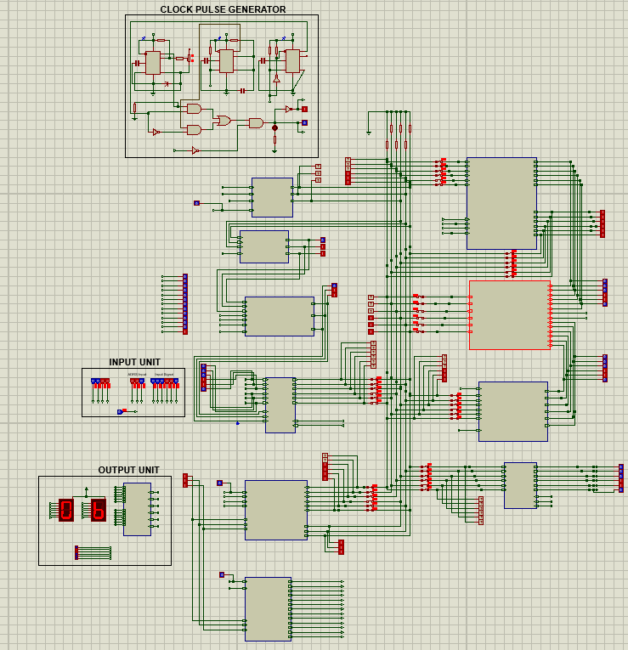

PROBLEMS FACED:
We faced problems during the integration of the bus with the parts. During the construction of the controller sequencer, problems were faced to build up the equations. Some difficulties were faced during the reduction of t-state also. Compilation of the different parts of the computer was also difficult since much debugging needed to be done after the compilation otherwise, we weren’t getting the output.

Discussion:
The project was successfully completed and the objective of implementing an 6bit computer based on the architecture of SAP-1 (Simple-As-Possible) using combinational and sequential circuits was achieved. All the submodules of the computer work coherently and the computer is able to perform addition and subtraction operations on 6-bit data defined by the user. Although the computer has a few limitations, it achieves its intended goals.

Contribution:
- Zayed (210021108): Clock Pulse, MAR, Instruction Register, Integration with 6-Bit bus and Debugging.
- Abeer (210021110): Clock Pulse, Input Unit, MAR, ALU, Controller Sequencer, Integration with 6- Bit bus, Output Unit and Debugging.
- Ishrak (210021120) : Clock Pulse, MAR, B Register, Accumulator, Instruction Register, Integration with 6-Bit bus, Debugging and Documentation.
- Ifty (210021217): Clock Pulse, Counter, Input Unit, RAM, Output Register, Control Sequencer, Address Selector, Integration with 6-Bit bus, Output Unit and Debugging and Documentation.
- Abrar (210021230): B Register, Accumulator, Controller Sequencer
- Atiq (210021262): RAM, Moral support
- Raja (210021337): ALU, Counter, Documentation.

