Guide: Draw an antenna in FreeCAD and simulate it with the GUI
Project: FreeCAD OpenEMS GUI
Goal: model a 3D antenna in FreeCAD, import it as STEP, simulate with openEMS and evaluate the S-parameters
GUI language: English (guide: English)
────────────────────────────────────────────────────────────

1. Overview
------ | ------ | --------
Draw antenna | FreeCAD | FCStd / STEP
Export | FreeCAD → Export STEP | .step
Import | GUI Import Geometry… or FreeCAD… | Triangle meshes + stl primitives
Terminations | Add Port…, Add Assignment… | 50 Ω port, material
Simulation | Build Mesh → Run Simulation | S-params, fields
Evaluation | S-Params Viewer; Antenna tab | S11/S21, Smith, markers; pattern (gain/directivity)

Important: openEMS does not read BREP-STEP directly. The GUI tessellates the CAD into triangle meshes automatically (CSX.AddMesh).
Compact step-by-step guide (FreeCAD → Geometry → Ports → Import → Simulation):
[docs/FREECAD_WORKFLOW_EN.md](FREECAD_WORKFLOW_EN.md) — with checklist and error table.
Details on port marking only: [docs/FREECAD_PORTS_EN.md](FREECAD_PORTS_EN.md).
────────────────────────────────────────────────────────────

2. FreeCAD: draw the antenna
Recommendation: one solid = one object, with a clear name (it becomes the name in the project later).

2.1 Units
- FreeCAD: View → Units → mm
- Draw objects in mm (GUI default drawing_unit=mm)

2.2 Concrete example: patch antenna 2.45 GHz (FR4, εr≈4.4, h=1.6 mm)
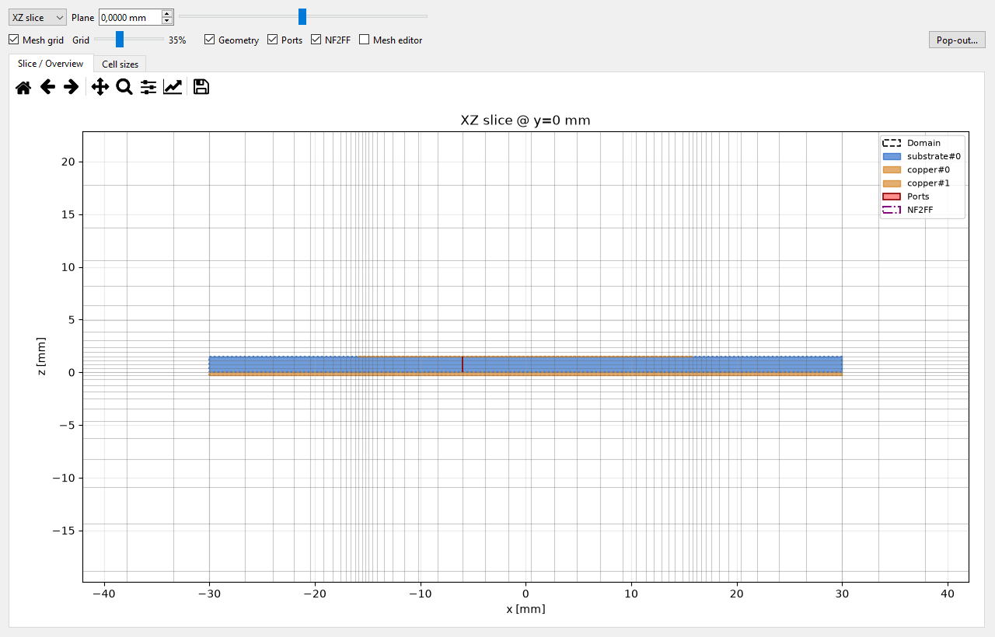
Cross-section of the target geometry. This is what the sketch has to look like: patch on 1.6 mm FR4 above the continuous ground, the port as a red line in the middle. The grid shown is already refined onto the thin layer — that is the mesh viewer, not FreeCAD.
Orientation: Z = height, patch in the XY plane.
------ | ----------------- | -------------
Substrate | 60 × 60 × 1.6 | Box, position z = 0…1.6
Ground (GND) | 60 × 60 × 1 | Box, z = −1…0
Patch | ~36 × 28 × 1 | Box on substrate, z = 1.6…2.6
Feed point | 5–7 mm from the patch edge | later port definition

Names in the model (object tree): gnd, substrate, patch.
Port (lumped):
Lumped port on an edge of the patch: start/stop on the patch, 50 Ω, direction x or y (set later in the GUI).
Mark ports already in FreeCAD (recommended):
Create points PORT_in1_start / PORT_in1_stop → the import adds the port automatically.
Step-by-step: [docs/FREECAD_PORTS_EN.md](FREECAD_PORTS_EN.md)

2.3 Wire / Yagi structure (alternative)
- Preset: Yagi Antenna… in the GUI (reference, 2.45 GHz) or FreeCAD cylinders / Part tools
- Yagi coordinate system: X = elements, Y = boom, Z = up
- Driven dipole with a gap → the port sits there

2.4 FreeCAD export
- File → Export…
- Type: STEP (*.step / *.stp) — recommended
- Save to e.g.
C:\Users\istra\Documents\claude_ps\FreeCAD_OpenEMS_GUI\work\freecad_export\antenna.step
- Optionally also save FCStd or export STL
────────────────────────────────────────────────────────────

3. Start the GUI
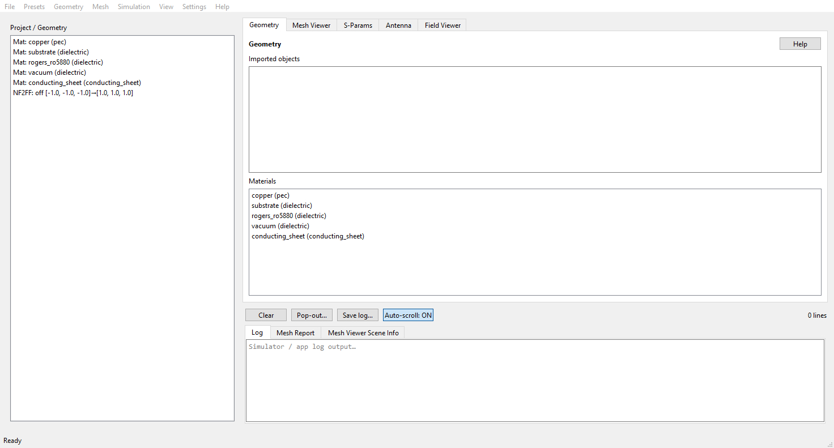
Main window after start. Tabs Geometry / Mesh Viewer / S-Params / Antenna / Field Viewer, the project tree on the left, the import and material panels in the middle, log and mesh report at the bottom.
C:\Users\istra\Documents\claude_ps\FreeCAD_OpenEMS_GUI
python app\main.py
Menu bar: File (New/Open/Save, Import Geometry, Open Work Folder, Exit),
Project (Presets), Geometry (Box/Cylinder/Port/Dump, Ports / Dumps… = Ctrl+Shift+D, Edit/Duplicate/Delete Selected = Ctrl+D/Del, Fit NF2FF — the same via right-click on a tree entry),
Mesh (Build CSX + Mesh + Validate = Ctrl+M), Simulation (Run Simulation = Ctrl+R, Script,
S-Params Viewer, Antenna Pattern Viewer / Pop-out Antenna Graph),
View (Tabs, Log Panel = Ctrl+L, Project / Geometry Panel = Ctrl+B),
Tools (Settings…),
Help (Help = F1, ANLEITUNG, README, About).
The Project / Geometry panel on the left (the tree) can be hidden and shown
again with a right-click on the empty area below the tree or via View →
Project / Geometry Panel (Ctrl+B); the state is remembered.
The log panel (below the tabs, toggled with Ctrl+L) has two
tabs: Log (openEMS/app log) and Mesh Report (the mesh-check report,
single source after a build). Right-click anywhere in the log area (text,
tab bar, button row, line counter or the divider above it) for the log options:
show/hide the Log and the Project / Geometry panel, pick a log tab, auto-scroll,
Save log…, Pop out log…. In the text, Copy / Select All are above them. The same
menu sits on the status bar at the bottom edge.
Settings… (once):
------- | -------
FreeCADCmd | c:\FreeCAD_1.1.4-Windows-x86_64\bin\FreeCADCmd.exe
FreeCAD GUI | c:\FreeCAD_1.1.4-Windows-x86_64\bin\FreeCAD.exe
Simulation Python | c:\Python\WPy64-31150\python-3.11.5.amd64\python.exe
openEMS root | c:\openEMS
Work dir | C:\Users\istra\Documents\claude_ps\FreeCAD_OpenEMS_GUI\work

────────────────────────────────────────────────────────────

4. Bring the model into the GUI

Variant A — import (standard)
- Import Geometry…
- Choose the file: .step / .stp / .fcstd / .stl / .obj / openems_export.json
(a folder of per-object STLs, e.g. stl/, also works)
- FreeCADCmd tessellates STEP/FCStd → .npy meshes; STL/manifests are loaded
directly — one primitive per FreeCAD object, object names are preserved
- Objects appear as stl primitives (default material: copper / PEC)
- Check the log: mesh paths, any WARNINGS

Variant B — FreeCAD tools in the GUI
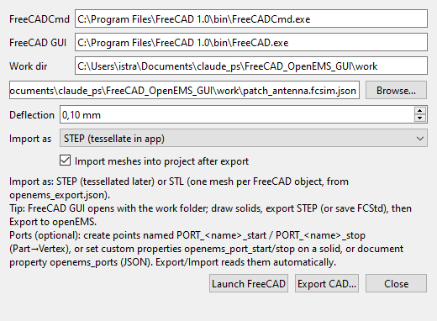
FreeCAD tools. Paths to FreeCADCmd and the FreeCAD GUI (example), work directory, deflection and import format. Launch FreeCAD opens FreeCAD with this work folder, Export CAD… writes STEP/STL into the project.
- FreeCAD…
- Launch FreeCAD (opens FreeCAD, cwd = work dir) — draw/edit, export STEP
- Export CAD…
- Source: .fcstd (preferred — object names are preserved) or .step
- Import as: STEP (the app tessellates it later) or
STL (one mesh per FreeCAD object) (uses openems_export.json,
no FreeCAD needed at simulation time)
- Deflection: 0.1 mm (default)
- Check Import meshes into project after export
- OK → export → auto-import into the project
Headless (without GUI):
c:\Python\WPy64-31150\python-3.11.5.amd64\python.exe examples\run_stl_import_example.py

Variant C — preset (only to test the simulation)
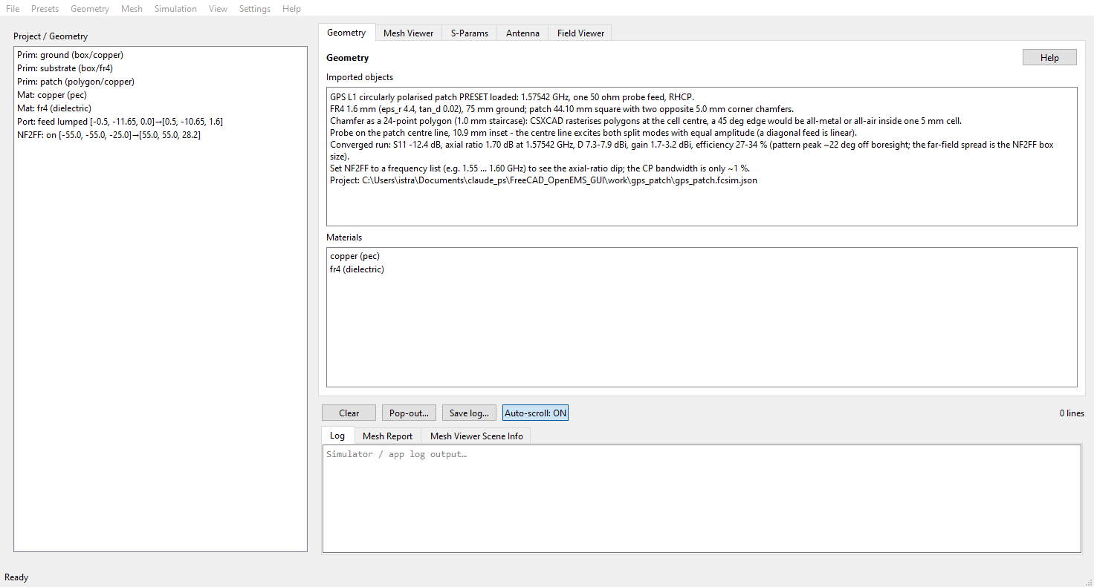
After loading the preset. Project tree with ground, substrate and patch, materials, port and NF2FF box; the geometry text carries the preset's figures and the hint how to make the axial-ratio dip visible with a frequency list.
- Preset: Patch Antenna…, Preset: Yagi Antenna… or Preset: PCB Filter…
- PCB Filter = 2-port microstrip notch filter on FR4 (stopband at 2.45 GHz):
two lumped ports, so the example measures both S-matrix columns.
The geometry comes from FreeCAD (FCStd → STL, 35 µm copper); --analytic
uses the analytic box primitives for comparison instead
c:\Python\WPy64-31150\python-3.11.5.amd64\python.exe examples\run_pcb_filter_example.py
Result (work\pcb_filter\simulation\): FreeCAD run −29.99 dB at 2.450 GHz
target, insertion −0.72 dB at 0.3 GHz; analytic run −28.96 dB at 2.429 GHz
(0.9 % difference = real 35 µm copper layer vs. zero-thickness trace in the tutorial).
Notes:
- Axis-aligned FreeCAD solids are created as openEMS boxes (exact
metal edges on the grid lines), everything else stays an STL
PolyhedronReader. In-memory Polyhedron primitives are not simulated
by openEMS (warning Unused primitive).
- [WARNING] grading_jump: Axis z 9.14 is normal: the 35 µm copper forces
0.035 mm cells next to the 0.32 mm substrate cells — just a warning,
exit code 0.
- Max. number of timesteps was reached is expected here; the stopband is
stable (0.019 dB change from 50 000 to 150 000 steps, work\pcb_filter_conv).

PCB band-pass 5.6 GHz (five stubs, Teflon)
Preset: PCB Bandpass (5.6 GHz)… loads a 5-pole Chebyshev band-pass
(0.1 dB ripple) on PTFE/Teflon (0.254 mm, eps_r 2.1, tan_d 0.0002, 35 µm
copper). Five open lambda/2 stubs hang off a 50 ohm line, separated by four
lambda/4 connecting lines acting as impedance inverters — no vias, so the
board stays single-sided planar.
--- | --- | --- | ---
Stub 1 / 5 (outer) | 50.8 | 0.80 | 18.37
Stub 2 / 4 | 15.0 | 3.74 | 18.69
Stub 3 (centre) | 68.0 | 0.50 | 22.91
Line 1 / 4 | 43.9 | 1.01 | 11.78
Line 2 / 3 | 61.0 | 0.60 | 8.04

c:\Python\WPy64-31150\python-3.11.5.amd64\python.exe examples\run_pcb_bandpass_example.py
Result (work\pcb_bandpass\sparams\): |S11| < -10 dB from 4.90 to 6.45 GHz,
passband -0.1 … -0.3 dB, rejection -42 dB at 4.0 GHz and **-38 dB at
7.2 GHz** (two FDTD runs, one S-matrix column each, merged; ~80 s per port on
8 cores).
Notes:
- The mesh uses min_cellsize = 0.15 mm (narrowest stub 0.50 mm) and
min_cellsize_z = 0.085 mm (three cells through the 0.254 mm substrate).
- smooth_metal_edge = False and handle_closely_placed_edges = False:
otherwise easyMesh creates a 4 µm cell between the 0.41 mm and 0.50 mm wide
trace edges, shrinking the CFL time step by a factor of 8 (the simulation
never decays).
- Stub band-passes are inherently wideband; the spurious pass-band near 2*f0 is
a property of the topology, not a meshing artefact.

PCB hairpin band-pass 2.4 GHz (five folded resonators, RT/duroid)
Preset: PCB Hairpin Bandpass (2.4 GHz)… loads a 5-pole Chebyshev band-pass
(0.1 dB ripple, 10 % bandwidth → 2.28–2.52 GHz) on RT/duroid 6010LM
(1.27 mm, eps_r 10.2, tan_d 0.0023, 35 µm copper). Five **folded lambda/2
resonators** (hairpins) couple side by side along their arms — no vias, no
stubs, copper area only 25.1 x 14.3 mm.
--- | ---
Centre frequency f0 / bandwidth | 2.40 GHz / 10 %
lambda_g in the odd mode | 51.23 mm (eps_eff = 5.946)
Strip width (all arms) | 1.186 mm (50 ohm)
Arm length | 11.814 mm
Inner gap between the U arms | 0.80 mm
Fold outer / electrical | 3.172 / 1.986 mm
Coupling gaps s0…s5 | 0.316 / 1.387 / 1.753 / 1.753 / 1.387 / 0.316 mm
J-inverters (normalised) | 0.370 / 0.125 / 0.096 / 0.096 / 0.125 / 0.370
Z0e / Z0o | 75.4/38.3 · 57.1/44.5 · 55.2/45.7 ohm

Synthesis: the two arms of one hairpin carry opposite currents, so the
resonator runs in the odd mode of the arm pair. The arm length therefore
uses eps_eff,odd = 5.946 (not the single-line eps_eff — that makes the arms
~15 % too short). The gaps come from the Hammerstad-Jensen even/odd model via
the J-inverters of the Chebyshev prototype; the strip width stays uniform and
only the gap sets the coupling.
c:\Python\WPy64-31150\python-3.11.5.amd64\python.exe examples\run_pcb_hairpin_example.py
What is verified is the single resonator: one hairpin (arm 11.814 mm, feed
coupling 0.316 mm) resonates at 2.365 GHz with S21 = -0.16 dB and
S11 = -47.6 dB; the skirt width gives Qe ~ 12.5 (synthesis: 13.1).
Notes:
- Runtime: the DFT resolution is 1/T_sim. A 240 MHz pass-band with ~50 MHz
mode spacing needs T_sim >~ 60 ns (>~ 1.2 M steps). With tan_d = 0.0023
(Q0 ~ 435) the stop-band decays very slowly. The preset therefore stops at
end_criteria = 1e-4 (-40 dB) and max_timesteps = 600_000.
- Validation status: single resonator and single coupling are verified in
FDTD. Short runs (< 200 k steps) do not resolve the filter's mode spacing and
then show no clean pass-band — extend the run as described above for the full
5-pole curve.
- Mesh: min_cellsize = min(s)/3 = 0.105 mm, the 1.387 mm gap is resolved by
four cells, strip edges sit on grid lines (edges2grid = "xy").
────────────────────────────────────────────────────────────

5. Configure the project

5.0 Simulation parameters (own window)
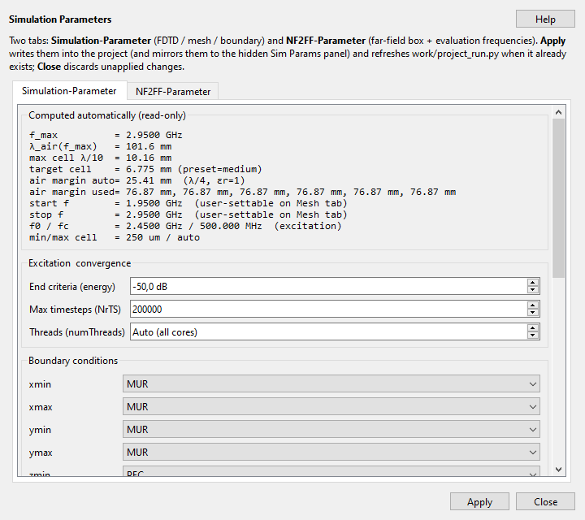
Simulation Parameters. Two tabs; the computed values on top (f_max, λ, cell sizes, air margin), below them the end criterion, timesteps, threads and boundary conditions.
Menu → Simulation → Simulation Parameters… (or Ctrl+Shift+P) opens a
separate, movable window with all simulation parameters — two tabs:
----- | ----------
Simulation-Parameter | Computed (read-only), excitation & convergence (end criteria, NrTS), boundary conditions ×6 + PML, air margin, mesh overrides, patch geometry
NF2FF-Parameter | Enable far-field (NF2FF), evaluation frequencies (mode: *Auto (S11 minimum)* / *N points (mesh range)* / *Frequency list*), θ/φ steps, Fit/Edit NF2FF box

Evaluation frequencies (NF2FF tab) select at how many frequencies the
far field is recomputed:
------ | --------
Auto (S11 minimum) | one frequency at the S11 dip (or the target frequency)
N points (mesh range) | N points equally spaced over the mesh frequency range (start/stop from the Mesh tab) — e.g. 11 points from 2.0…2.8 GHz → *Gain vs Frequency* curve in the Antenna tab
Frequency list | explicit list, each entry with a unit Hz / kHz / MHz / GHz (bare number = Hz), e.g. 2.4 GHz, 2.45 GHz, 2500 MHz

-------- | --------
Apply | Writes the values into the project, mirrors them into the hidden Sim Params panel (save/build use it) and refreshes work/<project>/project_run.py when it already exists (a visible Script editor reloads the file unless it holds unsaved edits)
Close | Discards unapplied changes

The window is modeless — a second menu click brings the same window
to the front and syncs it with the current project. Changes take effect only
after Apply; then Build Mesh so the mesh picks them up.
Menu → Mesh → Mesh Parameters… (or Ctrl+Shift+M) opens a
separate, movable window with all mesh parameters (preset, drawing unit,
f0/fc, start/stop, air margin). Apply writes them into the project and
mirrors them into the hidden mesh form, Close discards unapplied changes.
This window is also modeless.

5.1 Mesh / frequencies
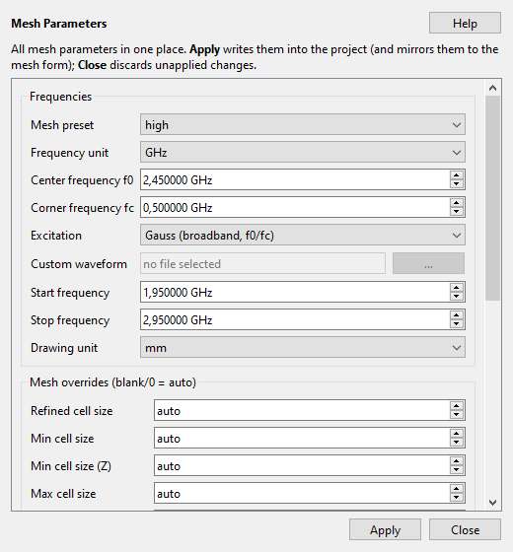
Mesh parameters. Preset, frequency range (f0/fc), excitation and the cell-size overrides in one place; Apply writes them into the project.
Mesh parameters (see §5.0):
----------- | ---------------- | ---------------
start_frequency | 2.2e9 | 2.2e9
stop_frequency | 2.7e9 | 2.7e9
target_frequency | 2.45e9 | 2.45e9
drawing_unit | mm | mm
max_timesteps | 150000+ | 25000 (preset)

Coordinate alignment (default: on). Mesh Parameters has "Align coordinates
(float32 grid)": every geometry coordinate then sits on the same float32 grid
CSXCAD uses for boxes/ports/dumps — triangle meshes from STEP/STL/FCStd included.
A vertex and a box face that are meant to be equal are bit-identical (no second
grid point, no sliver cell that collapses the timestep). Switching it off
restores the old behaviour (triangle meshes rounded decimally to 0.1 µm), which
is only useful for A/B comparisons. Stored .npy meshes keep their old rounding
until they are re-imported.
Fine-cell attribution (P2, default: on). The checkbox "Attribute fine cells
to their source" writes the geometry that forces each flagged cell onto the mark
(e.g. box:feed + manual) — visible in the Mesh Viewer marks and in the report
under "Fine-cell sources". Cells without an authored source come from easyMesh
itself (circle/arc detection, grading, PML transition).
Critical cells in the Mesh Viewer (default: off). Right-click →
"Mark critical cells (N)" shows the cells that cost runtime: the smallest
cell of each axis (they set the timestep), cells below the requested minimum size
and — after a run — the cell the solver reports as the smallest timestep. They
appear as dashed outlines in the slices (the grid stays visible) and as bands in
the Cell sizes plots; consecutive cells are merged into one region. Grading
jumps and too-large cells stay in the mesh report only. The marks are always
computed but drawn only on request; the count in the menu entry tells you
beforehand whether there is anything to see.
Repairing cells (opt-in, preview first). Right-click a mark →
"Critical cells (N open)" offers: Repair this x/y/z region… (preview with the
lines removed, the new smallest cell and dt before/after; OK stores the rule in
the project), Remove the offending line… (delete one auto line), *Snap onto the
neighbour line… (duplicate-scale slivers only), Accept region (do not repair)*
(grey, no longer counted as an open finding) and Explain… (cause, source,
runtime penalty). Only unprotected lines are touched; a cell with two geometry
faces stays and is reported as geometry. The repair runs as the last step of
the mesh build — the preview and the generated solver script produce the same
grid.
Enforcing the min cell size (V2, default: off). In Mesh Parameters,
"Enforce min cell size (repair)" turns "Min cell size" into a hard lower bound
("Min cell size (Z)" overrides the layer thickness): cells below it are merged
into the smaller neighbour and the grading is re-spaced; genuine gaps (both faces
from the geometry) stay and are reported as "not reached". The switch is opt-in
so existing presets stay reproducible; easyMesh no longer sees the floor (it
would otherwise refine the lateral axes against the repair).
Both are also in the Mesh menu under Critical cells (N open): overlay
toggle, repair/remove/snap/accept/explain for the worst open finding and the
enforcement switch. The actions are only enabled where the right-click menu
would enable them too.
Full description: F1 → "Mesh Repair" (also the Help button in the repair
preview and Help → "Mesh repair (critical cells)…").

5.2 Material / assignment
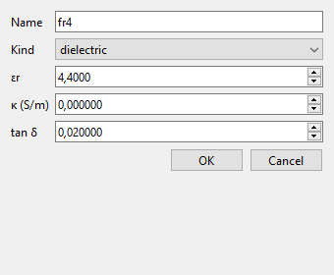
Material. Kind (dielectric / pec), εr, κ and tan δ — FR4: εr 4.4, tan δ 0.02; copper as pec.
- Add Material… — e.g. substrate (εr=4.4, tanδ=0.02), copper
- Add Assignment…
- Object: substrate (or the substrate name from the import)
- Role: dielectric / pec / conductor …
- Choose the material
- The assignment syncs stl primitives (pec → copper, dielectric → substrate …)

5.3 Port
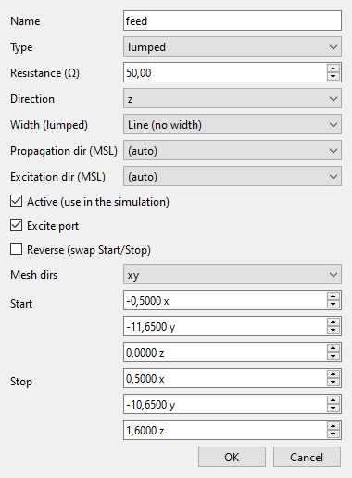
Port. Lumped, 50 Ω, direction, mesh dirs and start/stop in mm. Example: the probe port of the GPS preset — 1 mm × 1 mm from the ground plane (z = 0) to the patch top (z = 1.6 mm).
- Add Port…
- Type: lumped (patch) — resistance 50
- start / stop: edge of the patch (mm), e.g.
start=[-1.0, 0.0, -1.0], stop=[1.0, 0.0, 1.0]
- Direction: x or y (parallel to the voltage drop across the port)
- excite_port = true (port 1)
- Check the geometry: viewer / mesh preview
Alternative (FreeCAD): mark ports as PORT_* points in the FCStd — they then appear automatically on import.
→ [docs/FREECAD_PORTS_EN.md](FREECAD_PORTS_EN.md)

5.4 NF2FF (radiation pattern)
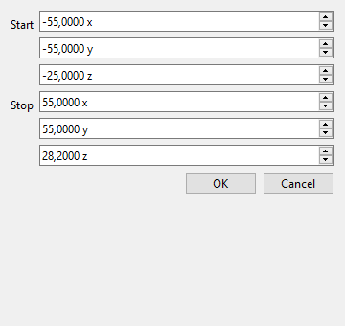
NF2FF box. Start/stop in mm; it has to enclose the antenna and its beam. Example: the GPS preset's box (±55 mm, z −25 … 28.2 mm). Fit NF2FF to Geometry sets it automatically.
- Edit NF2FF Box… or Fit NF2FF to Geometry
- Box around the antenna, e.g. start [-40,-40,-20], stop [40,80,20], center [0,20,0]
- enabled = true
- Pick the evaluation frequencies (Sim Params → NF2FF tab, see §5.0):
Auto (one frequency at the S11 minimum), N points (Gain vs Frequency
curve) or an explicit list with units (e.g. 2.4 GHz, 2.45 GHz).
- The mesh viewer shows the new box immediately (violet dash-dot line) —
provided the mesh has already been built; the black dashed line is the
simulation domain and only changes on the next Build Mesh.

5.5 Save the project
Save… → e.g. work\my_antenna\antenna.fcsim.json

5.6 Domain size (black frame in the mesh viewer)
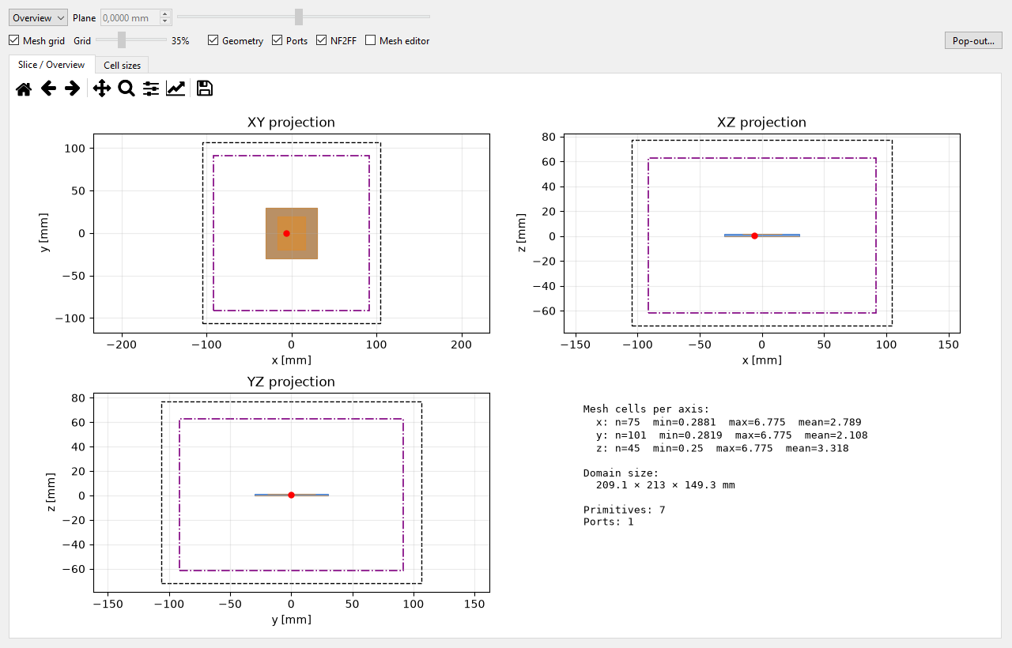
Domain and boxes. The overview shows all three projections: black dashed the FDTD domain, violet dashed the NF2FF box, plus the cell count per axis and the domain size. The black frame in the mesh viewer is exactly this domain.
The domain cannot be edited directly — it results from **geometry + air margin +
grid rounding**. Levers:
------- | --------
Air margin auto (Sim Params → Boundary conditions) | λ/4 at the stop frequency, always εr=1 (at 2.7 GHz = 27.76 mm per face). Changing the stop frequency therefore also changes the margin
Air margin (all faces) | Auto off → fixed value in mm for all 6 faces. In the project JSON settable as a 6-element list boundary.air_margin = [xmin,xmax,ymin,ymax,zmin,zmax] per face (the GUI writes the same value for all)
Geometry | Domain = geometry bbox + margin (easyMesh boundary_distance)
PML size | per PML face easyMesh adds PML_size + 1 cells outside → larger domain. Only effective for boundary = PML; no effect for MUR
Mesh preset / min cell size | Air cells grow to λ/10…λ/40 per preset (max_cellsize_air) → the outer grid line is rounded to that: deviation of a few mm, slightly different per side (that is the small asymmetry of the black line)

Procedure: change values → Build Mesh (black line updates) →
Fit NF2FF to Geometry so the violet box stays inside. The result
appears in the viewer info panel as Domain size.
Limits: too small → warning outside the field domain, NF2FF/dumps are
clamped or disabled; too large → significantly more cells (RAM/runtime).
Geometry that sticks out past the black line is reported by the validator as
primitive_outside_domain (error, blocks the run; dumps/probes only as a
warning) — the mesh viewer outlines such primitives in red and writes
OUTSIDE DOMAIN in the overview.
────────────────────────────────────────────────────────────

6. Simulate
- Build Mesh
- Check: mesh cells, ports, preview (mesh_preview.png)
- Viewer shows the 3D geometry
- Run Simulation
- Log panel: openEMS running, max_timesteps, end_criteria
- A warning for max_timesteps < 150000 is possible
- Script… (Simulation menu) — view and edit project_run.py
- The script is what openEMS actually runs (paths, mesh, ports, export)
- Save / Revert / Regenerate from project
- Run Simulation regenerates the script; your own changes are backed up to
project_run_edited.py first — the GUI asks whether to regenerate or run
your edited script as-is
- Manual: <python> work\<project_name>\project_run.py
- Result files under work\<project_name>\ (among others project_run.py, meshes, S-params)
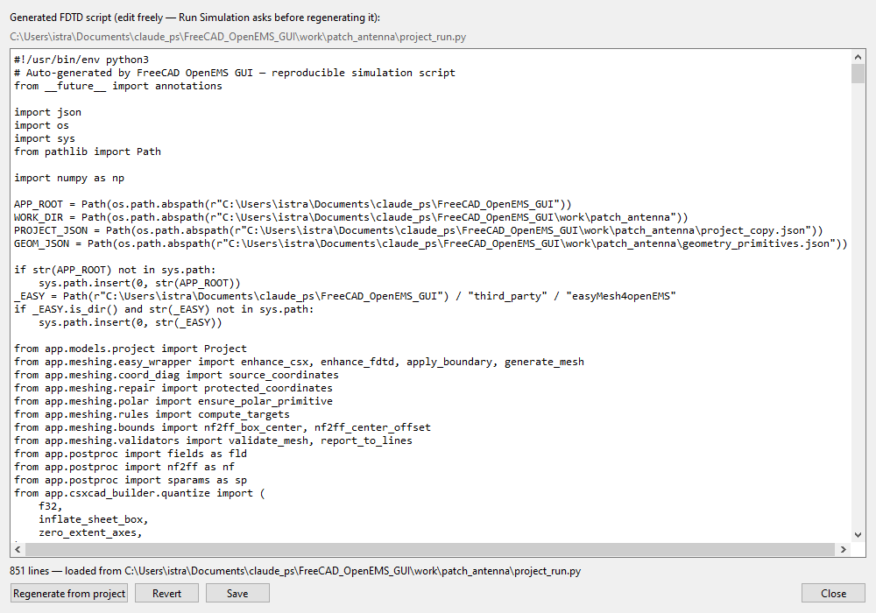
Script editor. Shows project_run.py — the script openEMS actually executes — with Save, Revert and Regenerate from project. Local edits are backed up as project_run_edited.py before a regeneration.

6.1 Mesh and simulation diagnostics
Two reports answer "is this run trustworthy?" — before and after the solver ran:
- Mesh ➤ Mesh Timing / Feasibility… (the same content appears right after
Build Mesh in the Mesh Report tab and as one log line per build): the
smallest cell per axis and the resulting dt (vacuum Courant limit plus the
lower bound inside the densest dielectric), cells per wavelength at f_max,
the runtime penalty of an over-refined cell against a typical one, the
timesteps needed to cross the domain, and the frequency resolution
1/(max_timesteps·dt) versus the requested sweep step. Every warning names
the concrete remedy (e.g. "raise max_timesteps to >= 389000", or which cell is
too coarse).
- Simulation ➤ Simulation Status… (after every run, successful or not; the
same block is appended to the end of the log): errors and warnings from the
solver log — including the mesh validation from before the run —, convergence
(end criteria reached or max timesteps hit), the engine's exact facts
(dt, Nyquist rate, excitation length, operator/field size,
steps/energy/speed), the mesh estimate cross-checked against the engine value,
the actual DFT window resolution, and the passivity of the S-parameters
(|S11|²+|S21|² ≤ 1) versus frequency — separated into the core band and the
sweep edge (a violation at the edge only is a DFT window artefact and
harmless). It ends in a verdict (OK / WARNING / ERROR) with a trust
rating ("reliable / use with care / unusable").

6.2 Mesh viewer
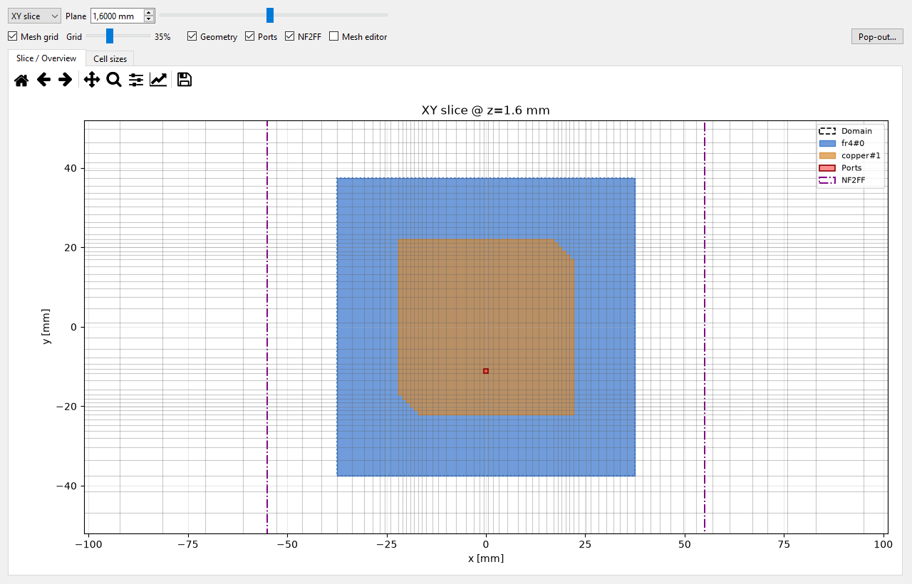
Mesh viewer, XY slice at z = 1.6 mm. The grid appears as lines, the geometry as areas: 75 mm board (blue), patch with its two staircase chamfers (orange), port (red), NF2FF box (violet dashed) and the FDTD domain (black dashed). You can see the cells refine over the patch and coarsen towards the maximum allowed cell size. The slider next to "Plane" moves the cut, "Mesh grid" toggles the lines, "Cell sizes" colours the cell sizes, "Overview" shows the 3D view. Right-clicking a marked cell opens the repair actions from section 6.1.
────────────────────────────────────────────────────────────

7. Evaluation
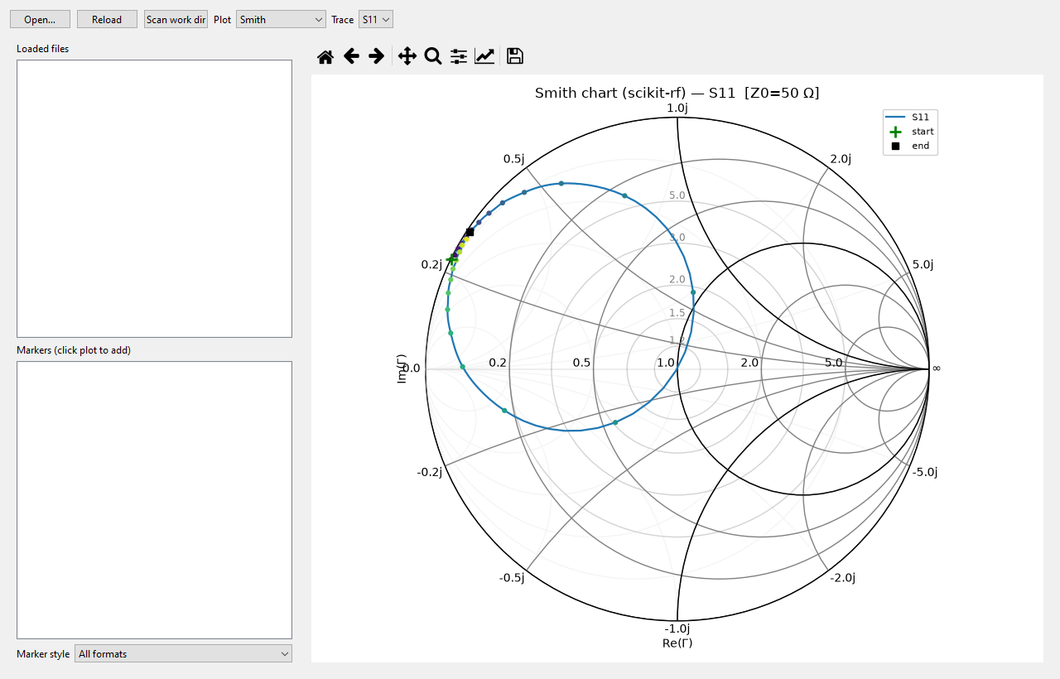
S-parameters. Smith chart, |S| dB, phase, VSWR; click markers, "Go to S-min" jumps to the resonance dip, "Pop out" detaches the plot into its own window.
- S-Params Viewer
- S11 / S21, dB, phase
- Marker: frequency, S, Γ, Z/Y, VSWR, RL
- Smith chart: Z and Y markers
- Pop-out S-Graph — plot in a separate window
- Antenna tab / Simulation → Antenna Pattern Viewer — NF2FF far field:
3D polar gain plot, 2D polar cuts (E/H plane), directivity/gain/η vs
frequency; Pop-out Antenna Graph = separate window; field dumps remain
under work/<project>/fields/ (S-parameters in
work/<project>/sparams/, NF2FF in work/<project>/nf2ff/).
Polarization… (button in the Antenna tab) shows quantities derived from
the same NF2FF result — no new run: axial ratio (dB, RHCP/LHCP sense,
tilt; linear → "linear") and phase center (Δx/Δy/Δz in mm plus the RMS
of the phase fit) relative to the NF2FF box centre. The phase center is an
estimate for a well-defined main beam; a fit that does not qualify shows
"—" / "phase not well-defined". Details: F1 → "Polarization & Phase Center".
- 2-port (S2P) — one FDTD run measures one column of the S-matrix (for 2 ports:
S11 + S21). Further columns need further runs with the other excited port
(excite_port switched); the JSON results are merged afterwards —
example: examples\run_pcb_filter_example.py.
Unmeasured entries stay empty (NaN) in sparams.json; the Touchstone file
(.s2p) is only written once the matrix is complete.
- Field Viewer — 3D view of the field dumps (F1 for the in-app help). The
vector arrows ("Vectors") replace the coloured field representation
(ParaView style), so no opaque slice/surface covers the arrows that point
into it; tick "field underneath" to get the overlay back. While stepping
through a series by hand, the step label reports how many arrows flipped
compared to the previous step — that makes it obvious whether the arrows
really follow the field. With "same length" switched off the arrow length
shows the amplitude; the reference is measured once over the whole series,
so the lengths are comparable from frame to frame.
The export writes a ParaView collection (<dump>.pvd) next to the per-step
files, so the whole series can be played in ParaView from one file — see §12.4.

7.1 The Antenna tab in pictures
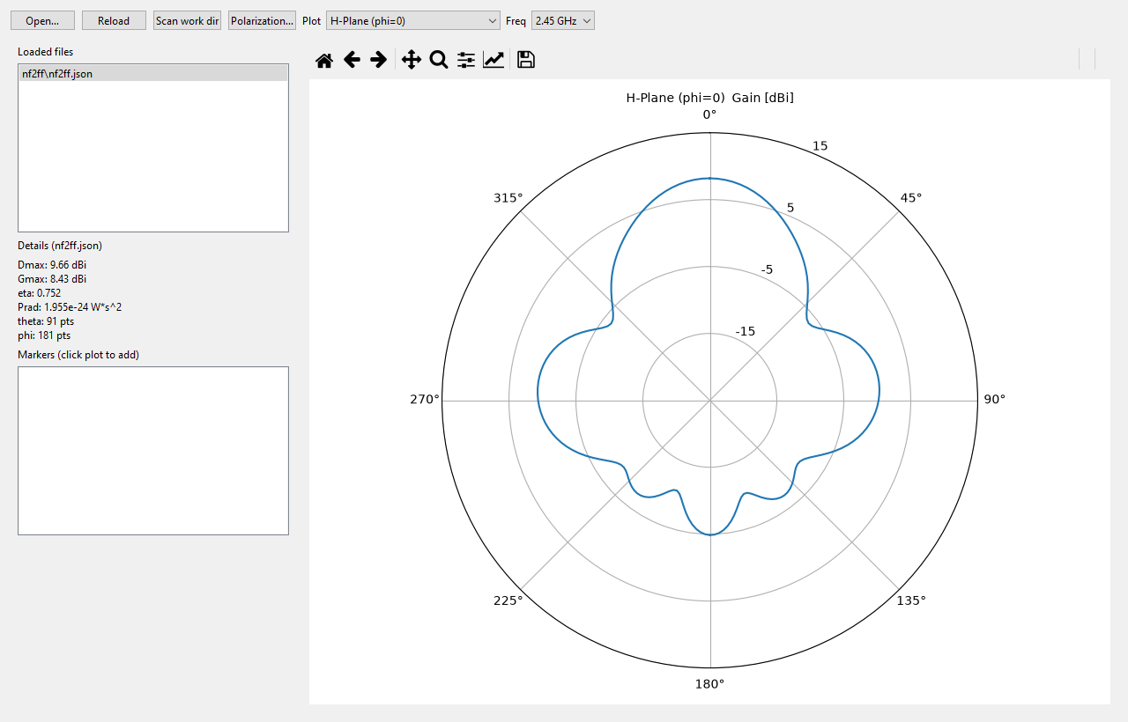
Antenna tab, H-plane. On the left the discovered NF2FF results and the details block (Dmax, Gmax, η, Prad, grid), on the right the polar cut with its dBi rings. Right-clicking the plot opens the analysis menu (HPBW, front-to-back ratio, markers, pop-out). Example: the 2.45 GHz patch from section 2.2.
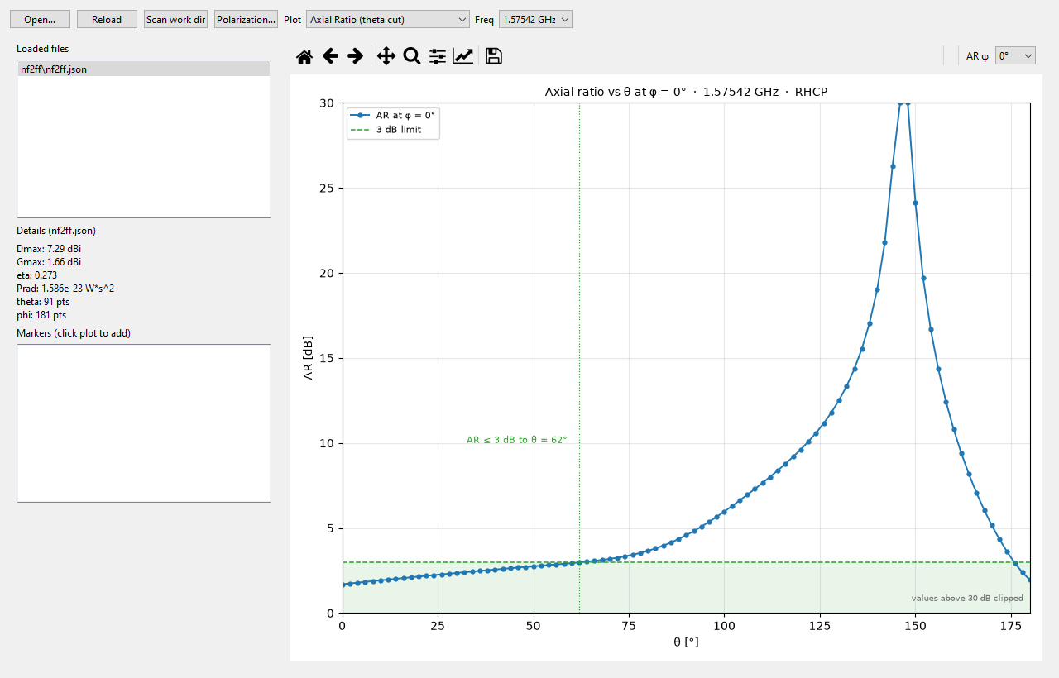
Plot type "Axial Ratio (theta cut)". AR against θ at a selectable azimuth ("AR φ" selector in the plot toolbar, 0…315°). The green band is AR ≤ 3 dB; the dotted line and its label give the widest angle from boresight that still meets it. Example: GPS L1 patch at 1.57542 GHz — 1.70 dB at θ = 0°, ≤ 3 dB out to θ = 62°. The linearly polarised 2.45 GHz example stays above 10 dB everywhere, so there the cut is only a check.
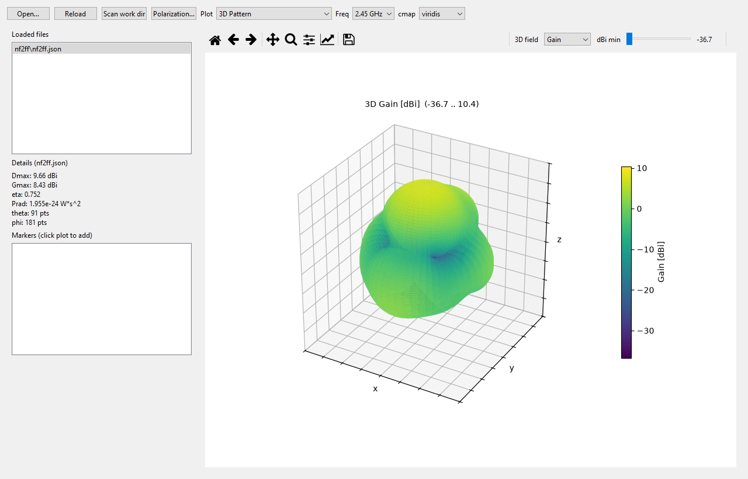
3D pattern. The three spatial directions are labelled x/y/z. The radius is normalised to the dBi window ("dBi min" slider in the toolbar); the colour bar carries the absolute values.
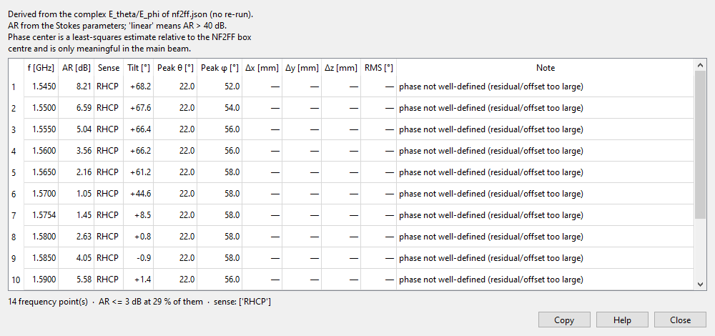
"Polarization…" dialog. One row per frequency with the AR at the pattern peak, the sense, tilt, peak direction and the phase center (Δx/Δy/Δz, RMS). The header line gives the number of points, the fraction with AR ≤ 3 dB and the senses present. "phase not well-defined" means the phase fit is not reliable for this pattern.

7.2 Field picture
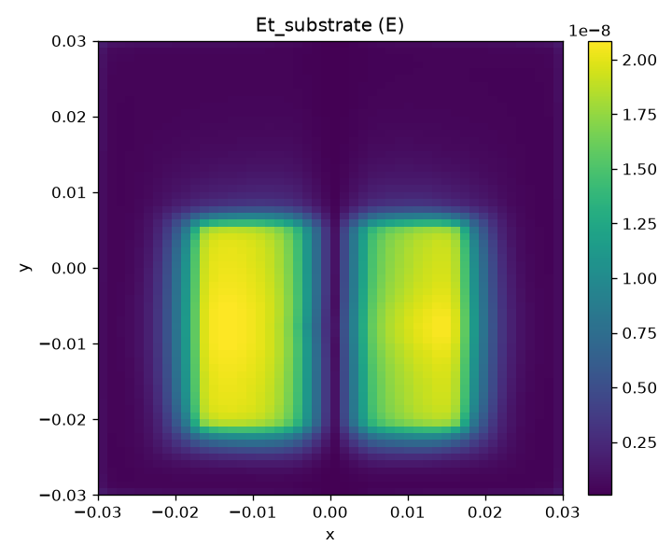
|Et| in the substrate, a slice from the field dump Et_substrate (2.45 GHz example). Two maxima left and right of the centre, with the mode null between them. The axes are in metres, the colour bar in V/m. The post-processing writes such slices as PNG next to the dump (work/<project>/fields/). The interactive view is the Field Viewer tab: slices and iso-surfaces, vector glyphs ("Vectors") for the field direction, series playback over the time or frequency steps, and export as a VTK series including the ParaView collection (<dump>.pvd) and as MP4.
────────────────────────────────────────────────────────────

8. Workflow checklist (2.45 GHz antenna)
- [ ] FreeCAD: `gnd`, `substrate`, `patch` in mm
- [ ] Ports in FreeCAD: `PORT_in1_start` / `PORT_in1_stop` (optional, recommended)
- [ ] Export: `.step` (or `.fcstd` with ports)
- [ ] GUI: New Project
- [ ] Mesh: 2.2–2.7 GHz, target 2.45e9, unit mm
- [ ] Import Geometry… → STEP / FCStd
- [ ] Add Assignment… substrate (dielectric) + copper
- [ ] Add Port… lumped 50 Ω at the feed (or check the FreeCAD ports)
- [ ] Fit NF2FF to Geometry + enabled
- [ ] Save…
- [ ] Build Mesh → Run Simulation
- [ ] S-Params Viewer → S11 minimum near 2.45 GHz
────────────────────────────────────────────────────────────

9. Common problems
--------- | -------------
Import does nothing for STEP | Check the FreeCADCmd path in Settings
Port missing or wrong | start/stop not on the edge of the patch
S11 bad | feed position, patch dimensions, mesh too coarse, max_timesteps too low
Material wrong | assignment missing; default is copper/PEC
FreeCAD does not start | Settings FreeCAD GUI (FreeCAD.exe next to FreeCADCmd)
Export without STL | export in FreeCAD / FreeCAD… → Export CAD…
Simulation aborts / empty S-params | check mesh/port; log path work\<project>\
[ERROR] port_alignment … is not on a mesh line | The port coordinate was not on a grid line (e.g. placed by a port-mode click). The GUI now puts the port coordinates on the grid itself (nearby interpolated lines are moved — see "port alignment: …" in the mesh log); only right next to a metal edge an offset < 15 % of a cell remains (warning port_snapped). Run Build Mesh again after updating.
AssertionError in openEMS.Run | project_run.py has relative paths (WORK_DIR=…) → regenerate the script (paths are saved absolute)
Warning outside the field domain | dump/NF2FF box too small → Fit NF2FF to Geometry; the script warns and clamps the box into the FDTD domain
Domain (black frame) too large/small | Air margin in Sim Params → Boundary conditions (auto = λ/4 at the stop frequency, otherwise an mm value for all faces) → then Build Mesh + Fit NF2FF (see 5.6)
S11 flat at ≈ 0 dB, Prad ≈ 0 | port short-circuited — for the Yagi that is the boom: the preset sets gfrp (dielectric, assignment boom), not copper
Own script “gone” after the run | project_run.py is regenerated on every run — your version is in project_run_edited.py; the GUI asks first (regenerate or run the script as-is)
2-port missing S12/S22 | one run = one column → second run with the other excite_port, then merge (examples\run_pcb_filter_example.py)

────────────────────────────────────────────────────────────

10. Tips
- Preset first: test the Patch/Yagi preset, then import your own FreeCAD geometry.
- Clear object names in FreeCAD (patch, gnd, via) — they appear as primitive names.
- STEP import: tessellation deflection ~0.1 mm; choose smaller for fine pins.
- FreeCAD export helper (CLI):
examples\freecad_export_for_openems.py (FreeCADCmd with FREECAD_SOURCE / FREECAD_OUT_DIR)
- Re-run Build Mesh after a material change.
- Make script changes via "Script…" — then the next run automatically backs up
your version to project_run_edited.py and asks whether to regenerate or
run it as-is.
- 2-port example (filter): Preset: PCB Filter… in the GUI or
examples\run_pcb_filter_example.py - both S-matrix columns, ready sparams.s2p.
- 2-port example (5.6 GHz band-pass): Preset: PCB Bandpass (5.6 GHz)… or
examples\run_pcb_bandpass_example.py - five open lambda/2 stubs on Teflon,
|S11| < -10 dB from 4.90-6.45 GHz, ready sparams.s2p.
- 2-port example (2.4 GHz hairpin band-pass): `Preset: PCB Hairpin Bandpass
(2.4 GHz)… or examples\run_pcb_hairpin_example.py` - five folded lambda/2
resonators on RT/duroid 6010 (eps_r 10.2, 1.27 mm), compact (~25 mm long),
no vias, ready sparams.s2p.
────────────────────────────────────────────────────────────

11. Paths & tools (reference)
--------- | ------
Start GUI | app\main.py
FreeCADCmd | c:\FreeCAD_1.1.4-Windows-x86_64\bin\FreeCADCmd.exe
FreeCAD GUI | c:\FreeCAD_1.1.4-Windows-x86_64\bin\FreeCAD.exe
openEMS | c:\openEMS
Work directory | work\
Export script | examples\freecad_export_for_openems.py
Port marker demo | examples\freecad_add_port_marks.py
Dipole + ports | examples\freecad_dipole_ports.py, examples\run_dipole_ports_example.py
FreeCAD port guide | docs\FREECAD_PORTS_EN.md
Yagi example | examples\freecad_yagi_model.py, work\yagi_antenna\
Smoke tests | tests\freecad_gui_smoke.py, tests\freecad_mesh_smoke.py, tests\port_marks_smoke.py, tests\dipole_ports_smoke.py

────────────────────────────────────────────────────────────

12. Export & interchange (CAD, CST, ParaView)
Four output paths are meant for data exchange: STEP (geometry), grid JSON
(mesh lines), Touchstone (S-parameters) and VTK (field data). Another
solver such as CST Studio Suite reads the first three directly; VTK is the
neutral format for fields.

12.1 STEP — geometry to CAD / CST
File → Export STEP…
- What is exported is the effective geometry, i.e. exactly the primitives the
simulation script is built from: analytic boxes, cylinders, spheres and
extruded polygons plus every imported triangle mesh. Imported STEP/FCStd
arrives tessellated (not as the original BREP) — the export shows what
openEMS actually computes.
- Output: AP214 STEP in millimetres. The drawing unit from *Mesh → Drawing
unit* is converted, so there is no unit guessing on the receiving side.
- Object names are preserved: every solid arrives in CST under the name it
has in the Mesh Viewer / project tree (STEP PRODUCT).
- A zero-thickness metal sheet (e.g. the patch of the patch preset) is
written as a planar face, not as a degenerate solid — openEMS only inflates
it to 2 nm after meshing, which is useless as CAD.
- Closed meshes become solids, open shells stay shells. Both are valid
STEP and either can be assigned a material in CST.
- Geometry that cannot be represented (a point, a line, a missing mesh) is
reported in the log and skipped; the rest of the file is still written.
- Requires FreeCADCmd (as does STEP import), path under Settings.
> The FreeCAD dialog's “Export CAD…” is the opposite direction (FCStd/STEP →
> per-object STL + openems_export.json for the importer), not a geometry
> export.

12.2 Grid JSON — identical cells in CST
Mesh → Export grid (JSON)…
Both openEMS and the CST time-domain solver run on a rectilinear (hexahedral)
grid. Feeding CST the same line positions (e.g. via Mesh.SetLines) makes both
run on identical cells instead of two independently meshed models — which is
exactly where the two solvers would otherwise disagree.
- The source is the Mesh Viewer's CSX, i.e. the grid that was actually built (no
re-derived estimate). Run “Build Mesh” first.
- Everything in mm, plus cell count, min/max cell size and the FDTD domain.
Cylindrical meshes export rho/phi/z.
{
"format": "visualopenems-grid", "version": 1,
"unit": "mm", "source_unit": "mm", "coord_system": "cartesian",
"axes": [
{"name": "x", "lines": [0.0, 0.5, 1.0, 2.0],
"cells": 3, "cell_size_min": 0.5, "cell_size_max": 1.0}
],
"shape": [3, 2, 2],
"domain": {"start": [0, 0, 0], "stop": [2, 3, 1.6]}
}

12.3 CSX XML
Mesh → Export CSX XML… / Open in AppCSXCAD (3D)…
Writes the full CSXCAD model (geometry + grid, no field data) for AppCSXCAD or
ParaView — useful for review and for handing the model over.

12.4 Field data — VTK, .pvd, MP4
Simulation → Export field dumps to VTK…
- One static <dump>.vtr per dump and — for time series — one
<dump>_0000.vtr … per stored step plus <dump>.series.json (labels, files,
times/frequencies, stride) for the built-in viewer.
- Additionally a ParaView collection `<dump>.pvd`: open it in ParaView and
the whole series plays from a single file. The slider value is the
physical step position (time for TD dumps, frequency for FD dumps), not the
step index. The .pvd is rebuilt from the sidecar whenever an up-to-date
series is reused, so older exports become complete too.
- Incremental: outputs newer than their dump are reused, so a second click
finishes instantly. The per-step switch writes the series (many files);
step_stride keeps only every N-th step.
- Point data: scalar magnitude (active) and, for xyz dumps, the vector field
(real part), in raw openEMS SI units (E in V/m …).
Simulation → Export field video (MP4)… renders the loaded series with the
current Field Viewer view (fps from Settings).

12.5 Network data — Touchstone
The S-Params viewer writes Touchstone (.s1p, .s2p, …) — the standard both
CST and openEMS read. One FDTD run measures one column of the S-matrix; the
Touchstone file is only written once the matrix is complete (partial matrices
stay in sparams.json). A 2-port therefore needs both excitations (switch
excite_port, results are merged).

12.6 Images
Every viewer (S-Params, Antenna, Field Viewer) exports PNG.

12.7 Overview
--- | --- | --- | ---
Geometry | STEP (mm) | out | CAD, CST, FreeCAD
Grid lines | grid JSON (mm) | out | CST FDTD (Mesh.SetLines)
S-parameters | Touchstone .sNp | out / in | CST, VNA, scikit-rf
E/H field volumes | VTK .vtr + .pvd | out | ParaView
Full model (CSX) | CSX XML | out | AppCSXCAD

12.8 Limits
- STEP carries geometry only — no materials, ports or boundaries. Assign
them in CST using the preserved object names.
- No field-data import: openEMS dumps are HDF5; CST exports its own formats.
Compare solvers via S-parameters / far fields or via VTK in ParaView.
- Units are converted to mm on export (STEP and grid JSON); Touchstone stays
in Hz. The source unit is the drawing unit from Mesh.

Generated from docs/ANLEITUNG_EN.md — FreeCAD OpenEMS GUI

