SLAC [enter DEPARTMENT NAME here]

[enter PROCESS name here] PROCEDURE

Document Revision Draft 1.0  
Date of Issue: [Month, Day, Year]

Process/Procedure Owner: [Author Name]

PROC-[DEPT]-00#



Table of Contents

[UPDATE TABLE OF CONTENTS: Right-click on any line, and select “Update Field” from the pull-down menu. You can update page numbers only, or the entire table, if you have added more heading levels.]

1. Introduction 3

1.1 Purpose 3

1.2 Scope 3

1.3 Roles 3

1.4 Definitions and Acronyms 3

1.5 References 3

1.5.1 Traceability 3

1.5.2 Policies 3

1.5.3 Standards 4

1.5.4 Processes 4

1.5.5 Procedures 4

1.5.6 Guidelines 4

1.5.7 Templates 4

1.5.8 Checklists 4

1.5.9 Training 4

1.5.10 Tools 4

1.6 Inquiries 4

2. Procedure (Steps) 5

2.1 Begin a list of steps beginning at the number one 5

2.2 Begin a list of steps that restart at the number one 5

3. Process/Procedure (Mapping) 6

3.1 Entry Criteria 6

3.2 Process/Procedure Map 6

3.3 Inputs 6

3.4 Activities 6

3.5 Outputs 7

3.6 Verification and Validation 7

3.7 Exit Criteria 7

3.8 Metrics 8

3.9 Records Control Table 8

3.10 Controlled Documents Table 8

Appendix A – Dictionary of Terms 9

Appendix B – Acronyms 10

Appendix C – Flowcharting Symbols 11

Appendix D – Bibliography 12

Appendix E – Document Change Control 13

# Introduction

## Purpose

Describe the rationale for this particular document (ensure, describe, control). State the intention/objective of the process/procedure.

**Note:** You know you’ve written a solid purpose statement when you can combine the policy statement and the purpose to form a logical what (policy) and why (purpose).

## Scope

When and to whom the process/procedure applies.

Who is affected, which areas, which activities, what are the limits (parameters for applying process/procedure).

## Roles

List the role and functions of anyone involved in the process/procedure.

Use verbs and nouns to describe the functions.

## Definitions and Acronyms

List definitions and acronyms that need to be defined in order to ensure proper interpretation of the process or procedure. Refer to a larger document if required. Create links to the larger set of definitions if available. Can also refer to appendices.

## References

List any reference documents that form parts of this process/procedure; may include sources. Use reference numbers when appropriate. Can also refer to appendices.

### Traceability

Map the process/procedure to industry certification standards, if applicable.

### Policies

Map the process/procedure to relevant policy, act, or regulation, if applicable.

### Standards

List the standards used to create the process/procedure.

### Processes

List the processes referenced in the process/procedure.

### Procedures

List the procedures referenced in the process/procedure.

### Guidelines

List the guidelines referenced in the process/procedure.

### Templates

List the templates referenced in the process/procedure.

### Checklists

List the checklists referenced in the process/procedure.

### Training

List courses that teach this process/procedure.

### Tools

List tools used to implement this process/procedure, if applicable.

## Inquiries

Identify contact information (web-site, email address, telephone number) for the owner or organization to direct inquiries to. Avoid identifying people and use organizations whenever possible.

# Procedure (Steps)

The following set of procedures must be followed to accomplish a given task.

## Step 1

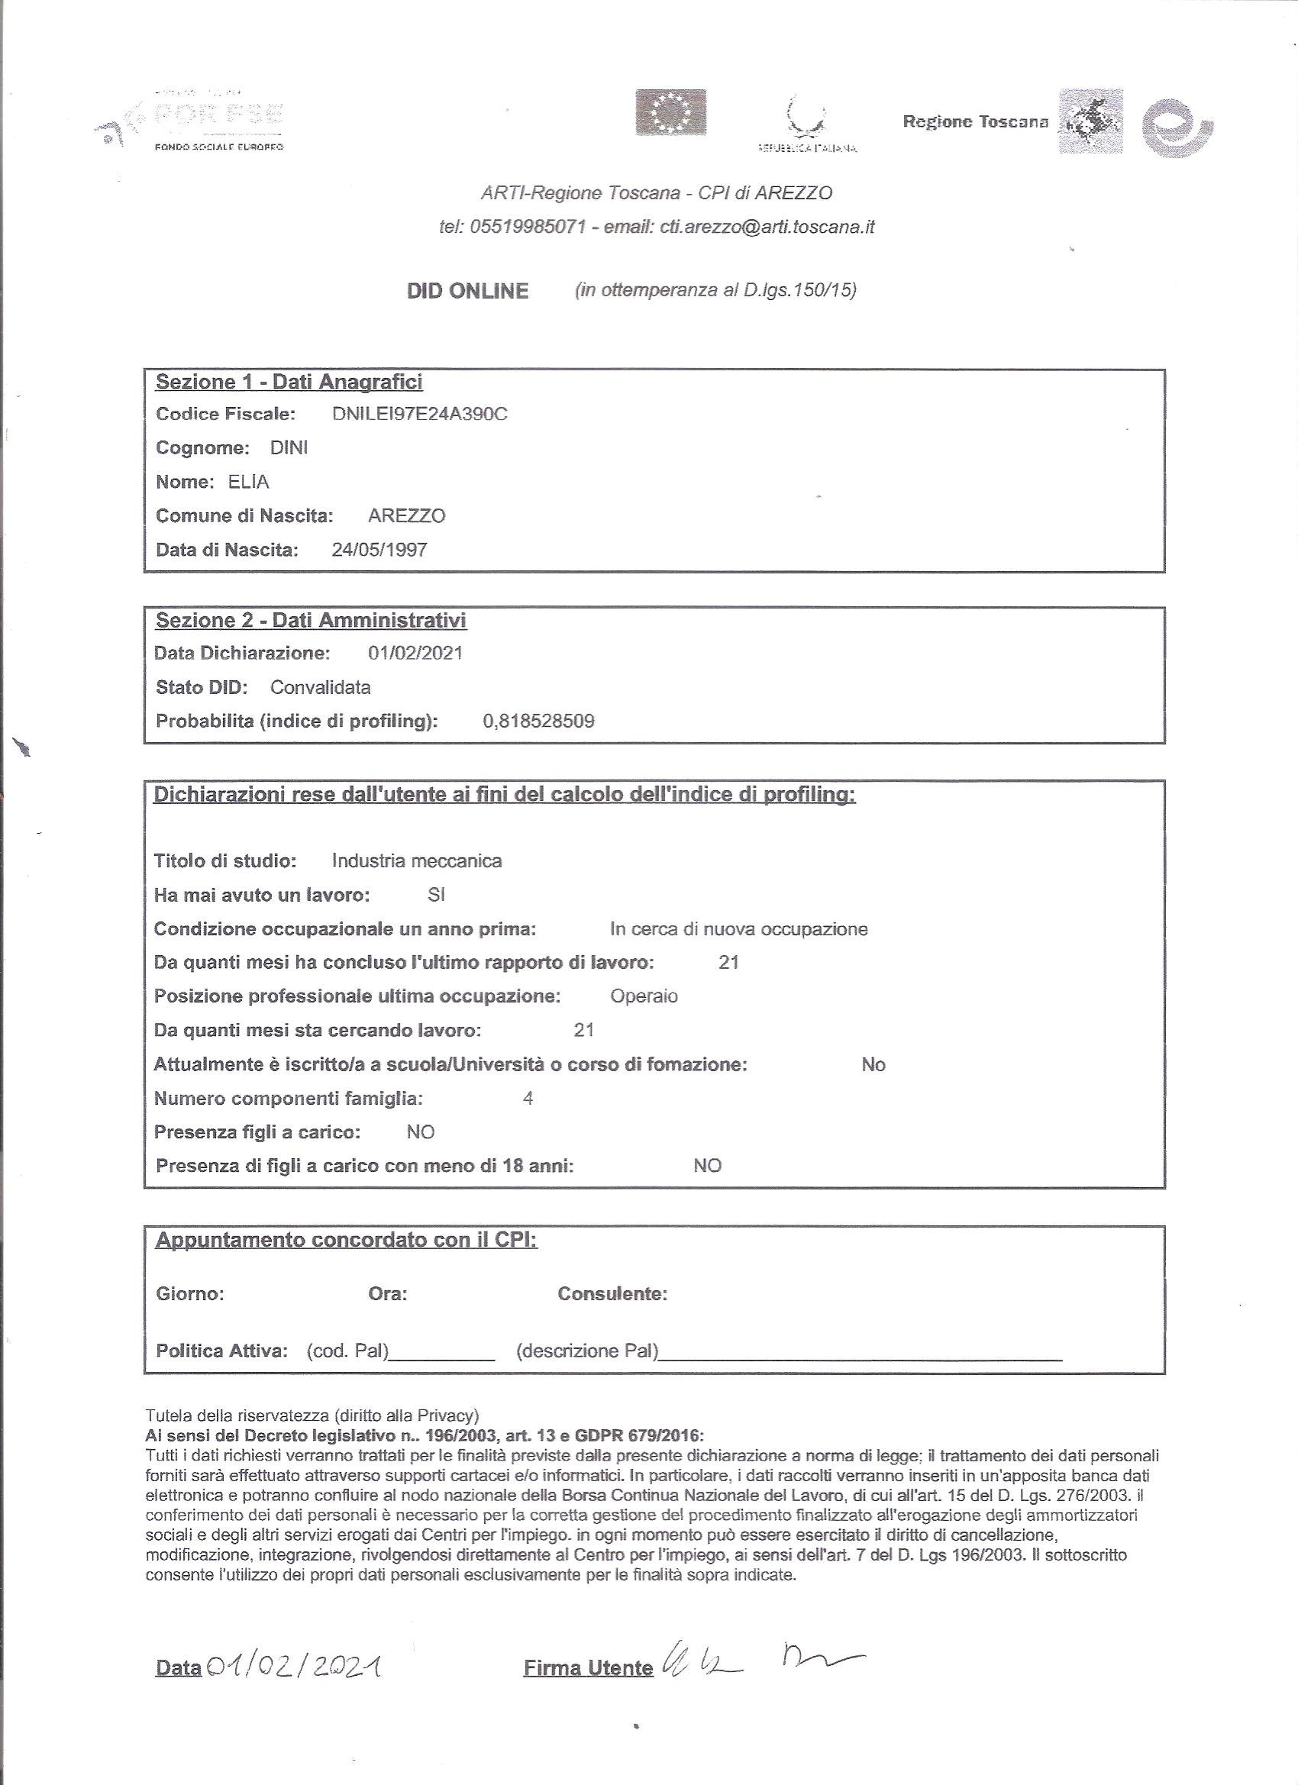

## Step 2

# Process/Procedure (Mapping)

## Entry Criteria

Describe an input’s state, an event, or an expired amount of time, which is required before this process or procedure can begin.

| Details of Entry Criteria |
| --- |
| * Bullets * Bullets |

## Process/Procedure Map

Using conventional rules for flowcharting, as referenced in Appendix C – Flowcharting Symbols, draw a pictorial presentation of the inputs, activities, sequence, decision points, and outputs within the process/procedure.

Number each activity that has further details in the Activities Table.

## Inputs

Describe the inputs consumed by the activities in the process/procedure.

| Input | Detail of Inputs and remarks | Ref. |
| --- | --- | --- |
|  | * Bullets * Bullets | Template Reference |
|  |  |  |
|  |  |  |

## Activities

Describe the set or web of activities performed as part of this process procedure.

| No. | Activities | Action by | Detail of activities and remarks | Ref. |
| --- | --- | --- | --- | --- |
|  |  |  |  |  |
|  |  |  |  |  |
|  |  |  |  |  |

|  |  |
| --- | --- |
| Field | Description |
| No. | Refers to number on process/procedure map. |
| Activities | Refers to name or title in box on process/procedure map (similar but not necessarily identical). |
| Action by | Functions that perform the activity. Refer to Roles. |
| Details | Describes main activities such as develop, review, and approve. |
| Ref. | Reference the elements of the standard being covered by the activity; can also reference other documents such as procedures, guidelines, templates, checklists, training, and tools. |

## Outputs

Describe the outputs produced or modified by the activities in this process/procedure.

| Output | Detail of Outputs and remarks | Ref. |
| --- | --- | --- |
|  | * Bullets * Bullets | Template Reference |
|  |  |  |
|  |  |  |
|  |  |  |

## Verification and Validation

Describe the validation activities or checklists to determine if the outputs are usable.

| Output Validation | A checklist of the properties that each output must have to validate each deliverable. | Reference |
| --- | --- | --- |

Describe the verification activities or checklists to determine if the outputs are within specification.

| Process/procedure Verification | A checklist that reflects the process/procedure flow of each input. | Reference |
| --- | --- | --- |

## Exit Criteria

Describe an output’s state (or condition) required before the process or procedure can be declared “complete”.

| Details of Exit Criteria |
| --- |
| * Bullets * Bullets |

## Metrics

|  |  |  |
| --- | --- | --- |
| Process Measures | How this process/procedure is measured to determine its contribution to the business. Will need to compile data, possibly to demonstrate to the organization the return on the investment from the process improvement | Reference |

## Records Control Table

| Description (no. and name) | Storage Location | Filing / Index | Minimum Storage Period |
| --- | --- | --- | --- |
|  |  |  |  |
|  |  |  |  |
|  |  |  |  |
|  |  |  |  |

|  |  |
| --- | --- |
| Field | Description |
| Description. | Number or title of the record or form. |
| Storage Location | Identifies where the item can be found. |
| Filing / Index | Sequence of the document. |
| Minimum Storage Period | Amount of time a record or document will be kept once created. |

## Controlled Documents Table

| Number | Name | Revision Date (or version) | Owner |
| --- | --- | --- | --- |
|  |  |  |  |
|  |  |  |  |

Other columns may be added to the document management table, however, this may be unnecessary given SharePoint’s functionality.

Appendix A – Dictionary of Terms

An alpha list of words and information about them

Appendix B – Acronyms

Appendix C – Flowcharting Symbols

|  |  |
| --- | --- |
|  |  |
| **Parallelograms** represent **inputs** and **outputs** to or from a process/procedure. |  |
|  |  |
|  |  |
| **Rectangles** represent individual process/procedure **activities**. | **Diamonds** represent important **decision points** in the process/procedure. |
|  |  |
|  |  |
| **Lines** with arrowheads connect symbols to show the progression or direction of the activities. | **Circles** represent connectors when a process/procedure flowchart continues on the next page. |

Appendix D – Bibliography

1. Human Resources Development Inc., *Writing Procedures* (example / template), No. 02 1999-06-07.

Appendix E – Document Change Control

This chart contains a history of the revisions made to this document. Typically the document itself should be stored in revision control, and a brief description of each version should be entered in the revision control system. This may be unnecessary given SharePoint’s functionality.

|  |  |  |  |
| --- | --- | --- | --- |
| Revision Number | Date of Issue | Author(s) | Brief Description of Change |
| 0.1 | 1999-06-15 | Last, First | Initial Draft |
| 0.2 | 1999-08-11 | Last, First | Updated to comply with TBS Document/Web Standards. |
| 1.0 | 1999-11-09 | Last, First | First Draft |
| 1.0 | 2000-01-14 | Last, First | Second Draft |
|  |  |  |  |