**Name :** Istyaque Ahammed

**SID :** 200240

**Course :** Advanced Programming (CSE-2113)

**Date :** 21.04.2022

# Dual Boot [Ubuntu & Windows]

## Implementation:

We had given a task to install the **Ubuntu** operating system on dual boot alongside **Windows 10**. The steps we follow in below.

* Downloaded **Ubuntu 20.04.4 LTS** .iso file, which is the latest version of **ubuntu**.
* Using **Rufus 3.18,** we create a USB bootable pen drive.
* We allocated some free space from our hard disk for installing **Ubuntu**.
* Then we restarted our PC and selected install ubuntu from the boot menu.
* We had to boot manually from BIOS/UEFI.
* Then we followed some procedure

Install Ubuntu Keyboard Layout Normal installation Install Ubuntu alongside windows Select Time Zone

* After that, we create a User Account.
* Finally, the **Ubuntu** installing completed. Then we had to restart our PC removing the USB pen drive.

## Hindrance & Overcome:

For installing **Ubuntu** we faced some problems. Here we discuss the problem and its solving.

* For allocating memory we do not have free spaces. So, we need to shrink a volume or delete a volume.
* After restarting PC did not automatically go to the boot menu. So, manually we have to press the F12 button from the keyboard.

## Advantage:

Let's take a look at the advantages of using ubuntu.

* User-friendly
* Totally free of cost
* It's secure. Say no to the anti-virus.
* Highly customizable
* Supportive Ubuntu community
* Low system requirements
* It's open-source
* Tons of free software

# Configuring Git on Ubuntu

## Implementation:

After installing **Ubuntu** we have to install git and configure the git profile. We have to follow some steps from the **Ubuntu** terminal. Those are shown below.

* sudo apt install git
* git --version
* git config --global user.name “istyaque-ahammed”
* git config --global user.email “[istyaque2040@cseku.ac.bd](mailto:istyaque2040@cseku.ac.bd)”
* git config --list

Then we need to show check-in and check-out on git. Here we also followed some steps on the **Ubuntu** terminal.

#### Check-in:

* git init
* git status
* git add Istyaque.txt
* git commit --m “First git file”
* git push origin master
* Verifying user id and password.

#### Check-Out:

* git init
* git clone git@github.com:istyaque-ahammed.git
* git pull origin master
* Verifying user id and password.

## Hindrance & Overcome:

For doing this task we had to face several problems. Problems are discussed below.

* 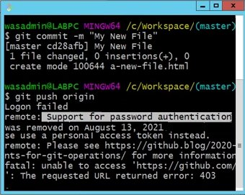We faced a password authentication problem. So, we used a personal token generator to solve the problem. Then we access it with a token.

## Drawbacks:

We have to write so many codes to perform anything. It took a lot of time. We have to memorize all code for each performance. We have to do the same things again and again.

**Thank You**