As per your request and after carefully reviewing the three pages of the Sykes Cottages website we:

* Home page  
  The Home page is well structured and has all the features needed for a powerful review website design. Responsive and with a very handy search feature instantly giving the user the chance to search and book a cottage. We think that maybe the Recent reviews could be grouped in a slider showing one per time. Quick links and Popular destination should follow the same principle as they occupy too much space on the page.
* Search  
  The Search page is the most important page in our opinion. Giving the ability to user to easily and quickly search for properties to go on and have a good time is what we believe the key to success. However, we believe that the loading time could be reduced and the search should be a dynamic one which means results should be presented without the need to reload the page every time the user clicks on the search button. Using a modern javascript library such as React or Vue could help achieve great results keeping the customers happy as it would minimize their interaction. Furthermore, the loading time would be improved with the use of an API serving all the data on the fly. A possible implementation is presented in our solution.
* Property page  
  Finally, the Property page is looking very nice as does the rest of the website. The property photo slider system works pretty great and there is more than information about the property, the location and a summary. Nonetheless, we believe that organizing all this text in tabs would seem a bit easier for the readers to follow and eliminate the need of constantly having to scroll down.  
  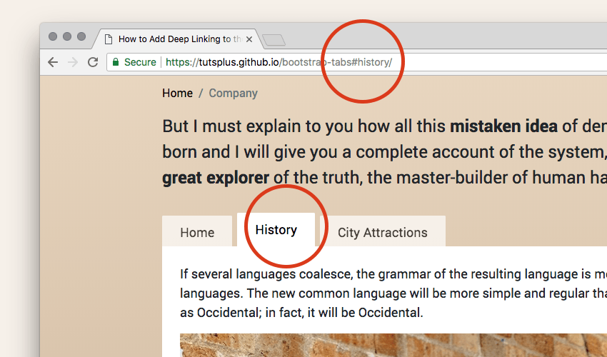
* Overall  
  The website offers a lot of information and it also has a very nice design. Our proposition is to just try and make use of modern technologies to make it even better. We noticed that some pages have an .html ending to them while others don’t so we believe that this has to be a CMS coupled with other technologies which requires a lot of javascript libraries to maintain and update every now and then which can be quite overwhelming (Ctrl+U). Since uniformity is the key, we would suggest implementing the rest of the components needed to make the website as consistent as possible. The use of a language such as PHP or even Python coupled with the right javascript libraries such as React or Vue can give a massive boost to the look and feel of this application offering a smoother user experience mitigating the bounce off rate.