Jia Wen Lee

ABE516x: Linear Regression using own dataset.

MATLAB was used for this task

**Introduction:**

I have data from LiDAR that consist of relative signal strength index (RSSI), distance and LiDAR beam angle. I know that RSSI value is affected by scan distance. RSSI value will be used as a metric for soil surface feature as such I would like RSSI values to be independent of distance. Linear regression is used to see if I can get a good model for RSSI and distance in order to correct RSSI value base on distance.

**Data:**

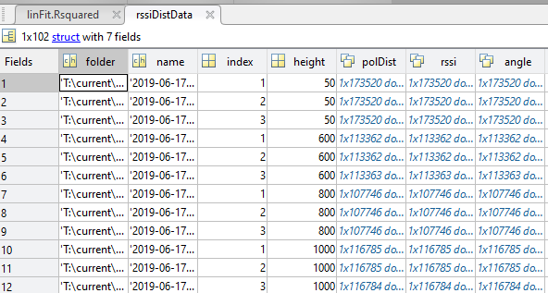

**Code:**

Data was filtered to keep only LiDAR scan values that were close to perpendicular to the scan surface to remove possible effect of scan angle. Mean polar distance and RSSI of each dataset was calculated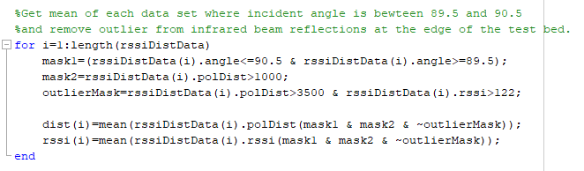

Linear model was fitted onto the data and confidence interval was calculated from the linear model.

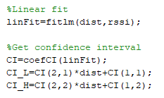

Figure of data, linear fit and confidence interval was plotted.

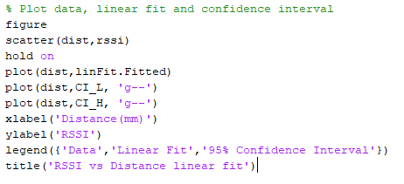

**Result:**

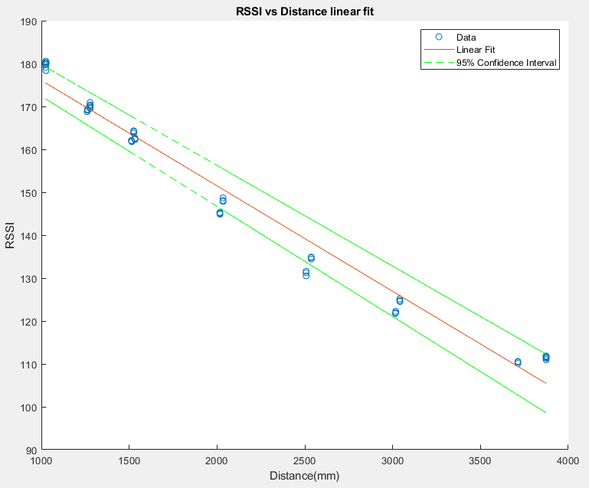

R-Squared Value

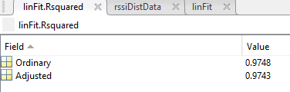

**Discussion:**

R-Squared value was used to determine how well model fits the data. R-Squared value is high which means this model fits data well. Confidence interval captures quite a large portion of the data as well. Though R-Squared value was high, it can be visually seen that a second order model might work better than a linear model.