Class: ABE516x

Name: Jia Wen Lee

SVM assignment

**Introduction:**

For this activity I will be combining aspects from suggestion 2 and suggestion 3. I will be using k-means clustering method on work dataset. Because I need to get this done for work pretty soon, I will be using MATLAB as all my data files are formatted as mat files.

**Background information:**

LiDAR data collected from the field show that while we can visually recognize difference in RSSI of soil surface residue and the soil itself, it is hard to draw a clear boundary between what values of RSSI constitutes surface residue and what value is the soil as RSSI values of surface residue and soil overlaps as shown below.

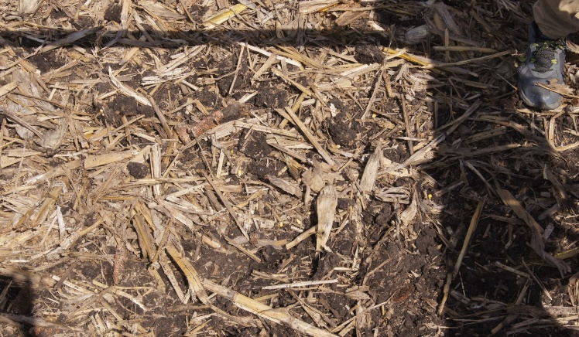 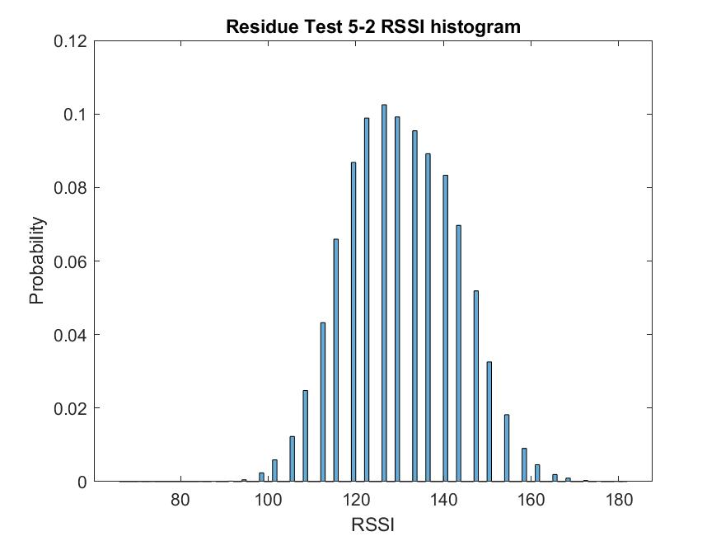

LiDAR scan plane

LiDAR RSSI distribution

LiDAR RSSI field scan.

Yellow: High Surface Residue, Blue: Low Surface Residue

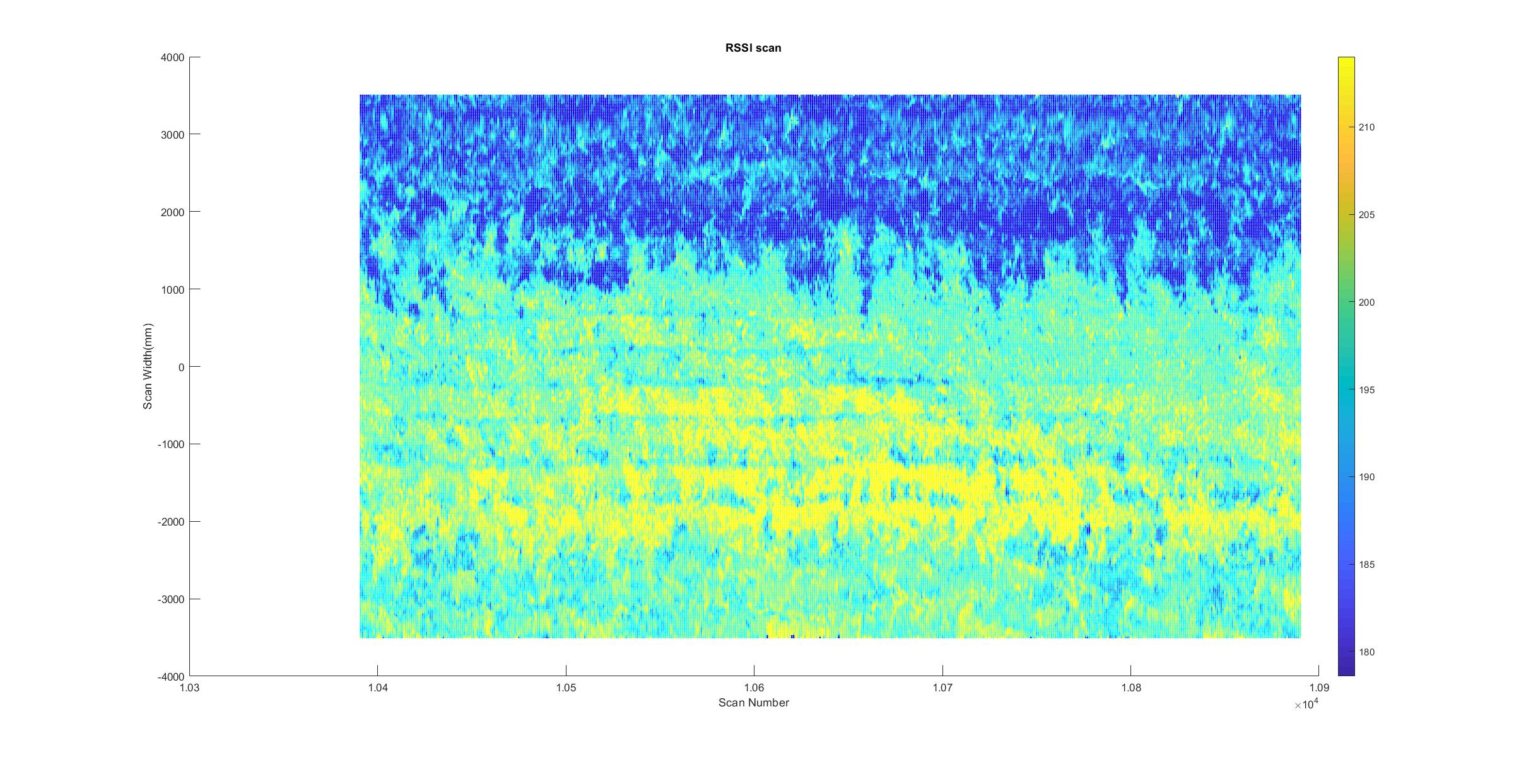

**Data Used:**

Data log was off a run where no tillage occurred in the middle, but outer sides were tilled. So there were clear regions of high surface residue and low surface residue as seen below. We want to separate data into two clusters, soil and residue.

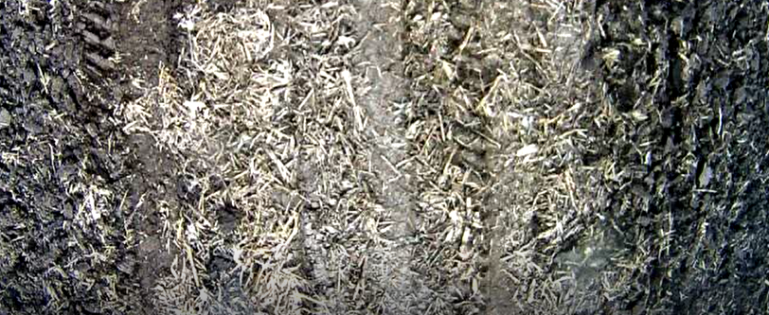  
Data file is named: P2NoTill_20191015_123506.mat

**MATLAB code:**

Code to get centroid values of k-mean, k=2

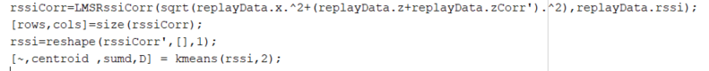

Once centroid was found, function was created to test which centroid an RSSI value is closest to and categorize data into one of two groups.

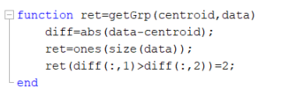

Data is randomly selected from a replay file for testing. Test File: P1NoTill_20191015_122957.mat

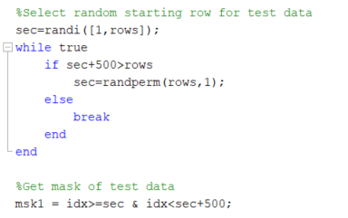

Original data is plotted:

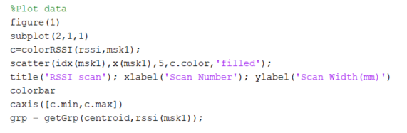

Surface residue estimate is plotted:

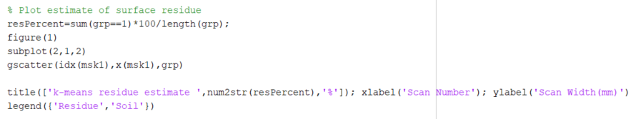

**Results:**

From visual inspection, clustering seems to have separated the high RSSI values from the lower RSSI values at the right areas.

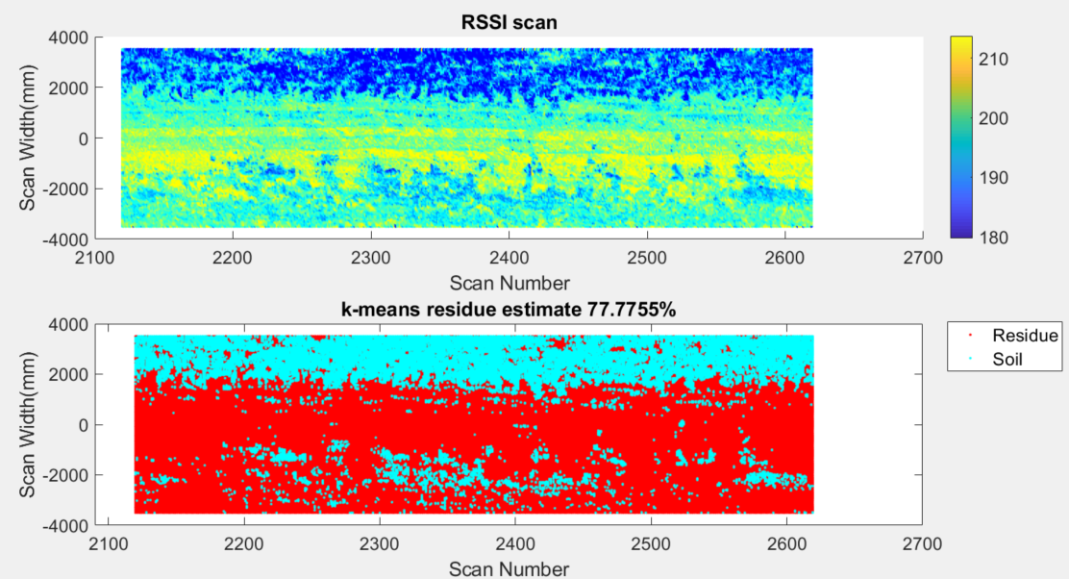

**Conclusion:**

K-mean clustering was able to separate high RSSI values from lower RSSI values. This is a good starting estimate as there is nothing currently to estimate surface residue on a moving vehicle. Field validation would need to be done to see how well clustering worked.