Escarpod 0.9 Release Notes
Escarpod is an open source podcatcher for UIQ. A podcatcher is a program for downloading and playing podcasts, radio and video shows downloaded from the Internet. Escarpod 0.9 only supports radio shows, but video might be added in a later release.
Escarpod is produced by the Bergamot Project, which you find at our website http://bergamot.googlecode.com.
About Podcasting
Podcasts are distributed though feeds, which are XML documents that describe the shows available for downloading. A podcatcher, such as Escarpod, uses the information in the feed to find and download new shows.
About the Bergamot Project
The Bergamot Project aims to produce high quality open source software for UIQ. You can contact us by emailing bergamot@googlegroups.com, or contacting the project manager:
Sebastian Brännström
Garvargatan 22
112 21 Stockholm
SWEDEN
E-mail: teknolog@gmail.com
Phone: +46-704-200196
Installation
To install Escarpod you must first copy the installation SIS file to your phone, either by cable, memory card or Bluetooth/infrared beaming. You can also download the SIS file directly to your phone from the Bergamot project website by pointing your phone web browser to http://bergamot.googlecode.com
By selecting the SIS file, the UIQ installer is launched. You typically want to accept all default choices, and answer yes to all questions, and you must grant the program the right to use remote services and the user environment.
Walkthrough of Escarpod
Escarpod makes use of two simple concepts: feeds, and shows. Shows are distributed by feeds, and it is the feed that tells Escarpod how to download a show.
When you start Escarpod you always enter the main menu, as seen below.
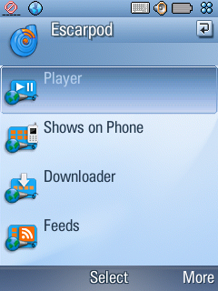
The main menu gives you access to four options:
- Player, which shows you show info and plays the show
- Shows on the phone, that you can listen to immediately
- The show downloader, which manages the download queue
- And the feed manager, which manages the feeds to which you subscribe.
The first step is to go into the Feeds manager, which will bring up the default feeds that come with Escarpod.
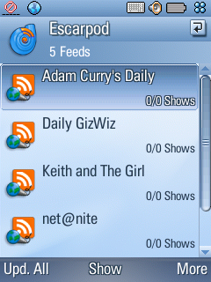
The manager lists all the feeds by title, and underneath the title the number of shows available, and the number of shows not played yet. It also lists the time at which the feed was last updated. We have not yet updated the feeds, so Escarpod does not know of any shows at all.
Press “Upd. All” to update all the feeds in the list. Then wait as the feeds are updated and the information changes to reflect this.
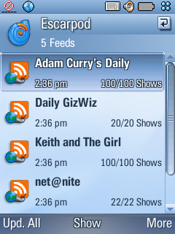
Now that the feeds are updated, we can download a show to listen to. We see that “net@nite” has 22 shows, and all 22 are unplayed. We select net@nite, to see the list of shows in this feed.
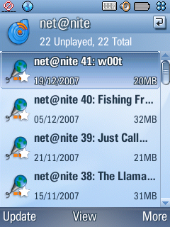
This is the show list, which lists all shows available, together with their publication date, and the size of the download. We choose the first show in the list, “w00t”, to see more information.
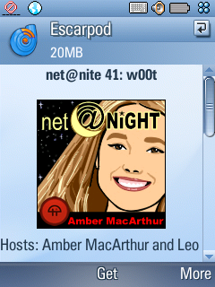
This is the player view, which shows us the show’s cover art and other show notes. You can scroll down to read all the notes.
Before we can play the show, we must download it by pressing “Get”. This adds the show to the download list. Before downloading, make sure to check your data rates with your service provider, as downloading large files can be extremely expensive. Alternatively, make sure you are connected to a local wireless network. You can make sure to only use a certain connection though the Settings, described below.
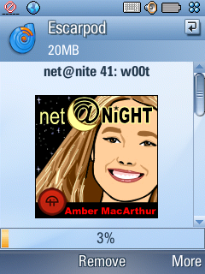
The progress bar at the bottom shows how far the download has come. We now go to the Downloader, by pressing More > View > Downloader. You can also go back to the main menu, and find the downloader from there.
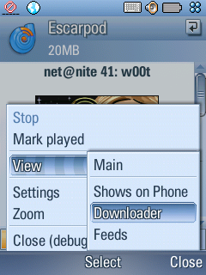
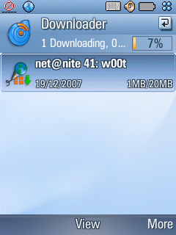
In the downloader view, you see the progress of your downloading show, as well as any other shows you may have queued up for downloading by pressing “Get” just like with the one above. Escarpod only downloads one show at a time, and all other shows end up in the download Queue.
Select the show again to go back to the player view, and wait until the download is complete. When the show has finished downloading, the download progress changes to a slider which allows you to move your position in the file.
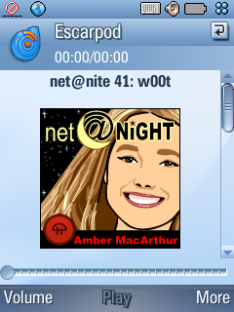
Press Play to play the show.
That’s it! You’ve downloaded and played your first show in Escarpod. What you probably want to do now is add your own feeds to download your own shows. You add a feed by opening the menu in the feeds view, and choosing Add Feed.
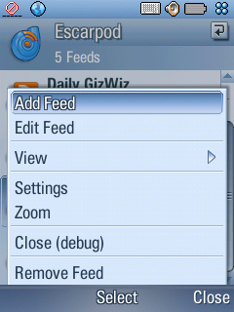
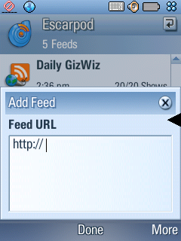
You type in the address to the feed you want to add, and press “Done”. The feeds must be in the standard RSS 2.0 podcasting format.
Settings
Escarpod has a small number of settings that you can access from the Settings option in the menu.
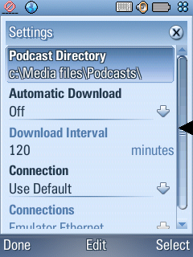
- Podcast Directory – where your downloaded shows are stored. By default this is set to your flash card.
- Automatic Download – Escarpod can automatically update your feeds, or even download new shows for you!
- Download Interval – This tells Escarpod how often to check the feeds if you have enabled automatic download.
- Connection – Here you can specify which connection to use. The easiest is to use the Default connection, which is whichever connection is the active one in your phone. A more refined option is to let Escarpod ask you whenever you try to download, which will give you an option to specify which connection to use. Finally, you can choose to specify a connection you always want to use.
- Connections – This lists all the available connections if you selected to specify connection. Select the one you want to use to make sure Escarpod never uses any other connections.

