**Location Analytics**

**Huff Gravity Model**

**Objective:**

Increase the probability of customer footfall by optimizing store location

**Huff Gravity model:**

The Huff Model is an established theory in spatial analysis. It is based on the principle that the probability of a given consumer visiting and purchasing at a given site is a function of the distance to that site, its attractiveness, and the distance and attractiveness of competing sites.

Huff Gravity Model assumes that a store’s attractiveness is based on its size and distance, you are going to need these 2 essential data sets for this analysis:

* Existing retail locations and store size
* Census tracts (as detailed as possible)

**Huff Gravity formula**

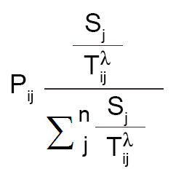

Pij: Probability of a consumer at point i travelling to retail location j

Sj: Size of retail location

Tij: Travel time (or distance) from consumer at point i to travel to location j

**Process**:

Step 1. Calculate distances from retail stores to census tracts

Step 2. Incorporate attractiveness with store size and distance

Step 3. Measure the probabilities for each retail store’s market share

**Reference links:**

[**https://gisgeography.com/huff-gravity-model/#:~:text=Attractiveness%20uses%20distance%20and%20the,divided%20by%20'dist12**](https://gisgeography.com/huff-gravity-model/#:~:text=Attractiveness%20uses%20distance%20and%20the,divided%20by%20'dist12)**'.**

[**https://rpubs.com/MichalisPavlis/huff_model**](https://rpubs.com/MichalisPavlis/huff_model)