Directories and files structure

(django_iris) cso@CSOIM03181168D:~/django_iris/django_iris$ tree -L 3
.
├── bin
│ ├── activate
│ ├── activate.csh
│ ├── activate.fish
│ ├── django-admin
│ ├── django-admin.py
│ ├── easy_install
│ ├── easy_install-3.5
│ ├── f2py
│ ├── gunicorn
│ ├── gunicorn_paster
│ ├── pip
│ ├── pip3
│ ├── pip3.5
│ ├── __pycache__
│ │ └── django-admin.cpython-35.pyc
│ ├── python -> python3
│ └── python3 -> /usr/bin/python3
├── include
├── iris_ml
│ ├── db.sqlite3
│ ├── iris
│ │ ├── admin.py
│ │ ├── apps.py
│ │ ├── __init__.py
│ │ ├── iris.py
│ │ ├── migrations
│ │ ├── models.py
│ │ ├── __pycache__
│ │ ├── SVMModel.pckl
│ │ ├── tests.py
│ │ ├── urls.py
│ │ └── views.py
│ ├── iris_ml
│ │ ├── __init__.py
│ │ ├── __pycache__
│ │ ├── settings.py
│ │ ├── urls.py
│ │ └── wsgi.py
│ └── manage.py
├── lib
│ └── python3.5
│ └── site-packages
├── lib64 -> lib
├── pip-selfcheck.json
├── pyvenv.cfg
└── share
└── python-wheels
├── CacheControl-0.11.5-py2.py3-none-any.whl
├── chardet-2.3.0-py2.py3-none-any.whl
├── colorama-0.3.7-py2.py3-none-any.whl
├── distlib-0.2.2-py2.py3-none-any.whl
├── html5lib-0.999-py2.py3-none-any.whl
├── ipaddress-0.0.0-py2.py3-none-any.whl
├── lockfile-0.12.2-py2.py3-none-any.whl
├── packaging-16.6-py2.py3-none-any.whl
├── pip-8.1.1-py2.py3-none-any.whl
├── pkg_resources-0.0.0-py2.py3-none-any.whl
├── progress-1.2-py2.py3-none-any.whl
├── pyparsing-2.0.3-py2.py3-none-any.whl
├── requests-2.9.1-py2.py3-none-any.whl
├── retrying-1.3.3-py2.py3-none-any.whl
├── setuptools-20.7.0-py2.py3-none-any.whl
├── six-1.10.0-py2.py3-none-any.whl
├── urllib3-1.13.1-py2.py3-none-any.whl
└── wheel-0.29.0-py2.py3-none-any.whl

15 directories, 51 files

Create folder django_iris/
cd django_iris/
sudo python3 -m venv django_iris
sudo chown -R cso:cso django/
source django_iris/bin/activate
cd django_iris/

pip install django

django-admin –version

sudo fuser -k 8000/tcp #To release port if engaged

pip install numpy
pip install scipy
pip install sklearn
pip install gunicorn
python iris.py # To generate pickle file of ML model

django-admin startproject iris_ml

cd iris_ml/

python manage.py startapp iris

cd /home/cso/django_iris/django_iris/iris_ml/iris

Update views.py with following code

from django.shortcuts import render
from django.http import HttpResponse
import numpy as np
import pickle
#import request

global svmIrisModel
svmIrisFile = open('iris/SVMModel.pckl', 'rb')
svmIrisModel = pickle.load(svmIrisFile)
svmIrisFile.close()

def home(request):
return HttpResponse("Welcome!!!")

def predict(request):
# Get values from browser
sepLen = request.GET.get('sepal_length')
sepWid = request.GET.get('sepal_width')
petLen = request.GET.get('petal_length')
petWid = request.GET.get('petal_width')
testData = np.array([sepLen, sepWid, petLen, petWid]).reshape(1,4)
try:
class_prediced = int(svmIrisModel.predict(testData)[0])
output = "Predicted Iris Class: " + str(class_prediced)
except Exception as e:
print(e)
return HttpResponse(output)

create urls.py with following code

from django.urls import path
from . import views
urlpatterns = [
# path('', views.home, name='home'),
path('', views.predict, name='predict'),
]

cd /home/cso/django_iris/django_iris/iris_ml/

update urls.py with following code

from django.contrib import admin
from django.urls import include,path
from iris import views as ml

urlpatterns = [
# path('admin/', admin.site.urls),
path('hello/', ml.home),
path('pre1', ml.predict),
path('predict', include('iris.urls')),
]

# Put model.pckl in iris folder (i.e. <app> folder)

cd /home/cso/django_iris/django_iris/iris_ml
python manage.py migrate

python manage.py runserver

Done!!

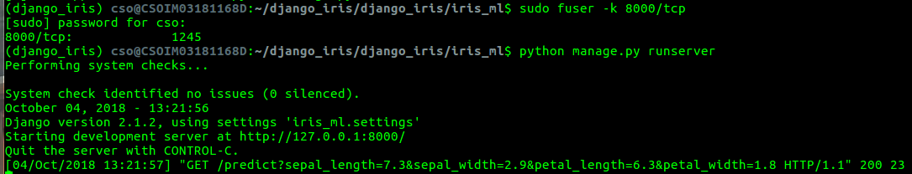

Open a browser and paste following url in address bar to verify

http://127.0.0.1:8000/predict?sepal_length=7.3&sepal_width=2.9&petal_length=6.3&petal_width=1.8





