SIT310 - TASK 6.2C

IMAGE PROCESSING WITH OPENCV

Student: Isumi Malinhara Liyanage
Student ID: s224816942

1. BAG FILE VIDEO
Video Link: https://deakin.au.panopto.com/Panopto/Pages/Sessions/List.aspx?folderID=e84ec11b-b921-4057-9013-b45100d17c67
This video shows unprocessed camera feed from the robot during bag file recording.

2. EXPERIMENT 1: CANNY EDGE DETECTION
Canny edge detection was applied using three different threshold pairs to observe the effect on edge detection sensitivity.

Low Threshold | High Threshold | Screenshot | Short Comment on Result
50 | 150 | 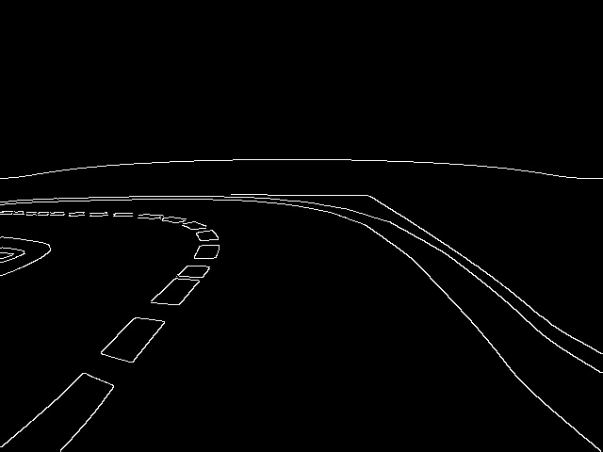 | Low sensitivity , detects only strong edges. 4446 edge pixels detected. Misses fine road markings.
100 | 200 | 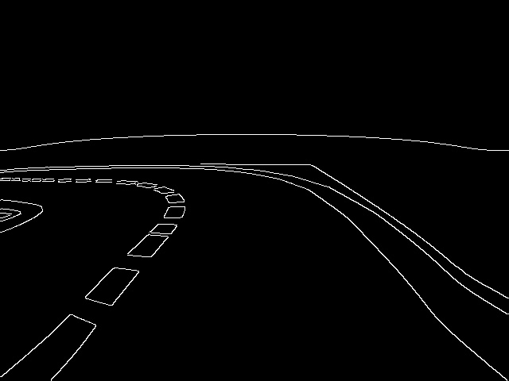 | Medium sensitivity , balanced detection. 4438 edge pixels. Good trade-off between detail and noise.
150 | 250 | 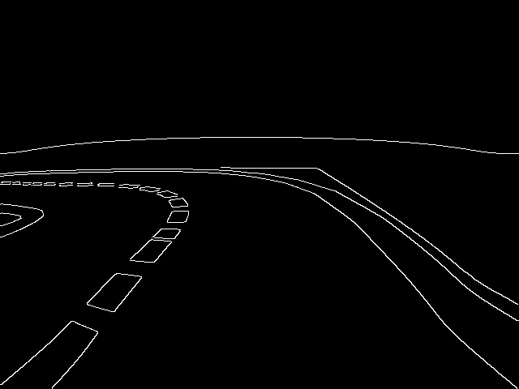 | High sensitivity , more edges including noise. 4383 edge pixels. Road texture starts appearing as false edges.

3. EXPERIMENT 2: HOUGH TRANSFORM
Hough Transform was applied with varying threshold parameter to observe its effect on line detection.

Parameter Changed | Value | Screenshot | Short Comment on Result
threshold | 30 | 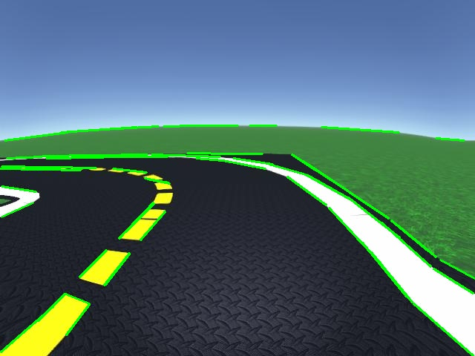 | Low threshold , 54 lines detected including noise and short spurious segments.
threshold | 50 | 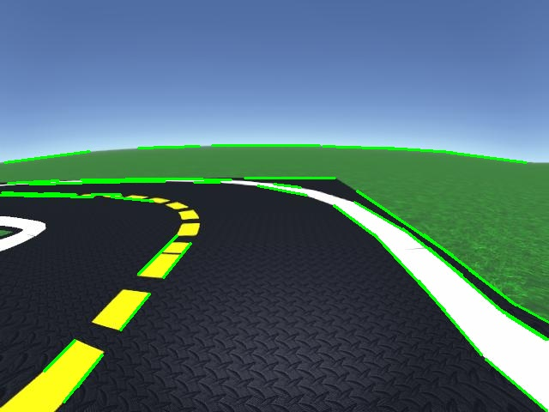 | Medium threshold , 41 lines, clean lane lines with reduced noise.
threshold | 80 | 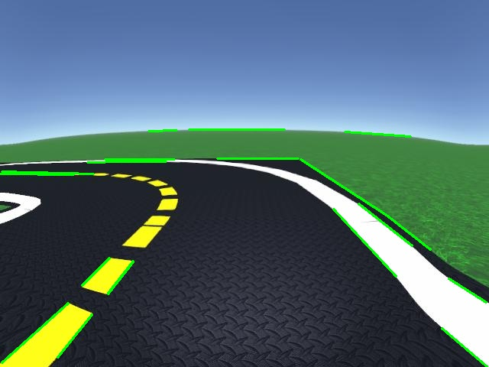 | High threshold , only 21 strong lines, some valid lane segments missed.

4. EXPERIMENT 3: HSV VS RGB COLOR SPACES
Yellow lane marking detection was performed using both HSV and RGB color spaces to compare their effectiveness.

RGB Color Space Result:
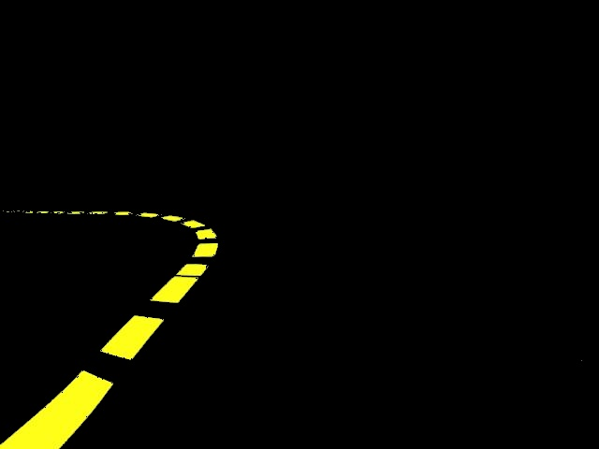

HSV Color Space Result:
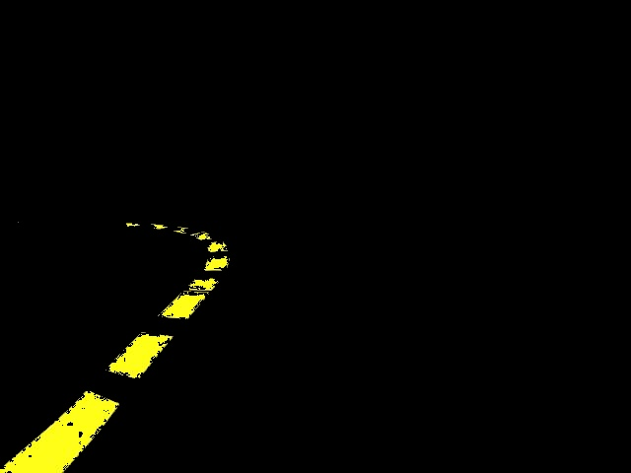

5. EXPERIMENT 4: LIGHTING CONDITIONS
Lane detection was tested under three lighting conditions using the same fixed parameters.

Normal Lighting:


Dark Lighting (50% brightness):
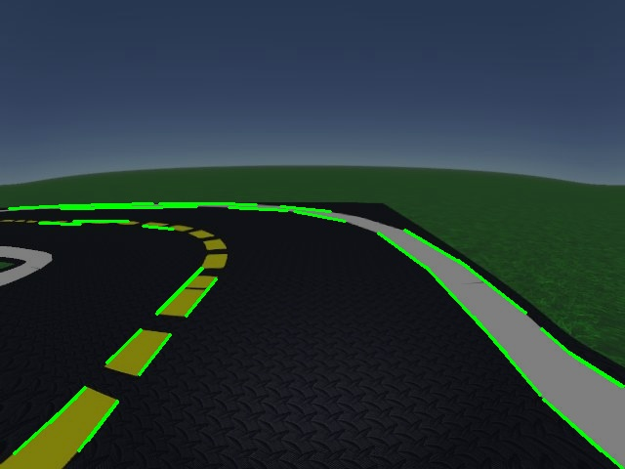

Bright Lighting (150% brightness):
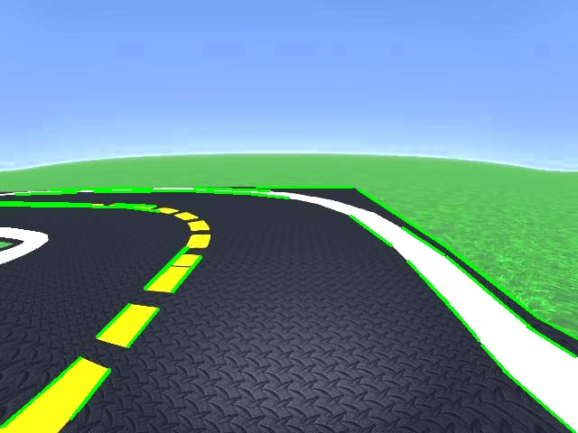

6. CRITICAL REFLECTION

Question 1: What difference did you notice between HSV and RGB? Which one worked better for you?

HSV and RGB produced different results for yellow lane detection on the virtual simulation. RGB detected 8324 yellow pixels while HSV detected 7072 pixels. In this virtual scene RGB captured more pixels due to wider per-channel ranges, however HSV provides more semantically meaningful segmentation by separating hue from intensity. HSV is more robust in real-world scenarios where lighting varies, since a fixed hue range [20-30] isolates yellow regardless of brightness, whereas RGB thresholds would need retuning under different illumination.

Question 2: How did the lighting conditions affect line detection?

Lighting conditions directly affected line detection counts when using fixed Hough thresholds. Normal lighting detected 41 lines; dark conditions (50% brightness) dropped to 30 lines , a 27% reduction because reduced contrast lowers Canny edge response. Bright conditions (150% brightness) recovered to 37 lines but introduced oversaturation artifacts. The same threshold set cannot handle all three conditions reliably.

Question 3: Why can fixed thresholds for image processing be problematic? Suggest one better method.

Fixed thresholds assume a static visual environment, which breaks under lighting changes, shadows, or different road surfaces. Our experiments showed a 11 line drop between normal and dark conditions with identical parameters. A better approach is Otsu's method, which automatically selects the optimal threshold by minimising intra-class pixel variance , adapting to each image's histogram rather than relying on pre-set values. Deep learning-based detectors that learn robust features across conditions are another strong alternative..

