**PRACTICE ASSIGNMENT Programming Fundamental 01**

**Isuru Prabhath GDSE61**

**Q 1**

class Example{

public static void main(String args[]){

System.out.println("Hello java");

}

}

**OUTPUT;**

**Q 2**

class Example{

public static void main(String args[]){

System.out.println("Hello java");

System.out.println("Hello java");

System.out.println("Hello java");

System.out.println("Hello java");

}

}

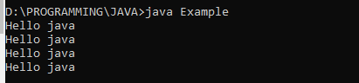**OUTPUT;**

**Q 3**

class Example{

public static void main(String args[]){

System.out.println("A");

System.out.println("B");

System.out.println("C");

System.out.println("D");

}

}

**OUTPUT;**

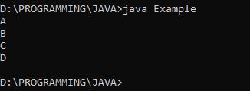

**Q 4**

class Example{

public static void main(String args[]){

System.out.println("1");

System.out.println(1000);

System.out.println(1.23);

}

}

**OUTPUT;**

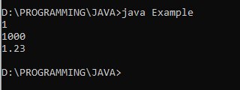

**Q 5**

class Example{

public static void main(String args[]){

System.out.println("Hello Java");

System.out.println("A");

System.out.println(1234);

System.out.println(-1234);

System.out.println(1.2334);

System.out.println(0.0032);

System.out.println(-0.0023);

System.out.println('A');

System.out.println('6');

System.out.println(true);

System.out.println(false);

}

}

**OUTPUT;**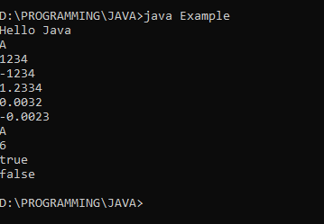

**Q 7**

class Example{

public static void main(String args[]){

System.out.print("A");

System.out.print("B");

System.out.print("C");

System.out.print("D");

}

}

**OUTPUT;**

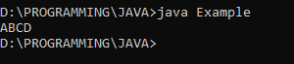

**Q 8**

class Example{

public static void main(String args[]){

System.out.print("A");

System.out.print("B");

System.out.println("C");

System.out.print("D");

System.out.println("E");

}

}

**OUTPUT;**

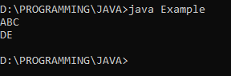

**Q 9**

class Example{

public static void main(String args[]){

System.out.print("A");

System.out.println("B");

System.out.println("C");

System.out.print("D");

}

}

**OUTPUT;**

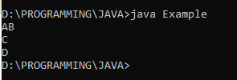

**Q 10**

class Example{

public static void main(String args[]){

System.out.println("A");

System.out.println("B");

System.out.println();

System.out.println("C");

System.out.println("D");

}

}

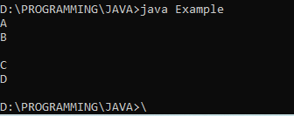**OUTPUT;**

**Q 11**

class Example{

public static void main(String args[]){

System.out.println("A");

System.out.println("B");

System.out.print();

System.out.println("C");

System.out.println("D");

}

}

**OUTPUT;**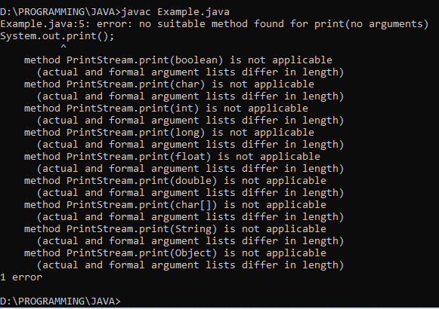

**Q 12**

class Example{

public static void main(String args[]){

int x;

x=100;

System.out.println(x);

}

}

**OUTPUT;**

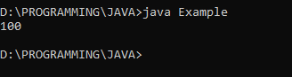

**Q 13**

class Example{

public static void main(String args[]){

int x;

x=100;

System.out.println("x");

}

}

**OUTPUT;**

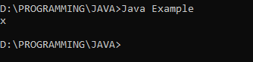

**Q 14**

class Example{

public static void main(String args[]){

int x;

System.out.println(x);

}

}

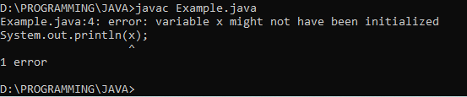**OUTPUT;**

**Q 15**

class Example{

public static void main(String args[]){

int x;

System.out.println(x);

x=100;

}

}

**OUTPUT;**

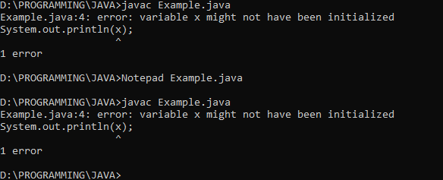

**Q 16**

class Example{

public static void main(String args[]){

int x; x=100;

x=200;

System.out.println(x);

}

}

**OUTPUT;**

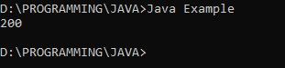

**Q 17**

class Example{

public static void main(String args[]){

int x;

x=100;

System.out.println(x);

x=200;

System.out.println(x);

}

}

**OUTPUT;**

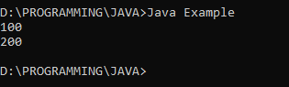

**Q 18**

class Example{

public static void main(String args[]){

int x;

x=100;

System.out.println(x);

int y;

y=200;

System.out.println(y);

}

}

**OUTPUT;**

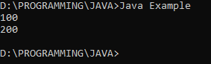

**Q 19**

class Example{

public static void main(String args[]){

int x;

x=100;

System.out.println(x);

y=200;

System.out.println(y);

}

}

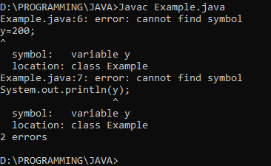**OUTPUT;**

**Q 20**

class Example{

public static void main(String args[]){

int x,y,z,total;

x=100;

System.out.println(x);

y=200; System.out.println(y);

}

}

**OUTPUT;**

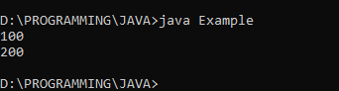

**Q 21**

class Example{

public static void main(String args[]){

int x=100;

int y=200;

System.out.println(x);

System.out.println(y);

}

}

**OUTPUT;**

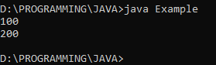

**Q 22**

class Example{

public static void main(String args[]){

int x=100,y,z=200;

System.out.println(x);

y=300;

System.out.println(y);

System.out.println(z);

}

}

**OUTPUT;**

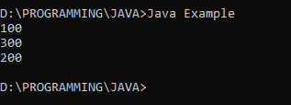

**Q 23**

class Example{

public static void main(String args[]){

int x=100,y,z=200;

System.out.println(x);

System.out.println(z);

int z; z=400; System.out.println(z);

}

}

**OUTPUT;**

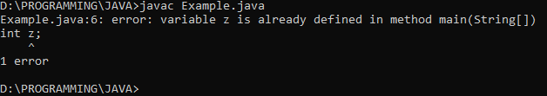

**Q 24**

class Example{

public static void main(String args[]){

int x=100; int y=200;

System.out.println(x);

System.out.println(y);

x=y; System.out.println(x);

System.out.println(y);

}

}

**OUTPUT;**

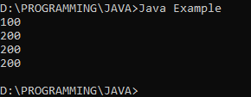

**Q 25**

class Example{

public static void main(String args[]){

System.out.println('A');

System.out.println("A");

}

}

**OUTPUT;**

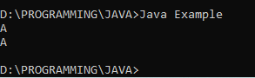

**Q 26**

class Example{

public static void main(String args[]){

System.out.println('A');

System.out.println("A");

System.out.println("AB");

System.out.println('AB');

}

}

**OUTPUT;**

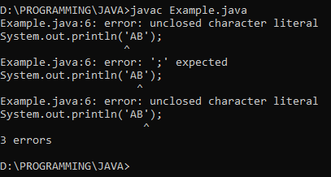

**Q 27**

class Example{

public static void main(String args[]){

System.out.println('A'); //Character A

System.out.println('7'); //Characrer 7

System.out.println(7); //Integer 7

}

}

**OUTPUT;**

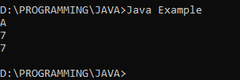

**Q 28**

class Example{

public static void main(String args[]){

System.out.println("AB\bCD");

}

}

**OUTPUT;**

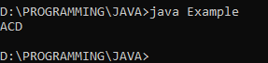

**Q 29**

class Example{

public static void main(String args[]){

System.out.println("AB\tCD");

}

}

**OUTPUT;**

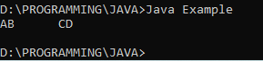

**Q 30**

class Example{

public static void main(String args[]){

System.out.println("AB\nCD");

}

}

**OUTPUT;**

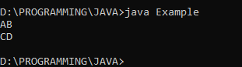

**Q 31**

class Example{

public static void main(String args[]){

System.out.println("AB"CD");

}

}

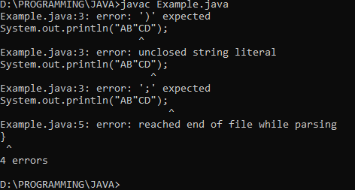**OUTPUT;**

**Q 32**

class Example{

public static void main(String args[]){

System.out.println("AB\\CD");

System.out.println("AB\'CD");

System.out.println("AB\"CD");

}

}

**OUTPUT;**

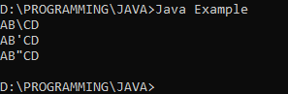

**Q 33**

class Example{

public static void main(String args[]){

System.out.println("AB\nCD");

System.out.println("AB\tCD");

System.out.println("AB\fCD");

System.out.println("AB\bCD");

System.out.println("AB\rCD");

System.out.println("AB\\CD");

System.out.println("AB\'CD");

System.out.println("AB\"CD");

System.out.println("AB\wCD");

}

}

**OUTPUT;**

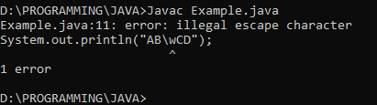

**Q 34**

class Example{

public static void main(String args[]){

System.out.print("A\nB");

System.out.println("CD");

System.out.print("\nEF\n");

System.out.print("G\nH");

}

}

**OUTPUT;**

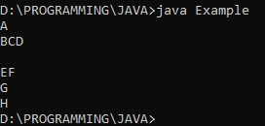

**Q 35**

class Example{

public static void main(String args[]){

System.out.println(10+20);

System.out.println("10"+"20");

System.out.println("10"+20);

System.out.println(10+"20");

}

}

**OUTPUT;**

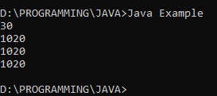

**Q 36**

class Example{

public static void main(String args[]){

System.out.println(4032016);

System.out.println("04-03-2016");

}

}

**OUTPUT;**

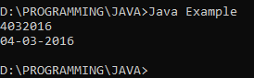

**Q 37**

class Example{

public static void main(String args[]){

int x,y,z;

x=10;

y=20;

z=x+y;

System.out.println(x+"+"+y+"="+z);

}

}

**OUTPUT;**

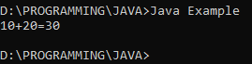

**Q 38**

class Example{

public static void main(String args[]){

int x=10,y=20;

System.out.println(x+y);

System.out.println("x"+"y");

System.out.println("x+y");

System.out.println("x"+y);

System.out.println(x+"y");

}

}

**OUTPUT;**

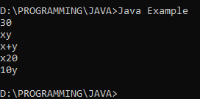

**Q 39**

class Example{

public static void main(String args[]){

System.out.println(10+20+30);

System.out.println("10+20+30");

System.out.println("10+20"+30);

System.out.println("10"+"20"+"30");

System.out.println("10"+20+30);

System.out.println(10+20+"30");

System.out.println(10+"20"+30);

}

}

**OUTPUT;**

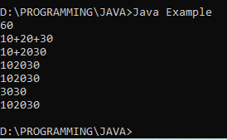

**Q 40**

class Example{

public static void main(String args[]){

int x=10,y=20,z=30;

System.out.println(x+y+z);

System.out.println("x"+"y"+"z");

System.out.println("x+y"+z);

System.out.println("x"+y+z);

System.out.println(x+y+"z");

System.out.println(x+"y"+z);

}

}

**OUTPUT;**

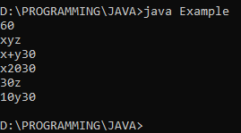

**Q 41**

class Example{

public static void main(String args[]){

int x=10,y=20;

System.out.println(x+" "+y);

}

}

**OUTPUT;**

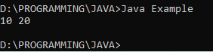

**Q 42**

class Example{

public static void main(String args[]){

int x=10;

System.out.println("Value of x is : "+x);

}

}

**OUTPUT;**

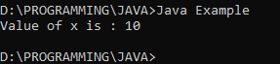

**Q 43**

class Example{

public static void main(String args[]){

int x,y;

x=10;

y=20;

System.out.println(x+"+"+y+"="+x+y);

System.out.println(x+"+"+y+"="+(x+y));

}

}

**OUTPUT;**

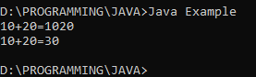

**Q 44**

class Example{

public static void main(String args[]){

int x,y;

x=10;

y=20;

System.out.println("x : ",x);

System.out.println("x : "x);

System.out.println(x+ +y);

}

}

**OUTPUT;**

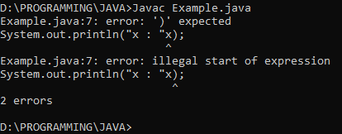

**Q 45**

class Example{

public static void main(String args[]){

int x,y,z;

x=input.nextInt();

y=input.nextInt();

z=x+y;

System.out.println(x+"+"+y+"="+z);

}

}

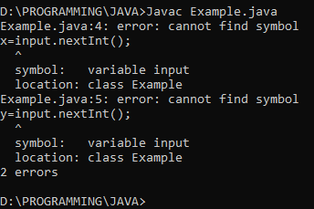**OUTPUT;**

**Q 46**

class Example{

public static void main(String args[]){

int x;

System.out.println(x);

x=100;

System.out.println(x);

}

}

**OUTPUT;**

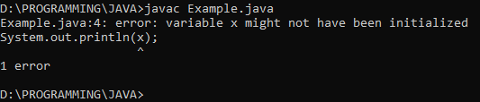

**Q 47**

import java.util.*;

class Example{

public static void main(String args[]){

Scanner input=new Scanner(System.in);

int a=input.nextInt();

int x;

if(a>100){

x=100;

}

System.out.println(x);

}

}

**OUTPUT;**

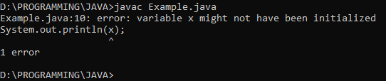

**Q 48**

class Example{

public static void main(String args[]){

for(int i=0; i<10; i++){

System.out.println(i);

}

}

}

**OUTPUT;**

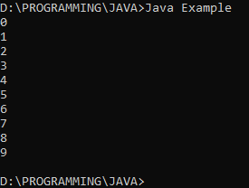

**Q 49**

class Example{

public static void main(String args[]){

for(int i=0; i<10; i++)

System.out.println(i);

System.out.println(i);

}

}

**OUTPUT;**

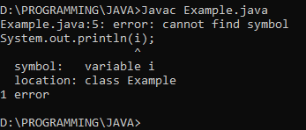

**Q 50**

import java.util.*;

class Example{

public static void main(String args[]){

Scanner input=new Scanner(System.in);

System.out.print("Input an integer : ");

int num=input.nextInt();

int fact=1;

for (int i = num; i>0; i--){

System.out.print(i+" * ");

fact*=i;

}

System.out.println("\b\b = "+fact);

}

}

**OUTPUT;**

