1. **Print** - This method prints the text on the console and the cursor remains at the end of the text at the console.

**Println -** This method prints the text on the console and the cursor remains at the start of the next line at the console.

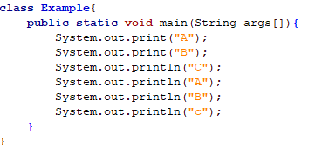**Example**

output

1. 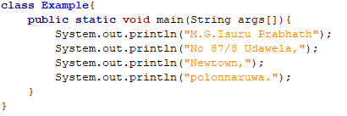

1. Java literals – It is a medium of expressing particular values in the program

Java Literals Types

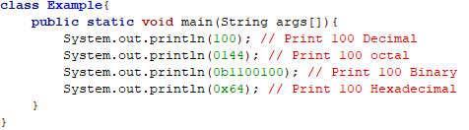 1.Integer Literals

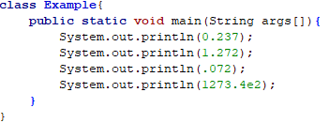 2.Floating Point Literals

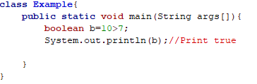 3.Boolean Literals

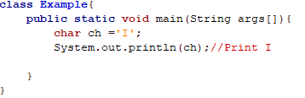 4.Character Literals

1. 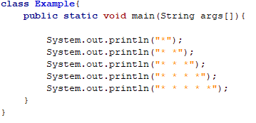
2. 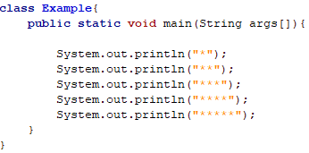

1. 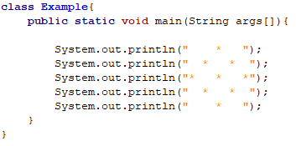
2. 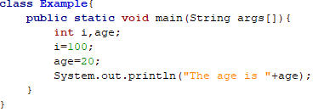

1. 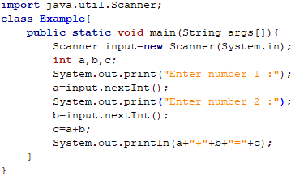
2. 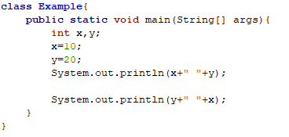
3. 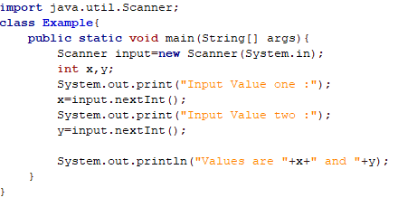
4. 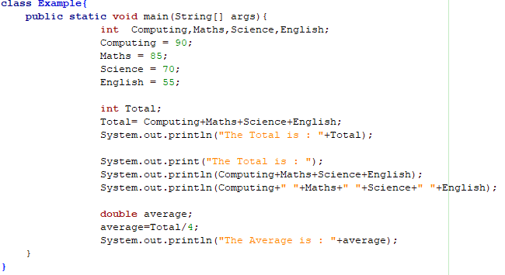
5. 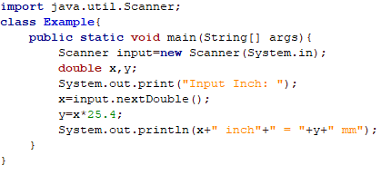
6. 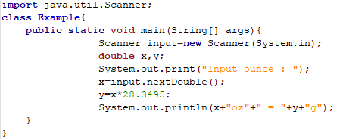
7. 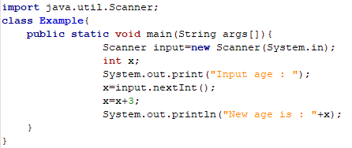
8. 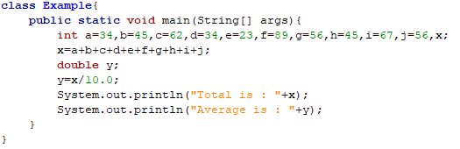
9. D. X=200

Since X is printed, X must be given a value, Since the value of X is printed, X must be given a value

1. C. int x=10, y=20;

Since the value of x and y is printed, we need to create variables for x and y and assign values to

them.



1. 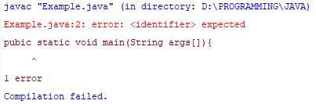Compile error

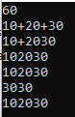 After

1. Line 1 valid

Line 2 valid

Line 3 invalid

Line 4 valid

Line 5 invalid

Line 6 valid

Line 7 valid

Line 8 invalid

Line 9 invalid

Line 10 valid

1. A. int sum,x;

B. x=1;

C. sum=0;

D. sum=x+sum;

E. System.out.println(‘’The sum is : “+sum);

1. 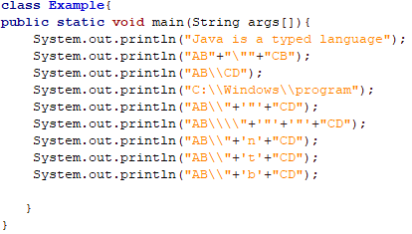
2. B. x=100

Since the value of x is printed, x must be given a value

1. 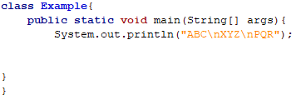
2. 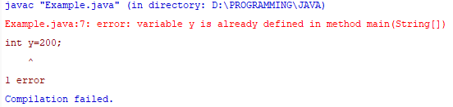Compile error

Variable y is already used

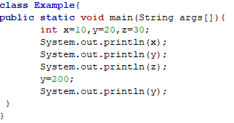 After

1. 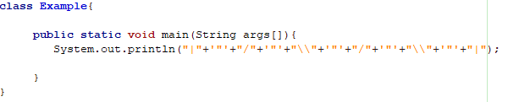
2. 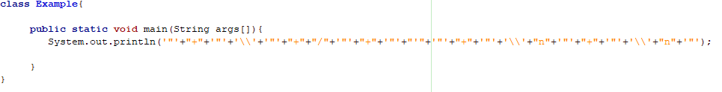
3. 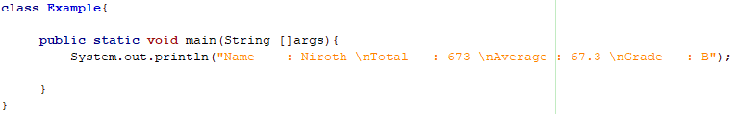
4. A. char a =’\u0061’;

C. cha \u0061 = ’a’;

D. ch\u0061r a = ‘a’;

1. D. Compile error at line 6

1. a b c g
2. e. Compile-time error
3. e. Compile time error
4. d. When run, the program will print 34
5. f. None of the above
6. A. 6 - All Integers

B. 123 - All Character

C. 150 – ASCII value of digits 1-49/ 2-50/ 3-51

D. 1 2 3 -Two are in the middle of the string and the other is converted to a string

E. 198 – ASCII value of character A-65/ B-65/ C-67

F. ABC  -  All Character

G. 365 - A character ASCII value is 65 ( 65+100+200=365 )

H. A B C -Two are in the middle of the string and the other is converted to a string

1. char a='a'; - variable a stores a lowercase a character

System.out.println(a=='\u0061'); - in UTF lowercase a character is represented as [\u0061](https://www.fileformat.info/info/unicode/char/0061/index.htm)

System.out.println(\u0061=='\u0061');  - \u0061 value is unquoted so it's [decoded into Lowercase a during compilation](https://stackoverflow.com/a/30727799/1602555) making it a=='\u0061',

System.out.println(\u0061==97);  - same as above because 97dec = 61hex except here we are not using UTF notation to represent character, instead we use numerical value of char

\u0061='\u0041'; - a variable assigned value of [\u0041](https://www.fileformat.info/info/unicode/char/0041/index.htm) which is uppercase A

System.out.println('A'=='\u0041'); in UTF lowercase A character is represented as '\u0041'

System.out.println(65=='\u0041'); -  - 65dec = 41hex, here we are comparing two constants, not the a variable

System.out.println(65==a); - - 65dec =  a,

System.out.println('\u0041'==a); - - a = 41hex



a. System.out.println(0B1010); 10

c. System.out.println(0B01010); 10

d. System.out.println(01010);  520

e. System.out.println(0x1010);  4112

f. System.out.println(01012); 522

1. 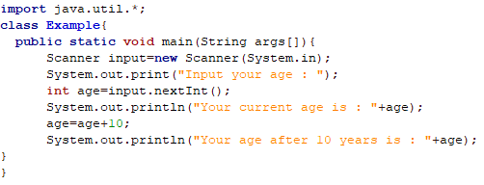
2. 