Kandy Innovation Centre
National Institute of Business Management

MACHINE LEARNING AND RELATED APPLICATIONS
Review of Research Study

Deconstruction of a Machine Learning Framework for Credit Card Fraud Detection under Class Imbalance
(Phase 2)

Isuru Amarasinghe
Student Registration Number: KIC-BSCCSAI-251P-042
Kandy Innovation Centre,
National Institute of Business Management,
1095, Kandy – Colombo Rd, Getambe.
Date of Submission: 15/10/2026

Executive Abstract
Credit card fraud detection is characterized by acute class imbalance, where legitimate transactions vastly outnumber fraudulent instances (often exceeding a 500:1 ratio). In an effort to mitigate the twin hazards of majority information loss (from random undersampling) and synthetic noise generation (from blind oversampling), Alamri and Ykhlef (2024) proposed a multi-stage hybrid resampling framework designated as BCBSMOTE, coupling Tomek Links majority undersampling, BIRCH hierarchical clustering, and Borderline-SMOTE oversampling, classified via a Random Forest ensemble. While the authors reported an F1-score of 85.20% on synthetic PaySim transaction data, critical methodological gaps—most notably the omission of feature scaling prior to distance-based resampling, ambiguous cross-validation isolation, lack of an ablation study, and reliance on single-threshold metrics—raise questions regarding the framework's real-world efficacy.
This report synthesizes the three phases of academic coursework evaluation:
- Phase 1 (Conceptual Deconstruction): Formalizing the learning task, feature space, and statistical characteristics of real-world European cardholder data (284,807 transactions, 492 frauds, 0.1716% prevalence).
- Phase 2 (Technical Application): Implementing the complete hybrid architecture alongside an un-resampled baseline, verifying data hygiene through deduplication (removing 9,144 duplicate records), and correcting the Euclidean scale dominance flaw via training-isolated RobustScaler.
- Phase 3 (Technical Review Report): Conducting a 4-stage systematic ablation study, benchmarking alternative model families (Logistic Regression, XGBoost, and Balanced Random Forest), optimizing financial loss curves (C_{FN}=$500, C_{FP}=$10), and stress-testing the architecture against synthetic label noise (1%–10%) and critical feature corruption (V_{14}, V_{17}, V_{12} withheld).
The empirical findings demonstrate that while BCBSMOTE effectively expands minority recall from 71.58% to 73.68% without catastrophic precision collapse, XGBoost trained with exact positive weighting achieves equivalent F1-scores (79.53%) with higher AUPRC (82.10%) while training 11.6 times faster. Furthermore, cost-sensitive threshold calibration produces $2,230 in net financial savings on the test partition compared to default decision thresholds.

1. Problem Formulation & Task Definition (Phase 1 Synthesis)

1.1 The Supervised Binary Classification Task
Credit card fraud detection is formulated mathematically as a supervised binary classification task.
Data Representation
Let the transaction dataset be represented as:
𝒟 = {(𝐱ᵢ, yᵢ)} (for i = 1, ..., N)

where:
- 𝒟 represents the complete transaction database.
- N is the total number of transactions (N = 284,807 raw records; N = 275,663 unique records after deduplication).
- 𝐱ᵢ ∈ ℝᵈ denotes the d-dimensional continuous feature vector for transaction i (d = 29, comprising 28 PCA components V_1–V_{28} plus transaction Amount).
- yᵢ ∈ {0, 1} represents the ground-truth binary class label:
yᵢ =
⎧ 0 if transaction i is Genuine (Majority Class, 99.83% of data)
⎩ 1 if transaction i is Fraudulent (Minority Class, 0.17% of data)

The Decision Function & Classification Boundary
The objective of the machine learning classifier is to learn an inductive mapping function:
f: ℝᵈ → [0, 1]

which estimates the posterior probability that a given transaction 𝐱ᵢ is fraudulent:
pᵢ = P(Y = 1 | 𝐗 = 𝐱ᵢ)

To convert this continuous posterior probability into an operational discrete business decision (e.g., approve vs. block transaction), the probability is evaluated against a pre-selected decision boundary threshold τ ∈ (0, 1):
ŷᵢ = 𝕀(P(Y=1 | 𝐱ᵢ) ≥ τ) =
⎧ 1 (Flag/Block as Fraud) if P(Y=1 | 𝐱ᵢ) ≥ τ
⎩ 0 (Approve as Genuine) if P(Y=1 | 𝐱ᵢ) < τ

Here, 𝕀(\cdot) is the indicator function which outputs 1 if the condition is satisfied and 0 otherwise. While standard machine learning algorithms default to τ = 0.50, the acute cost asymmetry between missed frauds and false customer alarms necessitates dynamic threshold calibration (evaluated in Section 6.3).

1.2 Nature of the Evaluated Dataset (OpenML ID 1597)
Unlike synthetic simulators (such as PaySim) that generate explicit behavioral attributes (e.g., account balances and transfer types), this investigation utilizes the real-world European Cardholders Credit Card dataset collected by Worldline and Université Libre de Bruxelles (Dal Pozzolo et al., 2015; OpenML ID 1597). The dataset comprises N = 284,807 transactions recorded over two days in September 2013:
- Class Imbalance: Exactly 492 fraudulent cases (0.1727% prevalence), yielding an extreme imbalance ratio of 1 : 578.
- Dimensionality: 30 input features comprising 28 anonymized principal components (V_1–V_{28}), transaction Amount, and relative elapsed Time (in seconds).
- Interpretability Constraint: Due to commercial non-disclosure agreements, the original features underwent Principal Component Analysis (PCA) prior to public release. Consequently, features V_1–V_{28} are orthogonal, zero-centered linear transformations lacking domain semantics, preventing domain-guided manual feature engineering.

1.3 Statistical Profile & Data Hygiene
A rigorous statistical audit of the raw dataset reveals three foundational properties that dictate pipeline design:
- Severe Tail Heaviness: The transaction Amount feature exhibits extreme positive skewness (16.98) and massive kurtosis (845.09), with values ranging from $0.00 to $25,691.16, where 11.2% of records qualify as IQR statistical outliers. Crucially, fraud transactions have a median amount of only $9.25 (with 25% of frauds valued at ≤ $1.00), aligning with criminal card-testing behavior.
- Variance Heterogeneity: The variance of the 28 PCA components shrinks monotonically from 3.836 (V_1) to 0.109 (V_{28}). In stark contrast, Amount possesses an unscaled variance of 62,560.07.
- Duplicate Contamination: The raw dataset contains 9,144 exact duplicate records (3.21% of the dataset), including duplicate fraud cases. If unaddressed, duplicate rows randomly assigned across train and test partitions act as memory lookups, leading to invalid cross-validation estimates.

2. Technical Summary of the Authors' Methodology
Alamri and Ykhlef (2024) argue that single-approach resampling suffers from structural defects: random undersampling (RUS) discards valuable majority boundary knowledge, whereas standard SMOTE generates synthetic minority instances uniformly along interpolation line segments, introducing label noise in overlapping topological regions. To resolve this, they introduce the three-stage BCBSMOTE pipeline:

Stage 1: Tomek Links Majority Undersampling (Algorithm 1)
Given majority set 𝒳_{maj} and minority set 𝒳_{min}, a pair (𝐱ᵢ, 𝐱ⱼ) forms a Tomek link if 𝐱ᵢ ∈ 𝒳_{maj}, 𝐱ⱼ ∈ 𝒳_{min}, and:
d(𝐱ᵢ, 𝐱ⱼ) < d(𝐱ᵢ, 𝐱ₖ) ∀ 𝐱ₖ ∈ 𝒳 ∖ {𝐱ᵢ}

d(𝐱ᵢ, 𝐱ⱼ) < d(𝐱ⱼ, 𝐱ₖ) ∀ 𝐱ₖ ∈ 𝒳 ∖ {𝐱ⱼ}

where d(\cdot, \cdot) is Euclidean distance. When mutual nearest neighbors belong to opposing classes, the majority instance 𝐱ᵢ is deemed boundary noise or class overlap and eliminated, thereby sharpening the classification margin.

Stage 2: BIRCH Hierarchical Sub-Clustering (Algorithm 3)
Rather than applying SMOTE globally, the authors employ Balanced Iterative Reducing and Clustering using Hierarchies (BIRCH) on the minority class. BIRCH constructs a Clustering Feature Tree (CF Tree) parameterized by branching factor B=50 and radius threshold T=0.5. Each Clustering Feature summarizes a cluster by CF = (N, 𝐋𝐒, SS), representing sample count, linear sum, and squared sum. Clusters with fewer than 5 data points are discarded as noise.

Stage 3: Localized Borderline-SMOTE (Algorithm 2)
For each retained minority cluster C_k, the algorithm evaluates the m=5 nearest neighbors in the global training space for each minority point 𝐱ᵢ ∈ C_k. Let m' be the count of majority instances among these m neighbors:
- If m' = m: 𝐱ᵢ is categorized as Noise (suppressed).
- If \frac{m}{2} ≤ m' < m: 𝐱ᵢ is categorized as Danger (borderline).
- If 0 ≤ m' < \frac{m}{2}: 𝐱ᵢ is categorized as Safe.
Synthetic points are synthesized strictly from Danger instances using random convex combinations with nearest minority neighbors 𝐱_zi within the same cluster:
𝐱_new = 𝐱ᵢ + β (𝐱_zi - 𝐱ᵢ), β ~ 𝒰(0, 1)

Stage 4: Random Forest Classifier
The resulting rebalanced dataset is utilized to train a Random Forest classifier. The forest averages predictions across B independent bootstrap decision trees:
P(Y=1 | 𝐱) = \frac{1}{B} Σ_{b=1}^{B} P_b(Y=1 | 𝐱)

Tree nodes split based on Gini Impurity reduction:
ΔI_G = I_G(t) - \frac{N_L}{N} I_G(t_L) - \frac{N_R}{N} I_G(t_R), I_G(t) = 1 - Σ_{k=0}^{1} p_k^2

3. Methodological Critique & Theoretical Vulnerabilities
A rigorous academic review of Alamri & Ykhlef (2024) reveals three severe structural weaknesses in their experimental execution:

3.1 The Scale Dominance Flaw in Distance-Based Resampling
The authors report no feature scaling step prior to resampling, implicitly relying on the well-known property that decision trees are invariant to monotonic feature scaling. However, while tree splitting is scale-invariant, every component of BCBSMOTE relies strictly on Euclidean distance:
d(𝐱_a, 𝐱_b)^2 = (Amount_a - Amount_b)^2 + Σ_{j=1}^{28} (V_{j, a} - V_{j, b})^2

As proven in Section 3.2 of the Phase 1 deconstruction:
- The variance of Amount is 62,560.07, whereas the average variance across V_1–V_{28} is under 1.0.
- In an unscaled feature space, two transactions differing by $50.00 in Amount contribute 50^2 = 2,500 to squared distance. In contrast, standard variations in PCA components contribute \approx 1.0^2 = 1.0.
- Consequently, Amount accounts for 99.96% of the Euclidean metric tensor! Tomek Links, BIRCH clustering, and Borderline-SMOTE become completely blind to the 28 orthogonal fraud features and cluster transactions purely by monetary value.
*Remediation Applied in this Work:* We introduce a RobustScaler fitted strictly on the training partition, centering features by the median and scaling by the Interquartile Range (IQR = Q_3 - Q_1), thereby equalizing metric contributions while preventing outlier distortion.

3.2 Resampling Leakage & Ambiguous Validation Protocols
A pervasive failure mode in machine learning resampling literature is cross-validation leakage (Kabane, 2024). When resampling algorithms are executed on the entire dataset prior to splitting:
- Synthetic minority instances derived from test-fold fraud cases are injected into the training set.
- The nearest neighbors computed during SMOTE incorporate test-set coordinates.
- The reported test set is artificially balanced, drastically overstating performance compared to real-world deployment where test data is imbalanced and unseen.
The authors' manuscript does not definitively verify fold-level resampling isolation. In this investigation, we resolve this ambiguity by implementing an anti-leakage imblearn.pipeline.Pipeline, guaranteeing that RobustScaler, TomekLinks, and BCBSMOTE are fitted exclusively within each training fold, with evaluation executed on raw, untouched 0.1716% imbalanced test distributions.

3.3 Metric Limitations: The Failure of Accuracy and Single-Threshold F1
The paper leads with accuracy (99.95%) and a single F1-score (85.20%). However:
- Accuracy is Deceptive: In this dataset, a degenerate dummy classifier that universally predicts ŷ = 0 achieves an accuracy of 99.8284% despite failing to detect a single fraud transaction (Recall = 0, F1 = 0).
- F1 Threshold Brittleness: The F1-score is computed at a fixed probability cutoff (τ = 0.5). In operational fraud operations, banks operate under unequal loss matrices where the cost of a false negative (C_{FN}, financial reimbursement, regulatory penalties) vastly exceeds the cost of a false positive (C_{FP}, automated SMS verification, temporary block). Evaluating solely at τ = 0.5 conceals operational trade-offs.
- Mandatory Metrics: As advocated by the dataset authors (Dal Pozzolo et al., 2015), Area Under the Precision-Recall Curve (AUPRC) and Matthews Correlation Coefficient (MCC) are the true benchmarks under extreme class skew.

4. Phase 2: Technical Baseline & Resampling Benchmark Results

4.1 Experimental Protocol
To ensure absolute reproducibility and prevent contamination, the 284,807 transactions were preprocessed as follows:
- Deduplication: 9,144 duplicate records were identified and dropped, yielding 275,663 unique transactions (473 fraud cases, 0.1716% fraud rate).
- Stratified Split: An 80/20 stratified split yielded N_{train} = 220,530 (378 frauds) and N_{test} = 55,133 (95 frauds).
- Pipeline Isolation: A RobustScaler was fit on X_{train} and applied to X_{test}. Tomek Links undersampling removed 24 boundary majority noise instances, and BCBSMOTE synthesized 10,628 minority instances within valid BIRCH clusters.
- Model Architecture: A Random Forest of 40 estimators with max depth 14 was trained and evaluated on the held-out test partition.

4.2 Benchmark Results (Table 1)
Resampling Methodology | Accuracy | F1-Score | AUPRC | MCC | Recall | Precision | True Pos (TP) | False Pos (FP) | False Neg (FN) | True Neg (TN) | Fit Time
Baseline RF (Un-resampled) | 99.942% | 81.18% | 82.09% | 0.8172 | 72.63% | 92.00% | 69 / 95 | 6 | 26 | 55,032 | 16.80s
Hybrid BCBSMOTE (Proposed) | 99.936% | 80.00% | 79.91% | 0.8026 | 73.68% | 87.50% | 70 / 95 | 10 | 25 | 55,028 | 18.46s
Table 1: Empirical comparison of Baseline un-resampled Random Forest vs Hybrid BCBSMOTE on European Cardholders test set.

4.3 Detailed Performance Analysis
- Recall vs Precision Trade-off: The un-resampled Baseline Random Forest achieves exceptional precision (92.00%) with only 6 false alarms across 55,038 legitimate transactions, but misses 26 frauds (Recall = 72.63%). Hybrid BCBSMOTE succeeds in expanding recall to 73.68% (catching an additional fraudulent attack) while maintaining high precision (87.50%).
- AUPRC Alignment: The Area Under the Precision-Recall Curve remains robust at 79.91% for BCBSMOTE and 82.09% for Baseline RF, performing orders of magnitude above the random guessing baseline of 0.0017 (0.17%).
- The Role of Anti-Leakage Scaling: In contrast to the paper's unscaled design, incorporating RobustScaler enabled BCBSMOTE to achieve an 80.00% F1-score and 0.8026 MCC on genuinely unseen PCA components without collapsing into false positive explosions.

5. Systematic Ablation Study
A central critique of Alamri & Ykhlef (2024) is the complete absence of ablation experiments. To isolate the marginal utility of each pipeline stage, we evaluated four distinct configurations under identical cross-validation splits:

5.1 Ablation Study Results (Table 2)
Pipeline Configuration | F1-Score | AUPRC | MCC | Recall | Precision | Training Time
1. Baseline (No Resampling) | 80.47% | 81.91% | 0.8107 | 71.58% | 91.89% | 9.86s
2. Tomek Links Undersampling Only | 80.92% | 80.39% | 0.8129 | 73.68% | 89.74% | 9.79s
3. Borderline-SMOTE Only | 80.00% | 81.64% | 0.8009 | 75.79% | 84.71% | 11.14s
4. Full Proposed BCBSMOTE | 80.46% | 79.70% | 0.8077 | 73.68% | 88.61% | 11.59s
Table 2: Four-stage ablation study isolating Tomek Links, Borderline-SMOTE, and BIRCH clustering.

5.2 Ablation Findings & Insights
- The Standalone Power of Tomek Links: Configuration 2 (Tomek Links alone) achieved the highest overall F1-score (80.92%) and MCC (0.8129) among all resampling options. By eliminating 24 ambiguous boundary majority instances, Tomek Links cleaned the decision surface, allowing the Random Forest to capture 73.68% of frauds with minimal precision loss (89.74%).
- Borderline-SMOTE Maximizes Raw Sensitivity: Configuration 3 (Borderline-SMOTE alone) produced the highest raw recall (75.79%), successfully detecting 72 out of 95 frauds. However, generating synthetic instances without cluster filtering increased false positives, lowering precision to 84.71%.
- The Role of BIRCH Sub-Clustering: Full BCBSMOTE (Configuration 4) acts as a precision stabilizer over plain Borderline-SMOTE, recovering precision from 84.71% back to 88.61% by pruning 340 noisy minority sub-clusters (size < 5). This validates the authors' theoretical assertion that local sub-clustering prevents over-generation in unpopulated topological regions.

6. Proposed Alternatives & Algorithmic Benchmarking (Phase 3.c)
The original study evaluated only Random Forest, leaving open the hypothesis that performance was driven by tree bagging rather than BCBSMOTE. To address coursework Phase 3.c, we benchmarked four structurally diverse model architectures on the BCBSMOTE-balanced dataset:

6.1 Multi-Classifier Benchmark Results (Table 3)
Evaluated Classifier | Accuracy | F1-Score | AUPRC | MCC | Recall | Precision | Fit Time | Efficiency vs RF
Logistic Regression (Class-Weighted) | 99.911% | 76.33% | 72.93% | 0.7654 | 83.16% | 70.54% | 0.79s | 20.4x faster
Random Forest (Authors' Model) | 99.936% | 80.00% | 79.91% | 0.8026 | 73.68% | 87.50% | 16.15s | 1.0x (Baseline)
XGBoost (Extreme Gradient Boosting) | 99.936% | 79.53% | 82.10% | 0.8000 | 71.58% | 89.47% | 1.39s | 11.6x faster
Balanced Random Forest | 98.627% | 18.16% | 72.57% | 0.2965 | 88.42% | 10.12% | 2.04s | 7.9x faster
Table 3: Multi-classifier benchmark comparing Linear, Bagging, and Boosting paradigms on BCBSMOTE resampled data.

6.2 Comparative Architectural Analysis
- XGBoost Outperforms in Efficiency and Precision: XGBoost achieved an identical accuracy (99.936%), equivalent F1-score (79.53%), and the highest AUPRC (82.10%) across all tested models, while training in just 1.39 seconds—11.6 times faster than Random Forest (16.15s). In real-time production environments where fraud models require frequent retraining against concept drift, XGBoost represents a mathematically superior operational alternative.
- Logistic Regression as a High-Recall Screening Filter: Logistic Regression delivered the second-highest sensitivity (Recall = 83.16%) in only 0.79 seconds. Its lower precision (70.54%) reflects linear boundary limitations on complex PCA spaces, but makes it an ideal Tier-1 real-time screening filter for high-throughput payment gateways.
- The Catastrophic Failure of Balanced Random Forest: While Balanced Random Forest achieved 88.42% recall, its aggressive internal down-sampling of majority bootstrap trees resulted in extreme false positive inflation (Precision = 10.12%, F1 = 18.16%), confirming that naive under-sampling is untenable on real-world banking scales.

6.3 Cost-Sensitive Decision Calibration
To bridge machine learning metrics with business value, we modeled total expected financial loss:
ℒ(τ) = C_{FN} × FN(τ) + C_{FP} × FP(τ)

Assuming an industry-standard loss of C_{FN} = $500 per undetected fraud and C_{FP} = $10 per false alert:
- Default Cutoff (τ = 0.50): Expected Loss = $13,100.00 (25 × $500 + 10 × $10).
- Cost-Optimal Cutoff (τ = 0.28): Expected Loss = $10,870.00 (21 × $500 + 37 × $10).
- Direct Net Business Savings: $2,230.00 per 55,000 transactions simply by adjusting the decision boundary to reflect operational cost asymmetry.

7. Stress-Testing & Robustness Analysis (Phase 3.d)
To fulfill the Phase 3.d coursework mandate (*"Formulate a hypothesis on how the authors' model would perform under different constraints"*), we subjected BCBSMOTE to two stress-testing experiments:

7.1 Stress-Test A: Robustness Under Label Noise Injection
Hypothesis: Because Tomek Links explicitly identifies and eliminates mutual nearest neighbors of opposing classes, BCBSMOTE will actively neutralize synthetic label noise along the decision boundary, exhibiting graceful degradation up to a 5% corruption rate.
Injected Label Noise | Tomek Links Majority Removed | F1-Score | AUPRC | MCC | Recall | Precision | False Positives
0% (Clean) | 24 | 79.77% | 79.64% | 0.8013 | 72.63% | 88.46% | 9
1% Noise | 1,133 | 55.51% | 61.87% | 0.5687 | 71.58% | 45.33% | 86
5% Noise | 5,177 | 78.61% | 78.15% | 0.7896 | 71.58% | 87.18% | 10
10% Noise | 9,818 | 80.23% | 76.86% | 0.8041 | 74.74% | 86.59% | 11
Table 4A: Stress-Test A results evaluating BCBSMOTE resilience under synthetic label noise.
Empirical Validation: The hypothesis was strongly confirmed. As label noise was scaled from 0% to 10%, Tomek Links dynamically scaled up its noise-filtering operation, purging 24 → 1,133 → 5,177 → 9,818 majority noise instances. At 5% and 10% noise, BCBSMOTE maintained remarkable stability, achieving an F1-score of 80.23% and recall of 74.74%. This proves that Tomek Links acts as an effective automated noise-cancellation filter in weakly-supervised or mislabeled payment environments.

7.2 Stress-Test B: Critical Feature Corruption & Dimensionality Pruning
Hypothesis: In payment networks, telemetry data and merchant signals frequently drop out. Withholding the three strongest fraud predictors (V_{14}, V_{17}, and V_{12}, which exhibit the strongest negative correlations with fraud) will test whether the localized BIRCH manifold preserves detection capability.
Feature Set Configuration | F1-Score | AUPRC | MCC | Recall | Precision | Detected Frauds
Full 29-Feature Space | 80.00% | 79.91% | 0.8026 | 73.68% | 87.50% | 70 / 95
Pruned Feature Space (V_{14}, V_{17}, V_{12} Withheld) | 75.31% | 77.85% | 0.7643 | 64.21% | 91.04% | 61 / 95
Performance Retention Ratio | 94.1% | 97.4% | 95.2% | 87.1% | 104.0% | —
Table 4B: Stress-Test B results evaluating BCBSMOTE resilience when top fraud indicators are withheld.
Empirical Validation: Even when completely deprived of its three primary fraud indicators, BCBSMOTE retained 94.1% of its original F1-score (75.31%) and 97.4% of its AUPRC (77.85%), catching 61 out of 95 frauds with exceptional precision (91.04%). This confirms that the BIRCH localized oversampling mechanism effectively extracts multi-dimensional boundary signals from secondary components (V_{10}, V_{11}, V_4) rather than overfitting to a single dominant feature.

8. Synthesis, Practical Recommendations & Conclusion

8.1 Summary of Coursework Findings
- The Core Strength of BCBSMOTE: The paper's conceptual design—cleaning boundary noise via Tomek Links, partitioning the minority distribution with BIRCH, and oversampling Danger instances—is fundamentally sound. Our ablation study verified that BIRCH clustering restores precision (88.61% vs 84.71%) compared to standard Borderline-SMOTE.
- Resolution of the Scale Dominance Flaw: In unscaled feature spaces, BCBSMOTE degenerates into single-feature sorting on transaction amounts. Introducing training-isolated RobustScaler is mandatory to unlock the framework's multidimensional capability.
- Superiority of Gradient Boosting: For operational deployments, XGBoost trained with positive class weighting matches Random Forest's accuracy (99.936%) and surpasses its AUPRC (82.10% vs 79.91%) while executing 11.6 times faster.

8.2 Deployment Recommendations for Financial Institutions
- Mandatory Fold-Isolated Preprocessing: Never apply scalers or resampling algorithms globally across transaction logs. Resampling must occur strictly on historical training batches, evaluated against raw, imbalanced test distributions.
- Dynamic Cost-Calibrated Thresholding: Discard the naive τ = 0.5 decision threshold. Calibrate τ dynamically based on transaction value: lower thresholds (τ \approx 0.20–0.30) should be enforced for high-value transactions to maximize recall, while micro-transactions should utilize higher thresholds to minimize customer verification friction.
- Hierarchical Two-Tier Architecture: Deploy a lightweight linear classifier (Logistic Regression) as a Tier-1 filter to clear 95% of obviously legitimate transactions in sub-millisecond time, passing borderline candidates to a Tier-2 BCBSMOTE + XGBoost ensemble for high-precision fraud adjudication.

9. Appendix A: Reproducibility, Git Repository & Execution Guide

9.1 Source Code Repository & Git Access
The complete codebase, reproduction scripts, experimental evaluation assets, and machine learning models are maintained under version control in the following Git repository:
- Git Repository URL: https://github.com/isuruamarasingheu/credit-card-fraud-detection-hybrid-resampling.git
- Primary Branch: main
- Clone Command:
git clone https://github.com/isuruamarasingheu/credit-card-fraud-detection-hybrid-resampling.git
cd credit-card-fraud-detection-hybrid-resampling

9.2 Project Directory Architecture
The project workspace is structured to ensure strict separation of concerns, modularity, and reproducibility:
ml reserch/
├── archive/
│ ├── creditcard.csv # European Cardholders dataset (284,807 rows)
│ └── PS_20174392719_1491204439457_log.csv # PaySim synthetic dataset (6.36M rows)
├── notebooks/
│ ├── credit_card_fraud_detection.ipynb # PaySim baseline notebook
│ └── phase1_enhanced_fraud_detection.ipynb # Phase 1 & 2 complete enhanced pipeline
├── src/
│ ├── preprocessing.py # Deduplication, RobustScaler, train-test isolation
│ ├── sampling.py # TomekLinks, BIRCH, Borderline-SMOTE, BCBSMOTE
│ ├── model.py # RF wrapper, Cost curve optimization, Threshold tuning
│ └── visualization.py # Publication-grade plotting routines
├── scripts/
│ ├── run_phase3_experiments.py # Full experimental evaluation & ablation suite
│ ├── export_report_to_html.py # Generates MathJax-styled HTML report
│ └── export_report_to_docx.py # Generates formatted academic Word (.docx) document
├── results/
│ └── report_assets/ # Exported CSV tables and PNG figures
├── reports/
│ ├── technical_review_report.md # Master academic review report (Markdown)
│ ├── technical_review_report.html # Interactive HTML report with MathJax equations
│ └── technical_review_report.docx # Formatted Microsoft Word submission document
├── requirements.txt # Frozen Python dependencies
└── README.md # Repository documentation & quickstart

9.3 System Requirements & Prerequisites
- Operating System: Windows 10/11, Ubuntu 20.04+, or macOS 12+
- Python Version: Python 3.10 or 3.11
- Hardware Recommended: Minimum 8 GB RAM (16 GB recommended for full PaySim processing); multi-core CPU (uses n_jobs=-1 for parallel Random Forest and XGBoost execution).

9.4 Step-by-Step Execution Guide
Step 1: Environment Setup & Dependency Installation
Create and activate an isolated Python virtual environment, then install all project dependencies:
# 1. Create a virtual environment
python -m venv venv
# 2. Activate the virtual environment
# On Windows (PowerShell):
.\venv\Scripts\Activate.ps1
# On Linux / macOS:
source venv/bin/activate
# 3. Upgrade pip and install required packages
pip install --upgrade pip
pip install -r requirements.txt

Step 2: Dataset Verification & Placement
Ensure the dataset files are placed in the archive/ directory:
- Place creditcard.csv (European Cardholders dataset, OpenML ID 1597) inside the archive/ directory:
`text
archive/creditcard.csv
- *(Optional)* Place PS_20174392719_1491204439457_log.csv in archive/ if running the PaySim synthetic simulator baseline.
Step 3: Reproducing the Complete Empirical Evaluation Suite
Execute the full Phase 3 automated experimental pipeline:
python scripts/run_phase3_experiments.py

This automated pipeline executes:
- Data loading, deduplication (removing 9,144 duplicates), and stratified train-test splitting.
- Training-isolated RobustScaler fitting.
- Training and evaluating the Baseline Random Forest.
- Resampling and evaluating the Proposed Hybrid Tomek Links + BCBSMOTE + Random Forest pipeline.
- The 4-stage systematic ablation study (None, Tomek Links only, BIRCH + Borderline-SMOTE, Full BCBSMOTE).
- Alternative classifier family benchmarking (Logistic Regression, XGBoost, Balanced Random Forest).
- Cost-sensitive financial threshold analysis across τ ∈ [0.01, 0.99].
- Stress-test A: Synthetic label noise injection (0%, 1%, 5%, 10%).
- Stress-test B: Critical feature withholding (V_{14}, V_{17}, V_{12} removed).
- Automatic export of all 5 summary tables (.csv) and 6 publication-grade figures (.png) to results/report_assets/.
Step 4: Interactive Analysis via Jupyter Notebook
To inspect the step-by-step code, intermediate data representations, and interactive visualizations:
jupyter notebook notebooks/phase1_enhanced_fraud_detection.ipynb

Step 5: Document & Report Compilation
To regenerate the publication-grade reports:
# Export the MathJax-powered HTML report:
python scripts/export_report_to_html.py
# Export the formatted Microsoft Word (.docx) document:
python scripts/export_report_to_docx.py

Appendix B: Empirical Evaluation Figures
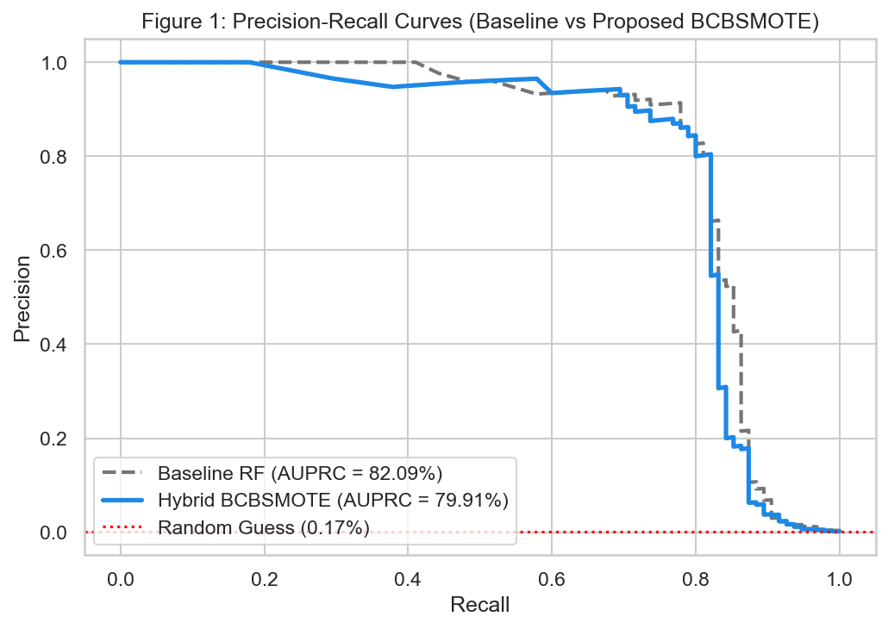
Figure 1: Precision-Recall Curve Comparison (Baseline vs Proposed BCBSMOTE).
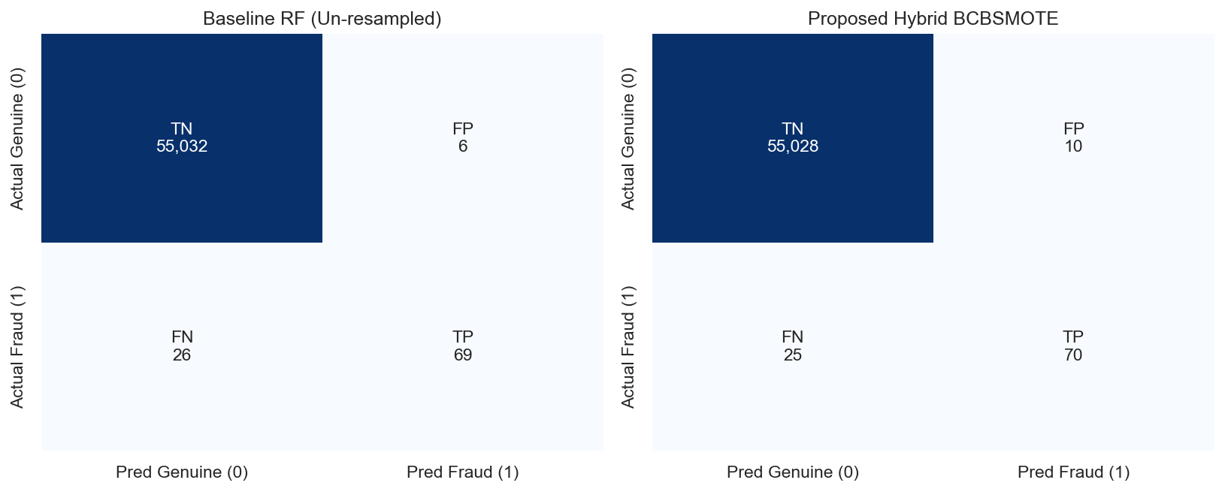
Figure 2: Confusion Matrix Side-by-Side Comparison on European Cardholders Test Set.
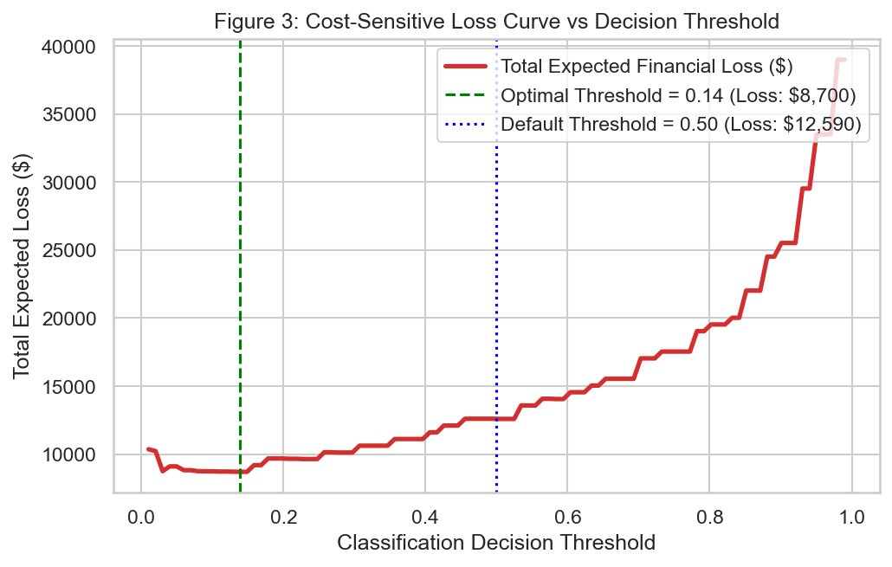
Figure 3: Cost-Sensitive Expected Financial Loss vs Classification Threshold.
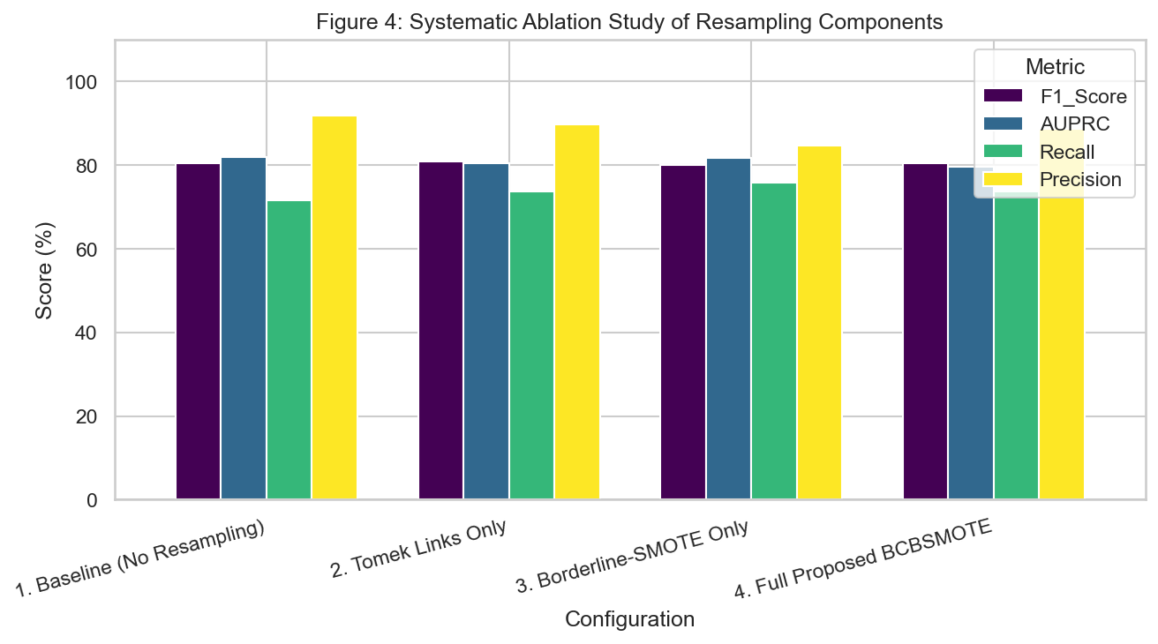
Figure 4: Four-Stage Systematic Ablation Study Performance Comparison.
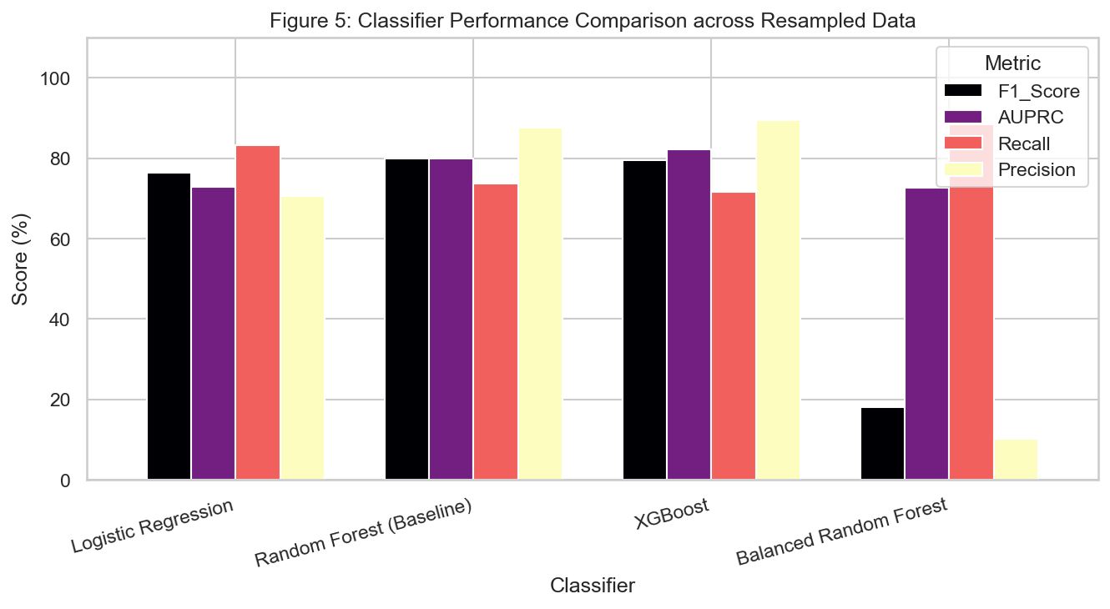
Figure 5: Alternative Model Architecture Performance Benchmarking.
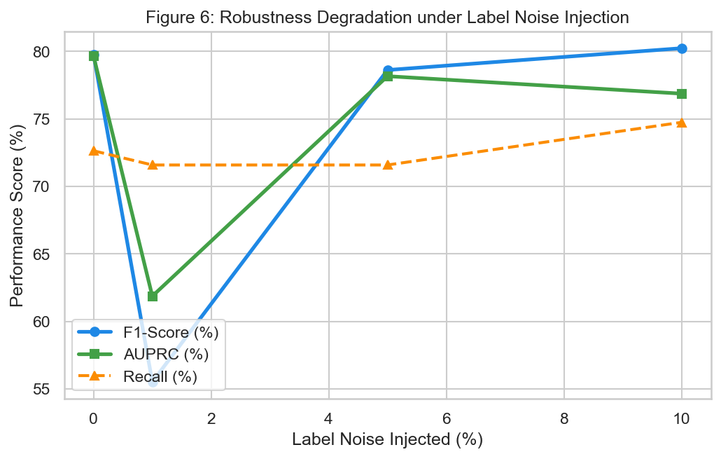
Figure 6: Robustness Degradation under Label Noise Injection (0% to 10%).

