KANDY INNOVATION CENTER
NATIONAL INSTITUTE OF BUSINESS MANAGEMENT
BACHELOR OF SCIENCE IN COMPUTER SCIENCE WITH AI

Individual Project Report

A Citation-Grounded AI Assistant for Sri Lanka's Motor Traffic Law

The Assignment Submitted by
I U Amarasinghe
(KIC-BSCCSAI-251P-042)

Date of Submission: 06/11/2026
Abstract
A Citation-Grounded AI Assistant for Sri Lanka's Motor Traffic Law
I U Amarasinghe
Kandy Innovation Centre, National Institute of Business Management (NIBM)
isuruamarasinghe02@gmail.com
Sri Lanka's motor traffic law is spread across the Motor Traffic Act No. 14 of 1951, its amendments and many extraordinary gazettes, and general-purpose chatbots often invent section numbers and fine amounts. This project built and evaluated an assistant that answers plain-English questions only from verified statutory text, cites the exact provision, and refuses questions outside motor traffic law.
The dataset is a hand-verified corpus of 991 section-level records (520 from the consolidated Act, 461 from 18 extraordinary gazettes and 10 from three official procedural guides), produced from 29 collected source documents by a structure-aware parser with an OCR number-verification step. Evaluation used 60 realistic citizen questions, split deterministically into an 18-question development set and a 42-question frozen test set whose SHA-256 checksum was recorded before final testing.
The system combines dense retrieval (OpenAI text-embedding-3-small in Chroma) and BM25 through Reciprocal Rank Fusion, with LLM query rewriting, inside a LangGraph pipeline of scope classification, a dev-calibrated confidence gate, grounded generation with gpt-4o-mini, and programmatic citation and number verification. It was compared with the same generator answering without retrieval.
On the frozen set the grounded system scored a mean faithfulness of 1.929 / 2.000 against 0.333 for the ungrounded baseline, and its invented-number rate fell from 76.2% to 0.0%. All seven out-of-scope questions were refused (100%), but six of 35 in-scope or edge questions were also refused (17.1%). Retrieval remains the main weakness: the best variant (hybrid + rewrite) reached MRR 0.391 and Recall@5 0.467, and 12 of 30 answerable questions ended as “not found”. Strict grounding and verification make a domain-scoped legal assistant safe in what it says; bridging citizen vocabulary and statutory drafting is the key to making it consistently useful.
Table of Contents
Abstract ii
Table of Contents iii
List of Tables v
List of Figures v
Chapter 01: INTRODUCTION 1
1.1. Background of the study 1
1.2. Justification of the problem 2
1.3. Objectives of the study 2
Chapter 02: LITERATURE REVIEW 4
2.1. Retrieval-augmented generation and domain-scoped legal assistants 4
2.2. Structured representations and small-corpus legal retrieval 5
2.3. Comparative evaluation of legal AI in Sri Lanka 6
2.4. Research gap and evaluation methods adopted 6
Chapter 03: METHODOLOGY 8
3.1. Data Collection 8
3.2. Data Preprocessing 9
3.3. System design and methods 10
3.3.1. Indexing and hybrid retrieval 10
3.3.2. Scope classification and confidence gating 11
3.3.3. Grounded generation and citation verification 11
3.3.4. Application interface 12
3.3.5. Evaluation design 14
Chapter 04: RESULTS 16
4.1. Data Preprocessing 16
4.2. Exploratory Data Analysis 16
4.3. Project outcomes 17
4.3.1. RQ1: Retrieval accuracy 17
4.3.2. RQ2: Faithfulness and hallucination 18
4.3.3. RQ3: Scope restriction 20
4.3.4. Overall behaviour on the frozen set 20
4.4. Comparison of results 21
Chapter 05: DISCUSSION 23
5.1. Interpretation of findings 23
5.2. Error analysis 23
5.3. Technical decisions 24
5.4. Limitations 25
5.5. Ethical considerations 26
Chapter 06: CONCLUSION 27
References 29
Appendix 31

List of Tables
Table 2.1: Positioning of this project against the reviewed literature 7
Table 3.1: Outline of the data: collected legal sources 8
Table 3.2: Composition of the frozen test set 9
Table 4.1: Corpus produced by preprocessing 16
Table 4.2: Retrieval performance on the frozen set (30 questions with gold sections) 17
Table 4.3: Faithfulness on the frozen set: proposed RAG vs. ungrounded baseline (n = 42) 18
Table 4.4: Scope-restriction results on the frozen set 20
Table 4.5: Outcome categories on the frozen set 21
Table 4.6: Feature comparison with existing approaches 22

List of Figures
Figure 3.1: Architecture of the LangGraph question-answering pipeline 10
Figure 3.2: Home screen with question box, topic suggestions and navigation sidebar 13
Figure 3.3: A grounded answer (status: answered, verified citation) with the verbatim source drawer open 13
Figure 3.4: Statute library listing the official instruments with an in-browser reader 14
Figure 3.5: Spot-fine calculator view 14
Figure 4.1: Distribution of the 991 verified records by source 17
Figure 4.2: Retrieval variants on the frozen set: P@1, MRR and Recall@5 18
Figure 4.3: Faithfulness score distribution and invented-number rate, baseline vs. proposed system 19
Figure 4.4: Outcome of each frozen-set question 21

INTRODUCTION
This chapter introduces the problem of access to motor traffic law in Sri Lanka, explains why general-purpose language models are unsafe for it, and sets out the research questions, objectives and scope of the project.
  - Background of the study
Road use touches almost every Sri Lankan household. Drivers, riders and vehicle owners regularly need answers to concrete legal questions: how long they have to pay a spot fine, what helmet is legally acceptable, how to transfer ownership after buying a used vehicle, or what the speed limit is on a particular class of road. The governing law is the Motor Traffic Act No. 14 of 1951, which has been amended many times and is supplemented by subsidiary regulations published as extraordinary gazettes on subjects such as speed limits, protective helmets, horns and noise, emission testing, spot fines and expressway rules.
For an ordinary citizen this body of law is hard to use. The text is long and written in formal drafting language, the relevant rule is often split between the principal Act and one or more gazettes, and older gazettes exist only as scanned images. Official portals provide the documents but only keyword search, so the citizen must already know the statutory term (for example “silencing device” rather than “loud exhaust”) to find anything.
Large language models (LLMs) appear to solve this problem because they accept everyday language and reply fluently. However, an LLM answering from its internal (parametric) memory has no reliable knowledge of local subsidiary legislation and is known to hallucinate: to produce confident statements, citations and numbers that are not supported by any source (Dahl et al., 2024; Magesh et al., 2024). In law, an invented fine amount or a non-existent section number is not a cosmetic error; it can mislead a citizen in a real dispute.
Retrieval-Augmented Generation (RAG) addresses this by retrieving relevant passages from a trusted corpus and conditioning the model's answer on them (Lewis et al., 2020). This project applies RAG to a single, well-defined legal domain, Sri Lanka's motor traffic law, and adds controls that general RAG systems lack: section-level citations that are checked programmatically, a confidence gate that prefers “not found” to a guess, and an explicit scope classifier that refuses unrelated questions.
  - Justification of the problem
Three observations justify the project.
- The law is fragmented. The project collected 29 source documents for this one domain: the consolidated Act (2024 edition), seven amending Acts, eighteen extraordinary gazettes and three official procedural guides (Section 3.1). A citizen cannot be expected to know which of these applies to a question.
- Ungrounded LLMs invent legal facts. In this project's own frozen-set baseline, gpt-4o-mini answering without retrieval included at least one unsupported number (fine, limit, period or age) in 32 of 42 answers (76.2%), and attempted to answer every out-of-scope question it was given (Section 4.3).
- Existing local tools do not show their evidence. Publicly accessible Sri Lankan legal AI tools such as LankaLAW AI Assistant and Aythiya answer in natural language across general law. In the project's informal checks they did not present the verbatim statutory text behind an answer or restrict themselves to a defined domain (Amarasinghe, 2026).
A useful assistant for this domain therefore has to do four things at once: understand lay phrasing, find the right provision, explain it plainly using only that provision, and show the provision so that the citizen can check it. Where it cannot do so it must say so. The system provides legal information, not legal advice, and displays a disclaimer to that effect with every answer.
  - Objectives of the study
Aim. To design, implement and evaluate a citation-grounded, scope-restricted AI assistant that answers citizen questions about Sri Lanka's Motor Traffic Act and related regulations using only verified statutory text.
Specific objectives.
- Collect the Act, its amendments, relevant gazettes and official procedural guides from public sources, record their provenance, and verify every number extracted by OCR against the scans.
- Convert the verified text into section-level records that keep their statutory hierarchy and citation.
- Build hybrid dense + BM25 retrieval with query rewriting, and measure it with precision@k, recall@k and MRR.
- Implement a LangGraph pipeline with scope checking, confidence gating, grounded generation and programmatic citation verification, exposed through a FastAPI service and a React web interface.
- Evaluate faithfulness and scope restriction on a frozen test set against an ungrounded baseline, using an LLM judge checked against human ratings.
Research questions.
- RQ1: Can RAG retrieve the correct statutory section for a citizen query with high accuracy (precision@k, recall@k, MRR)?
- RQ2: Does strict grounding reduce hallucination compared with an ungrounded LLM (faithfulness and invented-number rate)?
- RQ3: Can the system distinguish in-scope from out-of-scope queries and refuse correctly (scope-restriction rate)?
Scope. The system is English-only and limited to motor traffic law. It uses only publicly available legal text, stores no personal data and has no user accounts. Sinhala and Tamil retrieval, and other areas of law, are outside the scope and are discussed as future work.

LITERATURE REVIEW
This chapter reviews the research that the project builds on, organised into three themes from the project's literature review: foundational RAG and domain-scoped legal assistants; structured representations and small-corpus legal retrieval; and comparative evaluation of legal AI in Sri Lanka. It closes with the research gap and the evaluation methods carried forward into this study.
  - Retrieval-augmented generation and domain-scoped legal assistants
Lewis et al. (2020) introduced Retrieval-Augmented Generation, combining a pre-trained sequence-to-sequence generator (BART-large, 406 million parameters) with a non-parametric memory: a Dense Passage Retrieval bi-encoder (BERT-base) searching a 21-million-passage Wikipedia index with HNSW approximate nearest-neighbour search. Its two variants, RAG-Sequence and RAG-Token, produced more factual, specific and diverse output than parametric-only models on open-domain QA (Natural Questions, TriviaQA, WebQuestions, CuratedTrec), MS-MARCO, Jeopardy question generation and FEVER, without retraining the generator. The design, however, targets broad encyclopaedic knowledge: it has no notion of jurisdiction-specific citation or section-level provenance, no mechanism to detect and refuse out-of-scope questions, and it was not tested on specialised legal text.
Socatiyanurak et al. (2021) moved legal assistance into a narrow domain with LAW-U, a LINE chatbot that guides survivors of sexual violence in Thailand. LAW-U combines a finite-state dialogue manager with spaCy embedding similarity, TF-IDF keyword extraction and WordNet synonym expansion over 182 Thai Supreme Court decisions on Sections 276–279 of the Thai Criminal Code. The combined similarity, keyword and synonym configuration reached 73.94% top-1 and 78.18% top-3 match accuracy (88.89% exact match on hold-out data), against 29.09% top-1 for unweighted word similarity. The study shows the value of a curated, domain-scoped knowledge base for lay users, but it relies on rigid dialogue trees and static matching rather than generative explanation, uses precedents instead of primary statutes, and provides no section-level citation of statutory provisions.
Taken together, these works mark the move from open-domain RAG to specialised legal assistance, and leave open the combination this project targets: generative, plain-language explanation that is grounded in and cites the exact statutory section, together with explicit refusal of questions outside the domain.
  - Structured representations and small-corpus legal retrieval
Wiratunga et al. (2024) addressed the weakness of unstructured chunking in legal RAG with CBR-RAG, which brings the retrieval stage, indexing vocabulary and similarity knowledge of Case-Based Reasoning into the RAG prompt. On the Australian Open Legal QA dataset (2,124 question–answer–snippet triplets generated by GPT-4) they used dual case embeddings (intra- and inter-embeddings) and compared BERT, LegalBERT and AnglEBERT with a Mistral-7B generator. Case reuse with AnglEBERT hybrid embeddings and k = 3 achieved the highest semantic similarity to reference answers (0.9141 vs. 0.8967 without retrieval, +1.94%), supporting the view that structured, multi-attribute representations outperform plain text chunks. Limitations include a synthetic rather than real lay-user dataset, whole-case context instead of section-level indexing, manually tuned attribute weights, and no evaluation of citation grounding or scope restriction.
Li et al. (2024) shifted attention to authentic lay questions with LegalQA: 323 questions from public advice forums, paired with expert-vetted answers and supporting citations. Retrieving with BAAI/bge-large-en-v1.5 from only 850 curated legal citations matched internet-wide Google retrieval, reducing GPT-3.5 factual disagreement from 11.8% (no RAG) to 8.7%, compared with 8.3% for full web retrieval, as judged by a GPT-4 “LLM-as-a-judge”. A small, curated corpus therefore keeps the legal context that matters while lowering cost and noise and allowing human review. The study covered broad North American topics with single-document retrieval and did not test statutory section-level provenance or low-resource South Asian legislation.
These findings motivate two design decisions in this project: building a small, expert-verified corpus rather than searching the open web, and representing it as section-addressable records that carry their Act, Part, section and heading, so that retrieval returns a citable legal unit rather than an arbitrary chunk.
  - Comparative evaluation of legal AI in Sri Lanka
Athulathmudali (2025) built an AI-driven legal guidance system for Sri Lankan civil law and compared a proprietary backend (GPT-3.5-Turbo) with an open-source one (Mistral-7B-v0.1) under the same RAG pipeline (k = 3 retrieval with Chroma) on 40 held-out queries on topics such as family law and fundamental rights. GPT-3.5-Turbo was correct on 37 of 40 queries (92.5%) with 4.17 s mean latency and the lowest cost per correct answer (US$0.000527); Mistral-7B on an L4 GPU reached 82.5% (33/40) at 15.64 s and US$0.000900 per correct answer, but offers data sovereignty for institutional use. The study reports scenario-level accuracy only: it does not measure whether answers cite the correct statutory section, does not test refusal of out-of-scope questions, and does not cover high-frequency regulatory domains such as traffic law.
The project proposal (Amarasinghe, 2026) adopts this comparative design for motor traffic law, adding a no-retrieval baseline that isolates the contribution of grounding, an intended comparison with public Sri Lankan legal AI tools, and metrics for section-level retrieval, citation faithfulness and scope restriction.
  - Research gap and evaluation methods adopted
Three patterns emerge from the literature: a shift from open-web retrieval towards small, curated legal corpora (Socatiyanurak et al., 2021; Li et al., 2024; Athulathmudali, 2025); evidence that structured representations beat unstructured chunking in legal QA (Wiratunga et al., 2024); and consistent accuracy, latency and cost trade-offs between proprietary and open-source backends (Li et al., 2024; Athulathmudali, 2025). What is missing is a citation-grounded, scope-restricted assistant for Sri Lankan statutory and subsidiary legislation that is evaluated on section-level retrieval, citation faithfulness and refusal behaviour. Table 2.1 summarises the positioning of this project.
Table 2.1: Positioning of this project against the reviewed literature
Study | Domain / corpus | Generative | Section-level citation | Scope refusal
Lewis et al. (2020) | Open-domain, 21M Wikipedia passages | Yes | No | No
Socatiyanurak et al. (2021) | Thai criminal law, 182 precedents | No (rule-based) | No | No
Wiratunga et al. (2024) | Australian legal QA (synthetic) | Yes | No | No
Li et al. (2024) | North American lay questions, 850 citations | Yes | No | No
Athulathmudali (2025) | Sri Lankan civil law scenarios | Yes | Not measured | No
This project | Sri Lankan Motor Traffic Act + 18 gazettes, 991 sections | Yes | Yes (verified) | Yes (classifier)

The evaluation methods carried forward from the literature are:
- Retrieval accuracy: precision@k, recall@k and MRR against gold sections (Lewis et al., 2020; Athulathmudali, 2025).
- Multi-tier faithfulness evaluation: human review, inter-rater agreement and an LLM-as-a-judge (Li et al., 2024; Zheng et al., 2023).
- Comparative baselines: an ungrounded LLM using the same generator and, qualitatively, public Sri Lankan legal AI tools (Athulathmudali, 2025).
- Scope-restriction rate: the proportion of out-of-scope questions correctly refused.

METHODOLOGY
The study follows a design-science approach: an artefact (the assistant) is built and then evaluated experimentally against a baseline on a held-out test set. The evaluation set was written before the system was built, and the frozen portion was only used for the final run. The system is implemented in Python 3.11 (FastAPI, LangGraph, Chroma, rank_bm25, OpenAI APIs) with a React + Tailwind CSS front end, and tested with pytest (74 test functions across 14 files) and linted with ruff.
  - Data Collection
All legal text came from publicly available official sources (LawNet / Ministry of Justice, the Department of Government Printing, the Department of Motor Traffic and Sri Lanka Police). Each file is stored read-only in data/raw/ and logged in data/raw/SOURCES.md with its publisher, date sourced and verification status. No legal text was written or completed from memory. Table 3.1 outlines the collection.
Table 3.1: Outline of the data: collected legal sources
Category | Files | Examples | Use in the corpus
Principal Act | 1 | Motor Traffic Act (Chapter 203 / Act No. 14 of 1951), consolidated edition 2024 | 520 section records
Amending Acts | 7 | Act No. 31 of 1979, 21 of 1981, 44 of 1992, 12 of 2005, 8 of 2009, 18 of 2017, 10 of 2019 | Reference; their effect is incorporated in the 2024 consolidated text
Extraordinary gazettes | 18 | 1738/37 (horns & decibel limits), 1775/32 (speed limits), 2054/09 (spot fines), 2287/28 (protective helmets), 2306/02 (DMT fees), 2455/29 (expressway seat belts) | 461 records
Procedural guides | 3 | DMT foreign-licence circular 2022-14; DMT registration & transfer guide; Police spot-fine payment & appeal guide | 10 records
Total | 29 |  | 991 verified records

Evaluation questions. Sixty realistic citizen questions were drafted and approved before the corpus was processed, following a written labelling rubric. They include plain-language and wrong-terminology phrasings, multi-section questions, “edge” questions near the domain boundary, questions whose answer is not in the corpus, and clearly out-of-scope questions (e.g. land deeds, divorce, a cake recipe). Each question records its type, gold section IDs and expected behaviour (answer_with_citation, say_not_found or refuse). A deterministic split (seed 42) produced an 18-question development set and a 42-question frozen set; the frozen file's SHA-256 (b0733bf5…e55f3) was recorded and the file made read-only.
Table 3.2: Composition of the frozen test set
Question type | Expected behaviour | Count
In-scope | Answer with citation | 23
Edge (near the domain boundary) | Answer with citation | 7
In-scope, answer not in corpus | Say not found | 5
Out-of-scope | Refuse | 7
Total |  | 42

  - Data Preprocessing
Text extraction and OCR. Machine-readable PDFs were extracted with PyMuPDF; scanned gazette schedules were rendered at high resolution and processed with RapidOCR. Outputs were written to data/interim/ with a log per file.
Number verification. Because a single wrong digit changes the law, a number-report script (src/ingest/number_report.py) lists every number, currency amount, decibel value, date and section reference found in the extracted text. Flagged items were checked by hand against the scans and corrected only by a human decision, never by assumption.
Structure-aware chunking. Instead of fixed-size character chunks, a parser (src/chunking/parser.py) follows the statutory hierarchy (Act → Part → Section → Subsection, or Gazette → Regulation / Schedule) and emits one record per legal unit. Each record carries its citation string, heading, parent context, the definitions it relies on, a regulation category and its source file (Appendix A). Tests check that no subsection is separated from its parent context, that no record has empty text and that IDs are unique. Only records marked verified: true are indexed; all 991 records meet this condition.
  - System design and methods
Figure 3.1 shows the request flow. A question passes through five LangGraph nodes; three of them can end the flow early with a safe response, so the generator is reached only for in-scope questions with adequate retrieval support.
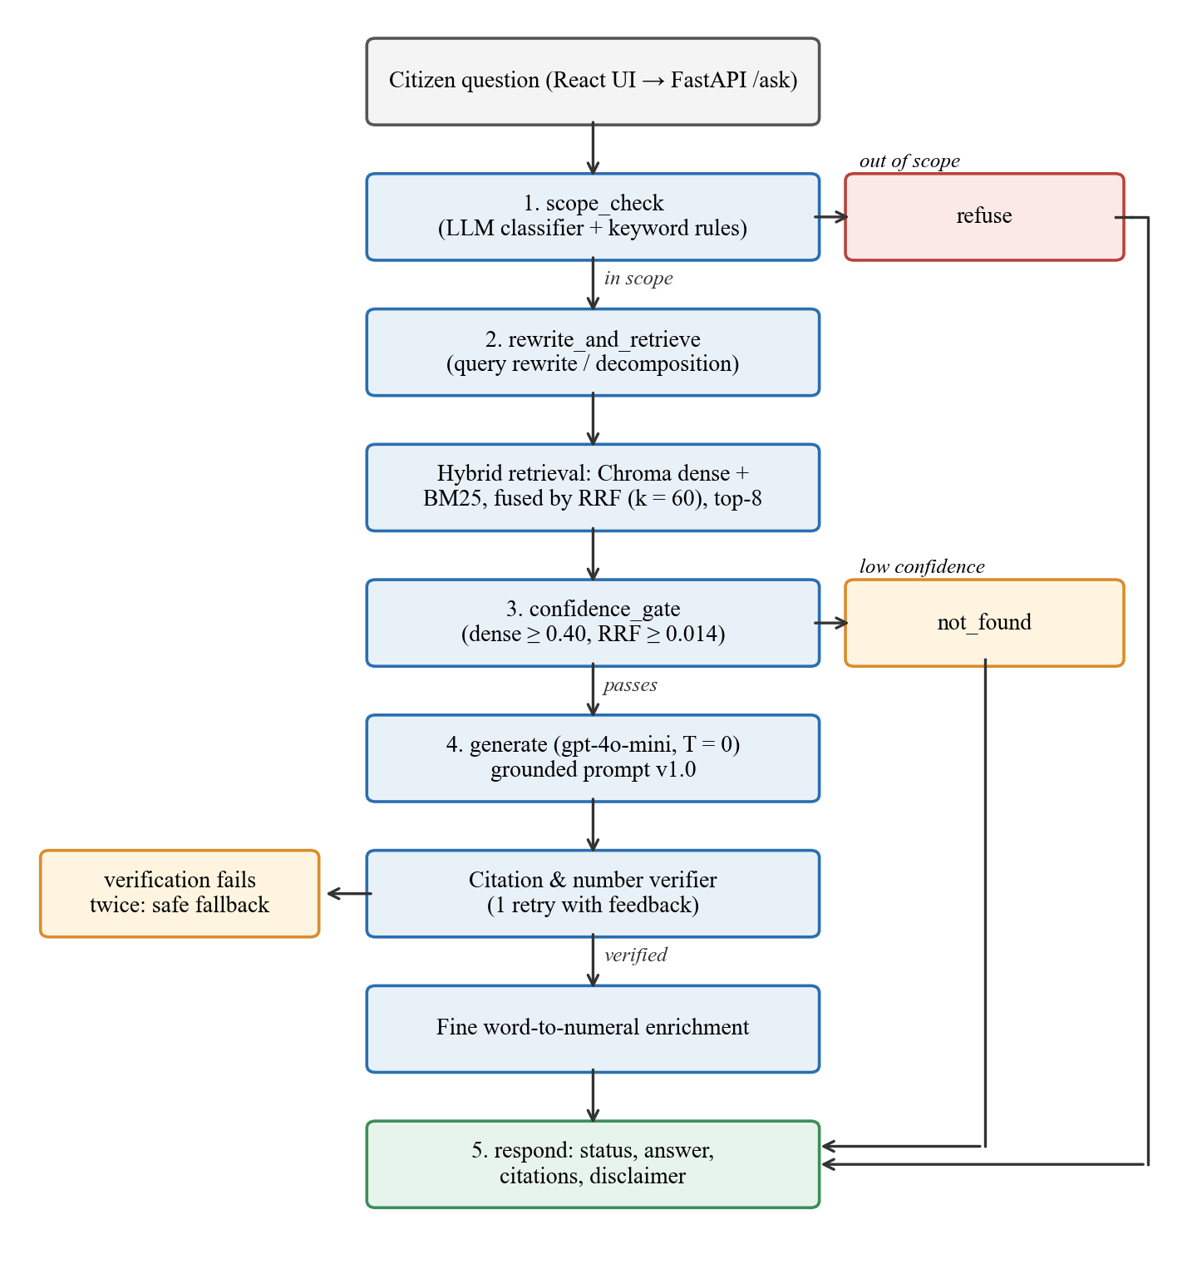
Figure 3.1: Architecture of the LangGraph question-answering pipeline
    - Indexing and hybrid retrieval
Each record is embedded with OpenAI text-embedding-3-small (1,536 dimensions) and stored in a persistent Chroma collection with metadata (Act, section, instrument type, category). An embedding cache means a re-run makes no API calls for unchanged records. A BM25 index (Okapi BM25, rank_bm25) is built over the same units so that exact terms such as a section number or a form name are matched lexically.
The two ranked lists are fused with Reciprocal Rank Fusion (Cormack et al., 2009). With rank r_dense(d) and r_bm25(d) for document d, the fused score is RRF(d) = w_d / (k + r_dense(d)) + w_b / (k + r_bm25(d)), using k = 60 and equal weights w_d = w_b = 0.5 (from configs/base.yaml). The top 8 fused sections are passed on.
Because citizens rarely use statutory wording, a query-rewriting step (gpt-4o-mini with a rule-based fallback) rewrites the question into statutory vocabulary and, for compound questions, decomposes it into two or three single-topic sub-queries. The original and rewritten queries are both logged for analysis.
At the current corpus size an exact brute-force cosine search would also be feasible; Section 4.4 reports a small comparison between exact search and Chroma's HNSW index (Malkov & Yashunin, 2020).
    - Scope classification and confidence gating
The first node, scope_check, combines a keyword rule list with an LLM classifier prompted with explicit in-scope topics (registration, licences, road rules, offences and fines, vehicle standards, accidents, seizure) and out-of-scope topics (tenancy, employment, family law, non-driving criminal law, tax and customs, company law). Out-of-scope questions receive a fixed refusal message without any retrieval.
After retrieval, confidence_gate routes to not_found unless the best dense similarity is at least 0.40 and the best fused RRF score at least 0.014. The thresholds were calibrated on the development set only: the lowest in-scope dense score there was 0.4302 and the highest out-of-scope score 0.3730.
    - Grounded generation and citation verification
The generator (gpt-4o-mini, temperature 0, prompt version 1.0) receives only the retrieved sections and is instructed to answer in plain English, cite section IDs, quote the key clause and say that the provision was not found if the text does not answer the question. Its output is then checked by a deterministic verifier (src/generation/verifier.py) that enforces three rules:
- every cited ID exists in the corpus registry;
- every cited ID is in the set retrieved for this question;
- every statutory number in the answer (fine, speed, decibel level, time limit) is present in the retrieved text.
If verification fails, the model is asked once more with the failure reason as feedback; a second failure returns a safe fallback message instead of an unverified answer. Finally, fine amounts written in statutory words (e.g. “twenty-five thousand rupees”) are annotated with numerals by a fixed lookup table, so that no arithmetic is left to the model. Every response follows the API contract in Appendix B and always includes the disclaimer.
    - Application interface
A FastAPI service exposes /ask, /sections, /resources and related endpoints, and a React + Tailwind interface provides a chat stream with a conversation history sidebar, a status badge on every answer (answered / not found / refused), a right-hand source drawer showing the verbatim text of each cited provision, a statute library with an in-browser reader for the official PDFs, and a spot-fine calculator. Each follow-up question is sent to the back end as an independent request, so earlier turns cannot leak unretrieved content into a new answer. The interface can also translate an already-verified English answer into Sinhala or Tamil on request; this is a convenience feature outside the evaluated English pipeline. Figures 3.2 to 3.5 show the implemented interface.

Figure 3.2: Home screen with question box, topic suggestions and navigation sidebar
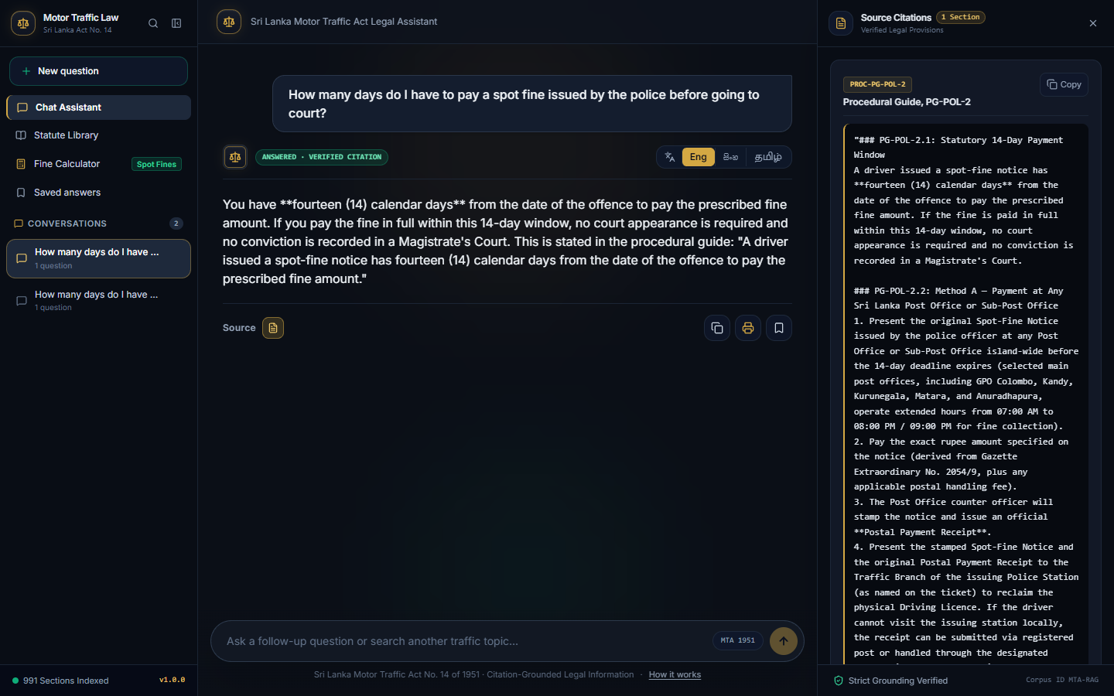
Figure 3.3: A grounded answer (status: answered, verified citation) with the verbatim source drawer open
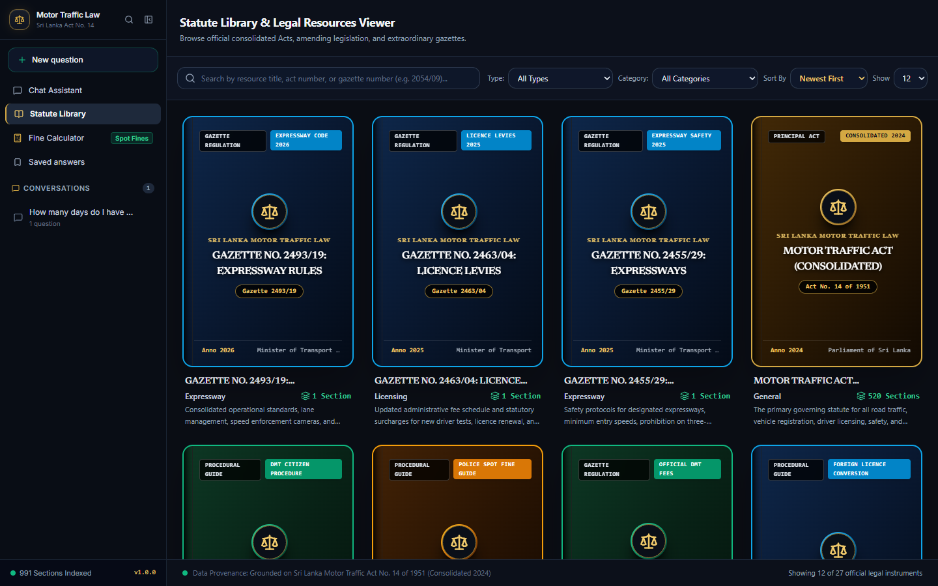
Figure 3.4: Statute library listing the official instruments with an in-browser reader

Figure 3.5: Spot-fine calculator view
    - Evaluation design
Four experiments address the research questions. All final numbers come from a single run on the frozen set (git commit ac414ae), except the retrieval-variant comparison, which was run separately (commit 5a47174).
- Retrieval benchmark (RQ1): dense only, BM25 only, hybrid RRF and hybrid + rewrite, scored with P@k and R@k for k ∈ {1, 3, 5} and MRR on the 30 frozen questions that have gold sections.
- Faithfulness benchmark (RQ2): each answer is scored 0 (ungrounded / hallucinated), 1 (partially grounded) or 2 (fully grounded) using a written rubric. Any number not supported by the retrieved text forces a score of 0 and sets an invented_number flag. Scoring is done by an LLM judge (gpt-4o) given the question, retrieved passages, answer and citations. For the baseline, the judge was given the corpus passages relevant to the question.
- Ungrounded baseline: the same generator (gpt-4o-mini) answering from parametric memory without retrieval, scored by the same judge.
- Scope benchmark (RQ3): scope-restriction rate (out-of-scope questions refused) and false-refusal rate (in-scope and edge questions refused).
- Judge validation: the judge's scores on the 18 dev answers were compared with a human rater, and a second (peer) human rater re-scored a 10-question subset; agreement is reported as exact agreement and Cohen's weighted kappa (Cohen, 1968; Landis & Koch, 1977).

RESULTS
This chapter presents the corpus produced by preprocessing, describes the corpus and test set, and reports the results for each research question, followed by comparisons with the baseline, the literature and existing tools.
  - Data Preprocessing
The pipeline processed all 29 collected documents. Twenty-two of them produced index records: the consolidated Act, all 18 gazettes and the 3 procedural guides. The seven amending Acts are kept as references because their amendments are already incorporated in the 2024 consolidated text; indexing them separately would duplicate superseded wording. Table 4.1 summarises the output.
Table 4.1: Corpus produced by preprocessing
Measure | Value
Collected source documents | 29 (1 Act, 7 amending Acts, 18 gazettes, 3 guides)
Documents contributing records | 22
Section records (all verified: true) | 991
from the consolidated Act | 520
from gazette regulations | 461
from procedural guides | 10
Records with a citation and source file | 991 (100%)
OCR numeric errors found in the final corpus during error analysis | 0

  - Exploratory Data Analysis
The corpus is uneven (Figure 4.1). The consolidated Act supplies just over half of all records. Two gazettes dominate the subsidiary legislation: Gazette 1775/32 on speed limits (163 records, largely road-by-road schedules) and Gazette 2306/02 on DMT fees (156 records). Several important gazettes contribute only one or two records, for example Gazette 2455/29 on expressway seat belts.
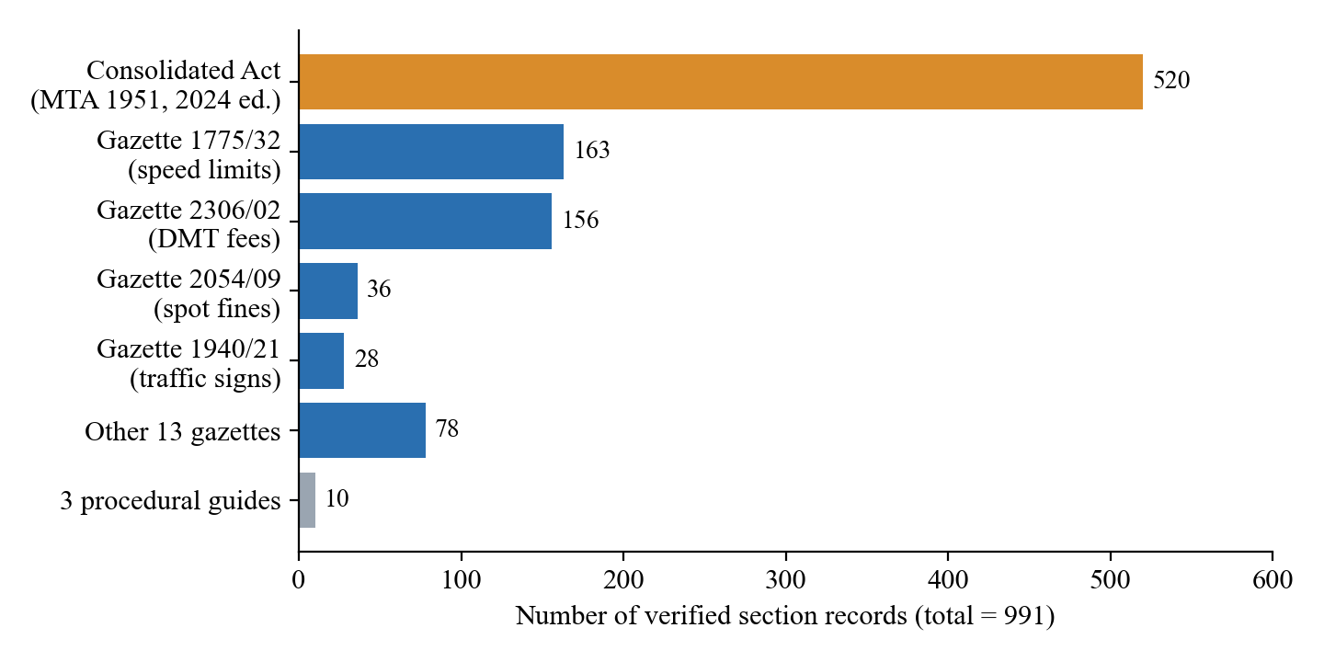
Figure 4.1: Distribution of the 991 verified records by source
By regulation category the records are registration (274), offences (246), other (198), fitness (117), licensing (95), procedure (36) and noise (25). This imbalance matters for retrieval: a query about a topic with many near-duplicate schedule rows (speed limits, fees) competes with many similar candidates, while a topic covered by a single short regulation has only one chance to be retrieved.
  - Project outcomes
    - RQ1: Retrieval accuracy
Table 4.2 and Figure 4.2 compare the four retrieval variants on the 30 answerable frozen questions.
Table 4.2: Retrieval performance on the frozen set (30 questions with gold sections)
Variant | MRR | P@1 | R@1 | P@3 | R@3 | P@5 | R@5
Dense only | 0.380 | 0.267 | 0.217 | 0.222 | 0.383 | 0.173 | 0.467
BM25 only | 0.259 | 0.167 | 0.117 | 0.144 | 0.283 | 0.107 | 0.367
Hybrid (RRF) | 0.362 | 0.267 | 0.183 | 0.178 | 0.350 | 0.140 | 0.400
Hybrid + rewrite | 0.391 | 0.267 | 0.183 | 0.211 | 0.350 | 0.180 | 0.467

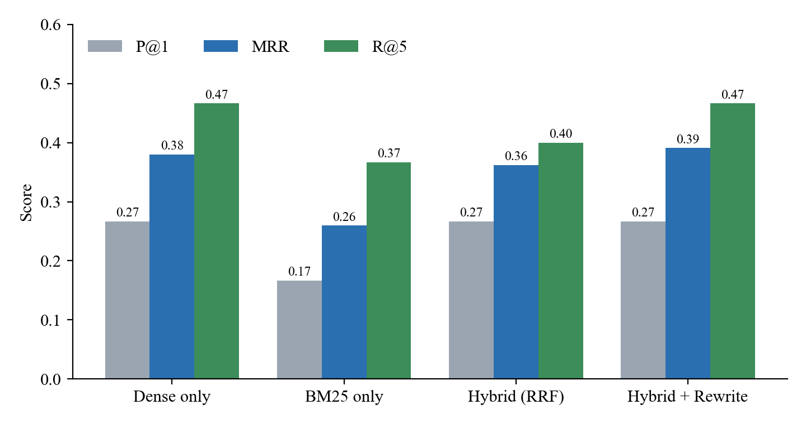
Figure 4.2: Retrieval variants on the frozen set: P@1, MRR and Recall@5
Hybrid retrieval with query rewriting gave the highest MRR (0.391) and tied with dense-only retrieval on Recall@5 (0.467). BM25 alone was weakest, and plain RRF fusion did not improve on dense retrieval; the gain came from rewriting lay questions into statutory language. The development set showed the same ordering, with hybrid + rewrite best or tied-best on every metric (MRR 0.330, R@5 0.400). Even the best variant, however, placed a gold section in the top five for fewer than half of the questions.
The end-to-end run, which records the sections present in the pipeline's final state, gave lower figures (MRR 0.155, P@1 0.067, R@5 0.167). Part of the gap is mechanical (a question refused by the scope node has no retrieved sections, and sub-query decomposition changes the final ranking), and the two runs used different code versions. The exact cause was not isolated in this study, so both figures are reported.
    - RQ2: Faithfulness and hallucination
Table 4.3: Faithfulness on the frozen set: proposed RAG vs. ungrounded baseline (n = 42)
Measure | Ungrounded baseline | Proposed RAG
Mean faithfulness score (0–2) | 0.333 | 1.929
Fully grounded (score 2) | 7 (16.7%) | 40 (95.2%)
Partially grounded (score 1) | 0 (0.0%) | 1 (2.4%)
Ungrounded / hallucinated (score 0) | 35 (83.3%) | 1 (2.4%)
Answers with an invented number | 32 (76.2%) | 0 (0.0%)
Mean score on the 17 questions the RAG system answered | – | 1.824

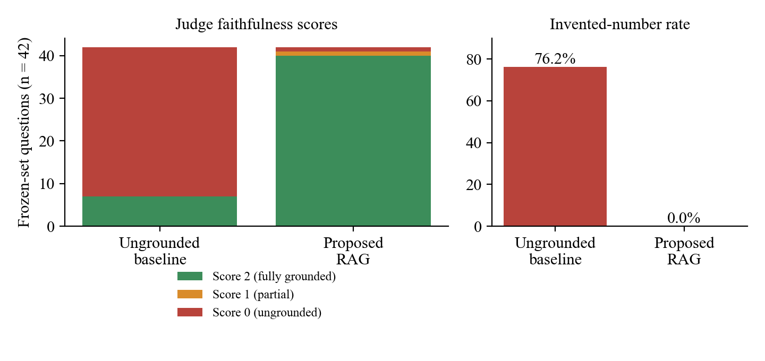
Figure 4.3: Faithfulness score distribution and invented-number rate, baseline vs. proposed system
Grounding produced a large change. The baseline's typical failures were plausible but unsupported specifics: a silencer limit of “80 decibels” (Q001), a 50 km/h built-up-area limit (Q002, Q006), seat-belt duties attributed to a Section 192 (Q003), a three-month temporary-permit validity (Q015) and an “LKR 2,500” speeding fine (Q031), none of which the judge could find in the corpus. The proposed system produced no answer with an unsupported number.
The headline mean of 1.929 needs to be read with care. Under the rubric, a correct “not found” or a refusal is fully faithful and scores 2, so 25 of the 42 scores come from responses that made no legal claim. Restricted to the 17 questions the system actually answered, the mean is 1.824 (15 scored 2, Q001 scored 1, Q045 scored 0). This remains far above the baseline and confirms that grounded answers were faithful, but it also shows that part of the safety comes from abstaining.
Judge validation. On the 18 dev answers the gpt-4o judge agreed exactly with the human rater (18/18), and a peer rater agreed with the primary rater on all 10 double-scored questions; both comparisons give weighted kappa = 1.0. However, every one of these items received a score of 2, so the samples contain no variation for the raters to disagree on. Perfect agreement here shows consistency on clearly grounded answers, not the judge's ability to detect hallucination, and should not be over-interpreted (Section 5.4).
    - RQ3: Scope restriction
Table 4.4: Scope-restriction results on the frozen set
Measure | Ungrounded baseline | Proposed RAG
Out-of-scope questions refused (scope-restriction rate) | 0 / 7 (0.0%) | 7 / 7 (100.0%)
In-scope and edge questions refused (false-refusal rate) | 0 / 35 | 6 / 35 (17.1%)
of which answer not in corpus (expected say_not_found) | – | 5
of which answerable (Q036, vehicle damaging a wall on private land) | – | 1

The scope classifier refused every out-of-scope question (land registration, theft, divorce, a geography question, company registration, a recipe and a commercial tenant eviction), while the baseline attempted all of them. It was also conservative: five questions about adjacent law that is not in the corpus (customs tariffs for imported hybrid cars, three-wheeler taxi fares in the Western Province, expressway toll-tag specifications, Motor Traffic Insurance Fund compensation for hit-and-run victims and railway level-crossing barriers) were refused instead of being answered with “not found”. Both responses avoid giving an answer, but the labels differ. One answerable edge question (Q036) was wrongly refused.
    - Overall behaviour on the frozen set
Figure 4.3 classifies the outcome of all 42 frozen questions, recomputed from the itemised benchmark output.
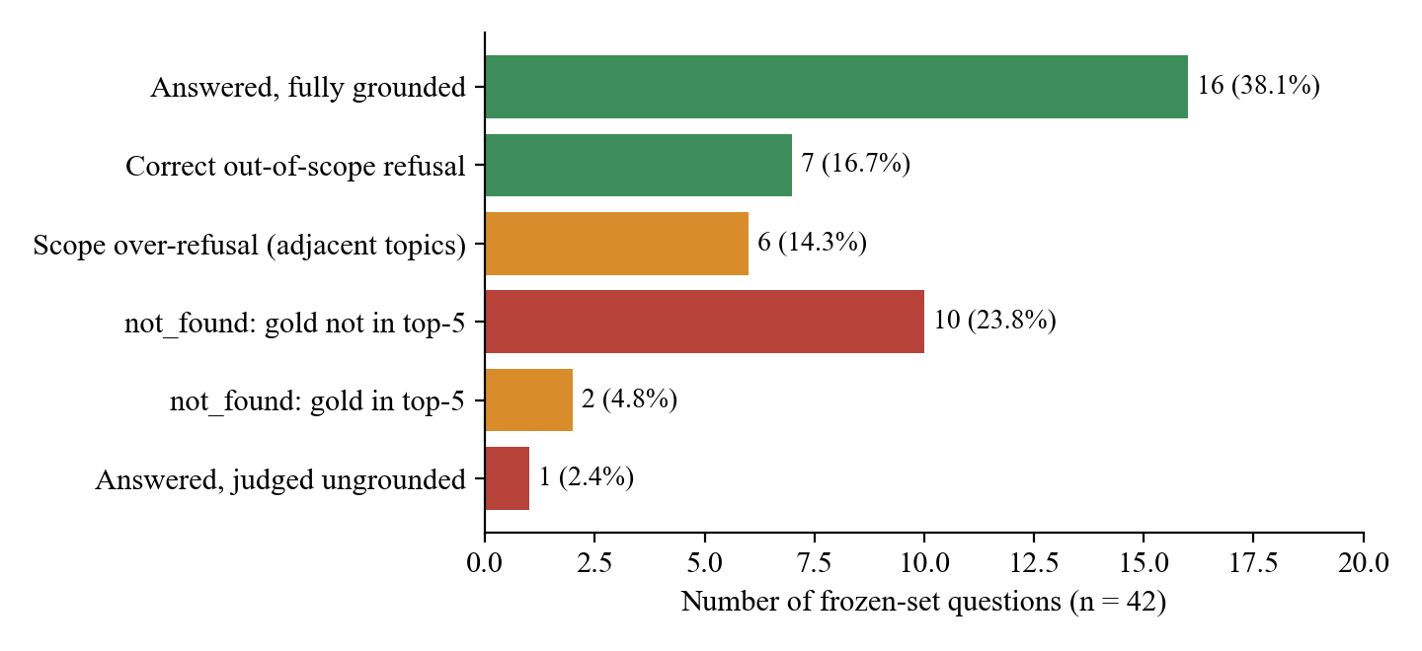
Figure 4.4: Outcome of each frozen-set question
Table 4.5: Outcome categories on the frozen set
Outcome | Count | Share | Questions
Answered and fully grounded | 16 | 38.1% | Q002–Q035 (answered), Q044
Correct out-of-scope refusal | 7 | 16.7% | Q051–Q059
Refused instead of not_found (adjacent law) | 5 | 11.9% | Q046–Q050
Wrongly refused answerable edge question | 1 | 2.4% | Q036
not_found, gold section not in top-5 | 10 | 23.8% | Q014, Q018, Q019, Q023, Q029, Q034, Q037, Q040, Q041, Q042
not_found although a gold section was in the top-5 | 2 | 4.8% | Q028, Q033
Answered but judged ungrounded | 1 | 2.4% | Q045 (hands-free Bluetooth)

Of the 30 questions that expected a cited answer, the system answered 17 (56.7%) and 16 of those answers were fully grounded. Every unanswered case ended in a safe status (not_found or a refusal) rather than a fabricated answer. Q001 (motorcycle silencer noise) cited Section 160 and the Gazette 1738/37 schedule and quoted its decibel figures, but scored 1 because the retrieved text did not make clear that those figures apply to exhaust noise and the citation was at parent-section level.
  - Comparison of results
Against the ungrounded baseline. With the same generator, adding verified retrieval and verification raised mean faithfulness from 0.333 to 1.929, removed invented numbers entirely (76.2% → 0.0%) and introduced reliable refusal (0% → 100%). No statistical significance test was run; with 42 paired items and differences of this size the direction of the effect is not in doubt, but the exact magnitude should be treated as specific to this test set.
Against the literature. Li et al. (2024) reported that RAG over 850 curated citations reduced GPT-3.5 factual disagreement from 11.8% to 8.7%; this project observed a larger reduction, consistent with a narrower domain, verbatim section text and an explicit number check, although the metrics and judges differ and the figures are not directly comparable. Athulathmudali (2025) reported 92.5% scenario-level accuracy for Sri Lankan civil law without measuring citation correctness; this project instead measured citation faithfulness and found that answer coverage (56.7% of answerable questions) rather than answer correctness is the main constraint.
Against existing Sri Lankan tools. Retrieval metrics cannot be measured for black-box tools, so the comparison in Table 4.7 is limited to observable features. An informal spot-check during development suggested that general tools answered out-of-scope and number-specific questions without citing gazettes, but these checks were not run on the frozen set with the same judge and are therefore not reported as scores.
Table 4.6: Feature comparison with existing approaches
Feature | Official portals (LawNet / gazettes) | General legal chatbots (e.g. LankaLAW, Aythiya) | Ungrounded LLM | This system
Plain-language questions | No | Yes | Yes | Yes
Section-level citation checked against a corpus | n/a | No | No | Yes
Verbatim source text shown with answer | Full PDF only | No | No | Yes (source drawer)
Refuses out-of-domain questions | n/a | No (general scope) | No (0/7) | Yes (7/7)
Says “not found” when unsupported | n/a | Not observed | No | Yes

Index type. On an earlier 945-record version of the corpus and 15 queries, exact brute-force search took 0.54 ms on average (P95 1.13 ms) and Chroma's HNSW index 10.86 ms (P95 40.12 ms), with 100% agreement on the top-5 results. At this scale the approximate index brings no accuracy loss and its value lies in persistence and metadata filtering rather than speed.

DISCUSSION
  - Interpretation of findings
RQ2 is clearly supported. Constraining the generator to retrieved statutory text, and checking every citation and number in code, removed the failure that matters most in legal information: confident, specific and wrong numbers. The baseline's errors were not random; they were plausible values drawn from general knowledge or other jurisdictions, which a lay reader could not distinguish from the law. The verifier converts “the model was told not to invent numbers” into “the system cannot return an unsupported number”, which is a stronger guarantee than prompting alone.
RQ3 is supported, with a precision cost. A dedicated scope node in front of retrieval gave perfect refusal of clearly unrelated questions. Its conservatism on adjacent transport topics is arguably appropriate, because those topics are governed by other legislation that is not in the corpus, but it produced one genuine false refusal (Q036, about a vehicle damaging a wall on private land). Scope restriction and helpfulness trade off against each other, and the threshold for “adjacent but not covered” needs a clearer policy.
RQ1 is only partly supported. Retrieval is the bottleneck. A best Recall@5 of 0.467 means that for more than half of the answerable questions the right provision was not among the first five candidates. Because the pipeline is designed to fail safe, poor retrieval shows up as “not found” rather than as hallucination: the system's safety (RQ2) was preserved, but its usefulness was limited. This agrees with Li et al. (2024) that a curated corpus helps, and adds that for statutory text the vocabulary gap between citizens and drafters is the main obstacle.
  - Error analysis
Inspection of the pipeline logs for every non-optimal frozen question identified the following causes.
- Retrieval misses (10 questions). Questions such as which documents a driver must produce when stopped (Q014), whether a three-wheeler can carry four adults (Q018), when headlights are mandatory (Q019) or whether tractors may use expressways (Q041) are phrased in everyday terms, while the gold provisions use formal drafting. The gold section did not reach the top five because more general offence and schedule records ranked higher, and query rewriting did not always bridge the gap.
- Correct section retrieved but not used (2 questions). For Q028 (laminating a revenue licence disc) a gold section was in the top five, but the generator judged that the retrieved text did not address lamination. For Q033 (helmet standards and the helmet spot fine) the answer failed citation verification twice and the safe fallback message was returned. In both cases the system chose caution over a possibly unsupported answer.
- Scope boundary (6 questions). Five adjacent-law questions and one answerable edge question were refused by the scope node (Section 4.3).
- Generation (1 question). For Q045 (hands-free Bluetooth devices) the system quoted Section 152A, which prohibits using a telephone or other movable communication equipment while driving, and concluded that hands-free devices are also prohibited. The provision does not mention hands-free use, so the judge scored this extension 0.
- Corpus integrity (0 questions). No failure was traced to a broken parent context, a severed definition or an OCR digit error, which supports the structure-aware chunking and manual number verification.
  - Technical decisions
RAG rather than fine-tuning. Fine-tuning would still store law in model weights, where it cannot be cited or audited, and every new gazette would require retraining. With RAG, updating the law means adding verified records and re-indexing.
Section-level records rather than fixed-size chunks. Legal meaning depends on the section and its parent context. Keeping each unit whole, with its citation and heading, makes every retrieved item directly citable and made citation verification possible.
Programmatic verification rather than trust in the prompt. Citation IDs and numbers are checked in code against the corpus and the retrieved set, with one retry. This is the mechanism behind the 0% invented-number rate.
Stateless follow-up questions. Each turn is answered independently from fresh retrieval, so text from an earlier answer cannot be presented as support for a later one. The cost is that follow-ups which depend on the previous turn (“and for a motorcycle?”) must be phrased in full.
  - Limitations
- Small test set. 42 frozen questions (30 answerable) give wide uncertainty around every percentage; one question changes a rate by 2.4–3.3 points.
- Judge independence. The project rules call for a judge from a different model family to the generator. The configuration file names a Claude model, but the recorded runs used gpt-4o, which comes from the same provider as the gpt-4o-mini generator. Self-preference bias cannot be ruled out (Zheng et al., 2023).
- Weak judge validation. Human–judge and peer agreement were measured only on items that all received the top score, so kappa does not demonstrate that the judge detects errors. A validation sample containing ungrounded answers (for example from the baseline) is needed.
- Faithfulness includes abstentions. Refusals and not_found responses score 2, which raises the overall mean; the answered-only mean (1.824) is the better measure of answer quality.
- Retrieval discrepancy. The standalone and end-to-end retrieval figures differ, and the runs used different commits; the cause was not isolated.
- Existing-tool comparison is qualitative. LankaLAW and Aythiya were not scored on the frozen set with the same judge.
- Fine calculator data are outside the verified corpus. The calculator reads data/processed/fine_schedule.json, whose 26 entries carry no source_file or verified fields, and the interface labels them “Gazette 2271/13”, which is not one of the sources in SOURCES.md. These values were not part of the evaluation and must be verified against an official source before the feature is relied on.
- Language and domain. Retrieval and evaluation are English-only and limited to motor traffic law; the Sinhala/Tamil translation of answers was not evaluated.
  - Ethical considerations
The system provides legal information, not legal advice, and shows a disclaimer with every response. It uses only publicly available legal text, stores no personal data, has no user accounts, and keeps query logs locally for evaluation only. Its main ethical safeguard is behavioural: when it cannot support an answer with verified text it says so instead of guessing.

CONCLUSION
This project built and evaluated a citation-grounded, scope-restricted legal-information assistant for Sri Lanka's Motor Traffic Act and its subsidiary regulations. A verified corpus of 991 section-level records from 22 official documents was created with structure-aware chunking and manual number verification, and indexed for hybrid dense and BM25 retrieval. A LangGraph pipeline adds scope classification, a calibrated confidence gate, grounded generation and programmatic citation and number checking, behind a web interface that shows the verbatim source of every cited provision.
On a frozen set of 42 citizen questions the system reached a mean faithfulness of 1.929 out of 2 against 0.333 for the same model without retrieval, reduced answers with invented numbers from 76.2% to 0%, and refused all out-of-scope questions. These results answer RQ2 and RQ3 positively. RQ1 is answered only in part: hybrid retrieval with query rewriting was the best variant (MRR 0.391, Recall@5 0.467), but retrieval misses left 12 of 30 answerable questions unanswered. The central contribution is evidence that, for a narrow statutory domain, combining section-level grounding with verification and explicit abstention makes an LLM assistant safe in what it says; the remaining challenge is making it answer more often.
Future research.
- Close the vocabulary gap with a cross-encoder re-ranker and a curated lay-to-statute synonym list, evaluated on the development set and then on a new frozen set.
- Strengthen evaluation: a larger frozen set, a judge from a different model family, judge validation on samples that include ungrounded answers, and a significance test on paired scores.
- Score public Sri Lankan legal AI tools on the same frozen questions with the same judge.
- Add native Sinhala and Tamil retrieval using official translations of the legislation and multilingual embeddings.
- Extend coverage to related transport legislation so that adjacent questions can be answered rather than refused.
Recommendations.
- Keep the assistant's role as legal information with a visible disclaimer, and keep the source drawer, which lets citizens check every answer themselves.
- Before public use, trace the fine-calculator values to verified gazette text, or remove the feature.
- Treat corpus maintenance as an ongoing process: each new gazette should pass the same OCR number check and verification before it is indexed.
References
Amarasinghe, I. U. (2026). A citation-grounded AI assistant for Sri Lanka's motor traffic law [Undergraduate research proposal and literature review]. National Institute of Business Management, Kandy Innovation Centre.
Athulathmudali, H. (2025). AI-driven legal guidance system for Sri Lankan civil law: A comparative study of proprietary and open-source RAG architectures. International Journal of Innovative Science and Research Technology, 10(12).
Cohen, J. (1968). Weighted kappa: Nominal scale agreement with provision for scaled disagreement or partial credit. Psychological Bulletin, 70(4), 213–220.
Cormack, G. V., Clarke, C. L. A., & Büttcher, S. (2009). Reciprocal rank fusion outperforms Condorcet and individual rank learning methods. In Proceedings of the 32nd International ACM SIGIR Conference on Research and Development in Information Retrieval (pp. 758–759).
Dahl, M., Magesh, V., Suzgun, M., & Ho, D. E. (2024). Large legal fictions: Profiling legal hallucinations in large language models. Journal of Legal Analysis, 16(1), 64–93.
Department of Government Printing, Sri Lanka. (1996–2026). Gazette of the Democratic Socialist Republic of Sri Lanka (Extraordinary), Nos. 924/12, 1295/11, 1557/14, 1718/12, 1738/37, 1775/32, 1847/32, 1887/20, 1940/21, 2003/41, 2054/09, 2083/03, 2128/09, 2287/28, 2306/02, 2455/29, 2463/04 and 2493/19.
Landis, J. R., & Koch, G. G. (1977). The measurement of observer agreement for categorical data. Biometrics, 33(1), 159–174.
Lewis, P., Perez, E., Piktus, A., Petroni, F., Karpukhin, V., Goyal, N., Küttler, H., Lewis, M., Yih, W., Rocktäschel, T., Riedel, S., & Kiela, D. (2020). Retrieval-augmented generation for knowledge-intensive NLP tasks. Advances in Neural Information Processing Systems, 33, 9459–9474. arXiv:2005.11401.
Li, J., Bhambhoria, R., Dahan, S., & Zhu, X. (2024). Experimenting with legal AI solutions: The case of question-answering for access to justice. arXiv:2409.07713.
Magesh, V., Surani, F., Dahl, M., Suzgun, M., Manning, C. D., & Ho, D. E. (2024). Hallucination-free? Assessing the reliability of leading AI legal research tools. arXiv:2405.20362.
Malkov, Y. A., & Yashunin, D. A. (2020). Efficient and robust approximate nearest neighbor search using hierarchical navigable small world graphs. IEEE Transactions on Pattern Analysis and Machine Intelligence, 42(4), 824–836.
Motor Traffic Act No. 14 of 1951 (Chapter 203), consolidated edition incorporating amendments to 2024. Ministry of Justice (LawNet), Sri Lanka.
Parliament of Sri Lanka. Motor Traffic (Amendment) Acts No. 31 of 1979, No. 21 of 1981, No. 44 of 1992, No. 12 of 2005, No. 8 of 2009, No. 18 of 2017 and No. 10 of 2019. Department of Government Printing.
Robertson, S., & Zaragoza, H. (2009). The probabilistic relevance framework: BM25 and beyond. Foundations and Trends in Information Retrieval, 3(4), 333–389.
Socatiyanurak, V., Klangpornkun, N., Munthuli, A., Phienphanich, P., Kovudhikulrungsri, L., Saksakulkunakorn, N., Chairaungsri, P., & Tantibundhit, C. (2021). LAW-U: Legal guidance through artificial intelligence chatbot for sexual violence victims and survivors. IEEE Access, 9, 131372–131388. https://doi.org/10.1109/ACCESS.2021.3113172
Wiratunga, N., Abeyratne, R., Jayawardena, L., Martin, K., Massie, S., Nkisi-Orji, I., Weerasinghe, R., Liret, A., & Fleisch, B. (2024). CBR-RAG: Case-based reasoning for retrieval augmented generation in LLMs for legal question answering. In International Conference on Case-Based Reasoning (ICCBR 2024). arXiv:2404.04302.
Zheng, L., Chiang, W.-L., Sheng, Y., Zhuang, S., Wu, Z., Zhuang, Y., Lin, Z., Li, Z., Li, D., Xing, E. P., Zhang, H., Gonzalez, J. E., & Stoica, I. (2023). Judging LLM-as-a-judge with MT-Bench and Chatbot Arena. Advances in Neural Information Processing Systems, 36.
Appendix
Appendix A: Example section record (data/processed/sections.jsonl)
The record below is copied from the corpus; the statutory text is truncated here for space.
{
"id": "MTA-1951-s160",
"act": "Motor Traffic Act No. 14 of 1951",
"instrument_type": "act",
"part": "PART VIII",
"section": "160",
"citation": "Motor Traffic Act, Section 160",
"text": "160.(1) The driver of a vehicle which is in motion or stationary shall not use
or permit any person to use, and no person in the vehicle shall use, any
amplifying equipment with loudspeaker fitted to or carried on the vehicle ...
(2) All motor vehicles which have an internal combustion engine shall be
equipped with an efficient silencing device ... [truncated]",
"source_file": "data/raw/principal_act/Motor-Traffic-Consolidated-2024.pdf",
"verified": true
}
Appendix B: API response contract
{
"status": "answered | refused_out_of_scope | not_found",
"answer": "plain-language text or null",
"citations": [{"id": "...", "citation": "...", "text": "verbatim source text"}],
"disclaimer": "This is legal information, not legal advice..."
}
Appendix C: Sample system outputs from the frozen benchmark
The following answers are reproduced verbatim from reports/frozen_benchmark_rag.csv.
Q007: How many days do I have to pay a spot fine issued by the police before going to court?
Status: answered | Judge score: 2 | Citations: Procedural Guide, PG-POL-2
You have fourteen (14) calendar days from the date of the offence to pay the prescribed fine amount. If you pay the fine in full within this 14-day window, no court appearance is required and no conviction is recorded in a Magistrate's Court. This is stated in the procedural guide: “A driver issued a spot-fine notice has fourteen (14) calendar days from the date of the offence to pay the prescribed fine amount.”
Q004: What kind of helmet is legally permitted when riding a motorbike?
Status: answered | Judge score: 2 | Citations: Gazette No. 2287/28, Regulation 2; Motor Traffic Act, Section 158
When riding a motorbike, you must wear a protective helmet that meets specific legal standards. According to Regulation 2 of Gazette No. 2287/28, the helmet must: (a) comprise a shell, shock absorbing liner, a chin strap, buffer padding, and a head band; (b) conform to the standards classified as Type B of the Sri Lanka Standard Specification for Protective Helmets for Vehicle Users (SLS 517:1994) or any applicable standard; and (c) not reflect light from its outer surface. Additionally, Section 158(2) of the Motor Traffic Act states that every person who drives or is carried on a motor cycle must wear a protective helmet of a type approved by the Minister.
Q014: What documents must a driver carry and produce when stopped by a police officer?
Status: not_found | Judge score: 2 | Citations: –
The retrieved provisions do not contain specific information regarding the documents a driver must carry and produce when stopped by a police officer.
Q051: How do I register a deed for a residential land plot at the Land Registry?
Status: refused_out_of_scope | Judge score: 2 | Citations: –
I am specialized exclusively in Sri Lanka's Motor Traffic Act No. 14 of 1951 and its subsidiary traffic regulations (including vehicle registration, driving licences, traffic police fines, speed limits, noise limits, and road safety). Your question falls outside this domain. I cannot answer queries concerning general civil, criminal, labor, property, or tenancy law.
Appendix D: Itemised frozen-set results (proposed system)
Table D.1: Itemised frozen-set results (end-to-end run; R@5 from the pipeline's final state)
ID | Type | Status | Judge score | R@5
Q001 | in_scope | answered | 1 | 0.50
Q002 | in_scope | answered | 2 | 0.00
Q003 | in_scope | answered | 2 | 0.00
Q004 | in_scope | answered | 2 | 1.00
Q006 | in_scope | answered | 2 | 0.00
Q007 | in_scope | answered | 2 | 0.50
Q008 | in_scope | answered | 2 | 0.50
Q009 | in_scope | answered | 2 | 0.00
Q011 | in_scope | answered | 2 | 0.00
Q013 | in_scope | answered | 2 | 0.00
Q014 | in_scope | not_found | 2 | 0.00
Q015 | in_scope | answered | 2 | 0.00
Q018 | in_scope | not_found | 2 | 0.00
Q019 | in_scope | not_found | 2 | 0.00
Q021 | in_scope | answered | 2 | 0.00
Q023 | in_scope | not_found | 2 | 0.00
Q025 | in_scope | answered | 2 | 0.50
Q028 | in_scope | not_found | 2 | 1.00
Q029 | in_scope | not_found | 2 | 0.00
Q031 | in_scope | answered | 2 | 0.00
Q033 | in_scope | not_found | 2 | 0.50
Q034 | in_scope | not_found | 2 | 0.00
Q035 | in_scope | answered | 2 | 0.00
Q036 | edge | refused_out_of_scope | 2 | 0.00
Q037 | edge | not_found | 2 | 0.00
Q040 | edge | not_found | 2 | 0.00
Q041 | edge | not_found | 2 | 0.00
Q042 | edge | not_found | 2 | 0.00
Q044 | edge | answered | 2 | 0.50
Q045 | edge | answered | 0 | 0.00
Q046–Q050 | in_scope (not in corpus) | refused_out_of_scope | 2 | –
Q051–Q059 (7) | out_of_scope | refused_out_of_scope | 2 | –

Appendix E: Reproducing the results
pip install -r requirements.txt
python -m src.chunking.build # build data/processed/sections.jsonl
python -m src.index.build # embeddings + Chroma + BM25
pytest -q && ruff check .
python -m src.eval.run --set dev # development metrics
python -m src.eval.run_frozen_benchmark # final frozen-set run
python -m src.eval.run_baseline # ungrounded baseline
uvicorn src.api.main:app --reload # API
cd frontend && npm install && npm run dev # web interface

