SUPERMARKET EDITION
WHAT’S NEW & QUICK GUIDE
Supplement to the User Manual
Weighed items, expiry & batches, gift cards, promotions, shelf labels and more
Step-by-step instructions with screenshots
Version 2.1 | October 2026
The screenshots in this guide use sample data (sample books, customers and users). Your own shop name and data will appear on your screens.

Contents
About this supplement 3
What is new - at a glance 3
Upgrading an existing system (for your technical helper) 3
1. Setting up supermarket products 5
1.1 Items sold by weight (loose goods) 5
1.2 Age-restricted items (18+) 6
1.3 More than one barcode, and carton barcodes 6
1.4 Departments and categories 7
2. Selling at the supermarket counter (POS) 8
2.1 Quick keys 8
2.2 Weighed items 8
2.3 Scale label barcodes 9
2.4 Carton and extra barcodes 9
2.5 Age-restricted items 10
2.6 Paying with a gift card or loyalty points 10
2.7 Loyalty cards 11
2.8 Cash pickups, paid-outs and float 11
2.9 Receipts 12
3. Promotions for a supermarket 13
4. Gift cards and vouchers 15
4.1 Selling a gift card 15
4.2 Using a gift card 16
4.3 Blocking a lost card or correcting a balance 16
5. Fresh food, batches and expiry 17
5.1 Receiving goods with batch and expiry 17
5.2 First expiry, first out 17
5.3 The Expiry & Batches page 17
5.4 Wastage and shrinkage 18
6. Shelf price tags and labels 19
7. New reports and dashboard boxes 20
8. Settings 22
9. Supermarket daily routines 23
10. Questions and answers 24
11. Updates in version 2.1 25
11.1 New products and "Out of stock" 25
11.2 Bills and invoices in Sinhala 26
11.3 Quick links between related records 29
11.4 User Guide in the top-right menu 31
11.5 More questions 32

About this supplement
Your system has been upgraded from a books-and-stationery shop system into a full supermarket system. Everything described in the main User Manual still works the same way. This supplement explains the new features and shows how to use them, step by step, in plain language.
Books and stationery are still supported (many supermarkets have a book and stationery corner), so nothing was removed.

What is new - at a glance
Area | New features
Products | Items sold by weight (price per kg), PLU codes for weighing scales, Groceries and Fresh Foods lists, aisle / shelf location, 18+ (age-restricted) items, quick keys, extra barcodes and carton / multipack barcodes, supermarket departments (Fresh Produce, Dairy, Bakery, Frozen, Beverages...).
Stock | Decimal quantities (for example 2.350 kg), batches and expiry dates, first-expiry-first-out selling, expiry page with mark-down and write-off, wastage reasons (expired, spoiled, theft).
POS | Quick-key buttons, weight entry, scale label barcodes, carton barcodes, age check at the till, gift cards, loyalty point redemption, loyalty card scanning, cash pickups / paid-outs, "You saved" on receipts, tax-inclusive prices.
Promotions | Buy X get Y free, N for a fixed price (multi-buy), happy-hour time windows, plus the existing percentage and amount-off promotions.
Labels | Shelf price tags (with per-kg price, promotion price and aisle) in addition to barcode stickers.
Reports | 12 new reports: sales by department, sales by hour, basket analysis, margin, wastage, expiry, slow stock, ABC analysis, promotion performance, tax summary, gift card liability, cash pickups. New dashboard boxes.
Settings | Tax-inclusive pricing, expiry warning days, value of a loyalty point.

Upgrading an existing system (for your technical helper)
IMPORTANT: Always take a backup of the database first (in Laragon: Database > HeidiSQL > Export, or ask your technical helper). The upgrade changes quantity columns to allow decimals.

- Stop selling and close all registers.
- Back up the database and the shop folder.
- Copy the new program files over the old ones (keep your app/config.local.php file).
- Open the Laragon Terminal, go to the shop folder (for example cd C:\laragon\www\bsrms) and run: php database\upgrade.php
- The screen shows "Upgrade to v2 complete". Existing data is kept; the new permissions are added to the standard roles (Manager, Cashier, Inventory Clerk, Accountant).
- Sign in as Administrator and review Roles & Permissions for any custom roles: tick the new rights (Gift Cards, Cash Management, Expiry & Wastage) where needed.
- Open Settings and check the new options (Section 9).

NOTE: For a brand new installation, nothing special is needed: run the normal installer and tick "Load demo data" to get a sample supermarket with fresh produce, groceries, promotions and a gift card.

1. Setting up supermarket products
Open Product & Inventory. The Catalogue menu now has Groceries & Household and Fresh Foods beside Books and Stationery. The product form has new boxes for supermarket needs.

1.1 Items sold by weight (loose goods)
For vegetables, fruit, rice, meat and other items weighed at the counter, choose Sold by: Weight. The Selling price then means the price per kilogram, and stock is counted in kilograms (for example 12.350 kg).
- Click Fresh Foods (or Groceries) in the Catalogue menu, then New.
- Type the product name and choose the category and the unit Kilogram.
- In Sold by, choose Weight (price is per kg).
- Type a PLU code (up to 6 digits) if you use a weighing scale that prints barcode labels. Each weighed product needs its own PLU.
- Type the cost price and selling price (per kg), the reorder level and the aisle / shelf location (for example F1).
- Tick Track batches and expiry dates for perishable goods and type the normal shelf life in days (the system suggests the expiry date when you receive goods).
- Tick Show as a quick key on the POS screen for items without a barcode that you sell often (loose bananas, carrier bags...).
- Click Save.

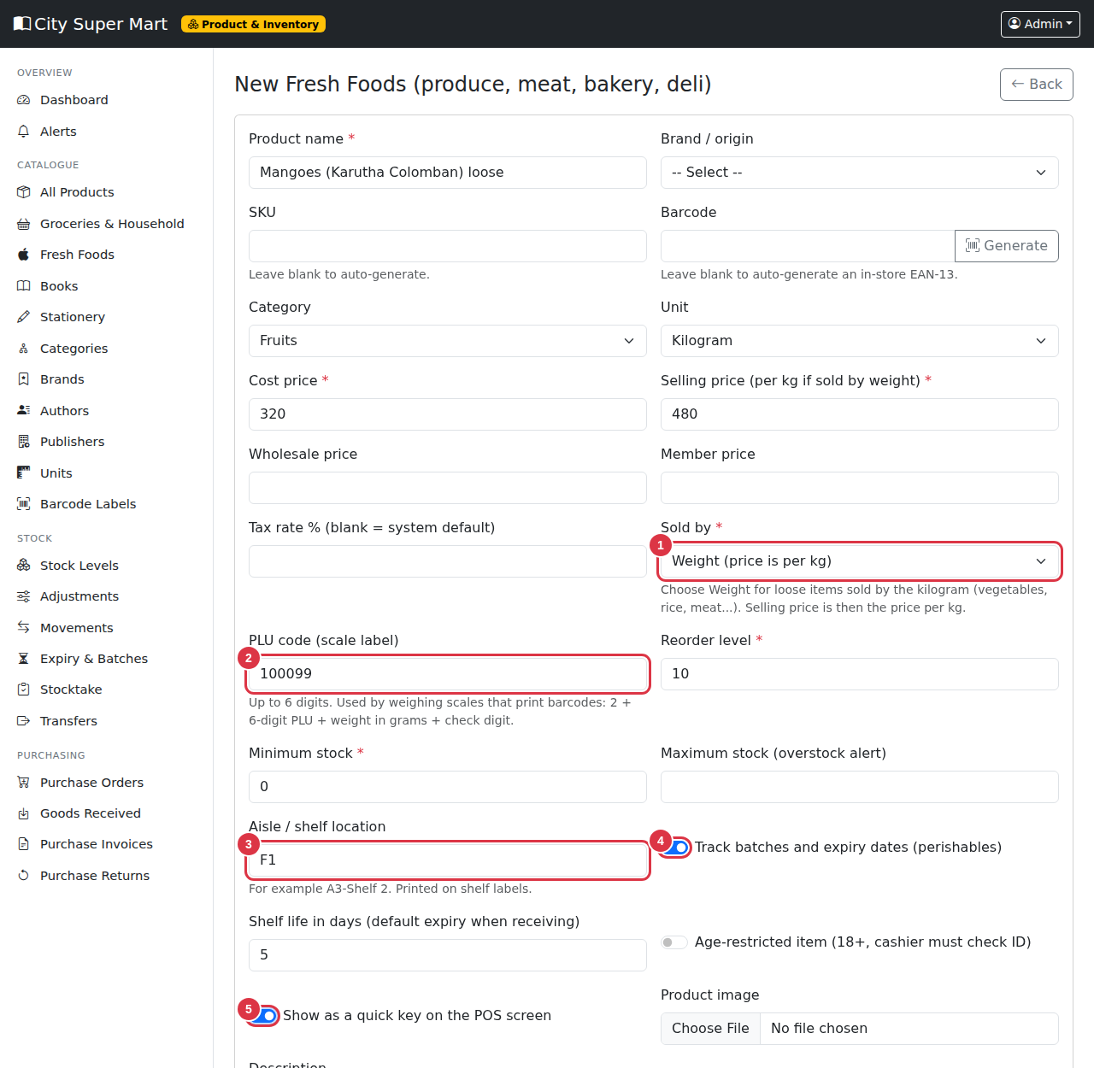
Figure 1. A loose, weighed product. 1 = Sold by weight, 2 = PLU code, 3 = Shelf location, 4 = Track batches and expiry, 5 = Quick key.
NOTE: Only items sold by weight accept decimals (0.350 kg). Items sold by unit (each, pack, bottle) must be whole numbers.

1.2 Age-restricted items (18+)
Tick Age-restricted item on products such as beer, liquor and tobacco. At the POS the cashier must confirm that the customer's ID was checked before the sale can be completed (Section 2.5).

1.3 More than one barcode, and carton barcodes
Some products arrive with more than one barcode, and cartons often have their own barcode. Click the boxes icon ("Extra barcodes / packs") beside a product in the list.
- Type the new Barcode.
- Type a Label such as "Carton of 24".
- In Units per scan type how many units one scan adds (1 for a second barcode of the same item, 24 for a carton of 24).
- Click Add.

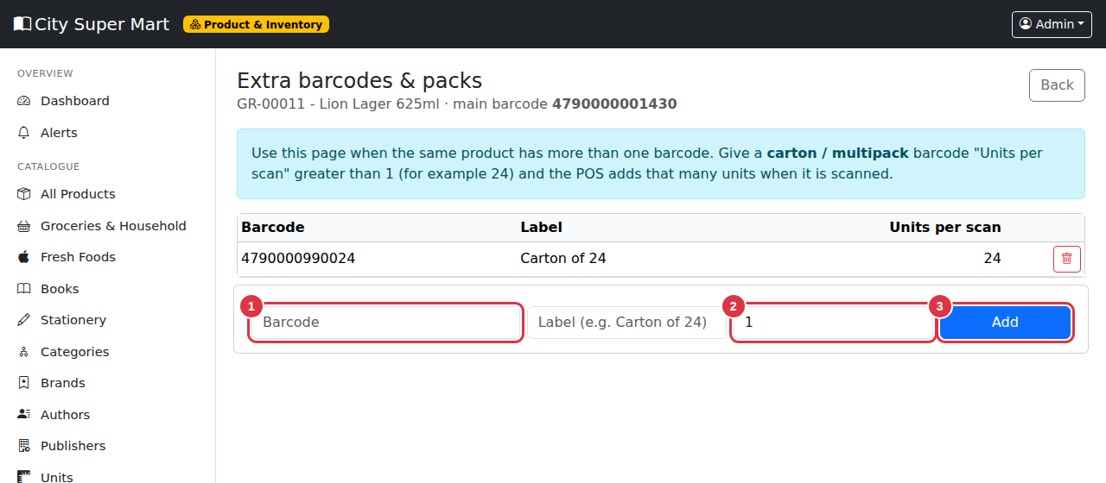
Figure 2. Extra barcodes. 1 = Barcode, 2 = Units per scan, 3 = Add.
At the till, scanning the carton barcode puts 24 units into the cart in one scan.

1.4 Departments and categories
Categories are arranged as departments with sub-categories, for example Dairy & Chilled > Milk. Standard supermarket departments are already set up (Fresh Produce, Meat & Seafood, Dairy & Chilled, Bakery & Deli, Frozen Foods, Grocery Staples, Beverages, Snacks, Household, Health & Beauty, Pet Care, plus Books and Stationery). You can add more under Categories. The Sales by department report uses the top level.

2. Selling at the supermarket counter (POS)

2.1 Quick keys
Products marked as quick keys appear as buttons above the search box. Tap a button to add the item. This is ideal for loose items and anything without a barcode.
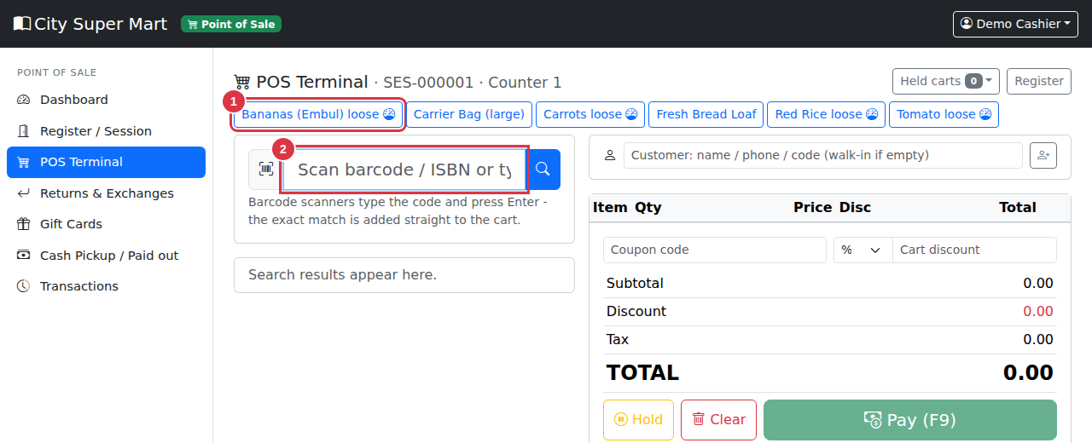
Figure 3. Quick keys on the POS terminal. 1 = A quick key button (the dial icon means the item is weighed), 2 = Search box.

2.2 Weighed items
- Place the item on the scale and read the weight.
- Tap the quick key (or search the item and click it). A window asks for the weight.
- Type the weight in kg (for example 0.750) and press Enter or click Add to cart.
- The line shows the weight and the price is calculated automatically (0.750 kg x 220.00 = 165.00).

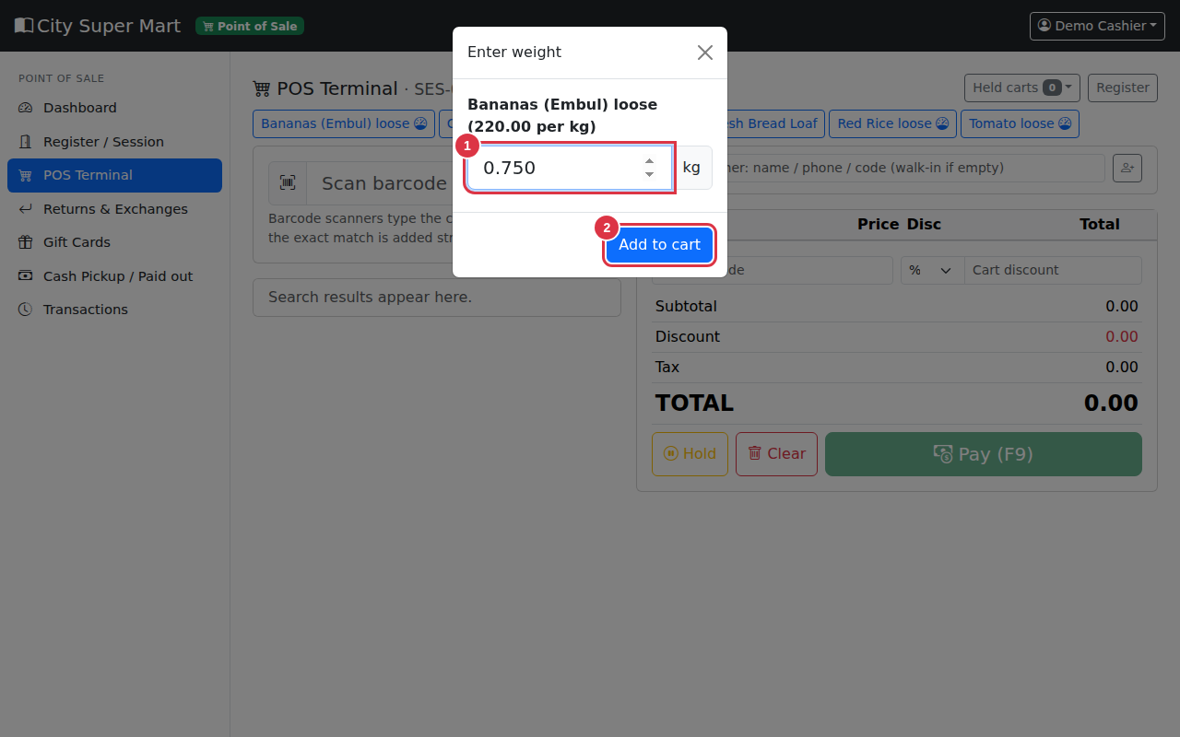
Figure 4. The weight window. 1 = Weight in kg, 2 = Add to cart.
TIP: In the cart, the + and - buttons change a weighed item by 0.1 kg. You can also type an exact weight in the quantity box.

2.3 Scale label barcodes
If your weighing scale prints price labels with a barcode, scan the label. The system reads the product (from its PLU code) and the weight from the barcode, and adds the item with the right weight. The label must be an EAN-13 barcode in this format:
Digits | Meaning
1 | The digit 2 (this is the scale label prefix set in Settings)
2 - 7 | The product's PLU code, 6 digits, with leading zeros
8 - 12 | The weight in grams, 5 digits (00750 = 0.750 kg)
13 | Check digit

NOTE: Example: 2 000123 00750 4 = product with PLU 123, weight 750 g.

2.4 Carton and extra barcodes
Scan the carton barcode: the quantity set for that barcode (for example 24) is added at once.

2.5 Age-restricted items
When an item marked 18+ is in the cart, a red box appears. The cashier checks the customer's ID and ticks I have checked the customer's ID. Until then the Pay button stays grey.
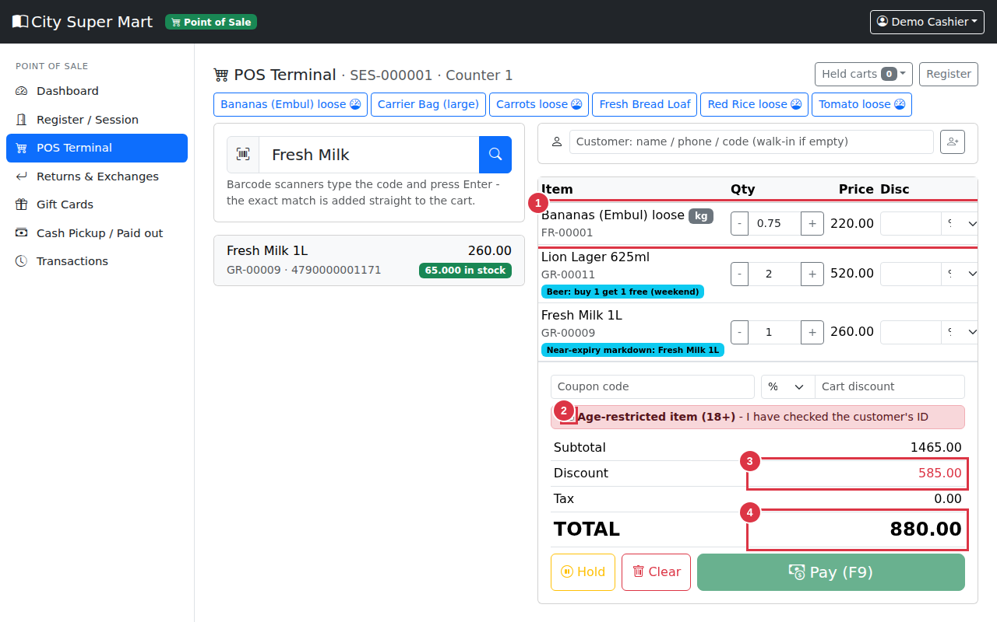
Figure 5. A supermarket cart. 1 = A weighed item (kg label), 2 = Age-restricted item box, 3 = Discount from promotions, 4 = Total. The blue labels show the promotion applied to each item.

2.6 Paying with a gift card or loyalty points
Click Pay. Besides cash, card, bank and digital payments, the payment window now has:
- + Gift card - type the gift card code (or scan it). The balance is used up to the amount due.
- + Points - redeem the loyalty points of the customer chosen for this sale. The value of one point is set in Settings. The customer must be selected first.
- + Exchange credit - as before, for exchange credit notes.

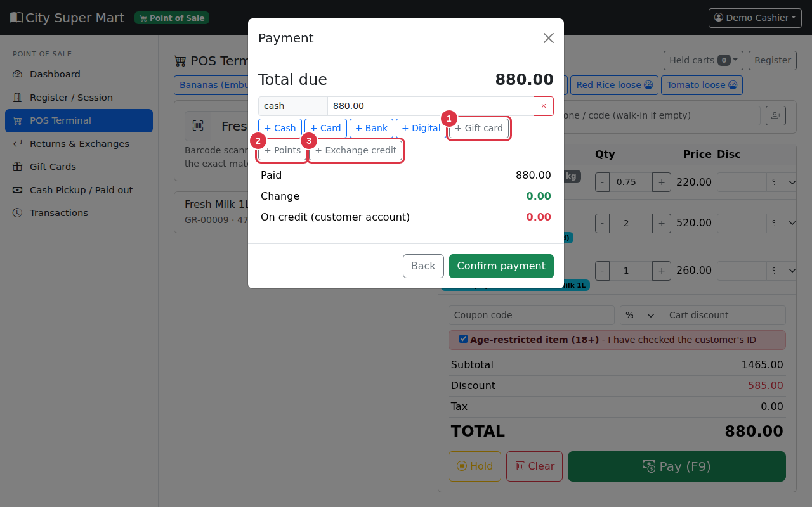
Figure 6. The payment window. 1 = Gift card, 2 = Points, 3 = Exchange credit.
You can combine methods in one sale, for example part gift card, part points and the rest in cash. If a sale is voided, the gift card balance and the loyalty points are returned automatically.

2.7 Loyalty cards
Give members a Loyalty card number (a field on the customer form). At the till, scan or type the number in the customer box and the customer is selected.

2.8 Cash pickups, paid-outs and float
When a drawer holds too much cash, move the extra to the safe. In the POS menu click Cash Pickup / Paid out.
- Choose the type: Cash pickup (safe drop), Paid out (small expense) or Float / change money in.
- Type the amount and the reason.
- If you do not have permission, a supervisor types their username and password in the boxes on the right.
- Click Record.

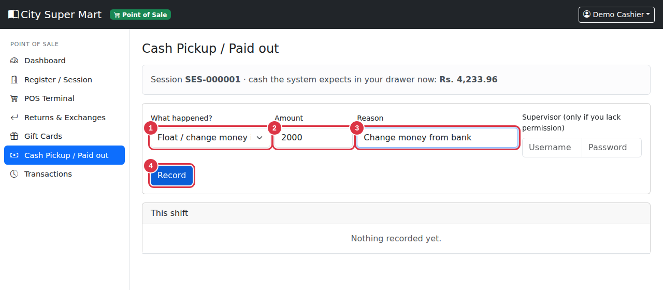
Figure 7. Cash pickup page. 1 = Type, 2 = Amount, 3 = Reason, 4 = Record.
The system includes these in the expected cash when you close the register, so your cash variance stays correct. All entries appear in the Cash pickups, paid-outs & float report.

2.9 Receipts
Receipts now show weights (for example 0.750 kg x 220.00/kg), the line "YOU SAVED" with the total discount, and, if your prices include tax, the amount of tax included.

3. Promotions for a supermarket
Go to Administration > Promotions > New. Besides percentage and amount-off promotions you can now create:
Promotion type | How it works | Example
Buy X get Y free | For every X + Y items bought, Y are free. | Buy 1 get 1 free on beer. Buy 2 get 1 free on soft drinks.
Multi-buy (N for a price) | N items cost a fixed bundle price. Items beyond a full set are charged normally. | 3 biscuits for 450.00.
Percentage off | A percentage off the price. | 20% off dairy this week.
Amount off | A fixed amount off each unit. | 10.00 off each tin.
Happy hour | Any promotion with a daily start and end time. | 30% off fresh bread from 6 pm to 9 pm.

- Choose the Promotion type.
- For Buy X get Y, type X in Buy X and Y in Get Y free. For Multi-buy, type the number of items in Minimum quantity (2 or more) and the price in Bundle price.
- Choose what it applies to: all products, a category or one product.
- Set the start and end dates. For happy hour also set the daily start and end time.
- Click Save.

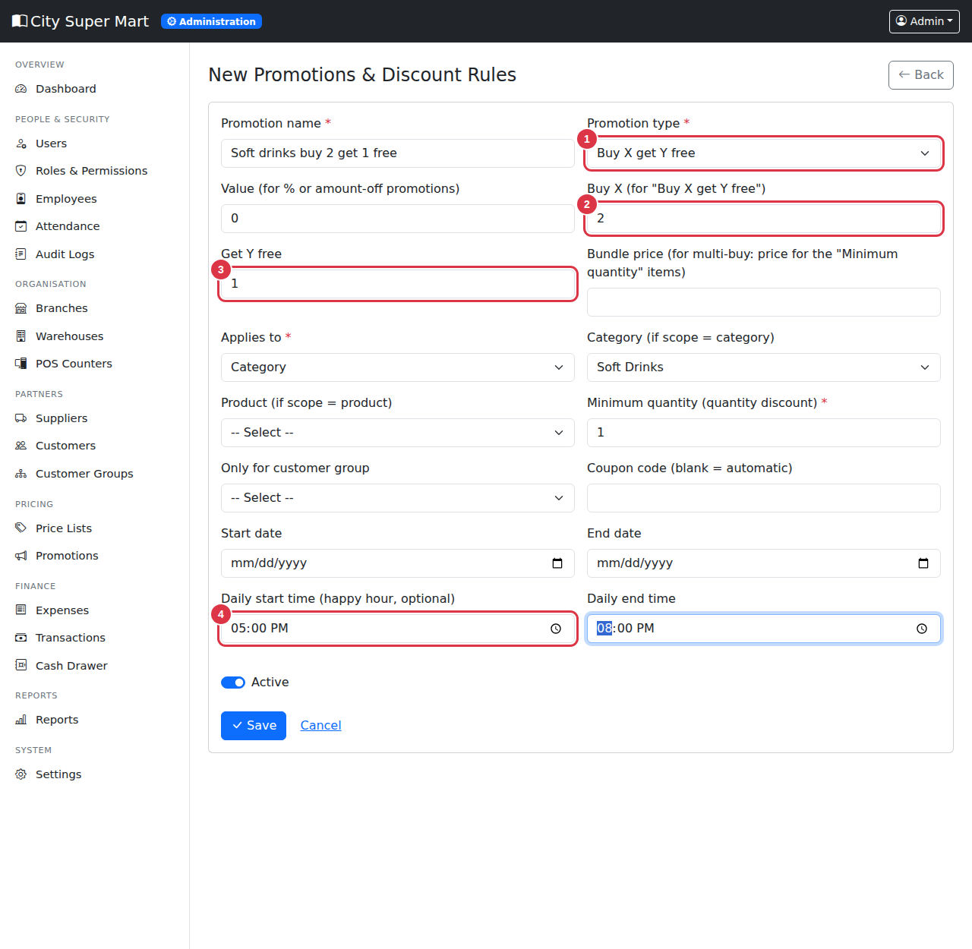
Figure 8. A buy-2-get-1-free promotion for a category in the evening. 1 = Promotion type, 2 = Buy X, 3 = Get Y free, 4 = Daily start time.
NOTE: If several promotions match an item, the customer gets the best one - promotions are not added together. Promotions work automatically at the POS; the cashier does nothing. Weighed items are not eligible for buy-X-get-Y or multi-buy.

4. Gift cards and vouchers
In the POS menu, click Gift Cards. The page lists all cards with balance and status and shows the outstanding balance - the value of gift cards you have sold but not yet used (money you still owe in goods).
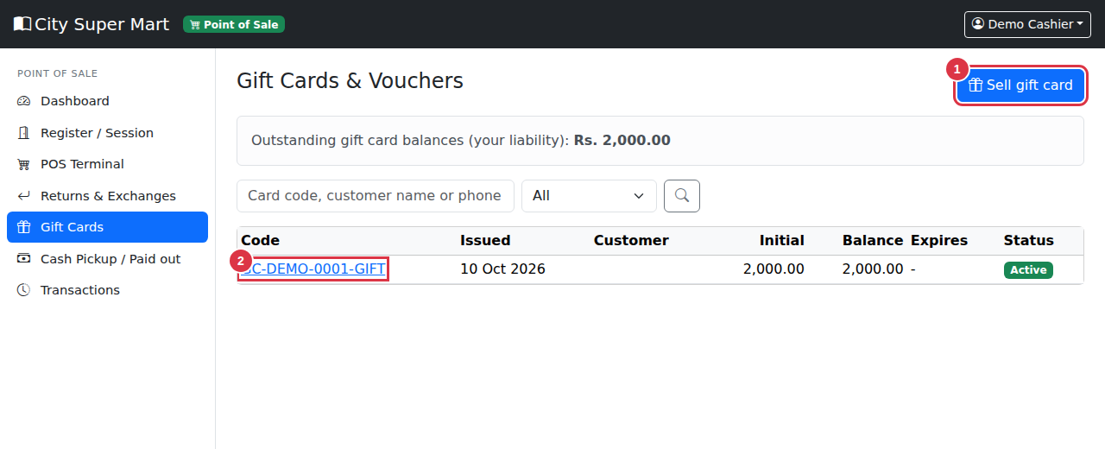
Figure 9. The gift card list. 1 = Sell gift card, 2 = A card (click to open).

4.1 Selling a gift card
- Click Sell gift card.
- Type the card value and choose how the customer pays (cash, card, bank or digital).
- Optionally set an expiry date, link a customer and add a note.
- Click Issue card. A unique code such as GC-XFSX-QF7G-MBQG is created.
- Click Print slip and give it to the customer. The slip has the code and a barcode.

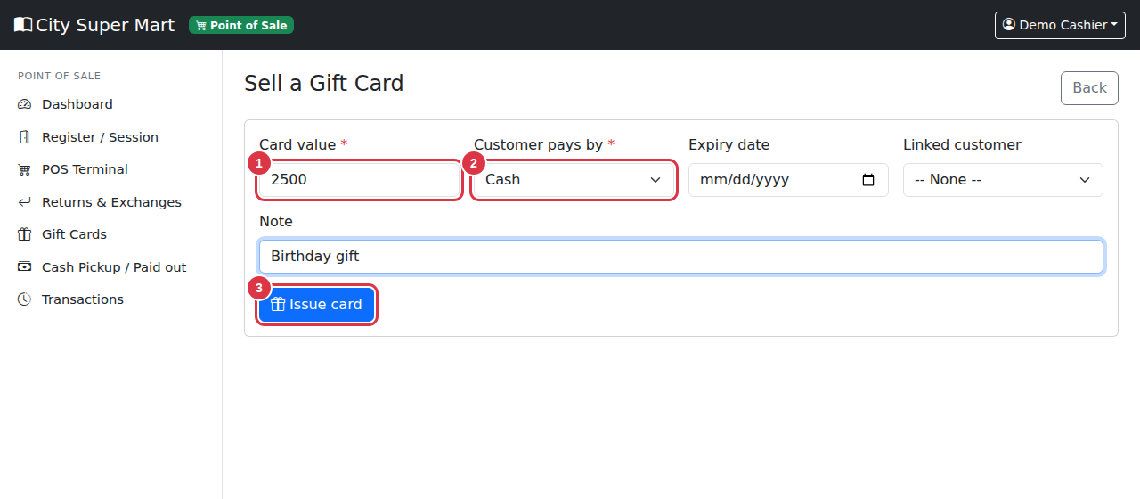
Figure 10. Selling a gift card. 1 = Card value, 2 = Payment method, 3 = Issue card.
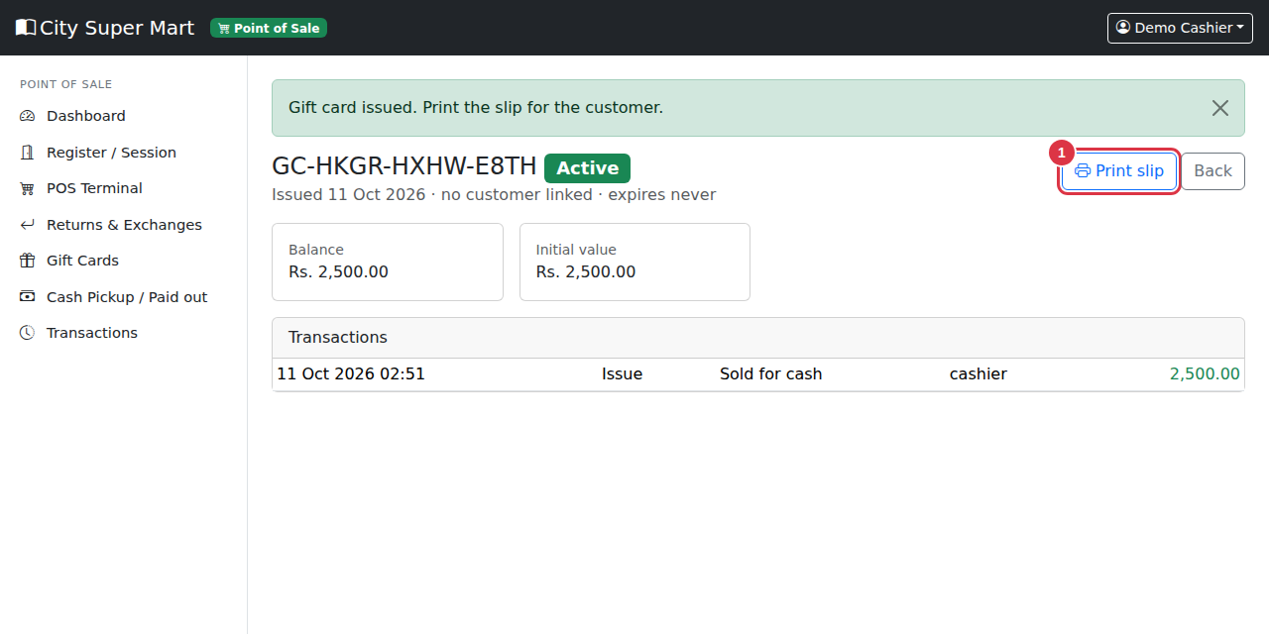
Figure 11. The card page. 1 = Print slip. Below you see the balance and every use of the card.
IMPORTANT: Cash for a gift card goes into your drawer, so your register must be open to sell for cash.

4.2 Using a gift card
At the payment window click + Gift card and type or scan the code (Section 2.6). The card must be active, not expired and have a balance. Any balance left stays on the card.

4.3 Blocking a lost card or correcting a balance
Users with the right permission open the card and click Block card (lost or stolen), or use Adjust to add or remove an amount with a reason. Every change is recorded.

5. Fresh food, batches and expiry

5.1 Receiving goods with batch and expiry
For products marked Track batches and expiry dates, the receiving page asks for a batch number and an expiry date. If the product has a shelf life, the system fills in the expiry date for you when you leave it empty.
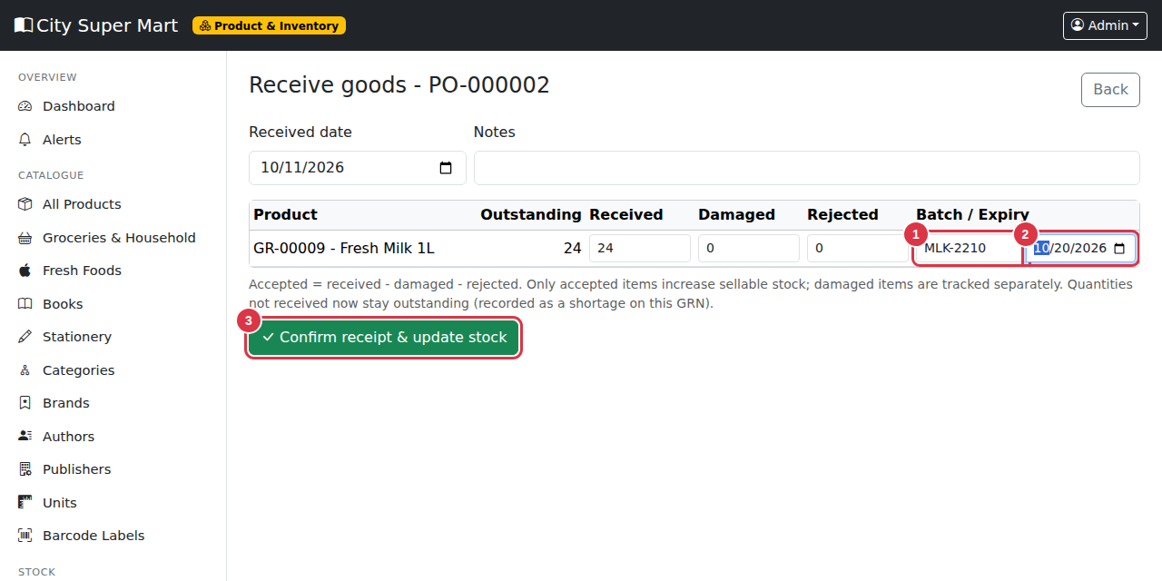
Figure 12. Receiving perishable goods. 1 = Batch number, 2 = Expiry date, 3 = Confirm receipt.
IMPORTANT: Check the expiry date printed on the goods. The system uses it to sell the oldest stock first and to warn you before goods expire.

5.2 First expiry, first out
When you sell a tracked item, the system takes the stock from the batch that expires first. You do not have to choose the batch. Stock counts, transfers and returns keep the totals correct.

5.3 The Expiry & Batches page
Open Product & Inventory > Stock > Expiry & Batches. Choose Expiring soon, Already expired, All dated batches or All batches. The boxes at the top show the cost value of expired stock and of stock expiring within the warning days.
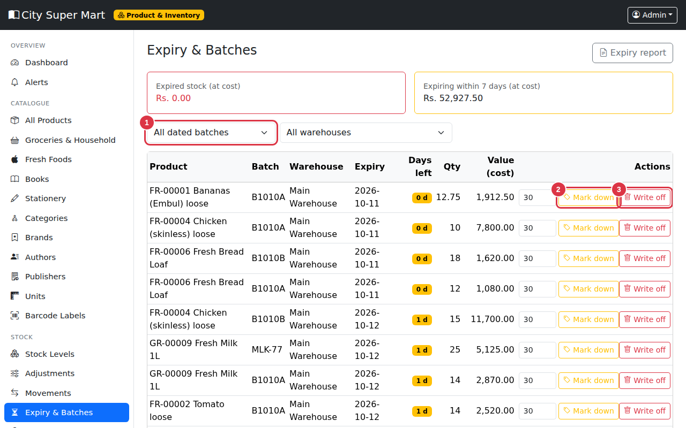
Figure 13. Expiry & Batches. 1 = Filter, 2 = Mark down, 3 = Write off.
- Mark down - type a percentage and click the button. A promotion is created for that product, active at the POS until the expiry date. (It applies to the product, not only to the old batch.)
- Write off - removes the batch from stock as expired. If you do not have approval rights, the write-off waits for a manager's approval.

5.4 Wastage and shrinkage
In Stock > Adjust stock there are new types: Write off - expired, Write off - spoiled / wastage and Write off - theft / shrinkage. Always type a clear reason.
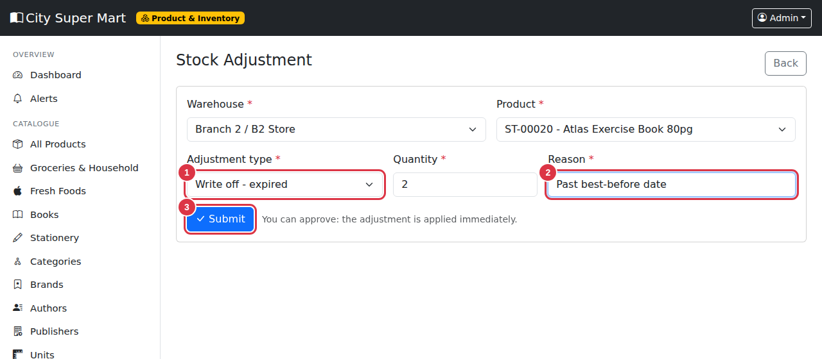
Figure 14. Recording wastage. 1 = Type, 2 = Reason, 3 = Submit.
The Wastage & shrinkage report shows the quantity and cost value lost, by reason and product. The dashboards show this month's wastage and the number of expired batches.

6. Shelf price tags and labels
Go to Product & Inventory > Barcode Labels. Choose Label type:
- Barcode sticker - a small sticker with the barcode, as before. The price shows "/kg" for weighed items.
- Shelf price tag - a tag for the shelf edge with the product name, a big price, the price per kg for weighed items, the promotion price (with the old price crossed out) if a product promotion is running, the aisle and a barcode.

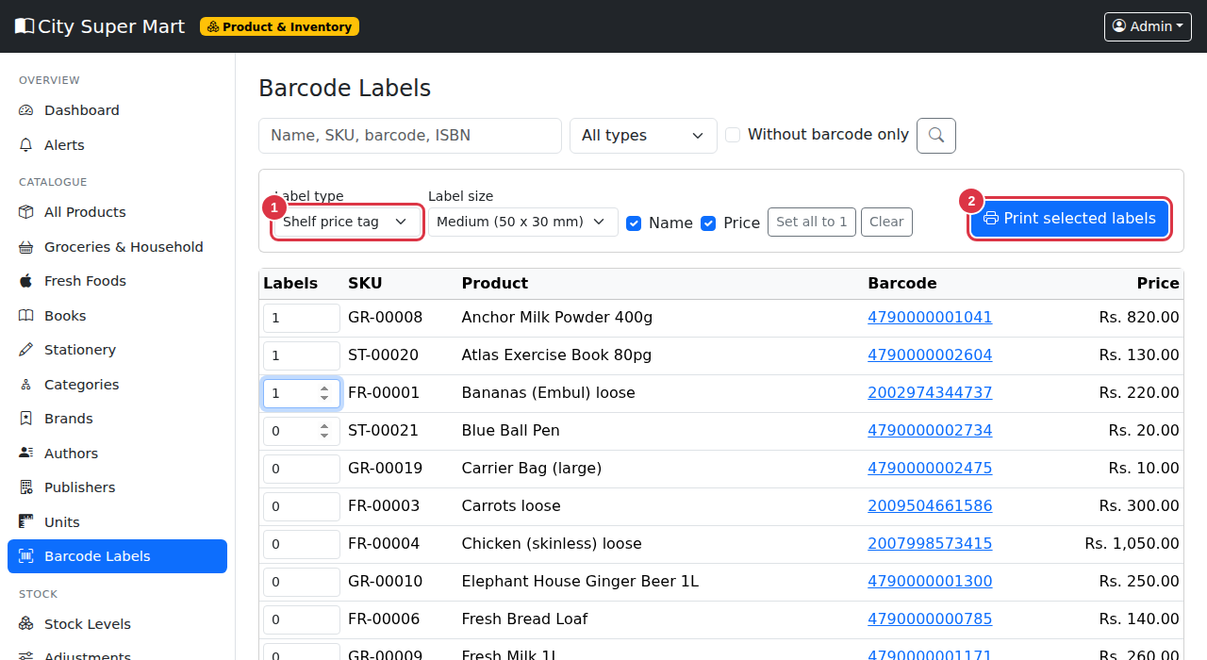
Figure 15. Choosing the label type. 1 = Label type, 2 = Print selected labels.
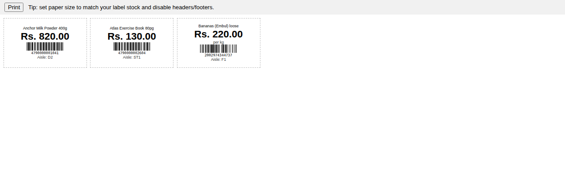
Figure 16. Shelf price tags ready to print.
TIP: Reprint shelf tags whenever a price changes or a promotion starts or ends.

7. New reports and dashboard boxes
Open Administration > Reports. A new Supermarket group has these reports (all can be exported to CSV and PDF):
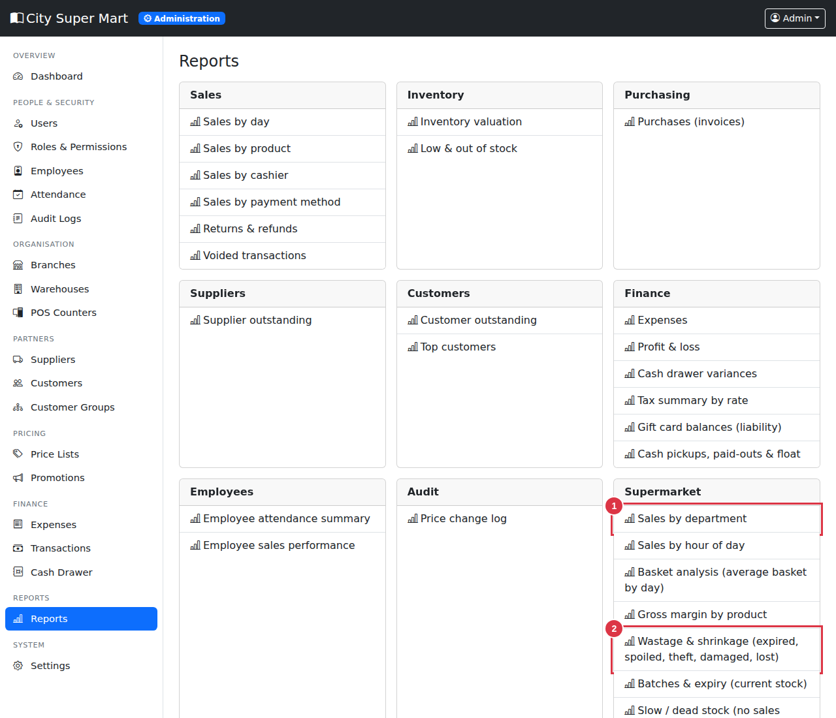
Figure 17. The Supermarket reports. 1 = Sales by department, 2 = Wastage & shrinkage.
Report | What it shows
Sales by department | Sales for Fresh Produce, Dairy, Beverages... to see which department earns most.
Sales by hour of day | Busy and quiet hours - helps with staff planning.
Basket analysis | Average basket value and items per basket each day.
Gross margin by product | Revenue, cost and margin % for each product.
Wastage & shrinkage | Expired, spoiled, stolen, damaged and lost stock with cost.
Batches & expiry | All batches with days left and value.
Slow / dead stock | Items with stock but no sales since a date.
ABC analysis | Class A items make about 80% of sales, B the next 15%, C the rest.
Promotion performance | How much discount each promotion gave and the sales it covered.
Tax summary by rate | Taxable amount and tax for each tax rate.
Gift card balances | Liability for unused gift cards.
Cash pickups, paid-outs & float | Every safe drop and paid-out, with reason.

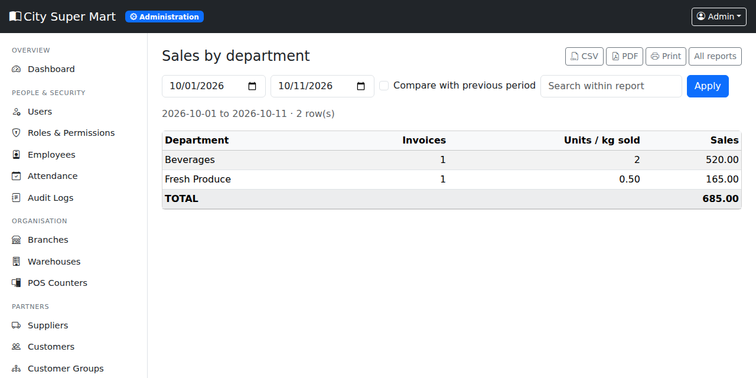
Figure 18. The Sales by department report.
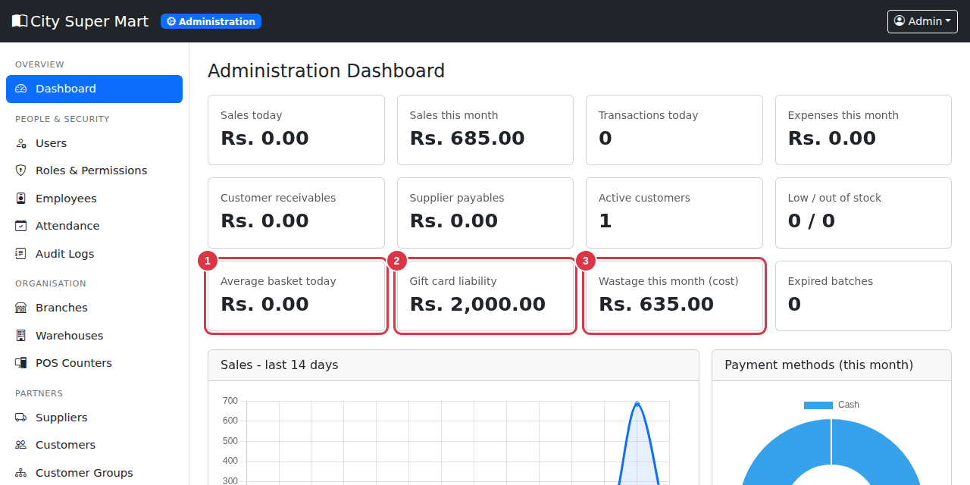
Figure 19. New dashboard boxes: average basket, gift card liability, wastage this month, expired batches.

8. Settings
Administration > Settings has new options:
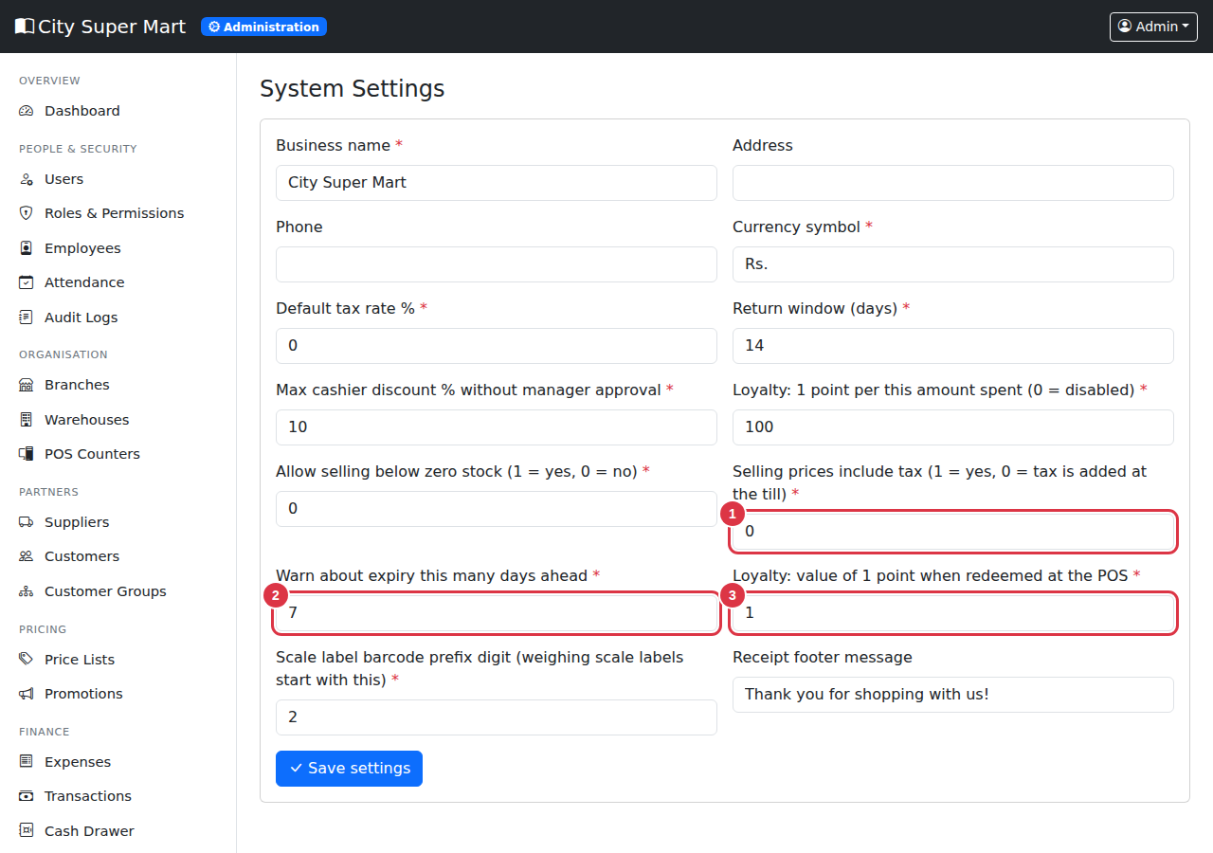
Figure 20. New settings. 1 = Prices include tax, 2 = Expiry warning days, 3 = Value of a loyalty point.
Setting | Meaning
Selling prices include tax | 1 = the shelf price already contains tax (the receipt shows "Tax included"). 0 = tax is added at the till.
Warn about expiry this many days ahead | Used for "Expiring soon" on the Expiry page and on the dashboard (default 7).
Value of 1 loyalty point | How much one point is worth when a customer redeems points at the till (default 1.00).
Scale label barcode prefix | The first digit of weighing scale labels (2).

9. Supermarket daily routines
Who / when | What to do
Cashier - start | Open register, count opening cash. Check the quick keys and the scale are ready.
Cashier - during the day | Scan or key weights. Check ID for 18+ items. Ask a supervisor to approve big discounts and returns. Do a cash pickup when the drawer is full.
Cashier - end | Count cash, close the register.
Fresh department - every morning | Receive deliveries with batch and expiry. Print shelf tags for new prices.
Fresh department - every evening | Open Expiry & Batches. Mark down items expiring soon; write off expired items with a reason.
Store keeper - weekly | Check Alerts and create purchase requests. Do a stocktake of one department.
Manager - weekly | Review Sales by department, Wastage, Slow stock and Promotion performance. Review gift card liability.

10. Questions and answers
Question | Answer
The weight window does not appear. | The product is not set to Sold by: Weight. Edit the product and change it.
A scale label does not add the item. | Check the PLU on the product matches the label, the product is sold by weight, and the barcode is a valid 13-digit label starting with 2.
I cannot save quantity 1.5 for a pack item. | Items sold by unit accept whole numbers only. Use a weighed product for loose goods.
The receiving page asks for an expiry date. | The product is expiry-tracked. Type the expiry date from the pack, or set a shelf life on the product so it is filled in for you.
Gift card "invalid, expired, blocked or empty". | Check the code, the expiry date and the balance on the Gift Cards page.
The Pay button is grey and a red box shows. | An age-restricted item is in the cart: check ID and tick the box.
The mark-down also cheapens fresh stock. | A mark-down applies to the product until the expiry date. Use Write off for spoiled packs, or deactivate the promotion when the old batch is gone.
Cash pickup says "more than the cash expected". | You cannot take out more than the system expects in the drawer. Check the amount.

11. Updates in version 2.1
This chapter describes four improvements: opening stock for new products, bills in Sinhala, quick links between related records, and the User Guide in the top-right menu.

11.1 New products and "Out of stock"
A new product starts with no stock. Until stock is received (or added), the POS correctly shows 0 in stock and refuses the sale with a message like "Insufficient stock". Two improvements make this easier:
- Every new product now gets a stock record in every warehouse automatically (at zero), so it appears in stock lists, alerts, transfers and stocktakes straight away. A new warehouse also gets a record for every product.
- The product form has new Opening stock boxes, so you can put the item in stock the moment you create it.

Adding opening stock when you create a product
- Click New in Groceries, Fresh Foods, Books, Stationery or All Products.
- Fill in the product as usual.
- In Opening stock quantity, type how many are on the shelves or in the store now (for a weighed item, type kilograms, for example 12.5).
- Choose the location (warehouse). If you leave it empty, your branch's main warehouse is used.
- For products with Track batches and expiry dates, also type the batch number and expiry date of this stock (or leave the expiry empty if the product has a shelf life).
- Click Save. The item can be sold at the POS immediately.

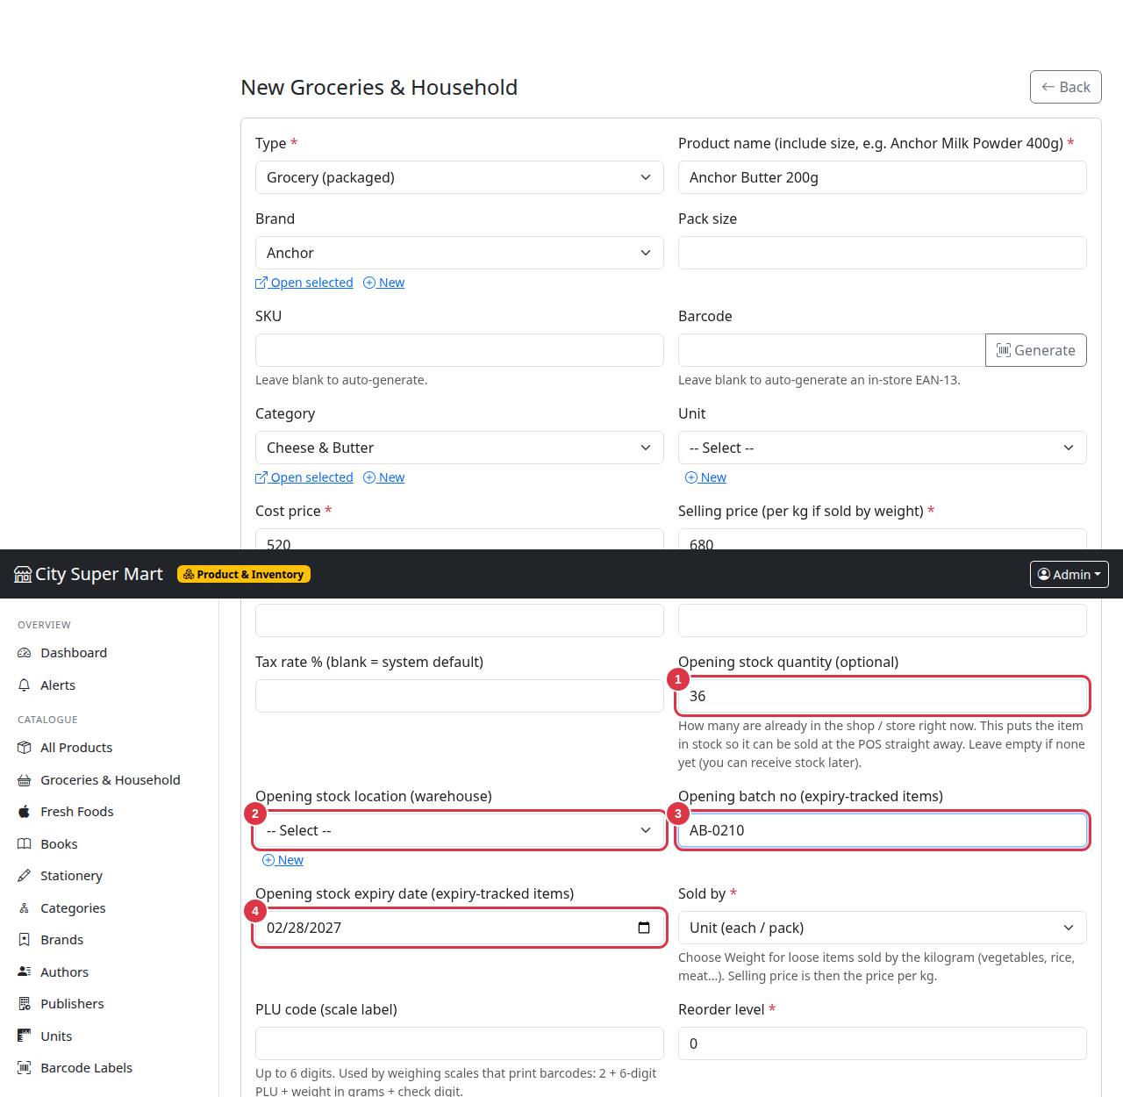
Figure 21. Opening stock on a new product. 1 = Opening quantity, 2 = Warehouse, 3 = Batch number, 4 = Expiry date.
NOTE: The opening quantity is recorded in the stock history as "opening" with your name, so it can be traced. Items sold by unit must have whole-number quantities.

IMPORTANT: Do not use the opening stock to fix wrong numbers later. For corrections, use Stock > Adjust stock or a Stocktake so the history stays clear.

If you really want the POS to sell items that are not yet in stock, the manager can set Allow selling below zero stock to 1 in Settings. This is not recommended because the stock numbers then become negative.

11.2 Bills and invoices in Sinhala
Receipts (80 mm), A4 invoices and gift card slips are printed in Sinhala by default. Headings such as invoice number, date, cashier, sub total, discount, total, change and the thank-you message appear in Sinhala. Product names are printed exactly as you typed them, so type a Sinhala name on the product if you want it in Sinhala on the bill.
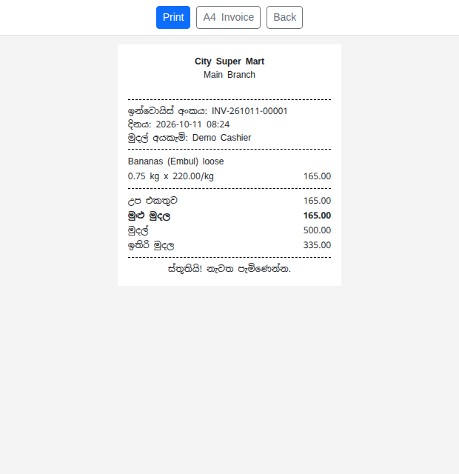
Figure 22. A Sinhala receipt (80 mm) with a weighed item.
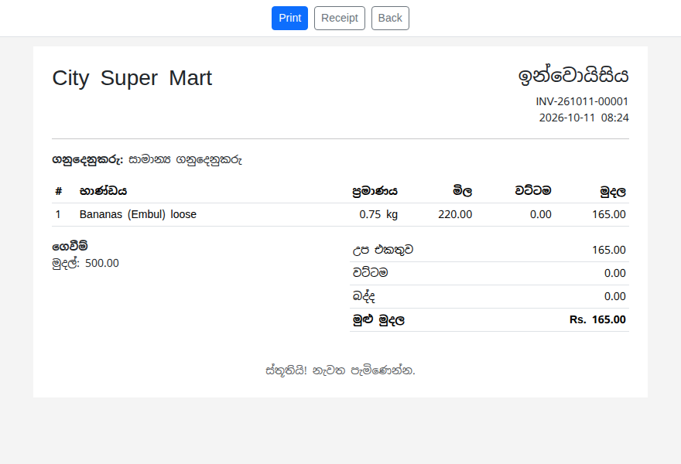
Figure 23. A Sinhala A4 invoice.

Choosing the bill language
- Open Administration > Settings.
- Change Receipt / invoice language: type si for Sinhala, en for English, or both to print both languages (for example "මුළු මුදල / TOTAL").
- (Optional) Change the Receipt footer message. If you leave the standard thank-you text, it is shown in the chosen language.
- Click Save settings.

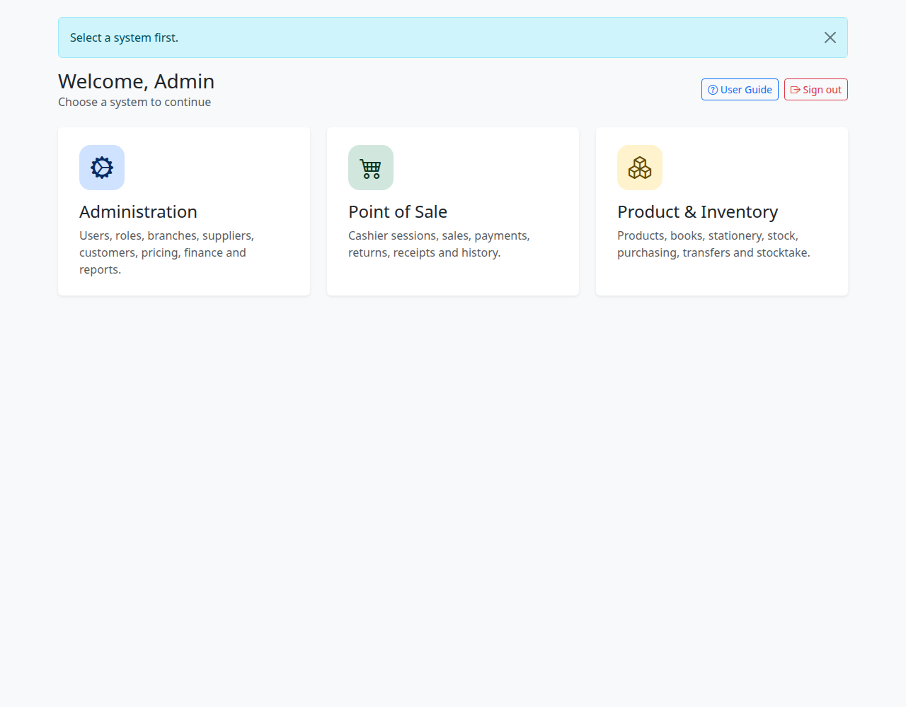
Figure 24. The language setting. 1 = Receipt / invoice language.
NOTE: Sinhala printing needs a Sinhala font on the computer. Windows 10 and 11 already include one (Nirmala UI / Iskoola Pota). If a printed bill shows empty boxes, ask your technical helper to install a Sinhala font such as Noto Sans Sinhala. The downloadable PDF reports use Latin letters only; for Sinhala text on reports, use Print > Save as PDF or CSV.

TIP: Your technical helper can change any Sinhala word on the bill in the file app/lang/receipt.php.

11.3 Quick links between related records
Wherever a screen shows the name of another record, you can now click it to jump straight there - for example a product's category, brand, author or publisher, the supplier on a purchase order, the product in stock lists, a warehouse on a transfer, or the customer on a sale. These names have a dotted underline.
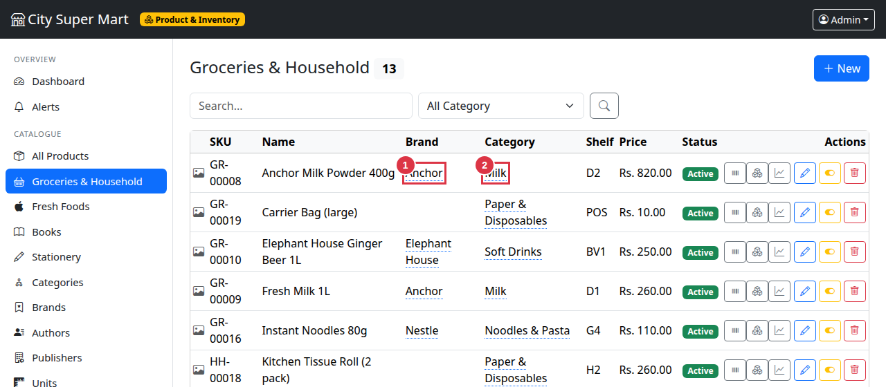
Figure 25. Links in a list. 1 = A category link, 2 = A brand link.
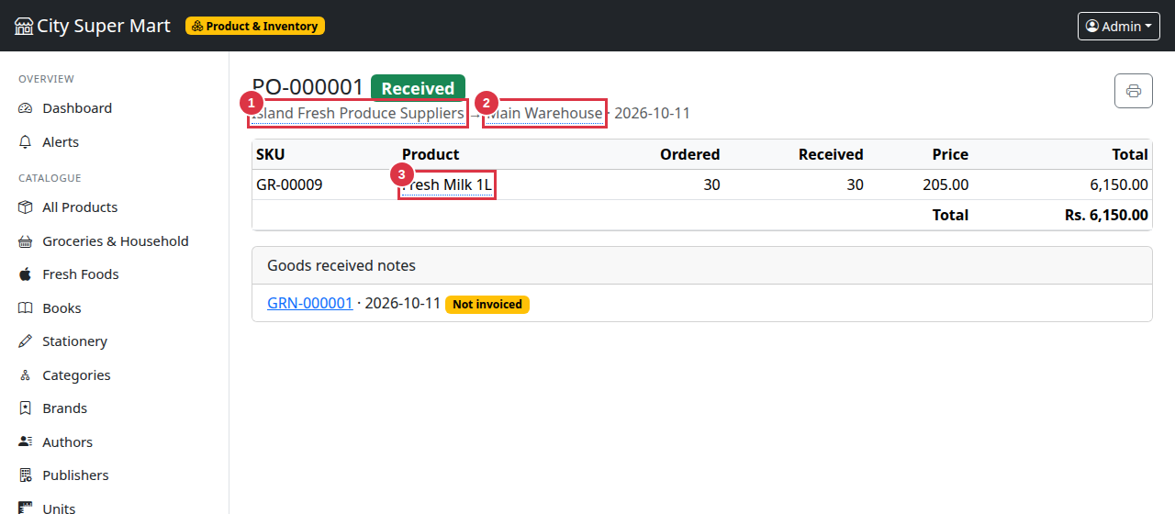
Figure 26. Links on a purchase order. 1 = Supplier, 2 = Warehouse, 3 = A product.
- Click the name to open the related record. If it lives in another system (for example a supplier from the inventory screens), the system switches for you automatically.
- You only see a link when your role allows you to open that record. Otherwise the name is shown as normal text.
- Use the browser Back button to return.

Links on forms
On forms with drop-down lists (category, brand, author, publisher, unit, customer group, branch...), a small row under the list offers Open selected (opens the chosen record in a new tab) and + New (opens a blank form in a new tab to add a missing item). Your half-filled form is not lost because the link opens in a new tab.
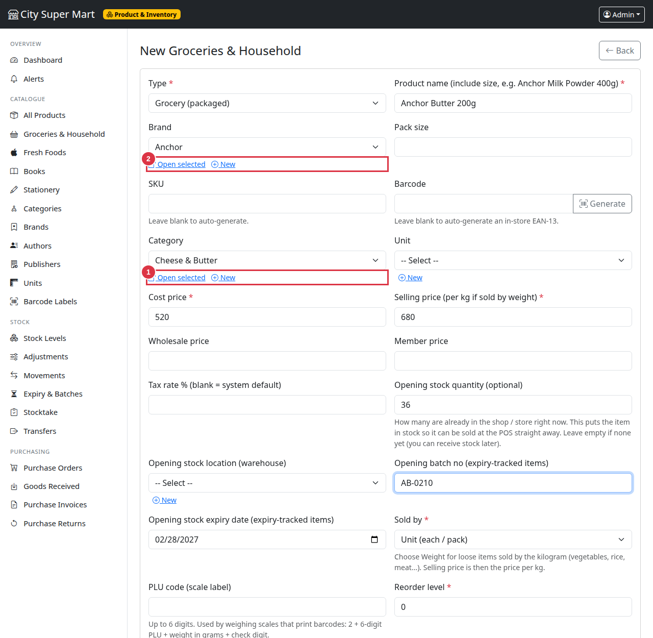
Figure 27. Links under drop-down lists on a product form. 1 = Open selected / New for Category, 2 = Open selected / New for Brand.

11.4 User Guide in the top-right menu
The guides are now inside the system. Click your name at the top right and choose User Guide (also available as a button on the system selection page).
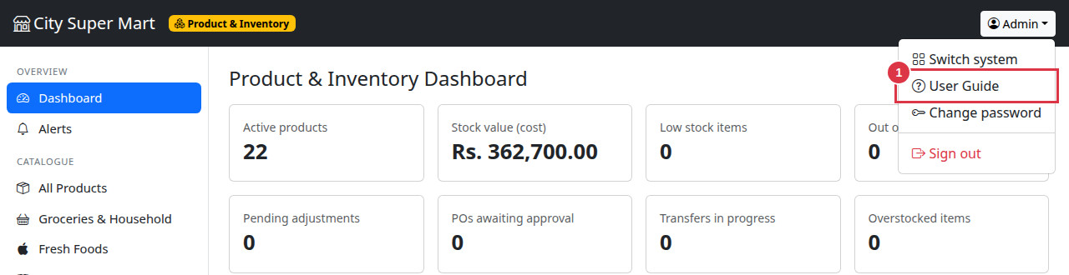
Figure 28. The top-right menu. 1 = User Guide.
The User Guide page lists the User Manual and this Supermarket Edition Guide. Click Open guide to read a guide in a new tab, or Download PDF to save or print it. The guides are only available after signing in.
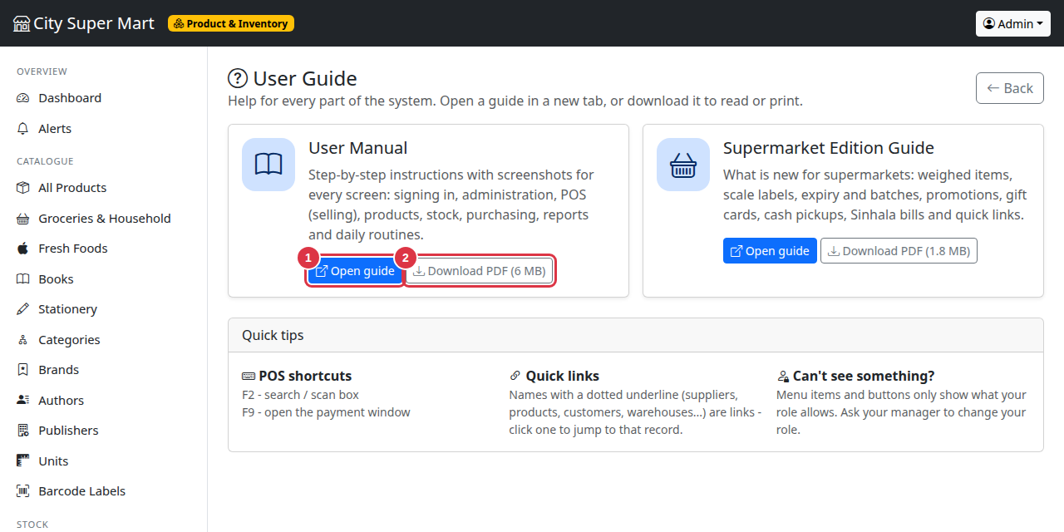
Figure 29. The User Guide page. 1 = Open guide, 2 = Download PDF.
NOTE: If a guide shows "Not installed", ask your administrator to copy the PDF files into the help folder of the system.

11.5 More questions
Question | Answer
The POS says "Out of stock" for a brand-new product. | No stock has been received yet. Type an Opening stock quantity when you create the product. For a product that already exists, use Stock > Adjust stock (increase) or receive it through a purchase order.
Can I edit opening stock after saving? | No. Use Stock > Adjust stock (increase / decrease) or a Stocktake. This keeps a clear history.
The bill shows empty boxes instead of Sinhala. | The computer has no Sinhala font. Install one (for example Noto Sans Sinhala) or use a Windows PC with Nirmala UI.
I want the bill in English only. | Settings > Receipt / invoice language > en.
A name is not clickable. | Your role cannot open that record, or the record has no linked item (for example a product without a brand).

