*Surya narayanan*

*S5 csb*

*Roll number 48*

# Experiment 4: VLAB - TCL

# 

**Refer the tables created in DDL statements lab**

**Perform the TCL operations on the created tables**

**Exercise related to Commit Data**

**1. Insert client no, name, city in client_master table and commit it.**

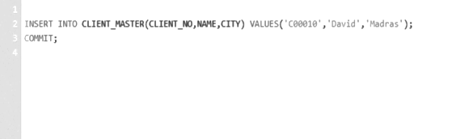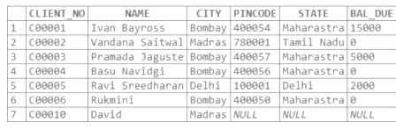

**2. Update data of product whose quantity on hand is less than 10 with quantity =20 and commit it.**

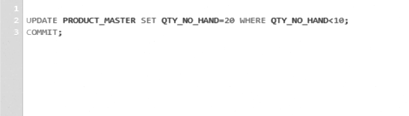

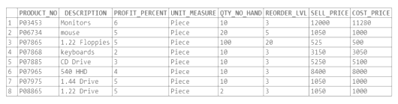

**3. Delete order details of salesman “Kiran” and commit it.**

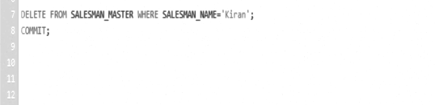

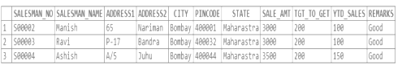

**Exercise related to Rollback Data**

**1. Delete all the salesmen from city “Maharashtra” and Rollback them.**

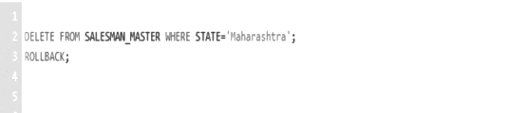

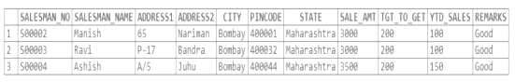

**2. Update order details from order table which are in “In process” status and make status as complete then Rollback it.**

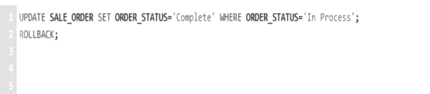

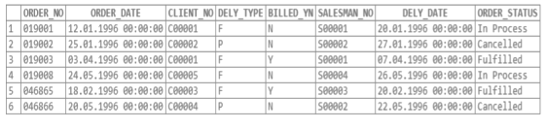

**3. Insert client no, name, city in client_master table and Rollback it.**

