*Surya narayanan*

*S5 csb*

*Roll number 48*

# Experiment 6: Cursors and Triggers

# 

**Cursor**

Illustration of cursor highest paid employee

Create a table Employee with eno,ename and salary.

Insert values into the table.

Create another table temp with sal,enum and hname.

Write a PL/SQL program using cursor to find the first five highest paid employees and insert the details into temp table.

**Trigger**

Create a table account with attributes custid, name, and balance.

Create another table loan with attributes custid, amount.

Insert values into account table.

Creata a trigger to check if the balance has gone below 40,if so make necessary modifications.

**Cursor**

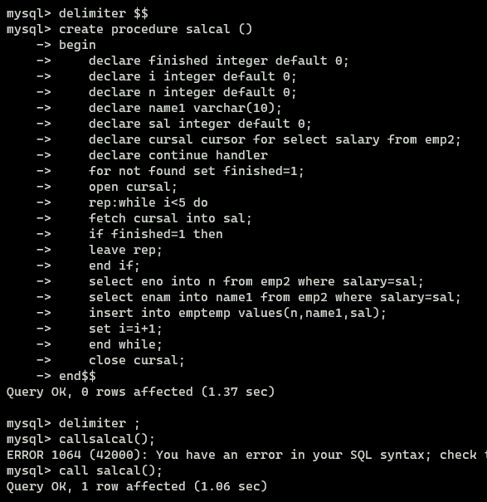

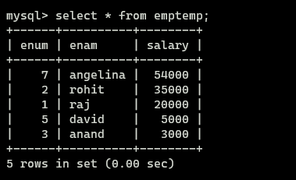

**Trigger**

