1. Go to URL <https://github.com/isuserselva/Smk>
2. Select **Clone or download** option and choose the **Download ZIP**, as shown in below screenshot.

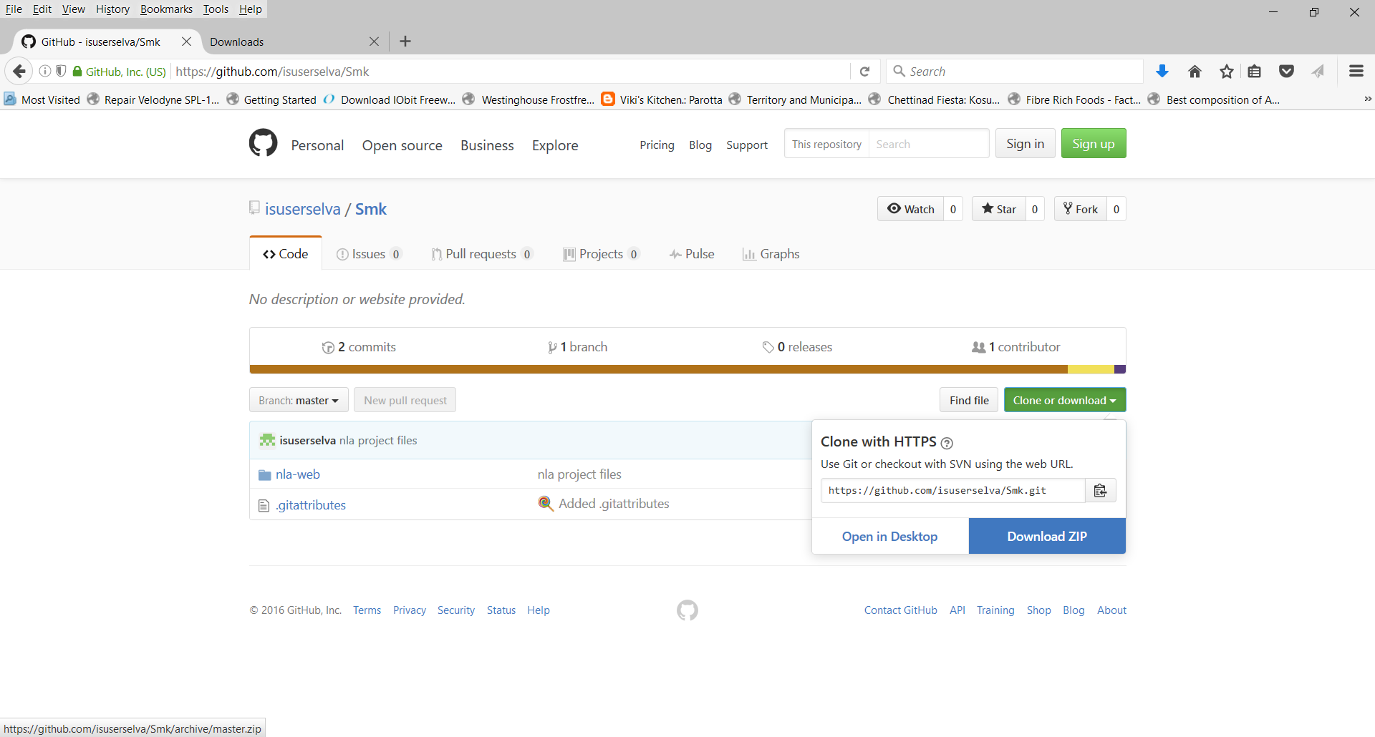

1. Open the folder from download folder.

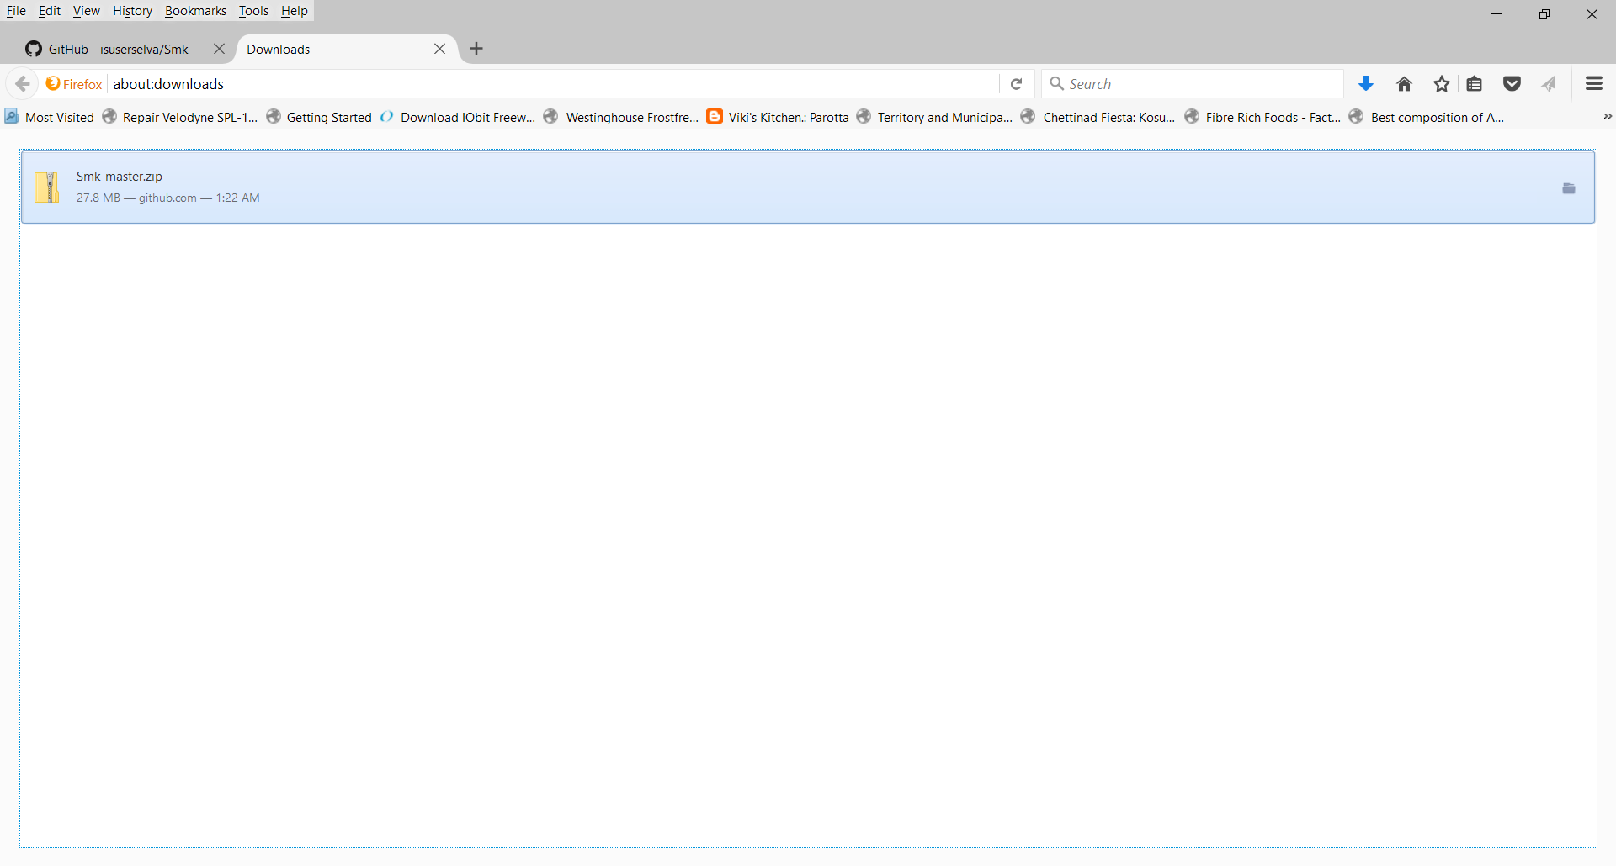

1. Unzip the folder using “Extract here” option, this will result in folder path **<YourDownloadFolder>\Smk-master**
2. Open **CMD** prompt and go to folder **<YourDownloadFolder>\Smk-master\nla-web**
3. Type command **mvn jetty:run** to start the app.

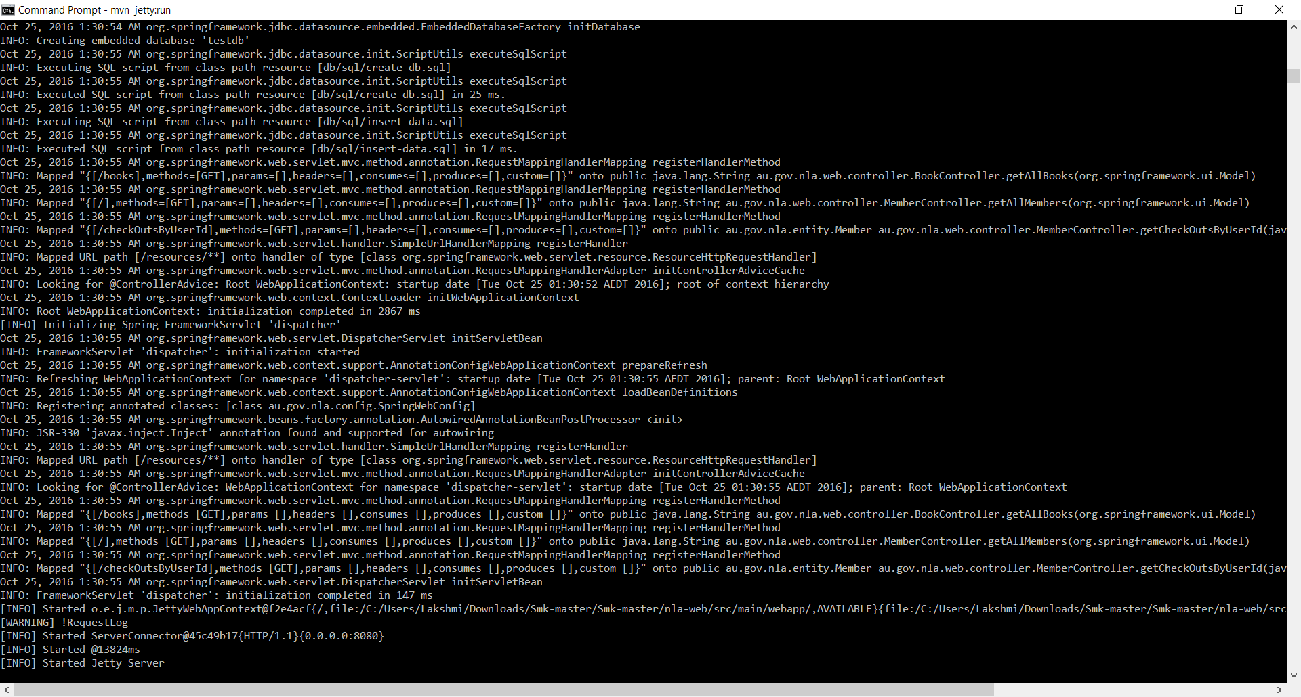

1. Type command **mvn clean install** to build and run junit tests.

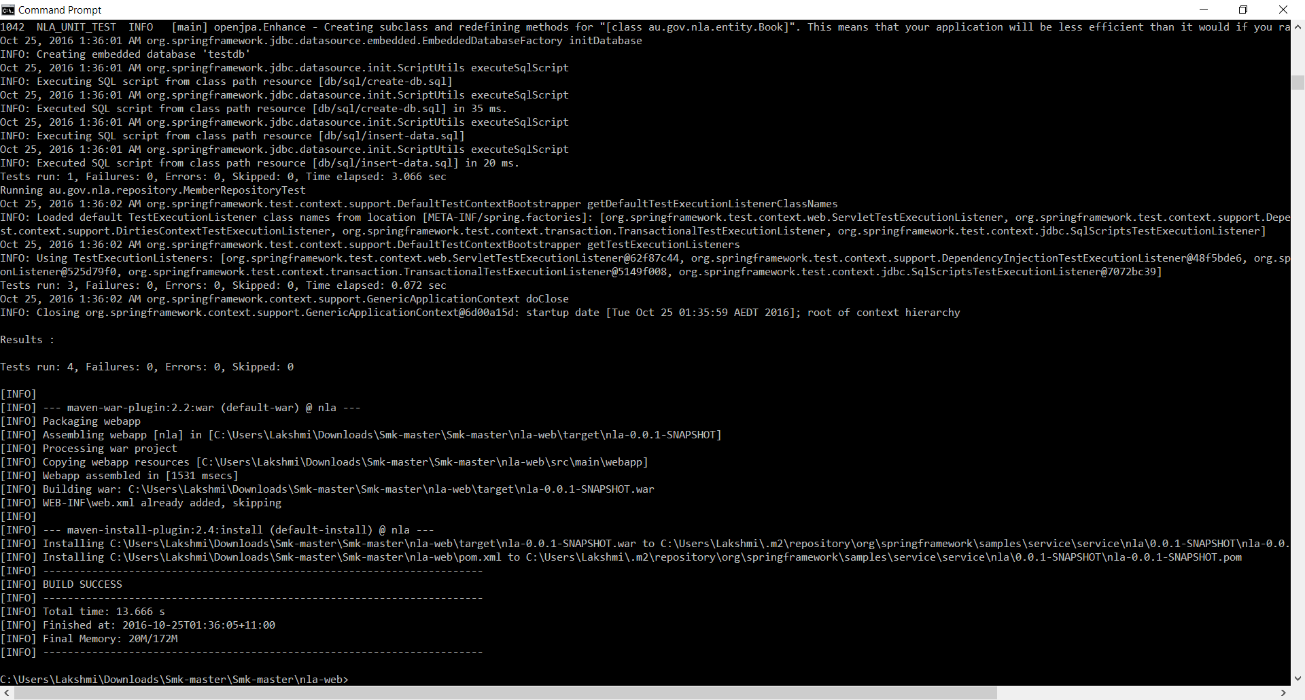

1. Enter URL <http://localhost:8080> to view the application pages.

