

Open-Source Technologies

A Project Report
Submi ed in par al fulfillment of the requirements for the award of degree of
Computer science & engineering
Submitted to
Rajeshwar Sharma
LOVELY PROFESSSIONAL UNIVERSITY
PHAGWARA,
PUNJAB, 144411

Submitted by:
SUSHIL PANDEY
11903138

April 10, 2023

DECLARATION

I am Sushil Pandey, registra on no. - 11903138., hereby declare that the work done by me on “Open-Source Technologies Project”. From 14 February 2023 to 10 April 2023, is recorded of original work for the par al fulfillment of the requirements for the award of the degree Computer Science & Engineering.

Sushil Pandey (11903138)

April 10, 2023

OBJECTIVE

The main purpose of utilizing an Open-source software to display system information is to equip users with detailed and precise data on various hardware components and their real-time performance.
By having access to such information, users can detect and address any issues with their computer's hardware, as well as optimize their system for improved performance. The software should have the ability to exhibit information about different hardware components, such as the CPU, motherboard, monitor, audio, network, and more. Additionally, it should display the current and average speed/rate of the memory, hard drive, and CPU, which can be useful for identifying any performance bottlenecks.
Moreover, the software should be open source, which implies that it can be accessed, modified, and distributed freely by anyone. This helps to ensure that the software is transparent, trustworthy, and can be customized to meet the specific needs of users.
Ultimately, the objective of utilizing an open-source software to display system information is to provide users with the tools they need to monitor and optimize their computer's performance, while also promoting transparency, trust, and collaboration within the software community.

DESCRIPTION

One open-source software that displays system information details for various components of a computer system is called "Speccy". This software tool allows users to view detailed information about the CPU, motherboard, monitor, audio, network, and other system components.
In addition to displaying information about the hardware components, Speccy also provides realtime monitoring of system performance. Users can view current and average speeds and rates for memory, hard drive, and CPU usage. This feature can help users identify system bottlenecks and diagnose performance issues.
Speccy has a user-friendly interface that displays system information in a clear and concise manner. Users can easily navigate through the various tabs and sections to find the information they need. The software can also generate reports in various formats, including HTML, XML, and plain text.
Overall, Speccy is a powerful open-source software tool for monitoring and analyzing system performance. Its ability to display detailed information about system components and real-time performance monitoring make it a valuable tool for both novice and advanced users.

SCOPE

The scope of use for Speccy open-source software is to provide users with a comprehensive and detailed overview of the hardware components and system information of their computer. It allows users to view information about their CPU, motherboard, monitor, audio, network, and other components, as well as the current and average speed/rate of the memory, hard drive, and CPU.

Speccy is a useful tool for system administrators, IT professionals, and regular users who need to troubleshoot hardware-related issues, optimize system performance, or gather information about their system configuration. With its user-friendly interface and intuitive design, Speccy provides an easy way to access and understand complex system information.

Some of the specific use cases of Speccy include:

- Hardware diagnostics: Speccy can be used to diagnose hardware issues, such as overheating or malfunctioning components. Users can view information about their system's temperature, voltage, and fan speeds to identify potential issues.

- System optimization: Speccy allows users to view the performance of their memory, hard drive, and CPU, and identify areas where optimization is needed. Users can use this information to make informed decisions about upgrades or changes to their system.

- System upgrades: Speccy provides detailed information about the hardware components in a computer, making it easier for users to identify compatible upgrades. This can include upgrades to memory, hard drives, or other components.

- System monitoring: Speccy provides real-time monitoring of system components, allowing users to track changes in temperature, fan speeds, and other metrics over time. This can be useful for identifying trends or potential issues before they become major problems.
Overall, the scope of use for Speccy is broad, and it can be a useful tool for anyone who needs to understand or optimize their computer's hardware configuration. Its open-source nature also makes it a flexible and customizable tool that can be adapted to meet specific needs or requirements.

ANALYSIS

Speccy is an open-source software that provides users with detailed information about various components of their system, including CPU, motherboard, monitor, audio, network, and other components. This software is designed to provide a comprehensive overview of the hardware components of a system and their current state, allowing users to identify and diagnose any issues that may be affecting their system's performance.

One of the key features of Speccy is its ability to display real-time and average speed or rate of the memory, hard drive, and CPU. This feature is particularly useful for users who want to monitor the performance of their system and identify any bottlenecks that may be slowing down their system's performance.

Another useful feature of Speccy is its ability to provide detailed information about the temperature of various components of the system, including the CPU, motherboard, and graphics card. This information can be invaluable for users who want to monitor the temperature of their system and ensure that it is running at a safe and optimal temperature.

Speccy is also highly customizable, allowing users to customize the information displayed and adjust the settings to their specific needs. This flexibility makes Speccy a highly versatile tool that can be used by users with varying levels of technical expertise.

Overall, Speccy is a highly useful open-source software that provides users with a comprehensive overview of their system's hardware components and performance. Its ability to display real-time and average speed or rate of various components of the system, as well as its detailed temperature monitoring capabilities, make it a highly valuable tool for users who want to monitor and optimize the performance of their system.

SNAPSHOTS
Operating System
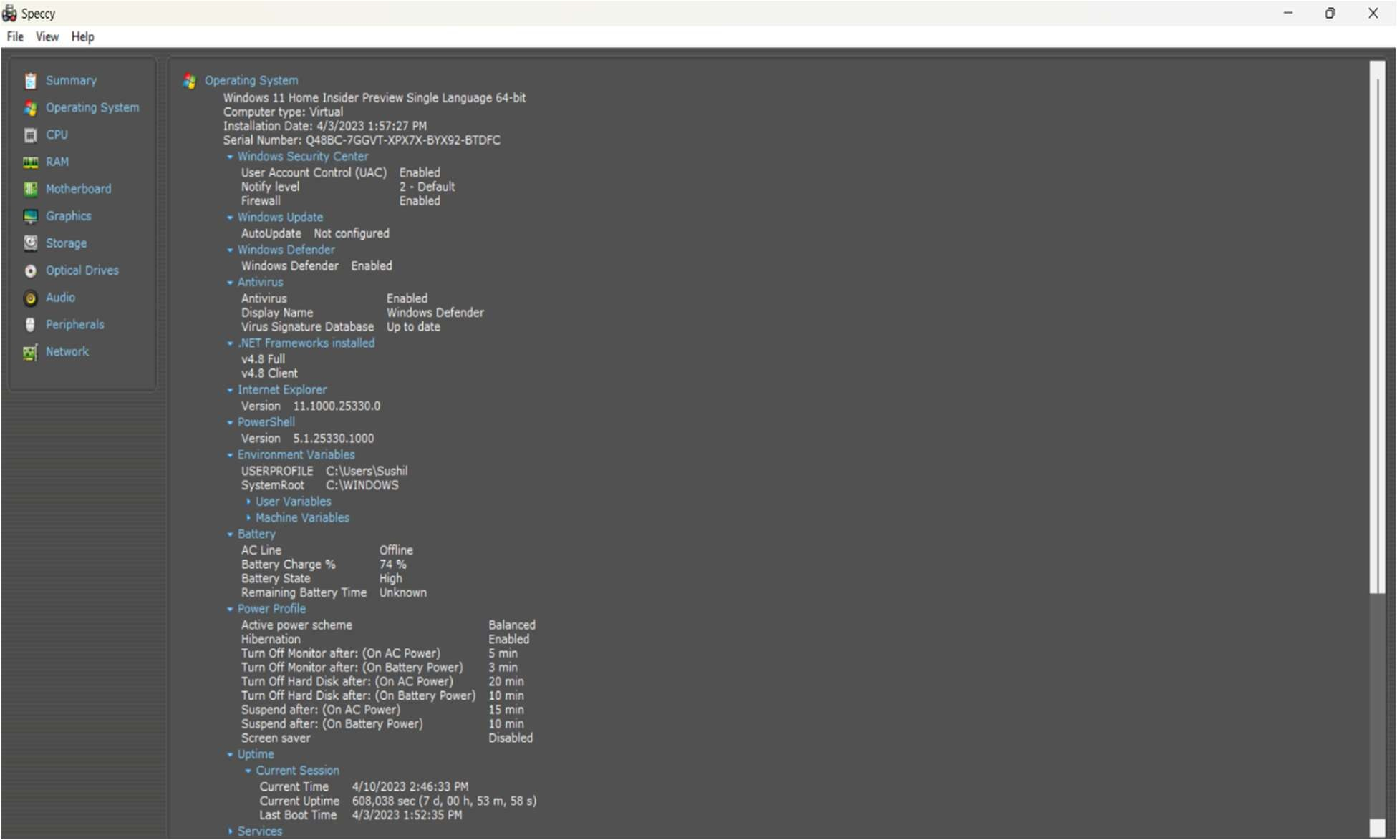

Cpu
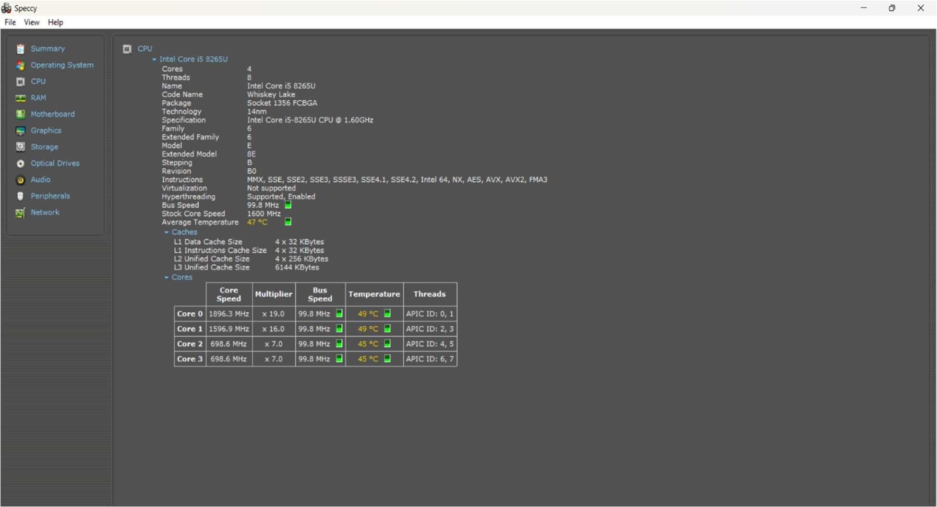

RAM
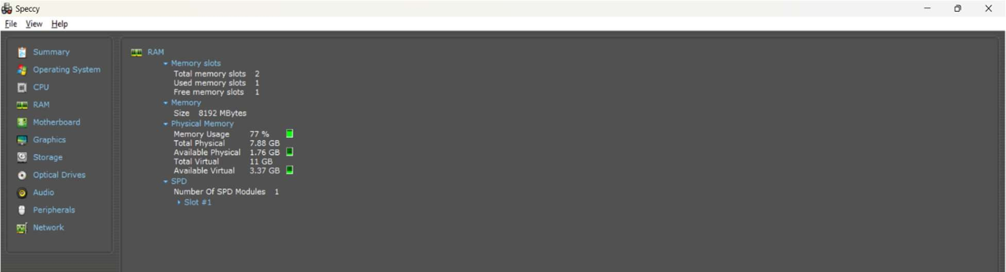

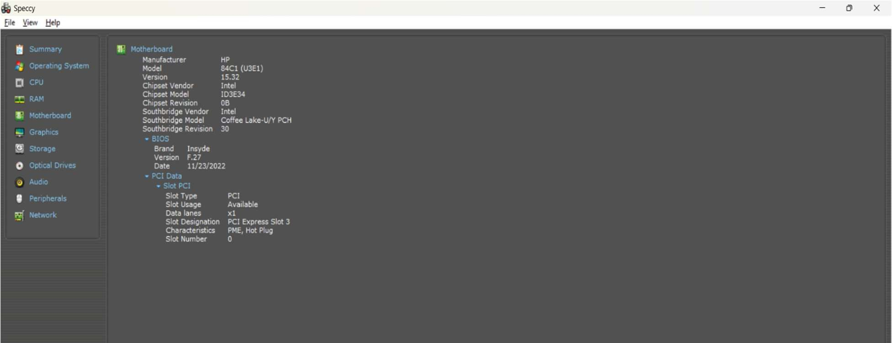
Motherboard

Graphics
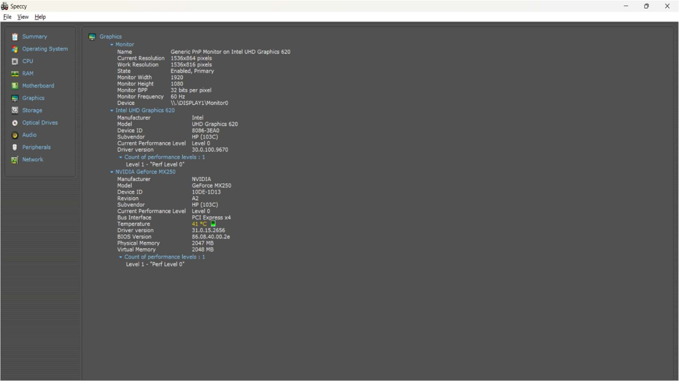

Storage
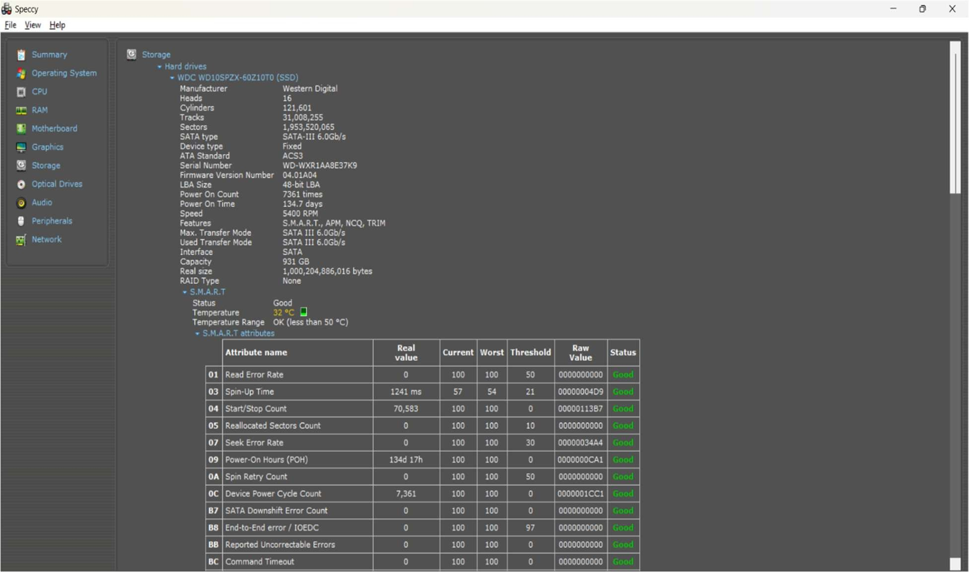

Audio
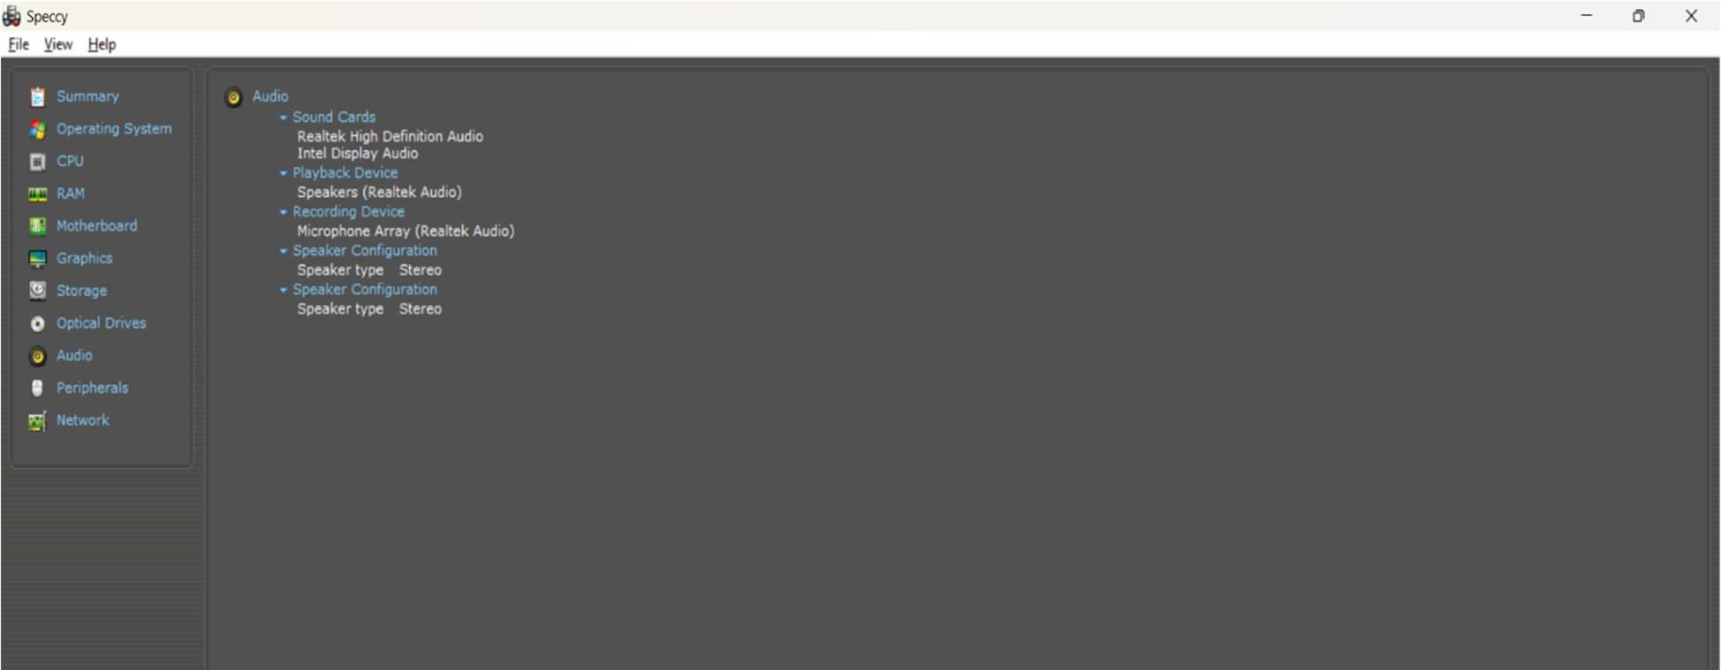

Network
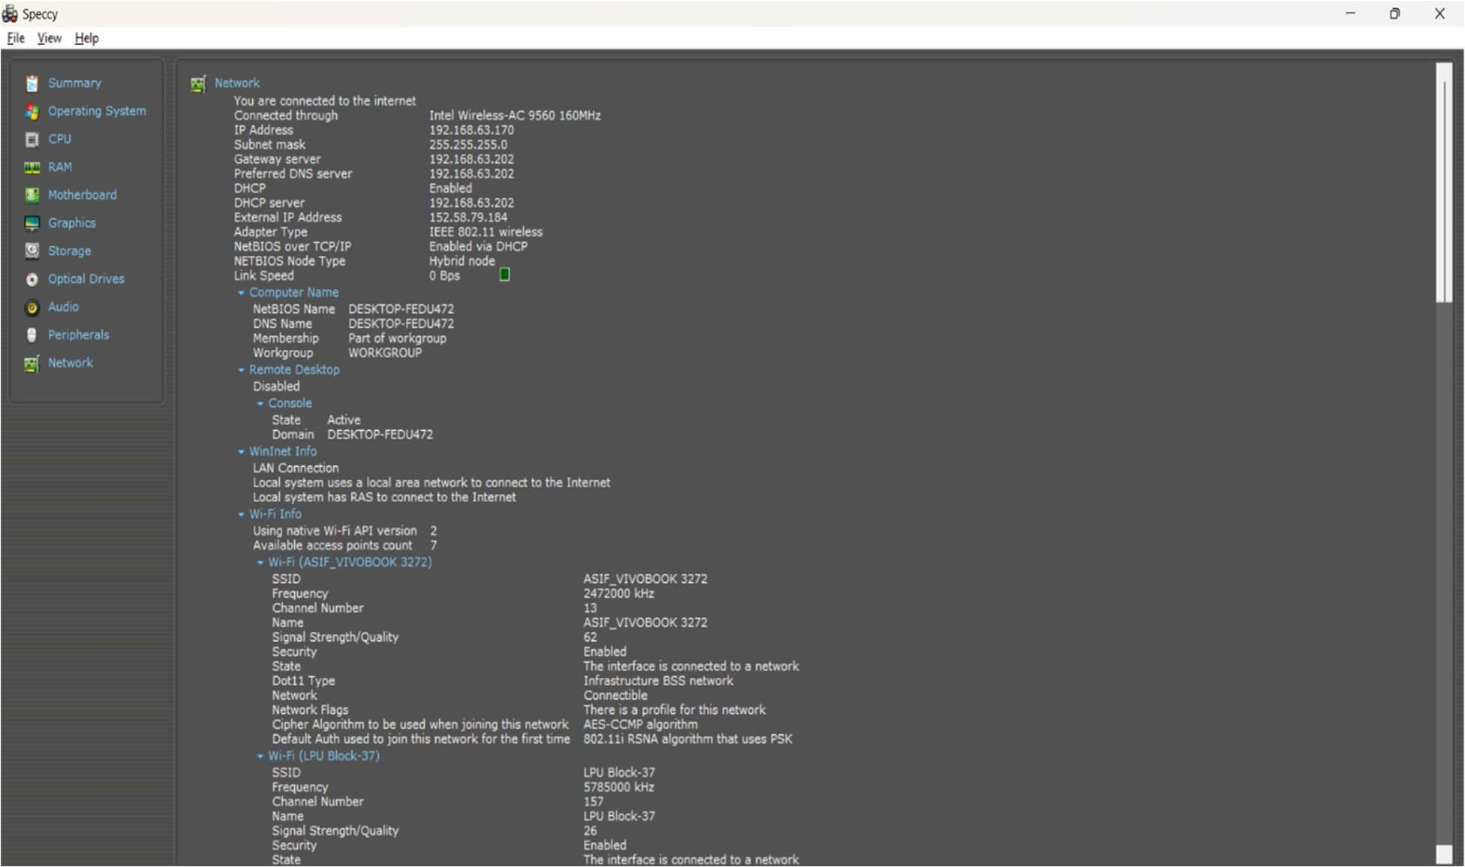

CONCLUSION

In conclusion, Speccy is an extremely useful open-source software that provides detailed information about various system components and tools. With its user-friendly interface and comprehensive reporting, it is an essential tool for any tech enthusiast or IT professional. The software displays important information about the CPU, motherboard, monitor, audio, network, and other components, making it easy to monitor system performance and troubleshoot any issues that may arise. Additionally, the software provides information about the current and average speed/rate of the memory, hard drive, and CPU, which is critical for identifying bottlenecks and optimizing system performance. Overall, Speccy is a valuable addition to any toolkit for those who want to keep their systems running smoothly and efficiently.

REFERENCES

- "How to Use Speccy to Monitor Your PC's Health." How-To Geek. Accessed April 10, 2023. https://www.howtogeek.com/166970/how-to-use-speccy-to-monitor-your-pcs-health/ .

- "Speccy - System Information - Free Download." Piriform. Accessed April 10, 2023. https://www.ccleaner.com/speccy .

- "How to Use Speccy to Monitor Your Computer's Health." Lifewire. Accessed April 10, 2023.
https://www.lifewire.com/how-to-use-speccy-to-monitor-your-computers-health-2626127 .

- "Speccy Review: A Comprehensive System Information Tool." TechSpot. Accessed April 10, 2023. https://www.techspot.com/review/521-speccy/ .

- "Best Free System Information Utility." Gizmo's Freeware. Accessed April 10, 2023.
https://www.techsupportalert.com/best-free-system-information-utility.htm .

